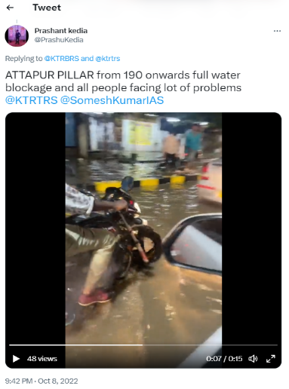
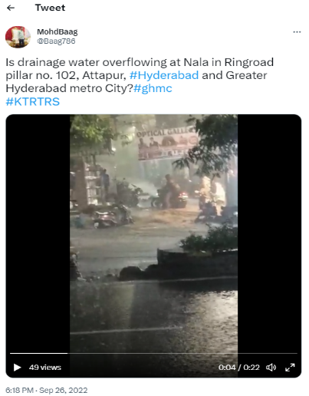
Supplementary Material
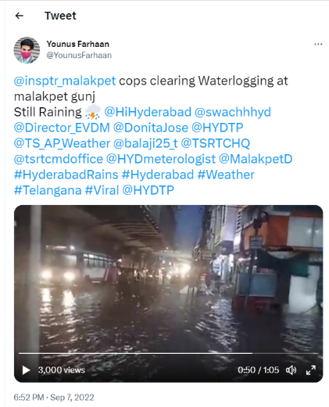
Figure S1(a) Tweet showcases the use of multiple keywords (“HyderabadRains”, “Malakpet”, “HYDTP”) for event E1. S1(b) Tweet’s media content shows nala overflow driven flood for the event E2. S1(c) Tweet from the event E3 shows flooding in a region, i.e., Attapur which frequently gets flooded and is observed commonly in the three events.

