Aerobic exercise supplementation improves depression scores: A systematic review and meta-analysis of randomized controlled trials
Search Strategy：((("Exercise"[Mesh]) OR (((((((((((((((((((((((((Exercise[Title/Abstract]) OR (Physical Activity[Title/Abstract])) OR (Activities, Physical[Title/Abstract])) OR (Activity, Physical[Title/Abstract])) OR (Physical Activities[Title/Abstract])) OR (Exercise, Physical[Title/Abstract])) OR (Exercises, Physical[Title/Abstract])) OR (Physical Exercise[Title/Abstract])) OR (Physical Exercises[Title/Abstract])) OR (Acute Exercise[Title/Abstract])) OR (Acute Exercises[Title/Abstract])) OR (Exercise, Acute[Title/Abstract])) OR (Exercises, Acute[Title/Abstract])) OR (Exercise, Isometric[Title/Abstract])) OR (Exercises, Isometric[Title/Abstract])) OR (Isometric Exercises[Title/Abstract])) OR (Isometric Exercise[Title/Abstract])) OR (Exercise, Aerobic[Title/Abstract])) OR (Aerobic Exercise[Title/Abstract])) OR (Aerobic Exercises[Title/Abstract])) OR (Exercises, Aerobic[Title/Abstract])) OR (Exercise Training[Title/Abstract])) OR (Exercise Trainings[Title/Abstract])) OR (Training, Exercise[Title/Abstract])) OR (Trainings, Exercise[Title/Abstract]))) AND (("Depression"[Mesh]) OR (((((((Depression[Title/Abstract]) OR (Depressive Symptoms[Title/Abstract])) OR (Depressive Symptom[Title/Abstract])) OR (Symptom, Depressive[Title/Abstract])) OR (Symptoms, Depressive[Title/Abstract])) OR (Emotional Depression[Title/Abstract])) OR (Depression, Emotional[Title/Abstract]))) AND (randomizedcontrolledtrial[Filter])) AND (((((aerobic exercise[Title/Abstract]) OR (Exercise, Aerobic[Title/Abstract])) OR (Aerobic Exercise[Title/Abstract])) OR (Aerobic Exercises[Title/Abstract])) OR (Exercises, Aerobic[Title/Abstract]))
Pubmed
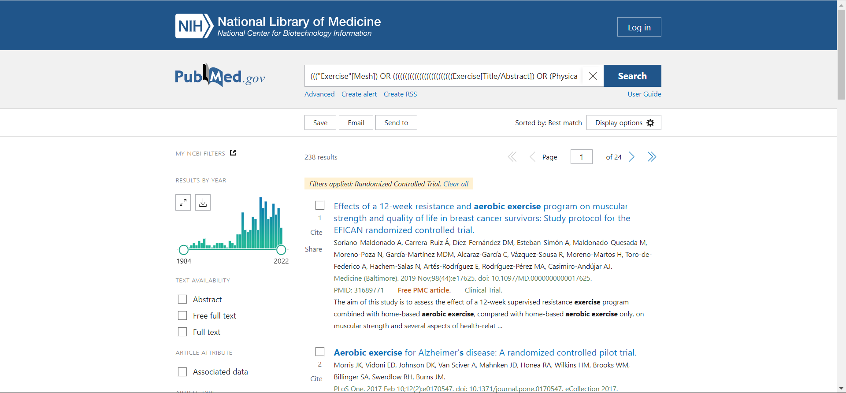
Cochranelibrary
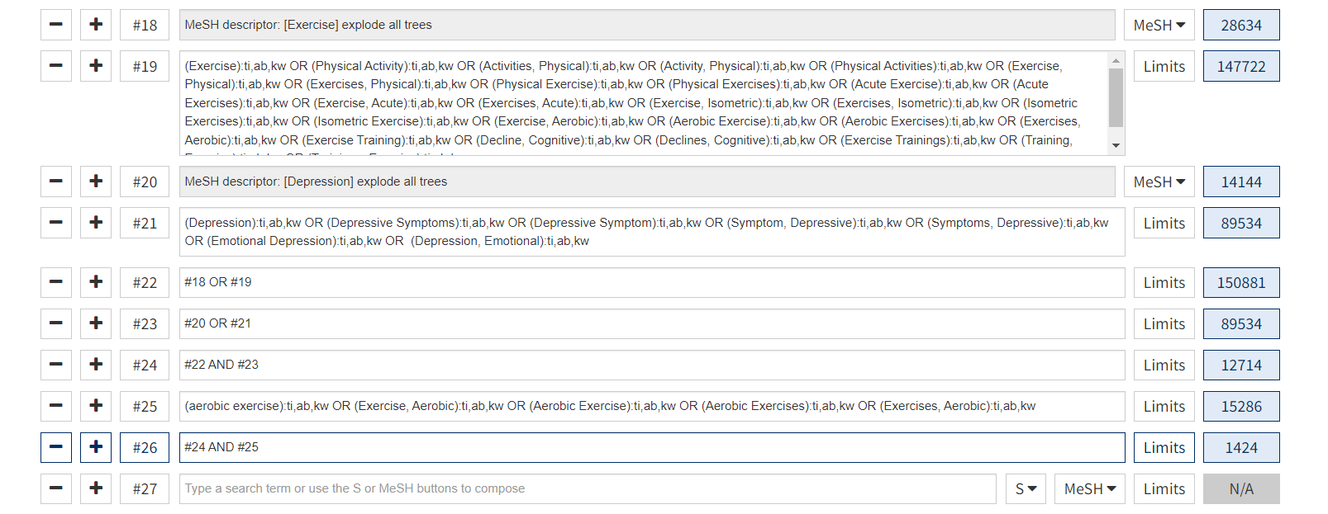
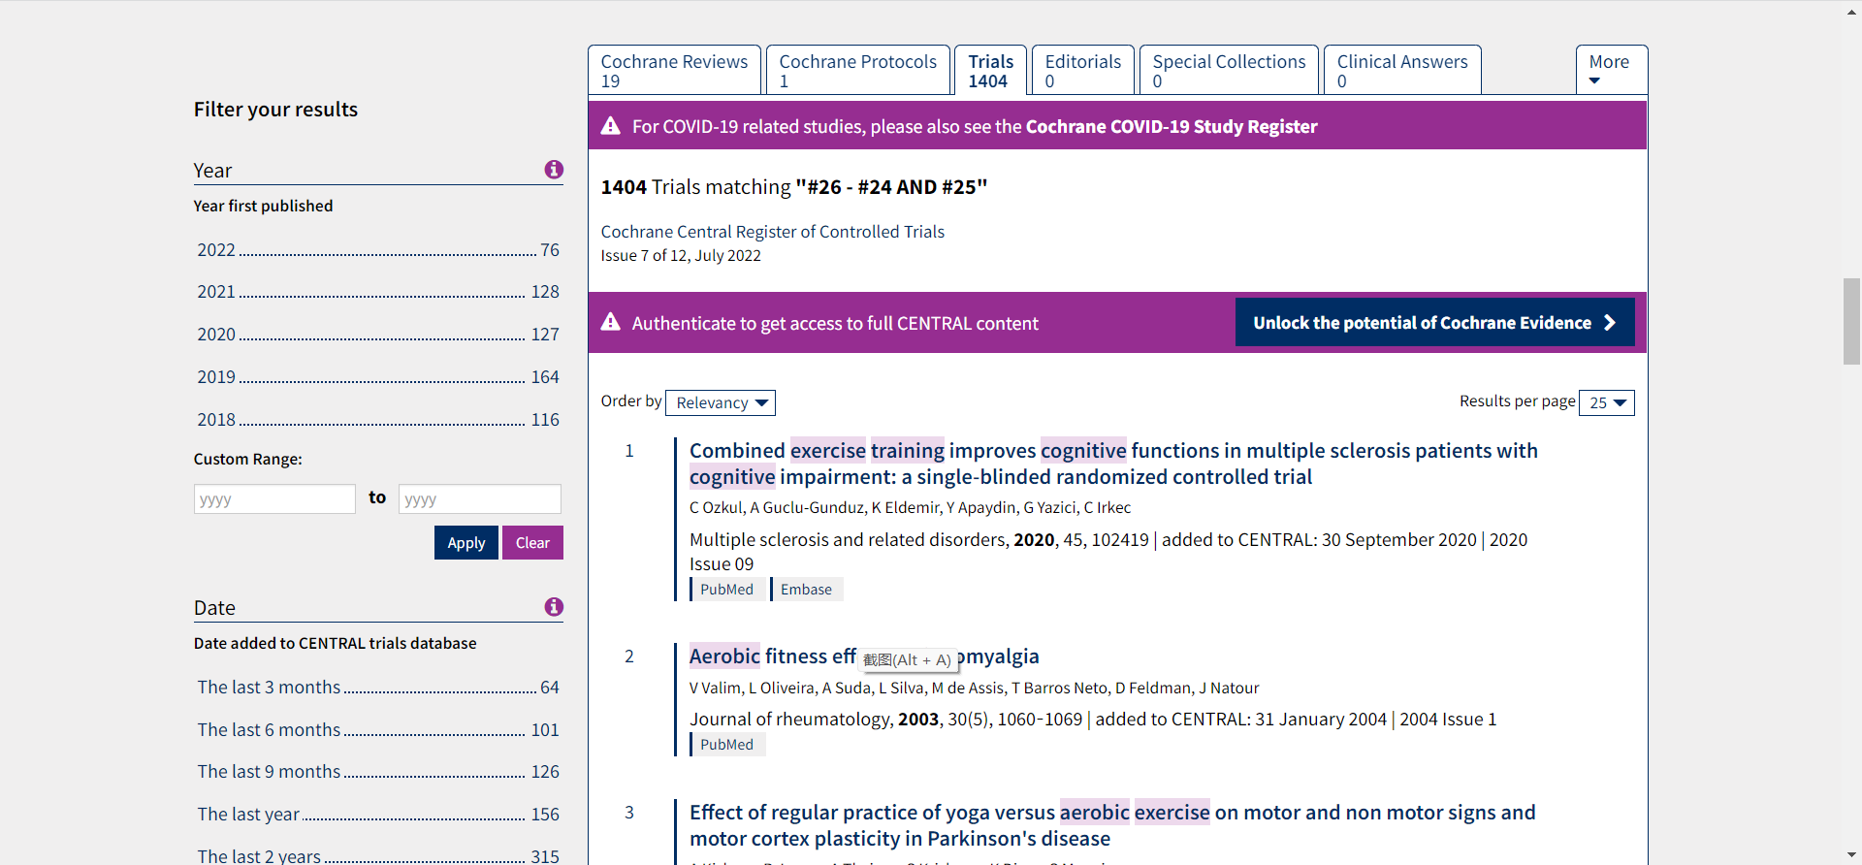
Web of science
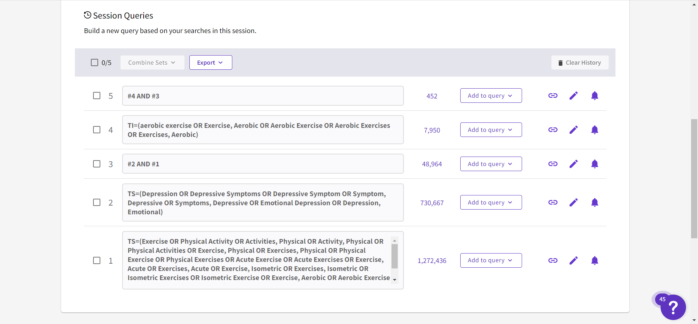
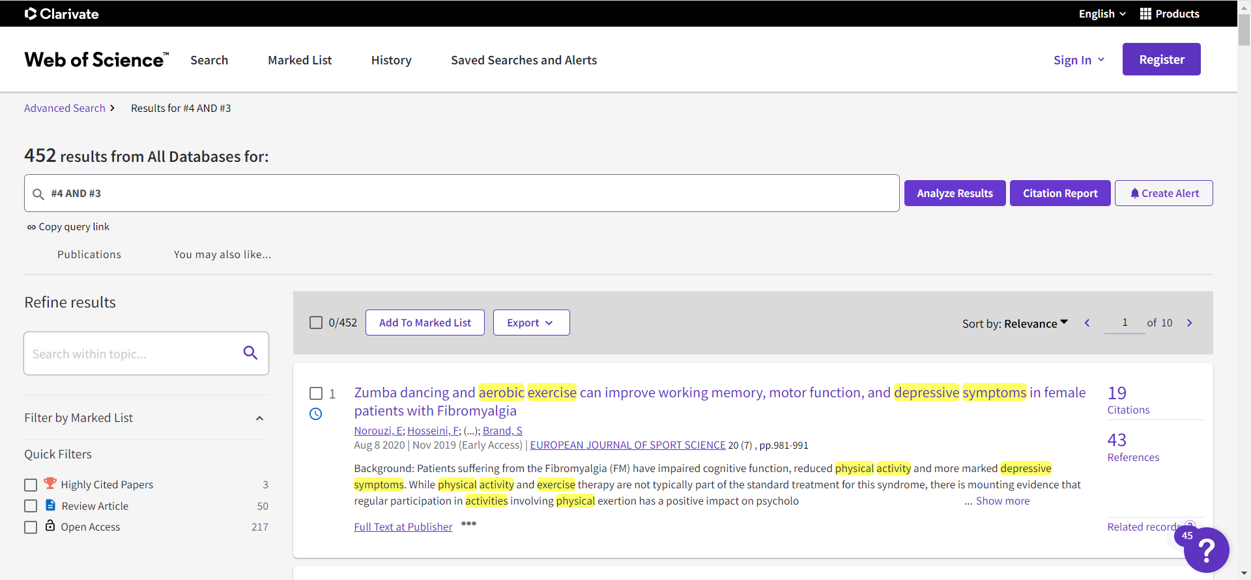
Embase
'Exercise':ab,ti or 'Physical Activity':ab,ti or 'Activities, Physical':ab,ti or 'Activity, Physical':ab,ti or 'Physical Activities':ab,ti or 'Exercise, Physical':ab,ti or 'Exercises, Physical':ab,ti or 'Physical Exercise':ab,ti or 'Physical Exercises':ab,ti or 'Acute Exercise':ab,ti or 'Acute Exercises':ab,ti or 'Exercise, Acute':ab,ti or 'Exercises, Acute':ab,ti or 'Exercise, Isometric':ab,ti or 'Exercises, Isometric':ab,ti or 'Isometric Exercises':ab,ti or 'Isometric Exercise':ab,ti or 'Exercise, Aerobic':ab,ti or 'Aerobic Exercise':ab,ti or 'Aerobic Exercises':ab,ti or 'Exercises, Aerobic':ab,ti or 'Exercise Training':ab,ti or 'Exercise Trainings':ab,ti or 'Training, Exercise':ab,ti or 'Trainings, Exercise':ab,ti
'Depression':ab,ti or 'Depressive Symptoms':ab,ti or 'Depressive Symptom':ab,ti or 'Symptom, Depressive':ab,ti or 'Symptoms, Depressive':ab,ti or 'Emotional Depression':ab,ti or 'Depression, Emotional':ab,ti
'Exercises, Aerobic':ab,ti or 'Exercise, Aerobic':ab,ti or 'Aerobic Exercise':ab,ti or 'Aerobic Exercises':ab,ti
