Supplementary material

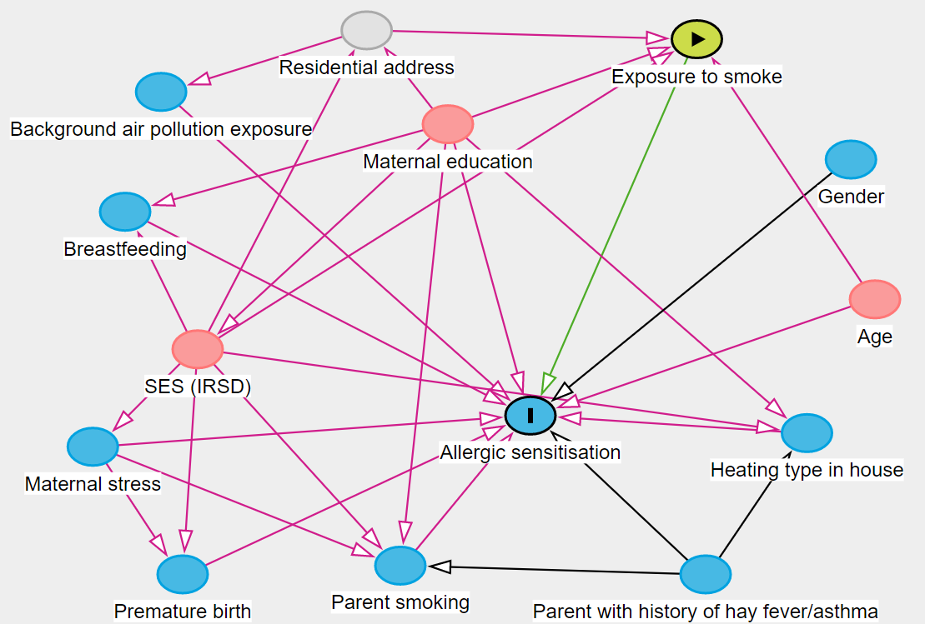
Figure S1 – Directed acyclic graph
Figure S2 – Pearson’s pairwise correlation coefficients between all exposures
Table S1 – Association between exposure to the various sources of PM_{2.5}, and sensitisation to various allergen categories and total IgE levels (adjustment for larger minimal sufficient adjustment set)
- Fire-related PM_{2.5}
Allergen categories | Prenatal |  | Postnatal
Allergen categories | Average | Peak | Average | Peak
Allergen categories | OR_{adj} [95% CI] | OR_{adj} [95% CI] | OR_{adj} [95% CI] | OR_{adj} [95% CI]
Dust | 0.94 [0.82,1.08] | 0.96 [0.82,1.13] | 0.95 [0.80,1.13] | 0.88 [0.52,1.51]
Cat | 1.00 [0.87,1.16] | 1.07 [0.90,1.29] | 1.14 [0.93,1.39] | 1.67 [0.90,3.10]
Grass | 0.90 [0.74,1.09] | 0.87 [0.68,1.13] | 1.08 [0.91,1.27] | 1.28 [0.77,2.13]
Fungi | 1.03 [0.86,1.24] | 1.13 [0.91,1.40] | 1.12 [0.90,1.38] | 1.26 [0.60,2.66]
Any | 0.90 [0.78,1.03] | 0.91 [0.77,1.07] | 0.97 [0.82,1.15] | 0.94 [0.56,1.58]
 | β [95% CI] | β [95% CI] | β [95% CI] | β [95% CI]
Total IgE | -0.1 [-9.7,9.5] | -1.9 [-16.2,12.5] | -9.5 [-24.4,5.4] | -31.2 [-78.3,16.0]

- Background PM_{2.5}
Allergen categories | PM_{2.5}
Allergen categories | OR_{adj} [95% CI]
Dust | 2.02 [1.12,3.65]
Cat | 1.31 [0.63,2.70]
Grass | 1.46 [0.87,2.46]
Fungi | 1.39 [0.65,2.96]
Any | 1.34 [0.84,2.13]
 | β [95% CI]
Total IgE | 19.2 [-20.1,58.5]
Note: Odds ratios and 95%CI from the adjusted models were estimated with logistic regression/linear regression models incorporating the outcome (logistic: sensitisation to allergen category, linear: total IgE levels), all three exposures, breastfeeding, main heating type in the house, maternal education, pregnancy stress, presence of a smoker in the house, parent with history of asthma or allergic rhinitis, and premature birth. All estimates were scaled by IQR increase of the relevant pollutant. IgE: Immunoglobulin E.
Table S2 – Association between exposure to the various sources of PM_{2.5}, and sensitisation to various allergen categories and total IgE levels (without imputation).
- Fire-related PM_{2.5}
Allergen categories | Prenatal |  | Postnatal
Allergen categories | Average | Peak | Average | Peak
Allergen categories | OR_{adj} [95% CI] | OR_{adj} [95% CI] | OR_{adj} [95% CI] | OR_{adj} [95% CI]
Dust | 0.93 [0.78,1.05] | 0.95 [0.79,1.11] | 0.89 [0.72,1.06] | 0.68 [0.35,1.22]
Cat | 1.03 [0.87,1.16] | 1.11 [0.91,1.31] | 1.12 [0.92,1.35] | 1.59 [0.87,2.84]
Grass | 0.91 [0.72,1.05] | 0.89 [0.66,1.08] | 1.06 [0.90,1.25] | 1.19 [0.72,1.99]
Fungi | 1.01 [0.76,1.17] | 1.11 [0.86,1.35] | 1.09 [0.87,1.31] | 1.14 [0.52,2.11]
Any | 0.90 [0.76,1.01] | 0.90 [0.75,1.05] | 0.92 [0.77,1.10] | 0.76 [0.42,1.34]
 | β [95% CI] | β [95% CI] | β [95% CI] | β [95% CI]
Total IgE | -2.5 [-12.3,7.4] | -7.1 [-22.0,7.8] | -12.8 [-28.5,3.0] | -49.4 [-99.9,1.1]

- Background PM_{2.5}
Allergen categories | PM_{2.5}
Allergen categories | OR_{adj} [95% CI]
Dust | 1.87 [1.16,3.31]
Cat | 1.38 [0.75,2.86]
Grass | 1.50 [0.95,2.58]
Fungi | 1.41 [0.77,3.03]
Any | 1.41 [0.94,2.25]
 | β [95% CI]
Total IgE | 15.5 [-27.2,58.2]
Note: Odds ratios and 95%CI from the adjusted models were estimated with logistic regression/linear regression models incorporating the outcome (logistic: sensitisation to allergen category, linear: total IgE levels), all three exposures, maternal education, age in months, and IRSD. All estimates were scaled by IQR increase of the relevant pollutant. IgE: Immunoglobulin E.

