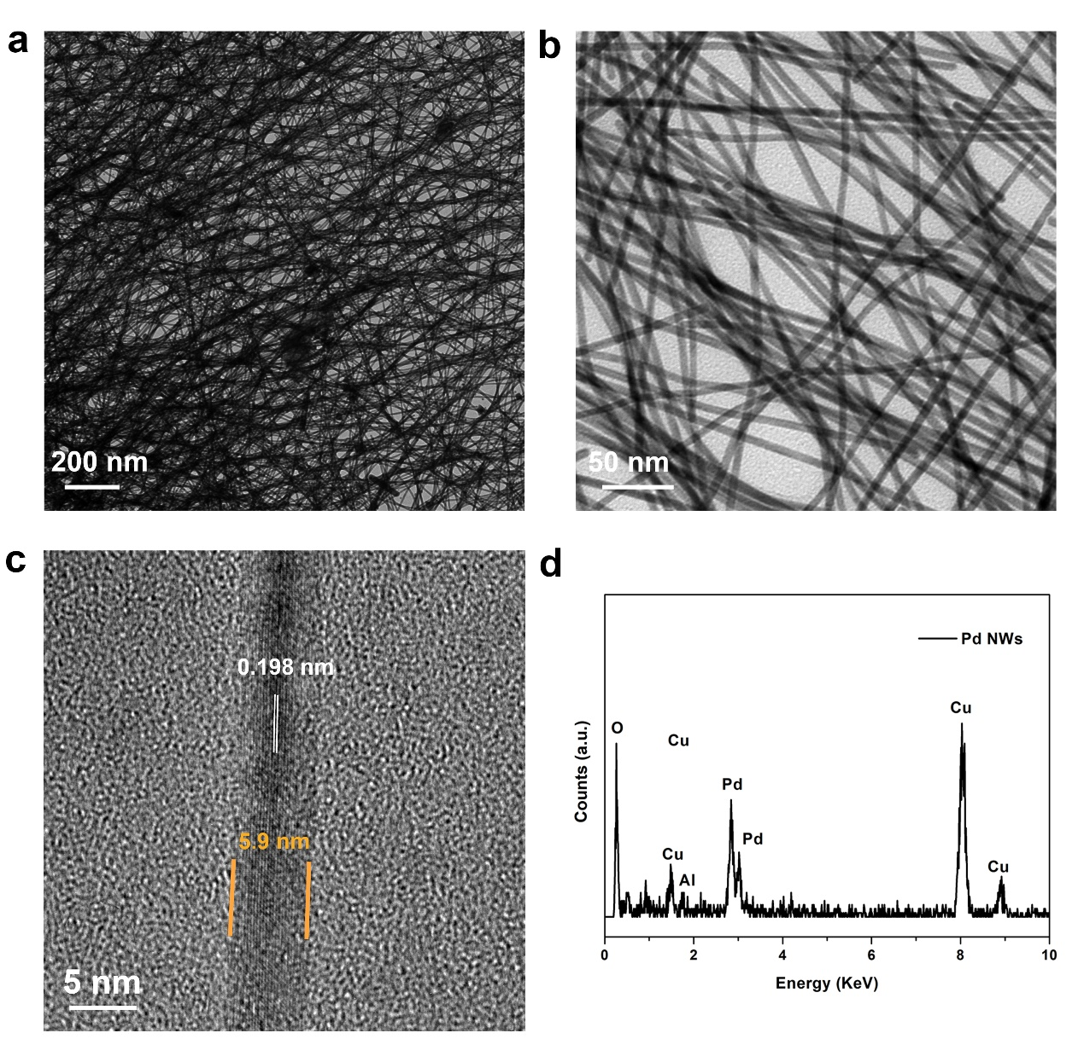
Figure S1. Structural and compositional analysis of pure Pd NWs. (a) Low- and (b) High- magnification TEM images. (c) HRTEM. (d) TEM-EDS.
Figure S2. XRD pattern of different Pd based NWs.

Figure S3. CVs of different catalysts recorded in N₂ saturated 0.1 M HClO₄ solution at a scan rate of 50 mV s⁻¹.

Figure S4. Histograms of ECSA of different catalysts.

Figure S5. CVs of different catalysts after 10000 potential cycles.

Figure S6. Histograms of ECSA of different catalysts after 10000 potential cycles.

Figure S7. ORR polarization curves of different catalysts after 10000 potential cycles.

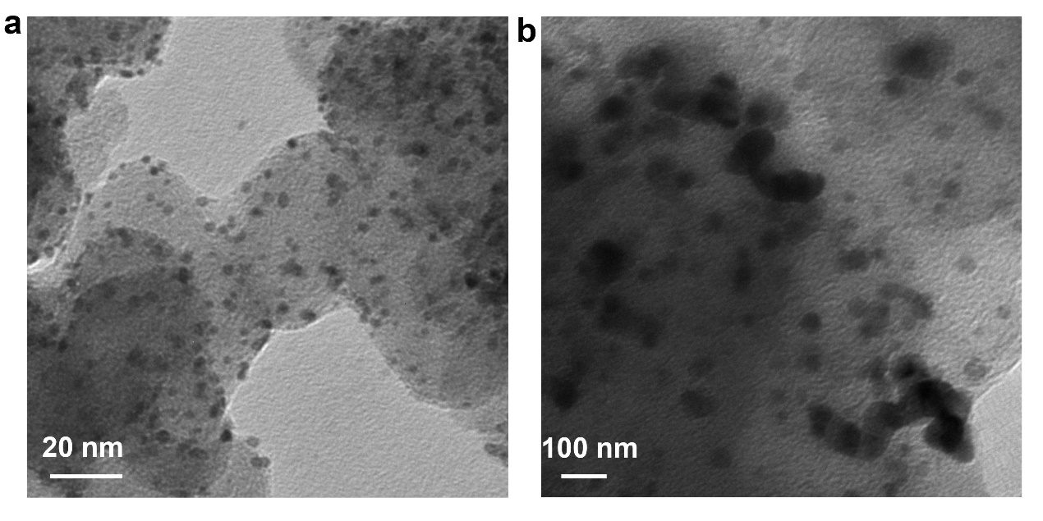
Figure S8. TEM images of commercial Pt/C catalyst before and after 10000 potential cycles between 0.6 and 1.1 V versus RHE.

 | E_{1/2} initial (V) | E_{1/2} after 10000 potential cycles (V) | △E_{1/2} (mV)
Pure Pd NWs/C | 0.701 | 0.610 | 91
PdFe NW /C | 0.821 | 0.763 | 58
PdCo NW /C | 0.774 | 0.738 | 36
PdNi NW /C | 0.828 | 0.804 | 35
Commercial Pt/C | 0.814 | / | /
Table S1. Half-wave potential (E_{1/2}) of different catalysts before and after 10000 potential cycles.

