Supplementary Table 1. Overview of clinical activity as assessed by the investigator
 | Total (N=146; 100%)
Best overall response, n (%)  Complete response  Partial response  Stable disease  Progressive disease  Not evaluable | 5 (3.4)  20 (13.7)  32 (21.9)  71 (48.6)  18 (12.3)
Objective response rate (95% CI),ª %^{b} | 17.1 (11.4-24.2)
Disease control rate (95% CI),ª %^{c} | 39.0 (31.1-47.5)
ª95% exact CI using the Clopper-Pearson method.
^{b}Best overall response assessment of complete response or partial response.
^{c}Best overall response assessment of complete response, partial response, or stable disease.
CI, confidence interval.

Supplementary Table 2. Individual responder baseline characteristics and other efficacy outcomes
Responder patient no. | Age at baseline, years | ECOG PS at baseline | Time since prior treatment, days | Sum of longest diameter by the IRC per RECIST, mm | OS, months | PFS by the IRC, months | DOR, months | Cervical cancer subtype | Prior Bev | HPV status
1 | 26 | 1 | 70 | 47 | 15.2ª | 13.8ª | 9.5ª | SCC | Y | High risk
2 | 39 | 1 | 94 | 186 | 12.6 | 12.6 | 10.6 | SCC | Y | NA
3 | 53 | 1 | 93 | 43 | 17.6ª | 13 | 7.6 | SCC | N | High risk
4 | 50 | 1 | 175 | 21 | 14ª | 3.9 | 2.3 | SCC | Y | High risk
5 | 50 | 0 | 0 | 19 | 14.4ª | 7.4 | 3.5 | SCC | N | High risk
6 | 79 | 0 | 110 | 55 | 17.1ª | 6.4ª | 4.6ª | Adenocarcinoma | N | HPV‒
7 | 35 | 1 | 101 | 18 | 14.3ª | 13.7ª | 11.9ª | SCC | Y | High risk
8 | 60 | 1 | 960 | 16 | 17.4ª | 12.5ª | 10.6ª | SCC | N | NA
9 | 51 | 0 | 759 | 21 | 13ª | 3.7ª | 1.9ª | SCC | N | High risk
10 | 49 | 1 | 65 | 37 | 11.8ª | 4.5ª | 2.7ª | SCC | Y | High risk
11 | 63 | 1 | 132 | 16 | 14.9ª | 13.3ª | 11.6ª | SCC | N | High risk
12 | 54 | 0 | 42 | 51 | 14 | 5.5ª | 1.9ª | SCC | Y | NA
13 | 55 | 0 | 304 | 36 | 21.7ª | 19.3ª | 17.4ª | SCC | Y | High risk
14 | 50 | 0 | 197 | 38 | 15.8ª | 12.8ª | 9.1ª | SCC | N | High risk
15 | 60 | 1 | 119 | 24 | 20.3ª | 19.3ª | 17.4ª | SCC | Y | High risk
16 | 56 | 0 | 74 | 56 | 18.4 | 11.1 | 7.4 | SCC | N | High risk
17 | 78 | 0 | 155 | 33 | 19.3ª | 19.3ª | 17.5ª | Adenocarcinoma | Y | HPV‒
18 | 53 | 0 | 506 | 28 | 19.3ª | 19.3ª | 17.5ª | SCC | Y | High risk
19 | 64 | 0 | 196 | 69 | 19.8ª | 19.4ª | 17.4ª | Adenocarcinoma | Y | High risk
20 | 43 | 0 | 364 | 36 | 15.4ª | 10.4 | 8.5 | SCC | Y | High risk
21 | 43 | 0 | 132 | 24 | 18.6ª | 7.2 | 3.4 | SCC | N | High risk
22 | 72 | 1 | 0 | 20 | 16.8 | 16.8 | 9.5 | SCC | N | High risk
23 | 67 | 0 | 133 | 16 | 14.4ª | 5.5ª | 3.7ª | Adenocarcinoma | Y | High risk
24 | 35 | 0 | 177 | 72 | 17.2ª | 16.5ª | 14.8ª | SCC | Y | High risk
25 | 55 | 1 | 326 | 38 | 20.9ª | 7.4 | 4.3 | SCC | Y | High risk
26 | 64 | 0 | 804 | 36 | 18.4ª | 17.9ª | 16.2ª | SCC | N | High risk
27 | 61 | 0 | 333 | 72 | 14.9ª | 7.3 | 5.6 | SCC | N | High risk
28 | 64 | 1 | 100 | 45 | 18.4ª | 5.4 | 3.7 | SCC | Y | High risk
29 | 64 | 0 | 133 | 43 | 6ª | 5.5ª | 3.7ª | SCC | Y | High risk
30 | 61 | 1 | 65 | 48 | 17.1ª | 11.9ª | 4.5ª | Adenocarcinoma | Y | NA
31 | 40 | 1 | 62 | 71 | 14.5ª | 11 | 7.4 | Adenocarcinoma | Y | High risk
32 | 38 | 1 | 55 | 68 | 12ª | 11.1ª | 9.2ª | SCC | N | High risk
ªObservations were discontinued due to data cutoff at this time point without having an event (death, progressive disease).
Bev, bevacizumab; DOR, duration of response; ECOG PS, Eastern Cooperative Oncology Group performance status; HPV, human papilloma virus; IRC, Independent Review Committee; NA, not applicable; OS, overall survival; PFS, progression-free survival; RECIST 1.1, Response Evaluation Criteria in Solid Tumors version 1.1; SCC, squamous cell carcinoma.
Supplementary Table 3. Immunogenicity of bintrafusp alfa
 | Bintrafusp alfa
ADA result
Never positive, n/N1 (%)ª | 109/142 (76.8)
Ever positive, n/N1 (%)^{b} | 33/142 (23.2)
ADA treatment-emergent status
Treatment-emergent n/N2 (%)^{c} | 23/138 (16.7)
Non-treatment-emergent n/N2 (%)^{d} | 115/138 (83.3)
ªNo positive ADA results at any time point.
^{b}At least 1 positive result at any time point, including baseline.
^{c}Not positive prior to treatment with bintrafusp alfa and with ≥1 positive post-baseline result or a positive ADA result prior to treatment with bintrafusp alfa and ≥1 post-baseline value with ADA titer result ≥8 baseline ADA titer result.
^{d}All patients with ≥1 valid post-baseline result at any time point minus treatment-emergent ALL.
ADA, anti-drug antibody; N1, number of subjects with ≥1 valid result at any time point; N2, number of patients with ≥1 valid post-baseline result at any time point.

Supplementary Fig. 1 Waterfall plot for ORR according to RECIST 1.1 as adjudicated by the IRC
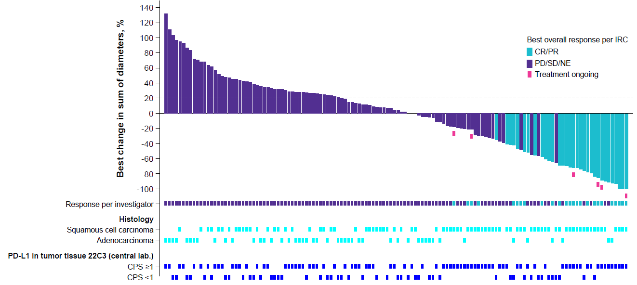

CBOR, confirmed best overall response; CPS, combined positive score; CR, complete response; IRC, Independent Review Committee; NE, not evaluable; ORR, objective response rate; PD, progressive disease; PD-L1, programmed death-ligand 1; PR, partial response; RECIST 1.1, Response Evaluation Criteria in Solid Tumors version 1.1; SD, stable disease.

Supplementary Fig. 2 Swimlane plot as adjudicated by the IRC

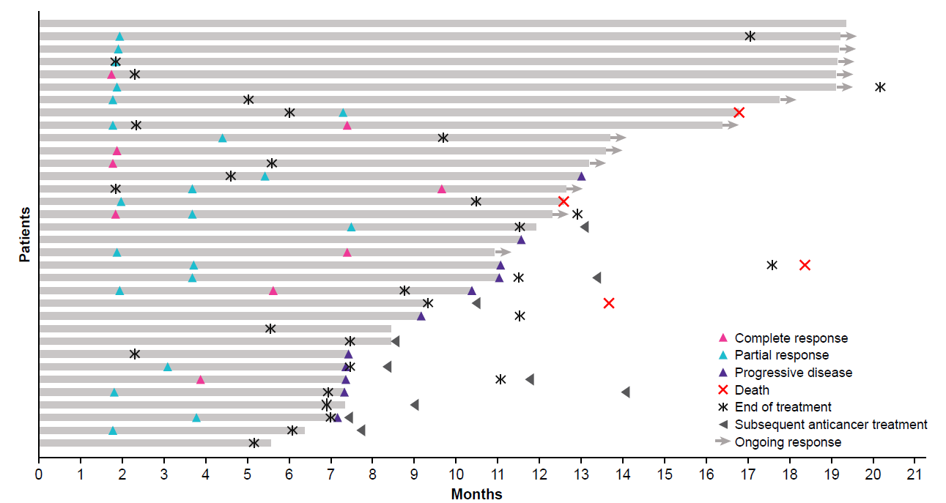

IRC, Independent Review Committee; RECIST 1.1, Response Evaluation Criteria in Solid Tumors version 1.1.
Supplementary Fig. 3 Forest plot for ORR according to RECIST 1.1 as adjudicated by the IRC

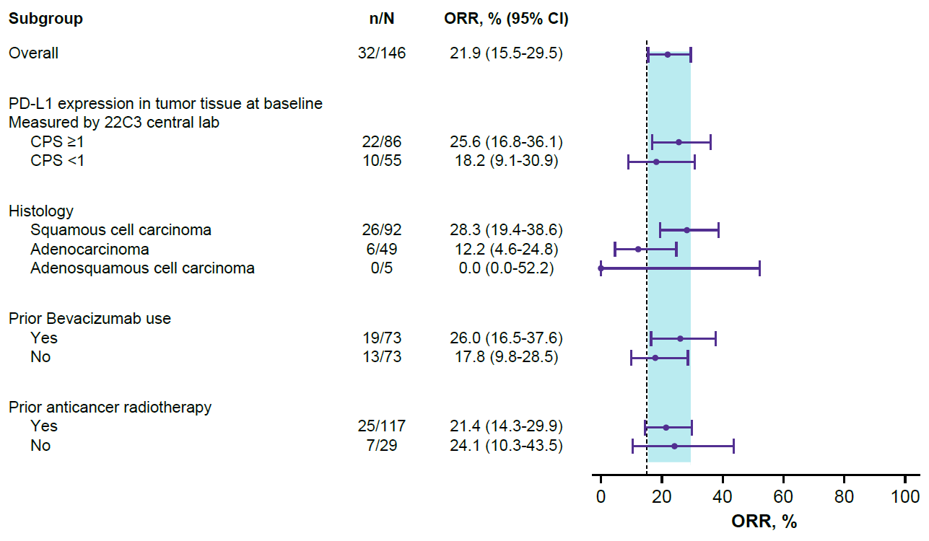
Dashed vertical line indicates benchmark ORR of 15%.
CI, confidence interval; CPS, combined positive score; IRC, Independent Review Committee; ORR, objective response rate; PD-L1, programmed death-ligand 1; RECIST 1.1, Response Evaluation Criteria in Solid Tumors version 1.1.

Supplementary Fig. 4 Kaplan-Meier curve of PFS as assessed by the IRC by PD-L1 status (A) and histology (B)

A
B

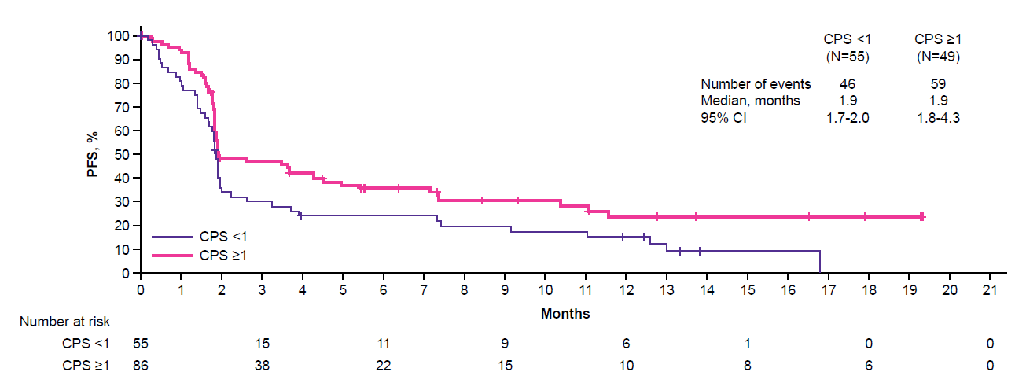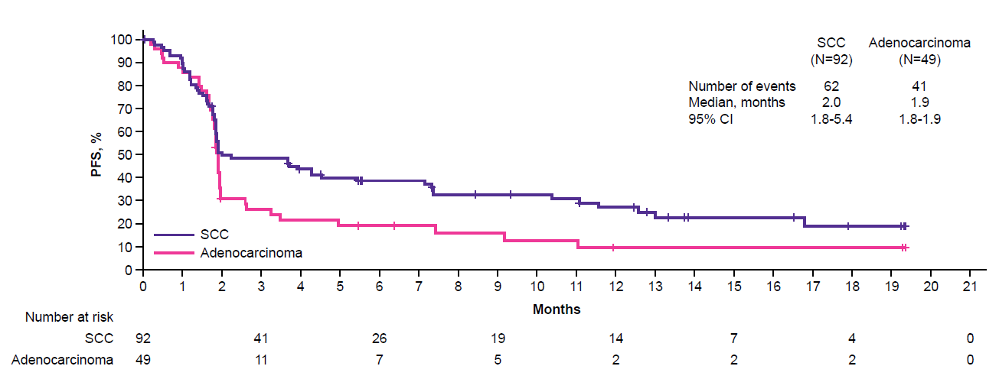

CI, confidence interval; CPS, combined positive score; IRC, Independent Review Committee; PD-L1, programmed death-ligand 1; PFS, progression-free survival; SCC, squamous cell carcinoma.
Supplementary Fig. 5 Kaplan-Meier curve of OS by PD-L1 status (A) and histology (B)

A
B

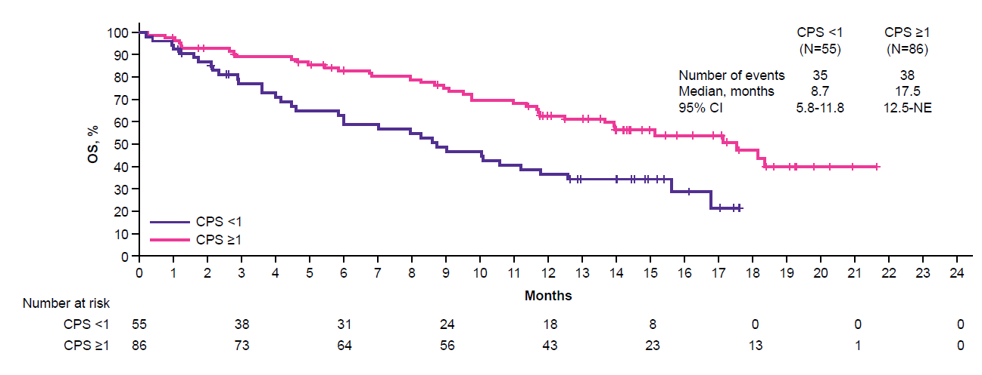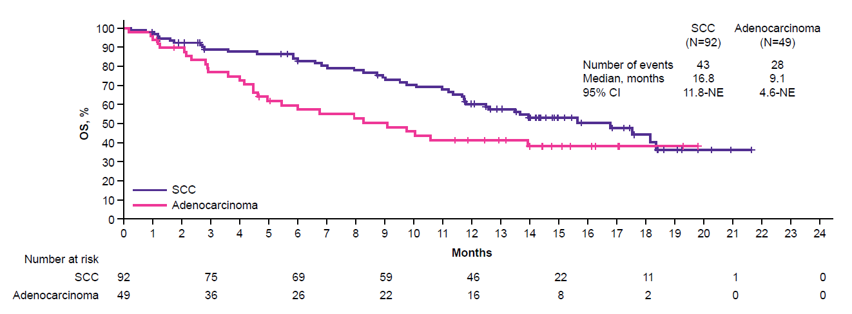

CI, confidence interval; CPS, combined positive score; NE, not evaluable; OS, overall survival; PD-L1, programmed death-ligand 1; SCC, squamous cell carcinoma.
Supplementary Fig. 6. Bintrafusp alfa serum C_{trough} (A) arithmetic mean ± SD and (B) geometric mean ± SD over time*

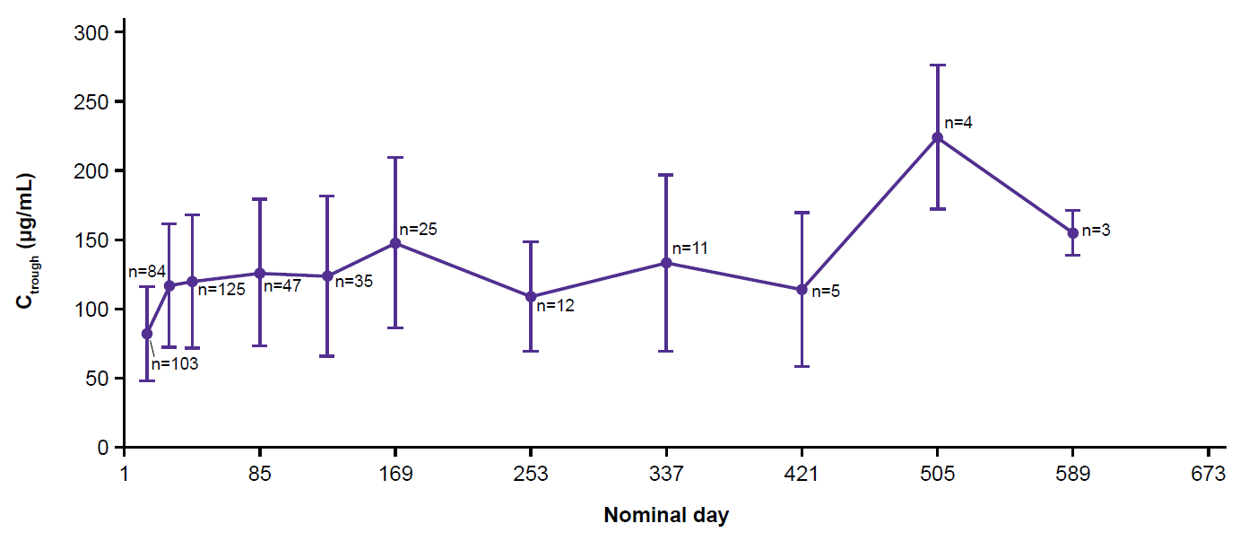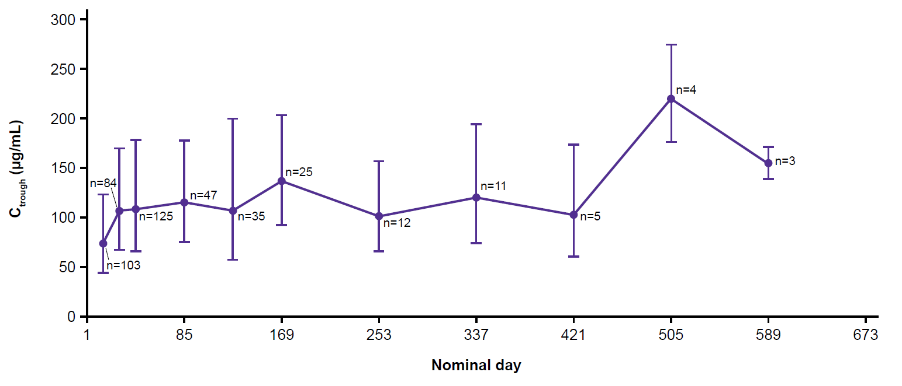

*Only data with n≥3 were summarized.
C_{trough}, trough concentration; SD, standard deviation.

