Table 1. The Brief Environmental Exposure and Sensitivity Inventory
Table 2. QEESI Symptoms Scale items scored on a 10-point Likert-type scale. (0 = not at all a problem, 5 = moderate symptoms, 10 = disabling symptoms)

Table 3. Indoor air sampling pre- and post-intervention shows a significant decrease in VOCs from mothballs, moth crystals, and coatings.
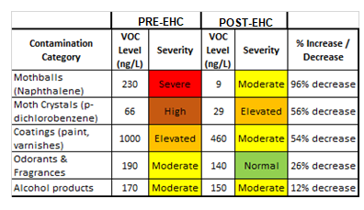

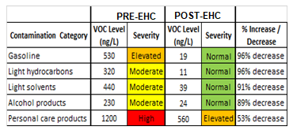
Table 4. A substantial decrease in VOCs from gasoline, light hydrocarbons/solvents, and alcohol products occurred after the patient stored many products in the new storage room.

Table 5. Lab report showed significant reductions in VOCs from moth crystals, odorants/fragrances, and coatings.
