Preparation and characterization of impurities of Teriflunomide - An Immunomodulatory agent

Chilamkurthi Suresh,*^{a,b} Dharmasoth Rama Devi,^{c} Keloth Basavaiah,^{b} Aaramadaka Sunil Kumar Reddy,ª K.V. V. Prasada rao,ª Guduri Anil Kumar,ª

S.No | Content | Page. No
1 | ¹H NMR,¹³C NMR, HRMS & HPLC of Chloromethyl Teriflunomide (2) | 2-5
2 | ¹H NMR,¹³C NMR, HRMS & HPLC of Ethyl Teriflunomide (3) | 6-9
3 | ¹H NMR,¹³C NMR, HRMS & HPLC of 2-Isomer Teriflunomide (4) | 10-13
4 | ¹H NMR,¹³C NMR, HRMS & HPLC of 3-Isomer Teriflunomide (5) | 14-17

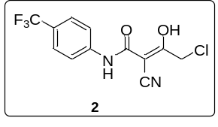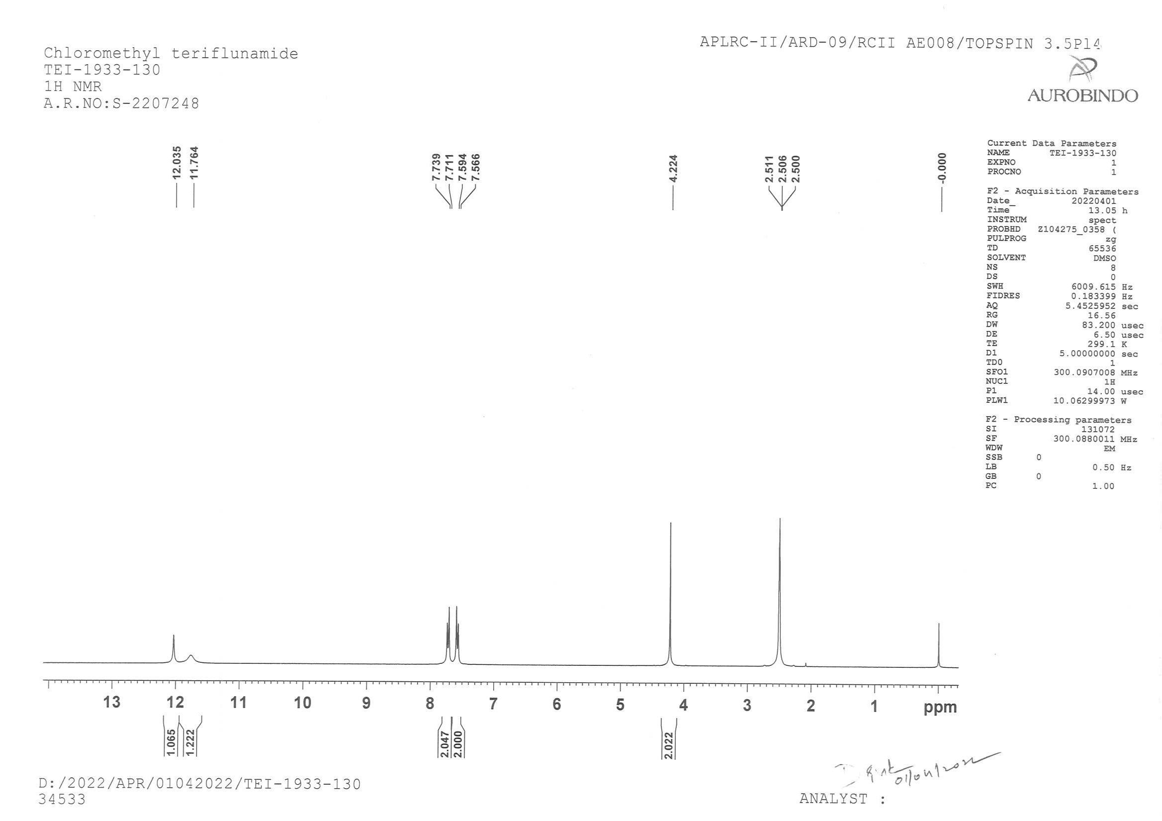
¹H NMR of Chloromethyl Teriflunomide (2)
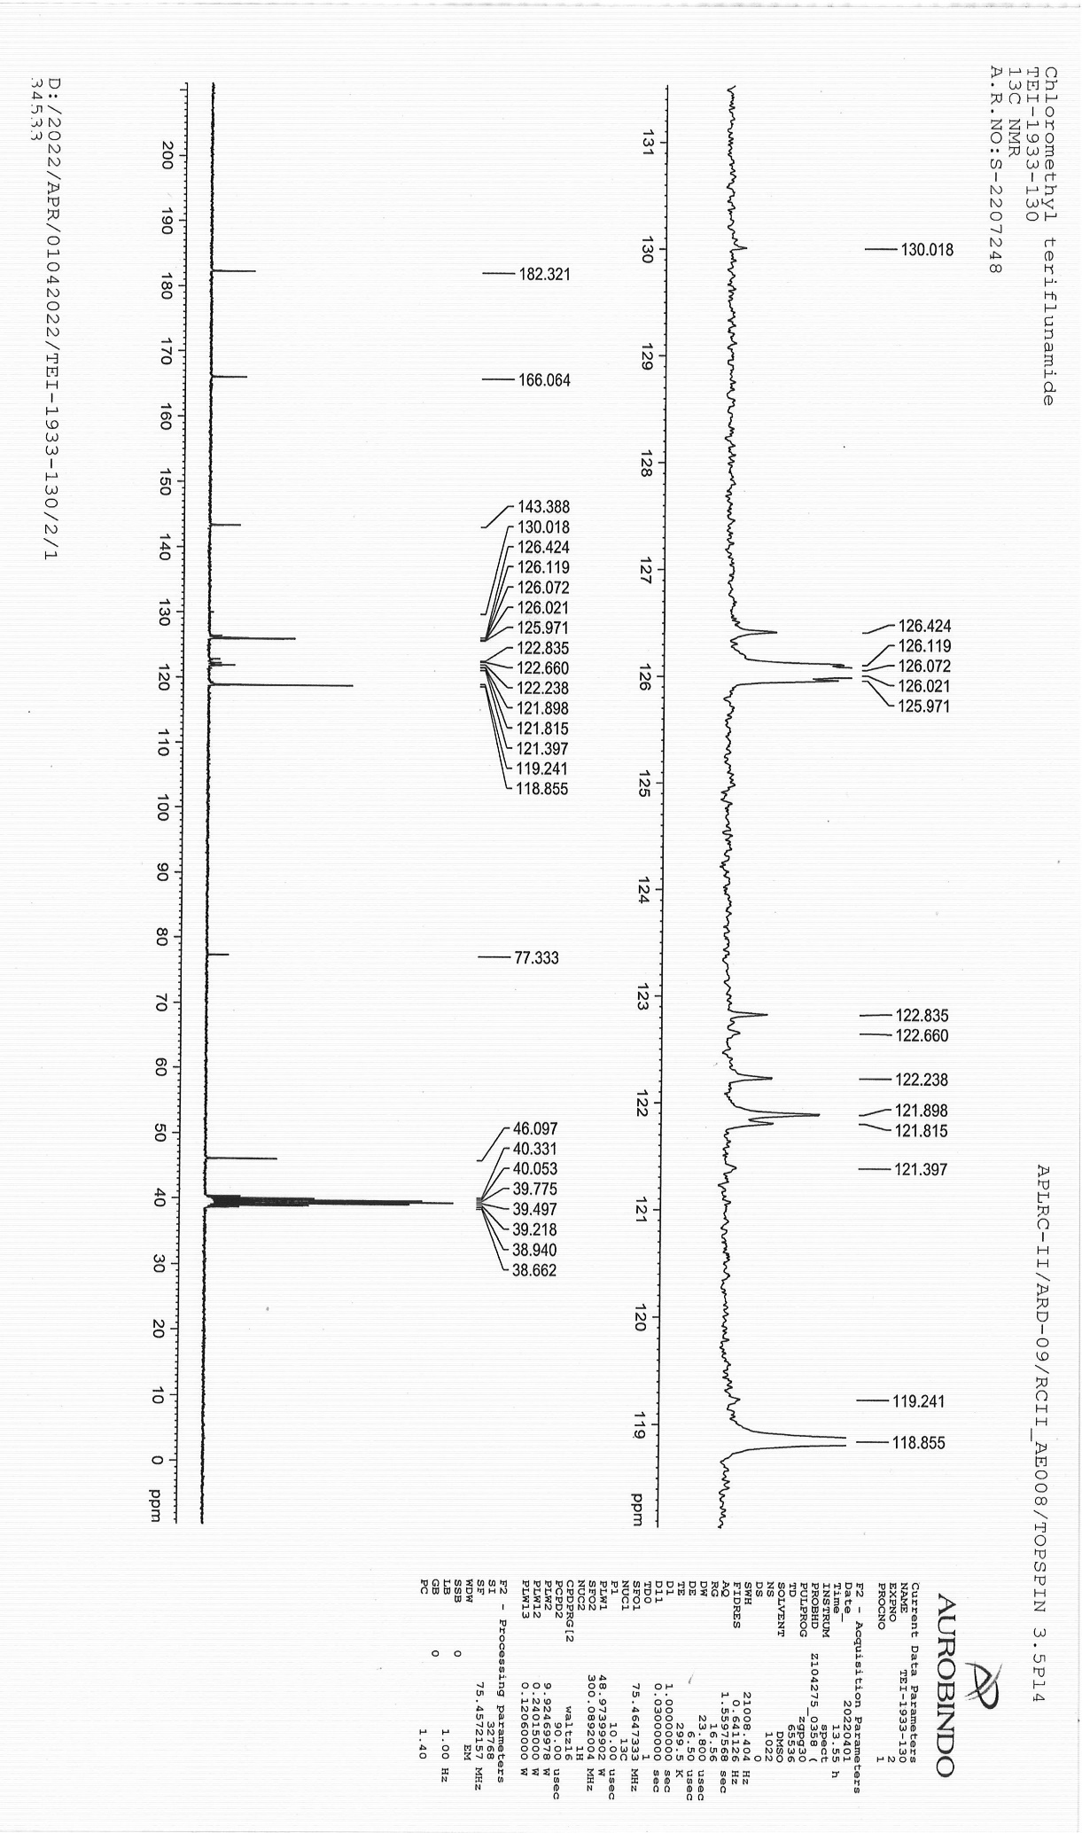

¹³CNMR of Chloromethyl Teriflunomide (2)

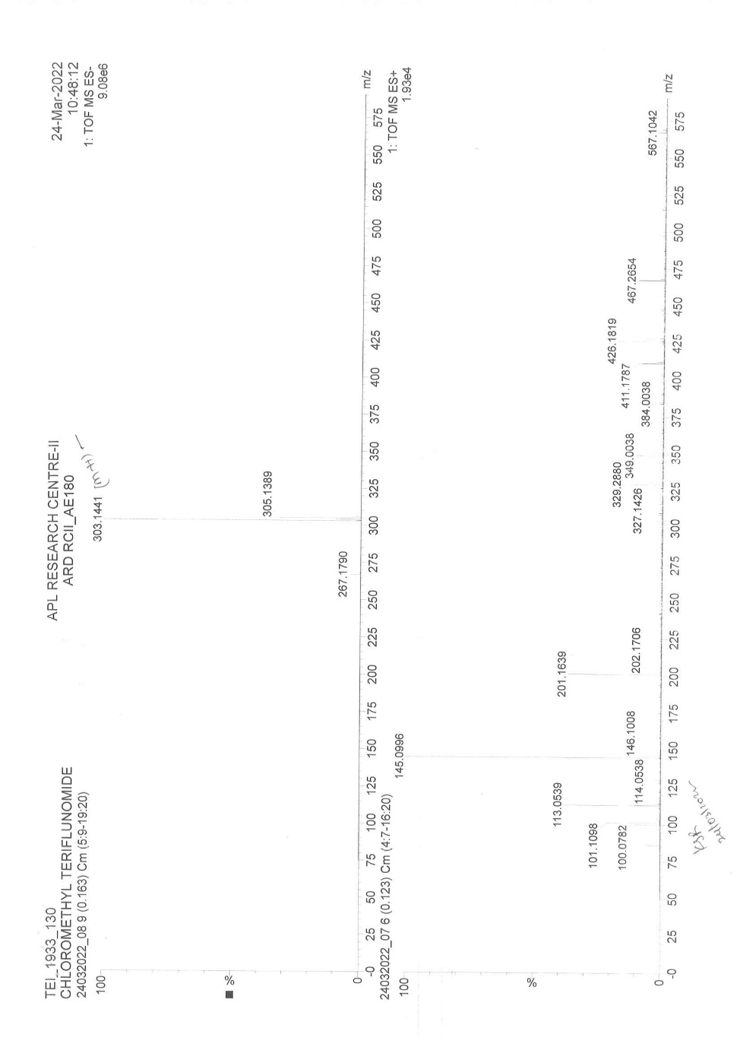
HRMS of Chloromethyl Teriflunomide (2)
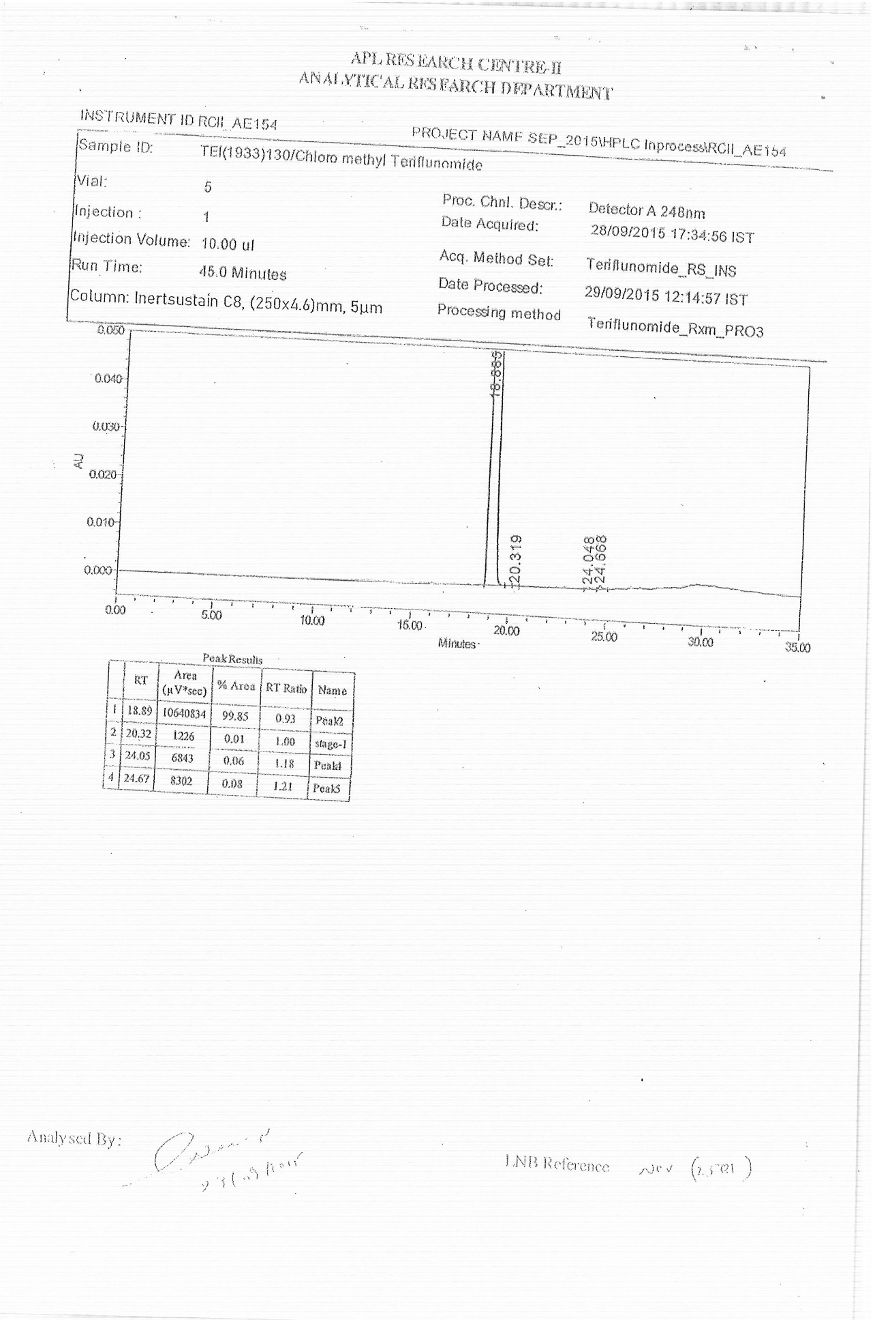
HPLC of Chloromethyl Teriflunomide (2)
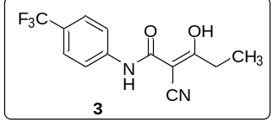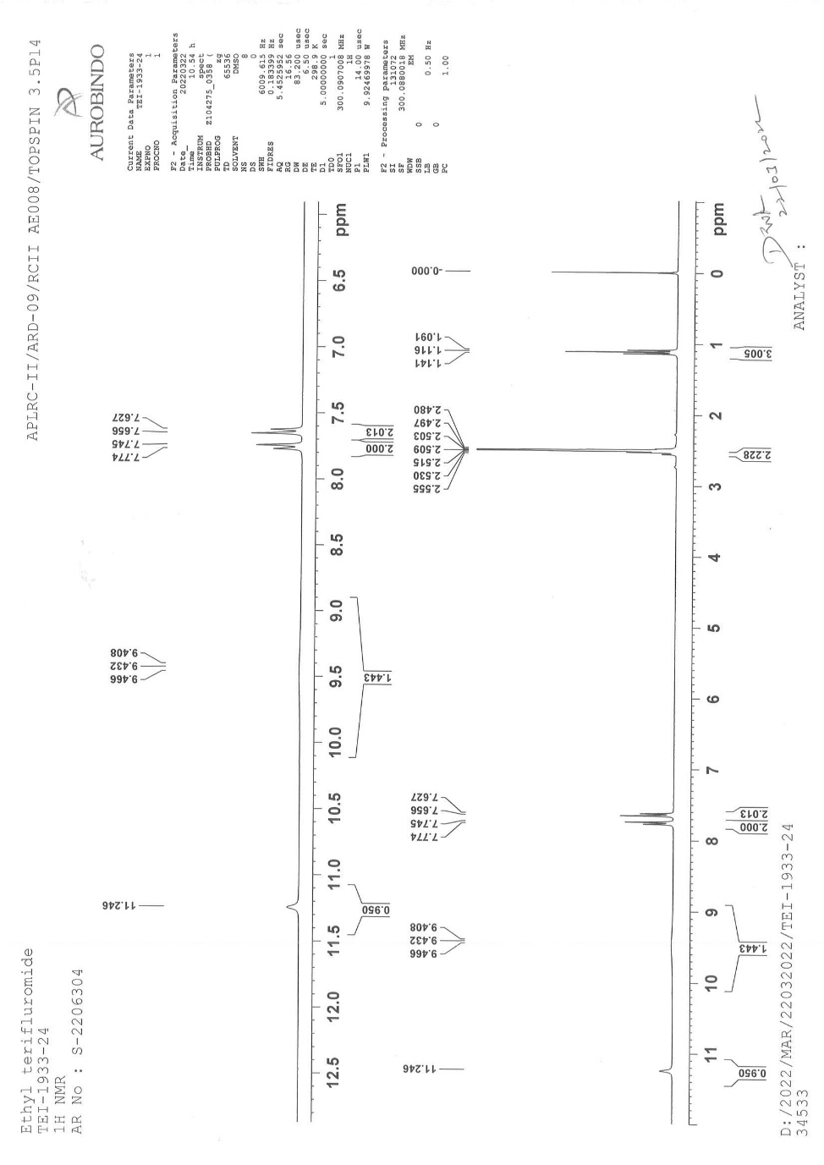
¹H NMR of Ethyl Teriflunomide (3)
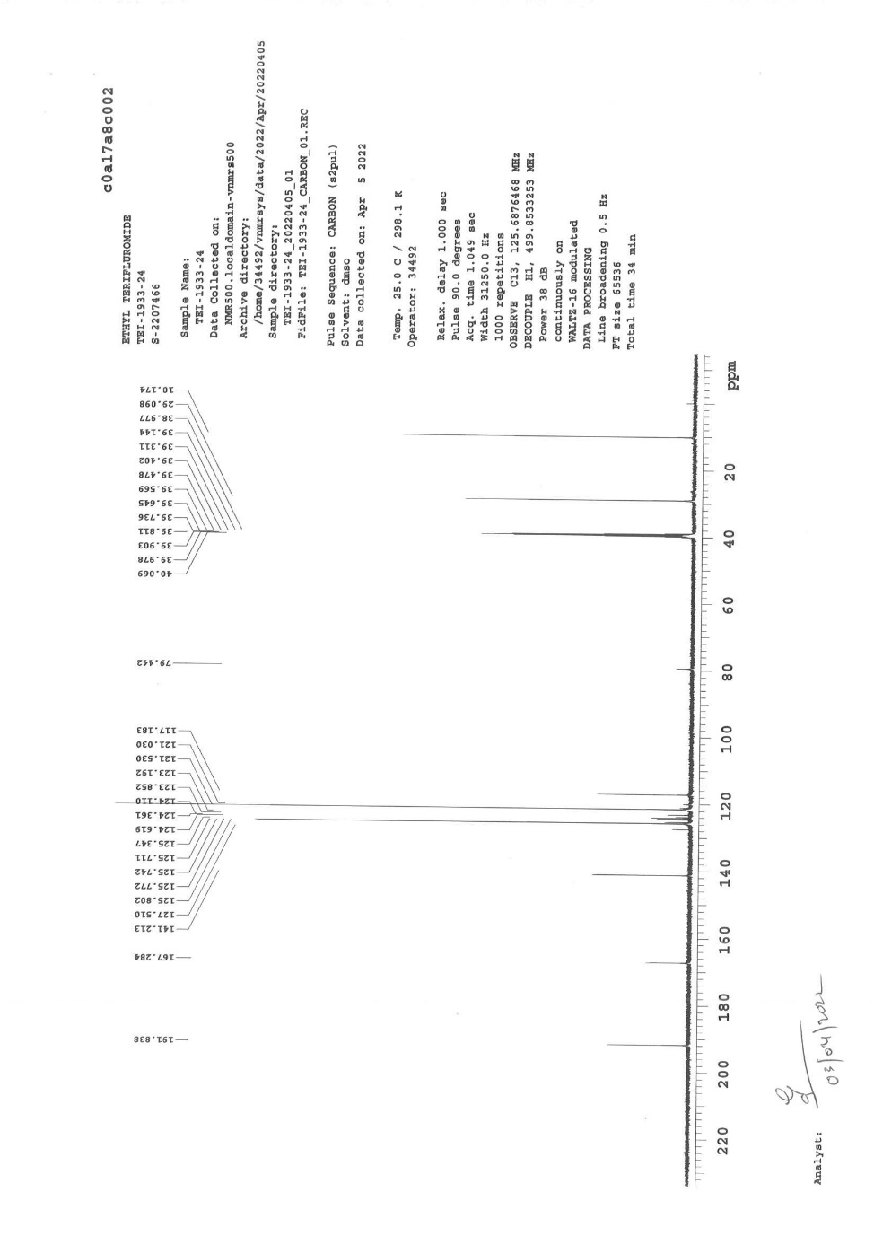
¹³CNMR of Ethyl Teriflunomide (3)
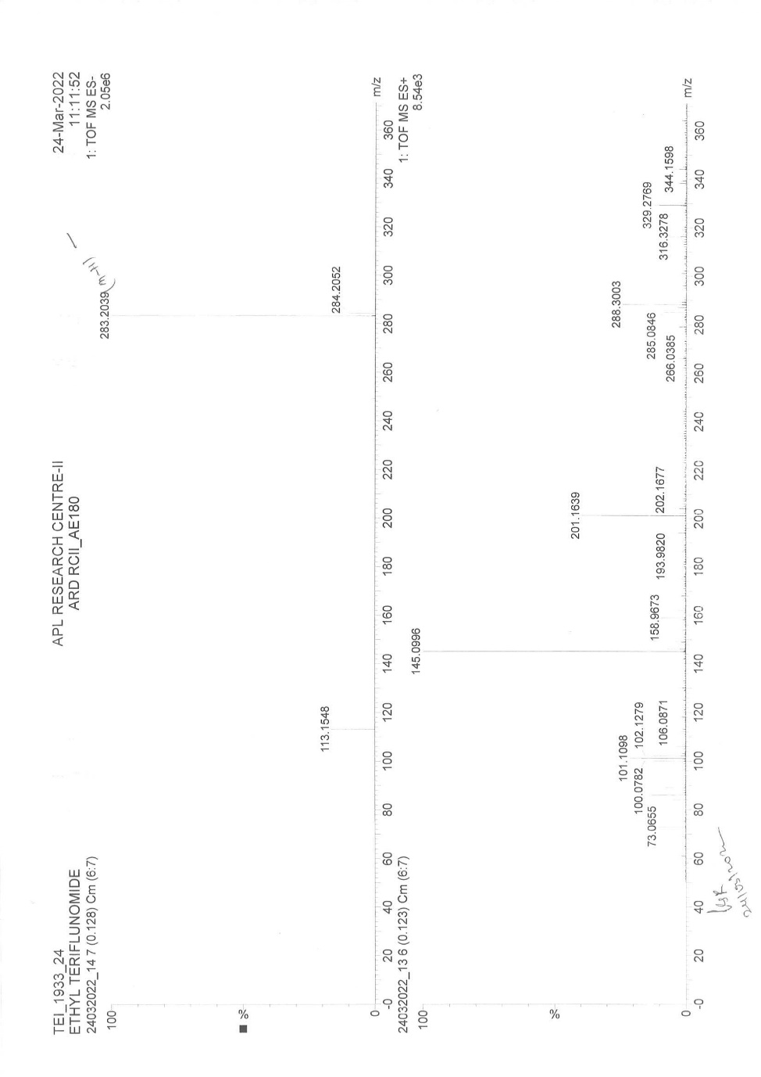
HRMS of Ethyl Teriflunomide (3)
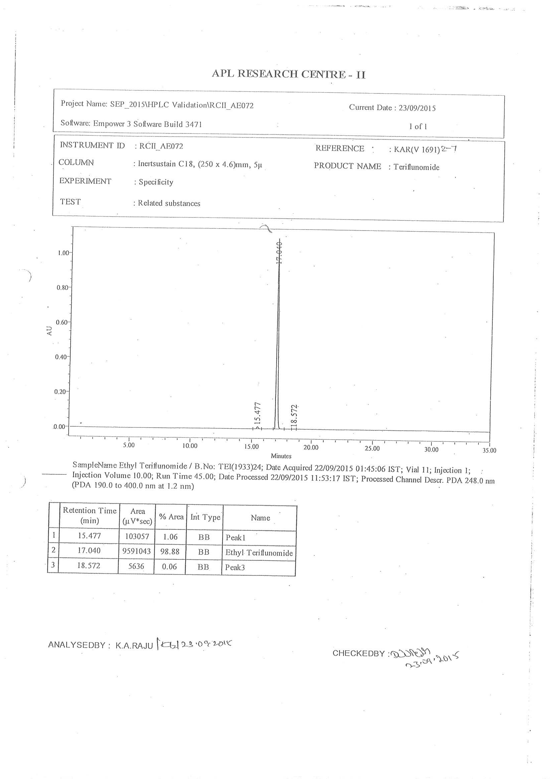
HPLC of Ethyl Teriflunomide (3)

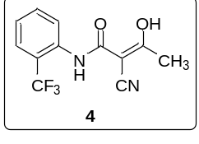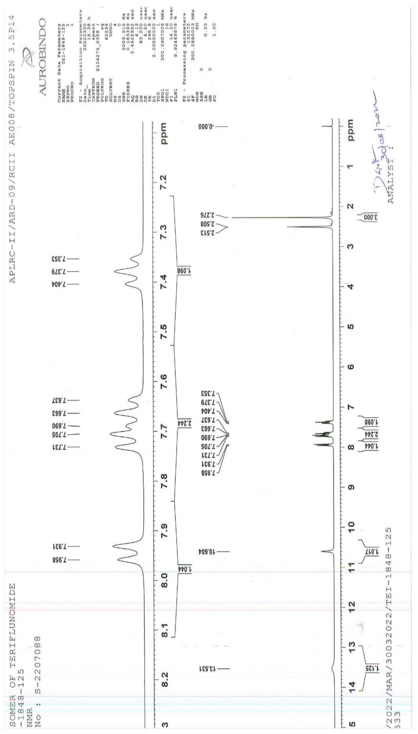
¹H NMR of 2-Isomer of Teriflunomide (4)

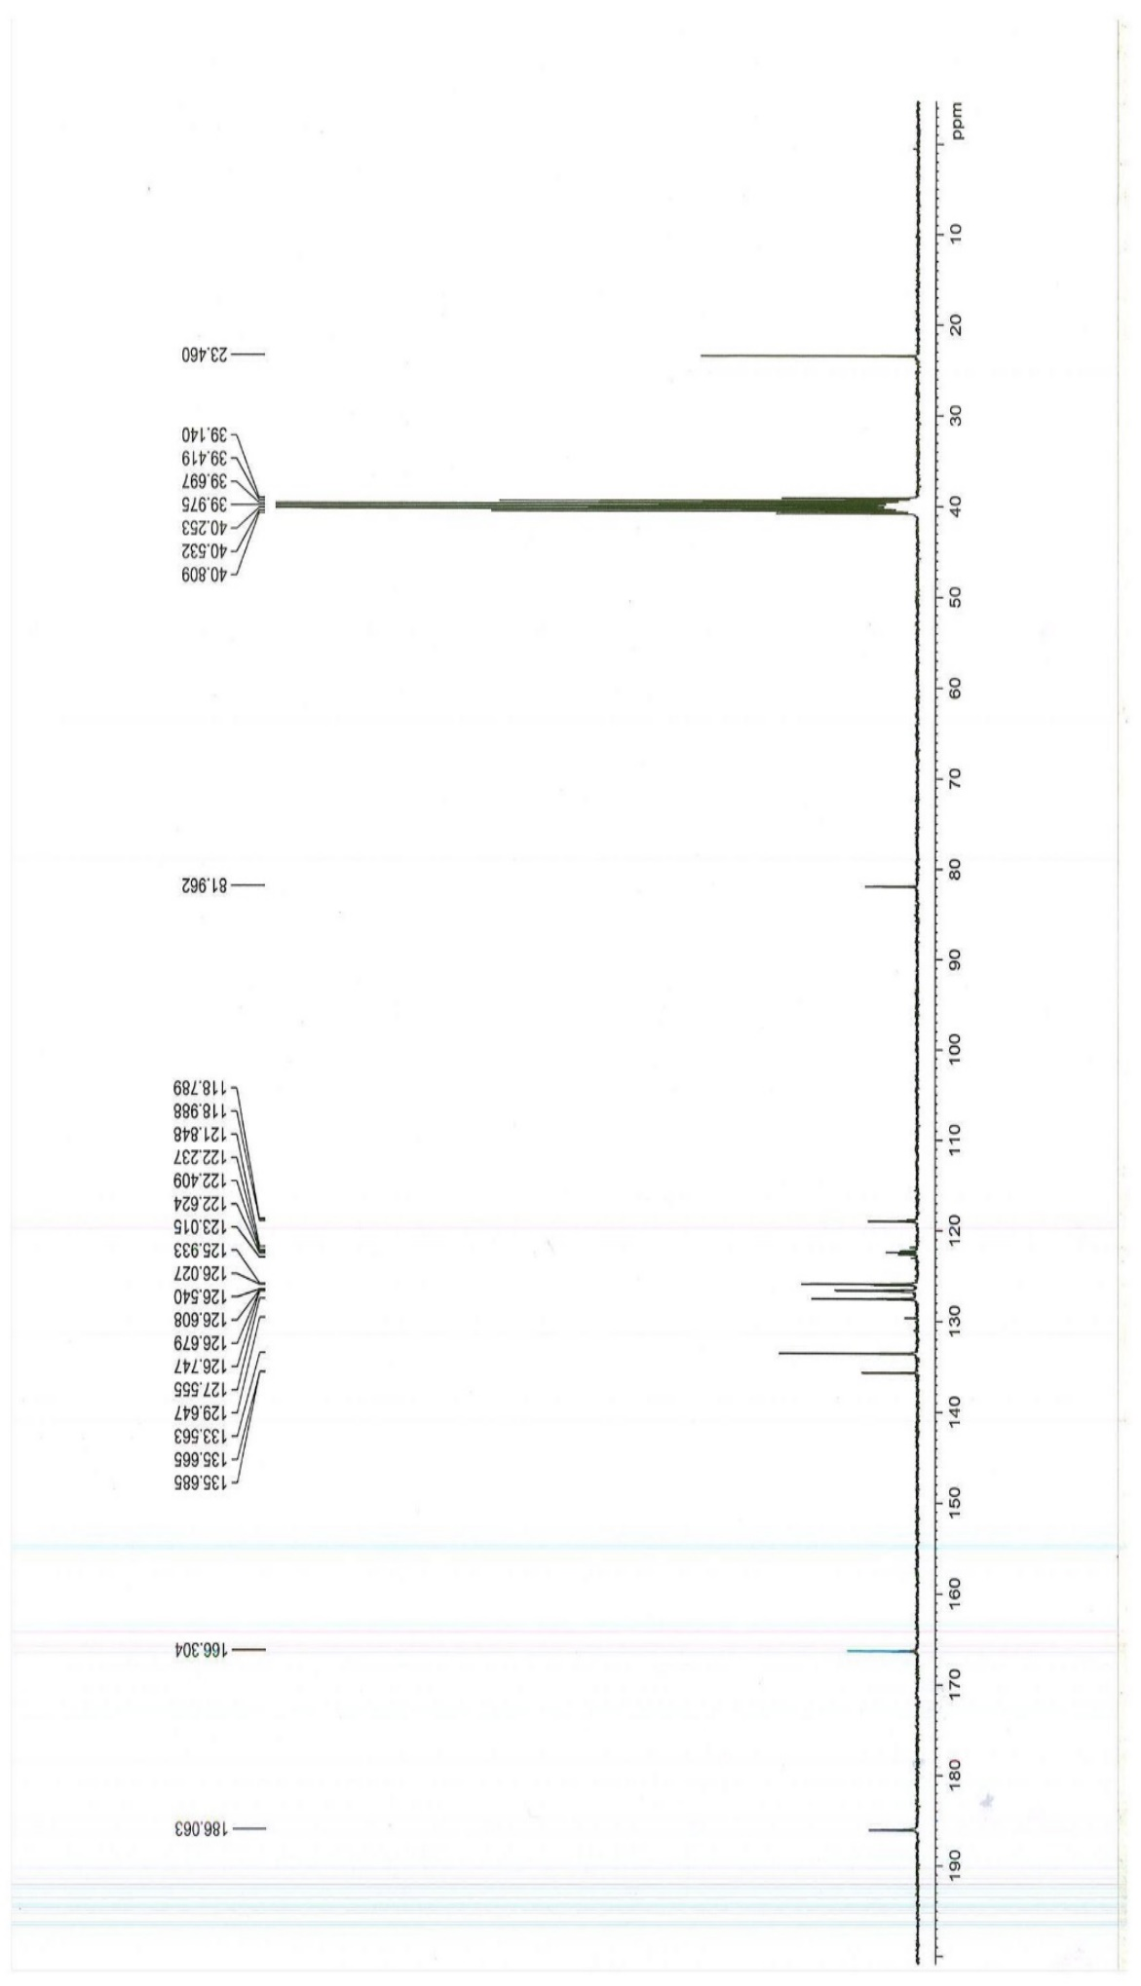
¹³CNMR of 2-Isomer of Teriflunomide (4)

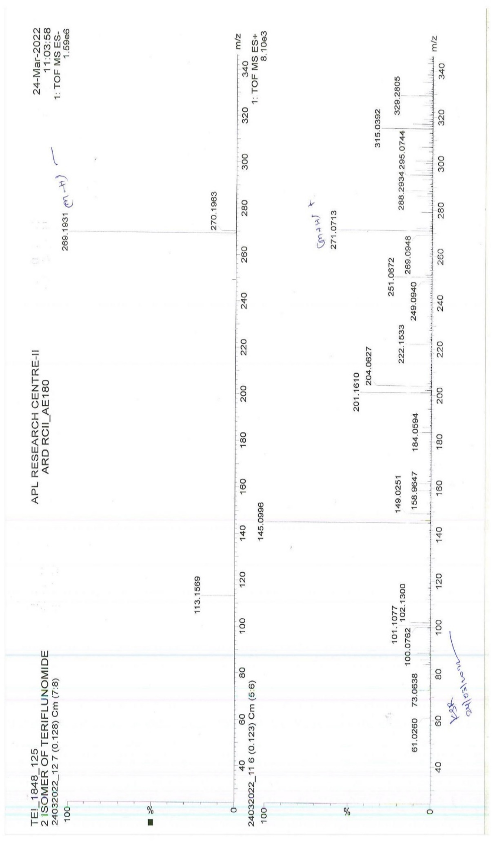
HRMS of 2-Isomer of Teriflunomide (4)

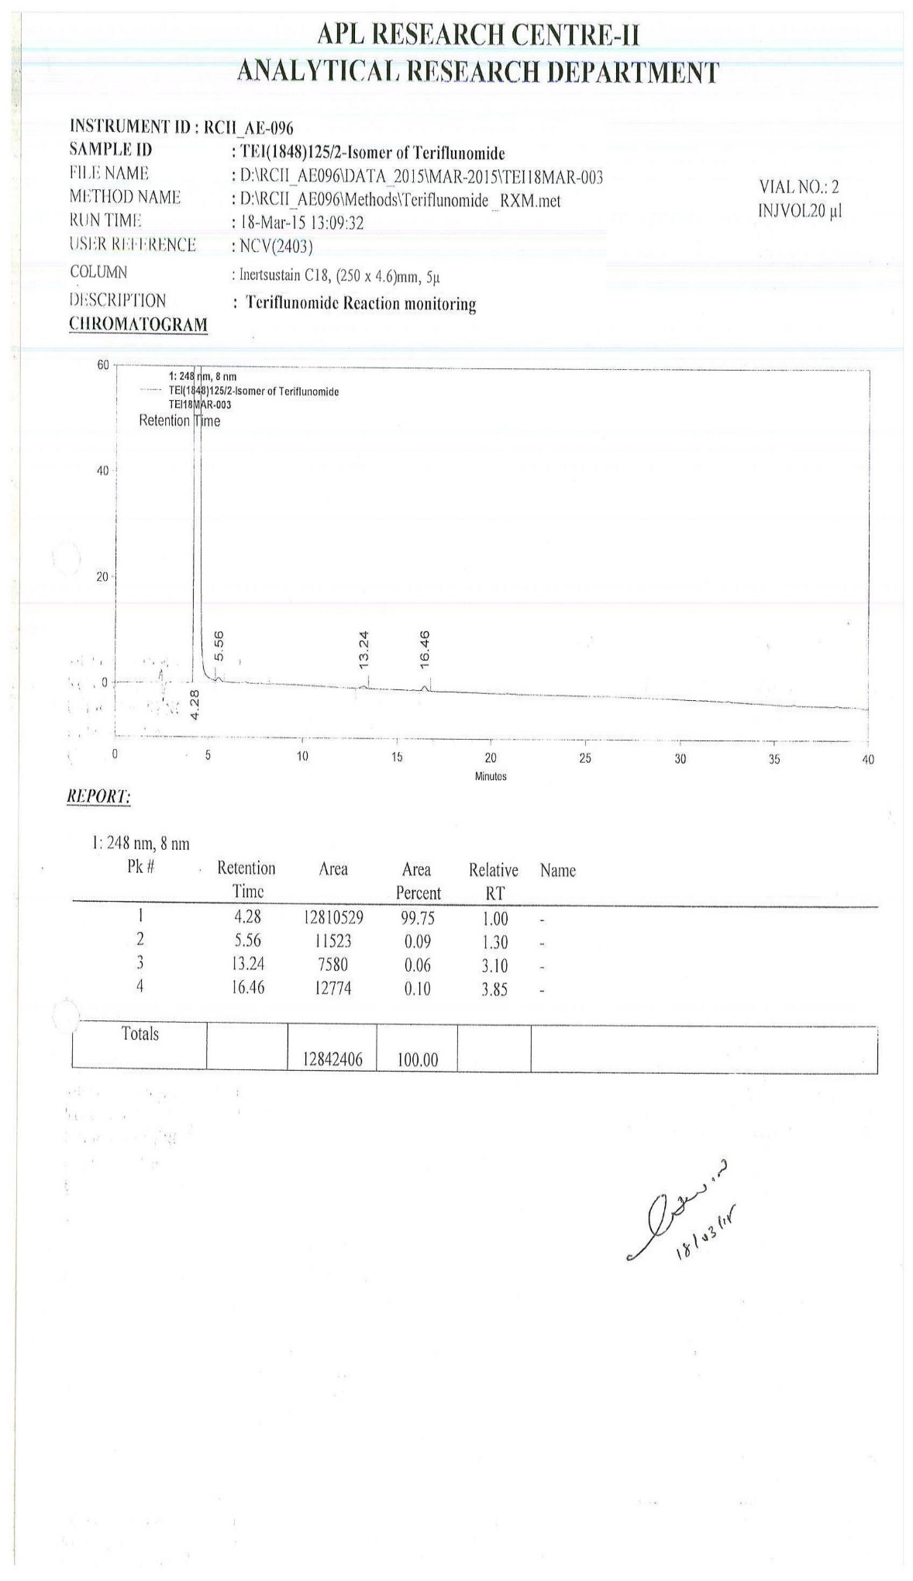
HPLC of 2-Isomer of Teriflunomide (4)

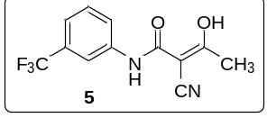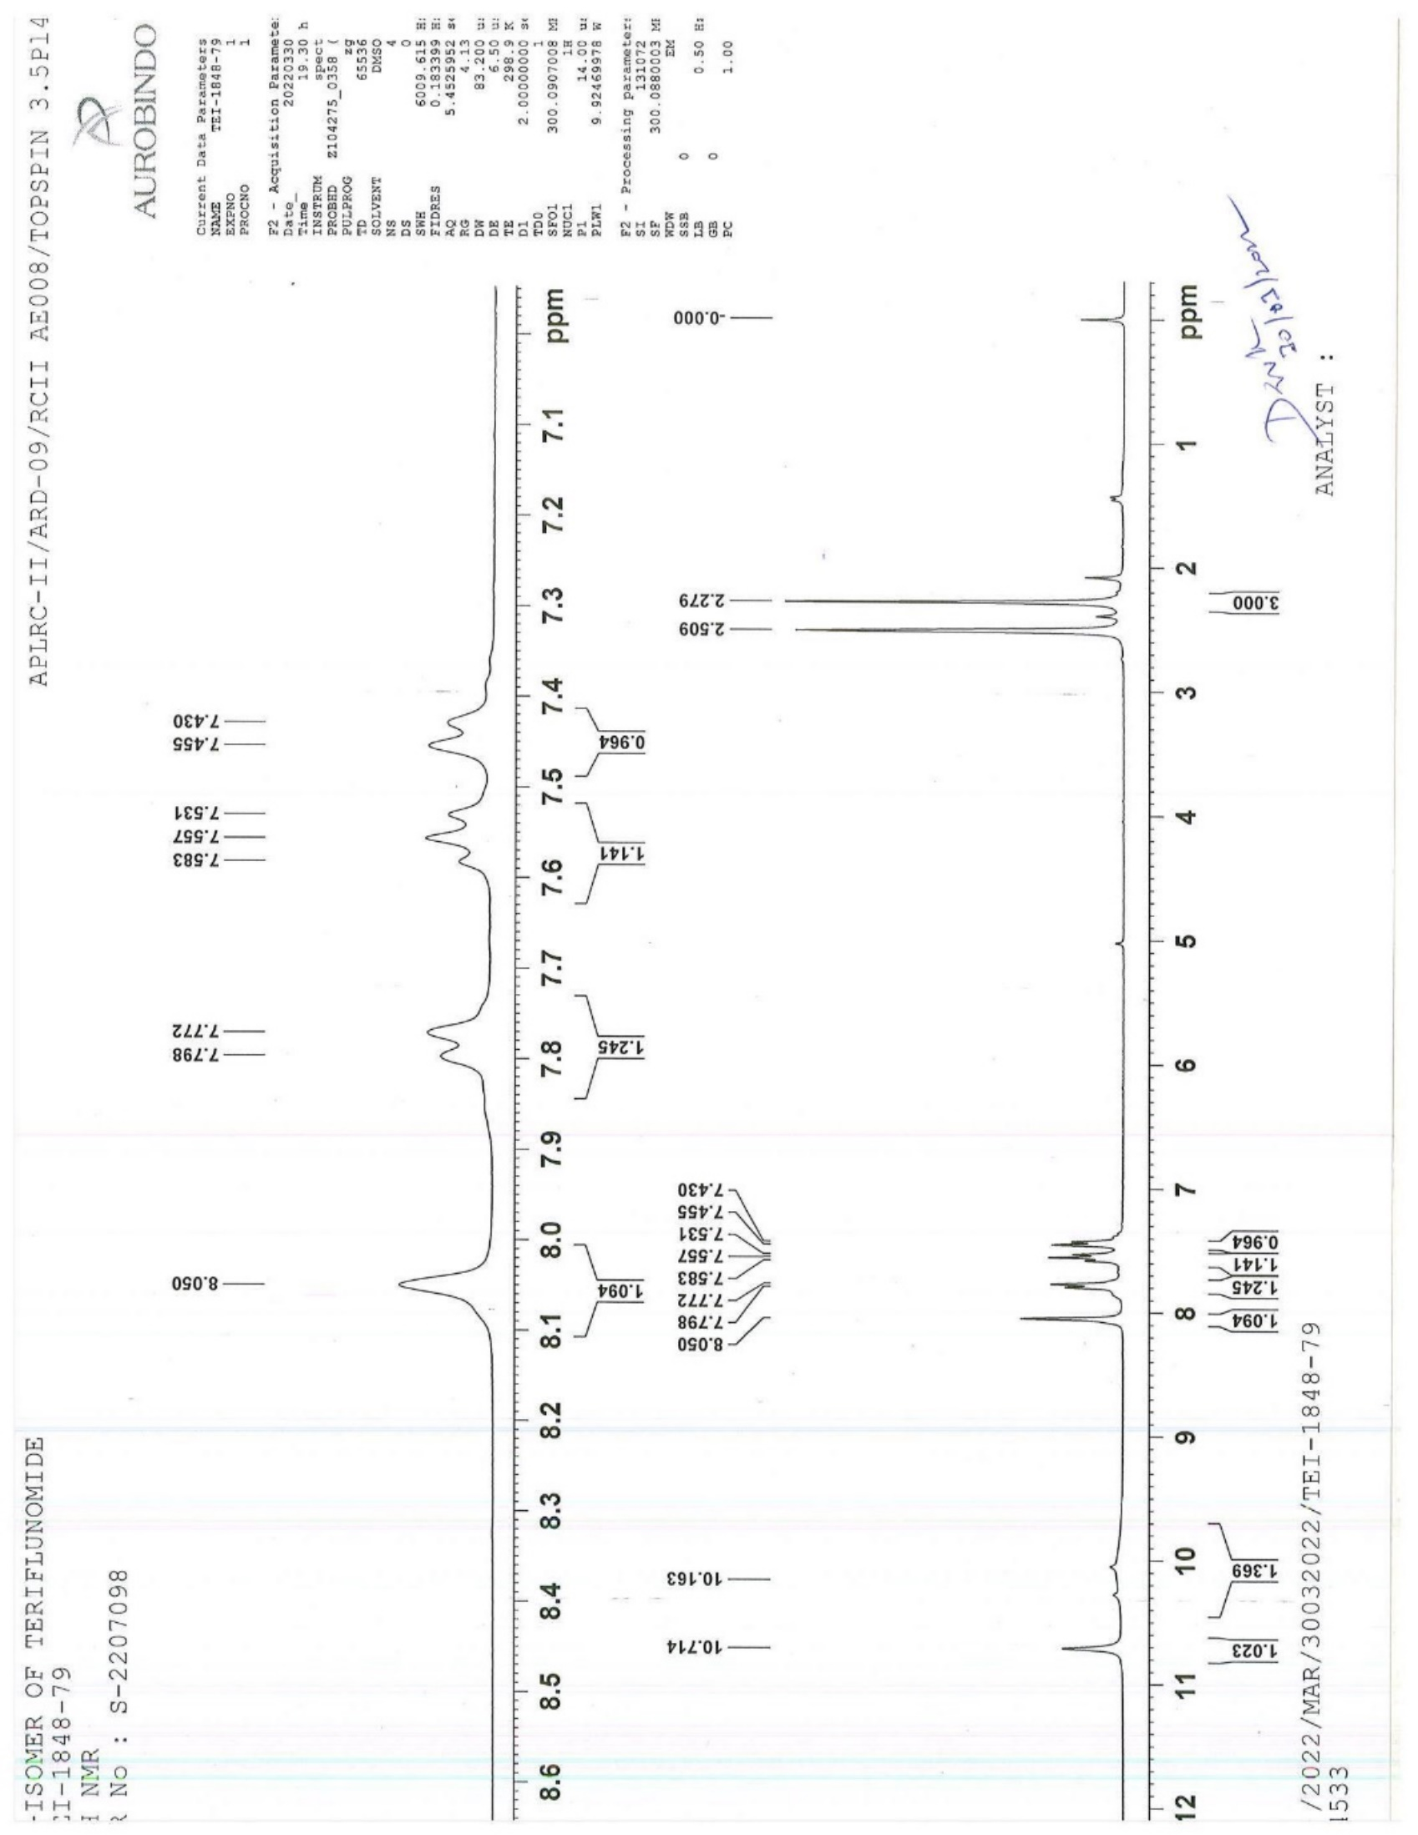
¹H NMR of 3-Isomer of Teriflunomide (5)
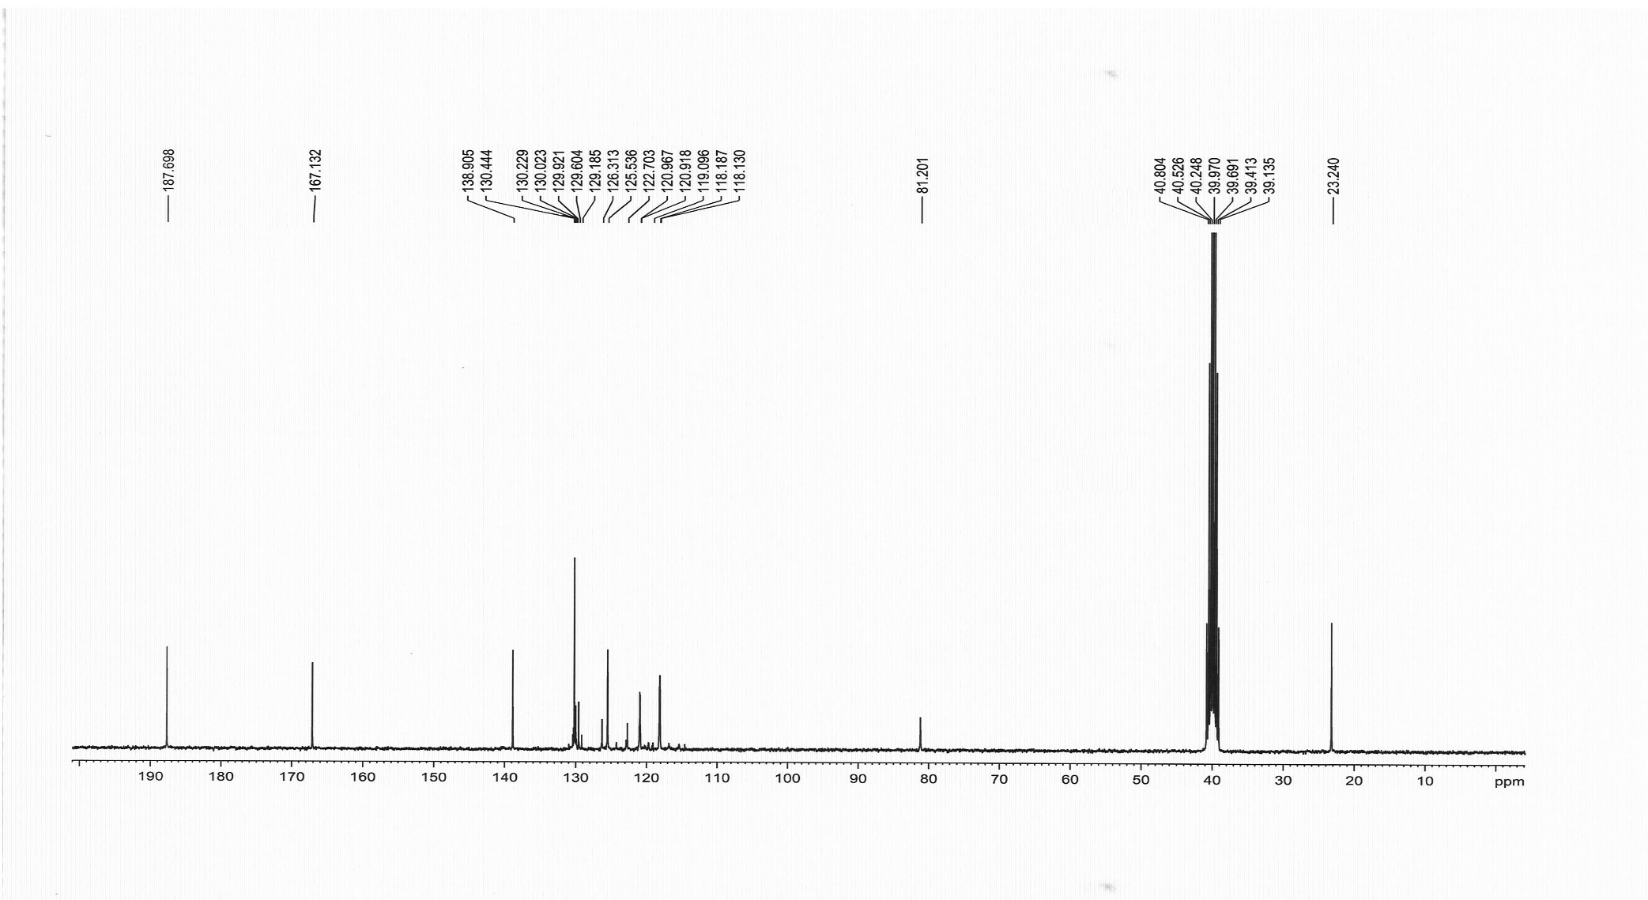
¹³C NMR of 3-Isomer of Teriflunomide (5)

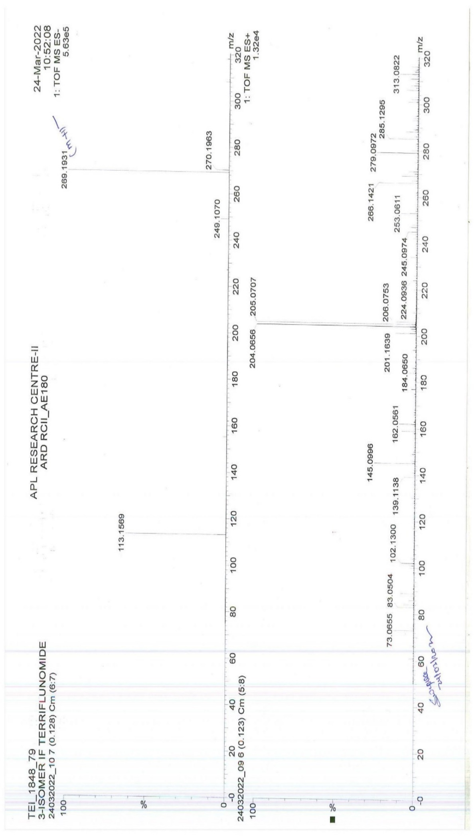
HRMS of 3-Isomer of Teriflunomide (5)

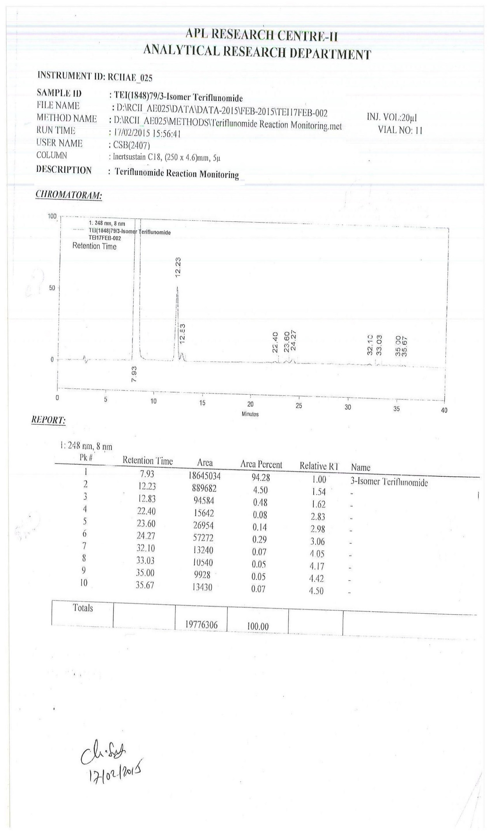
HPLC of 3-Isomer of Teriflunomide (5)

