Supporting information

Fig.S1 Principal coordinate analysis (PCoA) of the fungal communities in the rhizosphere at the tillering (a) heading (b) and ripening (c) stages under the three nitrogen fertilization levels.

Fig.S2 Diversity and richness of fungal communities in the rhizosphere subjected to three levels of nitrogen fertilization at the different growth stages, characterized by Shannon and Ace indices according to Alpha diversity analysis. * and **indicate significant differences at P<0.05 and P<0.01 levels, respectively.

Fig.S3 Relationship between the Alpha diversity index and soil properties based on Spearman correlation analysis.

Fig.S4 Relationship between soil fungal community composition (phylum level) and soil pH and nutrient content (a) and enzyme activity (b) based on Spearman’s analysis.
Fig.S1
a.
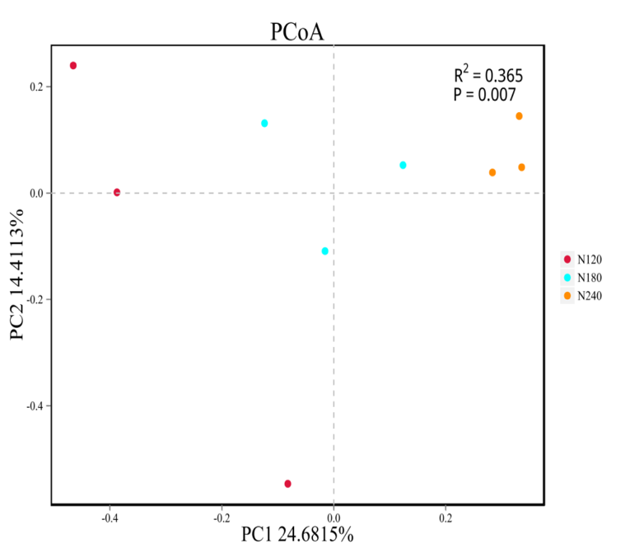
b.
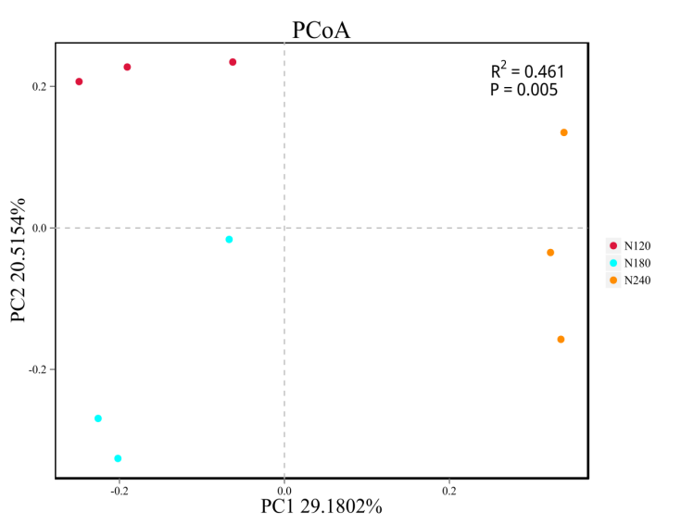
c.
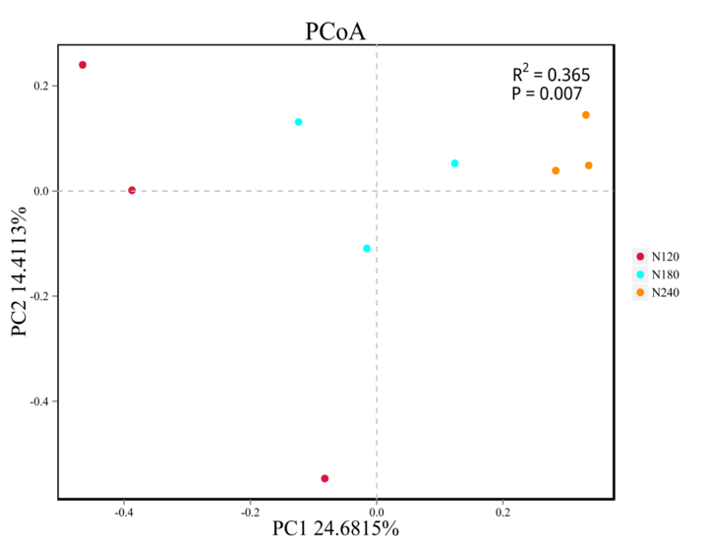
Fig.S2

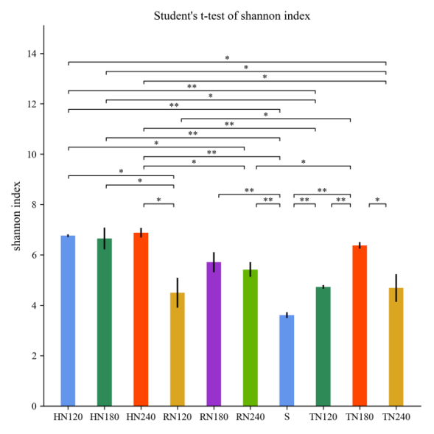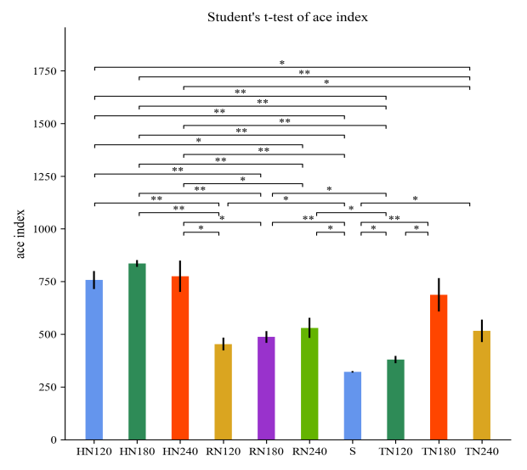
Fig.S3
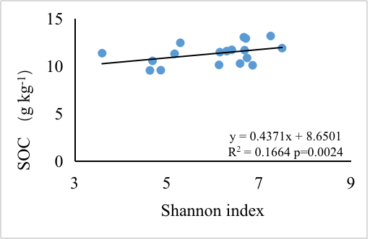
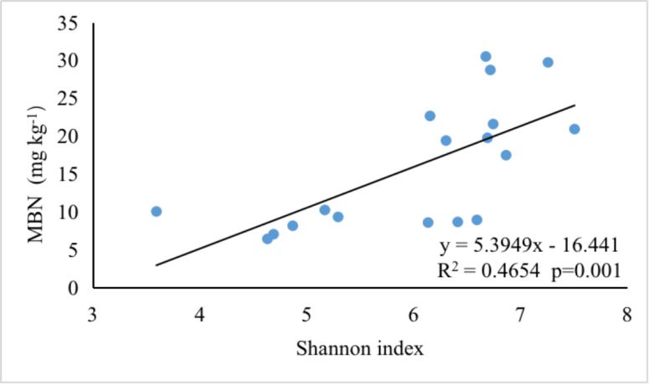
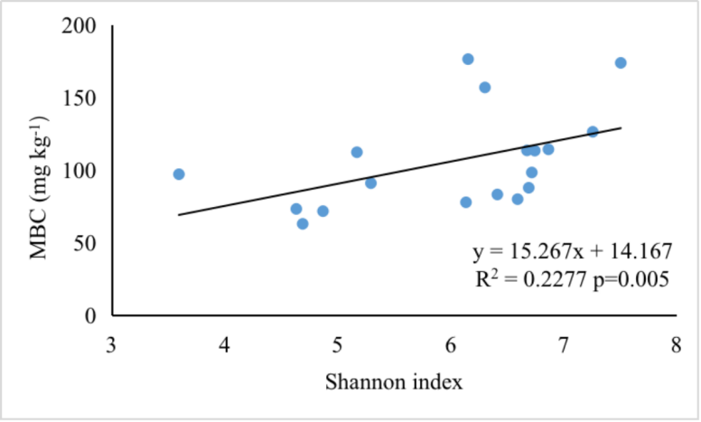
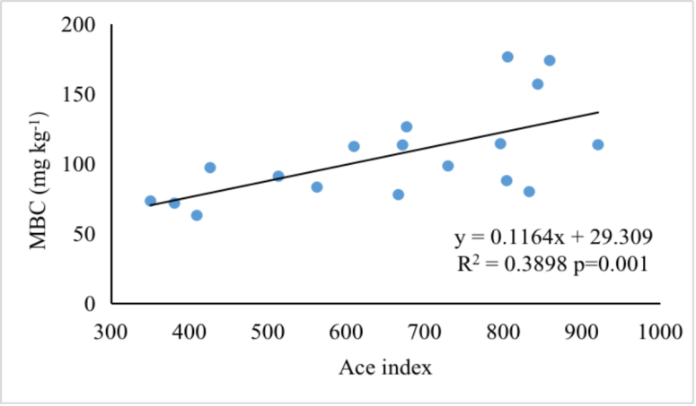
Fig.S4
a.
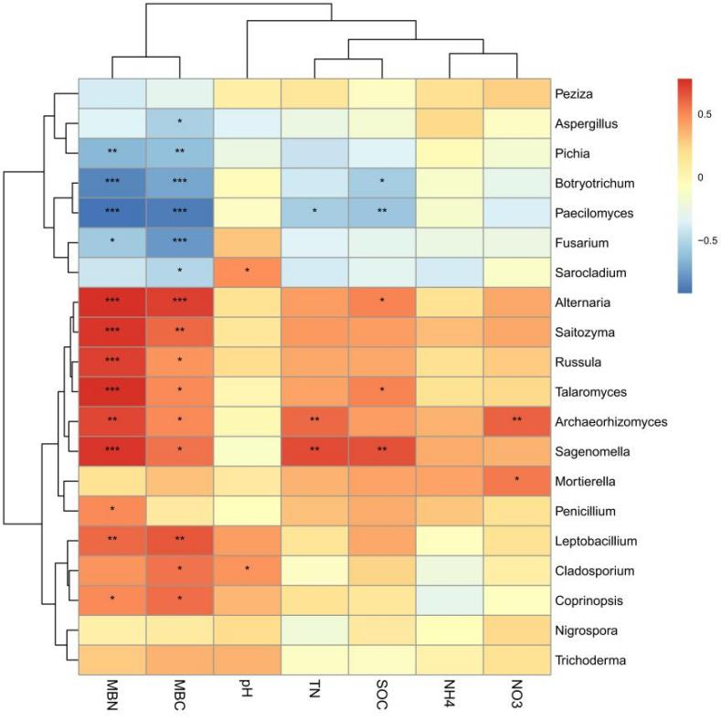

b.

