Supplementary material

Distribution of punctuality
In order to study the normality of the distribution of punctuality (Fig.1), both Kolmogorov-Smirnov test and Q-Q plot (Fig.S1) were performed. The first one is used to compare the distribution of a sample with a reference distribution (Normal distribution for the present case) and the second one is used to compare the cumulative distribution of the observed variable with the cumulative Normal distribution. The Kolmogorov-Smirnov test gave a negative result, so the hypothesis of normality of the distribution was rejected (p-value < 0,001). The Q-Q plot confirmed the non-normality of the data, since cumulative distribution of our variable was very far from the cumulative Normal distribution.
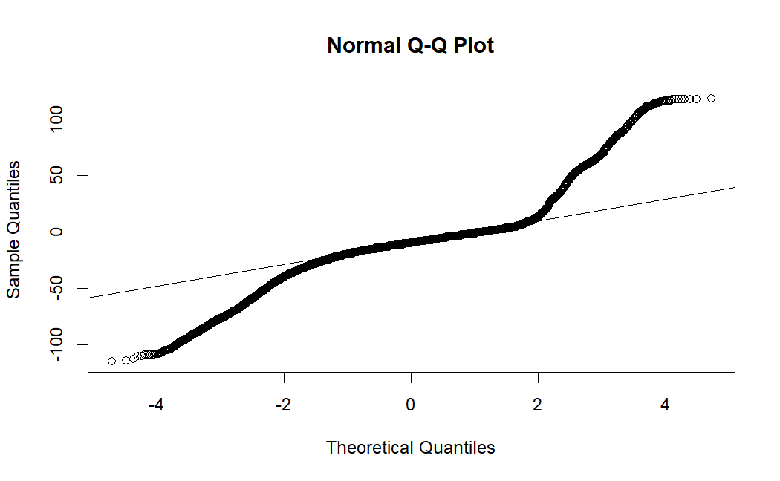
Figure S1: Normal Q-Q plot of punctuality distribution. Data are not normally distributed since there is a large difference between cumulative Normal distribution and our variable’s one. The result is also confirmed by the Kolmogorov-Smirnov test which rejects the hypothesis of normality (p-value < 0,001).

Estimation of standard deviations for frequency distributions
In order to estimate mean value and standard deviation values for frequency distributions, from our population we randomly extracted samples without replacement with the same numerosity. This procedure was performed separately for our different analyses: analyses were performed separately for different patients’ attributes, like age, visit time slot, etc., and each attribute had a given number of categories, e.g. categories of 18 years old patients, 19 years old patients etc., for the attribute ‘age’. Hence for instance we collected the category of all 18 years old patients, and sampled without replacement within this category. The sample size was chosen on the basis of dimension of the population for the aforementioned categories, as a tradeoff between the number of samples for the considered category, and the numerosity of the category itself.
We calculated the frequency of delays in each sample of appointments and then we averaged these frequencies among the different samples to obtain the mean value and the standard deviation (SD) for the considered category.

Punctuality distribution for geographical location of the clinics
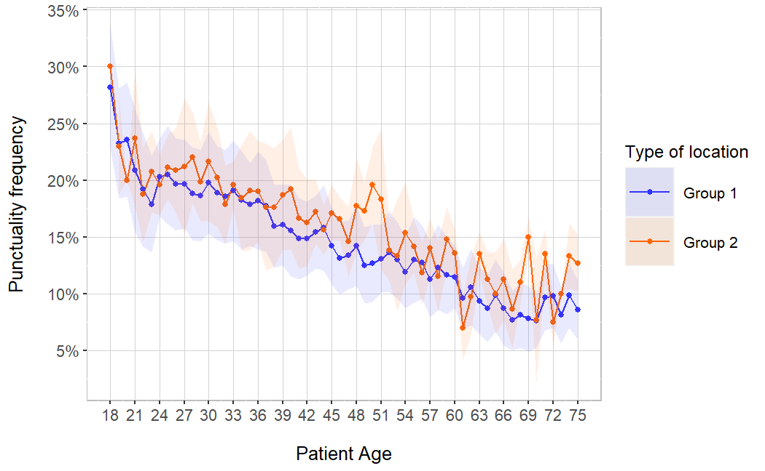
Figure S2: Punctuality frequency as a function of the patient's age for different types of medical location: ‘Group 1’ includes locations within 1 km from the closest underground station (23 locations, blue) and the other ones as ‘Group 2’(11 locations, orange). Error band semi-amplitude represents one SD. No significant difference is found for the two groups.

Frequency distribution of delay, for every age
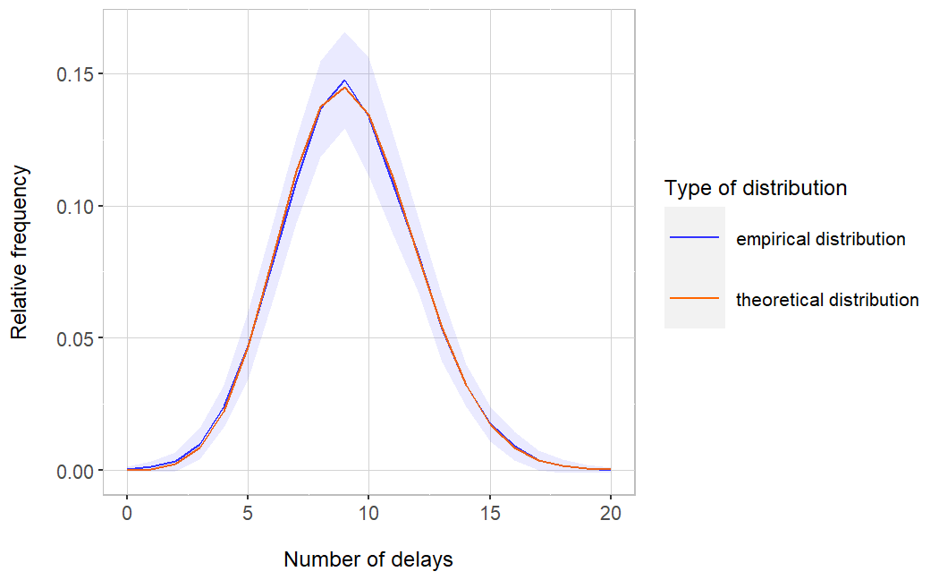
Figure S3: Frequency distribution of delay for patients of age =32 (as an example). Theoretical probability distribution (orange) and frequency distribution calculated from data (blue). Average on 100 random samplings (from different seeds) without replacement with sampling numerosity=50, Mean Square Error = 6,93 x 10E-7. The theoretical probability distribution is a Binomial distribution with the probability of success estimated from our sample for age=32 (namely 0,184 ± 0,026), and number of independent trials=50. To construct the empirical distribution, we randomly selected groups of data up to our chosen number of independent trials (n=50) among all the 32 years old patients, and we calculated the frequency of a certain number of delays in these groups. We performed a total of 100 random samplings and averaged their results in order to smoothen the dependency of the calculated empirical distribution on possible outliers of a single random sampling.

Visits characterization for each patient’s age
Patient's age | Overall cohort | Check-in late | Check-in early
18 | 1212 | 341 | 871
19 | 2337 | 534 | 1803
20 | 2760 | 641 | 2119
21 | 3446 | 729 | 2717
22 | 3964 | 760 | 3204
23 | 4965 | 897 | 4068
24 | 5709 | 1157 | 4552
25 | 7314 | 1504 | 5810
26 | 8494 | 1677 | 6817
27 | 9651 | 1899 | 7752
28 | 11252 | 2149 | 9103
29 | 12230 | 2293 | 9937
30 | 13194 | 2633 | 10561
31 | 13436 | 2550 | 10886
32 | 14213 | 2621 | 11592
33 | 13721 | 2629 | 11092
34 | 13394 | 2446 | 10948
35 | 12553 | 2257 | 10296
36 | 11942 | 2178 | 9764
37 | 11707 | 2077 | 9630
38 | 11211 | 1797 | 9414
39 | 10674 | 1742 | 8932
40 | 9534 | 1520 | 8014
41 | 8725 | 1311 | 7414
42 | 8113 | 1215 | 6898
43 | 8117 | 1255 | 6862
44 | 7959 | 1255 | 6704
45 | 7867 | 1140 | 6727
46 | 7848 | 1061 | 6787
47 | 7965 | 1074 | 6891
48 | 8051 | 1174 | 6877
49 | 8038 | 1042 | 6996
50 | 7512 | 997 | 6515
51 | 7422 | 1007 | 6415
52 | 7607 | 1038 | 6569
53 | 6827 | 889 | 5938
54 | 6779 | 831 | 5948
55 | 6770 | 887 | 5883
56 | 6358 | 805 | 5553
57 | 6121 | 714 | 5407
58 | 5940 | 728 | 5212
59 | 5559 | 668 | 4891
60 | 5595 | 658 | 4937
61 | 5127 | 483 | 4644
62 | 5035 | 538 | 4497
63 | 4477 | 438 | 4039
64 | 4730 | 423 | 4307
65 | 4251 | 418 | 3833
66 | 4001 | 365 | 3636
67 | 3639 | 282 | 3357
68 | 3444 | 288 | 3156
69 | 3244 | 285 | 2959
70 | 3084 | 233 | 2851
71 | 3222 | 331 | 2891
72 | 3155 | 317 | 2838
73 | 3095 | 259 | 2836
74 | 3184 | 323 | 2861
75 | 3034 | 272 | 2762

Table S1: Cohort characteristics by patients’ age. For each age the total number of visits is shown; this number is then splitted into two other columns, the first one with the number of visits where the patient checked-in late and the second one with the number of visits where the patient checked-in early.

