Supplementary Information
Thylakoid-Inspired Microreactors Continuously Synthesize CO₂ into Glucose Precursor at 15.8 nmol min⁻¹

Supplementary Methods
S1. Soft photolithography
Briefly, a 4″ silicon wafer was firstly cleaned by acetone, ethanol, and deionized water (DIW), followed by drying in an oven to remove any contamination. Then, the SU-8 was spin-coated to a thickness of 40 μm (at 500 rpm for 15 s followed by 2500 rpm for 60 s) on the cleaned wafer and then soft-baked at 65 ºC for 5 min and another baking step at 95 ºC for 15 min. The soft-baked SU-8 was then exposed to UV light for 45 s (with exposure energy of 180 mJ/cm²), followed by a post-baking process at 65 ºC for 5 min and at 95 ºC for 15 min (as shown in Step 1 of Figure S1). Afterward, the SU-8 was developed in SU-8 developer for 3 min and then washed with isopropyl alcohol (IPA) for 10 seconds, followed by air dry using compressed nitrogen. Finally, the mold was hard baked at 150 ºC for 5 min. The SU-8 mold was ready for further use (Step 2). Next, the PDMS compound which was formed by mixing PDMS and its curing agent at a weight ratio of 10:1 was poured onto the SU-8 mold and put on a hot plate at 85 ºC for 30 min (Step 3). The bonding of the microfluidic chips was realized by gently placing one cured molded PDMS onto another half-cured flat PDMS slice which was baked on the hot plate for 7 min with PDMS compound poured onto a flat silicon wafer (Step 4). The two slices were finally sealed together after another 30 min of baking (Step 5).

S2. Confirmation of the immobilization of RuBisCO
S2.1 AFM measurements
The thickness of dried (PEI/RuBisCO)_{n} assembly on PDMS films was measured with a scanning probe microscope (Asylum Research MFP-3D Infinity) at tapping mode. Scratch lines were made by surgical blades to uncover the PDMS substrate and measure the thickness of the bilayers. The samples were scanned in air over an appropriate area, which consists of (PEI/RuBisCO)_{n} assembly and exposed PDMS substrate at a scan rate of 0.5 Hz. The bilayer thicknesses were calculated by the average height difference of the line drawn at different positions including both the PEI/RuBisCO assembly and the PDMS substrate from the collected images.
S2.2 ATR-FTIR measurement
To obtain the ATR-FTIR spectra, PEI/RuBisCO were deposited on thin PDMS films alternatively and then dried in the air at room temperature before the observation. For free RuBisCO, a standard KBr disk was prepared. The spectra were collected over 650-4000 cm⁻¹ at the resolution of 4 cm⁻¹ for 32 scans.
S2.3 Fluorescent experiments
For the fluorescent analysis, (PEI/RuBisCO)_{n}-PMRs were firstly incubated at room temperature with 1% (w/v) BSA in PBS buffer for 30 min and then washed by PBS buffer. Then primary anti-RuBisCO (0.5 μg mL⁻¹) in PBS buffer was injected into the (PEI/RuBisCO)_{n}-PMRs and incubated at room temperature for 1 hour. After washing the weakly bonded antibodies by PBS at 2.5 μL min⁻¹ for 20 min, Alexa Fluor 488-conjugated goat anti-chicken IgG (H + L) secondary antibody (AF488 GTXCH, 5 μg mL⁻¹) was injected into the channel and incubated at room temperature for another 1 hour. Afterwards, the reactor was thoroughly rinsed by PBS buffer at 2.5 μL min⁻¹ for 20 min and then observed under the fluorescence microscopy. The fluorescent images for each (PEI/RuBisCO)_{n}-PMRs were synthesized from 12 images that were vertically taken every 3.45 μm by focusing on the channel of the reactors. The fluorescent images were then used to plot the fluorescent intensity by ImageJ and calculated the fluorescent intensity difference between the microchannel and the microchannel wall.
S2.4 CD measurement
PDMS thin film, RuBisCO solution, and (PEI/RuBisCO)_{n} assembly deposited on thin PDMS films were prepared to obtain CD spectra. All the CD spectra were collected by a JASCO J-1500 spectrophotometer at room temperature. The spectra of the solution samples were recorded over a wavelength range of 260–200 nm using a cuvette of 1-mm pathlength at a scan speed of 50 nm min⁻¹ with the data integration time of 8s, a data pitch of 0.2 nm, and a bandwidth of 1 nm. Three accumulations were carried out per data point. The concentration of RuBisCO solution was about 0.25 mg mL⁻¹ in the reaction buffer. For the measurements of (PEI/RuBisCO)_{n} on PDMS films, 200 μL of PEI solution (10 mg mL⁻¹) and RuBisCO solution (0.25 mg mL⁻¹) were cast onto a PDMS thin film for 1 h at room temperature alternately for different number of bilayers. The CD spectra were recorded after the films were dried at room temperature. The parameters for recording the thin films were the same as the solution except for an unidentified film thickness (pathlength). CD spectra for PDMS thin film was also recorded as the control. All the data were presented as ellipticities (θ, mdeg) in Figure S4.

S3. Amplification method for RuBisCO activity assay
For the immobilized RuBisCO activity assay, reactant mixture (66 mM HCO₃⁻ and 0.5 mM RuBP in the reaction buffer) was passed through the RIMRs and the production solution (containing RuBisCO, RuBP, HCO₃⁻ and 3-PGA in the reaction buffer) was collected from the outlet of the reactors for further assay. 20 μL of the production solutions were added with 80 μL of assay mixture (the final concentrations were 5 unit mL⁻¹ PGK, 0.5 unit mL⁻¹ GAPDH, 0.5 unit mL⁻¹ TPI, 0.5 unit mL⁻¹ G3PDH, 1 unit mL⁻¹ G3POX, 1000 unit mL⁻¹ catalase, 0.5 mM ATP, 2 mM NADH, 1.5 mM MgCl₂ and 100 mM Tricine/KOH pH 8.0). The reaction was immediately and continuously monitored by measuring the absorbance change at 340 nm by a UV-Visible spectrometer. During the reaction, the product 3-PGA was first converted to dihydroxyacetone-phosphate (DAP) with PGK, GAPDH, ATP and NADH. Catalase was also added here to prevent the inhibition of GAPDH. Then, DAP was transformed into the cycle of mutual conversion with glycerol-3 phosphate (G3P). It could be monitored as the cumulative oxidation of NADH, whose amount was much larger than the original amount of 3-PGA, therefore providing strong amplification of signal for 3-PGA monitoring (Figure S6a). The signal of production solutions could be converted to the specific amount of 3-PGA using a standard curve (orange dashed line in Figure S6b) generated by adding different amounts of standard 3-PGA into the assay mixture (blue squares in Figure S6b).

S4. Residence time and operation time determination in (PEI/RuBisCO)_{n}-PMRs
The residence time t_{r} is regarded as the residence time of the reaction mixture flowing through the (PEI/RuBisCO)_{n}-PMRs, which is calculated by the equation of
 | t_{r} = V_{r}/Q | (S1)
where V_{r} is the volume of the (PEI/RuBisCO)_{n}-PMRs and Q is the flow rate of the injected RuBP solution controlled by the syringe pump. In this work, the volume of RI-PMR is 7 μL, the corresponding residence time is 0.25min, 0.5 min, 1 min, 2 min, 3.5min, 5 min for the flow rates of 28 μL min⁻¹, 14 μL min⁻¹, 7 μL min⁻¹, 3.5 μL min⁻¹, 2 μL min⁻¹, 1.4 μL min⁻¹, respectively.
The operation time t_{o} is regarded as the total operation time to collect a specific volume of the production solutions from the outlet of the (PEI/RuBisCO)_{n}-PMRs, which is calculated by the equation of
 | t_{o} = V_{c}/Q | (S2)
where V_{c} is the volume of the collected production solutions from the outlet of the (PEI/RuBisCO)_{n}-PMRs and Q is the flow rate of the injected RuBP solution controlled by the syringe pump. In this work, when the flow rate is 7 μL min⁻¹, the corresponding operation time is 30 min, 120 min, 240 min for collecting 210 μL, 840 μL, and 1680 μL respectively from one (PEI/RuBisCO)_{n}-PMR. If the reactor is scaled out to six parallel reactors, then the corresponding operation time will be 5 min, 20 min, 40 min for collecting 210 μL, 840 μL, and 1680 μL respectively from the sixe (PEI/RuBisCO)_{n}-PMRs.
Supplementary Figures
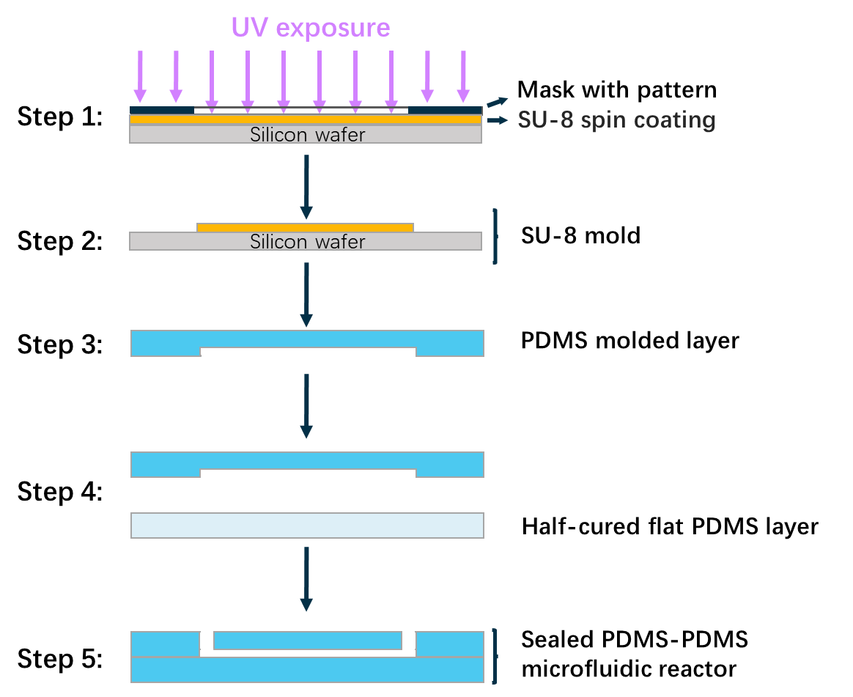
Supplementary Figure 1. Process flow of the fabrication of PMRs by the soft photolithography, including photopatterning, PDMS molding and flat layer fabrication and microfluidic chip sealing.

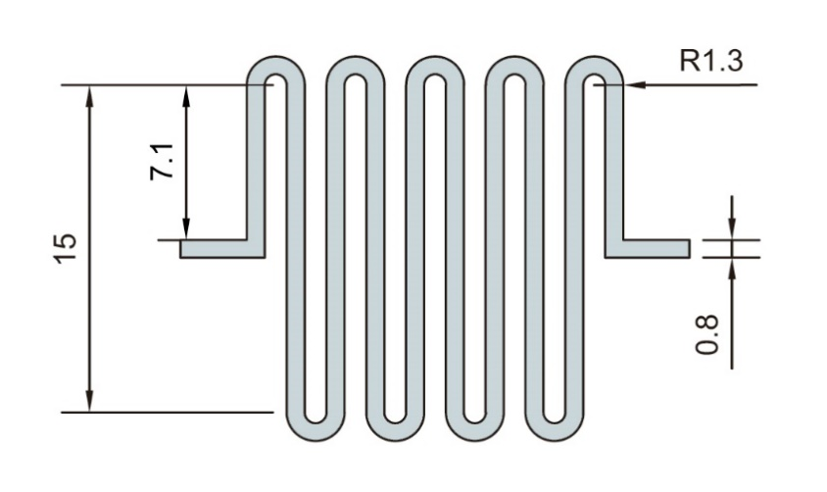
Supplementary Figure 2. Detailed dimensions of the microchannels as shown by the gray-blue area. The unit is millimeter. The height of the microchannel is 40 μm.

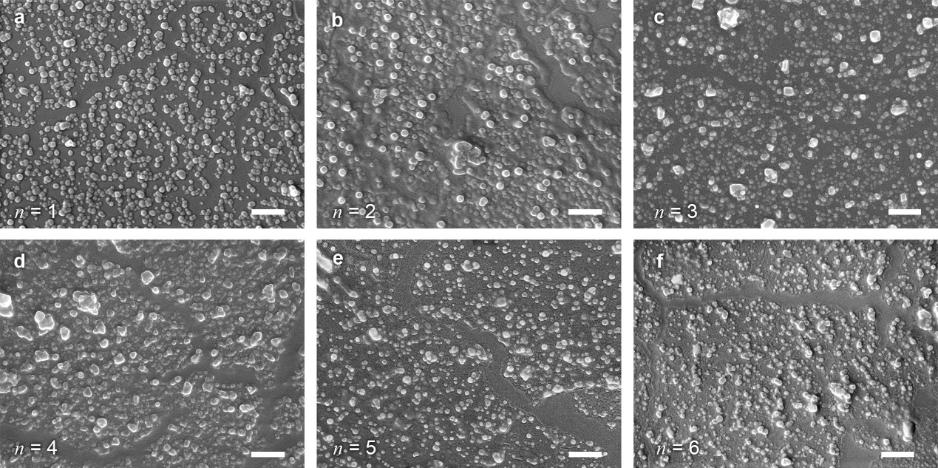
Supplementary Figure 3. FESEM images of the microchannels’ inner surfaces of (PEI/RuBisCO)_{n}-PMRs. (a) (PEI/RuBisCO)₁-PMRs, (b) (PEI/RuBisCO)₂-PMRs, (c) (PEI/RuBisCO)₃-PMRs, (d) (PEI/RuBisCO)₄-PMRs, (e) (PEI/RuBisCO)₅-PMRs, (f) (PEI/RuBisCO)₆-PMRs. The number of the bilayers, n, is indicated at the lower left of each image. The scale bars are 1 μm.

Supplementary Figure 4. CD spectra of PDMS film (red line), RuBisCO solution (purple line), and (PEI/RuBisCO)_{n} assembly deposited on PDMS films. The spectrum of the PDMS thin film shows no peak (red line). But the RuBisCO solution has the peak at ~220 nm (purple line), indicating the secondary structure of RuBisCO¹. The spectra of the (PEI/RuBisCO)_{n} assembly deposited on the PDMS thin film also present the similar negative peak at ~ 220 nm, which confirms the immobilization of RuBisCO on PDMS. It is noticed that the peak intensity increases with the increasing number of the PEI/RuBisCO bilayer, suggesting the increasing amount of the immobilized RuBisCO on PDMS film, which is consistent with the ATR-FTIR spectra.

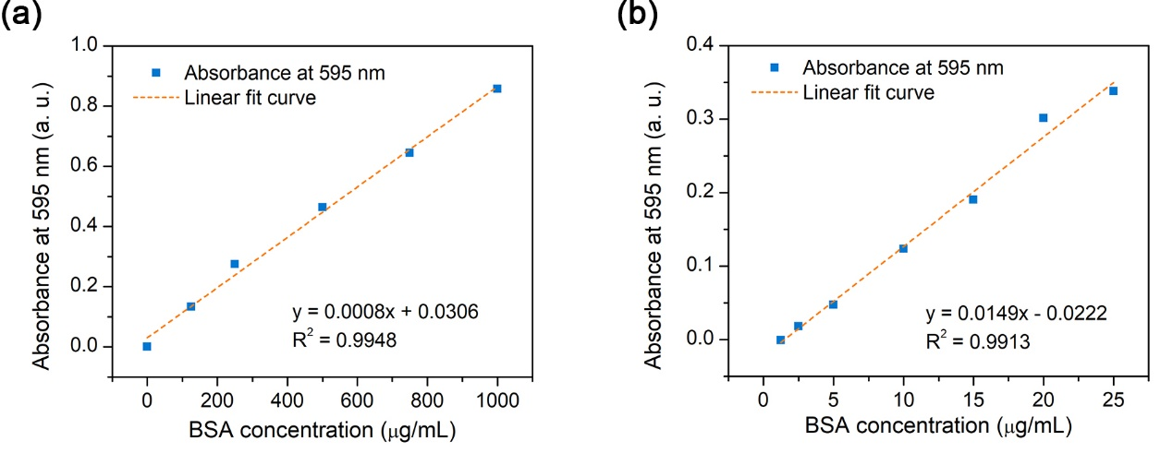
Supplementary Figure 5. Calibration of protein amount determined from BSA solutions by the Bradford method. Protein amount was qualified using the Quick Start Bradford Protein Assay kit (Bio-Rad Pacific Limited.), which were determined by measuring the absorbance at the wavelength of 595 nm using a microplate reader (Thermo Scientific Varioskan LUX Multimode Microplate Reader). BSA solutions at different concentrations were selected as standards to plot the calibration curve.^{2,3} (a) BSA at 0.125-1 mg mL⁻¹ for the microplate standard assay and (b) BSA at 1.25-25 μg mL⁻¹ for the microplate micro-assay.

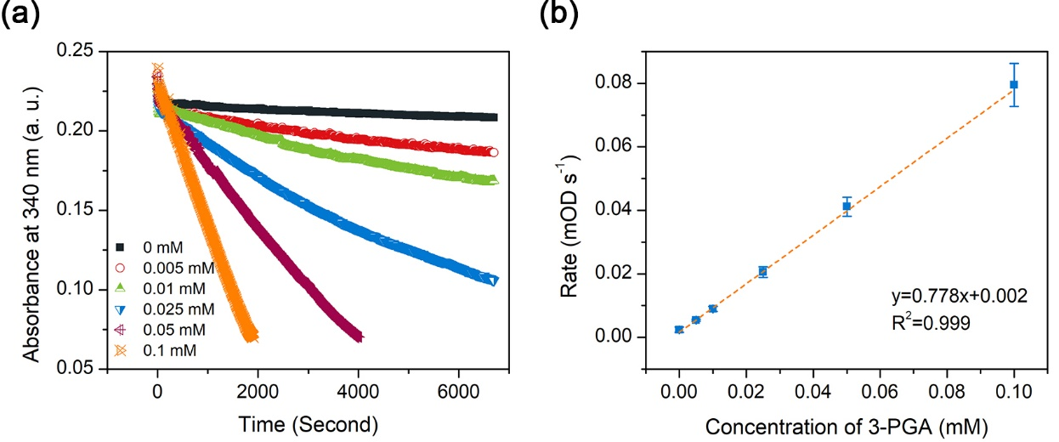
Supplementary Figure 6. Calibration of standard 3-PGA amount by UV-Visible spectrometry. (a) Decrease of the absorbance at 340 nm as a function of the time for different concentrations (from 0.005 to 0.1 M) of 3-PGA dissolved in the reaction buffer. (b) Calibration line of 3-PGA in the reaction buffer by the amplification signal assay with using the microplate reader. Error bars represent the standard deviations from three independent experiments.¹

Supplementary Figure 7. Kinetics parameters of the (PEI/RuBisCO)₁-PMRs. Blue squares are the RuBisCO activities at different concentration of RuBP. The collected production solutions are 100 μL. The RuBP concentrations are 0.125 – 5 mM for the (PEI/RuBisCO)₁-PMRs reaction. The concentration of bicarbonate (HCO₃⁻) in the reaction buffer is 66 mM. K_{m} and V_{max} values are calculated by the GraphPad Prism 7 according to the hyperbola regression fitting of Michaelis–Menten model. The hyperbola regression fitting line is shown in orange dashed curve.

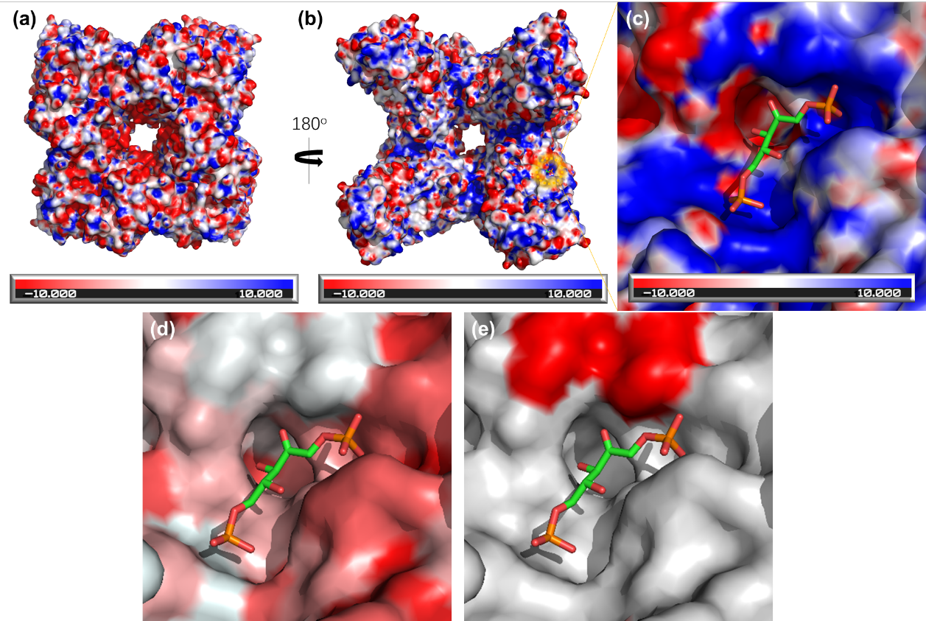
Supplementary Figure 8. Visualization of the charge distribution on the surface of the RuBisCO under pH of 8.0 (positive charge - blue, negative - red, neutral – white) (a-c). (a) and (b) refer different orientations for the 3D structure of RuBisCO indicating the charge distribution; (c) shows one of the active centre of RuBisCO with RuBP; (d) shows one of the active centre of RuBisCO with RuBP visualizing the surface hydrophobicity of RuBisCO (red: hydrophobic area; white: hydrophilic area); (e) shows one of the active centre of RuBisCO with RuBP visualizing the possible covalent bonding site (red: lysine); Figures are prepared with PyMOL using the PDB coordinates 1RXO.

Supplementary Figure 9. Relative activities of (PEI/RuBisCO)₄-PMRs retained after a prolonged incubation time up to 60 min at 50 ºC. RuBP concentration is 0.5 mM and HCO₃⁻ is 66 mM. RuBP and HCO₃⁻ are flowed through the (PEI/RuBisCO)₄-PMRs continuously at the flow rate of 7 μL min⁻¹. Error bars represent the standard deviations from three independent experiments.

Supplementary Figure 10. Comparsion of the reusability for the (PEI/RuBisCO)₄-PMRs (solid blue squares) and the (PEI/RuBisCO)₁-PMRs (open orange circles). About 96% of the relative activity is retained after 10 cycles of reusing for (PEI/RuBisCO)₄-PMRs, while only ~ 55.4% of the relative activity is retained after 10 cycles of reusing for (PEI/RuBisCO)₁-PMRs. RuBP (0.5 mM) and HCO₃⁻ (66 mM) are flowed through the (PEI/RuBisCO)₄-PMRs and (PEI/RuBisCO)₁-PMRs continuously at the flow rate of 7 μL min⁻¹.

Supplementary Tables
Supplementary Table 1. Measured kinetic parameters of the immobilized RuBisCO and the free RuBisCO ^{a)}.
Enzyme immobilization type | V_{max} (mmol⋅min⁻¹⋅g⁻¹ RuBisCO) | K_{m} [RuBP] (mM) | k_{cat} (s⁻¹) | k_{cat}/K_{m}  (mM ⁻¹⋅s ⁻¹)
LBL assembly with 4 layers | 2.494 ± 0.108 | 0.474 ± 0.069 | 2.86 | 6.03
LBL assembly with 1 layer | 1.146 ± 0.159 | 0.378 ± 0.187 | 1.31 | 3.47
Covalent immobilization ^{b)} | 0.070 ± 0.003 | 0.070 ± 0.012 | 0.079 | 1.13
Physical adsorption ^{c)} | 0.008 ± 0.001 | 0.090 ± 0.028 | 0.009 | 0.10
Free in solution ^{d)} | 0.169 ± 0.006 | 0.049 ± 0.008 | 0.19 | 3.88
^{a)} The collected production solutions are 100 μL. RuBP concentrations are 0.125 – 5 mM for the RuBisCO immobilized by LBL assembly. The concentration of bicarbonate (HCO₃⁻) in the reaction buffer is 66 mM. K_{m} and V_{max} values are the means ± s.d. of three independent experiments; ^{b) - d)} The data are collected from the previous studies^{2,4}.

Supplementary Table 2. Performance comparison of the immobilized RuBisCO and the free RuBisCO.
Enzyme immobilization type | Thermal stability ^{d)} | Long-term thermal stability ^{e)} | Storage stability ^{f)} | Reusability ^{g)}
LBL assembly | 72% | 74% | 49% | 96%
Covalent immobilization ^{a)} | 67% | 75% | 43% | 74%
Physical adsorption ^{b)} | 57% | 65% | - | 40%
Free in solution ^{c)} | 10% | 47% | 6% | -
^{a) - c)} The data are collected from the previous studies using the same detection method;^{2,4} ^{d)} Thermal stability is the remained relative activity after the incubation at 70 °C for 10 min; ^{e)} Long-term thermal stability is the remained relative activity after the incubation at 50 °C for 60 min; ^{f)} Storage stability is defined as the remaining relative activity after 15 days; ^{g)} Reusability is the remained relative activity after 10 cycles of reuse at the flow rate of 7 μL min⁻¹.

Supplementary References
1 Tomimatsu, Y. & Donovan, J. W. Effect of pH, Mg²⁺, CO₂ and Mercurials on the Circular Dichroism, Thermal Stability and Light Scattering of Ribulose 1,5-Bisphosphate Carboxylases from Alfalfa, Spinach and Tobacco. Plant Physiol. 68, 808-813, (1981).
2 Zhu, Y. et al. Continuous artificial synthesis of glucose precursor using enzyme-immobilized microfluidic reactors. Nat. Commun. 10, 4049, (2019).
3 Bradford, M. M. A rapid and sensitive method for the quantitation of microgram quantities of protein utilizing the principle of protein-dye binding. Anal. Biochem. 72, 248-254, (1976).
4 Zhu, Y. et al. Biomimetic reusable microfluidic reactors with physically immobilized RuBisCO for glucose precursor production. Catal. Sci. Technol., (2022).

