Legends to Supplementary Figures:
Supplementary Figure 1:
The foundational science curriculum schema for the University of Toledo College of Medicine’s MD program. The 18-month curriculum is split between two academic years. The individual systems from each year are further grouped into “threads”.
Supplementary Figure 2:
The figure depicts an example worksheet provided to the students for guidance on how to prepare their assignments. The assignment of points, as per the rubric, is indicated in parentheses next to each section.
Supplementary Figure 3:
The survey questionnaire is shown in the figure. The students can choose one of the options from “Strongly disagree-Disagree-Neither agree nor disagree-Agree-Strongly agree” for each subsection (For example 1a, 1b, 2a, 2b, etc.) from questions 1-5. Questions 6a and 6b are open-ended.

Supplementary Figure 1:
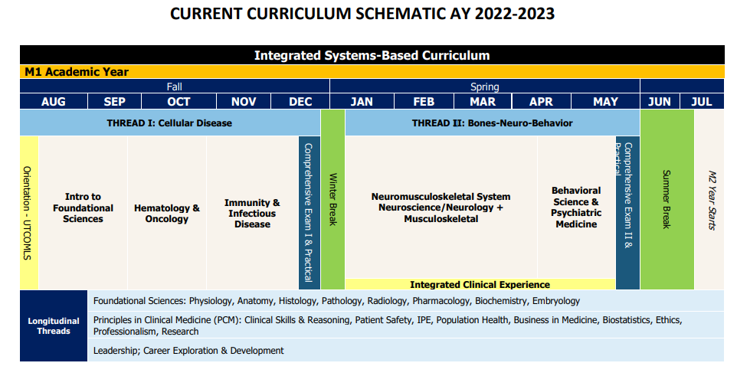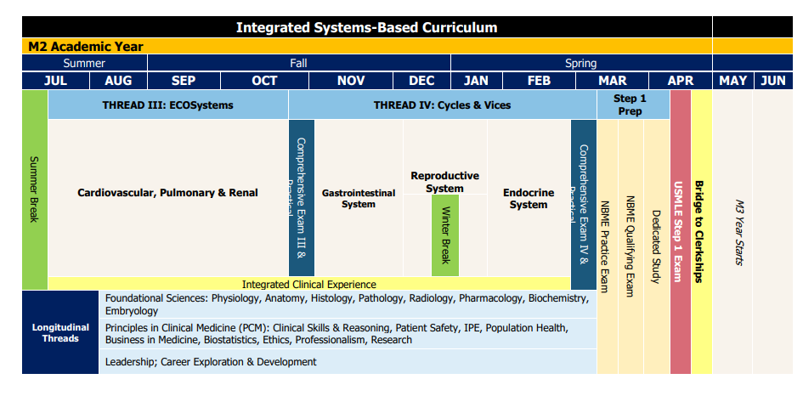
Supplementary Figure 2:

SDL: Self Directed Learning – Anticoagulation, WORKSHEET EXAMPLE

Clinical Question / Learning Objective (0-2 points)
For this patient with a pulmonary embolism, why did she not receive r-tPA?

Conclusion / Points to Share (0-2 points)
I agree with this management. This patient was not given tPA for acute pulmonary embolism as the risk of bleeding exceeded the benefit of treatment at initial presentation, and she continued to remain hemodynamically stable and improve over the following 24 hours of the hospitalization. While this patient did not have an absolute contraindication to tPA, high-risk factors for poor prognosis with PE were absent (she was initially hypotensive and mildly tachycardic which responded/resolved with IV fluid, there were no signs of RV dysfunction – with very mild elevation in BNP/troponin-I, there were no additional DVT seen on ultrasound of lower extremities, she was not hypoxic, and without additional significant comorbidities).

Top 3 Relevant Facts, Source, and Level of Credibility (0-4 points)

Relevant Information Reviewed Relating to Clinical Question: | Resource: | Level of Credibility (1-5)
tPA is a thrombolytic which is formed by aggregation of activated platelets into fibrin meshes by activating plasminogen.  tPA attaches to fibrin on the clot surface → activation of fibrin-bound plasminogen → plasmin is subsequently cleaved from the plasminogen affiliated with the fibrin → plasmin breaks up the molecules of fibrin → clot dissolves…fibrin is inactivated by alpha 2-antiplasmin → PAI 1 binds to tPA to form complex → removed by liver | Jilani TN, Siddiqui AH. Tissue Plasminogen Activator. [Updated 2021 Mar 21]. In: StatPearls [Internet]. Treasure Island (FL): StatPearls Publishing; 2021 Jan. | 1(Peer Reviewed Book)
Indications for r-tPA use in PE include: shock or persistent hypotension (100% mortality without thrombolysis~); new or worsening right ventricular dysfunction (through echocardiogram, CT chest, elevated troponin and BNP, or absence of comorbidities which affect RV function), significant hypoxemia or respiratory  distress, tachycardia, poor | Tapson, V et al. Approach to thrombolytic (fibrinolytic) therapy in acute pulmonary embolism: Patient selection and administration. In: UpToDate, Post TW (Ed), UpToDate, Waltham, MA. (Accessed on August 10, 2021). | 1(RCTs,  Meta- Analyses, Clinical Practice Guidelines)

cardiopulmonary reserve, proximal DVT in the lower extremities, high clot burden, or presence of right-sided cardiac thrombus; or sPESI score >0 – which includes age>80, history of cancer (HR: 2.3*), chronic cardiopulmonary disease (HR: 2.4*), pulse  >109, systolic pressure <100 (HR: 2.9*), arterial oxygen saturation <90%).  * Other than refractory hypotension and shock due to acute PE in patients with a low bleeding risk, none of the listed factors by itself is an absolute indication for thrombolytic therapy. Rather, all factors are considered collectively so that the risk of death from PE can be assessed appropriately. Other reported factors include hyponatremia, elevated lactate and white cell count, poor performance, and older age >65 years.  Contraindications for r-tPA use include: Absolute (prior intracranial hemorrhage, known structural cerebral vascular lesion, known malignant intracranial neoplasm, ischemic stroke within the last 3 months, suspected aortic dissection, active bleeding or bleeding diathesis, significant close-head trauma within 3 months). Relative (history of chronic severe and poorly controlled hypertension, SBP>180 or DBP>110 upon presentation, history of ischemic stroke  >3months prior, >10min CPR or major surgery <3 weeks ago, recent (2-4 weeks) internal bleeding, noncompressible vascular punctures, recent invasive procedure, pregnancy, active peptic ulcer, pericarditis or pericardial fluid, current use of an anticoagulant, age >75, diabetic  retinopathy). | ~Jerjes-Sanchez C, Ramírez- Rivera A, de Lourdes García M, Arriaga-Nava R, Valencia S, Rosado-Buzzo A, Pierzo JA, Rosas  E. Streptokinase and Heparin versus Heparin Alone in Massive Pulmonary Embolism: A Randomized Controlled Trial. J Thromb Thrombolysis. 1995;2(3):227-229. doi:  10.1007/BF01062714. PMID:  10608028.  *Goldhaber SZ, Visani L, De Rosa  M. Acute pulmonary embolism: clinical outcomes in the International Cooperative Pulmonary Embolism Registry (ICOPER). Lancet. 1999 Apr 24;353(9162):1386-9. doi:  10.1016/s0140-6736(98)07534-  5. PMID: 10227218. | ~2 (RCT)  *3 (Retro- spective review)
Risk of bleeding with r-tPA use: Major bleeding may occur in 20% of patients. | Miller DJ, Simpson JR, Silver  B. Safety of thrombolysis in acute ischemic stroke: a review of complications, risk factors, and newer | 1(Peer Reviewed Book with RCTs,  Meta-

Hemorrhagic complications are higher with r-tPA use than with anticoagulation alone (9.2% vs 3.4%).  Intracranial hemorrhage can be a devastating adverse event leading to significant morbidity or mortality after r-tPA use, and occurs in 1.5-3% of all patients. | technologies. Neurohospitalist. 2011;1(3):138-147.  doi:10.1177/ 1941875211408731 | analyses, clinical guidelines)

(Additional Consideration - Optional: Feedback Synthesis: How to improve the SDL process for the next clinical question encountered?
For my next self-directed learning, I would choose a more specific question and dive deeper into the data to learn about the odds ratio/hazard ratio associated with the treatment intervention.

Supplementary Figure 3:
Survey Questionnaire
Strongly disagree-Disagree-Neither agree nor disagree-Agree-Strongly agree
- The two SDLs introduced in thread 3 was helpful for me to identify critical knowledge gaps in the corresponding areas:
  - Anticoagulants
  - COVID-19
- The faculty feedback was helpful to identify my weaknesses as a learner:
- Anticoagulants
- COVID-19
- The faculty feedback provided clear directions on how to improve in my areas of weaknesses:
- Anticoagulants
- COVID-19
- The two SDLs introduced in thread 3 will support my development as a life-long learner:
- Anticoagulants
- COVID-19
- The SDL assignments integrated key clinical concepts that was helpful to reinforce my learning of the material:
- Anticoagulants
- COVID-19
- Please share in a few words how each of the SDL experiences shaped your perception of your self-directed learning skills.
- Anticoagulants
- COVID-19

