Supplemental data
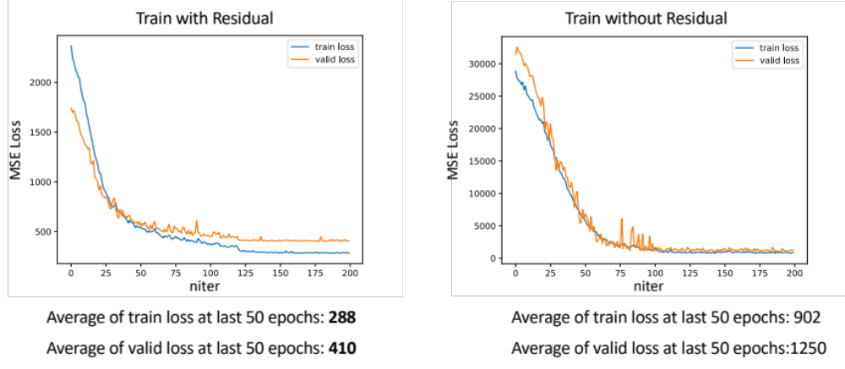
Fig. 1. Training/validation loss curve of residual CNN vs. non-residual CNN during 200 epochs of training.

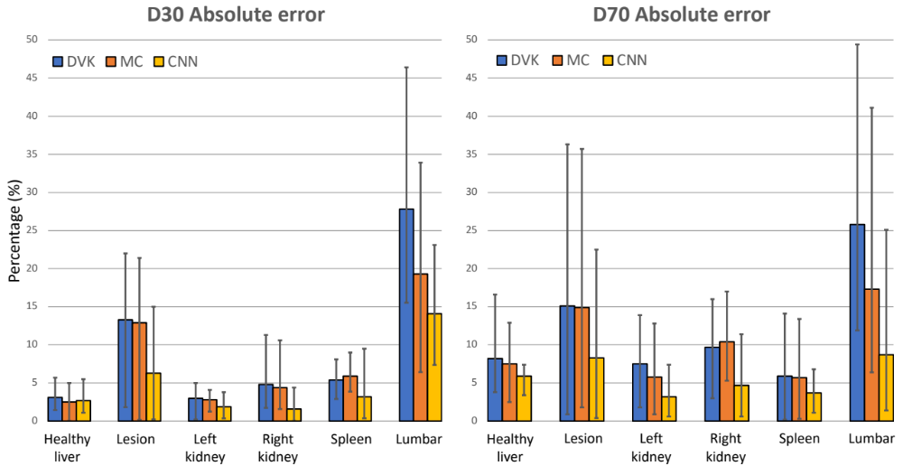
Fig. 2. Comparisons of DVK, MC and CNN in terms of D30/D70 absolute error in VOIs across all test phantoms.

Table 1. Dose-rate values comparing GT, DVK, MC and CNN in VOIs across all test phantoms. The medians (ranges) for the VOI volumes are: healthy liver: 1607mL (1164mL – 2262mL); lesion: 16mL (4mL – 181mL); Left kidney: 177mL (98mL – 211mL); Right kidney: 156mL (76mL – 249mL); Spleen: 191mL (131mL – 467mL); Lumbar: 54mL (34mL – 68mL). Healthy liver is defined as liver minus lesions. Lumbar corresponds to lumbar vertebra L2 to L5.

Organ/Dose-rate ($×{10}^{-6}$Gy/MBq-sec) | GT | DVK | MC | CNN
Healthy Liver | 3.4 (2.3 – 4.4) | 3.3 (2.1 – 4.4) | 3.4 (2.2 – 4.4) | 3.3 (2.2 – 4.4)
Lesion | 12.4 (2.8 – 15.2) | 10.9 (2.6 – 14.8) | 10.9 (2.7 – 14.9) | 11.8 (2.6 – 14.7)
Liver | 4.0 (2.3 – 5.2) | 3.9 (2.1 – 5.1) | 4.0 (2.2 – 5.1) | 3.9 (2.2 – 5.1)
Left Kidney | 5.5 (3.7 – 7.2) | 5.3 (3.6 – 7.0) | 5.4 (3.6 – 7.1) | 5.5 (3.7 – 7.0)
Right Kidney | 5.7 (3.7 – 7.8) | 5.6 (3.5 – 8.2) | 5.6 (3.5 – 8.2) | 5.7 (3.7 – 8.0)
Spleen | 8.1 (5.3 – 11.4) | 8.3 (5.0 – 11.7) | 8.3 (5.0 – 11.7) | 8.0 (5.0 – 11.2)
Lumbar | 0.88 (0.35 – 3.4) | 0.67 (0.17 – 2.7) | 0.73 (0.21 – 2.7) | 0.79 (0.26 – 3.0)

Table 2. Dose-rate values comparing DVK, MC and CNN in VOIs across all test patients. The medians (ranges) for the VOI volumes are: lesion: 15 mL (2.3 mL – 582 mL); Left kidney: 192 mL (105 mL – 275 mL); Right kidney: 180 mL (122 mL – 259 mL).

Organ/Dose-rate  ($×{10}^{-6}$Gy/MBq-sec) | DVK | MC | CNN
Lesion | 13.7 (0.2 – 87.9) | 13.9 (0.3 – 88.9) | 14.4 (0.3 – 88.8)
Left Kidney | 3.7 (0.7 – 8.6) | 3.8 (0.7 – 8.7) | 3.8 (0.7 – 8.3)
Right Kidney | 4.2 (0.7 – 9.1) | 4.3 (0.8 – 9.2) | 4.2 (0.8 – 9.1)

