Supplementary Information for:
A non-FRET DNA reporter that changes fluorescence color upon nuclease digestion
Soonwoo Hong¹, Jada N. Walker², Aaron T. Luong¹, Jonathan Mathews¹, Samuel Shields², Aaron Luong¹, Yu-An Kuo¹, Yuan-I Chen¹, Duc Trung Nguyen¹, Yujie He¹, Anh Thu Nguyen¹, Jennifer S. Brodbelt², Hsin-Chih Yeh^{1,3*}
¹Department of Biomedical Engineering, University of Texas at Austin, Austin, TX 78712, USA
²Department of Chemistry, University of Texas at Austin, Austin, TX 78712, USA
³Texas Materials Institute, University of Texas at Austin, Austin, TX 78712, USA
*Corresponding author
H.-C. Yeh: tim.yeh@austin.utexas.edu

Table of Content
Supplementary Table 1 3
Supplementary Table 2. 4
Supplementary Table 3. 5
Supplementary Equation 1 6
Supplementary Equation 2. 7
Supplementary Figure 1 8
Supplementary Figure 2. 9
Supplementary Figure 3. 10
Supplementary Figure 4. 11
Supplementary Figure 5. 12
Supplementary Figure 6. 13
Supplementary Figure 7. 14
Supplementary Figure 8. 15
Supplementary Figure 9. 16
Supplementary Figure 10. 17
Supplementary Figure 11. 18
Supplementary Figure 12. 19
Supplementary Figure 13. 20
Supplementary Figure 14. 21
Supplementary Figure 15. 22
Supplementary Figure 16. 23
Supplementary Video 1 and 2. 24
Source data 1-4 26

Supplementary Table 1

Cost breakdown concerning Subak probes compared to FRET probes
Materials | Subak (ours) | Gel-purified Subak (ours)
DNA  (from IDT) | $31.08 (200 nmol) | $31.08 (200 nmol)
Silver nitrate ($485.00/50g  from Sigma Aldrich) | <$0.01 | <$0.01
Sodium borohydride  ($99.10/25g  from Sigma Aldrich) | <$0.01 | <$0.01
Gel cassette ($230/25units  from Thermo Fisher) | n/a | $27.60 (3 gels for 210 nmol)
Gel materials | n/a | <$0.01
3K centrifugal filter ($518/96units  from Sigma Aldrich) | n/a | $16.20 (3 filters)
PVDF centrifugal filter  ($234.53/100units  from Thermo Fisher) | n/a | $7.05 (3 filters)
Yield rate* | ~40% | ~40%
Total cost  (for 80 nmol) | <$31.10 | <$81.96
Total cost  (per nmole) | <$0.39 | <$1.02
*Yield rate was calculated by quantifying gel bands (Supplementary Figure 8) using ImageJ.
vs. DNaseAlert – ($62.475/nmol from IDT)
vs. single-channel oligo reporters (/56-FAM/TTATTATT/3BHQ_1/)¹ – ($17.01/nmol from IDT)
vs. dual-channel oligo reporters (/5Cy5/TTATTATT/3Cy3Sp/) – ($33.60/nmol from IDT)

Materials
DNAs with standard desalting were purchased from Integrated DNA Technologies, Inc. (IDT). 99.9999% silver nitrate (Cat. No. 204390-50G), 99.99% sodium borohydride (Cat. No. 480886-25G), 3K Amicon Ultra-0.5 centrifugal filters (Cat. No. UFC500396) were purchased from Sigma Aldrich. PAGE gel was made using 1.0 mm empty gel cassettes (Cat. No. NC2010), 2D well empty gel cassette combs (Cat. No. NC3002), SureCast ammonium persulfate (Cat. No. HC2005), SureCast acrylamide solution (Cat. No. HC2040), and SureCast TEMED (Cat. No. HC2006) purchased from Thermo Fisher Scientific (USA). PVDF (0.45 µm of pore size) centrifugal filters (Cat. No. F2517-6) were also purchased from Thermo Fisher Scientific USA). 10X tris-borate-EDTA (TBE) was purchased from Fisher Scientific (Cat. No. BP1333-1).

Supplementary Table 2.

List of DNA sequences used for DNA/AgNCs preparation
(When a sequence is a hairpin DNA, overhang arms, a stem, and a loop are colored in orange, blue, and black, respectively.)
Sequence name | Sequence (5’->3’)
Subak-seed | AACCACCCCATTGTCTTTTTTAAGACAAGTTCCCCCC
Subak-1 | AACCACCCCATCGTCTTTTTTAAGACGAGTTCCCCGC
Subak-2 | AACCACCCCATCGTCTCTTTTGAGACGAGTTCCCCCC
Subak-3 | AATCCCCAACTTGTCTTTTTTAAGACAATCCCCAAC
Subak-4 | GTTCCCCCCTTGTCTTTTTTAAGACAAAACCACCCCA
Subak-5 | TCCCCAACAATTGTCTTTTGACAATTTTTAATCCCCAAC
Subak-6 | GTTCCCCCCTTGTCTTTTTTAAGACAAATCCCCAAC
Subak-1 A1-A25 | AACCACCCCATCGTCTTTTTTAAGA
Subak-1 C26-C37 | CGAGTTCCCCGC
Subak-1 A1-T16 | AACCACCCCATCGTCT
Subak-1 T17-C37 | TTTTTAAGACGAGTTCCCCGC
Subak-1 and Subak-2 5’-arm | AACCACCCCA
Subak-1 3’-arm | GTTCCCCGC
Subak-2 5’-arm | GTTCCCCCC

Supplementary Table 3.
List of DNA/RNA sequences for CRISPR/Cas12a experiments
Sequence  name | Sequence  (5’->3’) | Reference  (If available)
TS1 | GCCGGGGTGGTGCCCATCCTGGTCGAGCTGGACGGCGACGTAAACGGCCACAAGC | Chen et al.²
NTS1 | GCTTGTGGCCGTTTACGTCGCCGTCCAGCTCGACCAGGATGGGCACCACCCCGGC | Chen et al.²
TS2  (SARS-CoV-2 N-gene cDNA TS) | ACATTCCGAAGAACGCTGAAGCGCTGGGGGCAAATTGTGC | Broughton et al.¹ Ramachandran and Santiago³
NTS2  (SARS-CoV-2 N-gene cDNA NTS) | GCACAATTTGCCCCCAGCGCTTCAGCGTTCTTCGGAATGT | Broughton et al.¹ Ramachandran and Santiago³
gRNA1 for TS1 | rUrArArUrUrUrCrUrArCrUrArArGrUrGrUrArGrArUrCrGrUrCrGrCrCrGrUrCrCrArGrCrUrCrGrArCrC | Chen et al.²
gRNA2 for TS2 | rUrArArUrUrUrCrUrArCrUrArArGrUrGrUrArGrArUrCrCrCrCrCrArGrCrGrCrUrUrCrArGrCrGrUrUrC | Broughton et al.¹ Ramachandran and Santiago³

Supplementary Equation 1

$$Response=Signal_{min}+\frac{signal_{max}-signal_{min}}{{\left(1+{\left(\frac{concentration}{EC_{50}}\right)}^{slope}\right)}^{assymetry parameter}}$$
The five-parameter logistic (5PL) equation was used for curve fitting. In general, the four-parameter logistic (4PL) equation is commonly used for assay data^{3, 4}, in which the asymmetry parameter is 1, but the ratiometric signals of Subak probes are asymmetric so that a better fitting result (high r-square) can be achieved using a 5PL regression⁵. All curve fitting was performed in MATLAB (R2023a) using a weighted curve fitting function, where weights, $w_{i}=\frac{1}{σ_{i}}$ .
Supplementary Equation 2.

Reaction velocity calculation. To calculate the reaction velocity in nM min⁻¹, we need to obtain the fluorescence intensity in molar concentration (nM). Following the method described by Ramachandran and Santiago³, we observed the standard curve of fully cleaved and uncleaved reporters with Cas12a (Supplementary Figure 13). Using the slopes of each standard curve, we could rewrite the fluorescence versus time ($F(t)$, S2-1), where $F_{cl}(t)$ and $F_{ucl}\left(t\right)$ are the fluorescence of cleaved and uncleaved reporters over time, respectively.
$$F\left(t\right)=F_{cl}\left(t\right)+F_{ucl}\left(t\right)$$ | S2-1
For DNaseAlert,
$$F_{alert}(t)=120660c_{alert,cl}(t)+4480c_{alert,ucl}(t)$$ | S2-2
For Subak-2
$$F_{Subak}(t)=18199c_{Subak,cl}(t)+515c_{Subak,ucl}(t)$$ | S2-3
, where $c_{cl}$ and $c_{ucl}$ represent cleaved and uncleaved reporter concentrations in nM, respectively.
And then, S2-2 and S2-3 can be rewritten from mass conservation, $c_{cl}\left(t\right)+c_{ucl}\left(t\right)=c_{0}$, where $c_{0}$ is the initial concentration of a reporter. The reaction velocities, $\frac{dc_{cl}}{dt}$ in nM min⁻¹, is finally obtained as follows:
$$\frac{dc_{alert,cl}\left(t\right)}{dt}=\frac{1}{120660-4480}×\frac{dF_{alert}\left(t\right)}{dt}$$ | S2-4
$$\frac{dc_{Subak,cl}\left(t\right)}{dt}=\frac{1}{18199-515}×\frac{dF_{Subak}\left(t\right)}{dt}$$ | S2-5
From S2-4, the reaction velocity of 2 μM DNaseAlert was 40.77 nM min⁻¹, whereas that of 2 μM Subak-2 was 1.13 nM min⁻¹.

Supplementary Figure 1
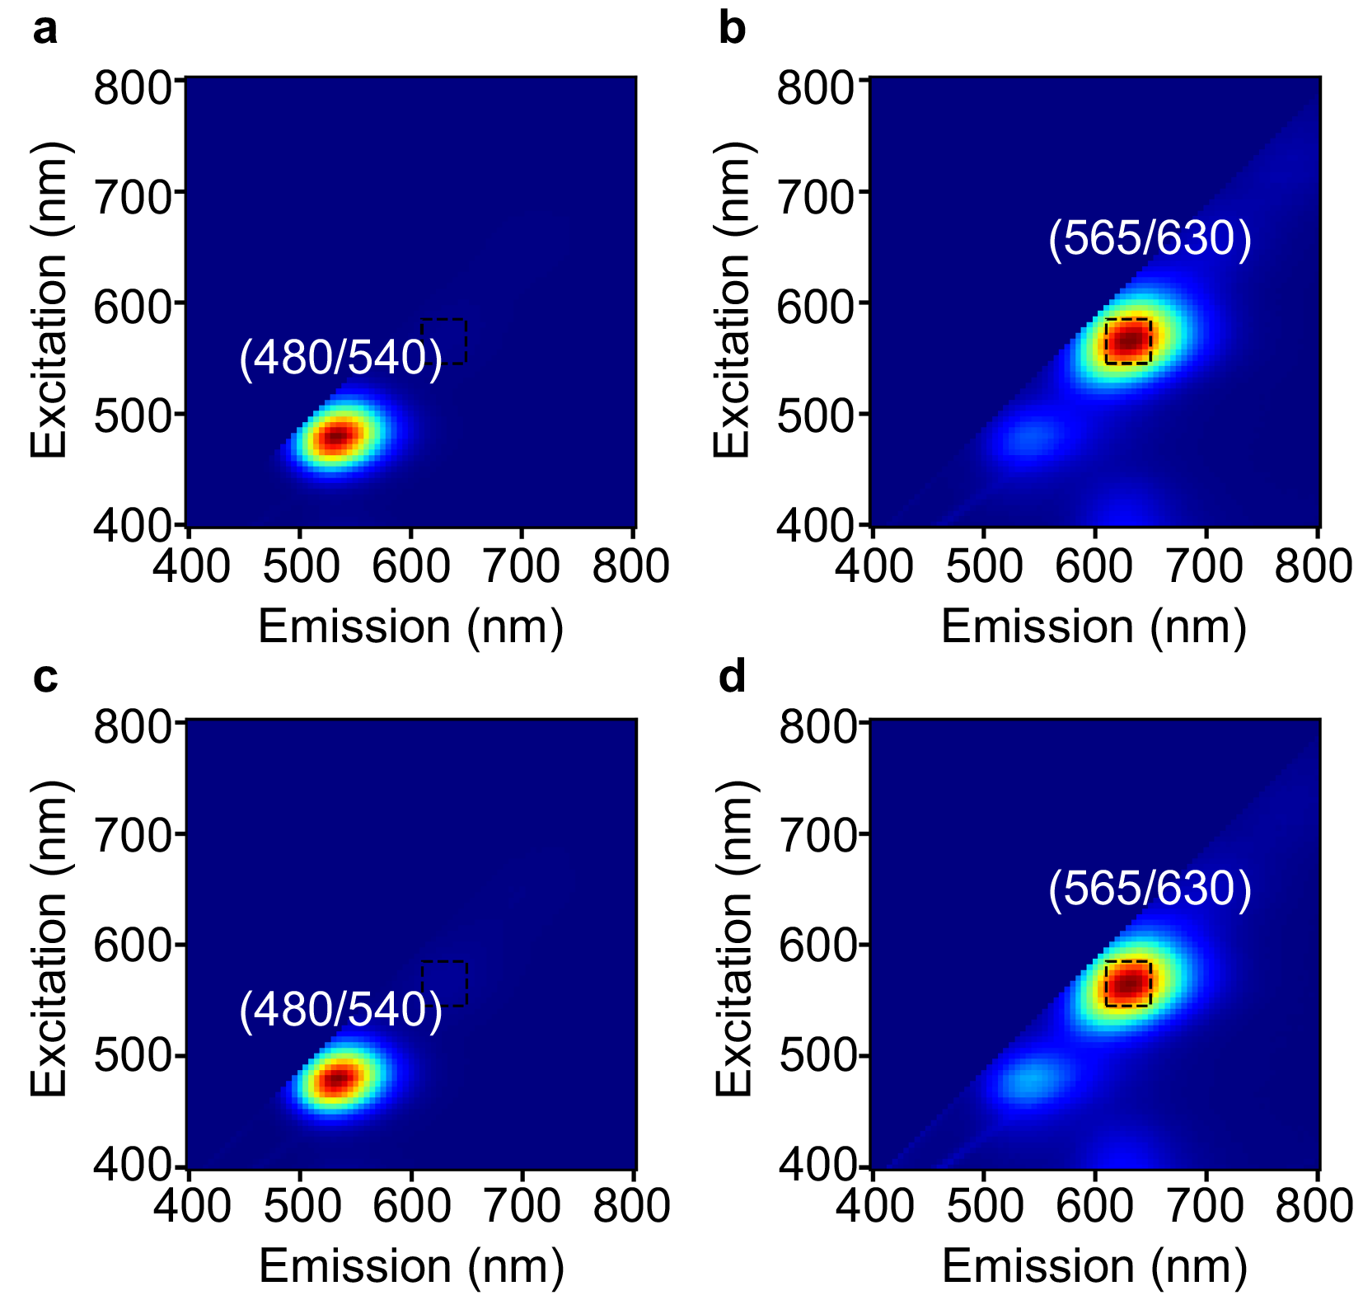
Fluorescence comparison between gel-purified and unpurified Subak-1 before and after digestion by DNase I. a,b, Normalized fluorescence excitation-emission matrix of gel-purified Subak-1 without (a) and with DNase I (b). c,d, Normalized fluorescence excitation-emission matrix of as-synthesized Subak-1 without (c) and with DNase I (d). The fluorescence of digested Subak-1 reporters was measured after 20 minutes. The dashed box represents the red channel from 610 – 650 nm. The enhancement ratio was calculated by integrating volumetric intensities over the excitation/emission windows (i.e. Ex565/40, Em630/40)⁶.
Supplementary Figure 2.
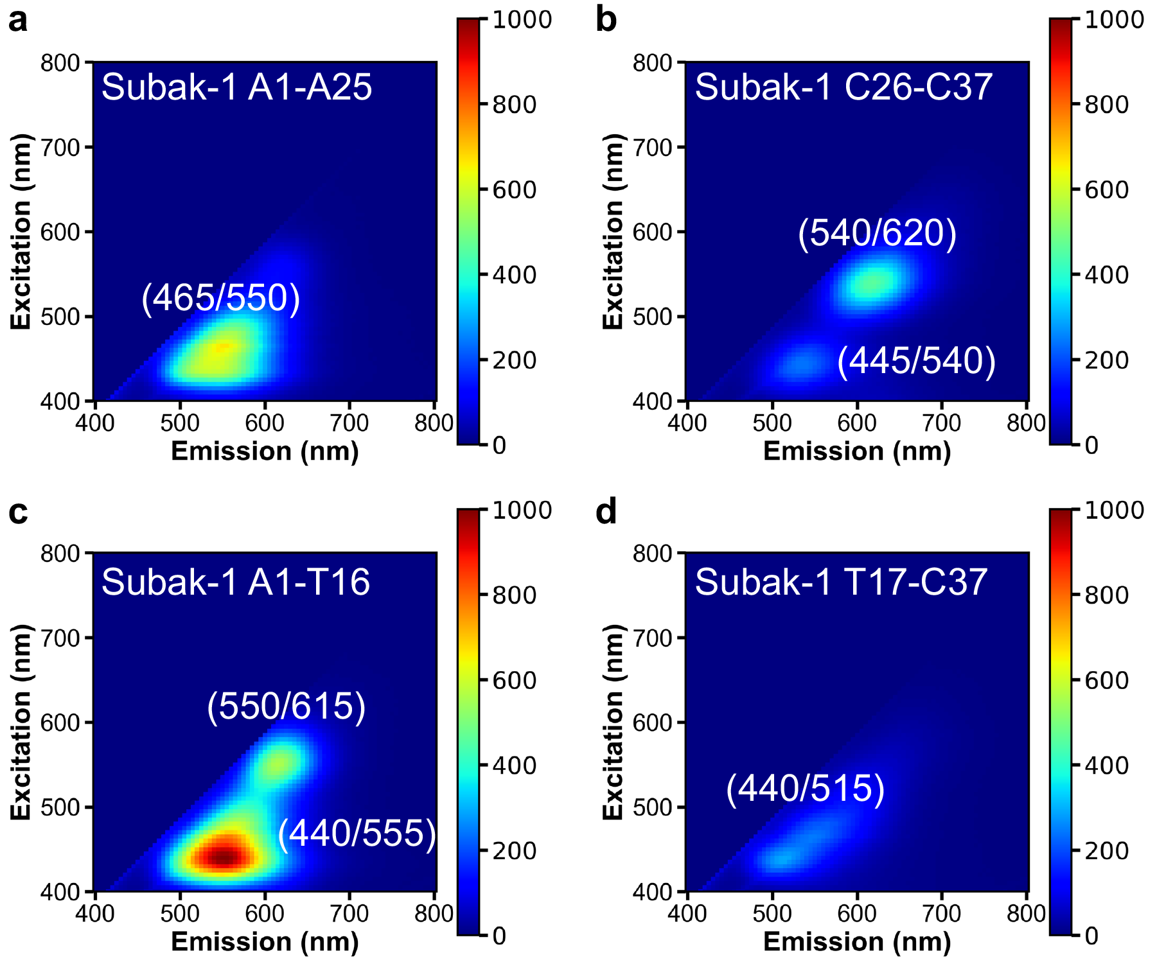
Normalized fluorescence intensity of DNA/AgNCs prepared by the traditional nucleation-and-reduction method with short DNA templates. a, When AgNCs are prepared with an intact Subak-1 fragment (A1-A15: AAC CAC CCC ATC GTC TTT TTT AAG A), they have a dim green fluorescence which is different from the fragmentation-induced method (vs. Ex565/Em630). b-d, Other clusters prepared from short DNA fragments (b, C26-C27, CGA GTT CCC CGC c, A1-A16, AAC CAC CCC ATC GTC T and d, T17-C37, TTT TTA AGA CGA GTT CCC CGC). It suggests that our fragmentation-induced methods provide a new and only strategy to create a new type of AgNC reporters that cannot be attained by the traditional methods.
Supplementary Figure 3.

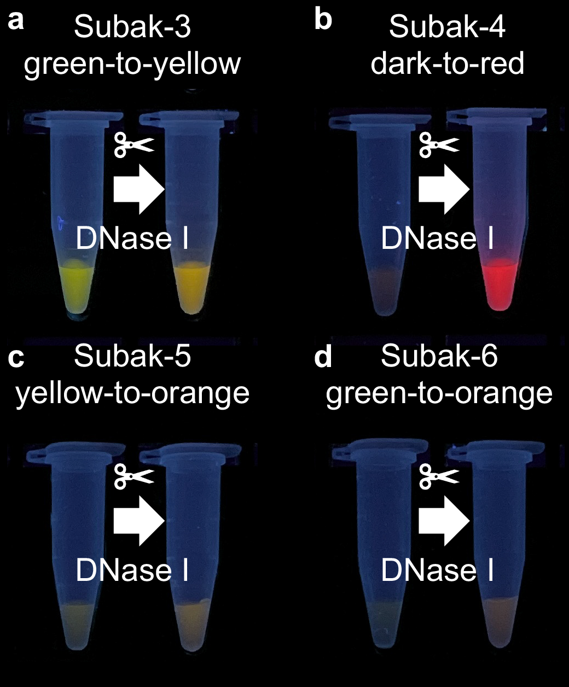
Subak-variants showing different fragmentation-induced-color-switching patterns. They all have a stem-loop structure with sizes ranging from 36 to 39 nt. Although “Subak” means watermelon in Korean, implying a green-to-red conversion, Subak reporters could represent any DNA/AgNCs that show fluorescence changes upon digestion. Subak-3: AAT CCC CAA CTT GTC TTT TTT AAG ACA ATC CCC AAC; Subak-4: GTT CCC CCC TTG TCT TTT TTA AGA CAA AAC CAC CCC A; Subak-5: TCC CCA ACA ATT GTC TTT TGA CAA TTT TTA ATC CCC AAC ; Subak-6: GTT CCC CCC TTG TCT TTT TTA AGA CAA ATC CCC AAC)
Supplementary Figure 4.
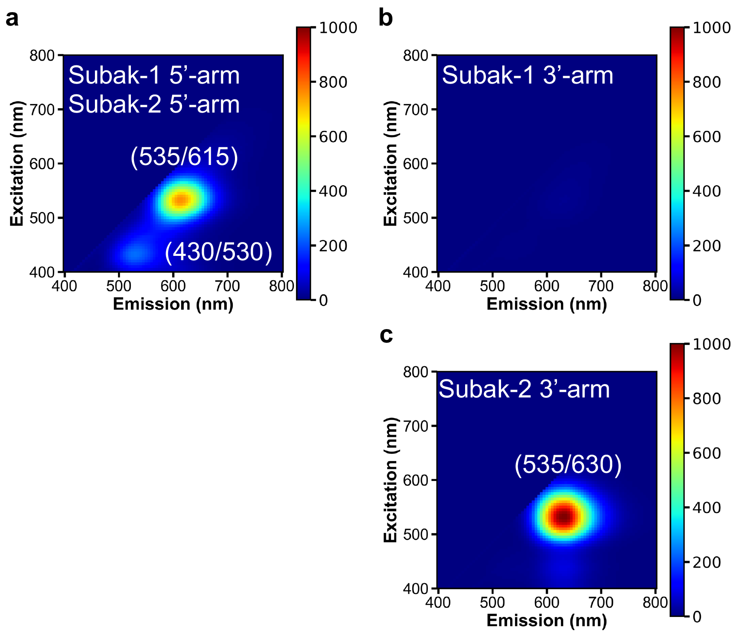

Normalized fluorescence of DNA/AgNCs prepared with 5’-arm (10-nt) and 3’-arm (9-nt) of Subak reporters. a,b, We strategically selected the overhang sequences of Subak-1 that have many cytosines, which have maximum interactions with the AgNCs. c, Subak-2 3’-arm was found after a couple of rounds of mutation tests (Fig. 4). The red fluorescence did not show up strong when prepared with an intact 37-nt long Subak-2 sequence, but it may help to enhance red fluorescence after digestion. Fluorescence intensity was normalized by the peak intensity at Ex535/Em630 in c. (Subak-1 and Subak-2 5’-arm: AAC CAC CCC A; Subak-1 3’arm: GTT CCC CGC; Subak-2 5’-arm: GTT CCC CCC)
Supplementary Figure 5.
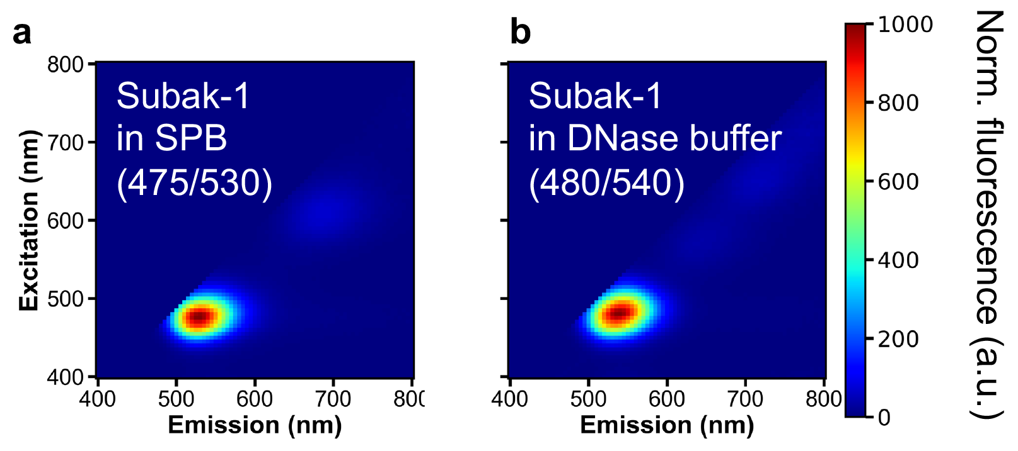
DNase I reaction buffer effect on intact Subak-1 reporters. a. As-synthesized Subak-1 reporters have green emitters (Ex475/Em530) in 20 mM sodium phosphate buffer (SPB, pH 7.4). b. DNase I reaction buffer from New England BioLabs (NEB) slightly induced a 10-nm red shift in emission, but the green emitter (Ex480/Em540) still survives in the solution. 1X DNase I reaction buffer components are 10 mM Tris-HCl, 2.5 mM MgCl₂, 0.5 mM CaCl₂ (pH 7.6).
Supplementary Figure 6.

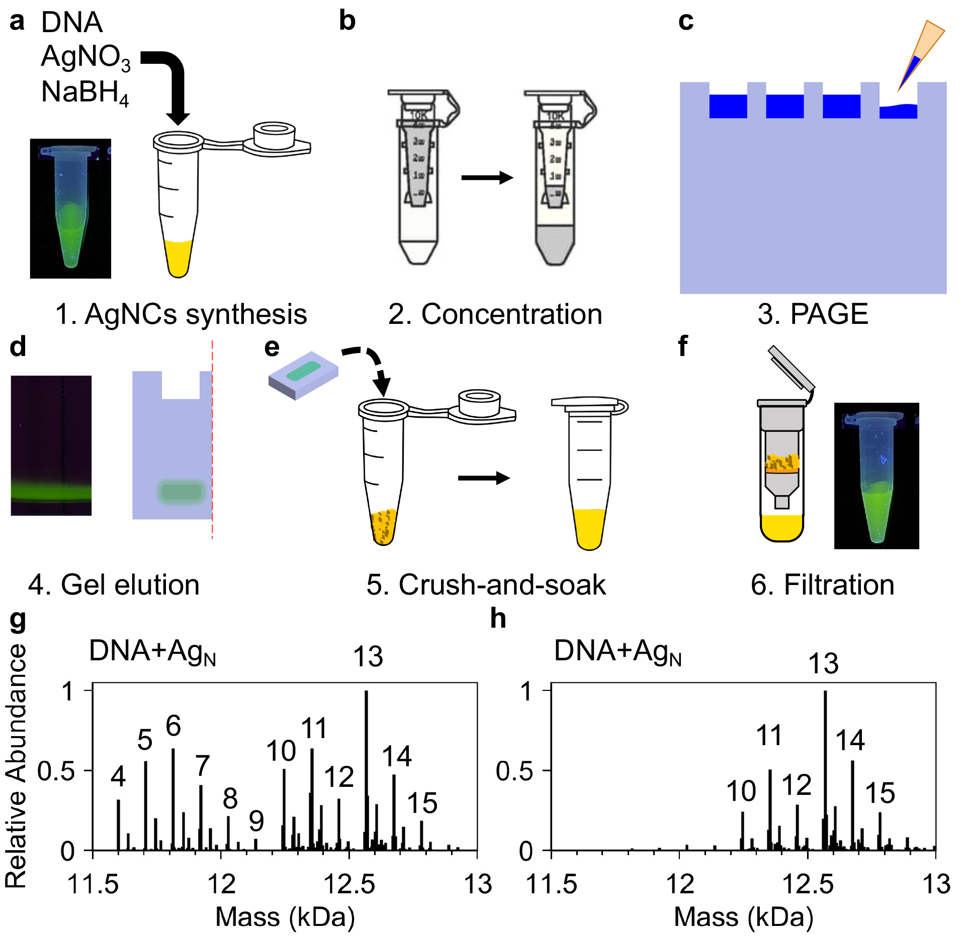
Gel-purification of Subak reporters. While unpurified Subak reporters work well to detect DNase I, we used gel-purification to quantify the DNase I activity more precisely. a, Subak reporters were prepared using the conventional method⁷. As-synthesized reporters include undesired species that can compromise nuclease activity. b,c, The reporters were concentrated and then loaded into a 24% PAGE gel. PAGE gel was run at 140 V for 400 minutes. d, Fluorescent species was easily visualized under a UV transilluminator. e, A fluorescent gel slab was crushed and soaked into 20 mM sodium phosphate buffer (pH 7.4) overnight. f, The solution was then filtered using a column filter and the concentrate was stored at 4 ˚C until future use. g, There are a variety of species before gel-purification, including low-number Ag species (N<9) which are expected to have no fluorescence. h, After purification, we could filter out these low-number Ag species but keep the fluorescent AgNCs (DNA+Ag₁₃₋₁₄).
Supplementary Figure 7.
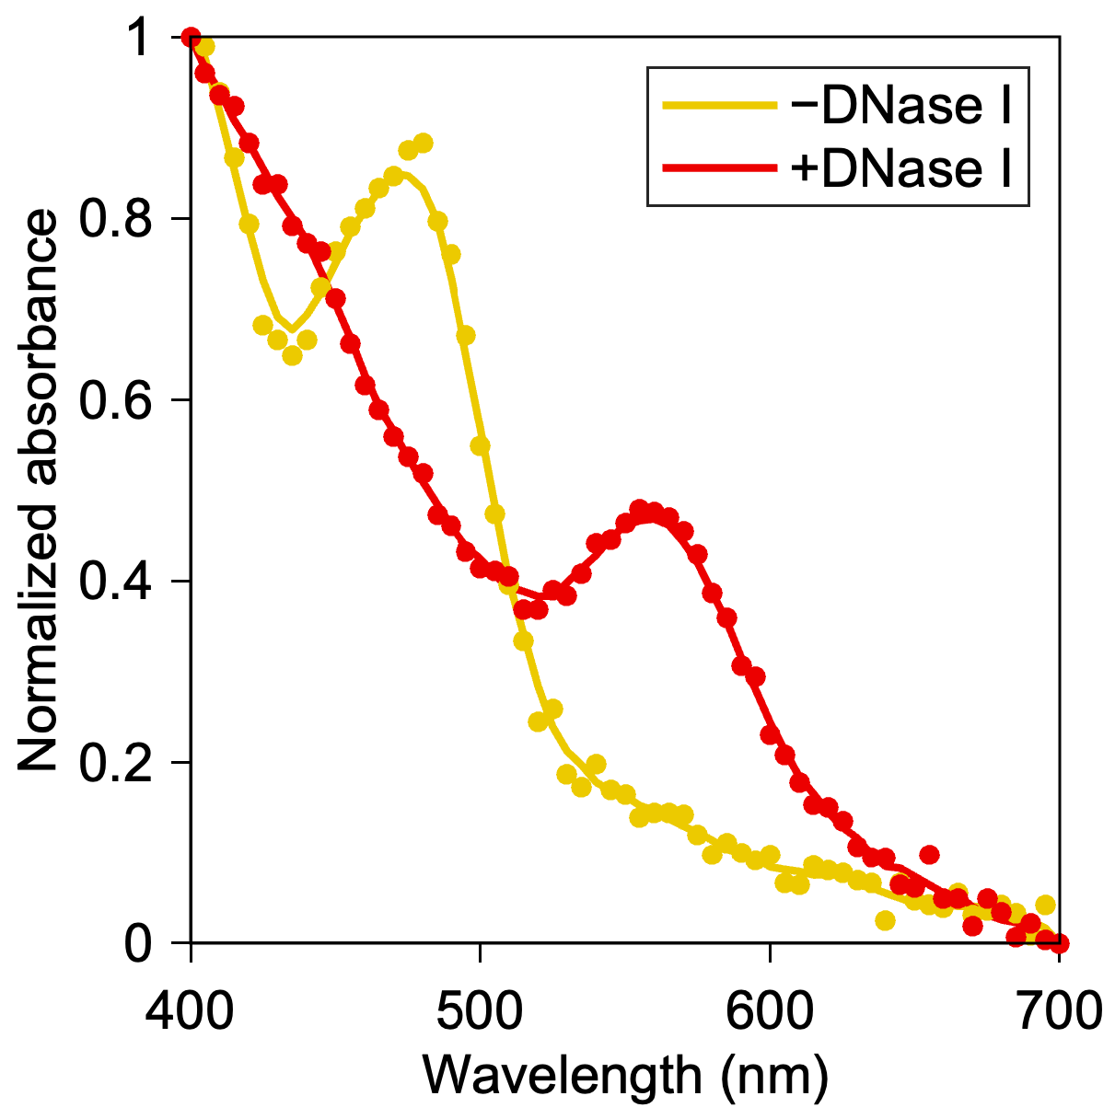
Absorbance measurement of Subak-1. Intact Subak-1 reporters exhibited strong absorption at 480 nm while digested Subak-1 showed the peak absorption at 565 nm. This peak absorption wavelength, 480 nm and 565 nm, corresponds to the peak excitation of green emissive intact Subak-1 (Ex480/Em540) and red emissive digested Subak-1 (Ex565/Em630). The increase at 565 nm was well correlated to the concentration of DNase I (Fig. 2f). Absorbance data was measured using a plate reader (SpectraMax I3, Molecular Devices). For 80 µl of reaction volume, 8 µl of 5 µM Subak-1 was mixed with 8 µl of 10 ng µl⁻¹ DNase I, 8 µl of 10X DNase reaction buffer (NEB), and 56 µl of deionized water. For control samples (-DNase I), 8 µl of deionized water was loaded instead of DNase I. The solution was incubated at 37 ˚C for 20 minutes before measurement. Scatter dots and lines represent the mean value (n=3 replicates) and smoothed data processed by MATLAB (R2023a), respectively.
Supplementary Figure 8.

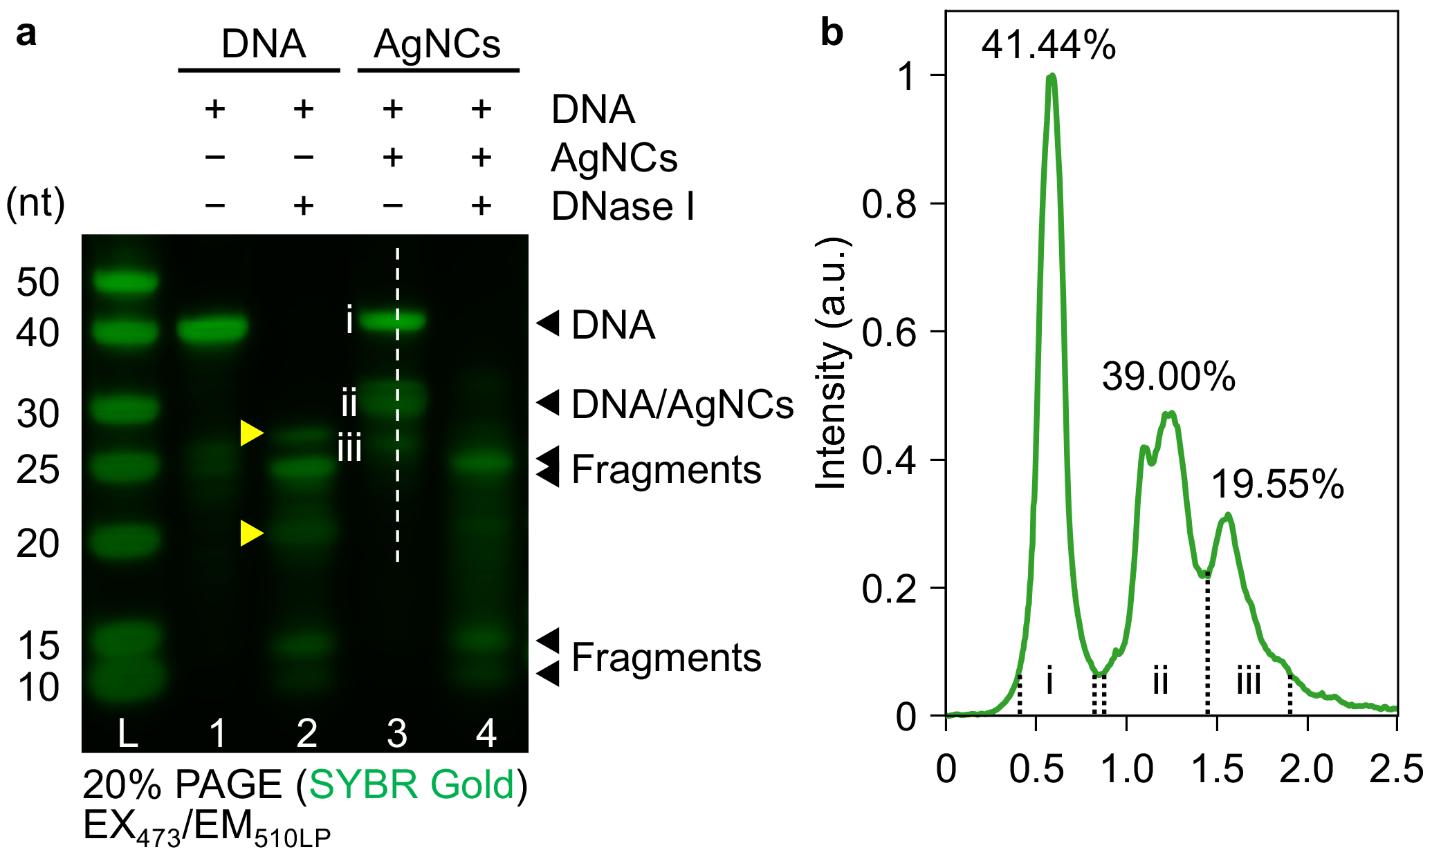
20% PAGE results of Subak-1 reporters stained by SYBR Gold. a, Lane 1 and 2 contain DNA-only samples; Lane 3 and 4 contain DNA/AgNCs. IDT oligo standard (10/60) was used as a ladder. Control samples (Lane 1 and 3) contain 25 µM DNA whereas DNase-positive samples contain 100 µM DNA that was mixed with 0.5 µg/µl DNase I and incubated at 37 ˚C for 20 minutes before loading. The gel was run at 160V for 130 minutes. While two more distinct bands were observed (yellow arrows in Lane 2) when DNase I cleaved bare DNAs, these bands disappeared when DNA/AgNCs were cleaved because AgNCs could protect a part of template DNA from being cleaved. b, Using ImageJ, we could roughly estimate the relative abundance of each band shown in Lane 3 (a) by integrating the area under the curve (AUC). Based on the true color gel image (Fig. 2b), we could find that the second band (ii) is fluorescent DNA/AgNCs (which did not appear in the DNA-only sample, Lane 1). The intensity profile suggests that ~40% of entire species can be green-emitting Subak-1 reporters, and they could be purified by gel electrophoresis (Supplementary Figure 6).
Supplementary Figure 9.
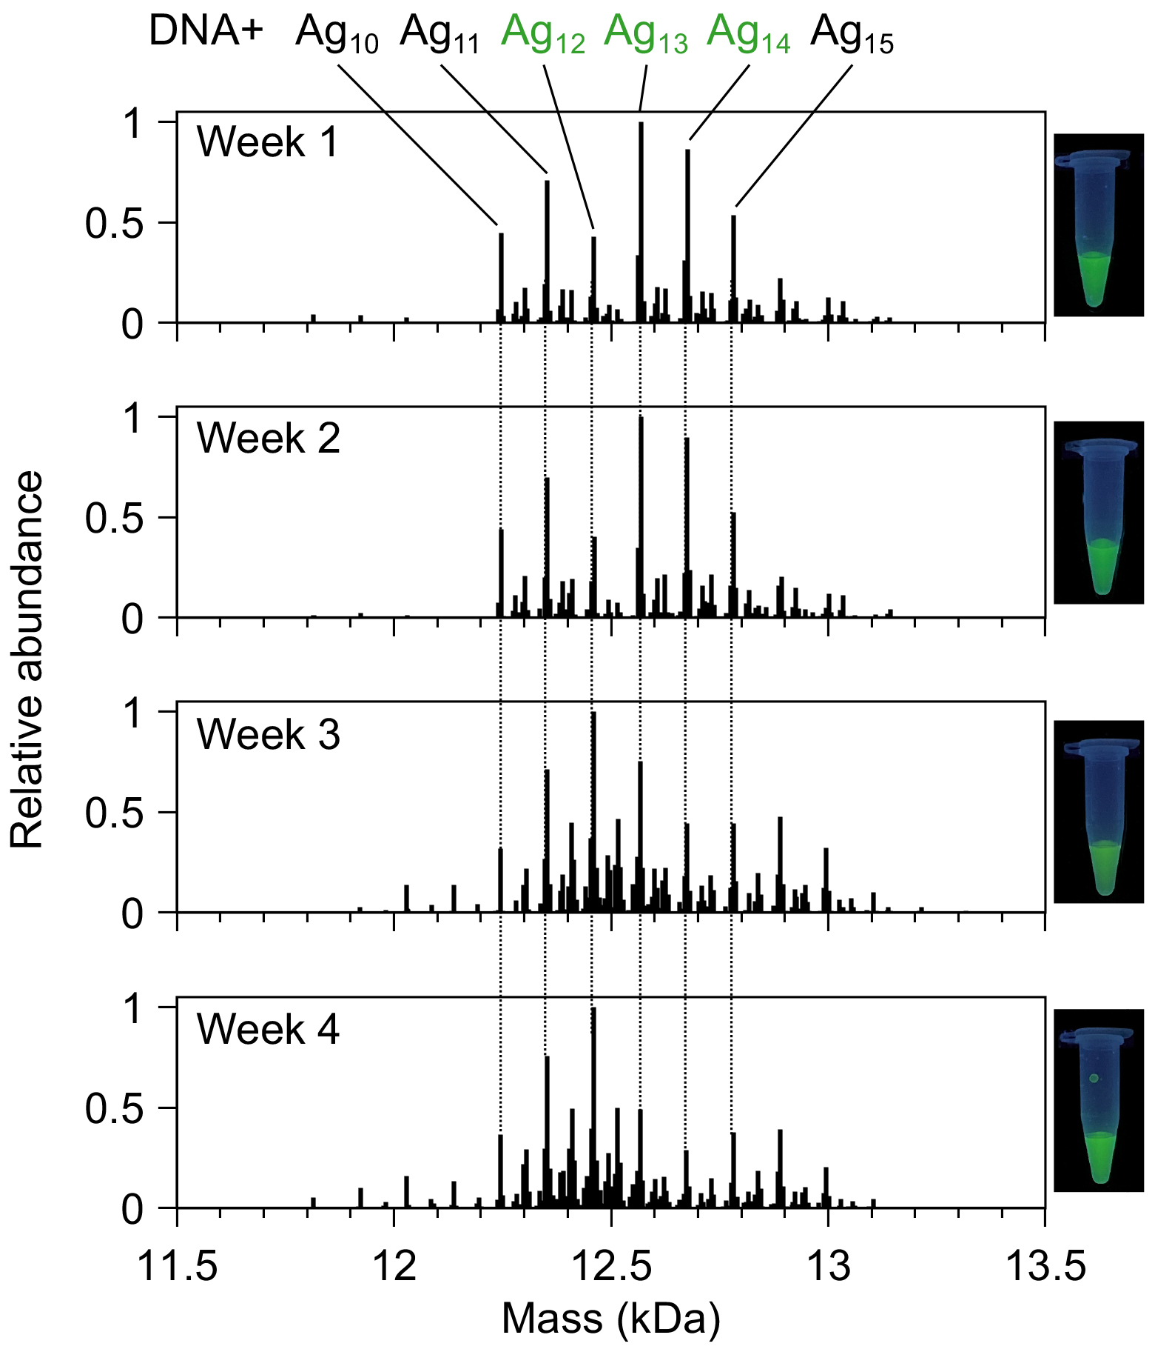
ESI-MS results of intact Subak-1 reporters over time. Subak-1 reporters are stable and keep the same green fluorescence when stored at 4 °C after 4 weeks. The dominant species, Ag₁₃₋₁₄, from 1-week aged Subak-1 changed to Ag₁₁₋₁₂ after 3 weeks, suggesting that there might be some weakly associated Ag atoms that have nothing to do with green fluorescence.
Supplementary Figure 10.
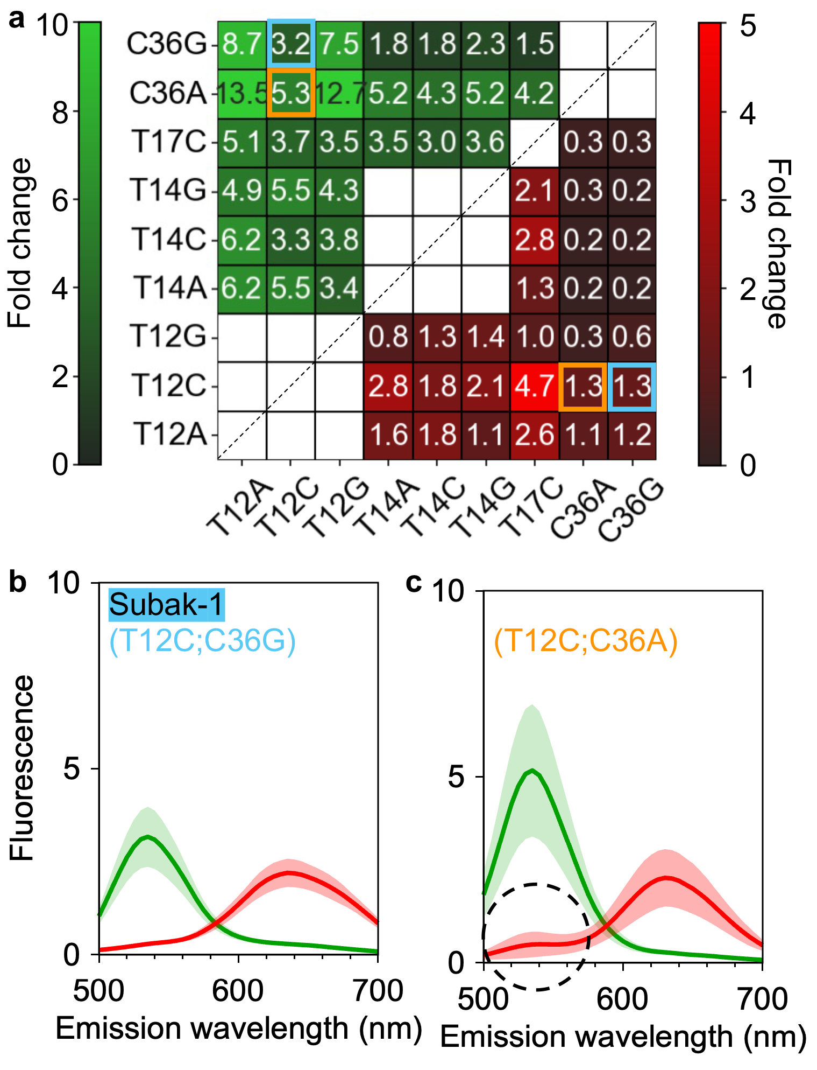
Subak-1 vs. T12C36A variant. Whereas T12C/C36A showed a higher increase in the green channel (5.3- vs. 3.2-fold) with the same enhancement in the red channel (1.3-fold), T12C/C36A had residual green fluorescence after fragmentation, which leads to the low ratio (I630/I540) for ratiometric assay. The shade represents mean±s.d. (n=3 replicates).
Supplementary Figure 11.
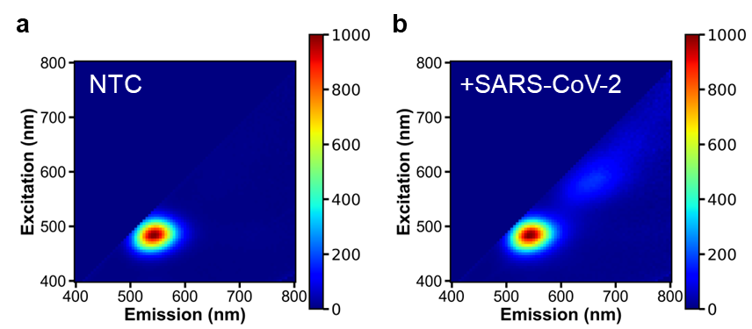
Subak-1 with CRISPR-Cas12a. Subak-1 works well with DNase I, but it does not respond strongly to the activated Cas12a. 500 nM Subak-1 reporters were mixed with 100 nM Cas12a, 120 nM gRNA without (non-target control, NTC, a) and with 1 nM double-stranded SARS-CoV-2 cDNA (b). The digested Subak-1 exhibited a low red fluorescence. Both were incubated in 1X NEB rCutSmart buffer (50 mM potassium acetate, 20 mM trice-acetate, 10 mM magnesium acetate, 100 μg ml⁻¹ BSA, pH 7.9) at 37 °C for 60 minutes.
Supplementary Figure 12.
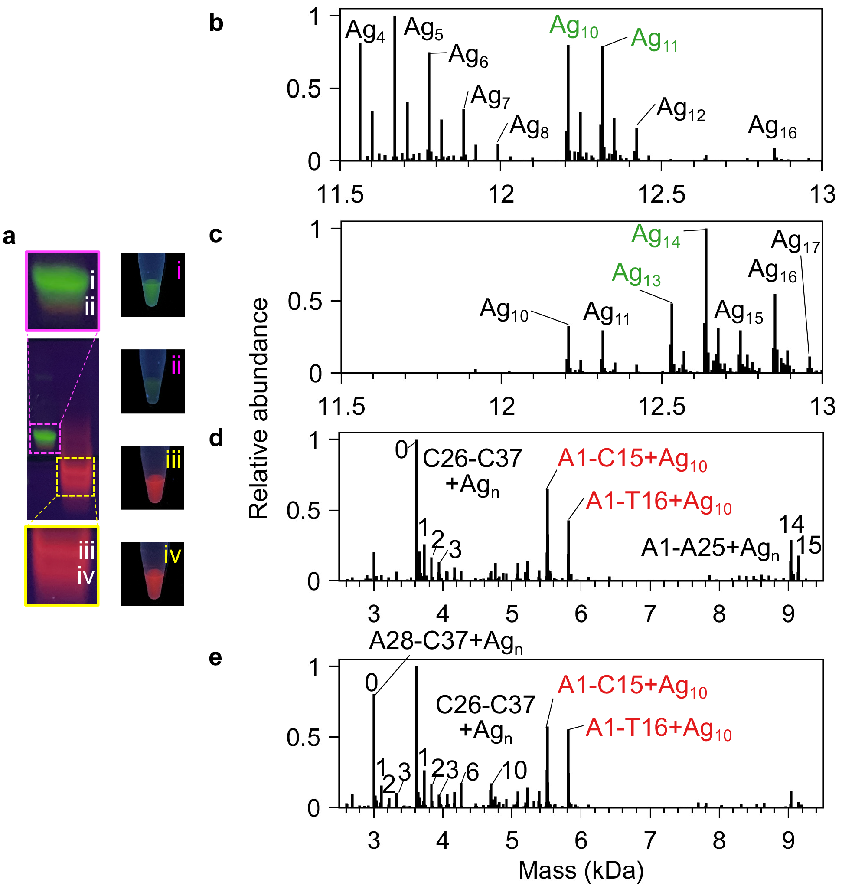
ESI-MS results of gel-purified Subak-2 reporters before and after DNase I digestion. a, Gel-purified Subak-2 reporters. Unlike Subak-1 (Fig. 3), intact Subak-2 had two distinct bands: (i) a strong green-emitting species and (ii) a dim low-emissive species. Digested Subak-2 also had two red-emissive bands (iii, iv). The right photos showed the corresponding gel-purified samples in a tube from each band (i-iv). b-e, Deconvoluted MS1 spectrum of gel-purified Subak-2 (b: i; c: ii; d: iii; e: iv). b,c, Before digestion, a clear difference in the number of Ag atoms could be observed between i and ii. The green-emissive Ag₁₃₋₁₄ was converted into the red-emissive Ag₁₀ (d,e), whereas the Ag₁₀₋₁₁ was changed to the dark species (Fig. 5).
Supplementary Figure 13.
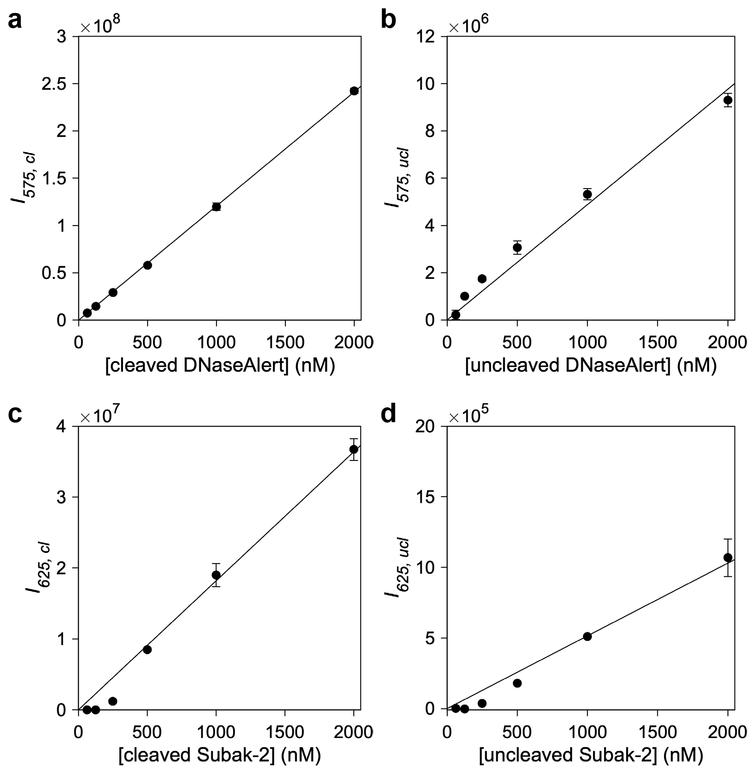
Fluorescence versus cleaved reporter concentration calibration. a,b, Fluorescence of fully cleaved (a) and uncleaved (b) DNaseAlert. c,d, Fluorescence of fully cleaved (c) and uncleaved (d) of Subak-2. For fully cleaved reporters, 100 nM Cas12a (with 120 nM gRNA) activated by 10 nM dsDNA target (SARS-CoV-2 cDNA, Supplementary Table 2) was mixed with reporters in different concentrations from 62.5 nM to 2000 nM. For Uncleaved reporters, 10 nM dsDNA target was replaced with a deionized water. The reaction was performed at 37 °C for >2 hours. We used a linear fit to the data from DNaseAlert (a,b), and obtained $F_{alert, cl}=120660c_{alert,cl}$ and $F_{alert,ucl}=4880c_{alert,ucl}$. With the same method, we also obtained $F_{Subak, cl}=18199c_{Subak,cl}$ and $F_{Subak,ucl}=515c_{Subak,ucl}$ for Subak-2 reporters. Data represent mean±s.d. (n=3 replicates).
Supplementary Figure 14.
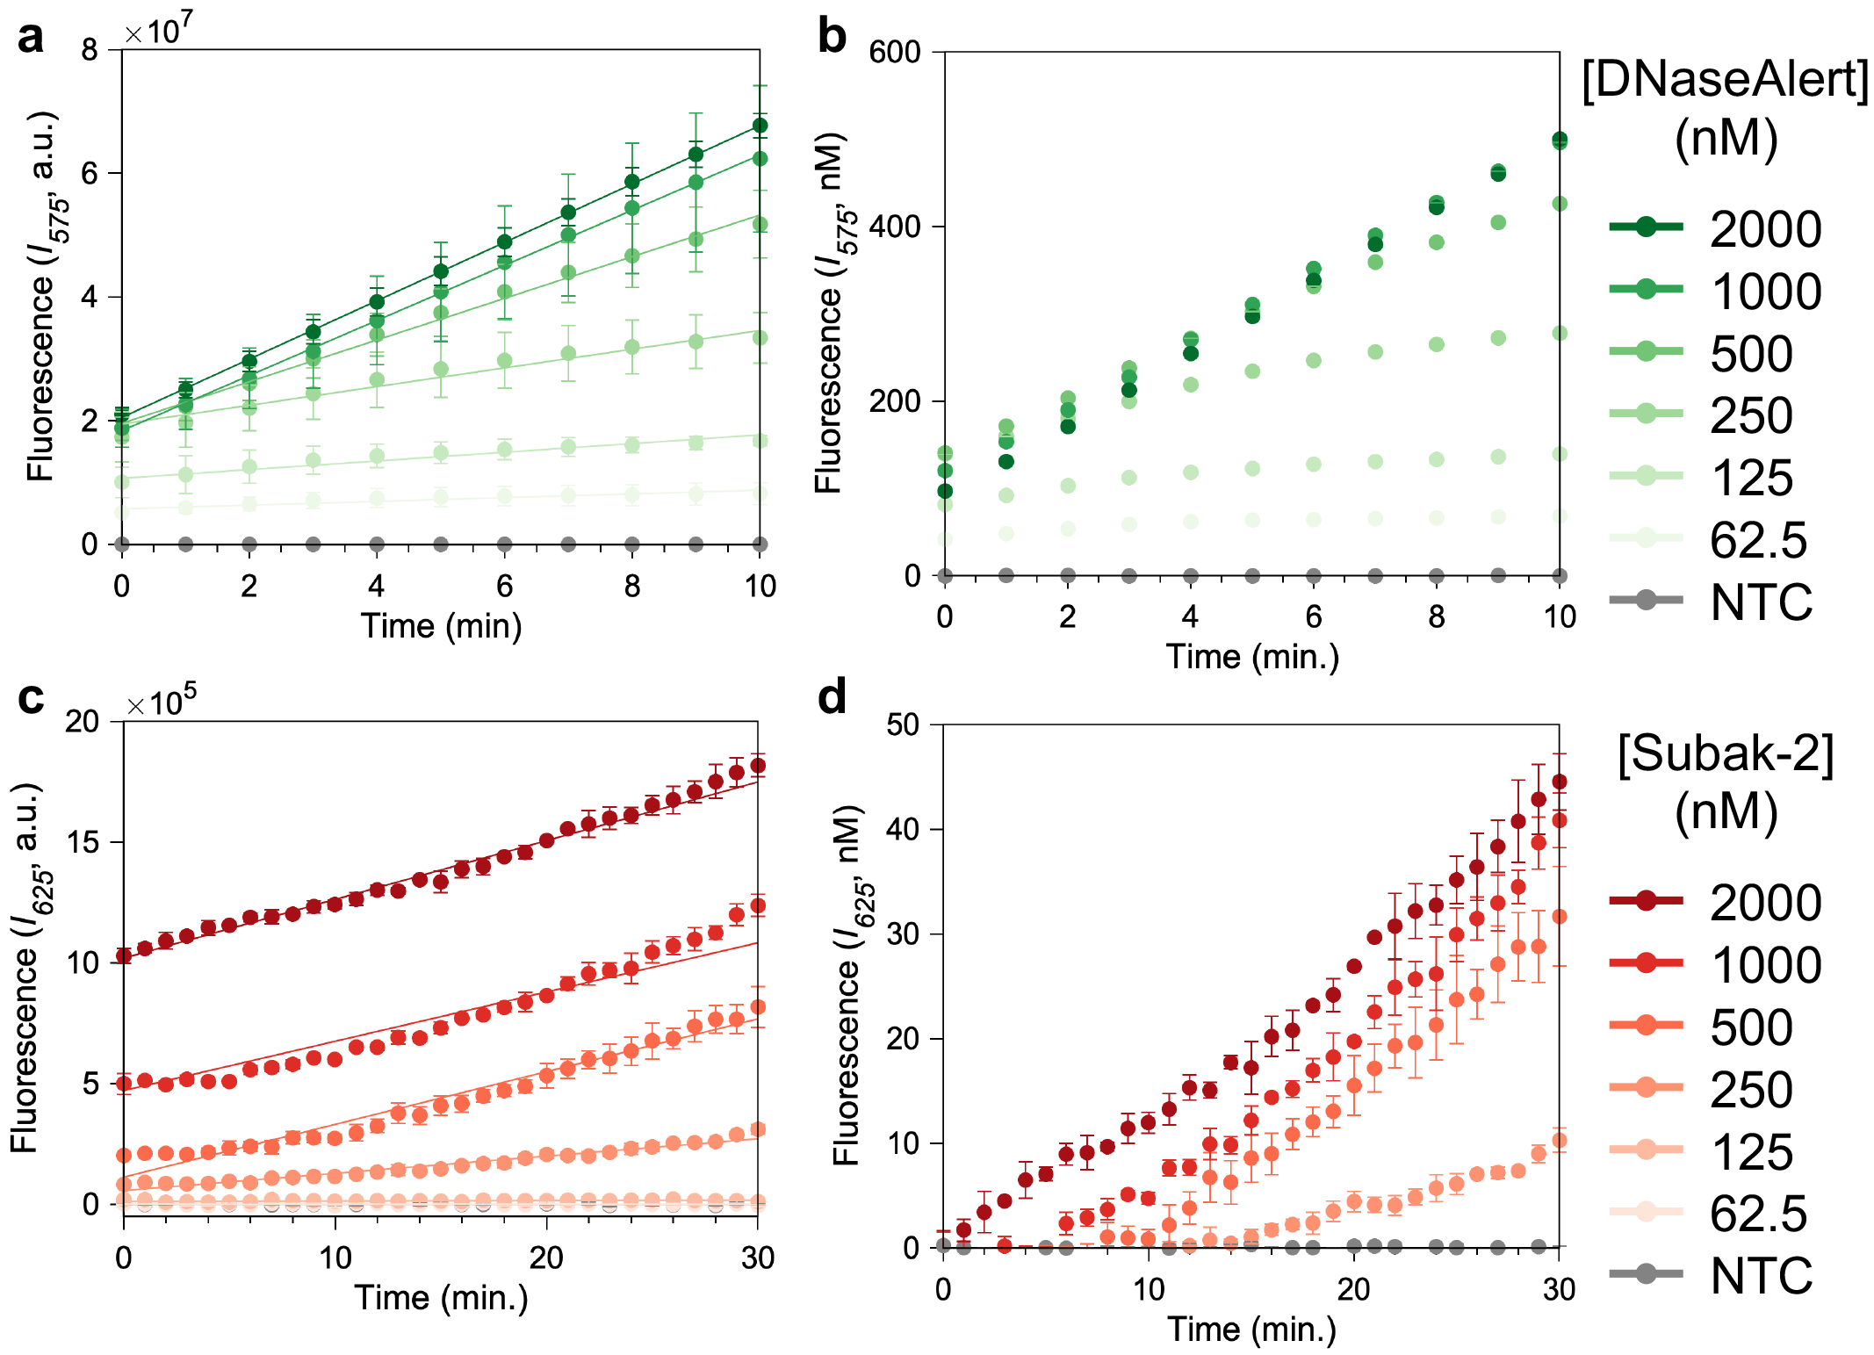
Raw fluorescence data to cleaved reporter concentration versus time. a,b, DNaseAlert. c,d, Subak-2 reporters. From Supplementary Figure 13 and Supplementary Equation 2, the raw fluorescence data were converted to cleaved reporter concentration in nM. Given $ν_{c0}=dc/dt$ where $ν_{c0}$ is the reaction velocity of reporters at the initial concentration, $c_{0}$. Therefore, the slope of each line in c,d represents the reaction velocity in nM min⁻¹.
Supplementary Figure 15.

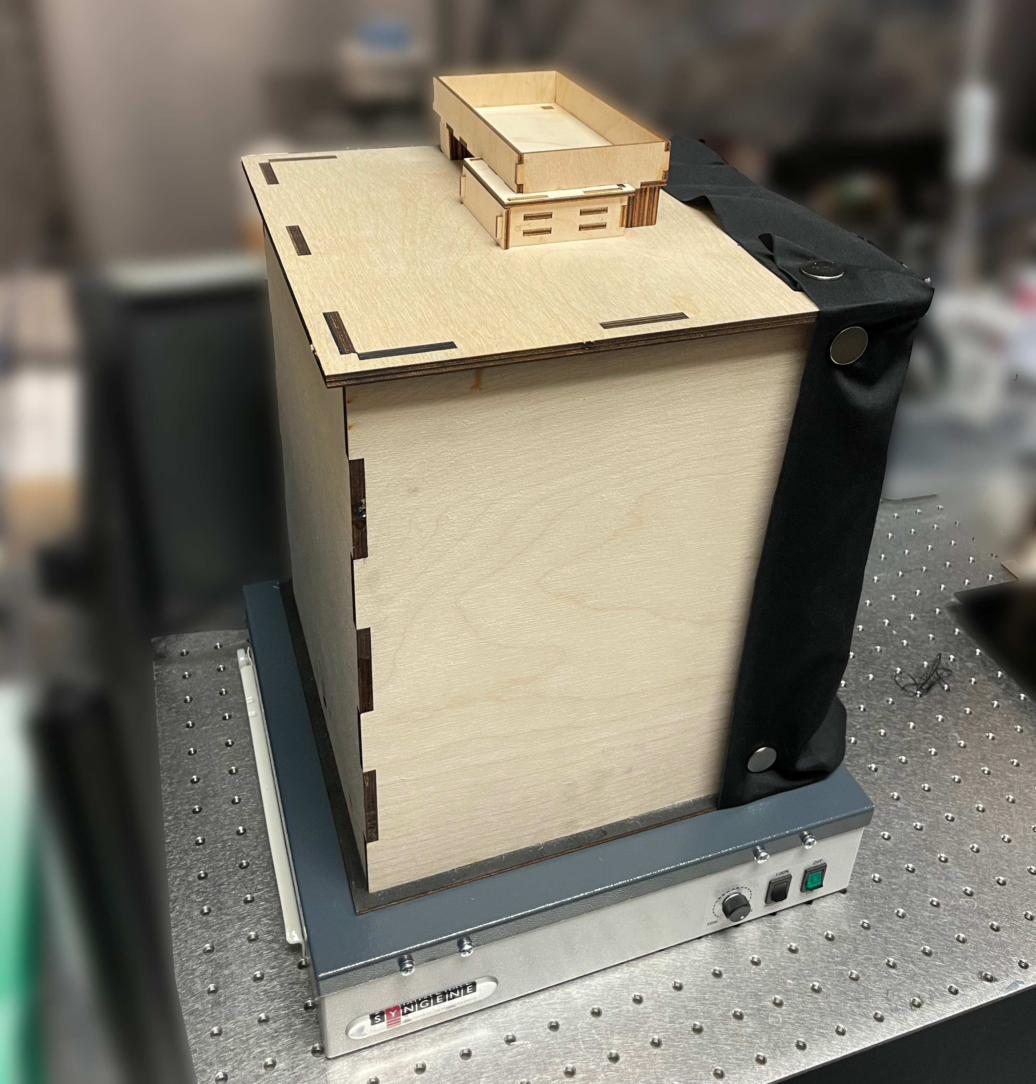
A custom-built imaging system for a true color UV image. It was made for Apple iPhone 12 Pro for consistent image quality using a laser cutter (Full Spectrum). Photos were taken using Adobe Lightroom with the following settings: ISO 500, 1/40 s for shutter speed, f/1.6 for aperture.
Supplementary Figure 16.
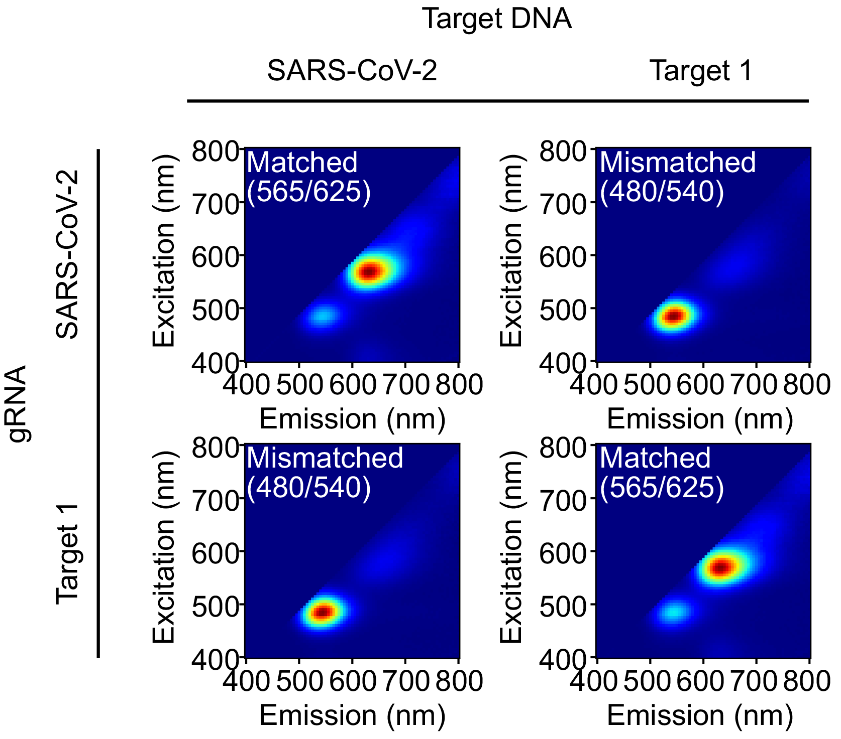
Cas12a-associated Subak-2 fluorescence changes with different pairs of targets/gRNAs. We validated the specificity of Cas12a assay using Subak-2 reporters. When the target is matched with the gRNA, Subak-2 reporters offered the green-to-red fluorescence conversion.
Supplementary Video 1 and 2.

Supplementary Video 1. Fluorescence changes of gel-purified Subak-1 under UV excitation.
Supplementary Video 2. Fluorescence changes of gel-purified Subak-2 (ii in Fig. 5) under UV excitation.

200 μl of positive solution (+DNase I) consisted of 20 μM Subak reporter, 200 pg μl-1 DNase I, 1X DNase reaction buffer. DNase I was substituted with nuclease-free water in the negative solution (-DNase I).
References
1. Broughton, J. P. et al. CRISPR–Cas12-based detection of SARS-CoV-2. Nature biotechnology 2020, 38(7): 870-874.
2. Chen, J. S. et al. CRISPR-Cas12a target binding unleashes indiscriminate single-stranded DNase activity. Science 2018, 360(6387): 436-439.
3. Ramachandran, A., Santiago, J. G. CRISPR enzyme kinetics for molecular diagnostics. Analytical Chemistry 2021, 93(20): 7456-7464.
4. Broto, M. et al. Nanozyme-catalysed CRISPR assay for preamplification-free detection of non-coding RNAs. Nat Nanotechnol 2022, 17(10): 1120-1126.
5. Gottschalk, P. G., Dunn, J. R. The five-parameter logistic: a characterization and comparison with the four-parameter logistic. Analytical biochemistry 2005, 343(1): 54-65.
6. Kuo, Y. A. et al. Massively Parallel Selection of NanoCluster Beacons. Advanced Materials 2022, 34(41): 2204957.
7. Chen, Y.-A. et al. NanoCluster beacons enable detection of a single N 6-methyladenine. Journal of the American Chemical Society 2015, 137(33): 10476-10479.

Source data 1-4

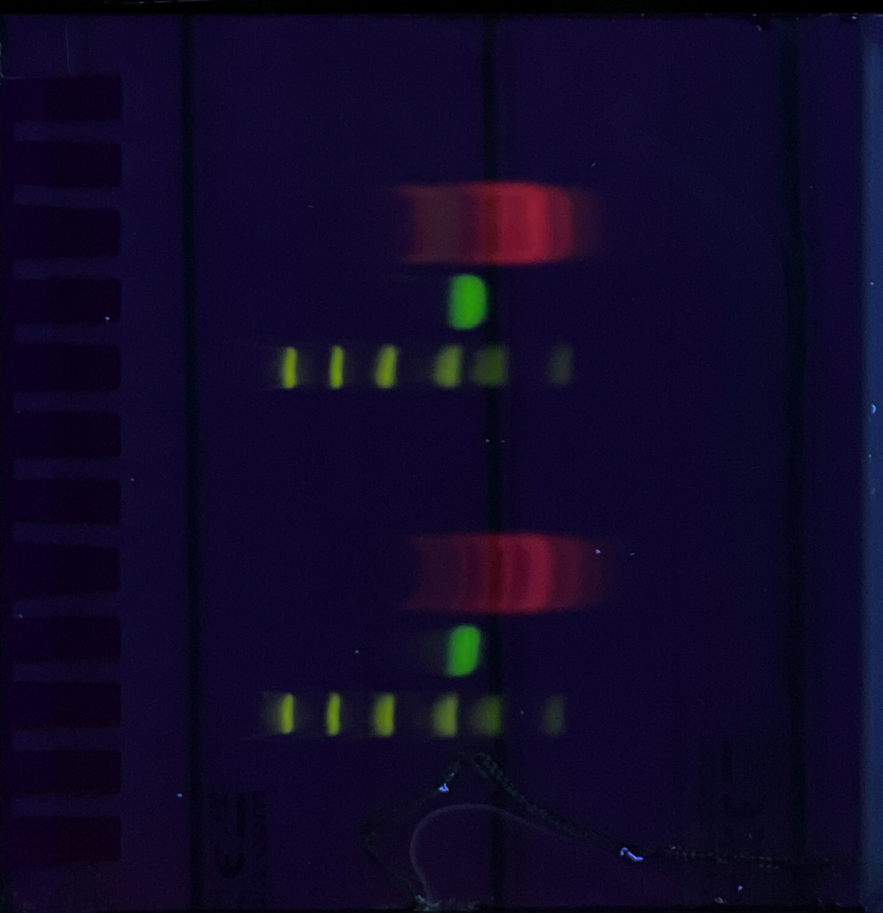

Source Data 1. Gel image for Fig. 2b and Fig. 3a.

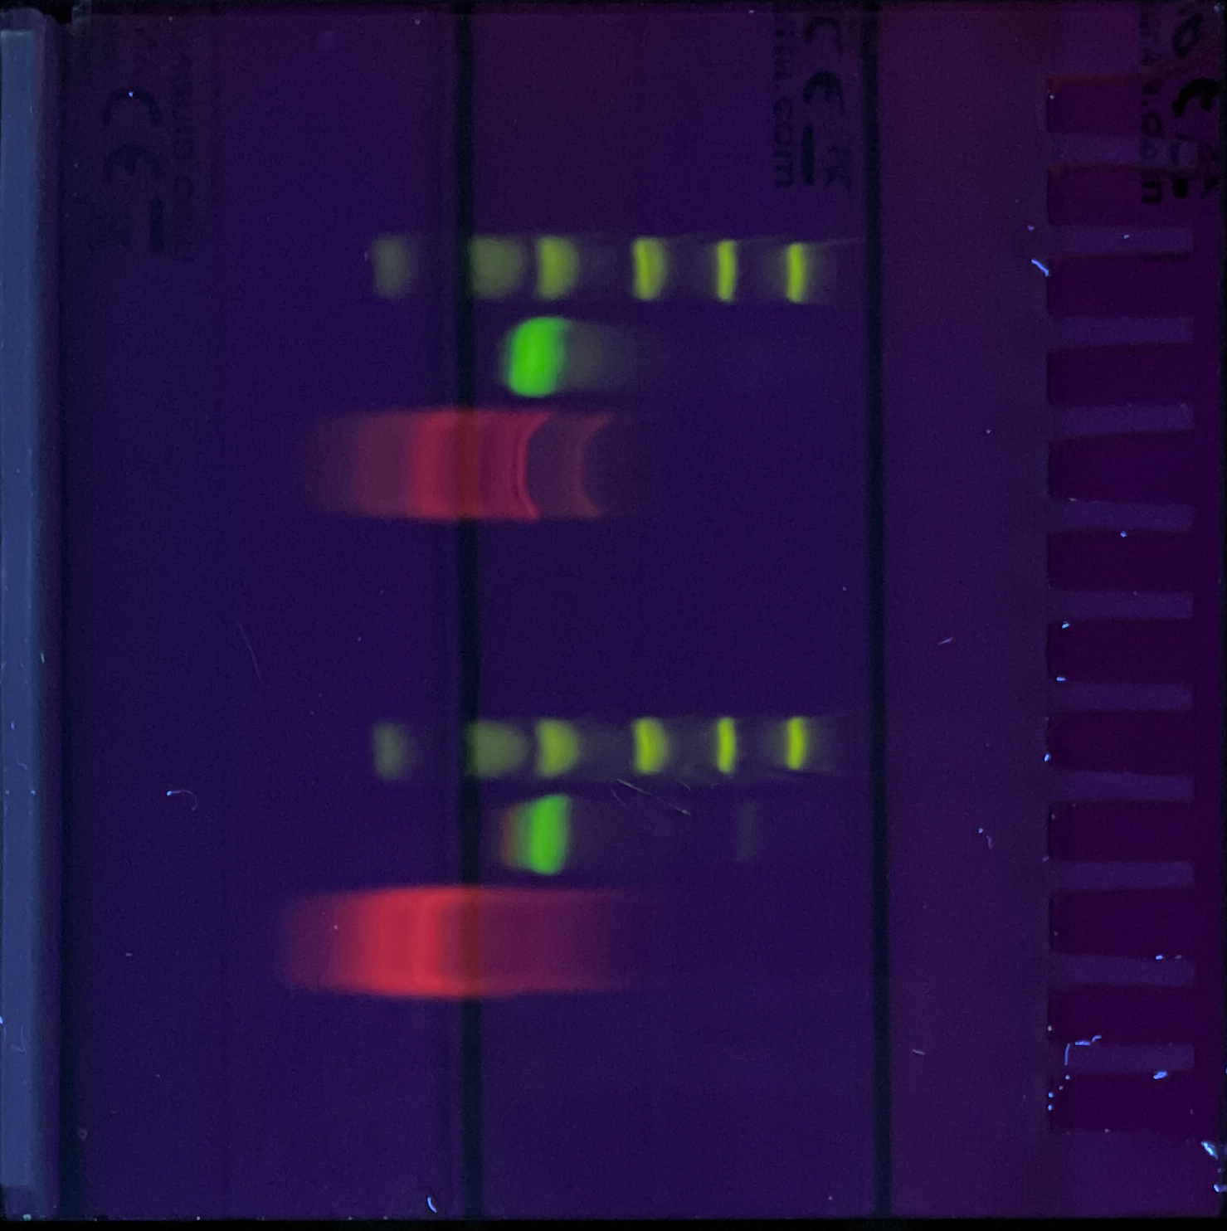

Source Data 2. Gel data for Fig. 5a,c and Supplementary Figure 12a.

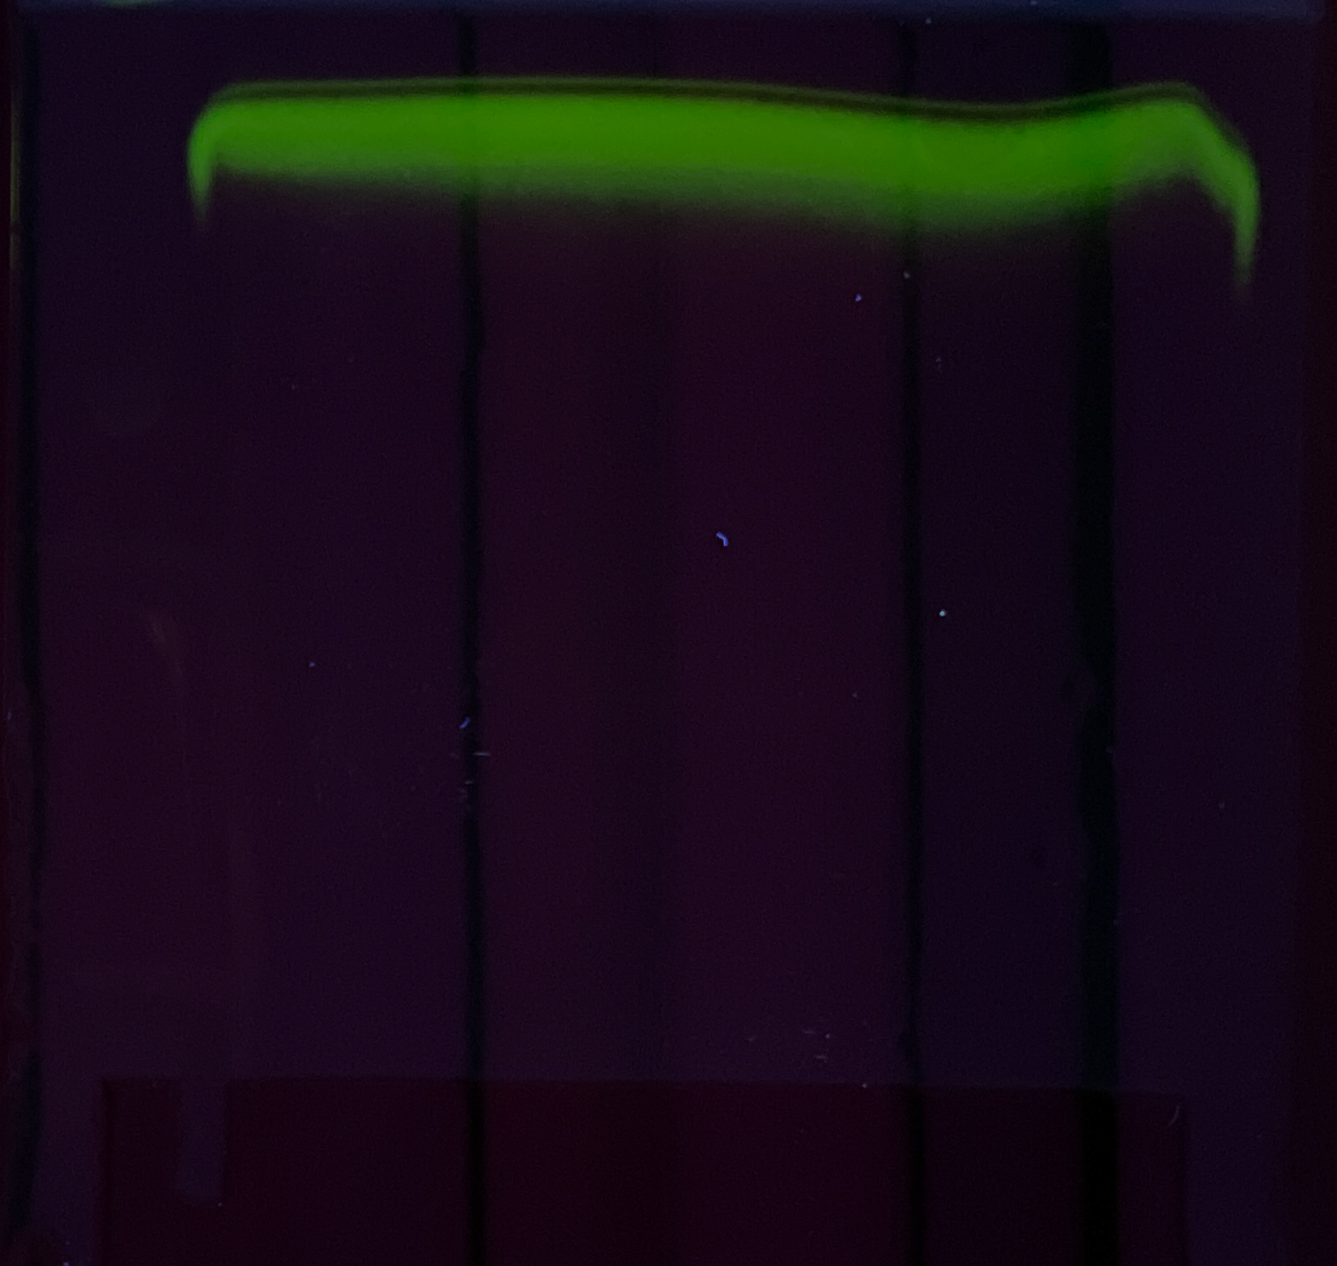

Source Data 3. Gel data for Supplementary Figure 6d.

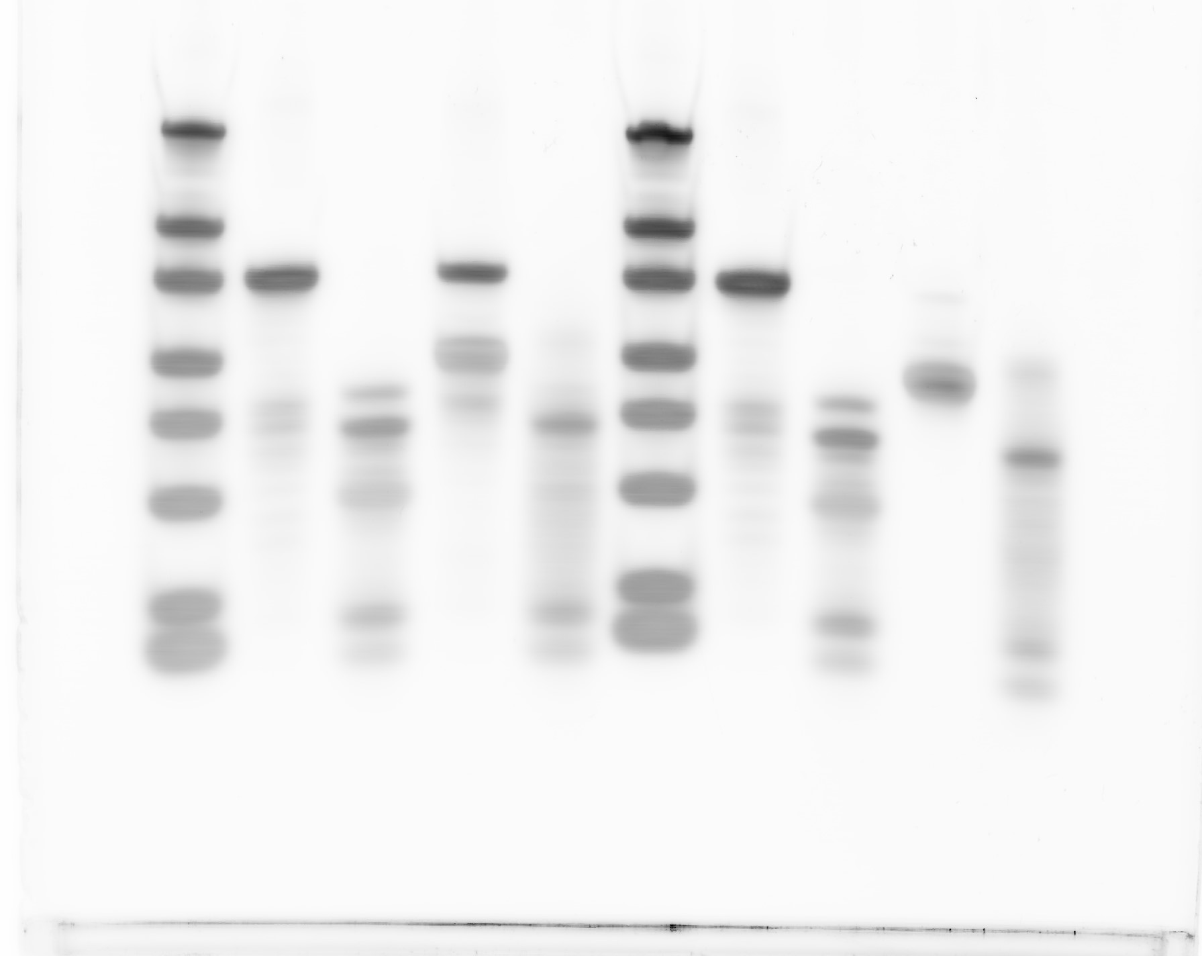

Source Data 4. Gel data for Supplementary Figure 8a.

