Supplement Figures
Figure. S1 The screening diagram of this study. Abbreviations: ALC, absolute lymphocyte count; dCCRT, definitive concurrent chemoradiotherapy.
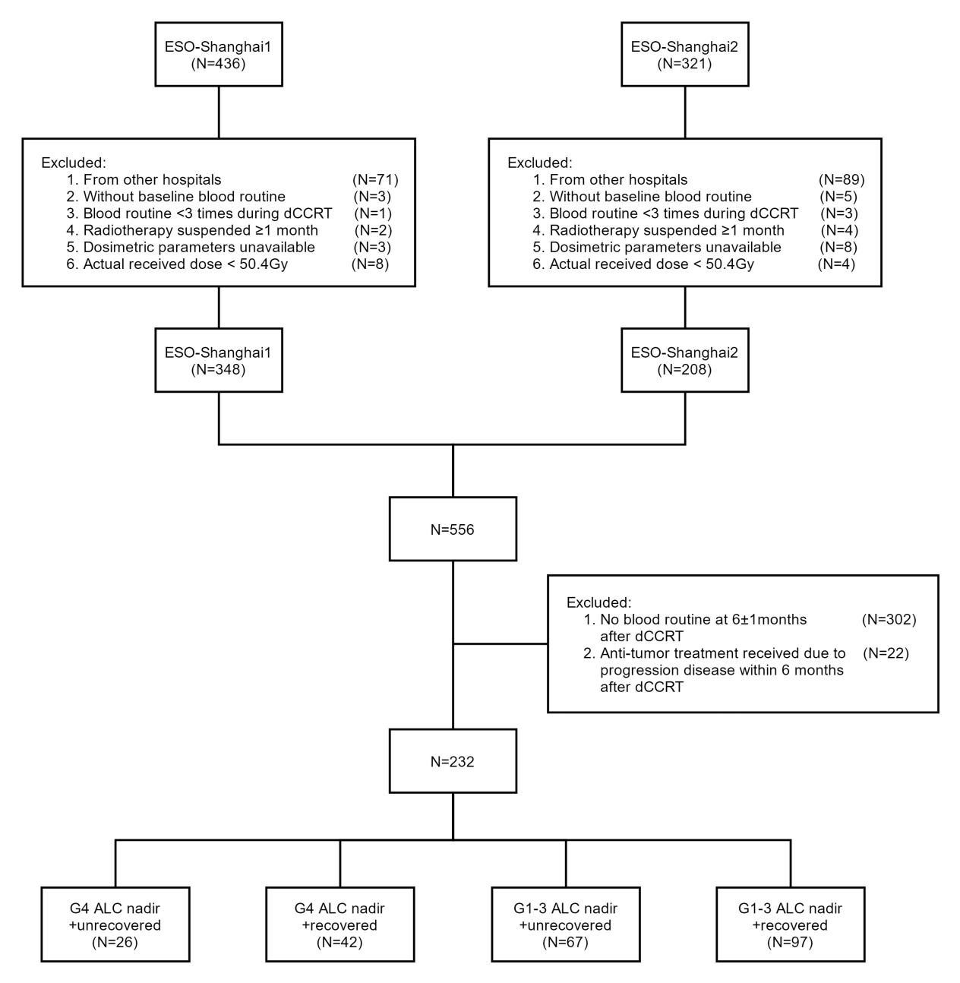
Figure S2. Maxstat analysis of lymphocyte recovery index (LRI) based on overall survival.

