Table 1: Demographic data of hypertensive patients
Table 2 Hope your friend got better. Cost of drugs per month of hypertensive patients at RHB
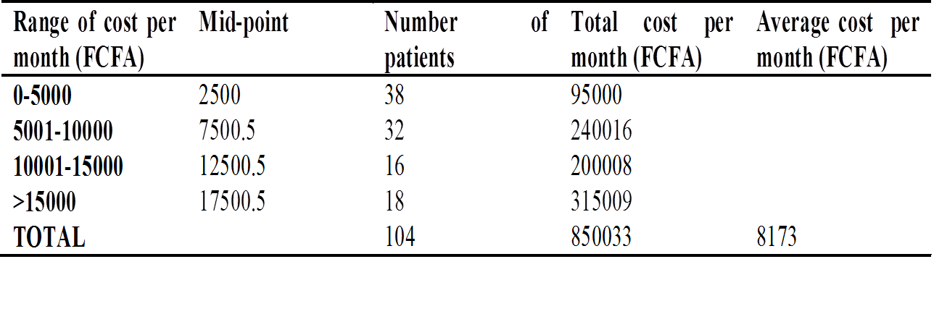

Table 3: Cost of hospitalization at RHB
Table 4 Cost of routine laboratory tests and medical consultations at the start of treatment per patient at RHB
Table 5: Transportation cost incurred by hypertensive patients visiting the RHB for treatment

Table 6: Total medical cost for treating hypertension in a study using orthodox medicine at the RHB

Table 7: Cost of managing hypertension for six months using traditional medicine in Belo by tradipractitioners
Table 8: Factors that influence anti-hypertensive drug adherence

