SUPPLEMENTARY MATERIAL – RESULTS
Study population (Table S1)
Median age at inclusion was 41years (average = 43.48). The sex ratio for the study population was 4 males to 3 females. About two thirds of psoriasis patients (68.8%) were obese (BMI ≥ 25 kg/m2), thereof six (37.5%) were adipose (BMI ≥ 30 kg/m2). One control had a BMI >30. One psoriasis patient was of african origin, the others were caucasian. Family history of psoriasis was reported in five psoriasis cases (31.25%). Seven out of sixteen (43.75%) had an over a decade long history of disease. Average Psoriasis Area and Severity Index (PASI) score, affected body surface area (BSA) and static Physician Global Assessment (sPGA) were 16.12, 16.67% and 3.3 in study subjects with no therapy, respectively. Mean Dermatology Life Quality Index (DLQI) value in this subgroup was 19.8, representing high disease burden in daily life. Collection of samples within IXE and ADA treated patients was performed within 12 weeks after treatment initiation to focus on early changes of the immune cell repertoire under therapy, (Figure 1). The PASI score before treatment initiation was comparable in both treatment groups (14.7 vs. 15.4 in the IXE vs. ADA group). Average PASI at inclusion in the IXE group was 4.74, BSA was 7%, and sPGA was 1.6. Among the ADA treated subjects the average PASI, BSA and sPGA at inclusion were 4.16, 5.2% and 1.2, respectively. Average DLQI under treatment was 3.5. One third of the included psoriatic patients (31.25%) had a record of psoriatic arthritis. Histopathologic psoriasis severity score (HPSS) (Figure S1) was high in untreated psoriatic skin (mean of 22), medium in the induction phase of IXE or ADA treatment (mean of 14) and low in non-lesional skin (mean of 0.3). In non-lesional skin low scores were detected in all subpopulations. Interestingly, a consistently negative HPSS was present in non-lesional untreated psoriatic skin. Biopsies of healthy controls showed negative to very low scores (HPSS < 2 points). According to their respective baseline PASI all participants under treatment achieved at least a 75% reduction in PASI values within 6 months after treatment initiation, 7 out of 10 had a PASI90 reduction, and three subjects were symptom-free.

SUPPLEMENTARY MATERIAL – METHODS
Recruitment of subjects
Subjects without treatment at timepoint of inclusion had not received any topical therapy during the last 2 weeks, systemic, non-biologic therapy or phototherapy during the last 4 weeks and/or biologic therapy during the last 3 months before inclusion. In addition to psoriatic patients without treatment, individuals on monotherapy with IXE, a humanized IgG4 monoclonal anti-IL-17A antibody, or on monotherapy with the recombinant human IgG1 monoclonal anti-TNFα antibody ADA, were eligible. Subjects on either biological agent were included in the early phase of therapy (< 12 weeks of treatment duration) and did not receive concomitant topical or alternative systemic psoriatic treatment. Exclusion criteria were vaccination within the last 3 months, major surgery within the last 4 months, active concurrent systemic infection requiring systemic antibiotic treatment within the last month, pregnancy, and/or the inability to give written informed consent.
Sample Collection
Twenty-four milliliters (mm) of blood were drawn from a peripheral arm vein in three heparin blood collection tubes (3x8ml) and transported to the laboratory of the Institute of Immunology. There, peripheral blood mononuclear cells (PBMCs) were isolated on the same day from heparinized buffy coats via standard density gradient centrifugation using Ficoll-PaqueTM Plus (GE Healthcare, Chalfont St. Giles, UK). T-cells and monocytes were purified from PBMCs using the MACS system (Miltenyi Biotec, Bergisch Gladbach, Germany) and stored in a liquid nitrogen container until further processing. Six mm punch biopsies from lesional and non-lesinal skin were obtained from each patient. Non-lesional skin was defined as non-involved, healthy looking skin taken from the same body area as the lesional biopsy with at least 5cm distance to the next psoriatic plaque. In participants under IXE or ADA resolving plaques were biopsied within the first twelve weeks of therapy (Figure S5). Each pair of biopsies was excised from the same body area and at the same time. For reasons of comparability, eligible body areas were defined as upper extremities, lower extremities and trunk. Healthy controls supplied one six mm punch biopsy. Each punch biopsy was split in two 3 mm specimens. One half was fixed in 4% formaldehyde solution, then embedded in paraffin and stored at room temperature until further processing. The other half was embedded in optimum cutting tissue compound (Tissue-Tek, Sakura Finetek Europe B.V.), snap-frozen in liquid nitrogen, and stored at – 80°C until further processing.
Histology, immunohistochemistry (IHC) and immunofluorescence (IF)
From each paraffin block five slides with 3 serial 4 µm sections per slide were prepared.
Histology & Histopathologic psoriasis severity score (HPSS). Two slides were stained with hematoxylin and eosin (HE) and analyzed by light microscopy using the HPSS to quantify morphologic changes (Figure S6). Criteria used to calculate the HPSS were chosen on the basis of well-established histopathological criteria for the diagnosis of plaque-type psoriasis (Ackerman, 2005). Specifically, changes affecting the epidermis, involvement of the blood vascular component and the amount and distribution of the inflammatory cell infiltrate are assessed. The individual changes for each main category (epidermal, vascular, inflammatory cells) are graded according to severity into 0 (absent), 1 (mild), 2 (moderate), 3 (severe), and added to obtain a total HPSS. The HPSS can range from 0 to 36, while each subcategory can yield a score between 0 and 12. Histopathological analysis was performed independently by a dermatopathologist in a blinded fashion.
Immunohistochemical staining strategy. The 4 µm sections used for immunohistochemistry were deparaffinized in xylene and rehydrated. Epitope retrieval was performed in antibody specific buffers (Agilent Dako Target Retrieval Solution, pH9). Staining was performed on an automated staining instrument (Agilent Dako Autostainer Link 48) using a labeled streptavidin–biotin method visualized by AEC as chromogen (Agilent Dako REAL Detection System, Peroxidase/AEC, Rabbit/Mouse, #K5003) with the CD68 antibody (Agilent Dako, Monoclonal Mouse Anti-Human CD68 Clone KP1; Table S3). All slides were counterstained with hematoxylin (Agilent Dako REAL Hematoxylin, #S2020). Slides were scanned with an Aperio Digital Pathology Scanner (Aperio CS2). Random fields of 1 mm length epidermis or one square millimeter of upper dermis covering representative proportions of the biopsy were selected, and positive cells were manually counted at a 20x magnification by two independent observers blinded to the condition.
Immunofluorescence staining strategy. Frozen sections for immunofluorescence were mounted on microscope slides (Star Frost, Germany, one slide per sample with 1 - 2 serial sections per slide). After 20 minutes of air-drying, 5 - 7 μm cryostat sections were fixed in ice-cold acetone (Sigma-Aldrich) for 10 minutes and stored at -20°C until further processing. The slides were de-frosted with phosphate-buffered saline (PBS) (Gibco Life Technologies, NY) and transferred to a dark, humid chamber. To minimize background, frozen sections were incubated with PBS containing 2% goat serum (DAKO, Glostrup, Denmark) for 20 minutes in the humid chamber at room temperature (RT), before the labelled primary antibodies were added. All antibodies were diluted with PBS containing 2% bovine serum albumin (BSA) (Sigma-Aldrich, St Louis, MO). Antibodies were either detected directly (A647) or indirectly with species- or isotype specific antibodies (Alexa Fluor 546 goat-α-mouse or Alexa Fluor 488 α-FITC as secondary antibodies). PBS was used as washing buffer before the second antibody was applied. In the end sections were counterstained with 4ʹ,6-diamidino-2-phenylindole (DAPI) (Roche Diagnostics, Mannheim, Gemany). Negative controls were obtained by substituting isotype-matched IgG1(X40, Becton Dickinson), IgG2a (X39, Becton Dickinson), IgG2b (MPC-11, BioLegend), or IgM (MM-30, BioLegend), for the respective primary antibodies and by applying the second step- and anti-FITC-antibodies alone.

SUPPLEMENTARY FIGURE LEGENDS
FIGURE S1 Histopathological psoriasis severity score (HPSS) of hematoxylin–eosin (HE)-stained sections in lesional and non-lesional psoriatic skin. Bar charts are depicted as mean ± standard deviation (SD) including HE-stained sections of lesional as well as non-lesional psoriatic skin biopsies and healthy controls. Single values are plotted as points. Psoriatic patients were grouped into subpopulations based on their treatment regime during the induction phase. C, healthy control; PSO, psoriasis without treatment; IXE, psoriasis under IL-17A inhibition with ixekizumab; ADA, psoriasis under TNFα inhibition with adalimumab; ns, non-significant.

FIGURE S2 Activation and proliferation of T-cells in psoriatic skin and blood. Epidermal and dermal CD3⁺ T-cells in combination with the proliferation marker Ki67⁺ (a, b) are given in cells/mm² (skin). Corresponding CD3⁺CD71⁺ cells of the PBMC fraction are given in % (c). Bar charts are depicted as mean ± standard deviation (SD). Single values are plotted as points. Psoriatic patients were grouped into subpopulations based on their treatment regime during the induction phase. C, healthy control; PSO, psoriasis without treatment; IXE, psoriasis under IL-17A inhibition with ixekizumab; ADA, psoriasis under TNFα inhibition with adalimumab; ns, non-significant; L, lesional; N, non-lesional.

FIGURE S3 Presence of NK cells and B cells in psoriasis. Data are depicted either in cells/mm² (skin a, b, d, e) or % (PBMC c, f) as bar charts with mean ± standard deviation (SD). Single values are plotted as points. Psoriatic patients were grouped into subpopulations based on their treatment regime during the induction phase. C, healthy control; PSO, psoriasis without treatment; IXE, psoriasis under IL-17A inhibition with ixekizumab; ADA, psoriasis under TNFα inhibition with adalimumab; ns, non-significant.

FIGURE S4 Modulation of the macrophage cell system via IL-17A and TNFα blockade. Bar charts are depicted as mean ± standard deviation (SD) including lesional (L) and non-lesional (N) epidermal and dermal localized CD68⁺ cells in numbers/mm² (a, b). Single values are plotted as points. Psoriatic patients were grouped into subpopulations based on their treatment regime during the induction phase. C, healthy control; PSO, psoriasis without treatment; IXE, psoriasis under IL-17A inhibition with ixekizumab; ADA, psoriasis under TNFα inhibition with adalimumab.

FIGURE S5 Representative clinical pictures from psoriatic lesions at timepoint of inclusion (biopsy). Untreated psoriatic plaque on the upper extremity of a participant (red frame, top picture). Psoriatic lesions on lower extremities of a participant under IL-17A inhibition for 6 weeks at timepoint of inclusion (red frame, middle picture). On the left the same patient is shown before treatment initiation (left side, top picture). Psoriatic lesions on the trunk of a participant under TNFα inhibition for 6 weeks at timepoint of inclusion (red frame, bottom picture). On the left the same patient is shown before treatment initiation (left side, bottom picture).

FIGURE S6 Representative HE-stained sections of skin biopsies from lesional versus non-lesional skin. On the left a representative HE-stained skin section of a healthy control is shown. To the right representative HE-stained sections of lesional psoriatic skin are outlined in the respective order: without treatment (left), under IL-17A inhibition (middle), under TNFα inhibition (right). In the bottom row representative HE-stained sections of non-lesional psoriatic skin are depicted in the respective order: without treatment (left), under IL-17A inhibition (middle), under TNFα inhibition (right). Populations: control, healthy control; PSO, psoriasis without treatment; IXE, psoriasis under IL-17A inhibition; ADA, psoriasis under TNFα inhibition. HE-stained sections, scale bar: 200 μm.

FIGURE S7 Representative multiplex immunofluorescence (mIF) for CD3⁺, CD4⁺, and CD8⁺ T-cells (Panel 8) of lesional (a) and non-lesional (b) psoriatic skin without treatment. Multiplex IF labeling (overlay) for CD3⁺ T-cells (FITC, green), CD4⁺ T-cells (PE, yellow), and CD8⁺ T-cells (APC, red) with DAPI counterstain (blue) in lesional (a) and non-lesional (b) skin. Scale bar: 50 μm.

FIGURE S8 Representative mIF for CD3 and CD69 (Panel 5) of lesional skin. IF labeling for CD3⁺ T-cells (FITC, green, upper row) in combination with CD69⁺ (PE, yellow, middle) with DAPI counterstain (blue) in healthy skin (control), lesional psoriatic skin of subjects without treatment (PSO lesional), under IL-17A inhibition (IXE lesional), and under TNFα inhibition (ADA lesional). Multiplex IF (overlay) is depicted in the bottom row. ADA, Adalimumab; IXE, Ixekizumab; PSO, psoriasis. Scale bar: 50 μm.

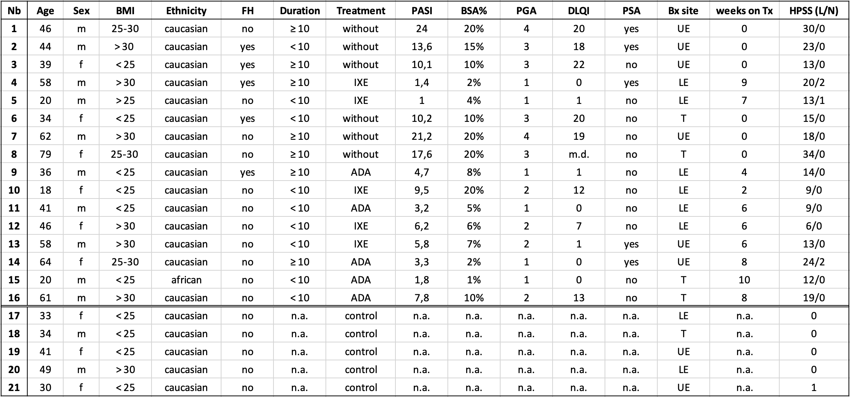
TABLE S1 Study population. Demographic and disease-associated baseline characteristics of participants at inclusion.
Nb, number, BMI, body mass index, FH, family history of psoriasis (relation in the first, second, or third degree), Duration, duration of disease (in years), PASI, psoriasis area and severity index; BSA%, body surface area in percentage terms; PGA, physician global assessment; DLQI, dermatology life quality index; PSA, psoriasis arthritis; Bx site, site of biopsy; weeks on Tx, weeks on therapy; HPSS, histopathologic psoriasis severity score; L, lesional skin; N, non-lesional skin; m, male; f, female; without, no psoriasis treatment at inclusion; IXE, on Ixekizumab therapy; ADA, on Adalimumab therapy; control, healthy donor; UE, upper extremity; LE, lower extremity; T, trunk; m.d., missing data; n.a., not applicable;
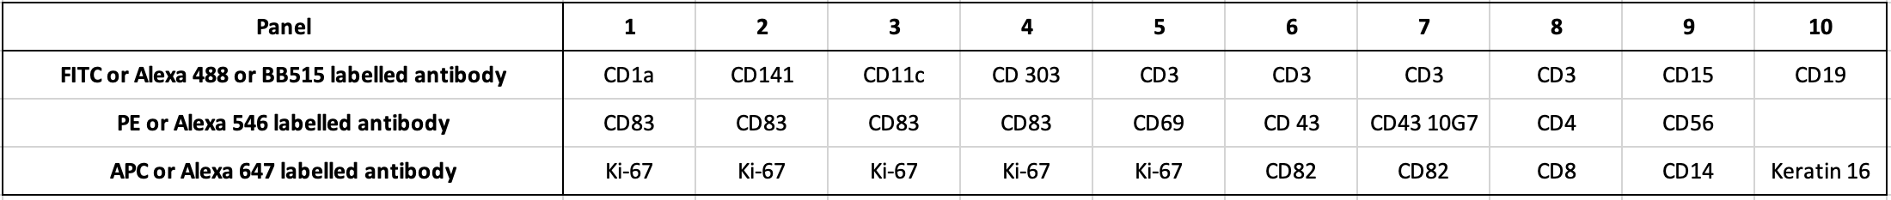
TABLE S2 Immunofluorescence co-expression panel. Immunofluorescence triple staining was done with FITC, Alexa 488 or BB515 labelled antibody for CD1a, CD141, CD11c, CD303, CD3, CD15, and CD19 (green), with PE or Alexa 546 labelled antibody for CD83, CD69, CD43, CD43 10G7, CD4, and CD56 (yellow) and with APC or Alexa 647 labelled antibody for Ki-67, CD82, CD8, CD14, and Keratin 16 (red), respectively. Each column presents one panel (total of 10). All panels were counterstained with DAPI.

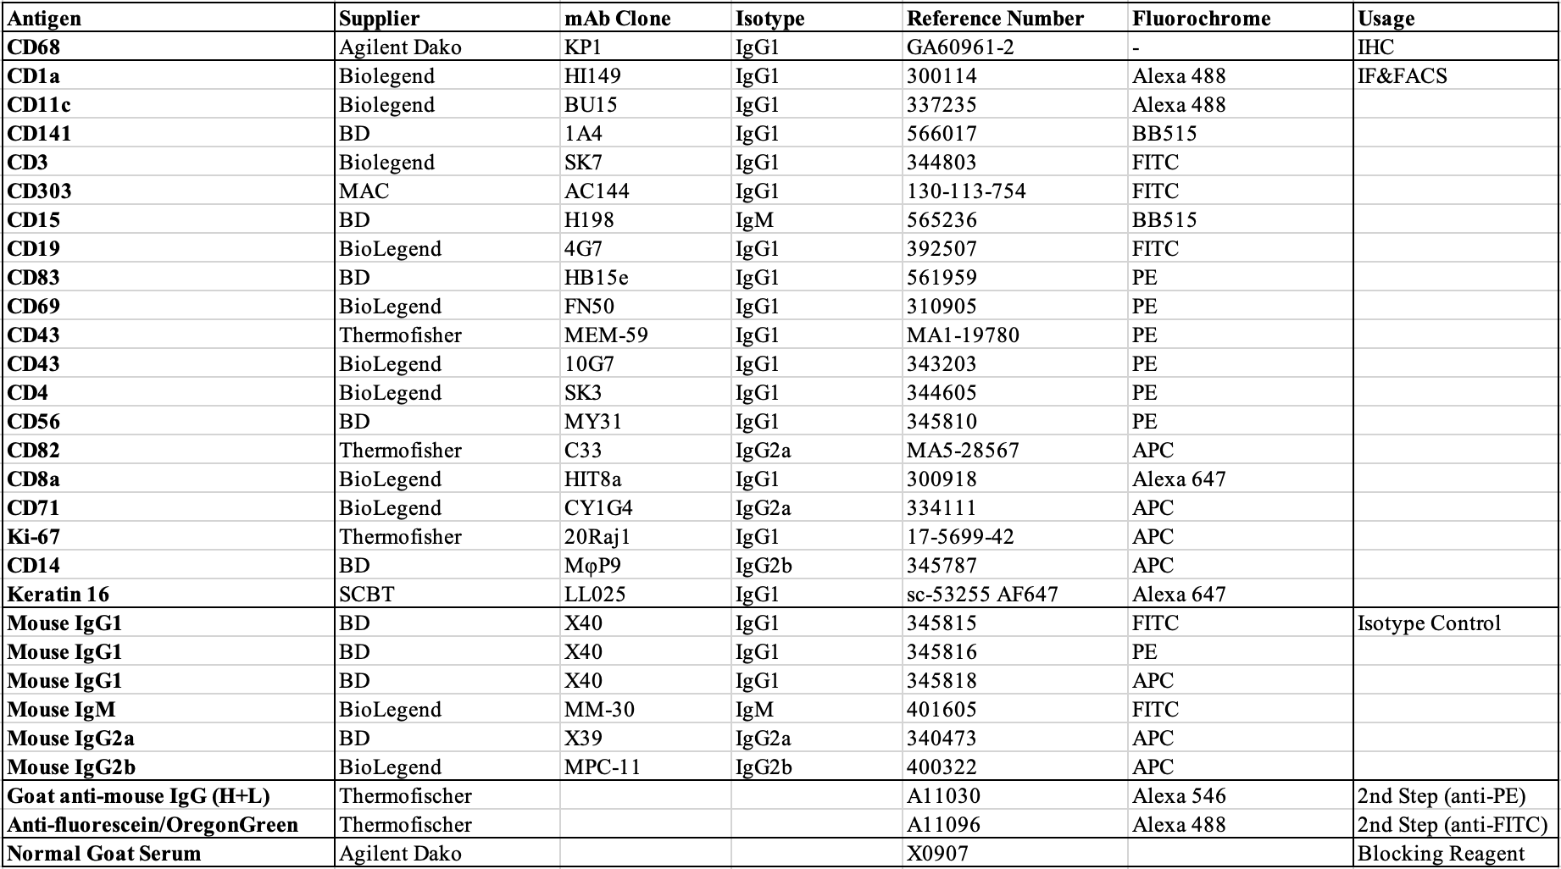
TABLE S3 Characteristics of selected monoclonal Antibodies (mAbs) for immunohistochemistry (IHC), immunofluorescence (IF), and fluorescence-activated cell sorting (FACS). Antibodies were either detected directly (A647) or indirectly with species- or isotype specific antibodies (Alexa Fluor 546 goat-α-mouse or Alexa Fluor 488 α-FITC as secondary antibodies). Negative controls were obtained by substituting isotype-matched IgG1(X40, Becton Dickinson), IgG2a (X39, Becton Dickinson), IgG2b (MPC-11, BioLegend), or IgM (MM-30, BioLegend). PBS containing 2% goat serum (DAKO, Glostrup, Denmark) was used to minimize background.

