Electronic supplementary information
Supplement Table 1: Average seawater temperature measured at the study site in different seasons in Bahía La Herradura, Northern Chile. Water temperature was recorded using HOBO® TidbiT v2 data loggers.
* Total temperature average of growth period, ** Temperature range for the season, warmest weeks are always in bold font.

 | Winter 2012 |  | Summer 2013 |  | Winter 2013 |  | Summer 2014
Time frame L. anatifera | 29.06. - 08.09. |  | 19.12. - 27.02.  19.12. - 02.01. |  | 24.06. - 11.09.  24.06. - 28.08. |  | 06.01. - 05.03.
L. australis | 29.06. - 08.09.
Week | 7 day average | ± | 7 day average | ± | 7 day average | ± | 7 day average | ±
1 | 14.7 | 0.4 | 16.9 | 1.7 | 13.7 | 0.2 | 18.9 | 0.7
2 | 15.1 | 0.2 | 17.3 | 0.7 | 12.9 | 0.3 | 19.9 | 0.9
3 | 13.6 | 1.1 | 17.8 | 0.7 | 13.2 | 0.3 | 19.8 | 0.9
4 | 13.2 | 0.2 | 19.3 | 0.9 | 13.4 | 0.3 | 19.0 | 1.3
5 | 13.1 | 0.3 | 20.1 | 0.9 | 13.1 | 0.4 | 19.4 | 0.9
6 | 13.0 | 0.4 | 19.2 | 0.9 | 13.0 | 0.2 | 19.5 | 0.7
7 | 13.5 | 0.3 | 18.9 | 0.6 | 13.3 | 0.3 | 19.1 | 0.5
8 | 13.4 | 0.3 | 19.8 | 0.8 | 13.0 | 0.3 | 18.1 | 0.6
9 | 13.8 | 0.3 | 19.2 | 1.1 | 13.1 | 0.3
10 | 13.7 | 0.3 | 16.8 | 0.8 | 14.0 | 0.4
11 | 13.8 | 0.4 | 17.4 | 0.8 | 14.5 | 0.6
Total average* | 13.7 | 0.8 | 18.3 | 1.4 | 13.4 |  | 19.4 | 1.0
Range** | 10.2 - 15.7 |  | 14.4 - 21.6 |  | 12.9 - 15.9 |  | 14.6 - 21.8

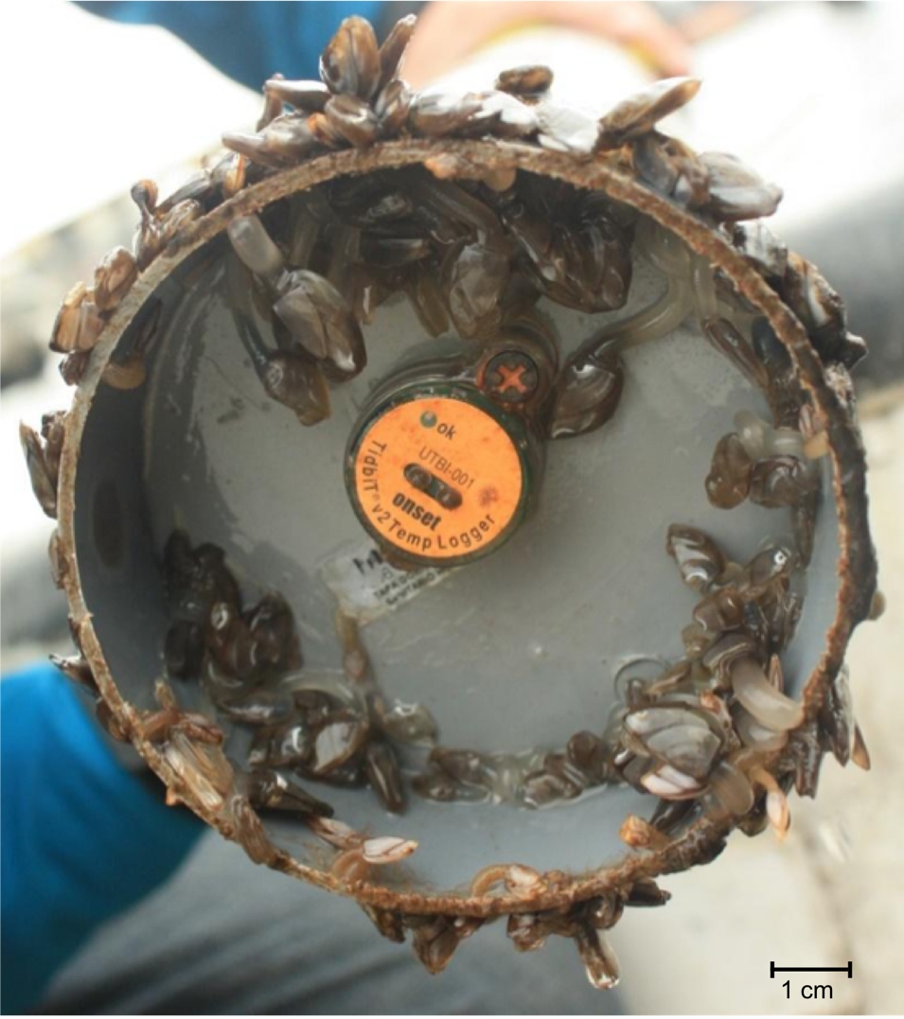
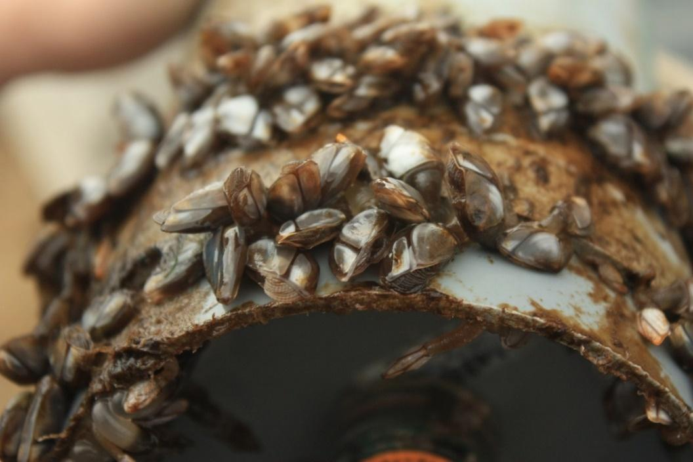

Supplement Figure 1: Lepas anatifera and Lepas australis growing at the bottom of floating buoys in the Bahia La Herradura. Photos: André-Philippe Drapeau Picard

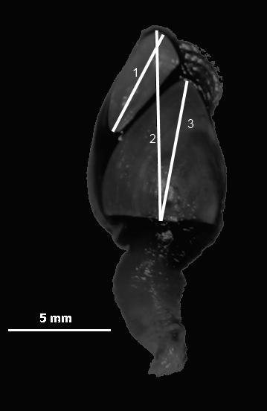

Supplement Figure 2: Lepas australis. Capitulum length (2) is measured from the tip of the tergum to the bottom of the scutum. Tergum length (1) is the distance between its two most distant points. Scutum length (3) is measured from its tip to the middle of its edge.

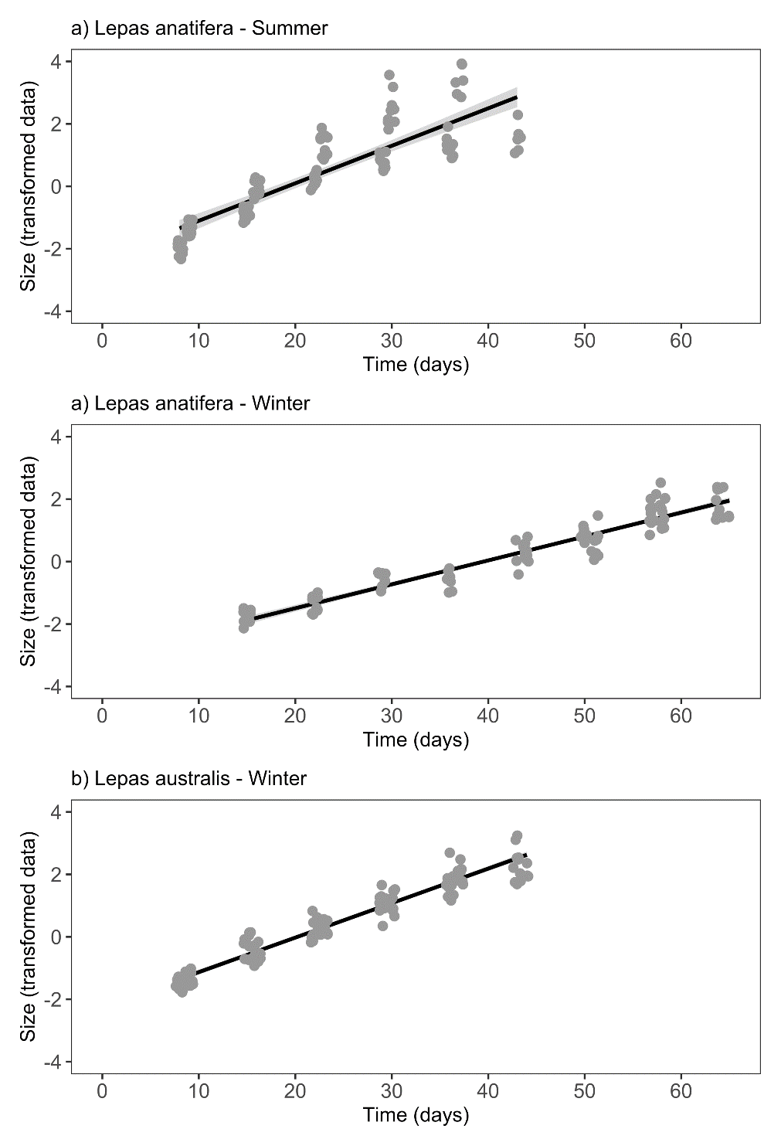
Supplement Figure 3: Linear growth models.
The transformed data of the capitulum size (Y’_{i}) were regressed against the individuals’ age (time in days) to fit linear regression models that allowed us to examine differences in seasonal variation in growth. Table 2 contains the parameters of each model.

