S3
Correlations
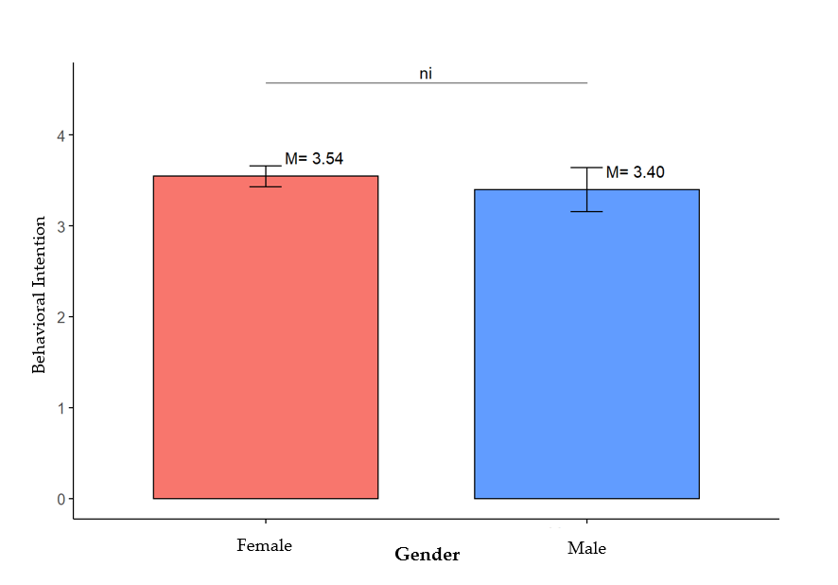
- Gender variable and UTAUT2 constructs: BI, PT, PC
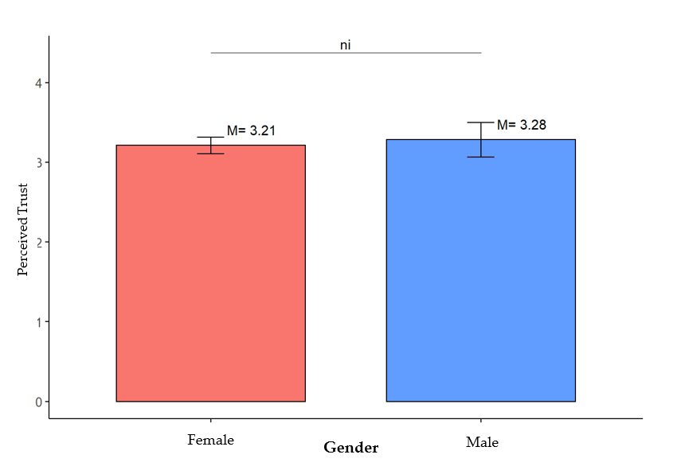
Figure S1. Comparison between Gender variable in terms of the level of Behavioral intention.
Figure S2. Comparison between Gender variable in terms of the level of the Perceived Trust.

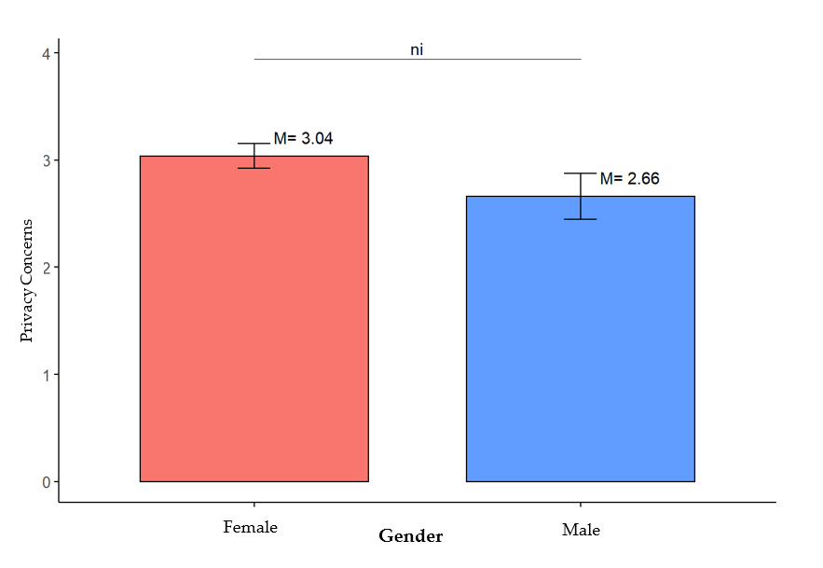
Figure S3. Comparison between Gender variable in terms of the level of the Privacy Concerns.

- Education level and UTAUT2 constructs: BI, PT, PC.
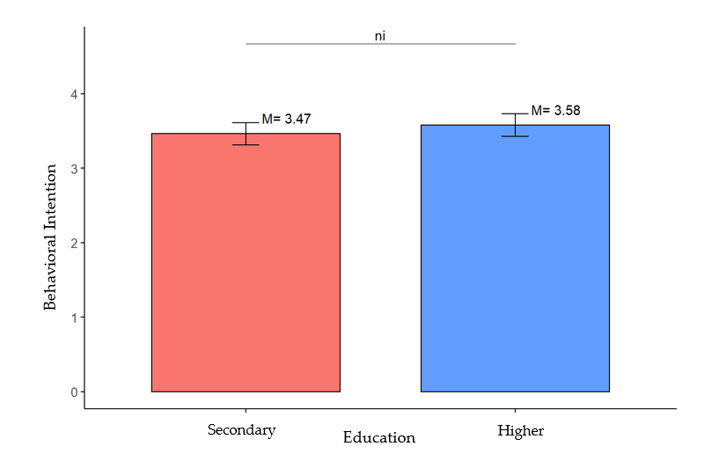

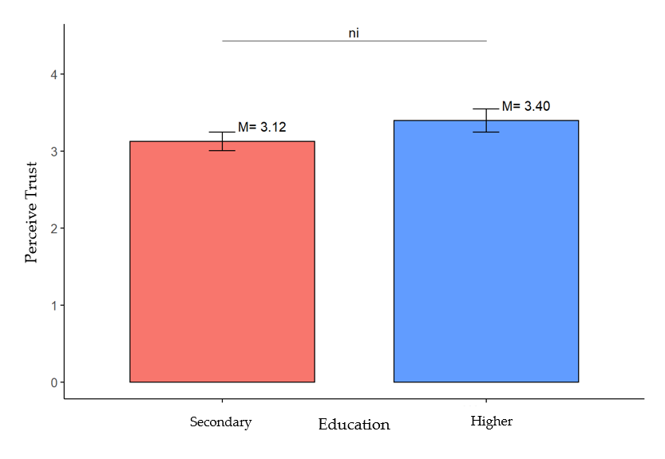
Figure S4. Comparison between education variable in terms of the level of Behavioral intention.
Figure S5. Comparison between Education variable in terms of the level of the Perceived Trust.

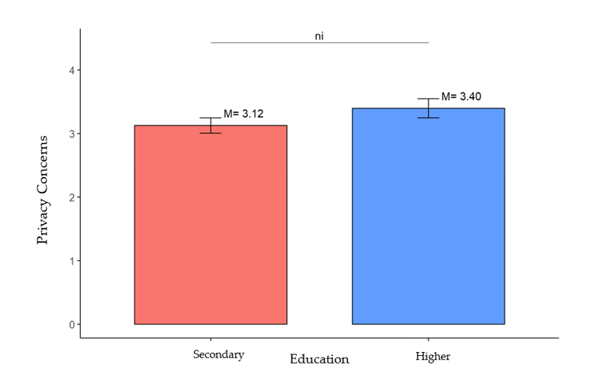
Figure S6. Comparison between Education variable in terms of the level of the Privacy Concerns.

