Supporting Information

Discovery of Ferroelectricity in Natural Product Androstane

Ren-Gen Xiong*, Han-Yue Zhang*, Huan-Huan Jiang
Jiangsu Key Laboratory for Biomaterials and Devices, School of Biological Science and Medical Engineering, Southeast University, Nanjing, Jiangsu, 210009 P. R. China
*Correspondence
E-mail: xiongrg@seu.edu.cn(R.-G. Xiong)
zhanghanyue@seu.edu.cn(H.-Y. Zhang)

Experimental and Measurement Methods
Materials. All reagents and solvents in the syntheses were of reagent grade and used without further purification. The progesterone and 17β-TCA are commercially available. The colorless needle-like crystals of progesterone and 17β-TCA were obtained by slowly evaporating their clear ethanol solutions respectively.
Thin-film preparation. The precursor solution of 17β-TCA was prepared by dissolving 1 mg of the as-grown crystals in 1 mL of ethanol. Then, 20 μL of precursor solution was dropped and spread on a clean indium-doped tin oxide (ITO) glass substrate (1 × 1 cm). The thin film of 17β-TCA was obtained after placing at room temperature for 30 min.
Single-crystal X-ray crystallography. Crystallographic data were collected using a Rigaku Saturn 924 diffractometer equipped with temperature control device, by using Cu Kα (λ = 1.54184 Å) radiation. Data processing including empirical absorption correction, cell refinement, and data reduction was performed using the Crystal Clear software package. CCDC 2153383-2153386 for the compounds contain the supplementary crystallographic data for this paper. These data can be obtained free of charge from the Cambridge Crystallographic Data Centre via www.ccdc.cam.ac.uk/data_request/cif. The data collection and structure refinement of these crystals are summarized in Table S1. Powder X-ray diffraction (PXRD) data were measured using a Rigaku D/MAX 2000 PC X-ray diffraction system with Cu Kα radiation in the 2θ range of 5°–40° with a step size of 0.02° and a scan rate of 10°/min.
DSC and SHG measurements. Differential scanning calorimetry (DSC) measurements were performed on a PerkinElmer Diamond DSC under nitrogen atmosphere in aluminum crucibles with a heating or cooling rate of 20 K/min. For second harmonic generation (SHG) experiments, an unexpanded laser beam with low divergence (pulsed Nd:YAG at a wavelength of 1064 nm, 5 ns pulse duration, 1.6 MW peak power, 10 Hz repetition rate) was used. The instrument model is Ins 1210058, INSTEC Instruments, while the laser is Vibrant 355 II, OPOTEK. The numerical values of the nonlinear optical coefficients for SHG have been determined by comparison with a KDP reference..
PFM characterization. The PFM measurement was carried out on a commercial piezoresponse force microscope (Oxford instrument, Cypher ES) with high-voltage package and in-situ heating stage. PFM is based on the atomic force microscopy (AFM), with an AC drive voltage applied to the conductive tip. Conductive Pt/Ir-coated silicon probes (EFM, Nanoworld) were used for domain imaging and polarization switching studies, with a nominal spring constant of ~2.8 nN/nm and a free-air resonance frequency of ~75 kHz.
Calculation condition. The dipole moment was calculated at b3lyp/6-31G(d) level with Gaussian 16 software. We constructed molecular conformation based on the experimentally measured single crystal X-ray diffraction structure. We carried out density functional calculations based on the Berry phase method developed by Kingsmith and Vanderbilt [1, 2]. The first-principles calculations were performed within the framework of density functional theory implemented in the Vienna ab initio Simulation Package (VASP; 5.4.4) [3, 4]. The energy cut-off for the expansion of the wave functions was fixed to 550 eV and the exchange−correlation interactions were treated within the generalized gradient approximation of the Perdew−Burke−Ernzerhof type [5]. Firstly, the geometrical optimization was performed by fixing the lattice constant based on the experimentally X-ray crystal structure. Then, the Berry phase calculation was calculated on the optimized geometry.

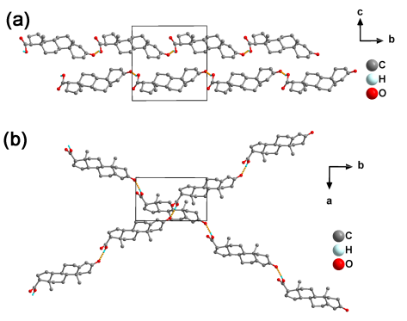
Fig. S1. Crystal structures of 17β-TCA at 293 K. Each 17β-TCA molecule links neighbor others through O–H···O hydrogen bonds, giving rise to an infinite head-to-tail one-dimensional hydrogen-bonded chain.

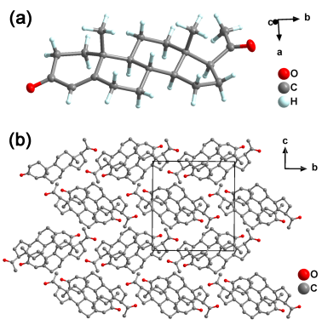
Fig. S2. a) The asymmetric unit and b) packing view of crystal structure of progesterone at 93 K.
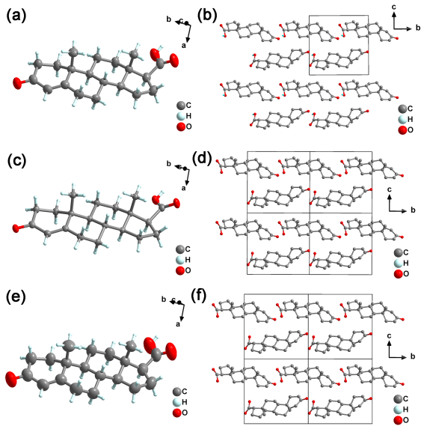
Fig. S3. The asymmetric unit of crystal structure of 17β-TCA at a) 293 K, c) 100 K and e) 423 K. The packing view of crystal structure of 17β-TCA at b) 293 K, d) 100 K and f) 423 K.

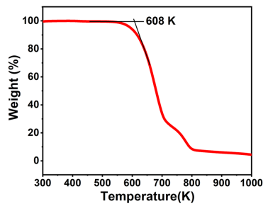
Fig. S4. Thermal Analysis of 17β-TCA.

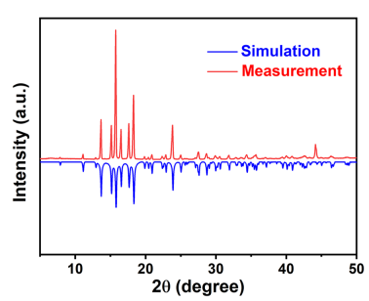
Fig. S5. The measured powder X-ray diffraction pattern of 17β-TCA at 293 K, matching well with the one simulated by crystal data.

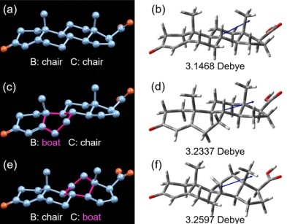
Fig. S6. Molecular structure diagrams containing different 'boat' and 'chair' conformations (a, c and e), with the corresponding molecular dipole diagrams on the right (b, d and f). (Blue arrows represent the direction of the dipole moment.)

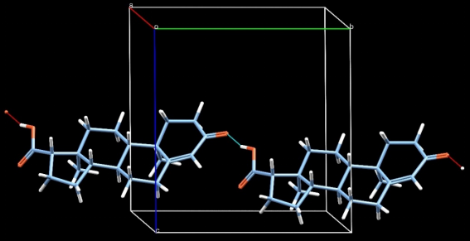
Fig. S7. Intermolecular hydrogen bonding contributes positively to the polarization.

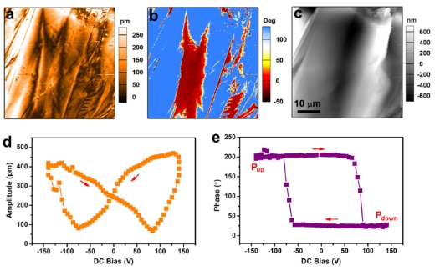
Fig. S8. PFM measurements on the 17β-TCA thin films. Lateral a) PFM amplitude and b) phase images, c) corresponding topographic image. PFM d) amplitude and e) phase switching hysteresis loops.

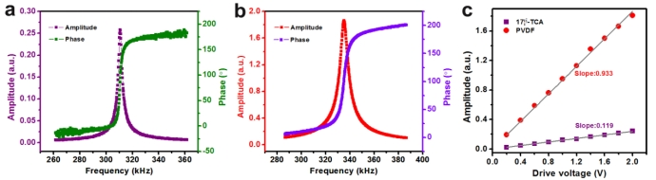
Fig. S9. Measured amplitude and phase signals versus excitation frequency in vertical PFM mode for a) 17β-TCA thin film and b) PVDF film. Here, the magnitude of the amplitude has been calibrated by dividing the Q factor to get the effective amplitude. c) First harmonic response as a function of drive voltage for 17β-TCA thin film and PVDF film.
Table S1. Crystal data and structure refinement for progesterone at 93 K, and 17β-TCA at 100 K, 293 K and 423 K, respectively.
Compound | progesterone | 17β-TCA
Temperature | 93 K | 100 K | 293 K | 423 K
Formula | C₂₁H₃₀O₂ | C₂₀H₂₈O₃ | C₂₀H₂₈O₃ | C₂₀H₂₈O₃
Weight | 314.45 | 316.42 | 316.42 | 316.42
System | orthorhombic | monoclinic | monoclinic | monoclinic
Space group | P2₁2₁2₁ | P2₁ | P2₁ | P2₁
a (Å)  b (Å)  c (Å) | 10.2362(2)  12.4735(3)  13.6126(3) | 6.95100(10)  11.2265(2)  11.3349(2) | 6.98120(10)  11.2441(2)  11.4552(2) | 7.0181(2)  11.2590(3)  11.5917(3)
β (º) | 90 | 102.863(2) | 102.088(2) | 101.242(2)
V (Å³) | 1738.07(7) | 862.33(3) | 879.26(3) | 898.36(4)
Z | 4 | 2 | 2 | 2
R_{int} | 0.0310 | 0.0302 | 0.0318 | 0.0268
R₁ | 0.0422 | 0.0352 | 0.0374 | 0.0424
wR₂ | 0.1151 | 0.0950 | 0.1049 | 0.1258
GOF | 1.040 | 1.045 | 1.077 | 1.052

References
- King-Smith RD, Vanderbilt D. Theory of polarization of crystalline solids. Phys Rev B. 1993; 47 (3): 1651-1654.
- Vanderbilt D, King-Smith RD. Electric polarization as a bulk quantity and its relation to surface charge. Phys Rev B. 1993; 48 (7): 4442-4455.
- Kresse G, Furthmu¨ller J. Efficient iterative schemes for ab initio total-energy calculations using a plane-wave basis set. Phys Rev B. 1996; 54 (16): 11169-11186.
- Kresse G, Furthmiiller J. Efficiency of ab-initio total energy calculations for metals and semiconductors using a plane-wave basis set. Comput Mater Sci. 1996; 6: 15-50.
- Perdew JP, Burke K, Ernzerhof M. Generalized Gradient Approximation Made Simple. Phys Rev Lett. 1996; 77 (18): 3865-3868.

