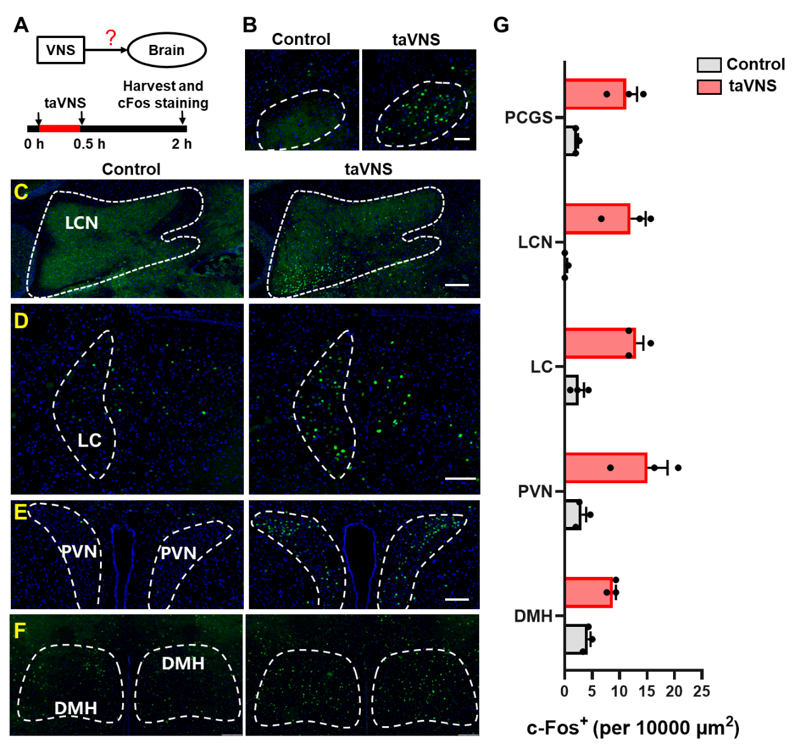
Figure S1: Brain nuclei activated by acute taVNS in 8-week-old MRL/lpr mice. (A) Timeline of cfos staining experiment. (B-F) Representative cfos staining image of PCGS, LCN, LC, PVN and DMH obtained from taVNS mice and their controls. (G) Quantification of cFos positive cells per 10000μm2 in PCGS, LCN, LC, PVN and DM of taVNS mice and their controls (control, n = 3; taVNS, n = 3). *p < 0.05, **p < 0.01; Welch’s t test was used for G (PCGS and LCN), unpaired Student’s t-test was used for G (LC, PVN and DMH).

Supplementary Table 1. Detailed information for statistics
Figure | Statistic test | Statistic parameter
Fig.1c | Unpaired t test | t=7.377, df=8; P<0.0001
Fig.1g | Paired t test | t=2.957, df=13; P<0.05
Fig.1h | Paired t test | t=3.122, df=13; P<0.01
Fig.2b | Unpaired t test | t=0.5016, df=16; P=0.6228
Fig.2c | Mann-Whitney U test | U=33, P= 0.5457
Fig.2e | Unpaired t test | t=3.166, df=16; P<0.01
Fig.2f | Unpaired t test | t=3.542, df=16; P<0.01
Fig.2g | Unpaired t test | t=2.211, df=11; P<0.5
Fig.2h | Unpaired t test | t=3.253, df=13; P<0.01
Fig.2i | Unpaired t test | t=5.461, df=6; P<0.01
Fig.2j | Unpaired t test | t=3.440, df=4; P<0.5
Fig.3a | Two-way ANOVA | F (1, 17) = 20.74, P=0.0003
Fig.3b | Unpaired t test | t=2.848, df=16; P<0.5
Fig.3f | Unpaired t test | t=5.885, df=6; P<0.01
Fig.3g | Unpaired t test | t=3.477, df=6; P<0.5
Fig.3h | Unpaired t test | t=1.361, df=6; P= 0.2225
Fig.3i | Unpaired t test | t=3.895, df=6; P<0.01
Fig.4b | Mann-Whitney U test | U=6, P= 0.0649
Fig.4c | Unpaired t test | t=2.233, df=10; P<0.5
Fig.4d | Unpaired t test | t=2.610, df=10; P<0.5
Fig.4e | Unpaired t test | t=1.374, df=10; P=0.1994
Fig.5b | Unpaired t test | t=8.364, df=6; P<0.001
Fig.5c | Unpaired t test | t=0.1144, df=9; P=0.9114
Fig.5d | Unpaired t test | t=0.03935, df=9; P=0.9695
Fig.5e | Unpaired t test | t=0.3712, df=9; P=0.7191
Fig.5f | Unpaired t test | t=0.2356, df=9; p=0.8190
Fig.5g | Unpaired t test | t=0.6814, df=9; P=0.5128
Fig.5h | Unpaired t test | t=1.452, df=9; P=0.1805
Fig.5i | Two-way ANOVA | F (1, 10) = 0.3590, P=0.3590
Fig.5j | Unpaired t test | t=0.9532, df=8; P= 0.3684
Fig.5l | Unpaired t test | t=0.07559, df=8; P=0.9416
Fig.5m | Unpaired t test | t=1.307, df=8; P=0.2274
Fig.5o | Unpaired t test | t=0.3636, df=8; P=0.7256
Fig.5q | Unpaired t test | t=0.2998, df=8; P=0.7720
Fig.6c (Control vs. taVNS) | Unpaired t test | t=2.339, df=10; P<0.05
Fig.6c (LC lesion vs. LC lesion + taVNS) | Welch’s t test | t=1.011, df=6.639; P= 0.3474
Fig.6d (Control vs. taVNS) | Unpaired t test | t=2.861, df=10; P<0.05
Fig.6d (LC lesion vs. LC lesion + taVNS) | Unpaired t test | t=0.3620, df=8; P=0.7267
Fig.6e (Control vs. taVNS) | Unpaired t test | t=1.566, df=10; P=0.1483
Fig.6e (LC lesion vs. LC lesion + taVNS) | Unpaired t test | t=3.325, df=8; P<0.05
Fig.6f (Control vs. taVNS) | Unpaired t test | t=1.304, df=10; P=0.2213
Fig.6f (LC lesion vs. LC lesion + taVNS) | Unpaired t test | t=2.633, df=8; P<0.05
Fig.6g (Control vs. taVNS) | Unpaired t test | t=0.1197, df=10; P=0.9071
Fig.6g (LC lesion vs. LC lesion + taVNS) | Welch’s t test | t=0.7796, df=4.814; P=0.4722
Fig.6i | Welch’s t test | t=2.683, df=6.897; P<0.05
Fig.6j | Unpaired t test | t=1.112, df=8; P=0.2984
Fig.6l | Welch’s t test | t=3.198, df=4.380; P<0.05
Fig.6m | Unpaired t test | t=3.276, df=8; P<0.05
Fig.S1g (DMH) | Unpaired t test | t=6.181, df=4; P<0.01
Fig.S1g (PVN) | Unpaired t test | t=3.243, df=4; P<0.05
Fig.S1g (LC) | Unpaired t test | t=6.338, df=4; P<0.01
Fig.S1g (LCN) | Welch’s t test | t=4.302, df=2.027; P<0.05
Fig.S1g (PCGS) | Welch’s t test | t=4.615, df=2.053; P<0.05

