Author’s Biography
Atul Kumar Srivastava
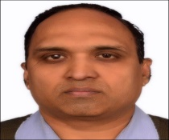
Atul Kumar Srivastava is PhD Scholar at AKTU University. He is presently working as Assistant Professor at Amity University.
Dhiraj Pandey
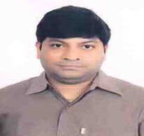
Dhiraj Pandey received his PhD in Computer Science and Engineering from Manipal University Jaipur in August, 2018. He received his B.Tech degree in Information Technology from CCS University Meerut in year 2003 and M.Tech degree from University School of Information Technology, GGSIPU, New Delhi in year 2007. He has more than 16 years of academic experience. He joined the Department of Computer Science and Engineering at JSS Academy of Technical Education Noida in January 2011 and currently working as Associate Professor there. His recent research interests include assistive technologies, machine learning, image processing and information security.
He is a senior member of IEEE. He has published various papers in International journals and conferences and associated as guest editor and an active TPC member of many reputed conferences.

Alok Agarwal

Alok Aggarwal received his bachelors’ and masters’ degrees in Computer Science & Engineering in 1995 and 2001 respectively and his PhD degree in Engineering from IIT Roorkee, Roorkee, India in 2010. He has academic experience of 20 years, industry experience of 4 years and research experience of 5 years. He has contributed more than 200 research contributions in different journals and conference proceedings. Currently he is working with University of Petroleum & Energy Studies, Dehradun, India as Professor in CSE department.

