Supporting Information
Synergistic Effect of N, O, S Heteroatoms in Bifunctional Covalent Organic Polymers Promotes Sensitive Detection and Efficient Capture of Mercury(II)

Ye Zhu,ª Cailing Ni,*ª Chao Zhang,ª Zhimin Liu,^{b} Guanghui Wu,ª Yanqing Chen,ª and Yuancheng Qinª
ª Key Laboratory of Jiangxi Province forPersistent Pollutants Control and Resources Recycle, Nanchang Hangkong University, Nanchang 330063, P. R. China
^{b}Sinocat Environmental Technology Co., Ltd.

Section 1 General Information and Synthesis Procedures

1.Synthesis of terephthalic hydrazide (HT)

A mixture of p-phthalic acid (2.3 g, 12.5 mmol), methanol (50 ml) and H₂SO₄ (1 ml) was heated to reflux for 4 h. The solution was evaporated under vacuum. The residue was dissolved in 150 ml CHCl₃ and extracted with saturated sodium bicarbonate solution. The solvent was removed by rotary evaporation and given the product as a white solid (2.4 g, 93%). The product was used directly for the next step without further purification.
Dimethyl terephthalate (DMT) (1 g, 15 mmol), methanol (10 ml), toluene (10 ml) and Hydrazine hydrate (85%) (6.7 ml) were heated to reflux for 24 h under N₂ atmosphere. The product precipitated during the reaction process and collected by filtration, washed with methanol and toluene, given the white solid (0.85 g, 85%).1H NMR (d6-DMSO, 300 MHz) δ 9.86 (s, 2H), 7.86 (s, 4H), 4.56 (s, 4H).

Synthesis of terephthalic hydrazide (HT)

2. The pseudo-first-order and pseudo-second-order rate models.

In order to describe the kinetics of mercury ion adsorption, we use a pseudo-first-order and pseudo-second-order model to fit the data, which can be known from the following equations:
$\frac{1}{q_{t}}=\frac{k_{1}}{q_{e}t}+\frac{1}{q_{e}}$ (1)

$\frac{t}{q_{t}}=\frac{1}{k_{2}q_{e}^{2}}+\frac{t}{q_{e}}$ (2)

In the formula, k₁ (min^{–1}) and k₂ (mg g^{–1} min^{–1}) are the rate constants for the pseudo-first-order and the pseudo-second-order models, respectively. q_{t} (mg g⁻¹) and q_{e} (mg g⁻¹) are the amount of mercury adsorbed at time t (min) and at equilibrium, respectively. The initial adsorption rate h (k₂q_{e}²) has been widely used for assessment of the adsorption rates. Typically, the distribution coefficient (K_{d}) is used to estimate the affinity of a sorbent for metal ions.

Section 2 Summary of Figures and Tables

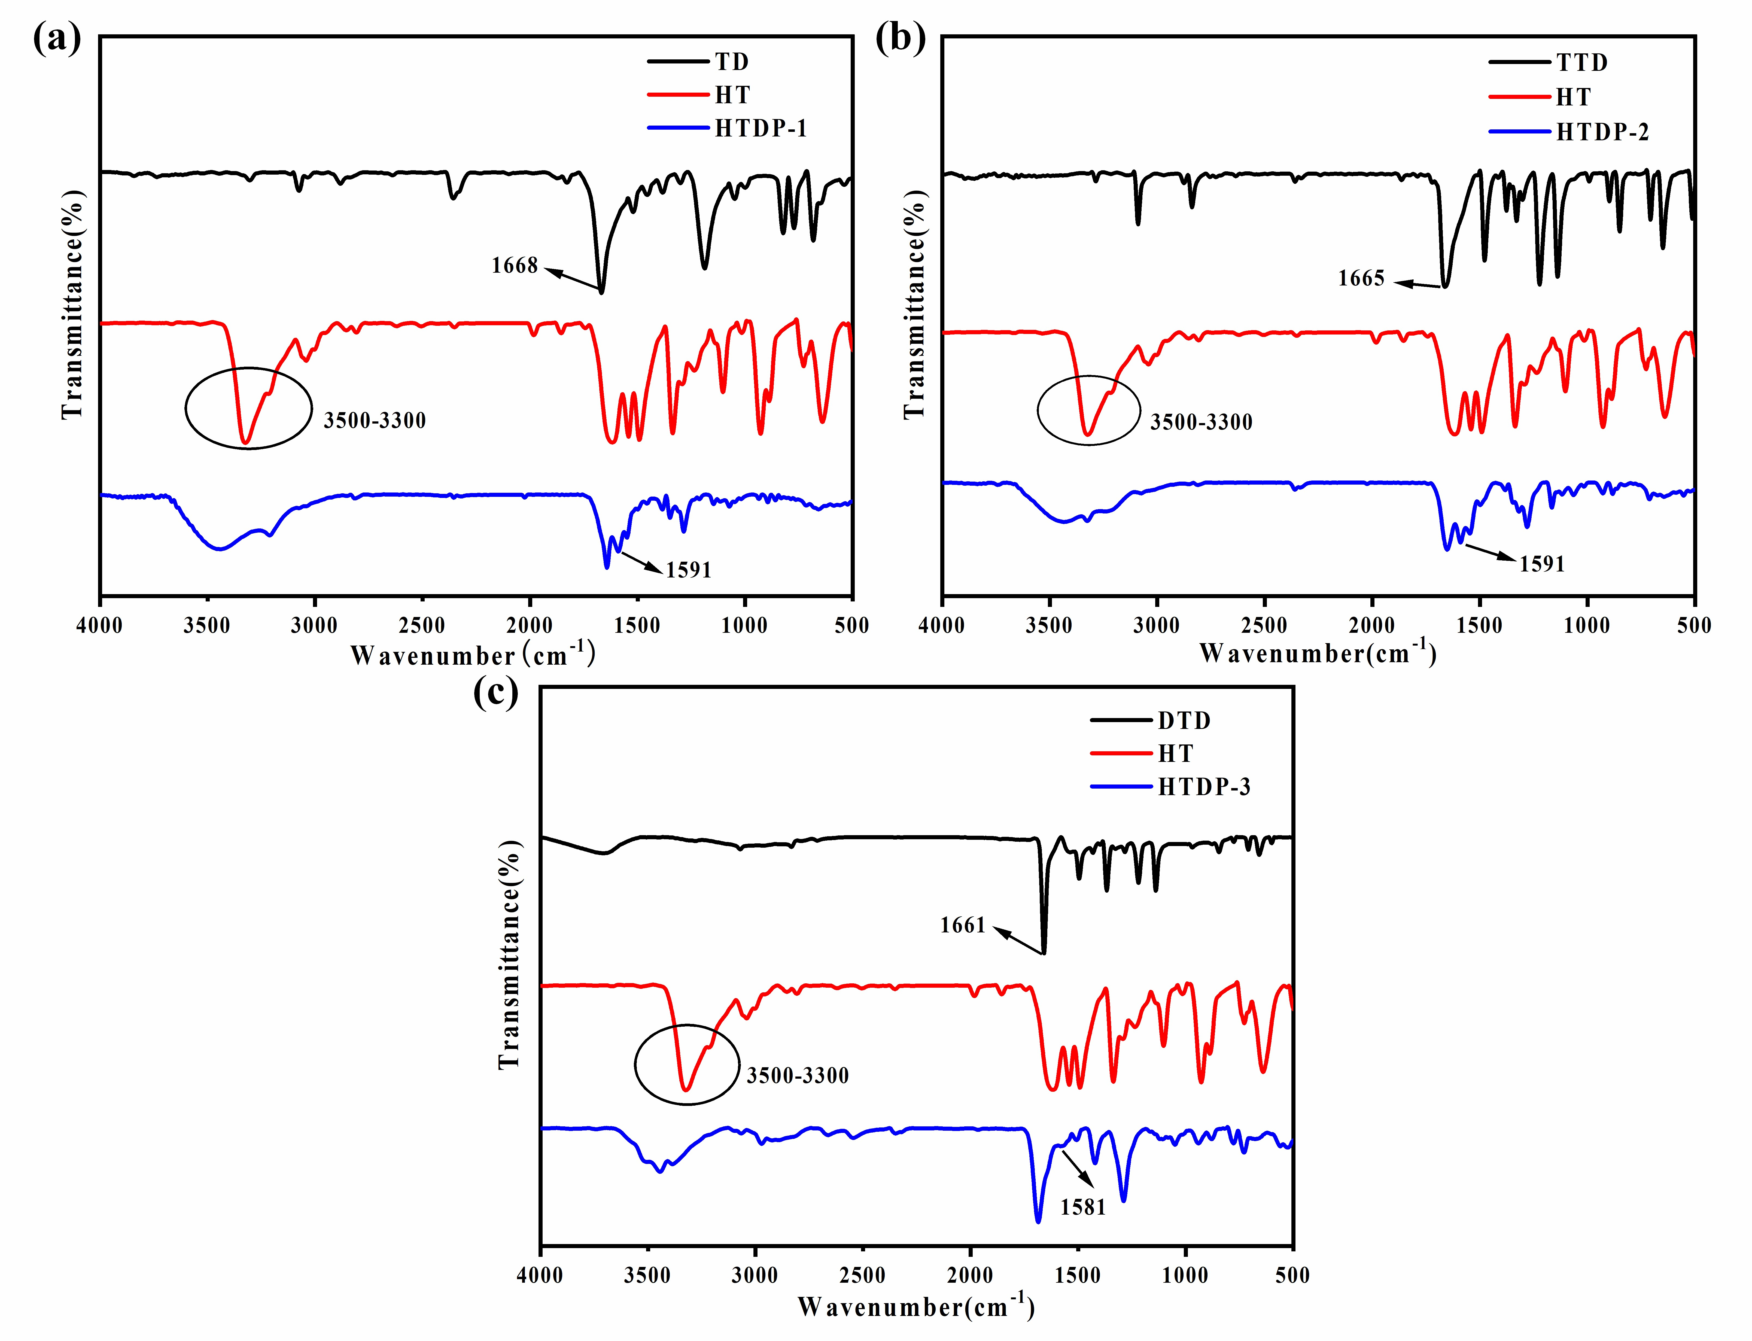
Fig S1. The FT-IR spectrum of polymers HTDP-1 (a), HTDP-2 (b) and HTDP-3 (c).

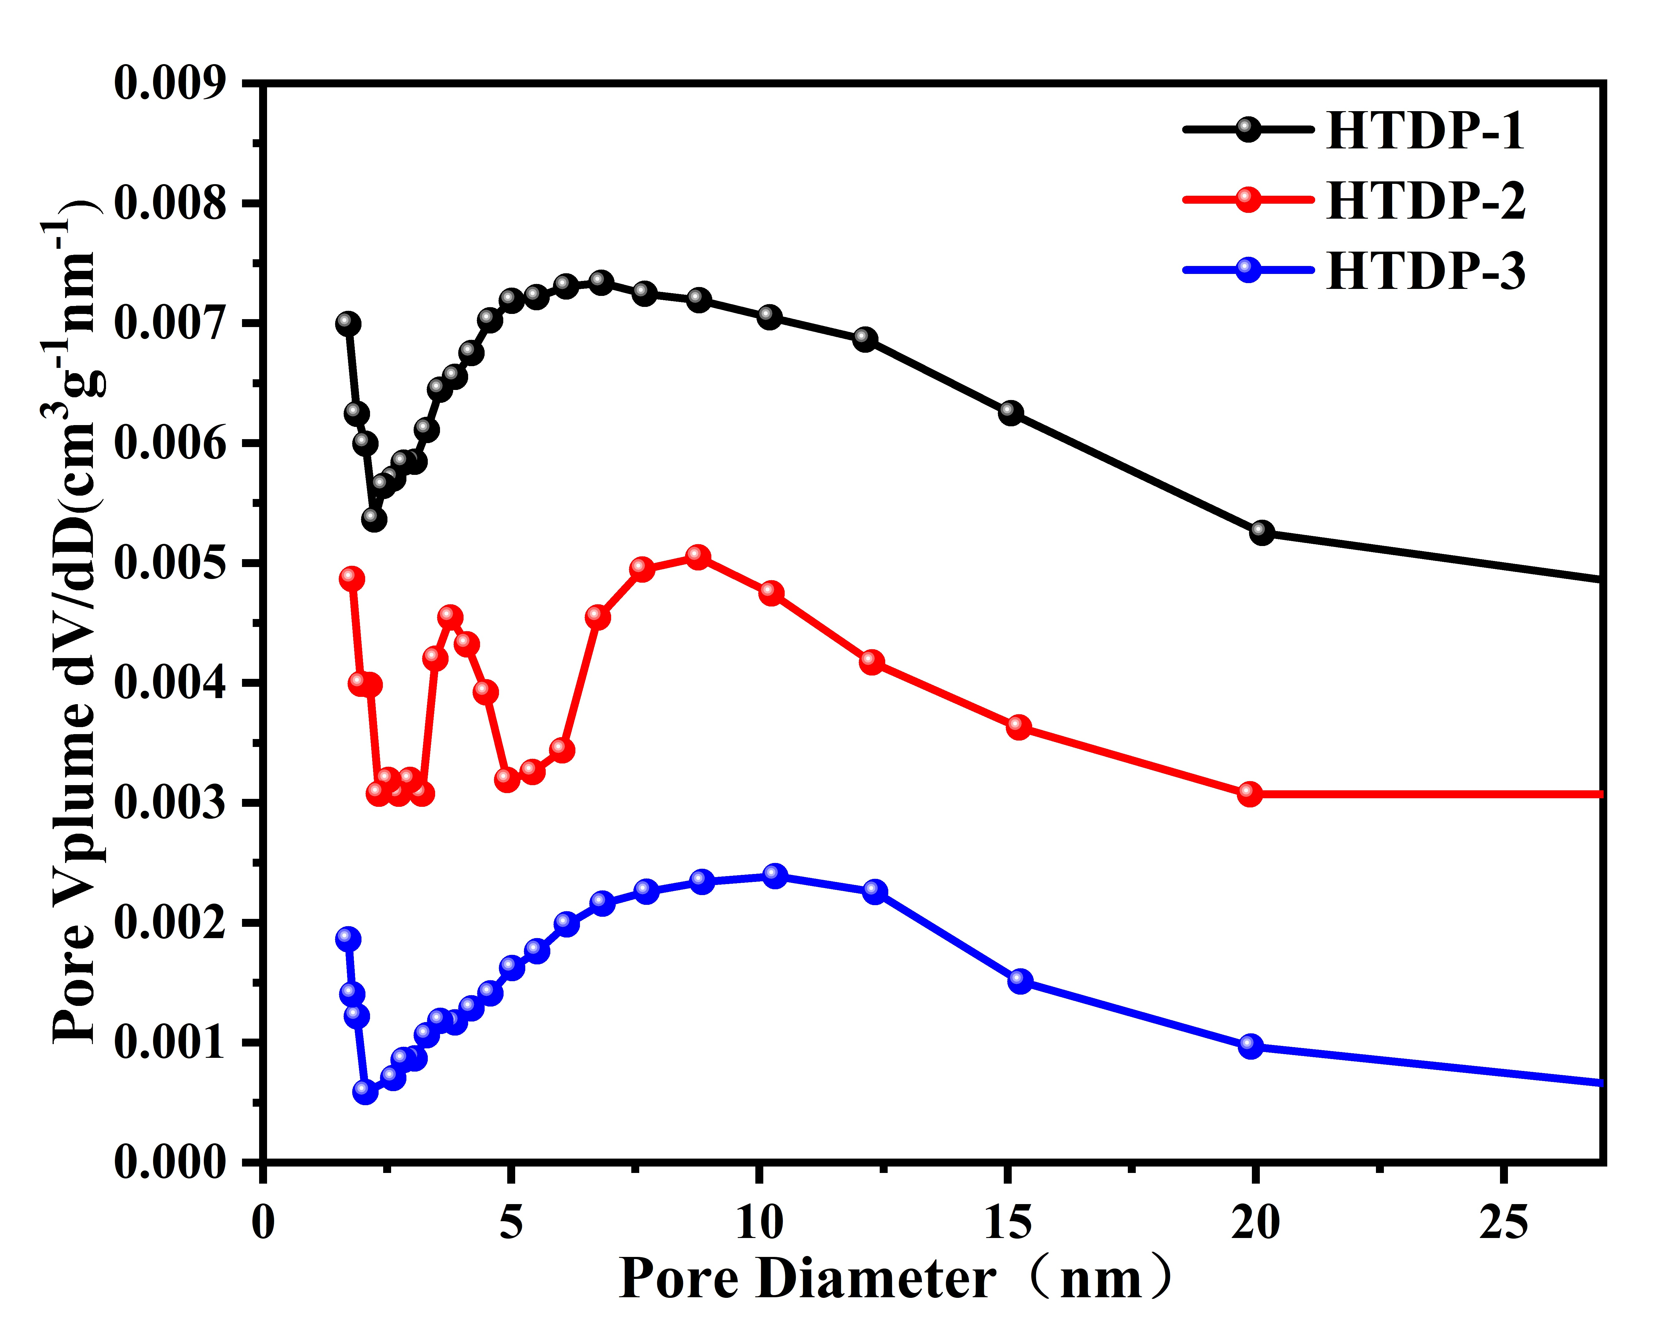
Fig S2. Pore size distribution profile of HTDP-1, HTDP-2, and HTDP-3 (77K).

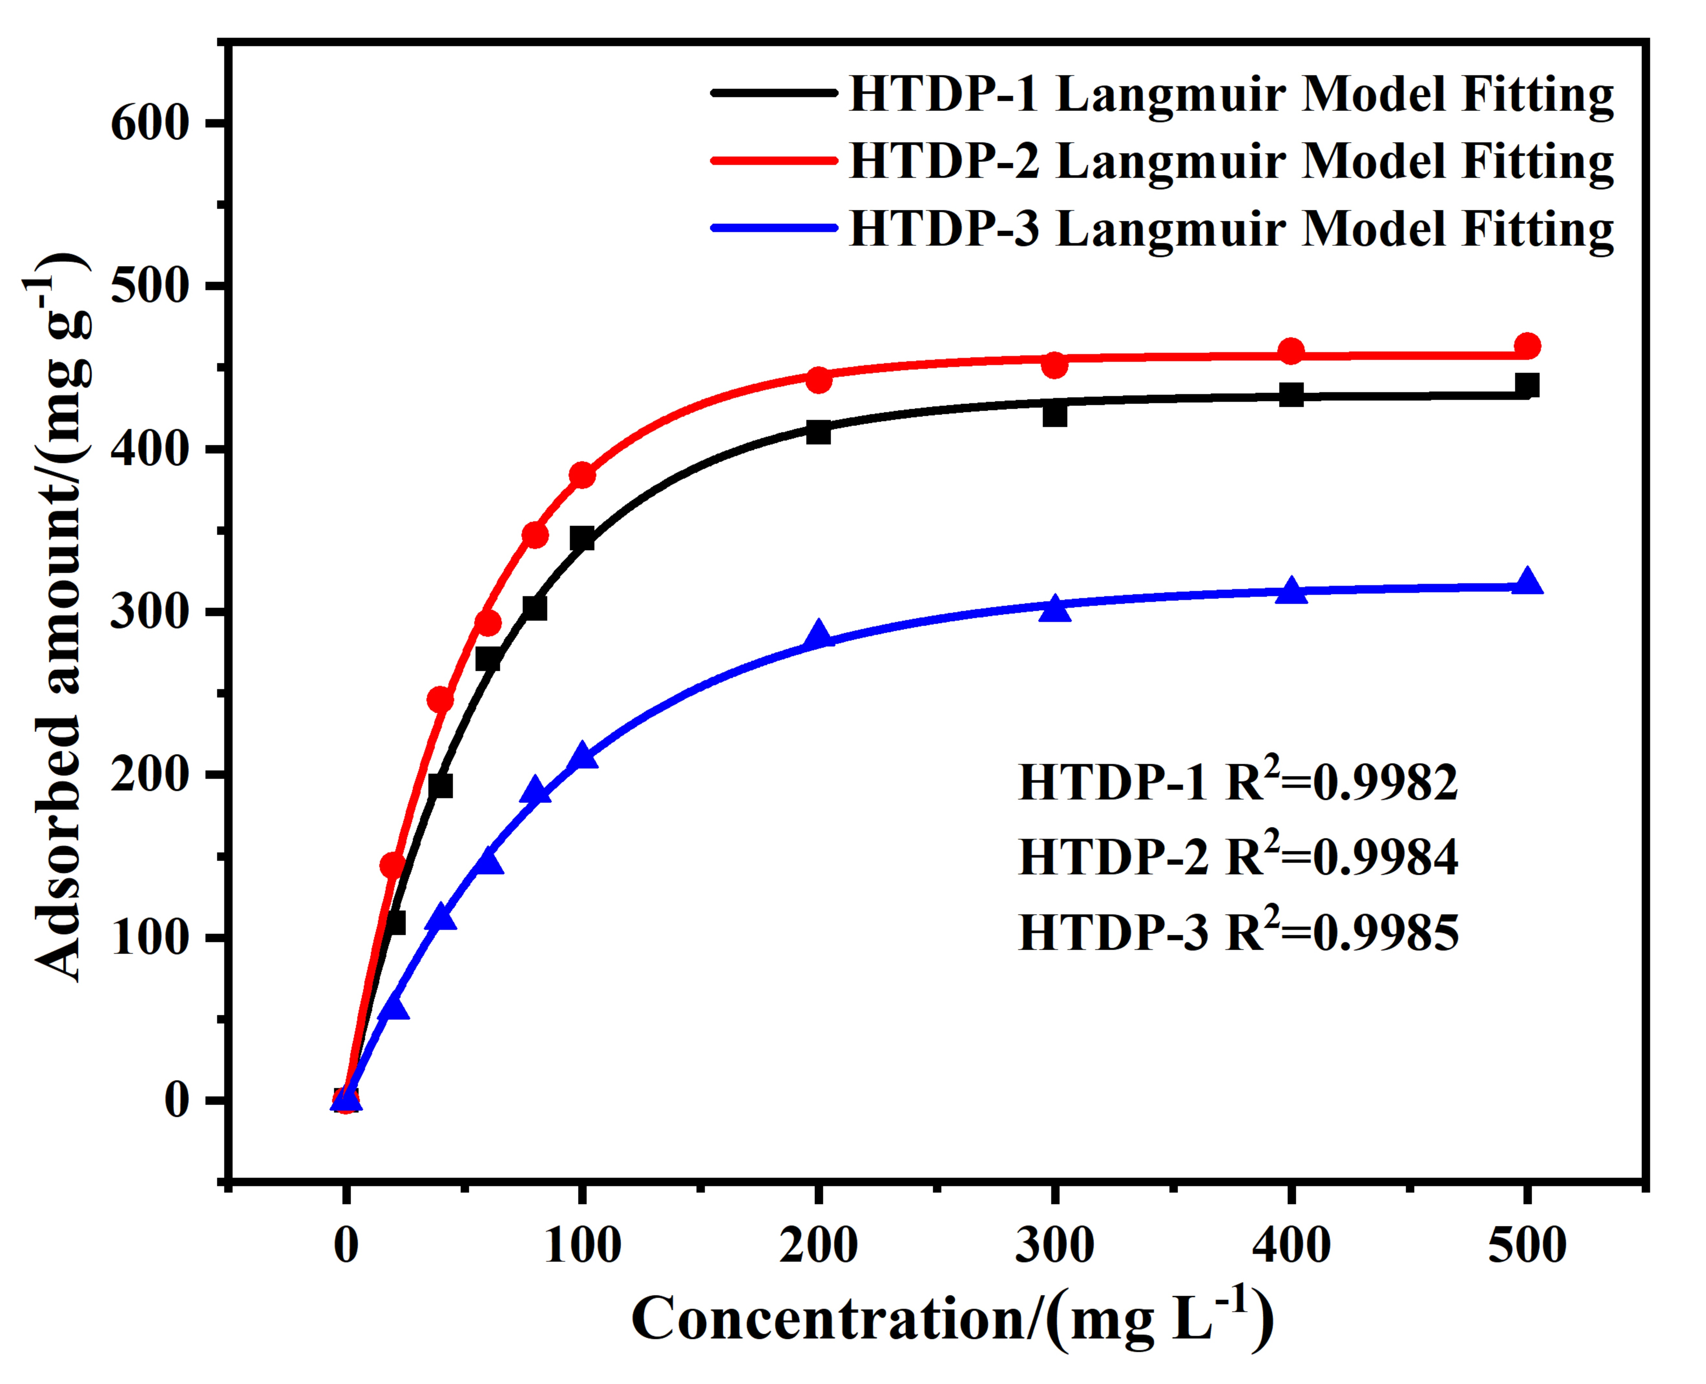
Fig S3. Hg²⁺ adsorption isotherm of HTDP-1, HTDP-2 and HTDP-3.

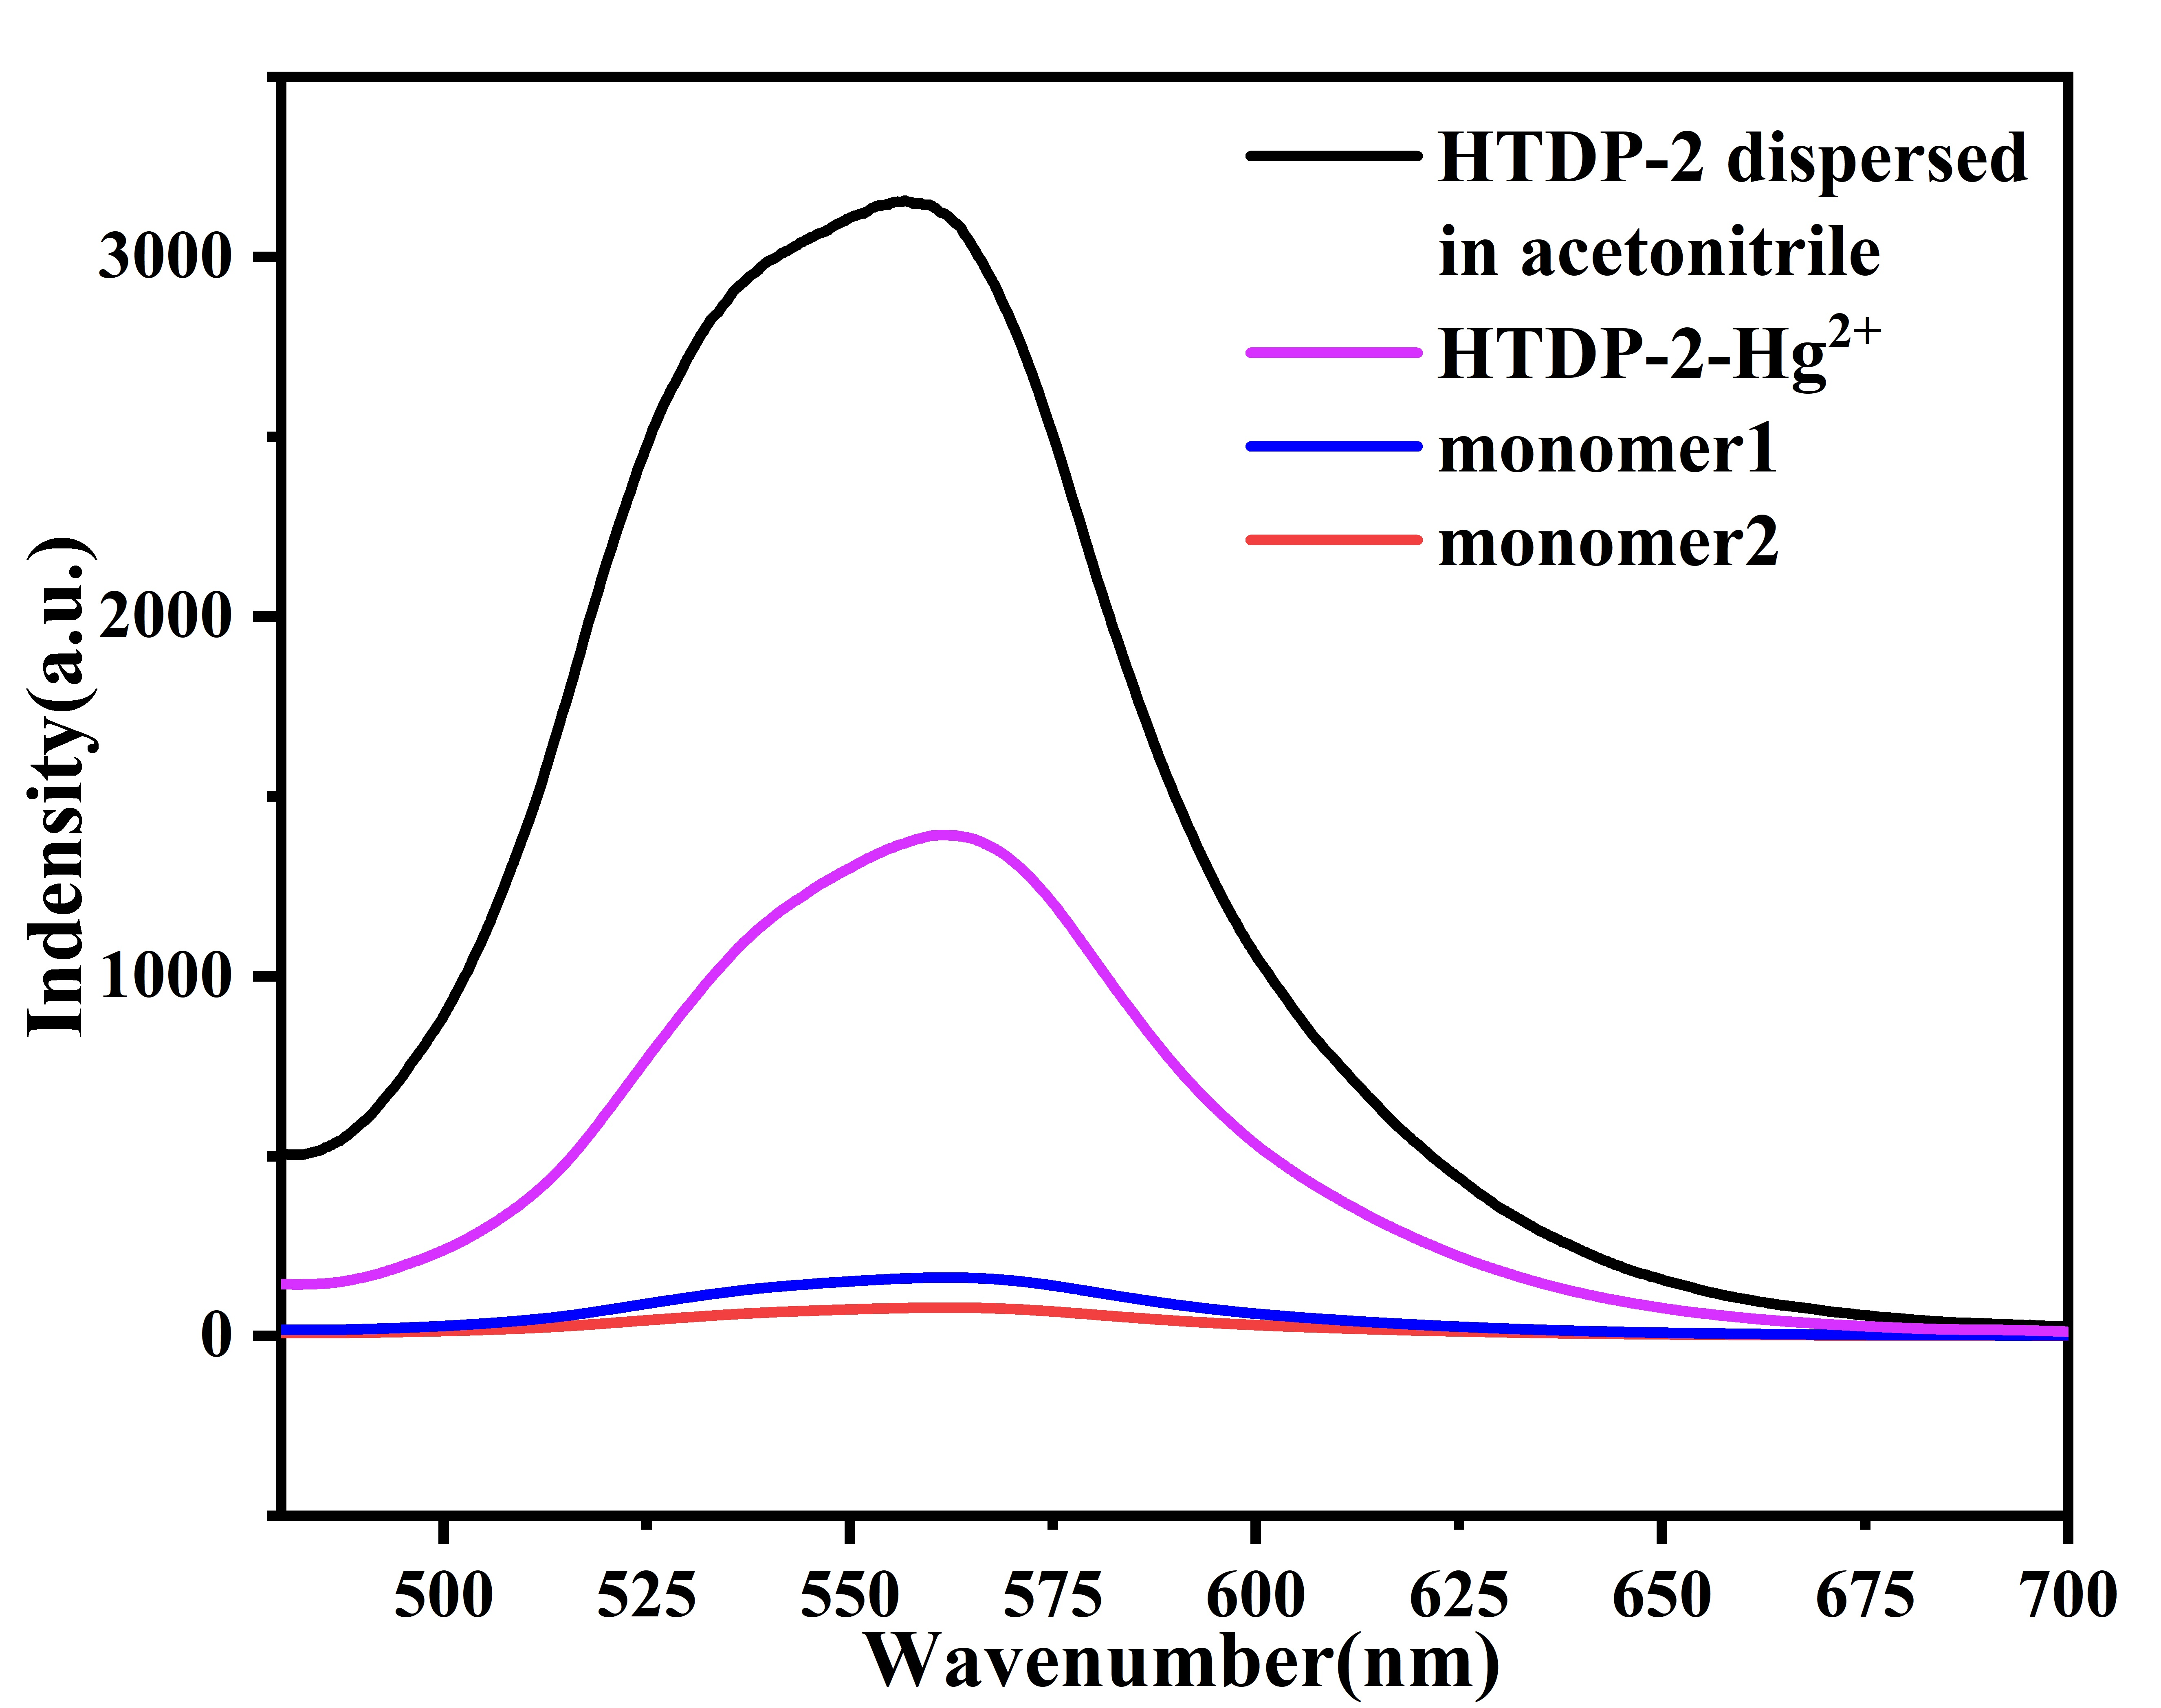
Fig S4. Fluorescence spectra of 1, 2, HTDP-2, and HTDP-2-Hg²⁺ in the dispersion solution of acetonitrile.

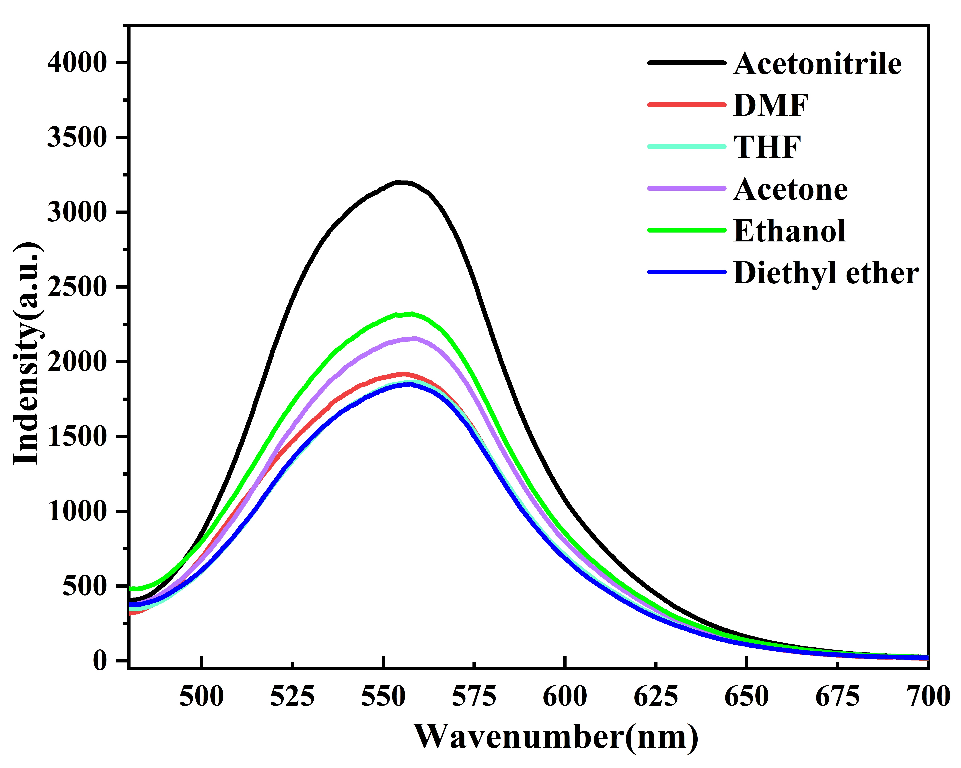
Fig S5. Fluorescence spectra of HTDP-2 in acetonitrile (black), DMF (red), THF (light blue), Acetone (purple), Ethanol (green) and Diethyl ether (dark blue).

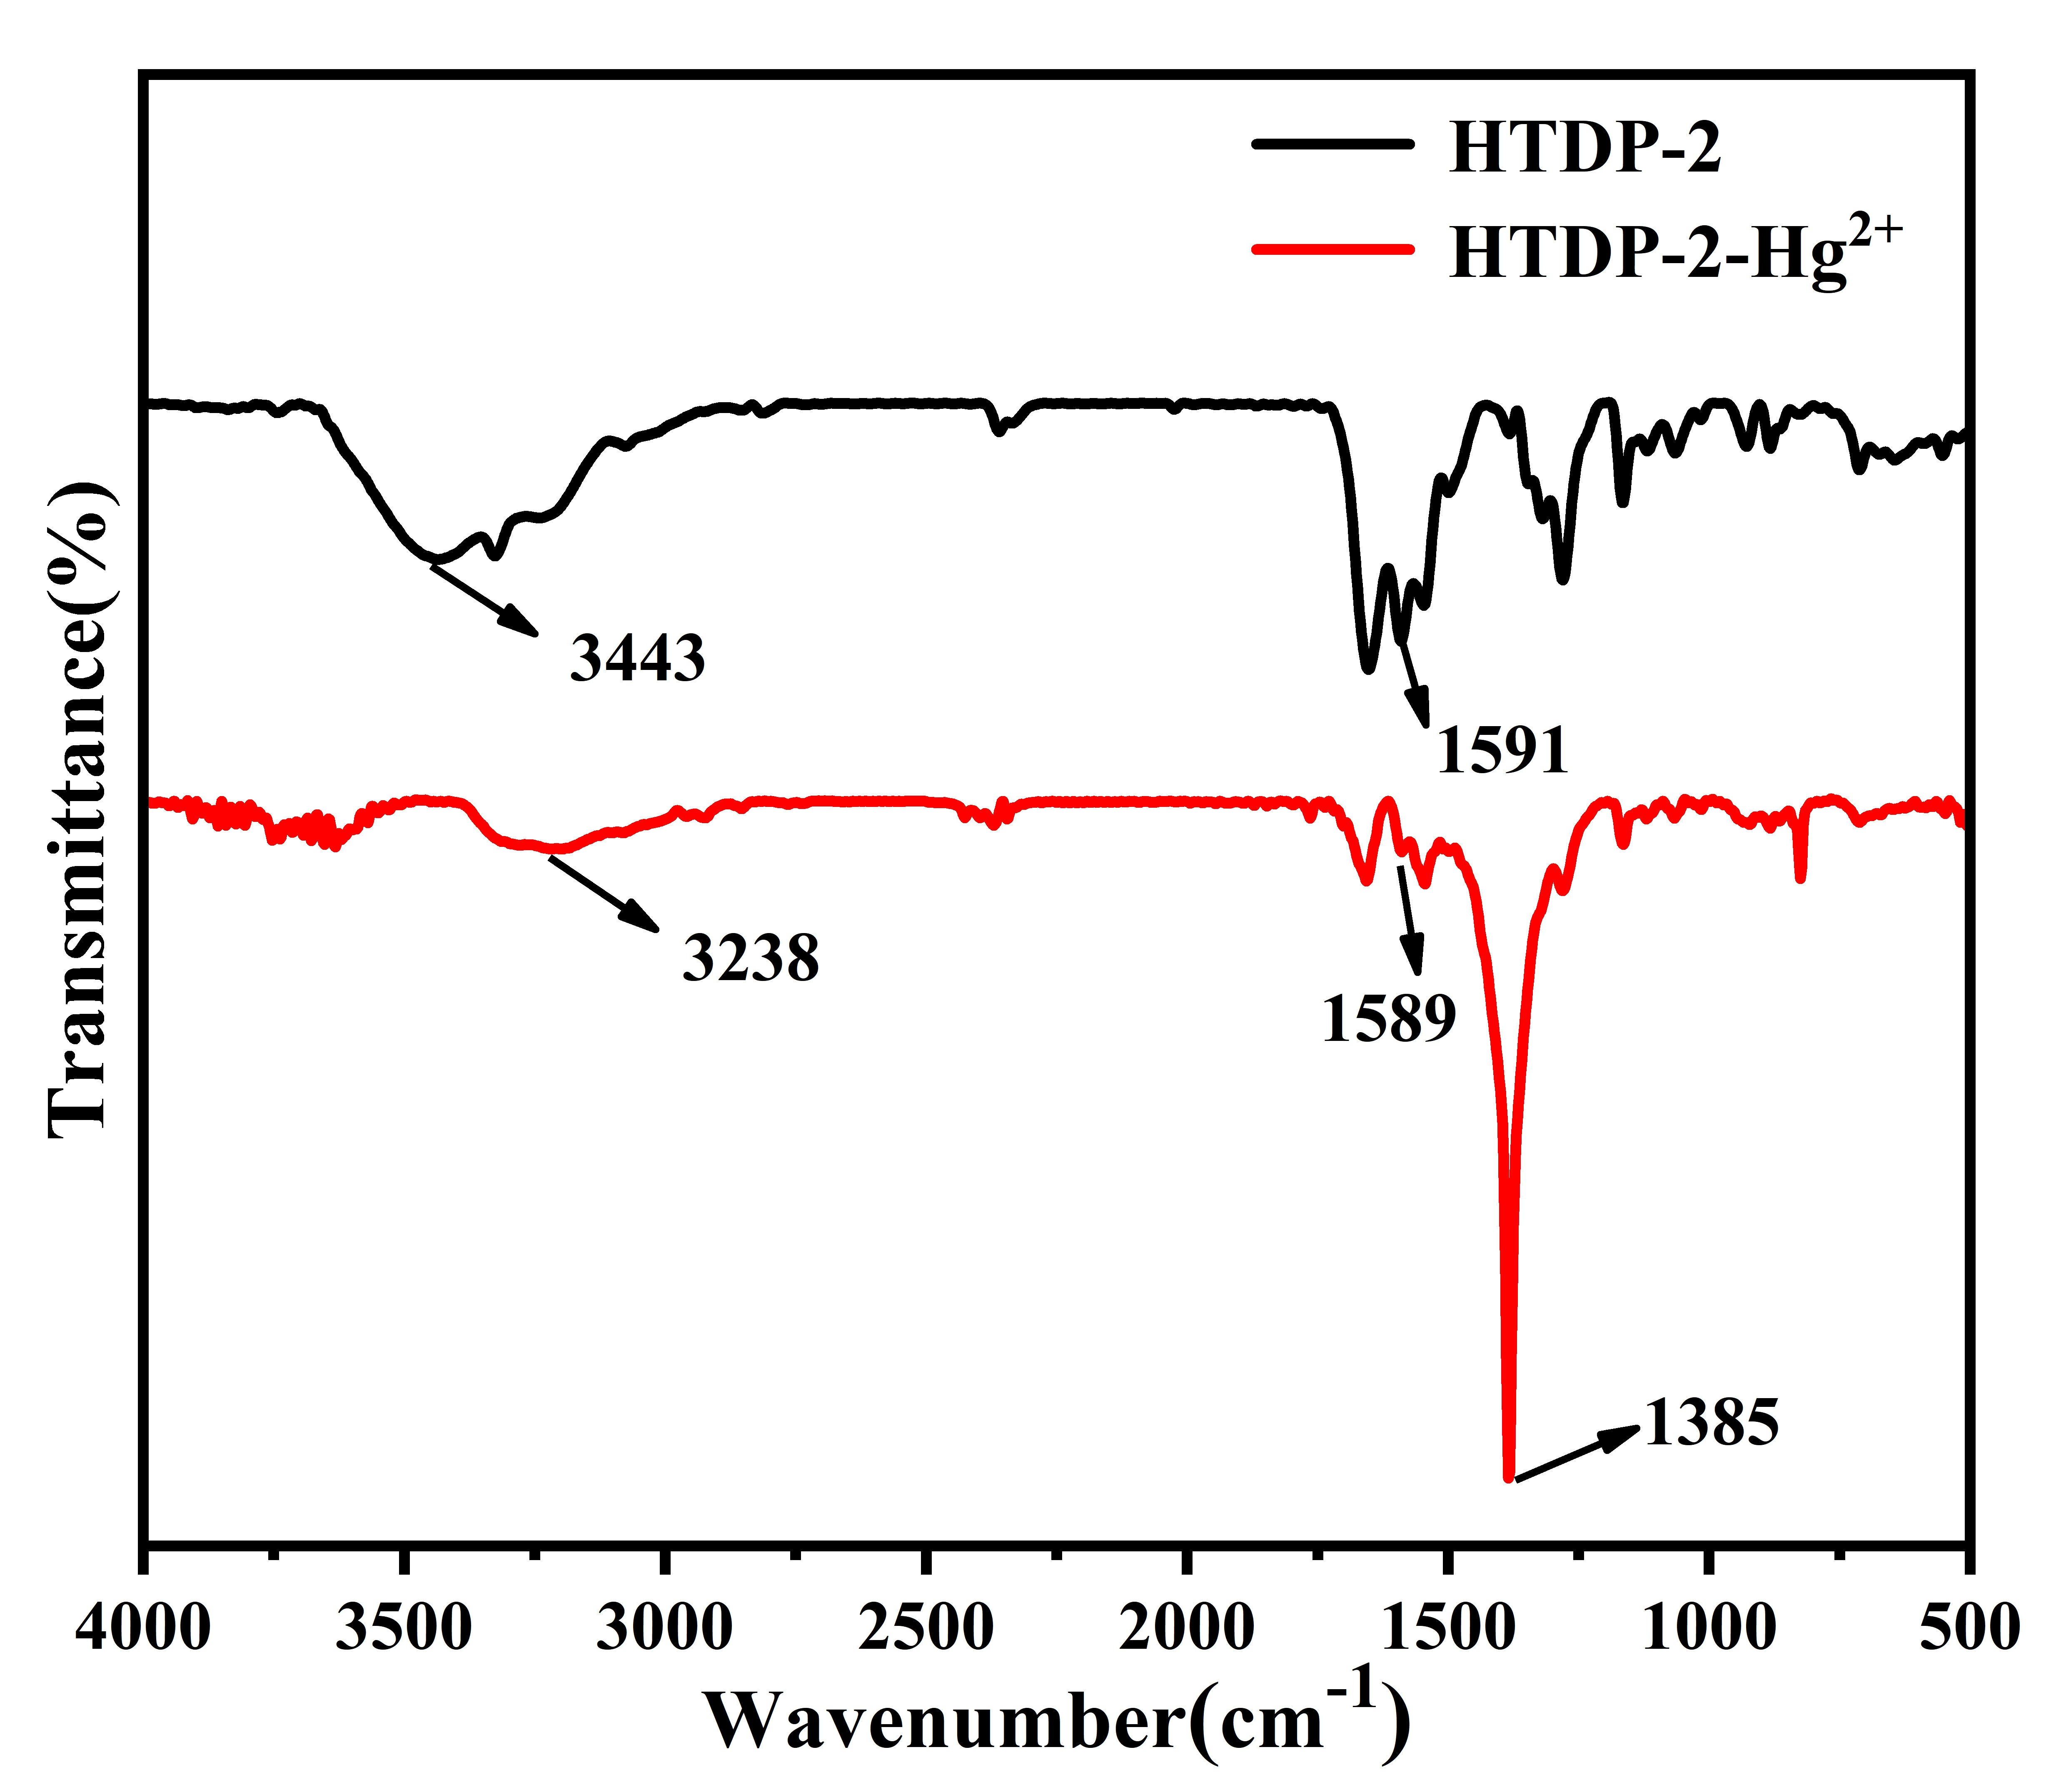
Fig S6. FT-IR of HTDP-2 and HTDP-2-Hg²⁺.

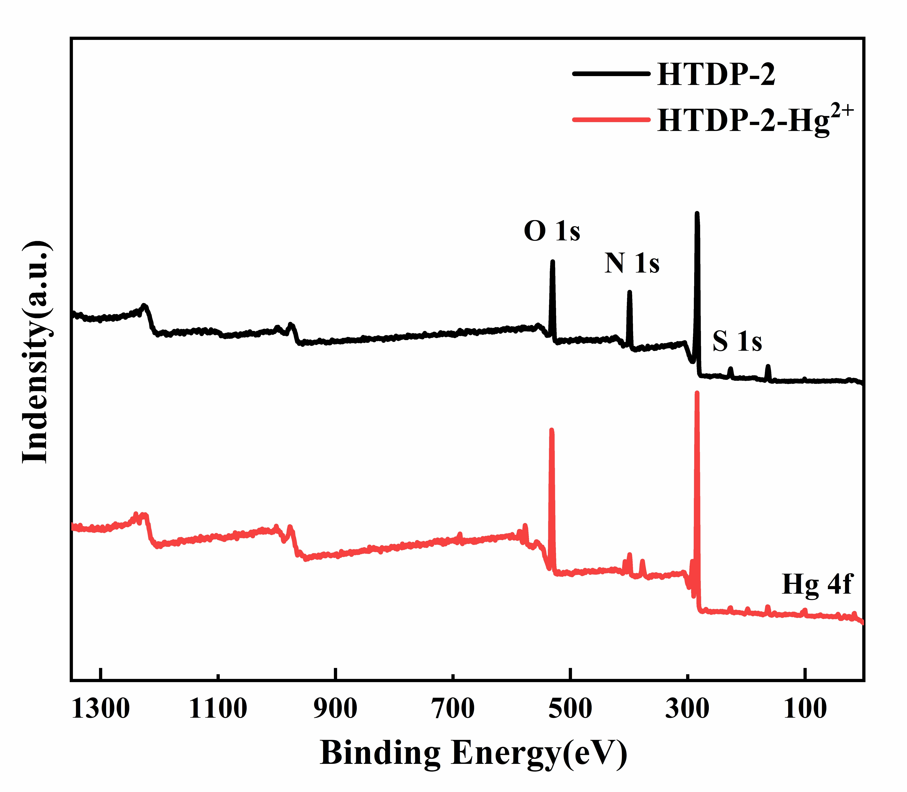
Fig S7. XPS spectra of HTDP-2 and HTDP-2-Hg²⁺.

Table S1. Mercury (II) adsorption on the porous materials reported in the literature.

Materials |  | Adsorption capacity/mg g⁻¹ | Polymer dosage |  | Reference
POP-SH |  | 180 | 0.01g/10mL |  | [1]
TP-TC-MA |  | 351.6 | 0.02g/25mL |  | [2]
COF-S-SH |  | 1350 | 0.005g/10mL |  | [3]
COP-108-S |  | 241 | 0.03g/30mL |  | [4]
TpTSC |  | 1035 | 0.01g/50mL |  | [5]
SA@MnNP |  | 299 | 0.5g/30 mL |  | [6]
M-DAPS50-COF-SH |  | 383 | 0.005g/10mL |  | [7]
Sulfonated COF |  | 98.42 | 0.01g/50mL |  | [8]
PHTCZ-1-MA |  | 416 | 0.02g/50mL |  | [9]
HTDP-2 |  | 463.3 | 0.01g/50mL |  | This work

Table S2. Comparison of various fluorescent probes for Hg²⁺ ion detection.

Materials |  | LOD (ppm) | Linear range(ppm) | Reusability of fluorescence (Times of cycles) |  | Reference
N, S/C-dots |  | 0.4 | 0-8 | — |  | [10]
TNPP |  | 2.28×10⁻² | 0-0.9 | 3 |  | [11]
BATH₂-Bt |  | 5.2×10⁻³ | 0-5.5 | 5 |  | [12]
TFPPy-CHYD |  | 3.4×10⁻³ | 0-2 | 6 |  | [13]
COP-108-S |  | 2.89×10⁻³ | 0-2006 | 5 |  | [4]
TpTSC |  | 2 | 0-10 | — |  | [5]
COF-LUZ8 |  | 2.5×10⁻² | 0-6680 | 3 |  | [14]
AH-COF |  | 2×10⁻² | 0-8 | 4 |  | [15]
HPP-SH |  | 4.48×10⁻³ | 0-100 | — |  | [16]
UiO-66-PSM |  | 1.18 | 0-15.7 | — |  | [17]
FS-G |  | 3.34×10⁻² | 0-12 | 7 |  | [18]
HTDP-2 |  | 0.7 | 0-150 | 5 |  | This work

Reference
1. Cheng J, Li Y, Li L, et al (2019) New J Chem 43:7683–7693.
2. Zhang C, Peng Z, Guo Y, et al (2021) Sep Purif Technol 274:119097.
3. Sun Q, Aguila B, Perman J, et al (2017) J Am Chem Soc 139:2786–2793.
4. Li J, Wang S, Cao X, et al (2021) Mater Chem Front 5:3428–3435.
5. Tang CM, Qin YC, Ni CL, Zou JP (2022) ACS Appl Polym Mater 4:849–858.
6. Arshadi M (2015) Chem Eng J 259:170–182.
7. Huang L, Shen R, Liu R, Shuai Q (2020) J Hazard Mater 392:122320.
8. Panda A, Yang Y, Venkateswarlu S, et al (2020) Microporous Mesoporous Mater 306:110399.
9. Sang Y, Cao Y, Wang L, et al (2021) J Colloid Interface Sci 587:121–130.
10. Li L, Yu B, You T (2015) Biosens Bioelectron 74:263–269.
11. He Y, Wang X, Wang K, Wang L (2020) Dyes Pigments 173:107880.
12. Yin Y, Liu G (2021) Mater Today Commun 27:102440.
13. Cui WR, Jiang W, Zhang CR, et al (2020) ACS Sustain Chem Eng 8:445–451.
14. Yu YX, Li GL, Liu JH, Yuan DQ (2020) Chem Eng J 401:126139.
15. Ding SY, Dong M, Wang YW, et al (2016) J Am Chem Soc 138:3031–3037.
16. Lv Z, Chen Z, Feng S, et al (2022) Polym Chem 13:2320–2330.
17. Zhang X, Xia T, Jiang K, et al (2017) J Solid State Chem 253:277–281.
18. Tang Y, Liu Y, Qin Y, et al (2016) J Colloid Interface Sci 479:7–14.

