Supplementary Fig. 1. Matrix-assisted laser desorption/ionization time-of-flight mass spectrometry (MALDI-TOF/TOF MS) of Streptomyces griseus MPPS2 strain
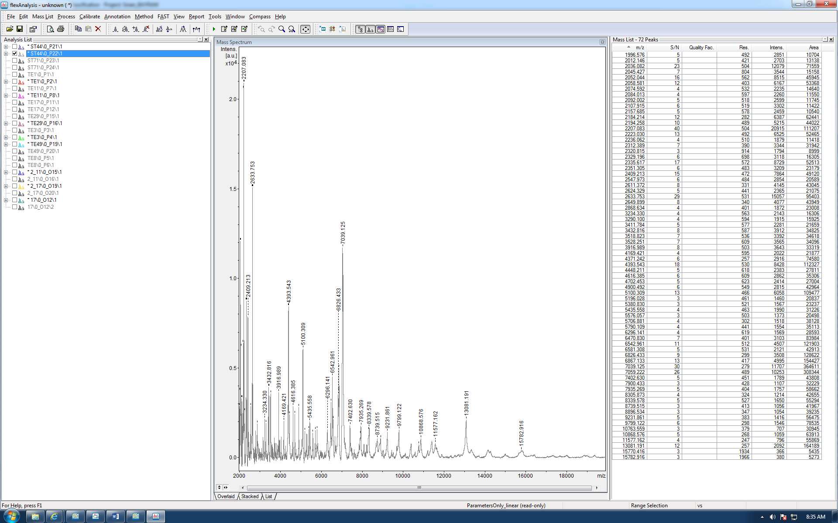
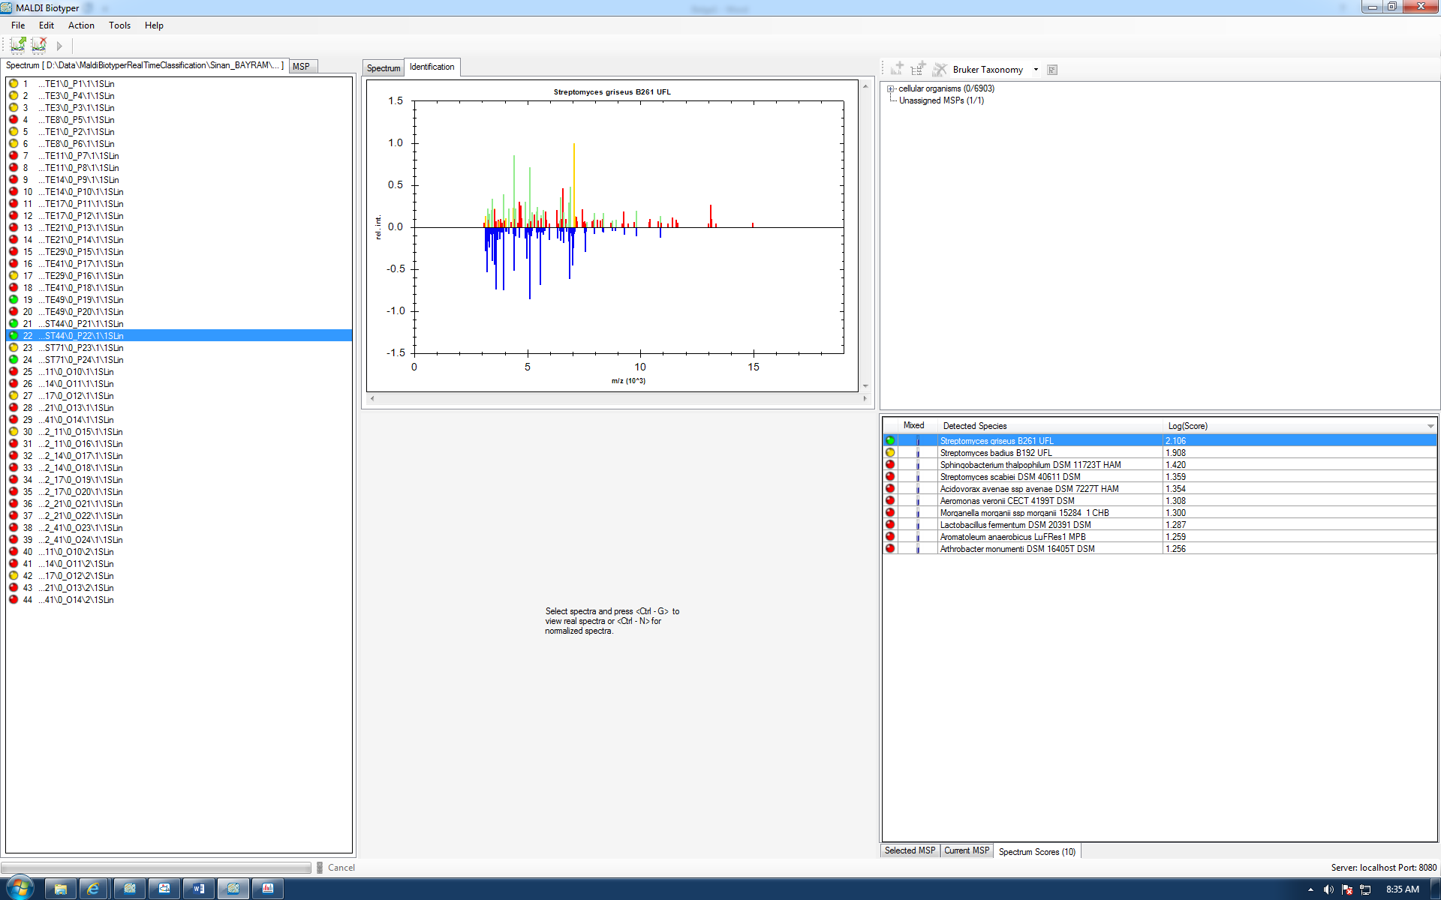
P22  ( ++ ) ( A ) | ST44 | Streptomyces griseus | 2.106 | Streptomyces badius | 1.908

