Supplementary Materials

Table S1 Summary of the draft genome assembly of the Y-M2^{T} strain.

Draft genome feature | Length/Number
Genome Size / bp | 3214613
ORF No. | 3016
rRNA No. (5S, 16S, 23S) | 3
tRNA No. | 48
Contigs No. | 27
G+C content | 68.07
N20 | 461460
N50 | 216590
N90 | 128336
Hit in KofamKOALA | 1970

Table S2 16S rRNA gene sequence similarities, average nucleotide identity (ANI), average amino acid identity (AAI), and percentage of conserved proteins (POCP) between strain Y-M2^{T} and representative species of family “Magnetospirillaceae”, “Novispirillaceae”, and Rhodospirillaceae.

strain | family | species | 16S rRNA similarities | ANI | AAI | POCP
Y-M2 | “Magnetospirillaceae” | Magnetospirillum moscoviense | 90.3 | 67.05 | 58.18 | 42.08
Y-M2 | “Magnetospirillaceae” | Magnetospirillum kuznetsovii | 90.4 | 70.32 | 58.00 | 41.28
Y-M2 | “Magnetospirillaceae” | Magnetospirillum molischianum | 89.4 | 70.37 | 58.34 | 42.88
Y-M2 | “Magnetospirillaceae” | Magnetospirillum fulvum | 88.8 | 70.55 | 58.42 | 45.96
Y-M2 | “Magnetospirillaceae” | Magnetospirillum marisnigri | 89.5 | 70.53 | 58.24 | 41.12
Y-M2 | “Magnetospirillaceae” | Magnetospirillum magneticum | 89.5 | 70.58 | 57.75 | 42.31
Y-M2 | “Magnetospirillaceae” | Magnetospirillum aberrantis | 89.6 | 70.28 | 58.26 | 45.30
Y-M2 | “Magnetospirillaceae” | Magnetospirillum caucaseum | 89.4 | 71.10 | 57.97 | 40.17
Y-M2 | “Magnetospirillaceae” | Magnetospirillum gryphiswaldense | 90.6 | 70.36 | 58.06 | 43.09
Y-M2 | “Magnetospirillaceae” | Magnetospirillum magnetotacticum | 89.5 | 69.95 | 57.70 | 40.48
Y-M2 | “Magnetospirillaceae” | Roseospira marina | 89.8 | 71.02 | 58.00 | 43.67
Y-M2 | “Magnetospirillaceae” | Roseospira navarrensis | 88.8 | 70.97 | 58.08 | 42.89
Y-M2 | “Magnetospirillaceae” | Roseospira visakhapatnamensis | 87.4 | 71.62 | 58.34 | 43.11
Y-M2 | “Magnetospirillaceae” | Roseospira goensis | 89.3 | 69.45 | 58.46 | 44.10
Y-M2 | Rhodospirillaceae | Pararhodospirillum oryzae | 88.7 | 70.13 | 57.99 | 47.73
Y-M2 | Rhodospirillaceae | Rhodospirillum rubrum | 89.3 | 70.38 | 58.37 | 47.26
Y-M2 | Rhodospirillaceae | Roseospirillum parvum | 90.6 | 71.31 | 58.21 | 48.03
Y-M2 | Rhodospirillaceae | Phaeovibrio sulfidiphilus | 88.5 | 70.20 | 57.24 | 41.95
Y-M2 | Rhodospirillaceae | Rhodospirillum photometricum | 89.3 | 69.85 | 58.15 | 45.94
Y-M2 | Rhodospirillaceae | Phaeospirillum molischianum | 88.8 | 69.45 | 58.34 | 42.88
Y-M2 | “Novispirillaceae” | Haematospirillum jordaniae | 89.9 | 71.69 | 57.40 | 43.84
Y-M2 | “Novispirillaceae” | Caenispirillum salinarum | 89.7 | 70.89 | 57.97 | 42.22
Y-M2 | “Novispirillaceae” | Caenispirillum bisanense | 90.2 | 71.83 | 58.65 | 43.07
Y-M2 | “Novispirillaceae” | Insolitispirillum peregrinum | 89.5 | 69.85 | 57.79 | 44.73
Y-M2 | “Novispirillaceae” | Novispirillum itersonii | 89.4 | 70.10 | 57.91 | 45.33

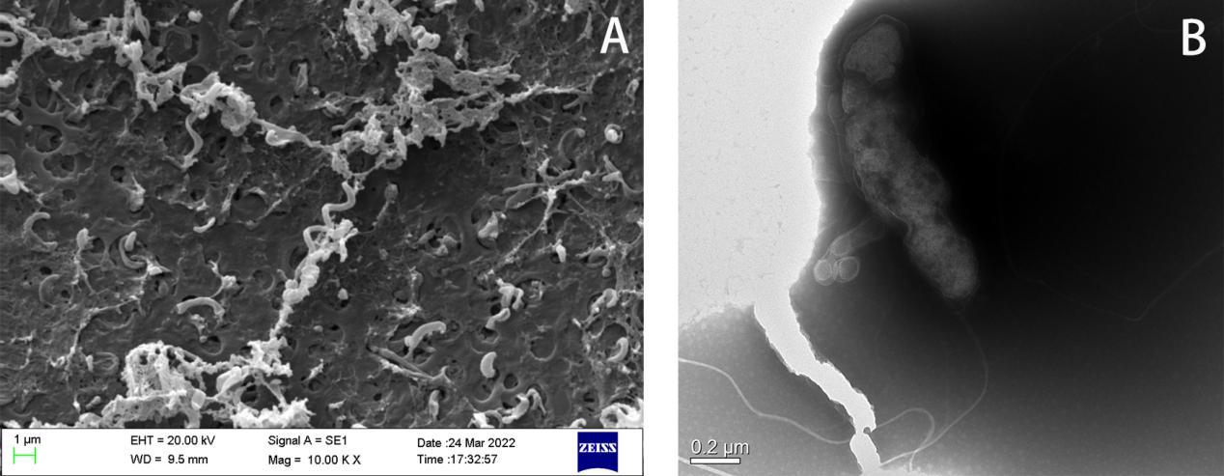
Fig S1. Micrographs of strain Y-M2^{T}. (A) Scanning electron micrograph. (B) Transmission electron micrograph.
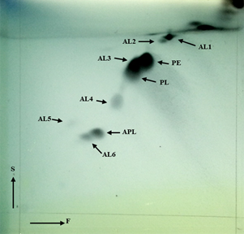
Fig S2. The major polar lipids of strain Y-M2^{T}. AL, aminolipid; APL, aminophospholipid; DPG, diphosphatidylglycerol; GL, glycolipid; L, unknown polar lipid; PC, phosphatidylcholine; PE, phosphatidylethanolamine; PG, phosphatidylglycerol; PME, phosphatidylmonomethylethanolamine; PL, phospholipid; SGL, sphingoglycolipid. F, first dimension of TLC; S, second dimension of TLC.
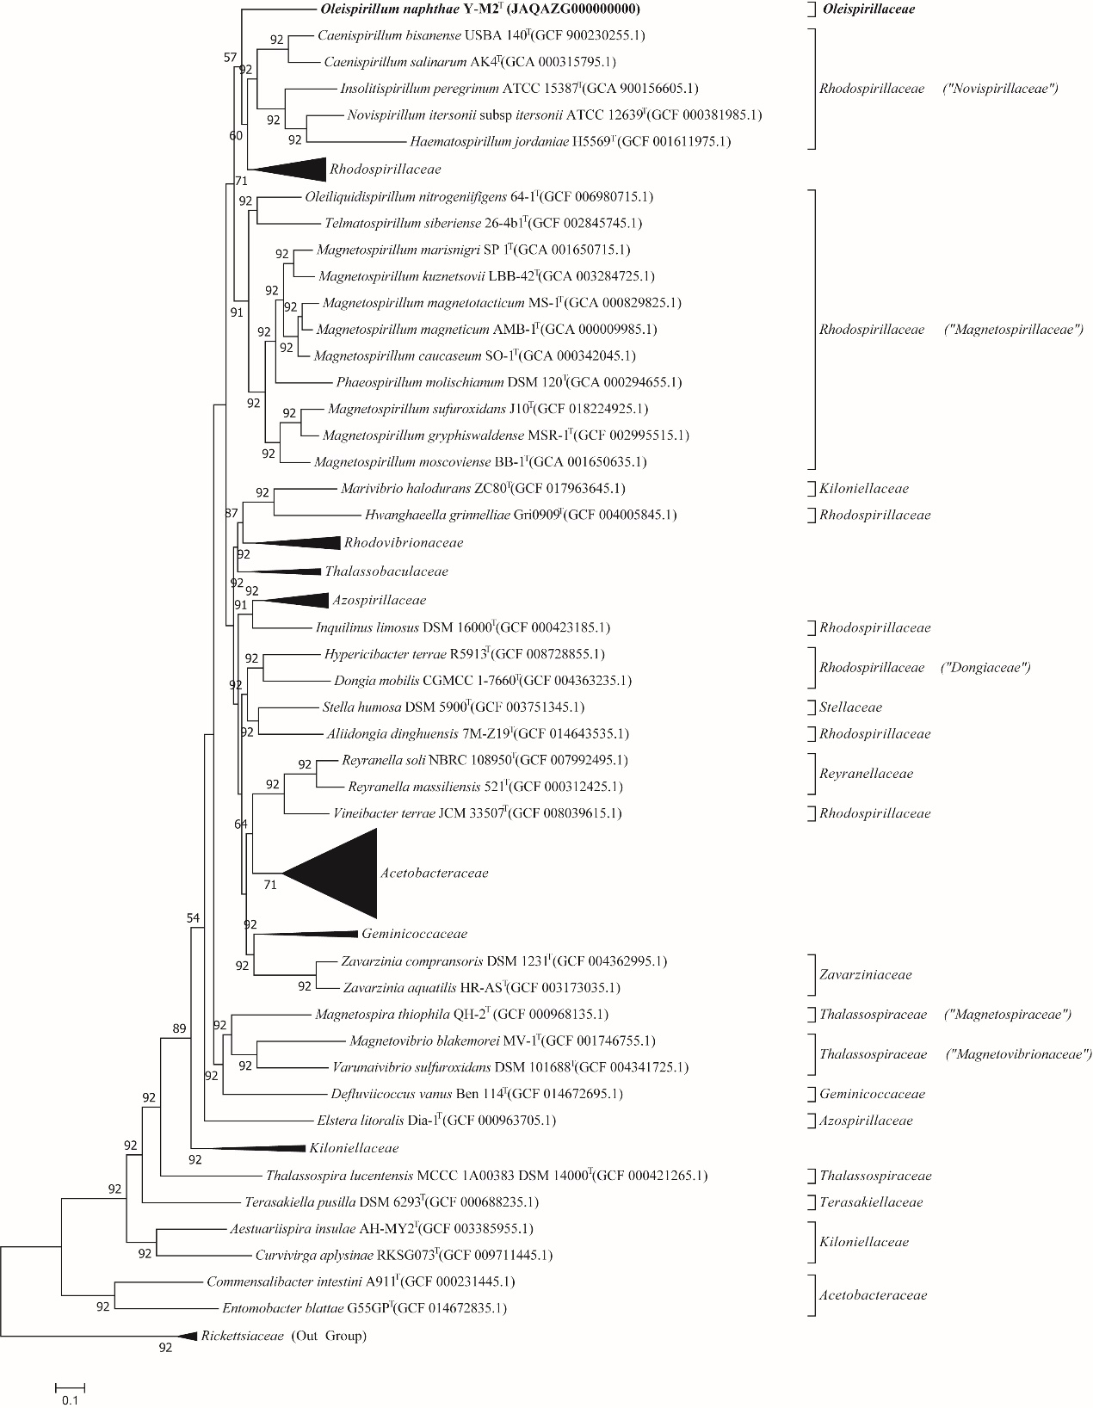
Figure S3. Phylogenetic tree of strain Y-M2^{T} and Rhodospirilles strains using concatenated alignment of 92 core genes.

