Supplementary file
Friction and degradation of graphite: a nanotribological approach
J.M. Kim, A. Caron*
KOREATECH – Korea University of Technology and Education, School of Energy, Materials, and Chemical Engineering, Cheonan, 31253 Republic of Korea
*Corresponding author: Arnaud Caron – arnaud.caron@koreatech.ac.kr

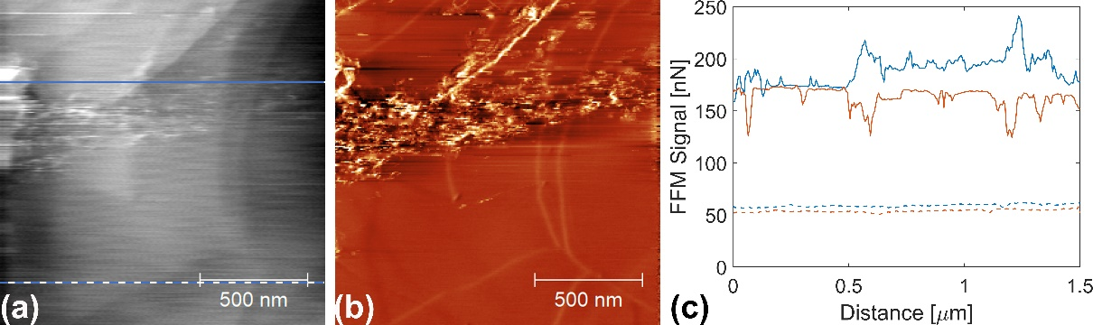
Figure S1: (a) topography and (b) lateral force images recorded in ambient on HOPG with a SiO_{x} tip with a normal force value F_{n} = 70 nN, and (c) representative friction loops for the effect of surface degradation on friction corresponding to the indicated line scan in (a). The friction loop drawn with continuous lines in (c) corresponds to the continuous blue line in (a). The friction loop represented with dashed lines corresponds to the dashed blue line in (a). In (c), the blue curves correspond to the forward sliding motion of the tip, while the orange curves correspond to its backward motion.
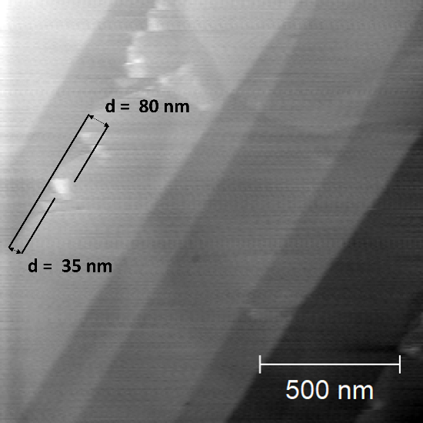
Figure S2: Topography image recorded in ambient on HOPG with a Pt tip. The upper left part of the image shows local exfoliations of graphite flakes at a surface step edge. The image also indicates the lateral dimension of the exfoliated areas.

