SUPPLEMENTARY MATERIAL

Supplementary file 1. Search strategy

Cochrane
ID Search Hits
#1 MeSH descriptor: [Chronic Urticaria] explode all trees 31
#2 (Chronic Urticarias):ti,ab,kw OR (Urticaria, Chronic):ti,ab,kw OR (Chronic Inducible Urticaria):ti,ab,kw OR (Chronic Inducible Urticarias):ti,ab,kw OR (Inducible Urticaria, Chronic):ti,ab,kw OR (Urticaria, Chronic Inducible):ti,ab,kw OR (CIndU):ti,ab,kw OR (Chronic Spontaneous Urticaria):ti,ab,kw OR (Chronic Spontaneous Urticarias):ti,ab,kw OR (Spontaneous Urticaria, Chronic):ti,ab,kw OR (Urticaria, Chronic Spontaneous):ti,ab,kw OR (Idiopathic Chronic Urticaria):ti,ab,kw OR (Chronic Urticaria, Idiopathic):ti,ab,kw OR (Idiopathic Chronic Urticarias):ti,ab,kw OR (Urticaria, Idiopathic Chronic):ti,ab,kw OR (Chronic Idiopathic Urticaria):ti,ab,kw OR (Chronic Idiopathic Urticarias):ti,ab,kw OR (Idiopathic Urticaria, Chronic):ti,ab,kw OR (Urticaria, Chronic Idiopathic):ti,ab,kw OR (Autoimmune Urticaria):ti,ab,kw OR (Autoimmune Urticarias):ti,ab,kw OR (Urticaria, Autoimmune):ti,ab,kw OR (Chronic Autoimmune Urticaria):ti,ab,kw OR (Autoimmune Urticaria, Chronic):ti,ab,kw OR (Chronic Autoimmune Urticarias):ti,ab,kw OR (Urticaria, Chronic Autoimmune):ti,ab,kw OR (hive):ti,ab,kw OR (CSU):ti,ab,kw OR (CIU):ti,ab,kw 1330
#3 #1 or #2 1330
#4 (Omalizumab) :ti,ab,kw OR (Xolair):ti,ab,kw 1031
#5 (randomized controlled trial) :ti,ab,kw OR (controlled clinical trial):ti,ab,kw OR (randomized):ti,ab,kw OR (placebo):ti,ab,kw OR (clinical trials as topic):ti,ab,kw OR (randomly):ti,ab,kw OR (trial):ti,ab,kw 1378994
#6 #3 and #4 and #5 with Cochrane Library publication date Between Jan 1900 and Jan 2023 213

Embase
No. Query Results Results
#7. #3 AND #4 AND #5 AND [01-01-1900]/sd NOT 262
[16-01-2023]/sd AND [<1966-2023]/py
#6. #3 AND #4 AND #5 262
#5. 'randomized controlled trial':ab,ti OR 2,057,900
'controlled clinical trial':ab,ti OR
'randomized':ab,ti OR 'placebo':ab,ti OR
'clinical trials as topic':ab,ti OR
'randomly':ab,ti OR 'trial':ab,ti
#4. 'omalizumab':ab,ti OR 'xolair':ab,ti 6,132
#3. #1 OR #2 6,143
#2. 'chronic urticarias':ab,ti OR 'urticaria, 6,143
chronic':ab,ti OR 'chronic inducible
urticaria':ab,ti OR 'chronic inducible
urticarias':ab,ti OR 'inducible urticaria,
chronic':ab,ti OR 'urticaria, chronic
inducible':ab,ti OR 'cindu':ab,ti OR 'chronic
spontaneous urticaria':ab,ti OR 'chronic
spontaneous urticarias':ab,ti OR 'spontaneous
urticaria, chronic':ab,ti OR 'urticaria, chronic
spontaneous':ab,ti OR 'idiopathic chronic
urticaria':ab,ti OR 'chronic urticaria,
idiopathic':ab,ti OR 'idiopathic chronic
urticarias':ab,ti OR 'urticaria, idiopathic
chronic':ab,ti OR 'chronic idiopathic
urticaria':ab,ti OR 'chronic idiopathic
urticarias':ab,ti OR 'idiopathic urticaria,
chronic':ab,ti OR 'urticaria, chronic
idiopathic':ab,ti OR 'autoimmune urticaria':ab,ti
OR 'autoimmune urticarias':ab,ti OR 'urticaria,
autoimmune':ab,ti OR 'chronic autoimmune
urticaria':ab,ti OR 'autoimmune urticaria,
chronic':ab,ti OR 'chronic autoimmune
urticarias':ab,ti OR 'urticaria, chronic
autoimmune':ab,ti OR 'hive':ab,ti OR 'csu':ab,ti
#1. 'chronic spontaneous urticaria':ab,ti 2,194

OVID
# Query
1 Chronic Urticaria.ab,ti. 4,538
2 (Chronic Urticarias or Urticaria, Chronic or Chronic Inducible Urticaria or Chronic Inducible Urticarias or Inducible Urticaria, Chronic or Urticaria, Chronic Inducible or CIndU or Chronic Spontaneous Urticaria orChronic Spontaneous Urticarias or Spontaneous Urticaria, Chronic orUrticaria, Chronic Spontaneous or Idiopathic Chronic Urticaria or Chronic Urticaria, Idiopathic or Idiopathic Chronic Urticarias or Urticaria, Idiopathic Chronic or Chronic Idiopathic Urticaria or Chronic Idiopathic Urticarias or Idiopathic Urticaria, Chronic or Urticaria, Chronic Idiopathic or Autoimmune Urticaria or Autoimmune Urticarias or Urticaria, Autoimmune or Chronic Autoimmune Urticaria or Autoimmune Urticaria, Chronic or Chronic Autoimmune Urticarias or Urticaria, Chronic Autoimmune hive or CSU or CIU).ab,ti. 3,349
3 1 or 2 6,978
4 (Omalizumab or Xolair).ab,ti. 4,602
5 ((randomized controlled trial or controlled clinical trial).pt. or randomized.ab. or placebo.ab. or clinical trials as topic.sh. or randomly.ab. or trial.ti.) not (animals not (humans and animals)).sh. 2,562,294
6 3 and 4 and 5 161
7 limit 6 to yr=“1900 – 2023” 161

Web of Science
1: TS=(Chronic Urticarias or Urticaria, Chronic or Chronic Inducible Urticaria or Chronic Inducible Urticarias or Inducible Urticaria, Chronic Or Urticaria, Chronic Inducible or CIndU or Chronic Spontaneous Urticaria orChronic Spontaneous Urticarias or Spontaneous Urticaria, Chronic orUrticaria, Chronic Spontaneous or Idiopathic Chronic Urticaria or Chronic Urticaria, Idiopathic or Idiopathic Chronic Urticarias or Urticaria, Idiopathic Chronic or Chronic Idiopathic Urticaria or Chronic Idiopathic Urticarias or Idiopathic Urticaria, Chronic or Urticaria, Chronic Idiopathic or Autoimmune Urticaria or Autoimmune Urticarias or Urticaria, Autoimmune or Chronic Autoimmune Urticaria or Autoimmune Urticaria, Chronic or Chronic Autoimmune Urticarias or Urticaria, Chronic Autoimmune or hive or CSU or CIU) retrieved result: 16288
2: TS= (Omalizumab or Xolair) retrieved result: 5697
3: TS=（(randomized controlled trial or controlled clinical trial or randomized or placebo or clinical trials as topic or randomly or trial) not (animals not (humans and animals))） retrieved result: 2558910
4: #1 AND #2 AND #3 retrieved result: 266
5: #1 AND #2 AND #3 retrieved result: 266

Supplementary Figure 1 Risk of bias 2. The evaluation parameters include: (1) Bias assessment during randomization; (2) Assessment of bias away from established interventions (effects of intervention allocation or compliance); (3) Bias assessment of missing outcome data; (4) Assessment of bias in outcome measures; (5) Assessment of bias in selective reporting results. There are three levels of bias risk in each area: “low risk of bias,” “some concerns” and “high risk of bias .” If the results of bias risk assessment in all fields are “low risk,” then the overall risk of bias is “low risk .” If the bias risk evaluation result of some fields is “with certain risk” and there is no “high risk” field, then the overall bias risk is “with certain risk .” If the evaluation result of bias risk in one domain is “high risk,” then the overall bias risk is “high risk.”
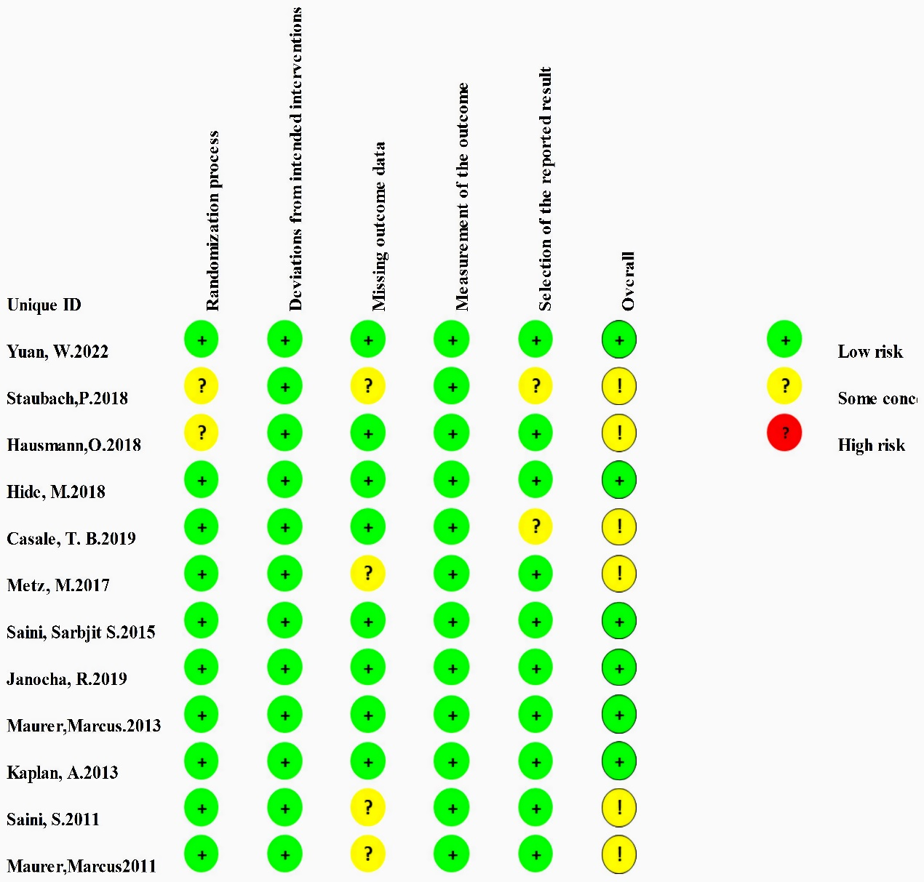

Supplementary Figure 2 Cumulative meta-analysis of the percentage of participants with UAS7 ≤ 6. Forest plots. A. Year; B. Dose; C. Number of patients. Horizontal lines represent 95% CIs of the RR estimates. Blue diamond represents the meta-analysis summary effect estimate; blue dots represent the RR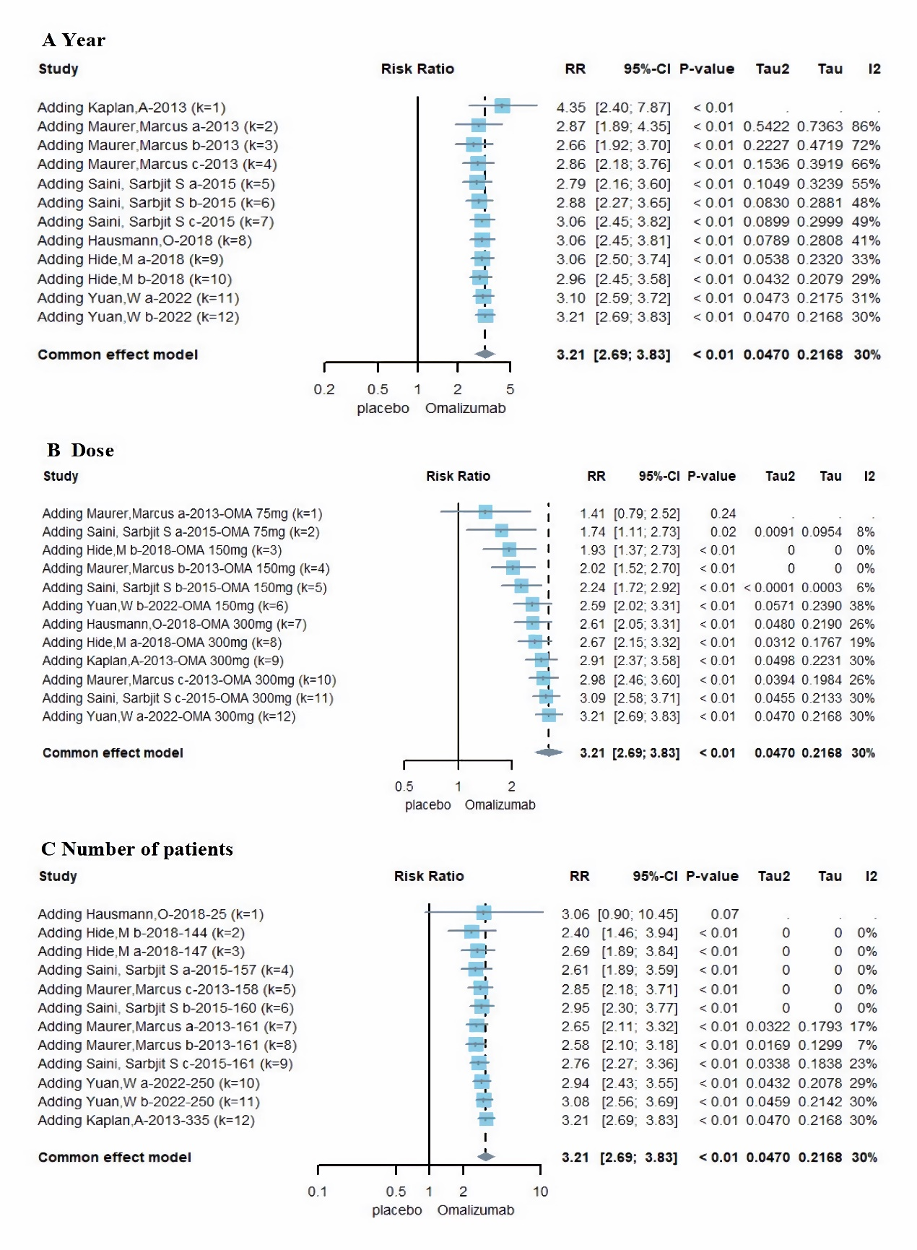

Supplementary Figure 3 Heterogeneity and meta-analysis of the percentage of participants with UAS7 ≤ 6. A. Labbe plot; B. Forest plot. Horizontal lines represent 95% CIs of the RR estimates. Blue diamond represents the meta-analysis summary effect estimate; blue dots represent the RR
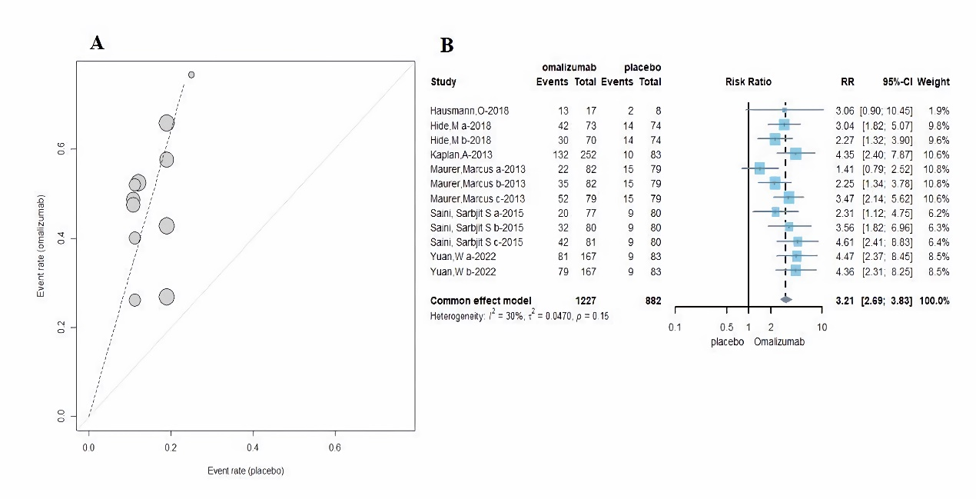

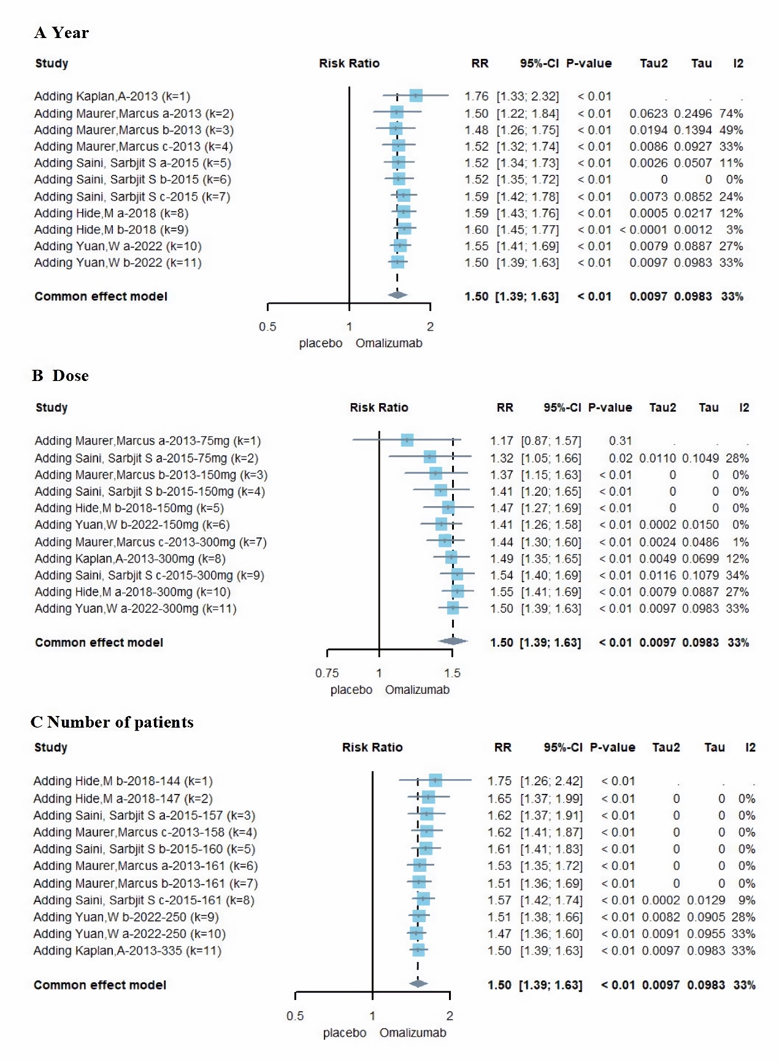
Supplementary Figure 4 Cumulative meta-analysis of the percentage of ISS7 MID responders. Forest plots. A. Year; B. Dose; C. Number of patients. Horizontal lines represent 95% CIs of the RR estimates. Blue diamond represents the meta-analysis summary effect estimate; blue dots represent the RR

Supplementary Figure 5 Heterogeneity and meta-analysis of the percentage of ISS7 MID responders. A. Labbe plot; B. Forest plot. Horizontal lines represent 95% CIs of the RR estimates. Blue diamond represents the meta-analysis summary effect estimate; blue dots represent the RR
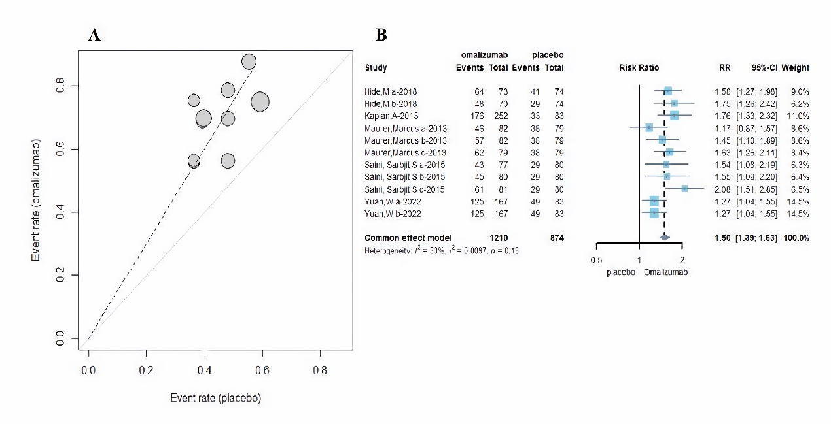

Supplementary Figure 6 Cumulative meta-analysis of adverse events. Subscript: Forest plots. A. Year; B. Dose; C. Number of patients. Horizontal lines represent 95% CIs of the RR estimates. Blue diamond represents the meta-analysis summary effect estimate; blue dots represent the RR
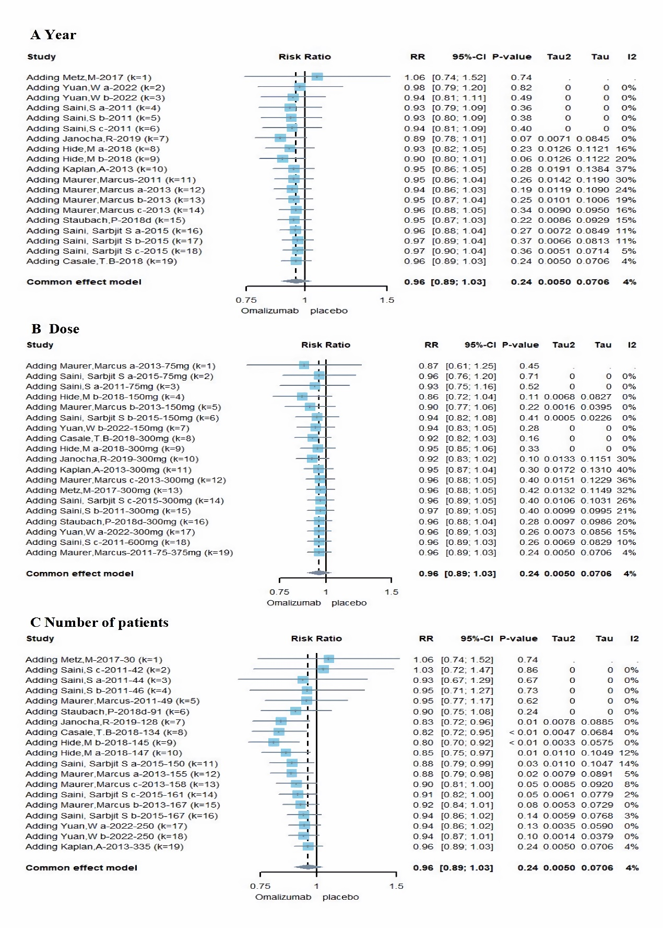

Supplementary Figure 7 Heterogeneity and meta-analysis of adverse events. A. Labbe plot; B. Forest plot. Horizontal lines represent 95% CIs of the RR estimates. Blue diamond represents the meta-analysis summary effect estimate; blue dots represent the RR
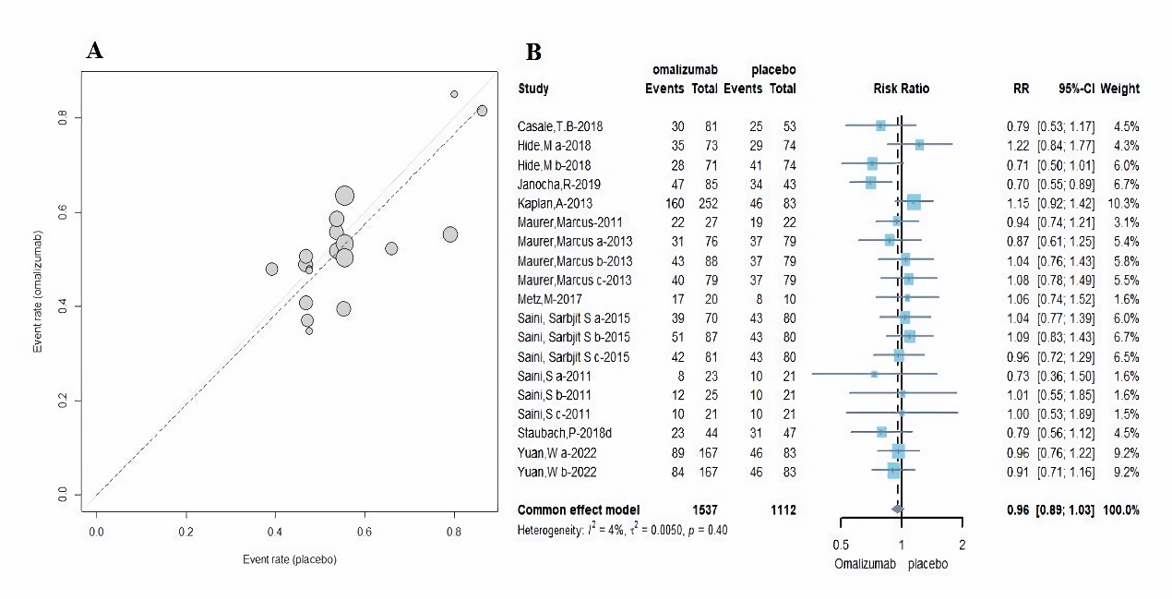

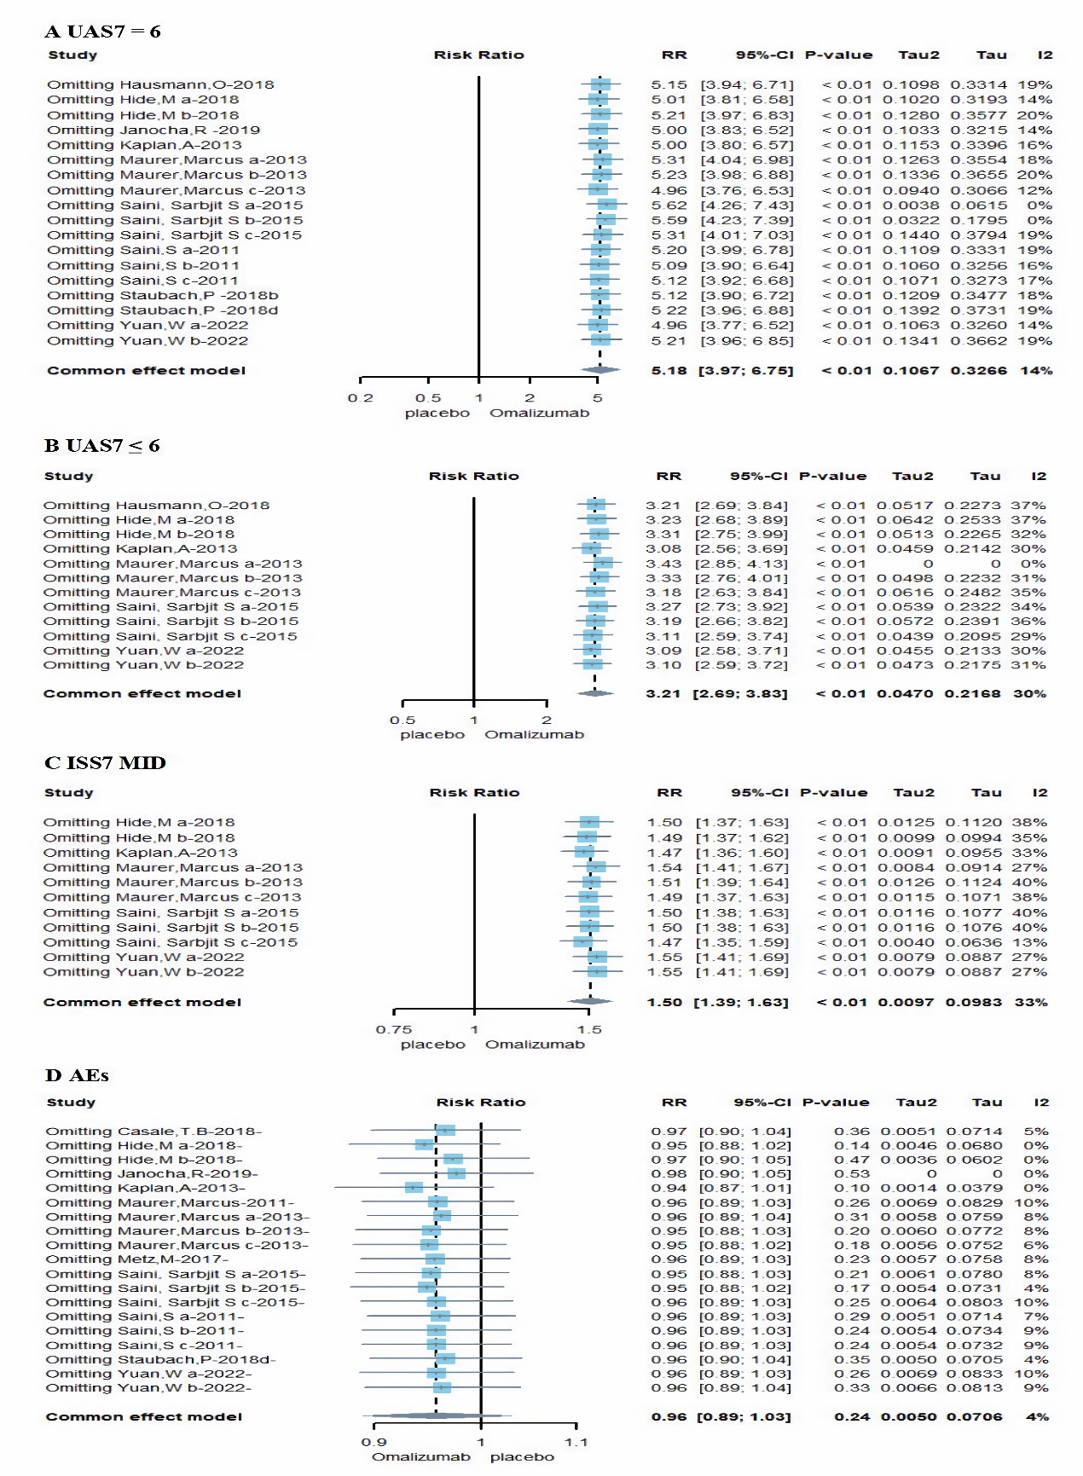
Supplementary Figure 8 Sensitive analysis. A. The percentage of complete responders (UAS7 = 0); B. The percentage of participants with UAS7 ≤ 6; C. The percentage of ISS7 MID responders; D. Adverse events. Horizontal lines represent 95% CIs of the RR estimates. Blue diamond represents the meta-analysis summary effect estimate; blue dots represent the RR

Supplementary Figure 9 Classic funnel plot. A. The percentage of complete responders (UAS7 = 0); B. The percentage of participants with UAS7 ≤ 6; C. The percentage of ISS7 MID responders; D. Adverse events
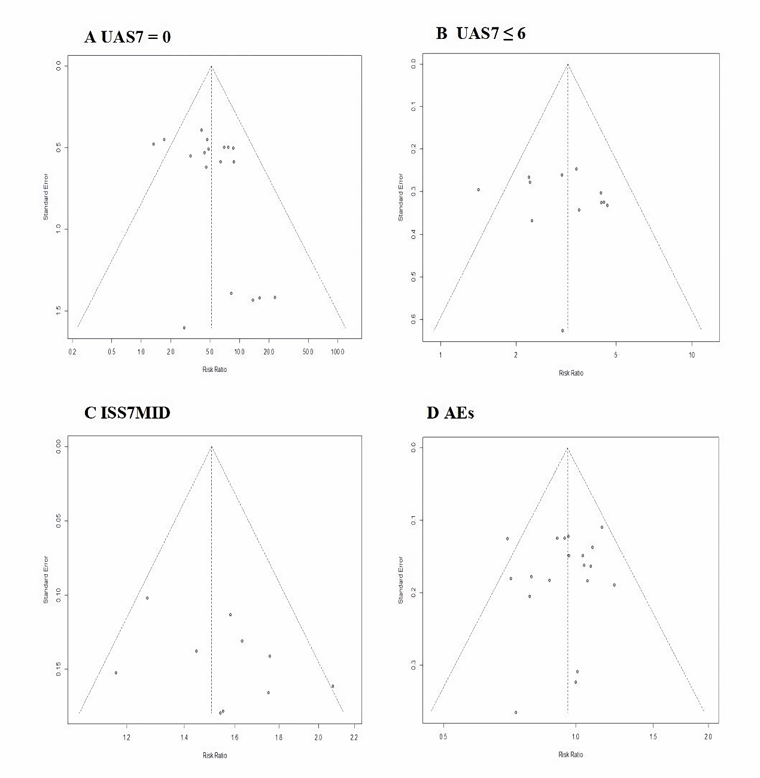

Supplementary Figure 10 Contour-enhanced funnel plot. A. The percentage of complete responders (UAS7 = 0); B. The percentage of participants with UAS7 ≤ 6; C. The percentage of ISS7 MID responders
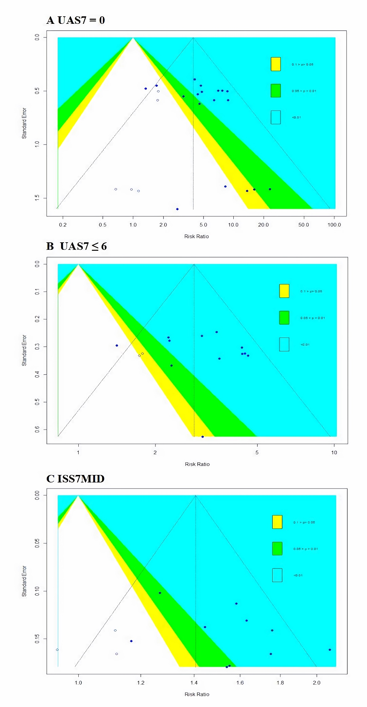

Subscript: The solid scatters in the figure represent the existing studies, while the hollow scatters represent the supplementary studies needed to correct the asymmetry obtained by the shear and complement methods. The yellow region, green region, blue region, and blank region, respectively, represent regions with different significance levels, which are P < 0.01, 0.01 < P < 0.05, 0.05 < P < 0.1, and P > 0.1. The first three regions are collectively referred to as statistically significant regions, and the last region is referred to as a no statistically significant region.

Supplementary Table 1. PRISMA checklist.
Section and Topic | Item # | Checklist item | Location where item is reported
TITLE
Title | 1 | Identify the report as a systematic review. | 1
ABSTRACT
Abstract | 2 | See the PRISMA 2020 for Abstracts checklist. | 2
INTRODUCTION
Rationale | 3 | Describe the rationale for the review in the context of existing knowledge. | 3
Objectives | 4 | Provide an explicit statement of the objective(s) or question(s) the review addresses. | 3
METHODS
Eligibility criteria | 5 | Specify the inclusion and exclusion criteria for the review and how studies were grouped for the syntheses. | 4
Information sources | 6 | Specify all databases, registers, websites, organisations, reference lists and other sources searched or consulted to identify studies. Specify the date when each source was last searched or consulted. | 3
Search strategy | 7 | Present the full search strategies for all databases, registers and websites, including any filters and limits used. | 3
Selection process | 8 | Specify the methods used to decide whether a study met the inclusion criteria of the review, including how many reviewers screened each record and each report retrieved, whether they worked independently, and if applicable, details of automation tools used in the process. | 4
Data collection process | 9 | Specify the methods used to collect data from reports, including how many reviewers collected data from each report, whether they worked independently, any processes for obtaining or confirming data from study investigators, and if applicable, details of automation tools used in the process. | 4
Data items | 10a | List and define all outcomes for which data were sought. Specify whether all results that were compatible with each outcome domain in each study were sought (e.g. for all measures, time points, analyses), and if not, the methods used to decide which results to collect. | 4
Data items | 10b | List and define all other variables for which data were sought (e.g. participant and intervention characteristics, funding sources). Describe any assumptions made about any missing or unclear information. | 4
Study risk of bias assessment | 11 | Specify the methods used to assess risk of bias in the included studies, including details of the tool(s) used, how many reviewers assessed each study and whether they worked independently, and if applicable, details of automation tools used in the process. | 4
Effect measures | 12 | Specify for each outcome the effect measure(s) (e.g. risk ratio, mean difference) used in the synthesis or presentation of results. | 4
Synthesis methods | 13a | Describe the processes used to decide which studies were eligible for each synthesis (e.g. tabulating the study intervention characteristics and comparing against the planned groups for each synthesis (item #5)). | 4
Synthesis methods | 13b | Describe any methods required to prepare the data for presentation or synthesis, such as handling of missing summary statistics, or data conversions. | None
Synthesis methods | 13c | Describe any methods used to tabulate or visually display results of individual studies and syntheses. | 4
Synthesis methods | 13d | Describe any methods used to synthesize results and provide a rationale for the choice(s). If meta-analysis was performed, describe the model(s), method(s) to identify the presence and extent of statistical heterogeneity, and software package(s) used. | 4
Synthesis methods | 13e | Describe any methods used to explore possible causes of heterogeneity among study results (e.g. subgroup analysis, meta-regression). | 4
Synthesis methods | 13f | Describe any sensitivity analyses conducted to assess robustness of the synthesized results. | 4
Reporting bias assessment | 14 | Describe any methods used to assess risk of bias due to missing results in a synthesis (arising from reporting biases). | 4
Certainty assessment | 15 | Describe any methods used to assess certainty (or confidence) in the body of evidence for an outcome. | None
RESULTS
Study selection | 16a | Describe the results of the search and selection process, from the number of records identified in the search to the number of studies included in the review, ideally using a flow diagram. | 5
Study selection | 16b | Cite studies that might appear to meet the inclusion criteria, but which were excluded, and explain why they were excluded. | 5
Study characteristics | 17 | Cite each included study and present its characteristics. | 5
Risk of bias in studies | 18 | Present assessments of risk of bias for each included study. | 5
Results of individual studies | 19 | For all outcomes, present, for each study: (a) summary statistics for each group (where appropriate) and (b) an effect estimate and its precision (e.g. confidence/credible interval), ideally using structured tables or plots. | 5-7
Results of syntheses | 20a | For each synthesis, briefly summarise the characteristics and risk of bias among contributing studies. | 5
Results of syntheses | 20b | Present results of all statistical syntheses conducted. If meta-analysis was done, present for each the summary estimate and its precision (e.g. confidence/credible interval) and measures of statistical heterogeneity. If comparing groups, describe the direction of the effect. | 6-8
Results of syntheses | 20c | Present results of all investigations of possible causes of heterogeneity among study results. | no
Results of syntheses | 20d | Present results of all sensitivity analyses conducted to assess the robustness of the synthesized results. | 6
Reporting biases | 21 | Present assessments of risk of bias due to missing results (arising from reporting biases) for each synthesis assessed. | 6-7
Certainty of evidence | 22 | Present assessments of certainty (or confidence) in the body of evidence for each outcome assessed. | None
DISCUSSION
Discussion | 23a | Provide a general interpretation of the results in the context of other evidence. | 7
Discussion | 23b | Discuss any limitations of the evidence included in the review. | 8
Discussion | 23c | Discuss any limitations of the review processes used. | 8
Discussion | 23d | Discuss implications of the results for practice, policy, and future research. | 7-8
OTHER INFORMATION
Registration and protocol | 24a | Provide registration information for the review, including register name and registration number, or state that the review was not registered. | no
Registration and protocol | 24b | Indicate where the review protocol can be accessed, or state that a protocol was not prepared. | no
Registration and protocol | 24c | Describe and explain any amendments to information provided at registration or in the protocol. | no
Support | 25 | Describe sources of financial or non-financial support for the review, and the role of the funders or sponsors in the review. | 9
Competing interests | 26 | Declare any competing interests of review authors. | 9
Availability of data, code and other materials | 27 | Report which of the following are publicly available and where they can be found: template data collection forms; data extracted from included studies; data used for all analyses; analytic code; any other materials used in the review. | 9

Supplementary Table 2. Bias tests.
Sequence  number | Outcome | N | Begg'S |  | Egger's
Sequence  number | Outcome | N | Z | P | t | P
A | UAS7 = 0 | 18 | 1.02 | 0.3065 | 1.61 | 0.1267
B | UAS7 ≤ 6 | 12 | 0.27 | 0.7839 | 0.47 | 0.6459
C | ISS7 MID | 11 | 1.25 | 0.2102 | 1.9 | 0.0896
D | AEs | 19 | -1.01 | 0.2102 | 1.9 | 0.0896

