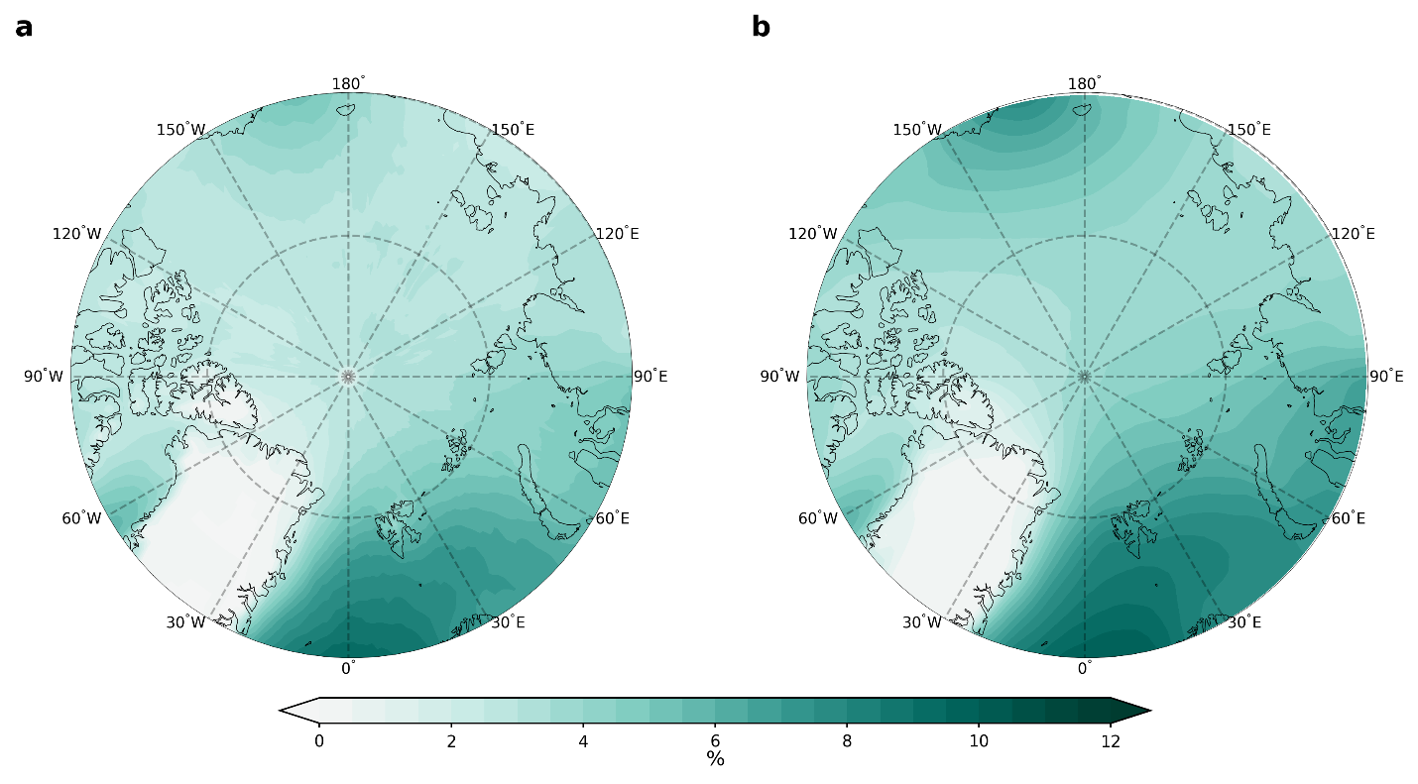
Extended Data Fig. 1 Atmospheric river (AR) climatology. Annual mean AR frequency (1981–2021) over the Arctic in ERA5 (a) and LENS2 (b).

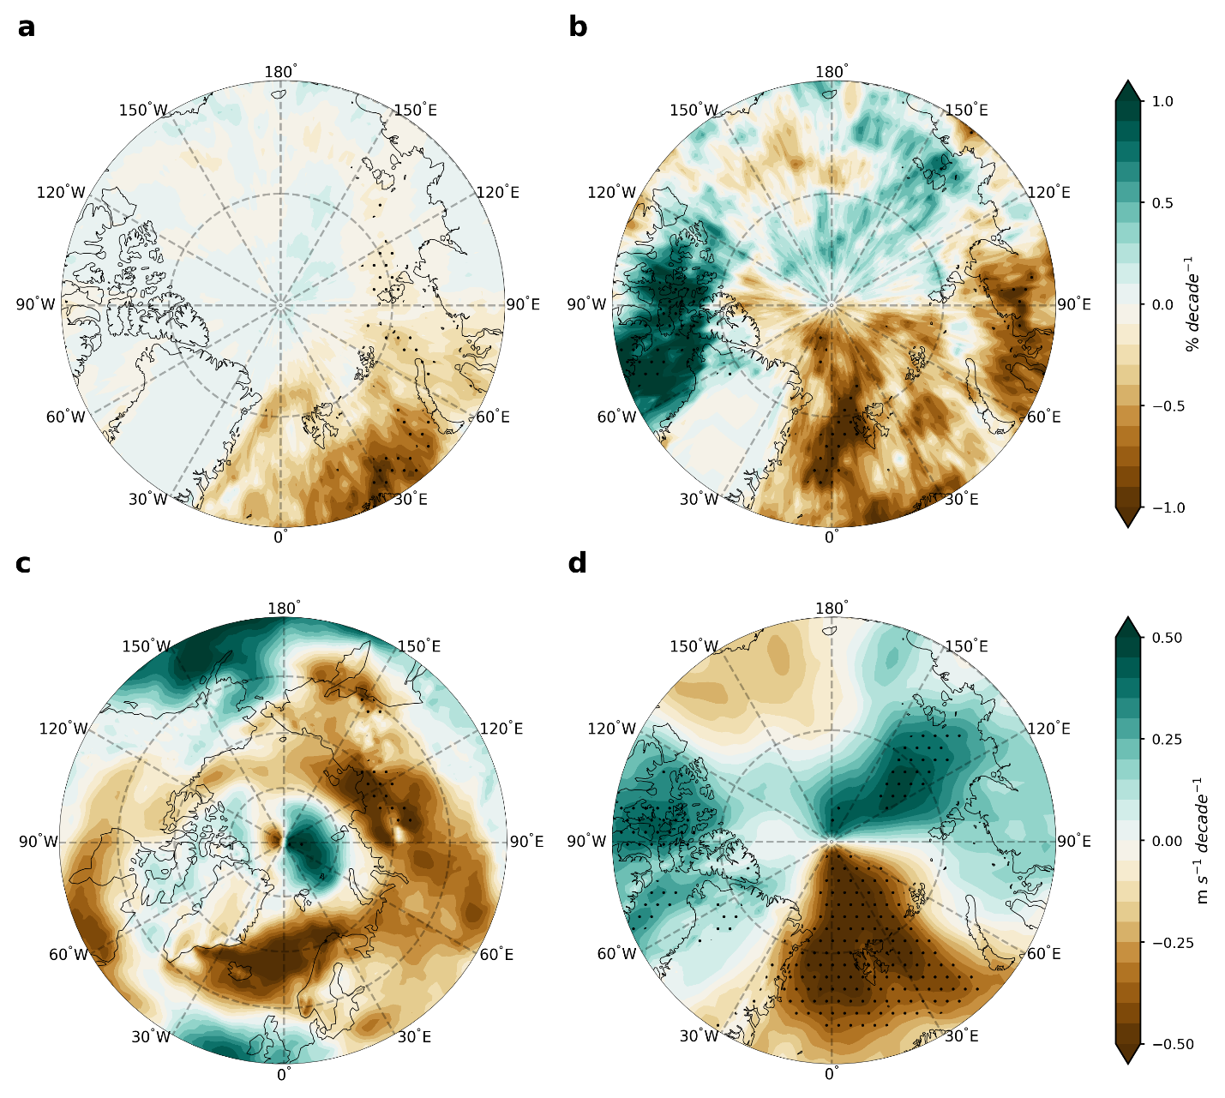
Extended Data Fig. 2 Seasonal Arctic atmospheric river (AR) frequency trends due to dynamic contribution in ERA5. a-b, winter (December-February) and summer (June-August) Arctic AR frequency trends due to dynamic contribution. c, 850 mb zonal wind trend in winter. d, 850 mb meridional wind trend in summer. Stippled areas indicate trends are significant at the 0.05 level based on the Student’s t-test.

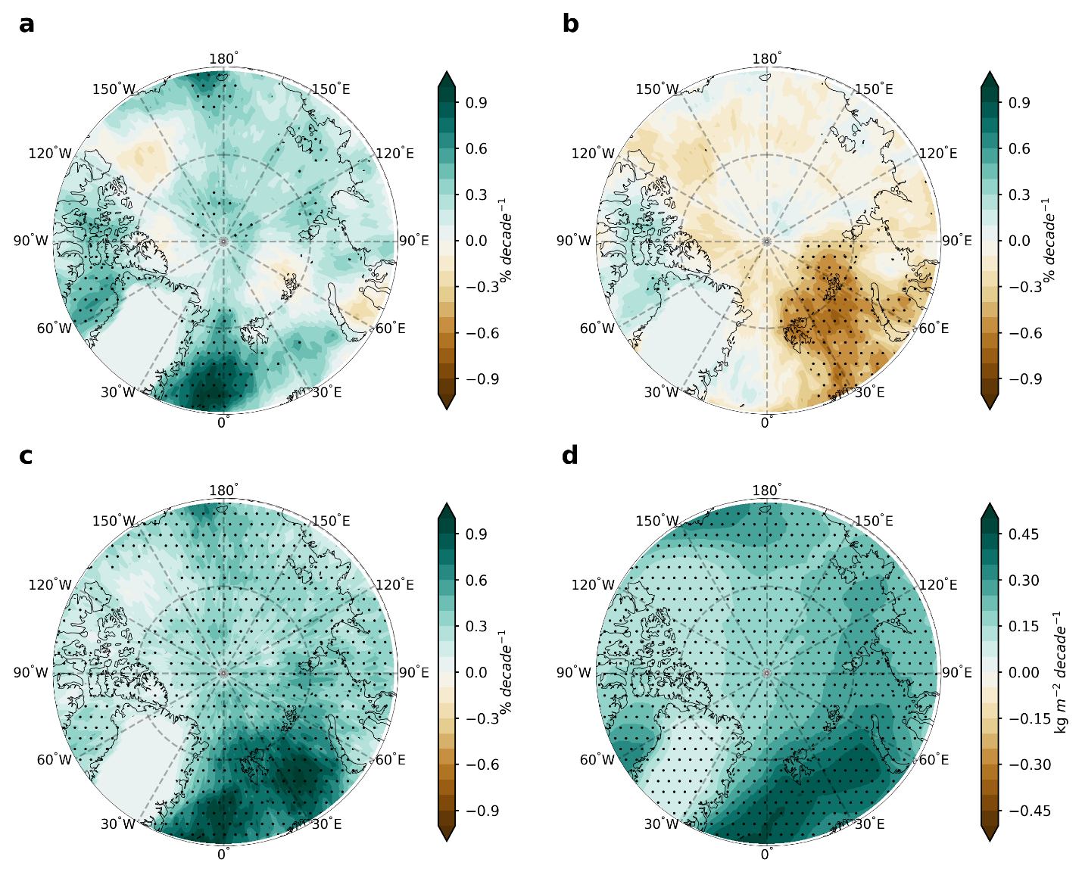
Extended Data Fig. 3 Atmospheric river (AR) trends over the Arctic in MERRA-2. a, Arctic AR frequency trend from 1981 to 2021. The dynamic contribution and thermodynamic contribution are shown in b and c, respectively. d, observed trends in column-integrated water vapor from 1981 to 2021. Stippled areas in a, b, c, and d indicate trends are significant at the 0.05 level based on the Student’s t-test.

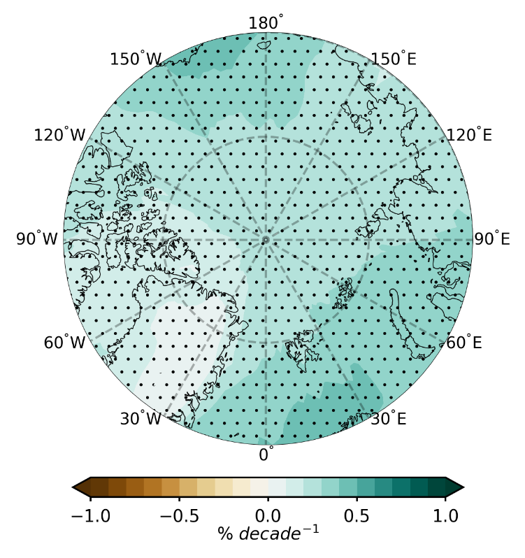
Extended Data Fig. 4 Ensemble mean atmospheric river (AR) frequency trend over the Arctic in CMIP6. The multi-model ensemble mean of Arctic AR frequency trend based on 23 CMIP6 model simulations. Stippled areas indicate trends are significant at the 0.05 level based on the Student’s t-test.

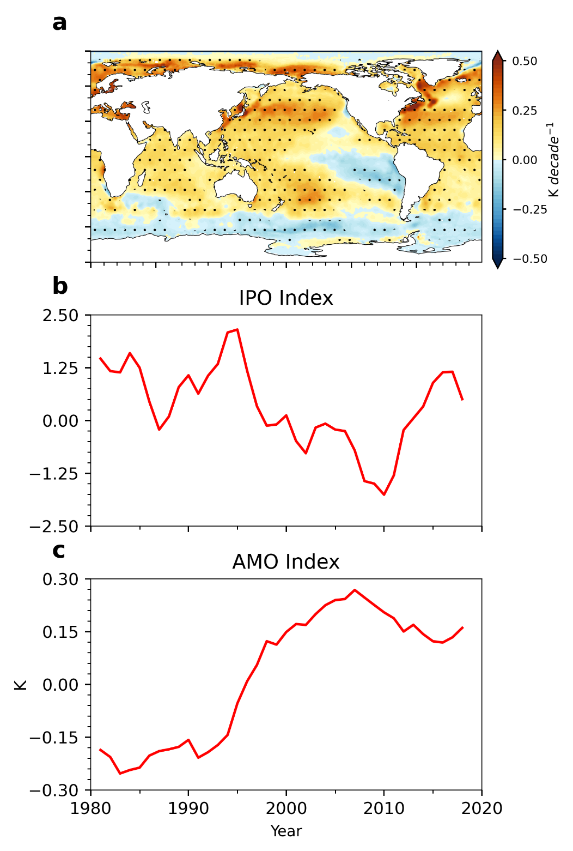
Extended Data Fig. 5 Observed IPO and AMO index. a, Observed SST trends from 1981 to 2021 based on the HadSST data. Stippled areas indicate trends are significant at the 0.05 level based on the Student’s t-test. b, Temporal evolution of the observed IPO index. c, Temporal evolution of the observed AMO index.
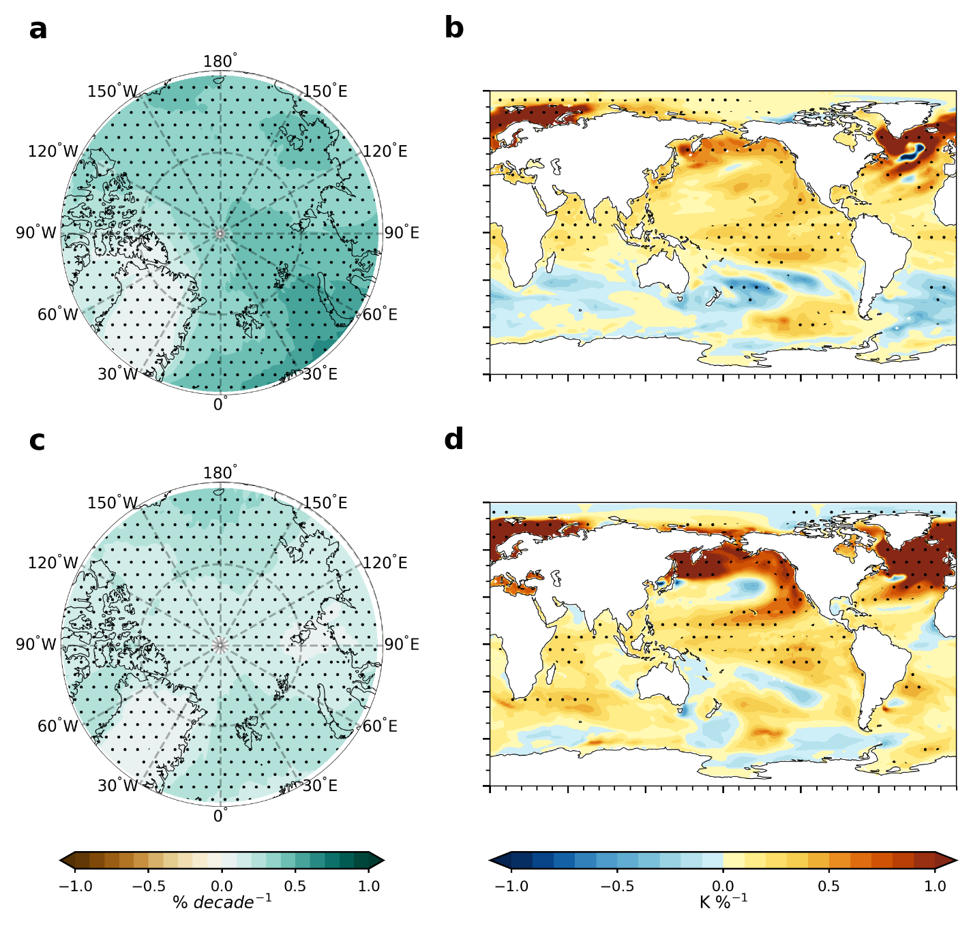
Extended Data Fig. 6 Intermember regressions in the ACCESS and CNRM ensembles. a, ensemble mean Arctic AR trend from 1981 to 2021 in the ACCESS ensemble. b, Intermember regression between SST trend and Arctic mean AR frequency trend in the ACCESS ensemble. c-d, Same as a-b, but for the CNRM ensemble. The results in c-d are based on data from 1979 to 2014. Stippled areas indicate trends or regressions are significant at the 0.05 level based on the Student’s t-test.
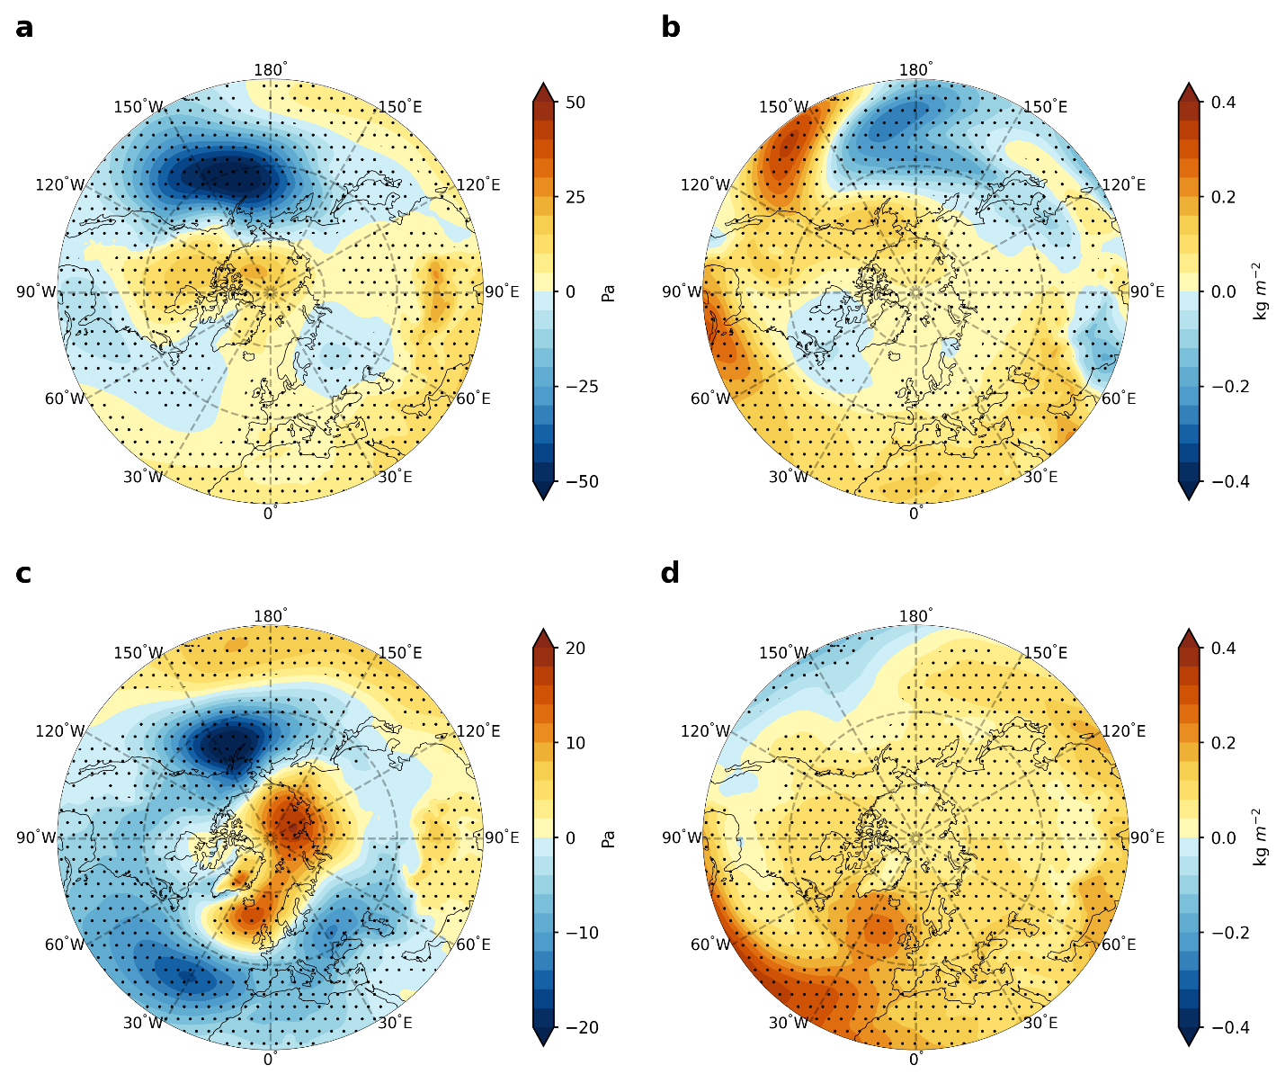
Extended Data Fig. 7. Sea level pressure (SLP) and column-integrated water vapor (IWV) regression patterns associated with IPO and AMO. a and c, Ensemble mean SLP patterns associated with the IPO and AMO, respectively, in LENS2. b and d, Same as a and c, but for the IWV. Regressions are based on data from 1979 to 2100. Stippled areas indicate the regression anomalies are significant at the 0.05 level based on the Student’s t-test. Note that the range of the color bar in c is different from that in a for visualization purpose.

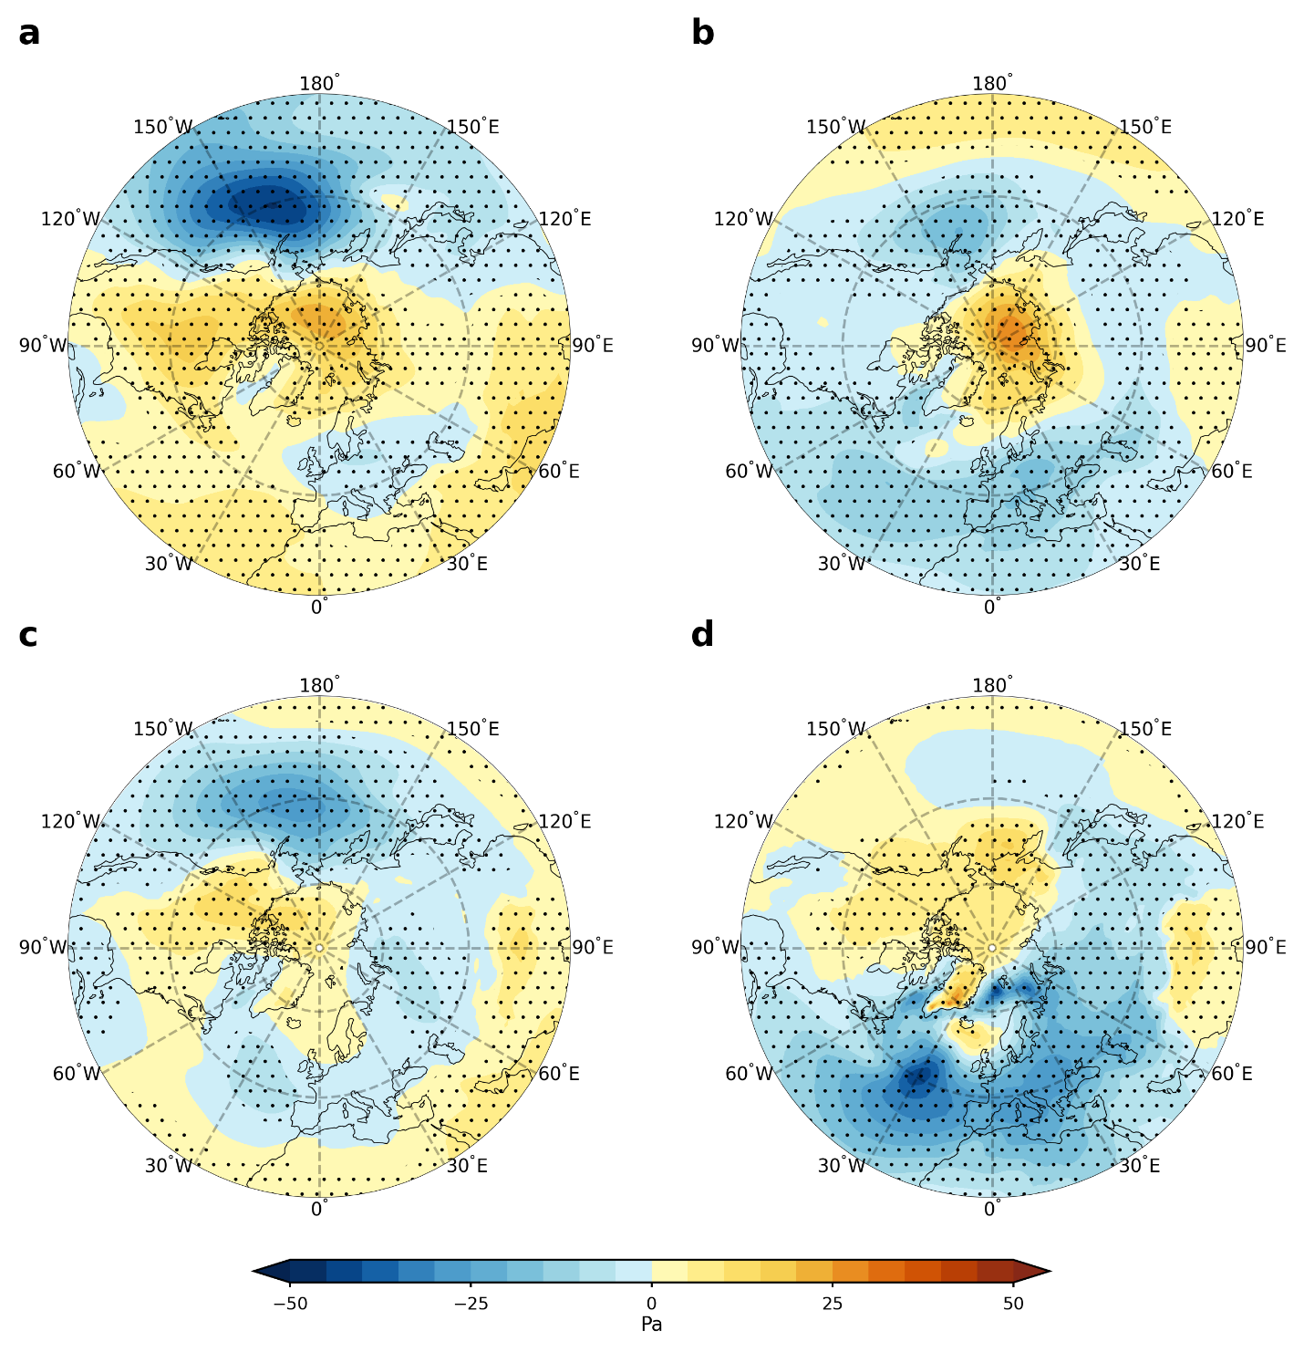
Extended Data Fig. 8 SLP regression patterns associated with the IPO and AMO in the ACCESS and CNRM ensembles. a-b, Ensemble mean SLP patterns associated with the IPO and AMO in the ACCESS ensemble. c-d, Same as a-b, but for the CNRM ensemble. The regressions for ACCESS ensemble are based on data from 1979 to 2100, but from 1850 to 2014 for CNRM ensemble. Stippled areas indicate regression anomalies are significant at the 0.05 level based on the Student’s t-test.
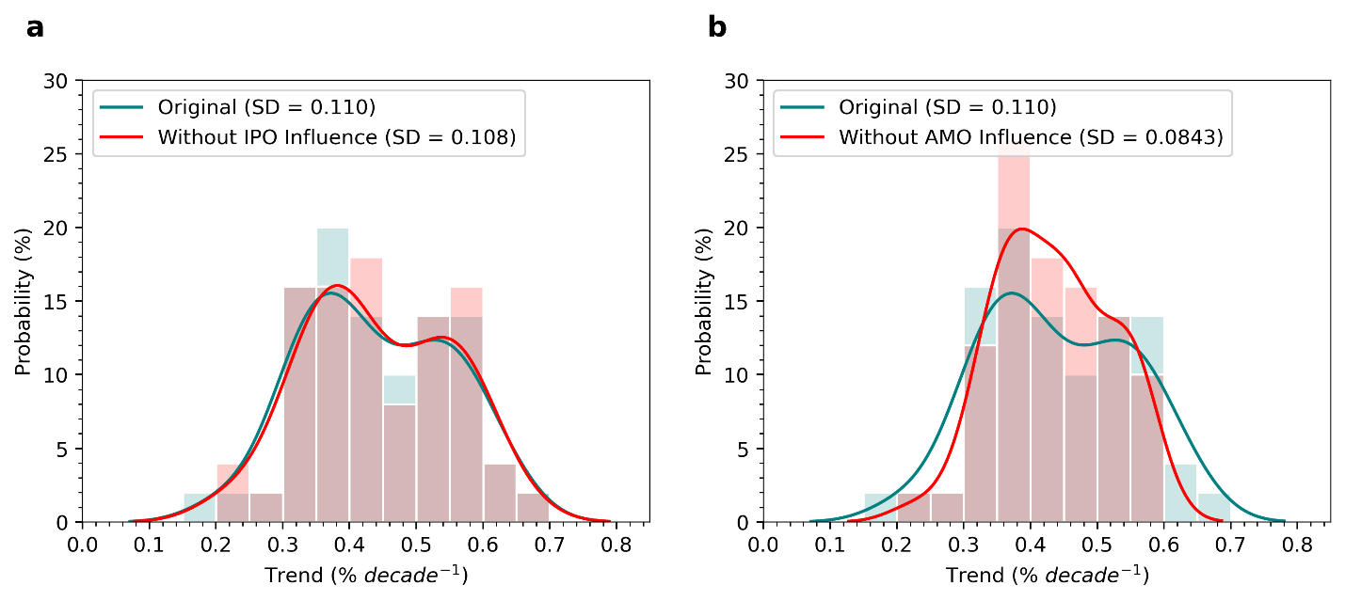
Extended Data Fig. 9 Influence of the IPO or AMO on uncertainties in near-future Arctic mean AR frequency trends. Histograms and the kernel density estimates of the near-future Arctic mean AR frequency trends are shown in bars and lines, respectively. The teal bars and line represent the original Arctic mean AR frequency trends. The red bars and line denote the Arctic mean AR frequency trends without the influences of IPO and AMO. a, The influence of the IPO. b, The influence of the AMO. Note that the dark pink bars indicate an overlap between red and teal.

