Supporting Information for

Terrestrial Water Storage Inversion Using Geodetic Measurements to Investigate the Characteristics of Drought in Yunnan, China

Chao Chen, Rong Zou, Zhiwei Fang, Jiaming Cao, and Qi Wang
Hubei Subsurface Multi-Scale Imaging Key Laboratory, Institute of Geophysics & Geomatics, China University of Geosciences (Wuhan), Wuhan 430074, China; e-mails: zourong@cug.edu.cn; chaoshu@cug.edu.cn; cjm@cug.edu.cn; wangqi@cug.edu.cn
* Corresponding author: Rong Zou (zourong@cug.edu.cn)

1. Data and preprocessing
To correct the nontidal oceanic and atmospheric loading displacements, we use the geophysical fluid loading products provided by the Earth System Modeling group at GeoForschungs Zentrum (ESMGFZ). The atmospheric loads have annual amplitudes ranging from 1.3 to 6.6 mm in the GNSS VTS. Along the coastal regions, the nontidal oceanic loads have annual amplitudes of approximately 1.0-2.5 mm, which is in contrast to the inland areas where the amplitudes are less than 0.5 mm. The postglacial rebound effect that causes crustal uplift of 0.3 to 0.6 mm/yr across China is corrected by the ICE-6G_D model developed by Purcell et al. (2016).
We fitted a model that included position, linear trend, annual and semiannual displacements, and coseismic and instrument offsets to the daily vertical time series (VTS). We removed the estimated long-term linear term, offsets, and postseismic deformations from the original time series before implementing a TWS inversion model. To address issues of missing data, we utilized GNSS Missing Data Interpolation Software (GMIS), which produces excellent results in dealing with continuous and random data gaps by leveraging the network position time series (Liu et al., 2018).
The GNSS TWS estimates are based on monthly average positions to facilitate direct comparison with other datasets. To calculate the weighted monthly average of the daily GNSS VCD, we followed the approach outlined by Knowles et al. (2006).
${\tilde{x}}_{month}=\frac{\sum_{i=1}^{n}{x_{i}σ_{i}^{−2}}}{\sum_{i=1}^{n}{σ_{i}^{−2}}}$ (1)

where $n$ represents the number of data points for every month, $x_{i}$ represents the $i$th VCD, and $σ_{i}$ represents the uncertainty of the $i$th data point.

2. Methodology

2.1 GF method for GNSS inversion
Both the GF method (GNSS-Green) (Argus et al., 2014; Argus et al., 2017; Fu et al., 2015) and the Slepian basis function method (GNSS-Slepian) (Simons and Dahlen, 2006; Han and Razeghi, 2017) can be applied for the inversion of equivalent water height using GNSS measurements.
The elastic mass load theory and the constitutive relation between VCD and spatial distribution load sources (Farrell, 1972) serve as the foundation of the GF method. This method utilizes VCD, which is highly sensitive to the distance from the load source center and enables the identification of high-spatial resolution distributed surface mass loads (Argus et al., 2014). Following the circular region load approach (Wahr et al., 2013; Argus et al., 2014; Fu et al., 2015; Argus et al., 2017), the study area was divided into 0.25°×0.25° rectangular grids, and GNSS seasonal VCD was used to determine the spatial distribution of the mass variations. To accomplish this, a least-squares algorithm was utilized, as shown below.
${\left\|Gx−d\right\|}^{2}+β^{2}{\left\|Lx\right\|}^{2}=min$ (2)
where $x$ is a vector of unknown EWH variations, d is a vector of the amplitudes of GNSS seasonal VCD, and $G$ is the GF matrix for a gravitating, spherical, and stratified Earth, which was estimated by applying the load Love numbers (LLN) with the largest degree from among the 46,341 values based on the PREM model (Wang et al. 2012; Dziewonski and Anderson, 1981). To be compatible with the geocentric reference frame of the GNSS measurements, the center of the figure frame was used to compute GF. The inversion was implemented on the condition that the sum of the data misfit (${\left\|Gx−d\right\|}^{2}$) and model roughness (${\left\|Lx\right\|}^{2}$) was minimized, where $L$ is a Laplacian operator that defines model roughness and ensures a smooth change for the derived EWH among neighboring pixels. An improved regularization Laplacian constraint matrix is presented in this paper for the inversion of regional surface mass changes using the GF method (Li et al. 2020), which is known to be an ill-posed problem. The relative weight between (${\left\|Gx−d\right\|}^{2}$) and model roughness is controlled by $β$, which is determined using the L-curve method (Hansen et al., 1993). In our case, the optimal smoothing factor $β$, estimated through cross validation, is 0.03 (Figure S1). This value results in a reasonable fit to the GNSS measurements in Yunnan (Argus et al., 2014; Fu et al., 2015).
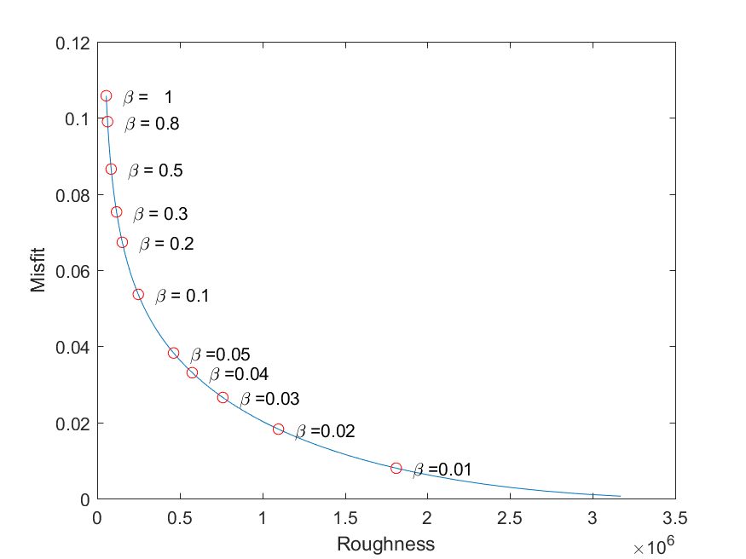
Figure S1 The optimal smoothing factor $β$ is 0.03, minimizing the sum of squared prediction errors.

2.2 Slepian basis function
Most previously published GNSS-derived water mass variation studies, as discussed in the preceding section, have utilized the GF approach, which is a spatial-domain convolution method. This approach is not ideal when the density of GNSS stations is insufficient due to the need for strong spatial smoothing (Argus et al., 2014; Jin and Zhang, 2016). The introduction of the SBF by Han and Razeghi (2017) has enabled the recovery of regional hydrological mass changes with greater accuracy. SBF is a window spherical harmonic function method that maximizes the local (space-limited) energy concentration of signals (Simons and Dahlen, 2006). Based on this theory, any truncated geophysical signal of degree $L$ can be expressed in the form of global spherical harmonics, as described by Equation (3):
$f\left(θ,λ\right)=\sum_{l=0}^{L}{\sum_{m=0}^{l}{ f_{lm}Y_{lm}\left(θ,λ\right)}}$ （3）
where $Y_{lm}\left(θ,λ\right)$ represents the spherical harmonic functions at colatitude and longitude, $f_{lm}$ denotes the harmonic coefficient at degree $l$ and order $m$, $r$ represents the Earth’s radius, and $L$ is the maximum of the expansion, corresponding to ${\left(L+1\right)}^{2}$ orthogonal SBF (Simons and Dahlen, 2006). The truncated geophysical signals with bandwidth $L$ in SBF are as follows:
$g_{α}\left(θ,λ\right)=\sum_{l=0}^{L}{\sum_{m=−l}^{l}{ g_{α, lm}Y_{lm}\left(θ,λ\right)}}$ (4)
where $g_{α, lm}$ is the $α$th Slepian basis function at the $l$th degree and order $m$th order SHc. With the chosen bandwidth $L$, it comprises a set of ${(L+1)}^{2}$ orthogonal basis functions. The optimal ratio is determined when the ratio between the power of the function $g_{α}\left(θ,λ\right)$within a given area $R$ and within the entire globe $Ω$ reaches a maximum:
$γ_{α}={\int_{R}{g_{α}^{2}(θ, λ)d}Ω}/{\int_{Ω}{g_{α}^{2}(θ, λ)d}Ω}$ (5)
Therefore, the ratio $γ_{α}$ (0$≤γ_{α}≤$1) represents how much energy from each basis function is concentrated in $Ω$. A function for which $γ_{α}$ is close to 1 is sufficiently concentrated in $R$, while one with $γ_{α}$ close to 0 is concentrated in $Ω−R$. The maximization problem of Formulas (2) and (3) results in calculating the eigenvalue $γ_{α}$ and eigenvector $g_{α, lm}$ of the square matrix of the integrals of the observations between two spherical harmonic functions over $R$ (Simons and Dahlen, 2006; Han and Razeghi, 2017). It should be emphasized that the SBF $g_{α, lm}$ and the ratio $γ_{α}$ are uniquely resolved under a given region $R$.
We indicate the mass load $σ\left(θ,λ,t\right)$ imposed on the surface in terms of a series of SH functions $S_{lm}\left(t\right)$ and the vertical motions $u\left(θ,λ,t\right)$ by Equation (6):
$$\left\{\begin{matrix}σ\left(θ,λ,t\right)=a\sum_{l=0}^{∞}{\sum_{m=−l}^{l}{ S_{lm}\left(t\right)Y_{lm}\left(θ,λ\right)}} \\ u\left(θ,λ,t\right)=a\sum_{l=0}^{∞}{\sum_{m=−l}^{l}{ U_{lm}\left(t\right)Y_{lm}\left(θ,λ\right)}}\end{matrix}\right.$$ | （6）

where $S_{lm}\left(t\right)$ and$U_{lm}\left(t\right)$ are the dimensionless coefficients of the mass loads and VCD, which have the following relationship in a spectral domain:
$$U_{lm}\left(t\right)=\left(\frac{3ρ_{w}}{ρ_{ave}}\right)\frac{h_{l}}{2l+1}S_{lm}\left(t\right)$$ | （7）
We illustrated the band-limited (the largest degree of $L$) surface load $σ_{L}\left(θ,λ,t\right)$ and vertical displacements $u_{L}\left(θ,λ,t\right)$ in the global SH expression (Han and Razeghi, 2017).
$\left\{\begin{matrix}σ_{L}\left(θ,λ,t\right)=a\sum_{β=1}^{{\left(L+1\right)}^{2}}{s_{β}^{ewh}\left(t\right)g_{β}\left(θ,λ\right)} \\ u_{L}\left(θ,λ,t\right)=a\sum_{α=1}^{{\left(L+1\right)}^{2}}{s_{α}^{vcd}\left(t\right)g_{α}\left(θ,λ\right)}\end{matrix}\right.$ (8)
where $g_{α}\left(θ,λ\right)$and $g_{β}\left(θ,λ\right)$ are the $α$th and $β$th SBFs, respectively, and $s_{α}^{vcd}\left(t\right)$ and $s_{β}^{ewh}\left(t\right)$ are the corresponding coefficients for VCD and EWH, respectively.
$\left\{\begin{matrix}s_{α}^{vcd}\left(t\right)=\sum_{l=0}^{L}{\sum_{m=−l}^{l}{ U_{lm}\left(t\right)g_{α,lm}}} \\ s_{β}^{ewh}\left(t\right)=\sum_{α=1}^{{\left(L+1\right)}^{2}}{s_{α}^{vcd}\left(t\right)}\sum_{l=0}^{L}{\sum_{m=−l}^{l}{ \left(\frac{ρ_{ave}}{3ρ_{w}}\right)\frac{2l+1}{h_{l}}g_{α,lm}g_{β,lm}}}\end{matrix}\right.$ (9)
where $U_{lm}\left(t\right)$ is the dimensionless coefficient of the VCD and surface loads, where $g_{α,lm}$ and $g_{β,lm}$ are the $l$th degree and $m$th order SHc of the $α$th and $β$th Slepian functions, respectively, $ρ_{ave}$ and $ρ_{w}$ indicate the Earth and the water density, respectively, and $h_{l}$ represents the VCD LLN in a laterally homogeneous Earth model.

2.3 Slepian-based inversion for GNSS vertical displacements
In this study, we employ SBF to investigate the TWS using GNSS VCD data from Yunnan. To estimate the regional mass load, we employ an eigenvalue weighting method that dampens the contribution from high-order coefficients and improves the estimation's robustness, as suggested by Han and Razeghi (2017).
$σ_{L}\left(θ,λ,t\right)=a\sum_{a=1}^{J}{γ_{a}s_{a}^{ewh}\left(t\right)g_{a}\left(θ,λ\right)}$ (10)
where $J$ represents the truncated number of SBFs, which is usually selected according to the magnitude of eigenvalue $γ_{a}$.
The TWS based on GNSS VCD data from Yunnan was examined in this study using SBF. The experiment chose L = 60 and J = 8, incorporating a total of 8 basis functions concentrated in Yunnan to approximate the regional mass variations down to a spatial resolution of 333 km (=20,000 km/L). The grid resolution of the GF method is 0.25°×0.25°, while the resolution for SBF is 333 km. Due to the different spatial resolutions of the two methods, the inverted amplitudes of SBF were consistently larger than those obtained by the GF method. To correct for these overestimated amplitudes, Equation (10) was modified as follows:
$σ_{L}\left(θ,λ,t\right)=a\sum_{a=1}^{J}{γ_{a}ωs_{a}^{ewh}\left(t\right)g_{a}\left(θ,λ\right)}$ (11)
The $ω$ term is used to correct the overestimated errors and is related to the characteristics of load GF, and we will discuss it in detail in the discussion section.
The inversion problem addressed in this study involves converting discrete GNSS VCD values to corresponding spectral information based on SBF. This information is then transferred to surface mass loads using the LLN based on a reference Earth model. In Formula (7), the SBF is truncated with the number $J$, and the corresponding motion coefficients are estimated using spatially limited GNSS observations. As a result, the estimated SBF results are largely dependent upon the density and spatial distribution of GNSS stations.
We use a self-developed C++ software package to calculate the SBF and estimate the maximum degree of L=60, corresponding to 3721 (=61²) orthogonal SBFs. The concentration ratio $γ_{α}$ for all 3721 SBFs is computed by summing up to 60 to match the spectral information contained in the GRACE solution. Out of a total of 3721 orthogonal SBFs, there are eight functions with a concentration ratio (eigenvalue) $γ_{α}≥0.84$, and the other 3713 functions have $γ_{α}<0.5$. The first eight sets of functions are concentrated in Yunnan ($R)$, and the remaining sets are suitable for representing the loads outside of Yunnan ($Ω−R)$. Therefore, the first 8 of the SBF should be sufficient to represent the displacements and gravity fields in Yunnan up to 60 degrees (Simons and Dahlen, 2016). In our case, the daily motion coefficients of the eight SBFs are estimated by using 54 VCD time series with least-squares regression (Figure S2).
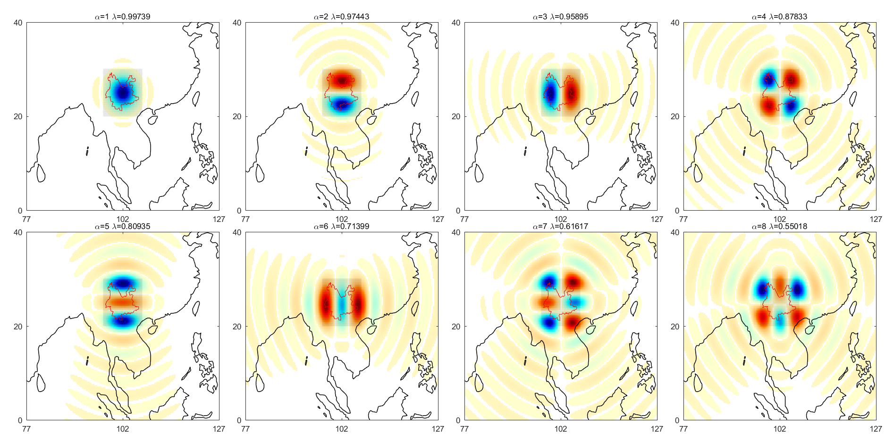
Figure S2 Examples of the SBF $g_{α}\left(θ,λ\right)$ in Yunnan. The first 8 basis functions with concentration ratios greater than 0.8427 are well concentrated in Yunnan $R$. The blue, white, and red colors indicate positive, zero, and negative, respectively.

2.4 Slepian-based inversion for GRACE products
GRACE level 2 products are released as coefficients to SH functions, which spread their energy over the entire globe. While the venerable SHs are based on an orthogonal function for the entire sphere, the distribution of Stokes expansion coefficients for the global gravitational geopotential remains the standard format for the release of the GRACE solutions. These monthly solutions are currently band-limited and complete to SH degree and order 60. However, when expanding in a region of interest, in our case Yunnan, the application of SHs is no longer practical or ideal. The reason is that the orthogonality cannot be maintained when only portions of the sphere are estimated. Without orthogonality, capturing regional signals becomes quite complicated due to the remaining errors of the results (Simons et al., 2006, 2007, 2008). Therefore, it becomes a classic example of an ill-conditioned inverse problem, which has deep-seated connections to Slepian’s spatial spectral localization problem. In our case, the goal is to find the band-limited spherical functions whose energy is optimally concentrated in Yunnan.
To investigate geophysical signals in Yunnan, we applied the method proposed by Harig and Simons (2012) to analyze the GRACE products using the scalar spherical SBF (Simons et al., 2006). The spherical SBF is formed by optimization to create a fully orthogonal, band-limited basis that is optimally concentrated within a restricted region, such as Yunnan. We calculated the SBF for the Yunnan area up to 60 degrees and the order of the available GRACE products:
$s_{α}^{grace}\left(t\right)=\sum_{l=0}^{L}{\sum_{m=−l}^{l}{ {∆C}_{lm}\left(t\right)g_{α,lm}}}$ (12)
where ${∆C}_{lm}\left(t\right)$ is the change in surface mass density from changes in the geoid coefficients and $s_{α}^{grace}\left(t\right)$ is the Slepian basis function corresponding to the coefficients for GRACE. Referring to the GNSS-Slepian method, GRACE calculated the EWH (${EWH}_{grace}\left(θ,λ,t\right)$) by the SBF method as follows:
${EWH}_{grace}\left(θ,λ,t\right)=\sum_{β=1}^{J}{γ_{α}s_{α}^{grace}\left(t\right)g_{α}\left(θ,λ\right)}$ (13)
Finally, the CSR GRACE Level 2 RL06 products for DC_{lm} are used.

2.5 Time series analysis

To analyze the time series $u\left(t\right)$ used in this paper, we adopted a linear model fitting approach:
$u\left(t\right)=b+vt+\sum_{k=1}^{2}{\left(C_{k}cos\left(2πkt\right)+S_{k}sin\left(2πkt\right)\right)}$ (14)
where $t$ is in years (yyyy.yyyy), $b$ is the intercept, and $v$ is the rate. The seasonal terms $A$ (for the annual and semiannual and phase day) can be calculated with the cosine $C_{k}$ and sine $S_{k}$ terms and the day of year from the following formulas:
$\left\{\begin{matrix}A=\sqrt{\left(C^{2}+S^{2}\right)} \\ day=\left(\frac{365}{2π}\right)\tan^{−1}\left(\frac{S}{C}\right)\end{matrix}\right.$ (15)

3. Results

3.1 Annual variations in vertical hydrological loading oscillation

The spatial distribution of annual amplitudes of GNSS vertical displacement presents a snapshot for quantifying TWS variations in different climatic regions. The multiyear average seasonal vertical motion exhibits strong spatial variation, which is illustrated in Figure S3, with the maximum and minimum annual amplitudes occurring in western and eastern Yunnan, respectively. Notably, the GNSS captures the greatest annual water changes in southwest Yunnan, with a peak amplitude of 11.3 mm observed at station YNLA. Furthermore, by analyzing the annual phase of the GNSS VTS, which is defined as the day of the year (doy) with the maximum surface subsidence or hydrological loads, we can gain insights into the complexity of hydrological dynamics. In Yunnan, seasonal TWS usually reaches its peak in September (doy:240-300), which is perfectly consistent with the timing of the South Asian monsoon circulation. The model of the phase for annual GNSS VCD demonstrates that GNSS is capable of capturing the first-order features of TWS changes in Yunnan.

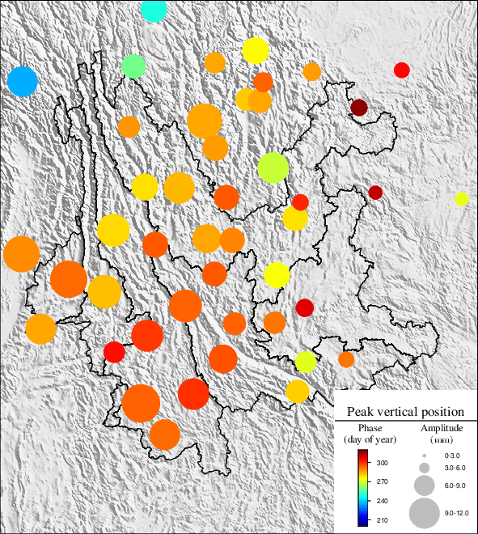
Figure S3. Displays the amplitudes and phases of annual VCD induced by hydrological cycles at 54 GNSS stations. The phase and peak-to-peak amplitude of annual vertical GNSS displacement for all stations illustrate the multiyear average phase and amplitude for annual periods in the GNSS VTS.

3.2 GNSS-inferred and GRACE-inferred EWH
In this study, we use the GF and SBF methods of inversion calculation to obtain two estimates of the equivalent water height time series. Figure S4 shows that the results evaluated at the locations of the GNSS sites calculated by the two inversion methods are in good agreement, both in terms of amplitude and phase. The largest differences are near the edge of the study area, likely due to edge effects. Moreover, the correlation between the two types of time series for all 54 GNSS stations is statistically analyzed, and the average value is 0.98.
The study compares three equivalent water heights inferred by GRACE. As shown in Figure S6 (YNMZ as an example), compared with the results of GRACE-SHc and GRACE-Mascons, the results from the GRACE-Slepian fluctuate greatly. This may be related to the lack of filtering and striping in the GRACE-Slepian calculation, and the result contains more regional physical information. We used the method mentioned in 3.5 to fit the time series.
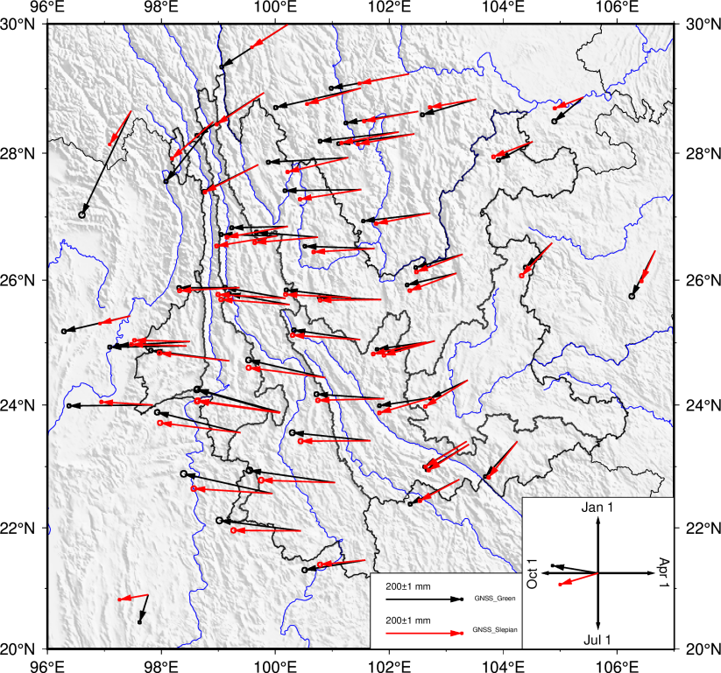
Figure S4. Comparison of the amplitude and phase of the equivalent water height time series retrieved by two GNSS methods. The red arrows are the results of the GF method, and the black arrows are the results of the SBF method. The length of the arrow indicates the amplitude, and the direction of the arrow indicates the phase.

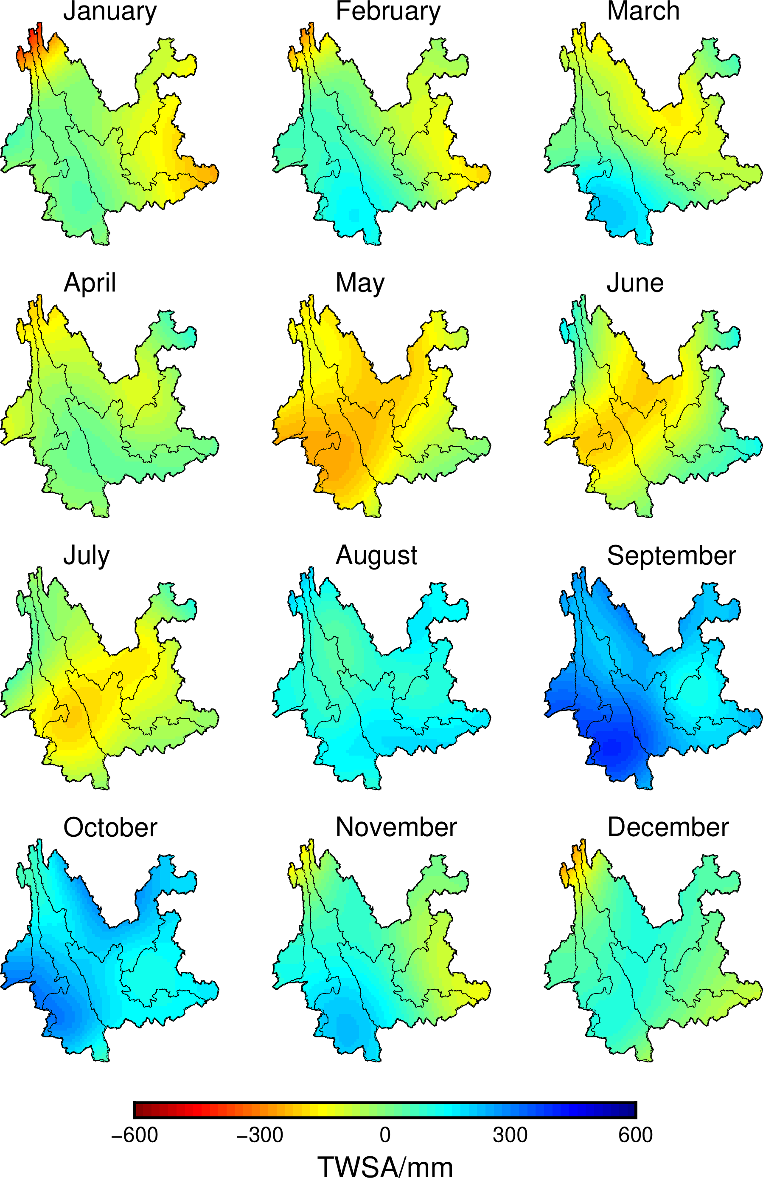
Figure S5. GNSS EWH inversion time series results on the 15th day of each month in 2015.

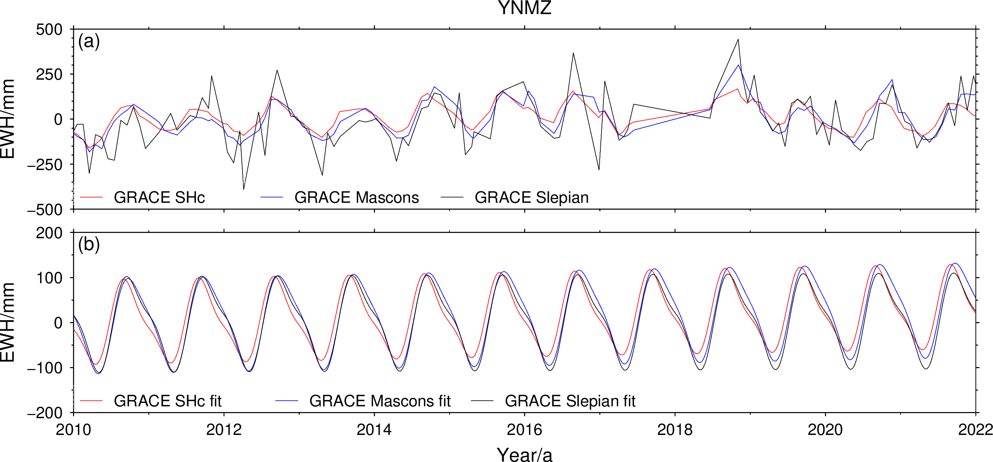
Figure S6. The time series from the GRACE EWH inversion. (a) GRACE_SHc (red lines), GRACE_Mascons (blue lines), and GRACE_Slepian (black lines). (b) The fitting EWH time series.
Based on the water height results inferred by GNSS and GRACE, mentioned above, we calculate the TWS mass anomaly in six major Yunnan basins from 2010 to 2022 (Figure S7). The GNSS-inferred result is the average of GF and SBF, and GRACE-inferred is the average of GRACE-SHC, -Mascons and -Slepian.

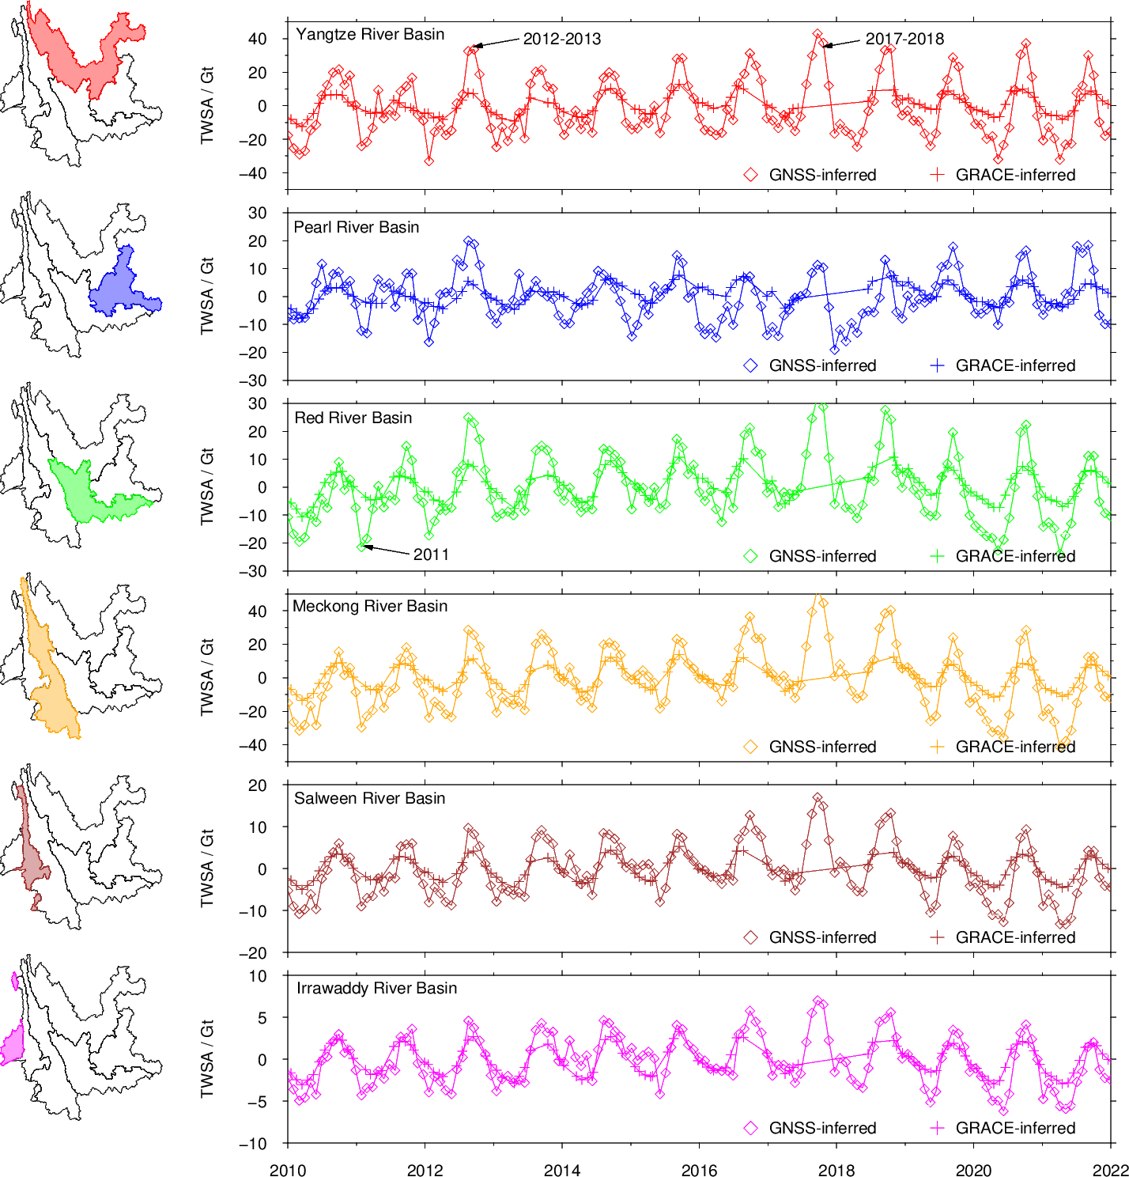
Figure S7. The TWSA time series in six Yunnan basins, including monthly mean GRACE-inferred TWSmass anomaly (plus sign ‘+’) and monthly mean GNSS-inferred TWSmass anomaly (solid line ‘-’).

Referring to publicly available data from the Yunnan Province Water Resources Bulletin from 2010 to 2020 (http://wcb.yn.gov.cn/), there were four consecutive years of major droughts in Yunnan Province from 2009 to 2012, and the rainfall was generally lower than the multiyear average. In 2011, the average rainfall of the whole province was only 985.2 mm, 23% less than usual and 16.9% less than 2010. Although rainfall in 2012-2013 was still below the annual average, it increased by 10.6% and 20.8%, respectively, compared with that in 2011. Since then, the annual rainfall in Yunnan has increased slowly (except for a slight decrease of 3.9% in 2014), and by 2017 and 2018, it exceeded the annual average. The total amount of surface water resources in Yunnan reached a peak of 220.6 billion cubic meters (220.6 Gt) over the past 12 years.
In this study, we not only calculated the TWSA of all of Yunnan but also investigated the annual amplitudes of land water reserves inferred by GNSS in six major basins of Yunnan from 2010 to 2022 (Table S1). The Yangtze River Basin covers the largest area, but the Nu River and Lancang River basins have the largest TWS variations, with EWH annual amplitudes of 250.4±23.3 mm and 232.2±20.1 mm, respectively, and the minimum annual EWH annual amplitude in the Pearl River basin is 169.1 ±16.8 mm. The total annual variation of the amplitude of land water reserves in six major basins in Yunnan is 72.6±6.0 Gt.
Table S1 GNSS-inferred Annual TWS Variability in 6 Regional River Basins
ID | Basins | Area (km2) | Annual TWSA
ID | Basins | Area (km2) | Mass (Gt) | EWH (mm)
1 | Yangtze River Basin | 99029.32 | 20.954±1.35 | 211.6±13.6
2 | Pearl River Basin | 52450.11 | 8.871±0.88 | 169.1±16.8
3 | Red River Basin | 65711.32 | 12.919±1.11 | 196.6±16.9
4 | Lancang River Basin | 78458.32 | 19.642±1.83 | 250.4±23.3
5 | Nu River Basin | 29996.64 | 6.965±0.60 | 232.2±20.1
6 | Irrawaddy River Basin | 17087.40 | 3.225±0.27 | 188.7±16.1

3.3 The overestimation of the amplitude inverted by SBF
In general, in the Yunnan area, the measured GNSS VTS EWH inversion derived using the GF method and the SBF method are quite effective, and both methods can be used to study the hydrology of Yunnan. However, the results from the GNSS station inversion from the study area show that the amplitude of the SBF inversion result is 25% larger than that of the GF inversion (Figure S8c, S8e). We speculate that the possible reason is that the SBF inversion overestimates the GNSS-equivalent water, and the results show a larger amplitude. Li et al. (2023) also found that unconstrained GNSS inversion solutions by the SBF method also presented stronger amplitudes than GF estimates, and after using 220-km Gaussian filtering for the SBF amplitudes, it was found that the amplitudes are comparable for these two methods without exploring further reasons.
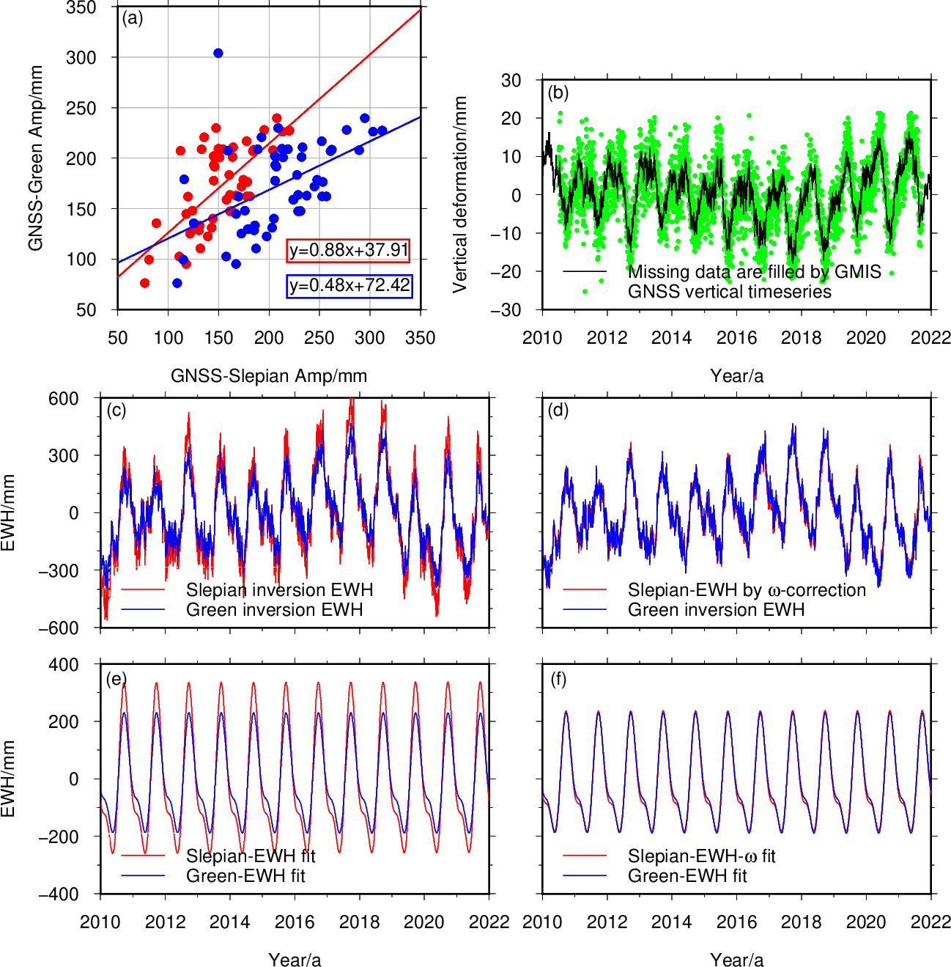
Figure S8. (a) Comparison of the SBF inversion results and the GF inversion results for all 54 GNSS stations in Yunnan. The red dots and their fitted lines are $ω$-corrected, and the blue dots and their fitted lines are not $ω$-corrected. (b) The GNSS original time series (green dots), and missing data are filled by GMIS (black lines). (c) EWH retrieved by two GNSS methods, which are SBF without $ω$-correction (red line) and GF (blue line). (d) Corresponding fitting of the EWH time series. (e) EWH retrieved by two GNSS methods, which are SBF with -correction (red line) and GF (blue line). (f) EWH time series fitting.
The VCD caused by the hydrological load at the GNSS site is the hydrological load contribution within a 50 km radius. The SBF inversion mathematical model, which collects all the surrounding hydrological load contributions at the GNSS site, clearly causes the large SBF inversion result; the contribution of the hydrological load of different radii (ranges) to the VCD at the GNSS station is related to distance. If the GNSS station reflects the land water load within the surrounding 50 km, the load‒displacement curves for different radii can be obtained according to the GF matrix, and a parameter is defined as the ratio of the area within ±25 km of the integral calculation curve to the whole area. Because the 0.25°×0.25° grid is used in the study area, each grid has a side length of approximately 28 km, and there are three different radii (the radius of the inscribed circle is 14 km, the radius of the circumscribed circle is 19.8 km, and radius of the equal area circle is 15.7 km). The equal area circle can better represent the information contained in each grid; therefore, in this study, the radius of the equal area circle is used as the radius of the circular region of interest, and the load for distances less than 25 km is used for the SBF inversion. In addition to the radius of the region of interest, the amount of surrounding load also contributes to the GNSS location load. Considering the above elements, we should choose a proper $ω$. In Figure S9, the blue area is the ratio of load response to the whole within ±25 km, and the corresponding $ω$equals 0.705.
After the $ω$-correction (Figure S8d, S8f), we find that the amplitude of the inverted EWH shows more consistency between both methods, which proves that our correction is effective. In past studies, these two methods were seldom used in the same area; therefore, we cannot assess the potential difference between them, which also demonstrates the necessity of performing corrections when applying the SBF inversion.
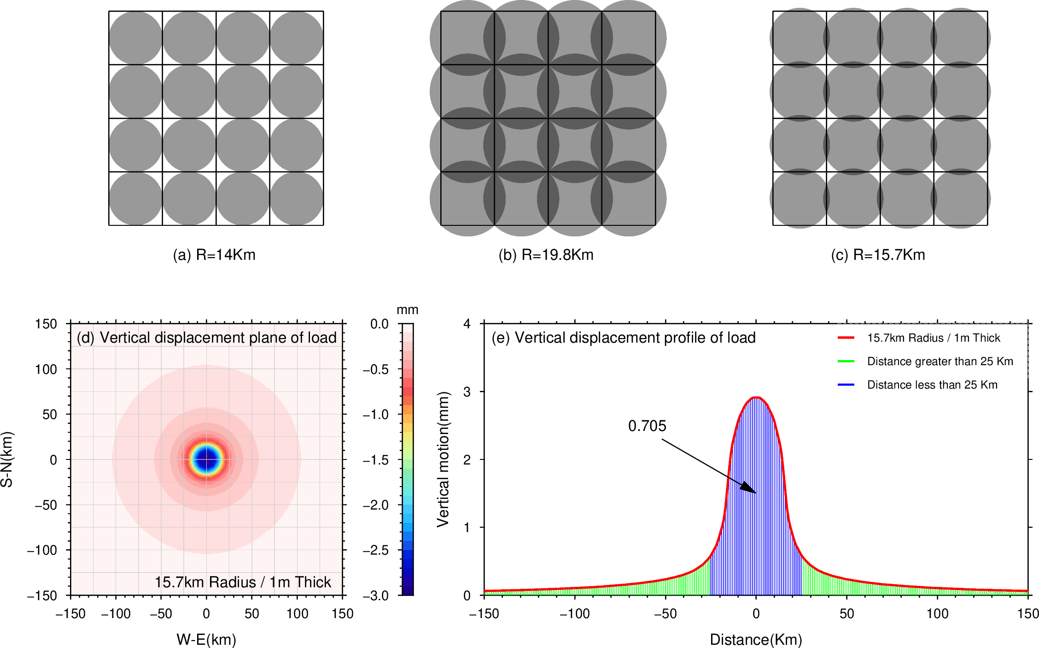
Figure S9. Conceptual model of how Earth's surface and attached GNSS sites move in response to loading, assuming strictly elastic Earth rheology. Three different circular areas within the grid are considered, (a) inscribed circle radius 14 km, (b) circumscribed circle radius 19.8 km and (c) equal area circle radius 15.7 km. Modeled VCD under a circular load of radius 15.7 km and an equivalent water depth of 1 m, (d) plane and (e) profile.

3.4 Comparison with previous studies
Because Yunnan’s altitude ranges from 1500 to 4000 m and the corresponding geographic environment and its apparent seasonal characteristics in this region are complicated, we should carefully identify the outliers, especially oscillations that fall well outside the station or network average behavior (e.g., Fok & Liu, 2019). In past studies, the GNSS-inverted EWH yielded a larger amplitude than those inferred from the GRACE data or modeled using GLDAS. Fok & Liu (2019) speculated that this is probably caused by the sparse and uneven distribution of the GNSS stations, which provides less spatial data constraint in remote areas, and concluded that better GNSS density is necessary to constrain the inversion solutions. In this study, we not only employed the CMONOC GNSS stations but also included eight additional CMA GNSS stations (Figure 1), which slightly increased the numbers, improved the geometric distribution of stations and made the inverted results more reliable. According to the checkerboard test, our inversion results show refined spatial resolution and are more robust, especially for YNCX and YNMZ.
Zhang et al. (2021) reported a significant difference between the amplitudes of GNSS-based water estimates obtained from GNSS estimated by GF and GRACE_SHc. For instance, the largest GRACE-inferred water amplitude was approximately 64% of the GNSS estimates. Jiang et al. (2021) attributed this difference to a significant underestimation by both GRACE and GLDAS data products. On the other hand, Li et al. (2023) concluded that GNSS observations were more sensitive to regional mass loads within a 100-km range around each GNSS station. In contrast, GRACE/GFO observations were more sensitive to large-scale mass loads. We also conducted a series of test inversions. Compared to using only the GF method in Jiang et al. (2021), we also used the SBF method to invert the TWSA in Yunnan and compared these two methods not only for GNSS but also for GRACE. The different amplitudes of GNSS and GRACE decrease when both are obtained by the SBF method.
Our study and that of Jiang et al. (2021) both found that the annual amplitudes of EWH estimates derived by ground-based GNSS observations were larger than those obtained from GRACE_SHc. Jiang et al. (2021) attributed this to significant underestimation by both GRACE and GLDAS data products. We speculate that the remaining slight difference may be due to some undeleted errors, such as thermal expansion of GNSS monuments, which require station-by-station correction, as suggested by Yan et al. (2009). While the contributions from known mass loading sources can explain only a small portion of the observed seasonal variations in GNSS VCD, the most significant reason for the difference probably relates to GRACE's data processing strategy. The native spatial resolution of GRACE estimates for water storage variations is 350 km, which makes it difficult to retrieve small-scale hydrological signals from GRACE_SHc and GRACE_Mascon. As a result, the peak annual TWS variation derived by GRACE is probably underestimated in comparison with GNSS-derived EWH change. However, the SBF method can retrieve most hydrological signals in the chosen area by choosing the optimal energy concentration rate, which can explain why the amplitudes from GRACE_Slepian are comparable with those from GNSS.

Reference
Purcell A, Tregoning P, Dehecq A, (2016) An assessment of the ICE6G_C(VM5a) glacial isostatic adjustment model. J Geophys Res Solid Earth 121(5):3939–3950. https://doi.org/10.1002/2015jb012742
Liu N, Dai W, Santerre R, Kuang C (2018) A MATLAB-based Kriged Kalman Filter software for interpolating missing data in GNSS coordinate time series. GPS Solut 22(1):25. https://doi.org/10.1007/s10291-017-0689-3
Argus DF, Fu Y, Landerer FW (2014) Seasonal variation in total water storage in California inferred from GPS observations of vertical land motion. Geophys Res Lett., 41(6):1971–1980. https://doi.org/10.1002/2014gl059570
Argus DF, Landerer FW, Wiese DN, Martens HR, Fu Y, Famiglietti JS, Thomas BF, Farr TG, Moore AW, Watkins MM (2017) Sustained water loss in California’s mountain ranges during severe drought from 2012 to 2015 inferred from GPS. J Geophys Res Solid Earth 122(2):10559–10585. https://doi.org/10.1002/ 2017jb014424
Fu Y, Argus DF, Landerer FW (2015) GPS as an independent measurement to estimate terrestrial water storage variations in Washington and Oregon. J Geophys Res Solid Earth 120(1):552–566. https://doi.org/10.1002/2014jb011415
Simons FJ, Dahlen FA (2007) A spatiospectral localization approach to estimating potential fields on the surface of a sphere from noisy, incomplete data taken at satellite altitudes. Proc. SPIE 6701(1-2):(670117). https://doi.org/10.1117/12.732406
Han SC, Razeghi SM (2017) GPS Recovery of daily hydrologic and atmospheric mass variation: a methodology and results from the Australian Continent. Journal of Geophysical Research: Solid Earth 122(11):9328–9343. https://doi.org/10.1002/2017jb014603
Farrell WE (1972) Deformation of the Earth by surface loads. Rev Geophys 10(3):761–797. Doi:https://doi.org/10.1029/RG010i003p00761
Wahr J, Khan SA, van Dam T, Liu L, van Angelen JH, van den Broeke MR, Meertens CM (2013) The use of GPS horizontals for loading studies, with applications to northern California and southeast Greenland. J Geophys Res Solid Earth 118(4):1795–1806. https://doi.org/10.1002/jgrb.50104
Wang H, Xiang L, Jia L, Jiang L, Wang Z, Hu B, Gao P (2012) Load Love numbers and Green's functions for elastic Earth models PREM, iasp91, ak135, and modified models with refined crustal structure from Crust 2.0. Comput Geosci 49:190–199. https://doi.org/10.1016/j.cageo.2012.06.022
Dziewonski AM, Anderson DL (1981) Preliminary reference Earth model. Phys Earth Planet Inter 25(4):297–356. https://doi.org/10.1016/0031-9201(81)90046-7
Li W, Jiang W, Li Z, Chen H, Chen Q, Wang J, Zhu G (2020) Extracting common mode errors of regional GNSS position time series in the presence of missing data by variational Bayesian principal component analysis. Sensors 20(8):2298. https://doi.org/10.3390/s20082298
Hansen J, Rossow W, Fung I (1993) Long-Term Monitoring of Global Climate Forcings and Feedbacks. National Aeronautics and Space Administration, Washington, D.C.
Jin S, Zhang T (2016) terrestrial water storage anomalies associated with drought in southwestern USA from GPS observations. Surv Geophys 37:1139–1156. https://doi.org/10.1007/s10712-016-9385-z
Simons FJ, Dahlen FA (2006) Spherical Slepian functions and the polar gap in geodesy, Geophys J Int 166(3):1039–1061. https://doi.org/10.1111/j.1365-246x.2006.03065.x
Simons FJ, Dahlen FA (2007) A spatiospectral localization approach to estimating potential fields on the surface of a sphere from noisy, incomplete data taken at satellite altitudes. Proc. SPIE 6701(1-2):(670117). https://doi.org/10.1117/12.732406
Harig C, Simons FJ (2012) Mapping Greenland's mass loss in space and time. Proc Natl Acad Sci U.S.A 109(49):19934–19937. https://doi.org/10.1073/pnas.1206785109
Li, X., Zhong, B., Li, J., & Liu, R. (2023) Inversion of GNSS vertical displacements for terrestrial water storage changes using Slepian basis functions. Earth and Space Science 10(2):e2022EA002608. https://doi. org/10.1029/2022ea002608
Fok, H. S., & Liu, Y. (2019). An improved GPS-inferred seasonal terrestrial water storage using terrain-corrected vertical crustal displacements constrained by GRACE. Remote Sensing, 11(12), 1433. https://doi.org/10.3390/rs11121433
Zhang, L., Tang, H., & Sun, W. (2021). Comparison of GRACE and GNSS seasonal load displacements considering regional averages and discrete points. Journal of Geophysical Research: Solid Earth, 126, e2021JB021775. https://doi. org/10.1029/2021JB021775
Jiang Z, Hsu Y-J, Yuan L, Yang X, Ding Y, Tang M, Chen C (2021) Characterizing spatiotemporal patterns of terrestrial water storage variations using GNSS vertical data in Sichuan, China. J Geophys Res Solid Earth 126(12):e2021JB022398. https://doi.org/10.1029/2021jb022398
Yan H, Chen W, Zhu Y, Zhang W, Zhong M (2009) Contributions of thermal expansion of monuments and nearby bedrock to observed GPS height changes. Geophys Res Lett 36:L13301. https://doi.org/10.1029/2009gl038152

