SUPPLEMENTAL MATERIAL
Table S1. ED Visit counts by season, decade, and type of diagnosis (primary only or primary and secondary combined) for each health outcome.
Health Outcome | Season | Visit Count | Percent of Visits
Combined Outcomes | Cold | 2,909,199.00 | 33%
Combined Outcomes | Moderate | 2,949,250.00 | 33%
Combined Outcomes | Warm | 2,945,833.00 | 33%
Hypertension | Cold | 2,423,743.00 | 33%
Hypertension | Moderate | 2,461,512.00 | 33%
Hypertension | Warm | 2,463,093.00 | 34%
Ischemic Heart Disease | Cold | 564,857.00 | 33%
Ischemic Heart Disease | Moderate | 571,073.00 | 34%
Ischemic Heart Disease | Warm | 562,421.00 | 33%
Dysrhythmia | Cold | 434,603.00 | 34%
Dysrhythmia | Moderate | 435,602.00 | 34%
Dysrhythmia | Warm | 427,113.00 | 33%
Congestive Heart Failure | Cold | 413,131.00 | 34%
Congestive Heart Failure | Moderate | 407,270.00 | 34%
Congestive Heart Failure | Warm | 390,872.00 | 32%
Stroke | Cold | 98,733.00 | 33%
Stroke | Moderate | 100,882.00 | 34%
Stroke | Warm | 100,011.00 | 33%
Peripheral Heart Disease | Cold | 84,425.00 | 33%
Peripheral Heart Disease | Moderate | 86,067.00 | 34%
Peripheral Heart Disease | Warm | 83,786.00 | 33%
Myocardial Infarction | Cold | 60,064.00 | 34%
Myocardial Infarction | Moderate | 58,858.00 | 34%
Myocardial Infarction | Warm | 55,353.00 | 32%
Health Outcome | Primary Diagnosis | Secondary Diagnosis | All Diagnoses
Combined Outcomes | 1,559,543 | 10,721,667.00 | 12,281,210
Hypertension | 517,244 | 6,829,996.00 | 7,347,240
Ischemic Heart Disease | 245,425 | 1,452,590.00 | 1,698,015
Dysrhythmia | 248,136 | 1,048,820.00 | 1,296,956
Congestive Heart Failure | 204,076 | 1,006,902.00 | 1,210,978
Stroke | 200,902 | 98,658.00 | 299,560
Peripheral Heart Disease | 19,472 | 234,744.00 | 254,216
Myocardial Infarction | 124,288 | 49,957.00 | 174,245
Health Outcome | Decade | Visit Count | Percent of Visits
Combined Outcomes | 1993-1999 | 403,122.00 | 3%
Combined Outcomes | 2000-2009 | 3,656,667.00 | 30%
Combined Outcomes | 2010-2019 | 8,223,680.00 | 67%
Hypertension | 1993-1999 | 181,402.00 | 2%
Hypertension | 2000-2009 | 2,138,469.00 | 29%
Hypertension | 2010-2019 | 5,028,477.00 | 68%
Ischemic Heart Disease | 1993-1999 | 75,276.00 | 4%
Ischemic Heart Disease | 2000-2009 | 532,134.00 | 31%
Ischemic Heart Disease | 2010-2019 | 1,090,941.00 | 64%
Dysrhythmia | 1993-1999 | 62,991.00 | 5%
Dysrhythmia | 2000-2009 | 403,859.00 | 31%
Dysrhythmia | 2010-2019 | 830,468.00 | 64%
Congestive Heart Failure | 1993-1999 | 41,016.00 | 3%
Congestive Heart Failure | 2000-2009 | 340,656.00 | 28%
Congestive Heart Failure | 2010-2019 | 829,601.00 | 68%
Stroke | 1993-1999 | 19,861.00 | 7%
Stroke | 2000-2009 | 102,205.00 | 34%
Stroke | 2010-2019 | 177,560.00 | 59%
Peripheral Heart Disease | 1993-1999 | 8,726.00 | 3%
Peripheral Heart Disease | 2000-2009 | 75,278.00 | 30%
Peripheral Heart Disease | 2010-2019 | 170,274.00 | 67%
Myocardial Infarction | 1993-1999 | 13,850.00 | 8%
Myocardial Infarction | 2000-2009 | 64,066.00 | 37%
Myocardial Infarction | 2010-2019 | 96,359.00 | 55%
Table S2. Interquartile Range of the Exposure Variables.
Temperature Variable | Fall |  | Winter |  | Spring |  | Summer
Temperature Variable | Mean | IQR | Mean | IQR | Mean | IQR | Mean | IQR
Minimum Temperature (°F) | 53.7 | 19.9 | 35.8 | 13.9 | 51.3 | 16 | 69.8 | 4
Maximum Temperature (°F) | 75.5 | 14.9 | 58.1 | 14.9 | 75.1 | 12.2 | 89.5 | 5.9
Mean Temperature (°F) | 63.8 | 16.7 | 46.1 | 13.6 | 62.9 | 14.1 | 78.7 | 5.3
Temperature Variability | 12.5 | 4 | 13.3 | 3.9 | 13.7 | 3.7 | 11 | 2.4

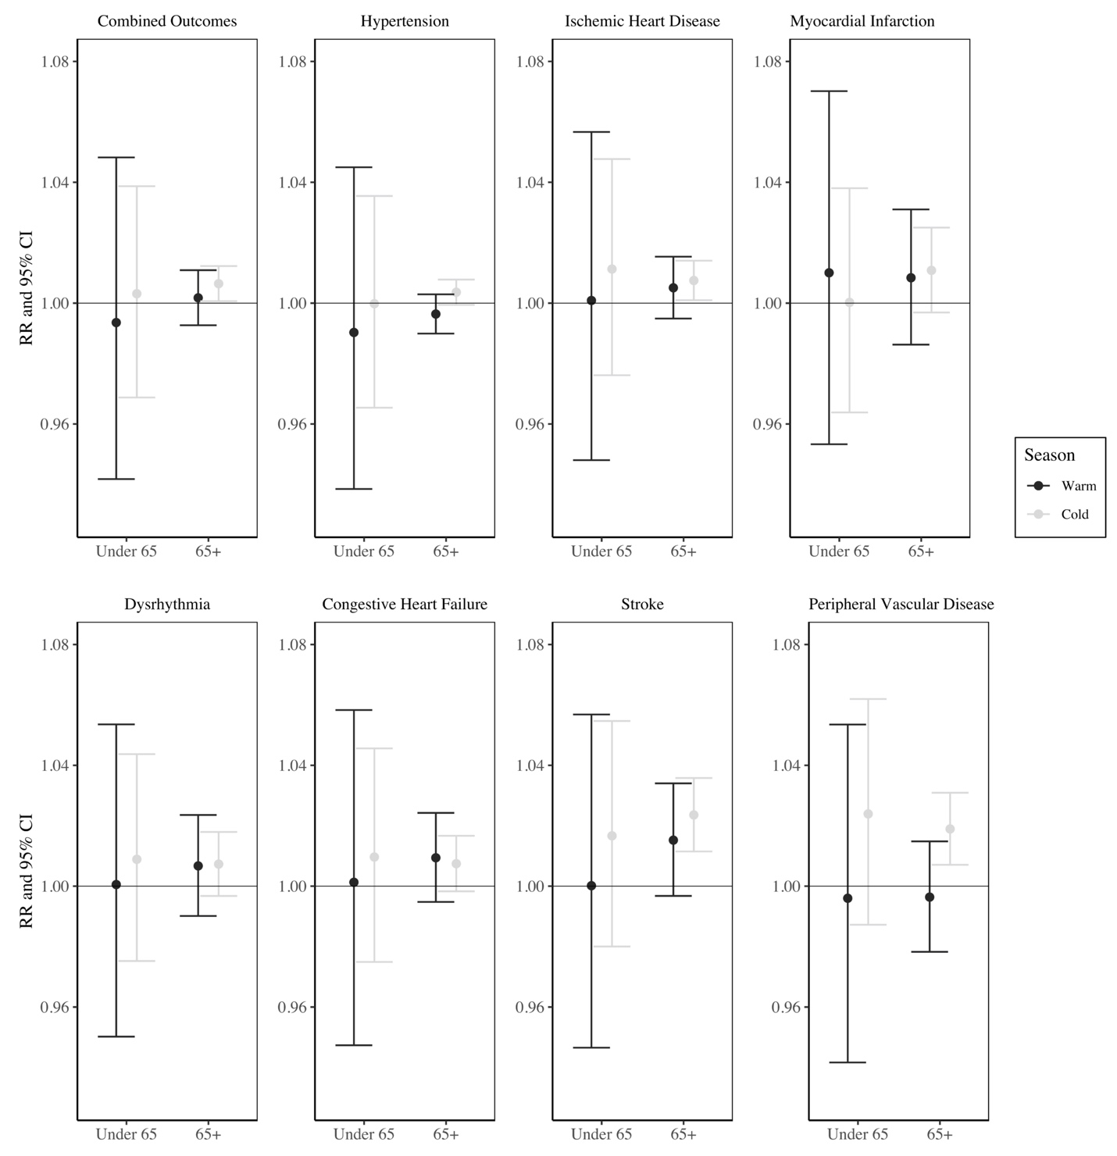
Figure S1. Relative risks and 95% confidence interval of an emergency department visits for each cardiovascular health outcome associated with an interquartile range increase in temperature variability from 1993-2019 in Atlanta, stratified by season (cold and warm) and age group (0-64 and 65+), and controlling for mean temperature, dew point temperature, time trend, day of the week, and holidays.
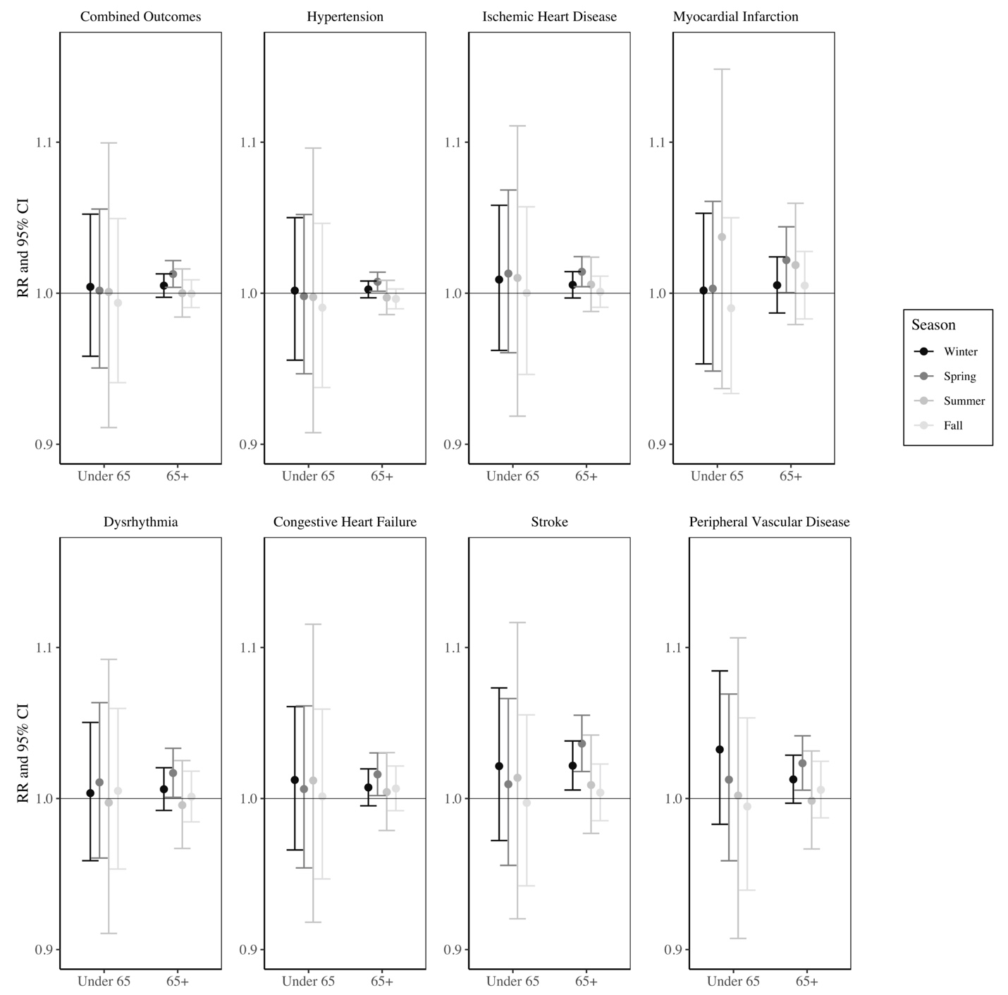
Figure S2. Relative risks and 95% confidence interval of an emergency department visits for each cardiovascular health outcome associated with an interquartile range increase in temperature variability from 1993-2019 in Atlanta, stratified by season (fall, winter, spring, summer) and age group (0-64 and 65+), and controlling for mean temperature, dew point temperature, time trend, day of the week, and holidays.
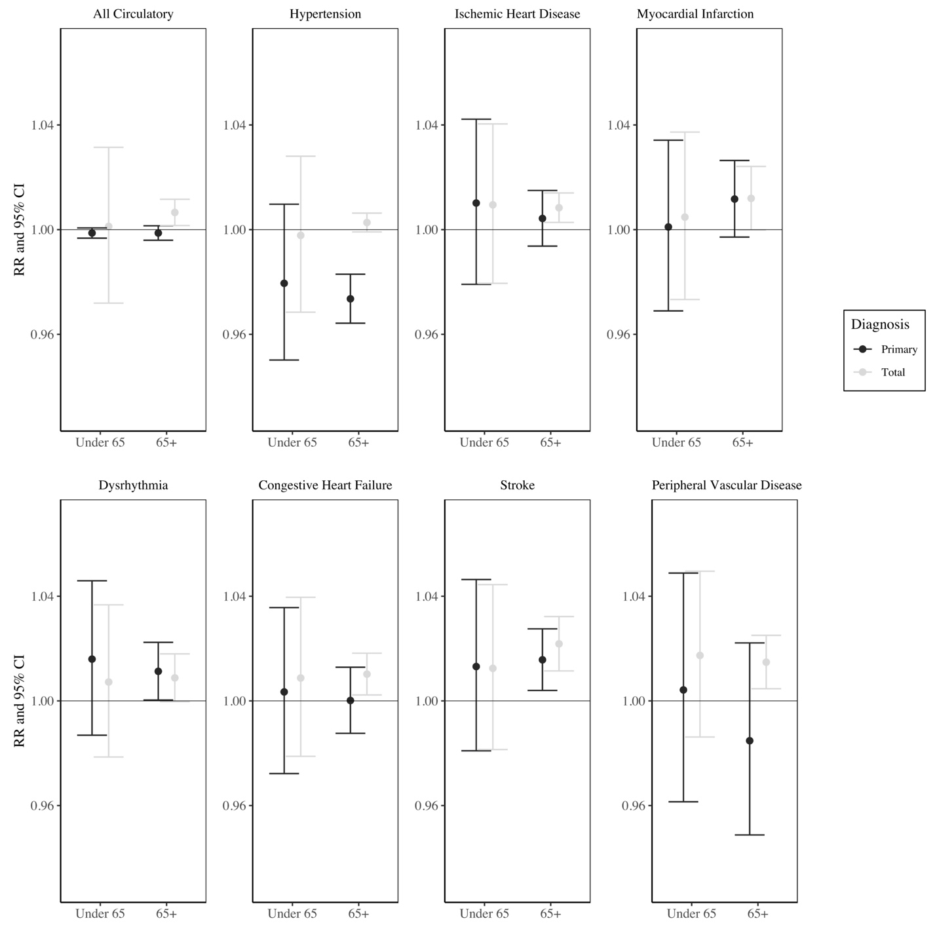
Figure S3. Relative risks and 95% confidence interval of an emergency department visits for each cardiovascular health outcome associated with an interquartile range increase in temperature variability from 1993-2019 in Atlanta, stratified by diagnosis type (primary only versus all diagnoses) and age group (0-64 and 65+), and controlling for mean temperature, dew point temperature, time trend, day of the week, and holidays.
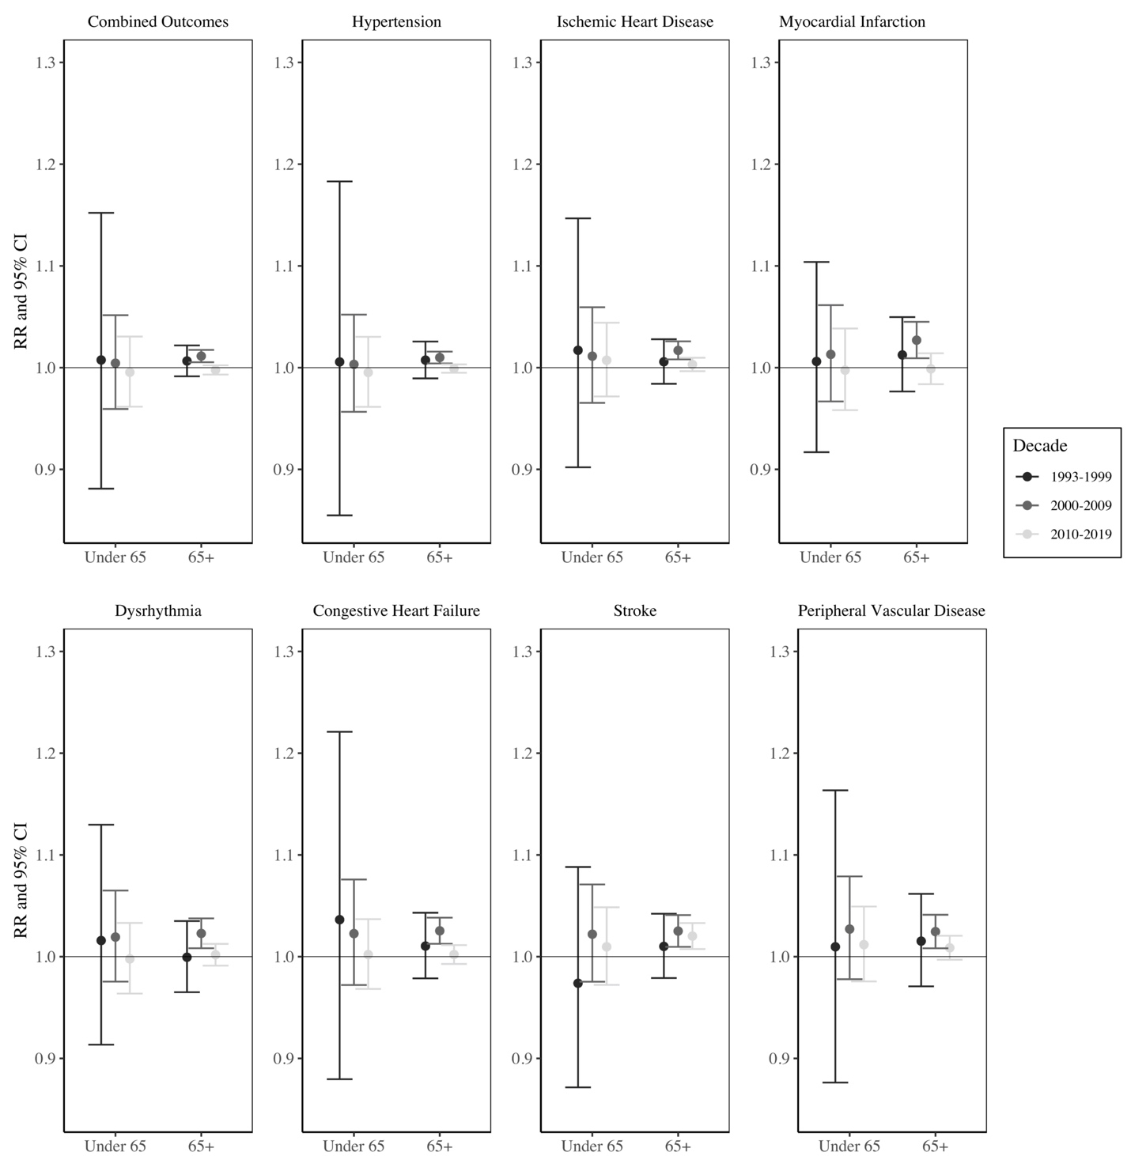
Figure S4. Relative risks and 95% confidence interval of an emergency department visits for each cardiovascular health outcome associated with an interquartile range increase in temperature variability from 1993-2019 in Atlanta, stratified by decade (1993-1999, 2000-2009, 2010-2019) and age group (0-64 and 65+), and controlling for mean temperature, dew point temperature, time trend, day of the week, and holidays.
Sensitivity Analyses
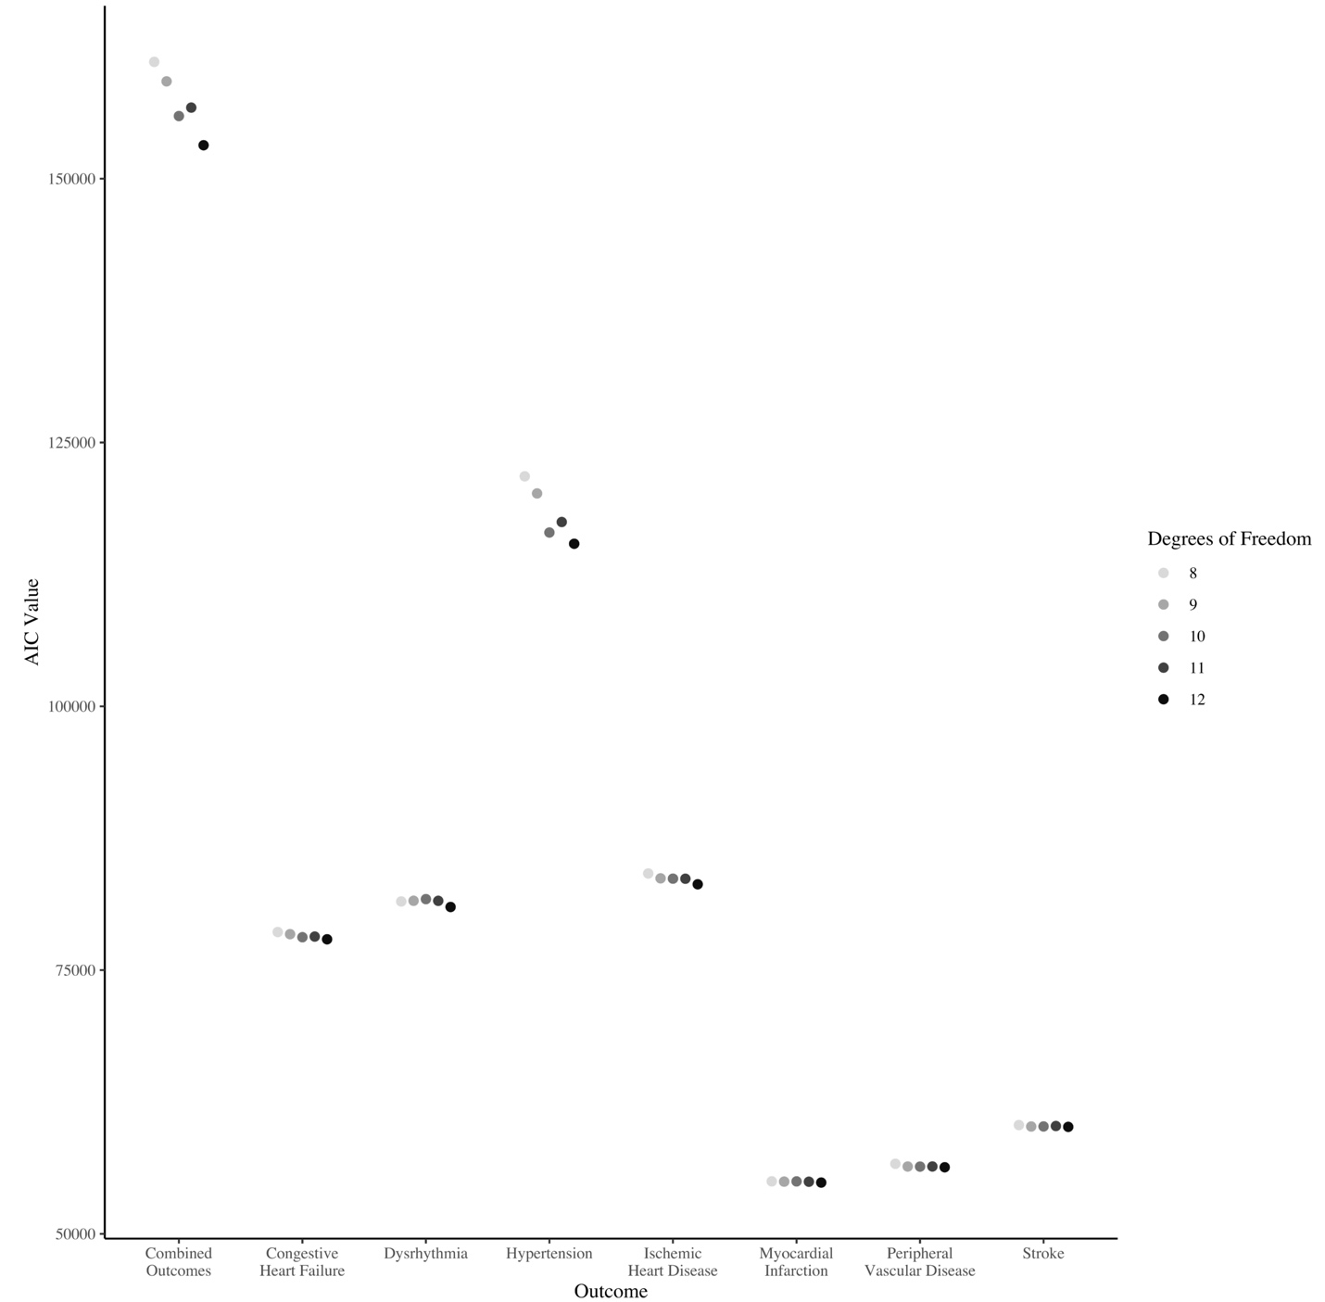
Figure S5. AIC values for the sensitivity analysis comparing varying degrees of freedom for the time spline.

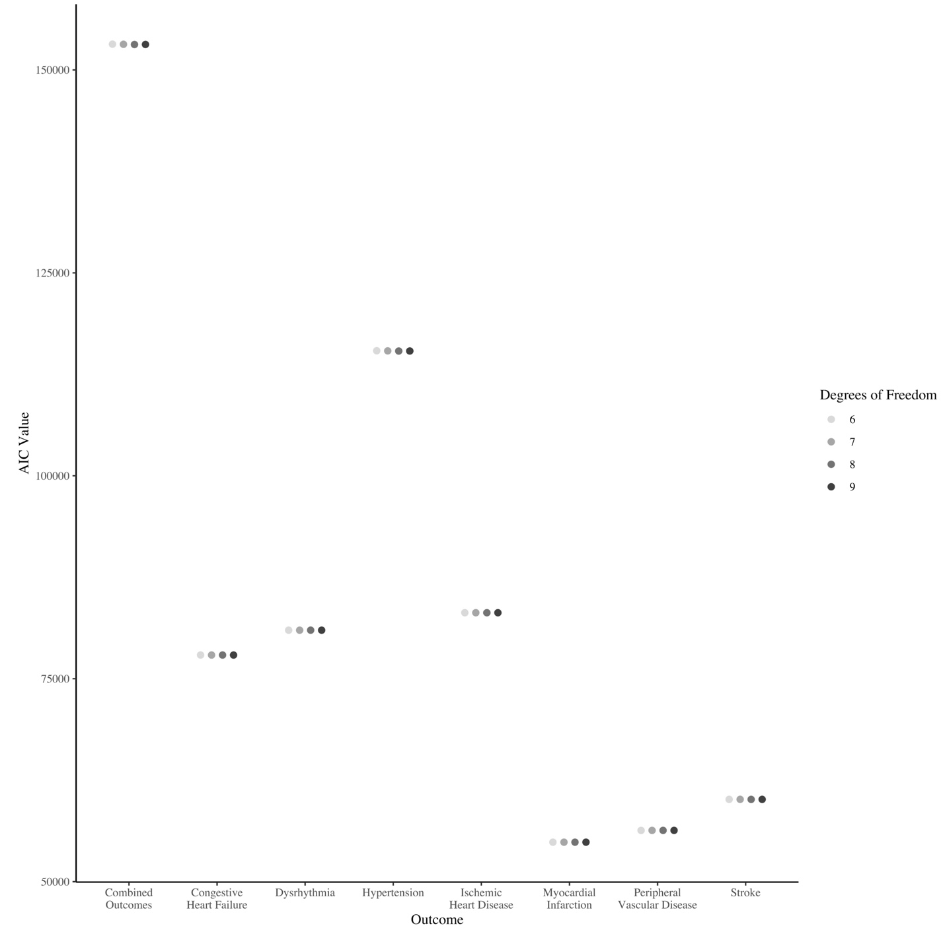
Figure S6. AIC values for the sensitivity analysis comparing varying degrees of freedom for the exposure spline.
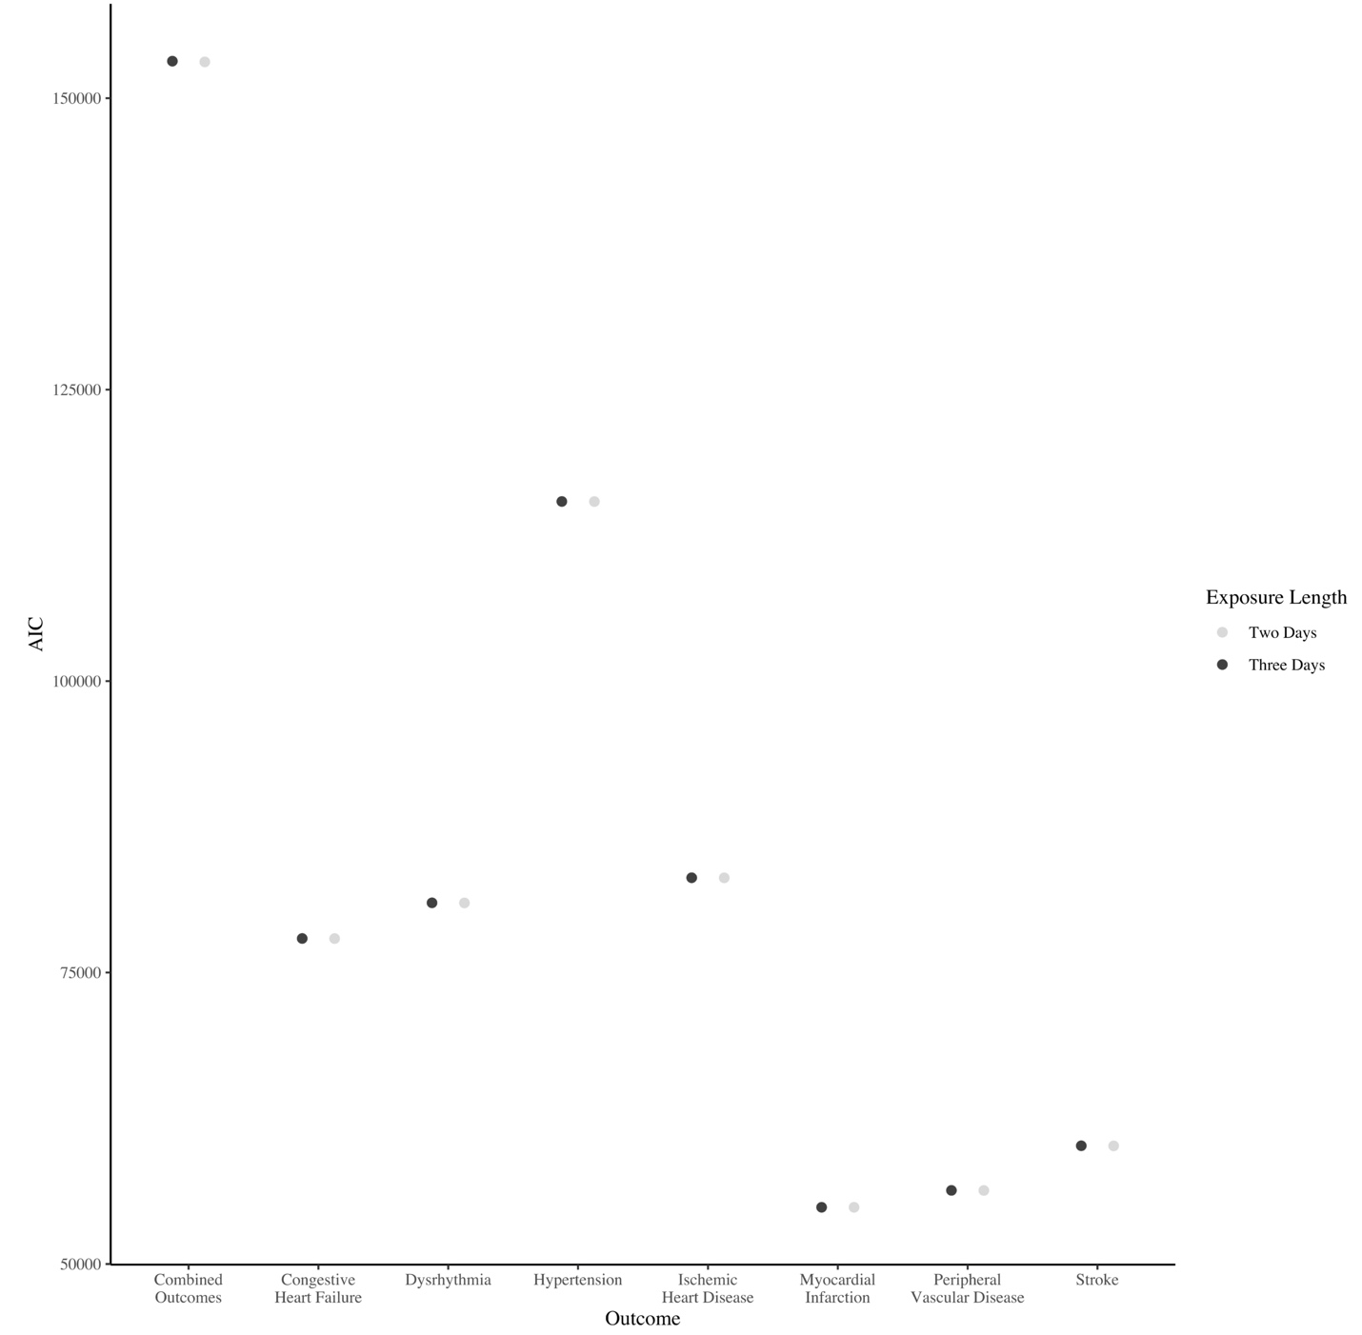
Figure S7. AIC values for the sensitivity analysis comparing varying day lengths of the temperature variability exposure.
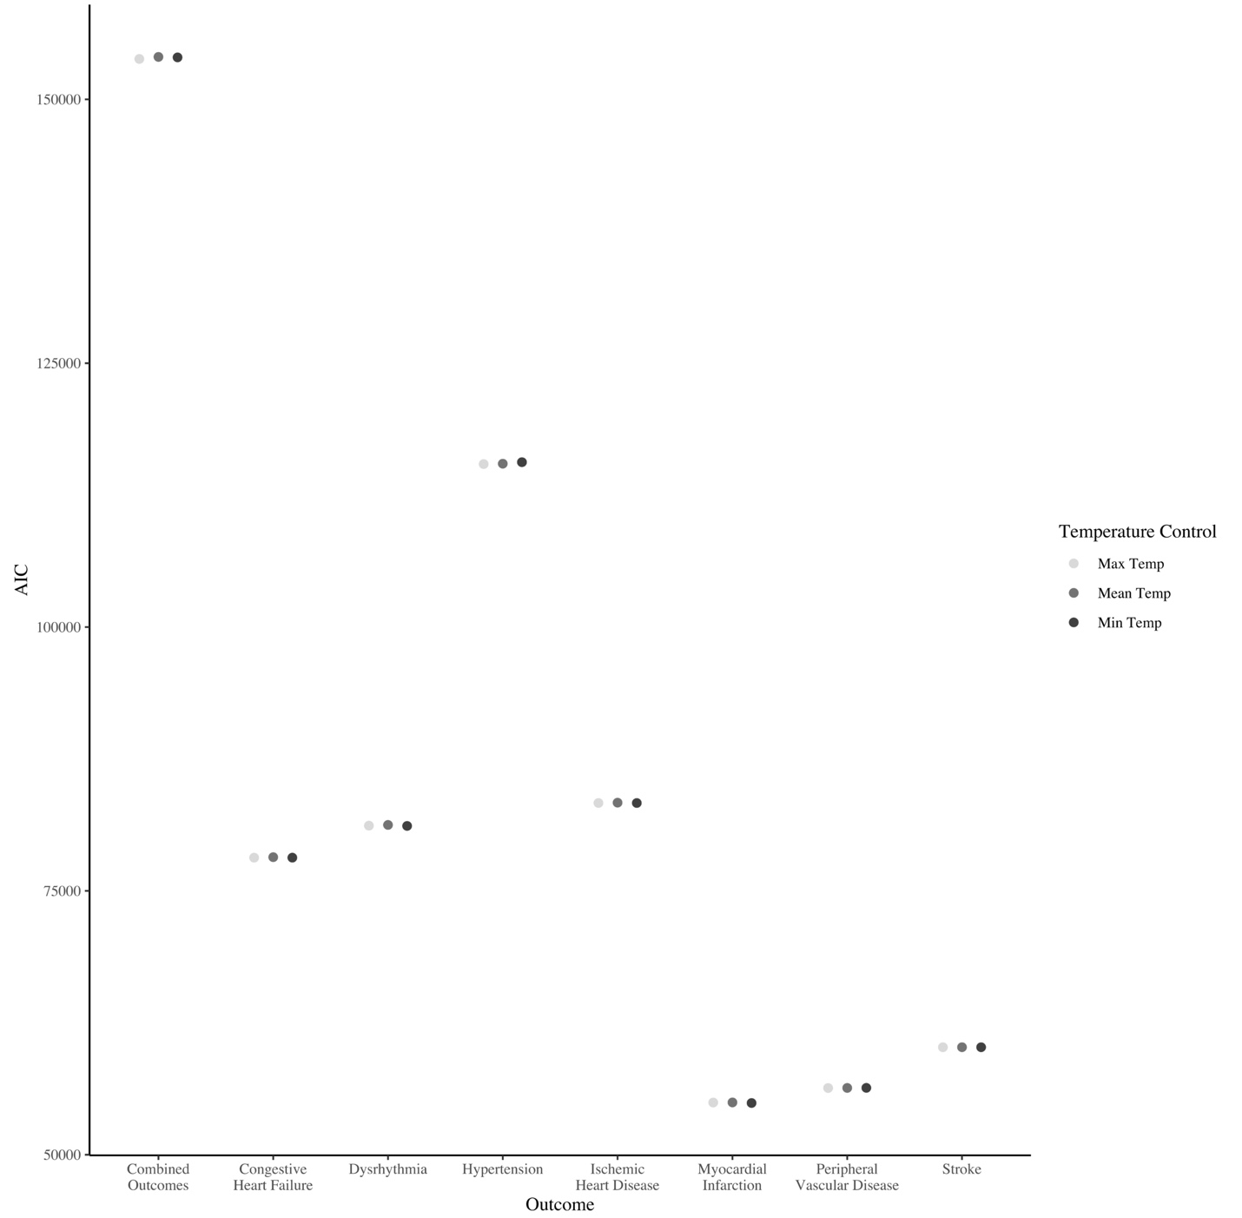
Figure S8. AIC values for the sensitivity analysis comparing varying three-day moving averages of temperature controls (maximum temperature, mean temperature, and minimum temperature).

