clc;
clear;
close all;

%% Load Data1

data=LoadData1();

Inputs = data.Inputs';
Targets = data.Targets';

nData = size(Inputs,1);

Targets = Targets(:,1); % Select 1st Output to Model

%% Shuffling Data

PERM = randperm(nData); % Permutation to Shuffle Data

pTrain=0.70;
nTrainData=round(pTrain*nData);
TrainInd=PERM(1:nTrainData);
TrainInputs=Inputs(TrainInd,:);
TrainTargets=Targets(TrainInd,:);

pVal=0.10;
nValData=round(pVal*nData);
ValInd=PERM(1:nValData);
ValInputs=Inputs(ValInd,:);
ValTargets=Targets(ValInd,:);

pTest=0.20;
nTestData=round(pTest*nData);
TestInd=PERM(1:nTestData);
TestInputs=Inputs(TestInd,:);
TestTargets=Targets(TestInd,:);

%% Selection of FIS Generation Method

Option{1}='Grid Partitioning (genfis1)';
Option{2}='Subtractive Clustering (genfis2)';
Option{3}='FCM (genfis3)';

ANSWER=questdlg('Select FIS Generation Approach:',...
'Select GENFIS',...
Option{1},Option{2},Option{3},...
Option{3});
pause(0.01);

%% Setting the Parameters of FIS Generation Methods

switch ANSWER
case Option{1}
Prompt={'Number of MFs','Input MF Type:','Output MF Type:'};
Title='Enter genfis1 parameters';
DefaultValues={'5', 'gaussmf', 'linear'};

PARAMS=inputdlg(Prompt,Title,1,DefaultValues);
pause(0.01);

nMFs=str2num(PARAMS{1}); %#ok
InputMF=PARAMS{2};
OutputMF=PARAMS{3};

fis=genfis1([TrainInputs TrainTargets],nMFs,InputMF,OutputMF);

case Option{2}
Prompt={'Influence Radius:'};
Title='Enter genfis2 parameters';
DefaultValues={'0.3'};

PARAMS=inputdlg(Prompt,Title,1,DefaultValues);
pause(0.01);

Radius=str2num(PARAMS{1}); %#ok

fis=genfis2(TrainInputs,TrainTargets,Radius);

case Option{3}
Prompt={'Number fo Clusters:',...
'Partition Matrix Exponent:',...
'Maximum Number of Iterations:',...
'Minimum Improvemnet:'};
Title='Enter genfis3 parameters';
DefaultValues={'15', '2', '200', '1e-5'};

PARAMS=inputdlg(Prompt,Title,1,DefaultValues);
pause(0.01);

nCluster=str2num(PARAMS{1}); %#ok
Exponent=str2num(PARAMS{2}); %#ok
MaxIt=str2num(PARAMS{3}); %#ok
MinImprovment=str2num(PARAMS{4}); %#ok
DisplayInfo=1;
FCMOptions=[Exponent MaxIt MinImprovment DisplayInfo];

fis=genfis3(TrainInputs,TrainTargets,'sugeno',nCluster,FCMOptions);
end

%% Training ANFIS Structure using PSO

Prompt={'Maximum Number of Epochs:',...
'Error Goal:',...
'Initial Step Size:',...
'Step Size Decrease Rate:',...
'Step Size Increase Rate:'};
Title='Enter genfis3 parameters';
DefaultValues={'200', '0', '0.01', '0.9', '1.1'};

PARAMS=inputdlg(Prompt,Title,1,DefaultValues);
pause(0.01);

MaxEpoch=str2num(PARAMS{1}); %#ok
ErrorGoal=str2num(PARAMS{2}); %#ok
InitialStepSize=str2num(PARAMS{3}); %#ok
StepSizeDecreaseRate=str2num(PARAMS{4}); %#ok
StepSizeIncreaseRate=str2num(PARAMS{5}); %#ok
TrainOptions=[MaxEpoch ...
ErrorGoal ...
InitialStepSize ...
StepSizeDecreaseRate ...
StepSizeIncreaseRate];

DisplayInfo=true;
DisplayError=true;
DisplayStepSize=true;
DisplayFinalResult=true;
DisplayOptions=[DisplayInfo ...
DisplayError ...
DisplayStepSize ...
DisplayFinalResult];

fis=CreateInitialFIS(data,10);

Options = {'Genetic Algorithm', 'Particl Swarm Optimization'};

[Selection, Ok] = listdlg('PromptString', 'Select training method for ANFIS:', ...
'SelectionMode', 'single', ...
'ListString', Options);

pause(0.01);

if Ok==0
return;
end

switch Selection
case 1, fis=TrainAnfisUsingGA(fis,data);
case 2, fis=TrainAnfisUsingPSO(fis,data);
end

%% Apply ANFIS to Data

Outputs=evalfis(Inputs,fis);
TrainOutputs=Outputs(TrainInd,:);
ValOutputs=Outputs(ValInd,:);
TestOutputs=Outputs(TestInd,:);

%% Error Calculation

TrainErrors=TrainTargets-TrainOutputs;
TrainMSE=mean(TrainErrors.^2);
TrainRMSE=sqrt(TrainMSE);
TrainErrorMean=mean(TrainErrors);
TrainErrorSTD=std(TrainErrors);

ValErrors=ValTargets-ValOutputs;
ValMSE=mean(ValErrors.^2);
ValRMSE=sqrt(ValMSE);
ValErrorMean=mean(ValErrors);
ValErrorSTD=std(ValErrors);

TestErrors=TestTargets-TestOutputs;
TestMSE=mean(TestErrors.^2);
TestRMSE=sqrt(TestMSE);
TestErrorMean=mean(TestErrors);
TestErrorSTD=std(TestErrors);

%% Plot Results

figure;
PlotResults(TrainTargets,TrainOutputs,'Train Data');
figure;
PlotResults(ValTargets,ValOutputs,'Val Data');
figure;
PlotResults(TestTargets,TestOutputs,'Test Data');
figure;
PlotResults(Targets,Outputs,'All Data');

if ~isempty(which('plotregression'))
figure;
plotregression(TrainTargets, TrainOutputs, 'Train Data', ...
ValTargets, ValOutputs, 'Val Data', ...
TestTargets, TestOutputs, 'Test Data', ...
Targets, Outputs, 'All Data');
set(gcf,'Toolbar','figure');
end

figure;
gensurf(fis, [1 2], 1, [500 500]);
xlim([min(Inputs(:,1)) max(Inputs(:,1))]);
ylim([min(Inputs(:,2)) max(Inputs(:,2))]);

figure;
gensurf(fis, [1 3], 1, [500 500]);
xlim([min(Inputs(:,1)) max(Inputs(:,1))]);
ylim([min(Inputs(:,3)) max(Inputs(:,3))]);

figure;
% View the graph in 2D, from 'overhead' with no grid.

gensurf(fis, [1 2], 1, [500 500]);
xlim([min(Inputs(:,1)) max(Inputs(:,1))]);
ylim([min(Inputs(:,2)) max(Inputs(:,2))]);
view ( 0, 90 );
title ( 'F(X,Y) > 1.5, XY contour view', 'FontSize', 24 );
xlabel ( '<--- X --->', 'FontSize', 12 );
ylabel ( '<--- Y --->', 'FontSize', 12 );
zlabel ( '<--- colormap,on --->', 'FontSize', 24 );

filename = 'surf_test01_2d.png';
print ( '-dpng', filename );
fprintf ( 1, ' Graphics saved as "%s".\n', filename );
pause ( 6 );

figure;
% View the graph in 2D, from 'overhead' with no grid.

gensurf(fis, [1 3], 1, [500 500]);
xlim([min(Inputs(:,1)) max(Inputs(:,1))]);
ylim([min(Inputs(:,3)) max(Inputs(:,3))]);
view ( 0, 90 );
title ( 'F(X,Y) > 1.5, XY contour view', 'FontSize', 24 );
xlabel ( '<--- X --->', 'FontSize', 12 );
ylabel ( '<--- Y --->', 'FontSize', 12 );
zlabel ( '<--- colormap,on --->', 'FontSize', 24 );

filename = 'surf_test03_2d.png';
print ( '-dpng', filename );
fprintf ( 2, ' Graphics saved as "%s".\n', filename );
pause ( 7 );
% View the graph in 2D, from 'overhead' with no grid.

gensurf(fis, [1 4], 1, [500 500]);
xlim([min(Inputs(:,1)) max(Inputs(:,1))]);
ylim([min(Inputs(:,4)) max(Inputs(:,4))]);
view ( 0, 90 );
title ( 'F(X,Y) > 1.5, XY contour view', 'FontSize', 24 );
xlabel ( '<--- X --->', 'FontSize', 12 );
ylabel ( '<--- Y --->', 'FontSize', 12 );
zlabel ( '<--- colormap,on --->', 'FontSize', 24 );

filename = 'surf_test04_2d.png';
print ( '-dpng', filename );
fprintf ( 2, ' Graphics saved as "%s".\n', filename );
pause ( 8 );
% View the graph in 2D, from 'overhead' with no grid.

gensurf(fis, [1 5], 1, [500 500]);
xlim([min(Inputs(:,1)) max(Inputs(:,1))]);
ylim([min(Inputs(:,5)) max(Inputs(:,3))]);
view ( 0, 90 );
title ( 'F(X,Y) > 1.5, XY contour view', 'FontSize', 24 );
xlabel ( '<--- X --->', 'FontSize', 12 );
ylabel ( '<--- Y --->', 'FontSize', 12 );
zlabel ( '<--- colormap,on --->', 'FontSize', 24 );

filename = 'surf_test05_2d.png';
print ( '-dpng', filename );
fprintf ( 2, ' Graphics saved as "%s".\n', filename );
pause ( 9 );

figure;
% View the graph in 2D, from 'overhead' with no grid.

gensurf(fis, [2 3], 1, [500 500]);
xlim([min(Inputs(:,2)) max(Inputs(:,2))]);
ylim([min(Inputs(:,3)) max(Inputs(:,3))]);
view ( 0, 90 );
title ( 'F(X,Y) > 1.5, XY contour view', 'FontSize', 24 );
xlabel ( '<--- X --->', 'FontSize', 12 );
ylabel ( '<--- Y --->', 'FontSize', 12 );
zlabel ( '<--- colormap,on --->', 'FontSize', 24 );

filename = 'surf_test06_2d.png';
print ( '-dpng', filename );
fprint ( 3, ' Graphics saved as "%s".\n', filename );
pause ( 10 );

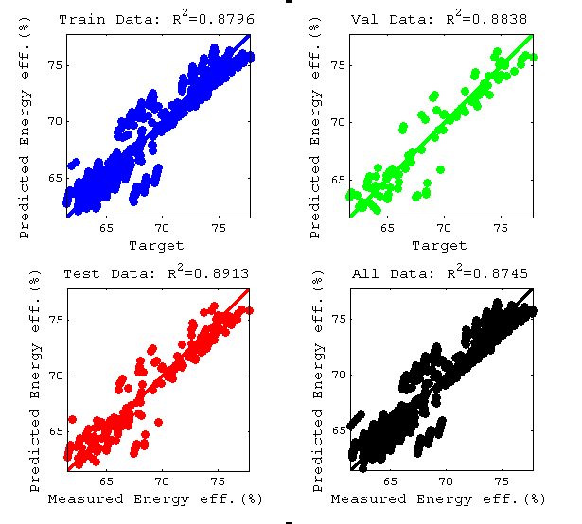

Fig. 1B: Comparison of predicted and measured energy efficiency values for GA-ANFIS-FCM1

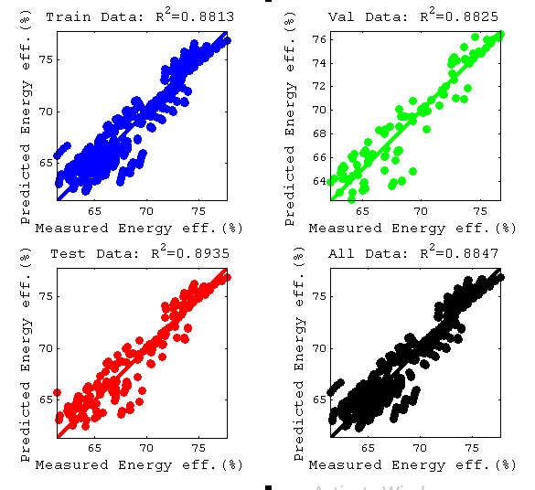
Fig. 2B: Comparison of predicted and measured energy efficiency values for GA-ANFIS-FCM3

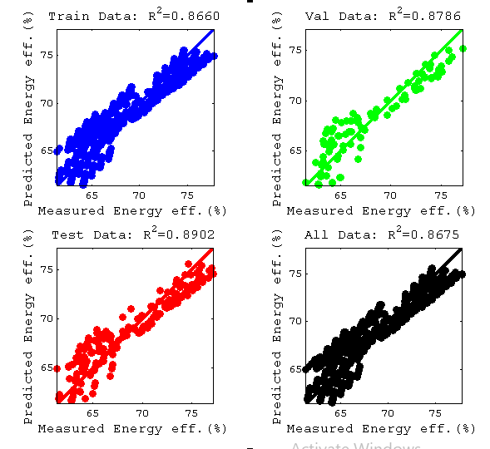
Fig. 3B: Comparison of predicted and measured energy efficiency values for GA-ANFIS-FCM4

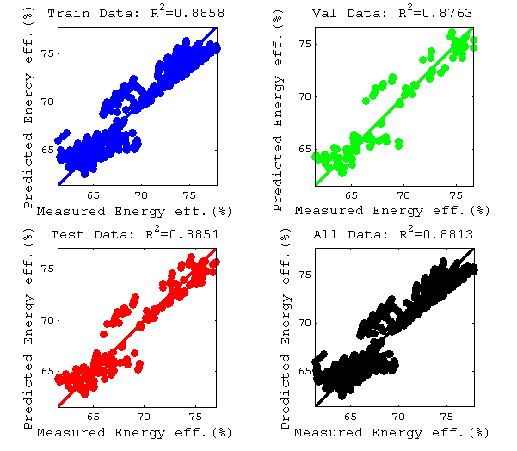
Fig. 4B: Comparison of predicted and measured energy efficiency values for GA-ANFIS-GP1

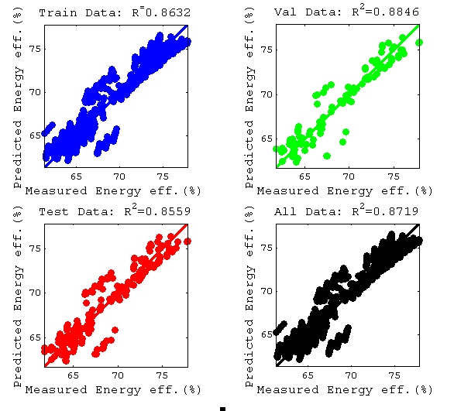
Fig. 5B: Comparison of predicted and measured energy efficiency values for GA-ANFIS-GP2

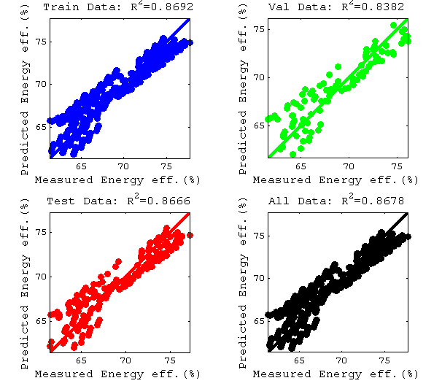
Fig. 6B: Comparison of predicted and measured energy efficiency values for GA-ANFIS-SC1

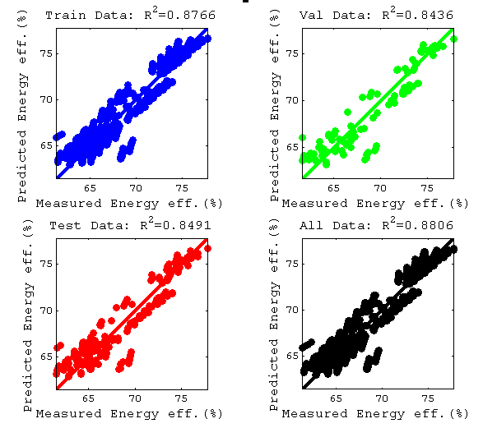
Fig. 7B: Comparison of predicted and measured energy efficiency values for GA-ANFIS-SC3

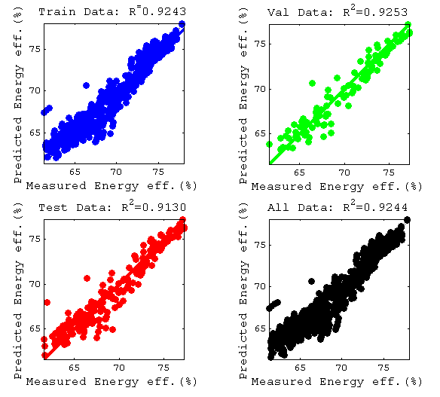
Fig. 8B: Comparison of predicted and measured energy efficiency values for PSO-ANFIS-FCM5

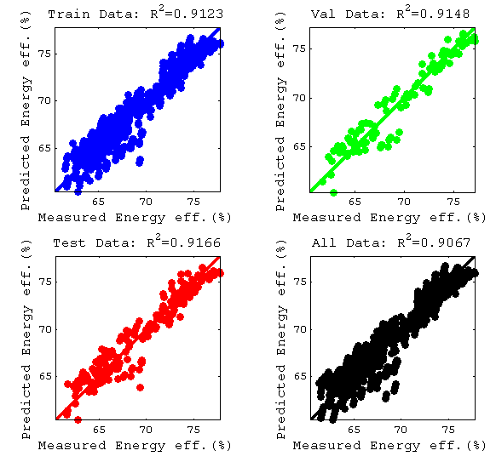
Fig. 8B: Comparison of predicted and measured energy efficiency values for PSO-ANFIS-FCM6

