Electronic Supplementary Material (ESM)
Journal: Molecular Imaging and Biology

Title:
Image Denoising of Low Dose PET Mouse Scans with Deep Learning: Validation Study for Cross-Tracer Preclinical Imaging Applicability

Running title:
Deep Learning Denoising for Low Dose Micro-PET

Authors:
Florence M. Muller^{1,2*}
Boris Vervenne^{1*}
Jens Maebe¹
Eric Blankemeyer²
Mark A. Sellmyer²
Rong Zhou²
Joel S. Karp²
Christian Vanhove¹
Stefaan Vandenberghe¹

* Co-first authorship

¹ Department of Electronics and Information Systems, Faculty of Engineering and Architecture, Ghent University, 9000 Ghent, Belgium
² Department of Radiology, Perelman School of Medicine, University of Pennsylvania, Philadelphia, PA19104, USA

Correspondence
FlorenceMarie.Muller@ugent.be
+32 (9) 3320054
MEDISIP, Institute Biomedical Engineering and Technology, Corneel Heymanslaan 10, Entrance 36, 5th Floor, UZ Ghent Campus, 9000 Ghent, Belgium

Table of Contents
MATERIALS AND METHODS 3
Supplemental Information 1 3
RESULTS 6
Supplemental Information 2: Results for 5-hour (ex vivo) scan of a ¹⁸F-FDG mouse 6
Supplemental Information 3: Contrast Recovery Coefficients. Tabular results for the NEMA-NU4 phantom. 8
Supplemental Information 4: Applicability to Other Tracer Studies 9
Supplemental Information 5: Training and Testing Computation Times 12
Supplemental Information 6: Results for the NEMA-NU4 phantom are compared between acquisitions with reduced scan time and reduced tracer dose 13
Supplemental Information 7: Visual comparison of M2Std CNN denoised mouse images from low-count (input) images reconstructed without and with attenuation correction 17

MATERIALS AND METHODS

Supplemental Information 1

1.1. U-Net structure
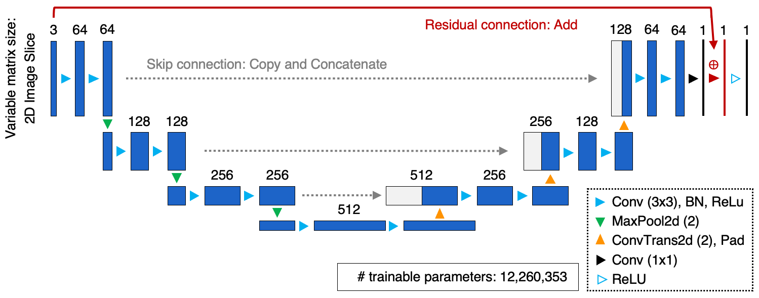
Suppl. Figure 1: U-Net structure of the CNN denoising algorithm used in this study. The neural network utilizes 2D convolutional kernels with a kernel size of 3x3 and consists of 18 convolutional layers with three downsampling layers (resulting in a receptive field size of 101²). The CNN has 12,260,353 trainable parameters. Also note that the network loads three adjacent image slices as input, and the expansion layer input is padded for concatenation with the contraction layer output.

1.2. Preprocessing
Before being passed through the network, the training input slices were cropped to only focus on the regions of interest within images (to avoid including unnecessary background). The cropping operation consisted of ten repetitions of a binary erosion applied on the mask image of non-zero count values of the input slices. The size of each cropped image slice had to be large enough to pass through the encoding path of the network. For the adopted U-Net, the matrix size after image cropping had to be at least 2^{n+1} with n equal to the number of encoding blocks (here: 4). Image slices that did not satisfy this prerequisite were disregarded as they lacked sufficient relevant image content. From the 28 mice datasets included for training, a total of 10,897 slices were selected from all three orientations (in total: transverse: 6026, coronal: 2413, sagittal: 2458).

1.3. NEMA-NU4 Phantom
As described by the NU-4 standards, image uniformity and contrast recovery coefficients (CRCs) were measured as follows. Uniformity was evaluated with a cylindrical ROI (length: 10 mm, and diameter: 25 mm) placed centrally in the uniform section of the phantom. Contrast recovery was determined by the five hot rods (5, 4, 3, 2 and 1 mm in diameter): circular ROIs of size equal to twice the rod diameter were drawn on the image averaged along the central 10 mm of the rods. To calculate the CRCs, the maximum voxel values in the circular ROIs were divided by the mean value in the cylindrical ROI (used to measure uniformity).

1.4. Data Acquisition and Data Analysis for Cross-Tracer Applicability Investigation

F18-PSMA
A mouse with a high PSMA expressing tumor was intravenously injected with 6.49 MBq ¹⁸F-PSMA-1007 ﻿(ECD 21/63). One hour after tracer injection, static total-body PET/CT scans were acquired for 15 min using the Molecubes β-CUBE. The full-count dataset (15-min scan) was under-sampled to 50, 25, 10 and 5% of the counts. All datasets were reconstructed with OSEM into 400 µm voxels.
F18-FAPI
Using a murine lung carcinoma model, an animal was intravenously injected with 5.03 MBq ¹⁸F-FAPI followed by a 5 min PET scan at 1 hour post-injection on the Molecubes β-CUBE. The 5-min dataset was under-sampled to reconstruct an image with 50, 25 and 10% of the counts. All datasets were reconstructed with OSEM with 400 µm voxel size.

Data analysis: Based on mean and maximum uptake value measurements from VOIs drawn around the tumor and muscle (background organ), the tumor-to-muscle ratio was determined using both the mean and maximum voxel values. In this quantitative analysis, reproducibility of the tumor-to-muscle ratio was studied; results were reported as mean ± standard deviation across the number of replicate frame images available at the particular count level.

Ga68-FAPI
A mouse was intravenously injected with 3.89 MBq ⁶⁸Ga-FAPI and scanned one hour post injection for 15 min on the Molecubes β-CUBE. The 15-min data was under-sampled to 50, 25, 10 and 5% of the counts. All datasets were reconstructed with OSEM into 400 µm voxels.

Data analysis: A spherical VOI was drawn in the liver to quantify the mean and maximum voxel value (in kBq/ml) in the liver. The mean uptake measurement was reported as the mean in the VOI ± standard deviation. Here, the standard deviation is a measure of the variability within a uniform region (i.e. measure of noise).

RESULTS

Supplemental Information 2: Results for 5-hour (ex vivo) scan of a ¹⁸F-FDG mouse

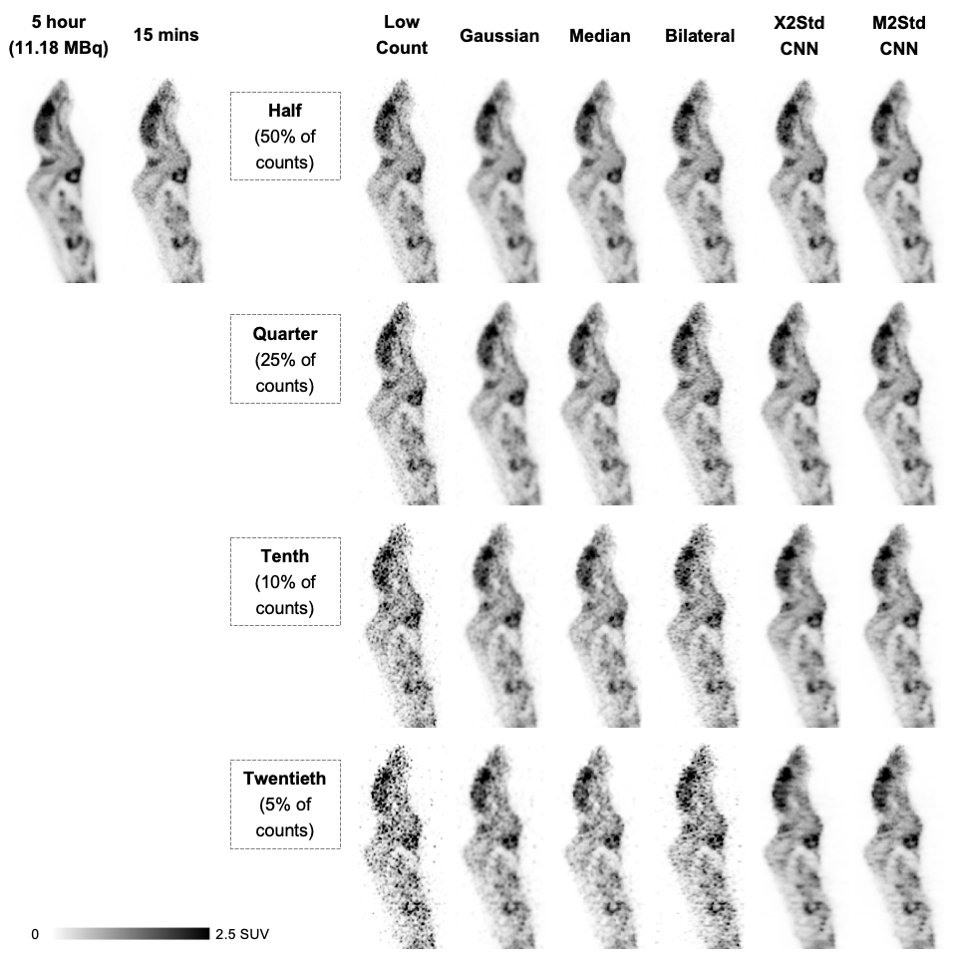
Suppl. Figure 2: Visual comparison between the estimated ground-truth image (obtained from an ex vivo 5-hour scan), high-count (standard 15-min scan), low-count and denoised images. The example shows a sagittal view from a ¹⁸F-FDG scan of a mouse (18.7 g) which was administered a tracer activity of 11.19 MBq and then scanned (68 min p.i.) for 5 hours. Each row illustrates one of the low-count levels (half, quarter, tenth, twentieth). Note that these images were reconstructed without attenuation correction.
Suppl. Table 2: Image enhancement performance is compared between different image processing methods evaluated in terms of the root mean squared error (RMSE), peak signal-to-noise ratio (PSNR) and structural similarity index metric (SSIM). These image quality metrics are derived on the 3D images with respect to the estimate image of a ground-truth obtained from a 5-hour scan.
Part A: RMSE
 | Low- Count | Gaussian | Median | Bilateral | X2Std CNN | M2Std CNN
Half  (50% of counts) | 0.183 | 0.160 | 0.163 | 0.151 | 0.140 | 0.131
Quarter  (25% of counts) | 0.242 | 0.171 | 0.184 | 0.183 | 0.147 | 0.145
Tenth  (10% of counts) | 0.362 | 0.198 | 0.230 | 0.256 | 0.168 | 0.171
Twentieth  (5% of counts) | 0.497 | 0.232 | 0.287 | 0.349 | 0.182 | 0.193
Part B: PSNR
 | Low- Count | Gaussian | Median | Bilateral | X2Std CNN | M2Std CNN
Half  (50% of counts) | 42.55 | 43.74 | 43.59 | 44.22 | 44.90 | 45.44
Quarter  (25% of counts) | 40.14 | 43.13 | 42.54 | 42.56 | 44.44 | 44.57
Tenth  (10% of counts) | 36.64 | 41.89 | 40.57 | 39.65 | 43.31 | 43.17
Twentieth  (5% of counts) | 33.88 | 40.49 | 38.67 | 36.94 | 42.61 | 42.08
Part C: SSIM
 | Low- Count | Gaussian | Median | Bilateral | X2Std CNN | M2Std CNN
Half  (50% of counts) | 0.980 | 0.992 | 0.988 | 0.989 | 0.990 | 0.992
Quarter  (25% of counts) | 0.965 | 0.987 | 0.981 | 0.982 | 0.989 | 0.990
Tenth  (10% of counts) | 0.928 | 0.980 | 0.965 | 0.964 | 0.984 | 0.984
Twentieth  (5% of counts) | 0.884 | 0.967 | 0.946 | 0.939 | 0.979 | 0.977

Supplemental Information 3: Contrast Recovery Coefficients. Tabular results for the NEMA-NU4 phantom.

Suppl. Table 3: Summary of contrast recovery measurements (CRC) from the NEMA-NU4 phantom. The measures are compared between the standard-count (20 min with 3.7 MBq), low-count (obtained by scan time reduction), Gaussian-filtered and M2Std CNN denoised images.
Contrast Recovery Measures |  | Sphere size (in mm)
 |  | 1 | 2 | 3 | 4 | 5
Standard: 20 min |  | 0.159 | 0.498 | 0.726 | 0.766 | 0.842
Half  (50% of counts) | Low-Count | 0.161 | 0.511 | 0.742 | 0.769 | 0.869
Half  (50% of counts) | Gaussian | 0.107 | 0.420 | 0.643 | 0.754 | 0.839
Half  (50% of counts) | M2Std CNN | 0.151 | 0.534 | 0.729 | 0.768 | 0.868
Quarter  (25% of counts) | Low-Count | 0.153 | 0.504 | 0.725 | 0.809 | 0.881
Quarter  (25% of counts) | Gaussian | 0.103 | 0.398 | 0.636 | 0.752 | 0.826
Quarter  (25% of counts) | M2Std CNN | 0.140 | 0.528 | 0.712 | 0.773 | 0.858
Tenth  (10% of counts) | Low-Count | 0.143 | 0.494 | 0.724 | 0.846 | 0.949
Tenth  (10% of counts) | Gaussian | 0.093 | 0.378 | 0.608 | 0.731 | 0.841
Tenth  (10% of counts) | M2Std CNN | 0.115 | 0.507 | 0.701 | 0.776 | 0.864
Twentieth  (5% of counts) | Low-Count | 0.178 | 0.505 | 0.704 | 0.822 | 0.897
Twentieth  (5% of counts) | Gaussian | 0.091 | 0.335 | 0.600 | 0.726 | 0.813
Twentieth  (5% of counts) | M2Std CNN | 0.097 | 0.485 | 0.664 | 0.768 | 0.870

Supplemental Information 4: Applicability to Other Tracer Studies

F18-PSMA
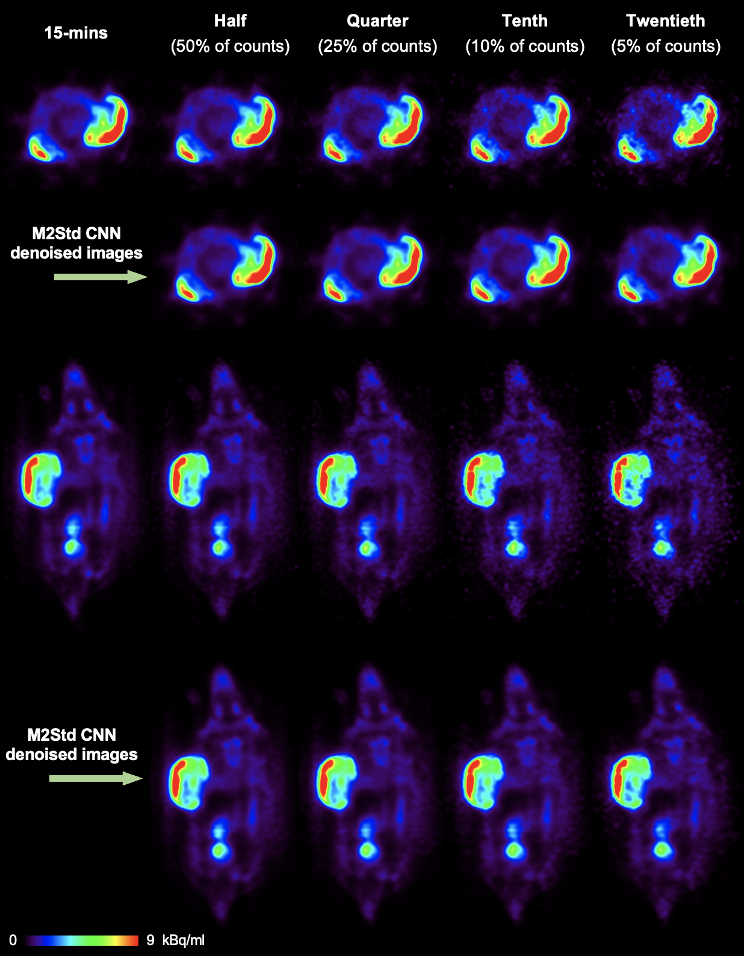
Suppl. Figure 3: A transverse and a coronal image slice shown for visual comparison between the standard-count (15-min scan), low-count and M2Std CNN-denoised images. This is for a ¹⁸F-PSMA scan of a mouse with an injected activity of 6.49 MBq.
F18-FAPI
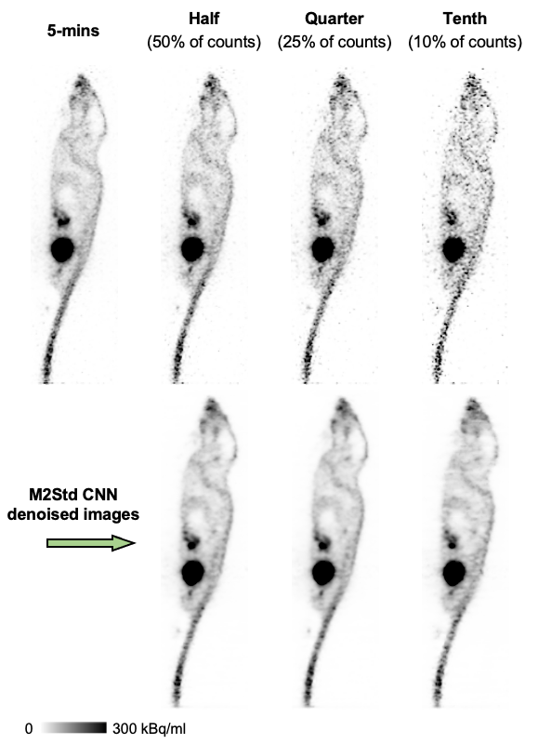
Suppl. Figure 4: One coronal image slice shown for visual comparison between the standard-count (5-min scan), low-count and M2Std CNN-denoised images. This is for a ¹⁸F-FAPI scan of a mouse with an injected activity of 5.03 MBq.

Ga68-FAPI
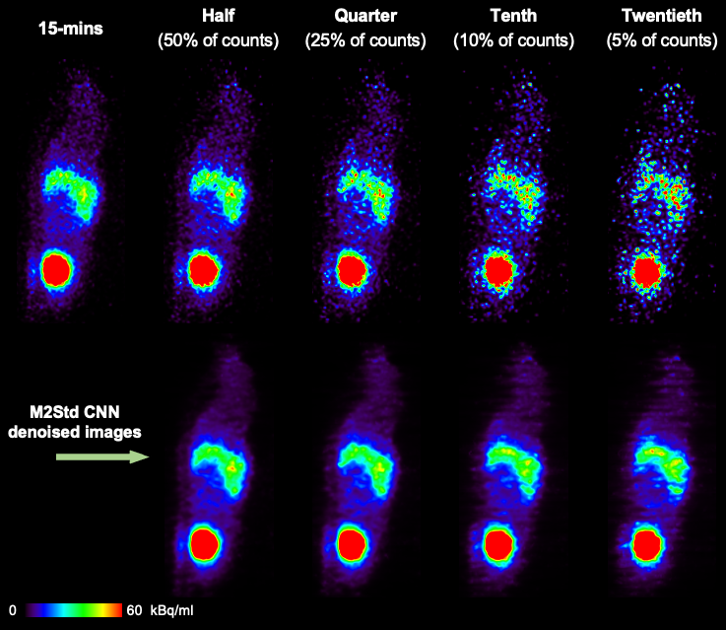
Suppl. Figure 5: One coronal and one sagittal image slice are shown for visual comparison between the high-count (15-min scan), low-count and M2Std CNN-denoised images. This is for a ⁶⁸Ga-FAPI scan of a mouse with an injected activity of 3.89 MBq.

Supplemental Information 5: Training and Testing Computation Times

Suppl. Table 4: Computation times for training and inference for the 5 CNN denoising models are reported. Early stopping was implemented in our work to end training when there was no improvement in validation loss (used as a performance measure) over seven consecutive epochs. Checkpointing was also implemented to only keep the ‘best’ model and restore that model (of the seventh previous epoch after early stopping). Inference run times of the CNN models (when run on a NVIDIA Volta V100 GPU) to process an image size of 384x192x192 voxels are reported.
Which CNN model? |  | Total training time until early stopping criteria reached | Inference time (s)
 |  | Total training time until early stopping criteria reached | GPU
X2Std | Half2Std | 3h23 (after 14 epochs) | 5.28
X2Std | Quarter2Std | 3h50 (after 14 epochs) | 4.41
X2Std | Tenth2Std | 4h01 (after 14 epochs) | 4.34
X2Std | Twentieth2Std | 8h50 (after 31 epochs) | 4.33
M2Std | Mixed2Std | 22h58 (after 20 epochs) | 4.23

Supplemental Information 6: Results for the NEMA-NU4 phantom are compared between acquisitions with reduced scan time and reduced tracer dose
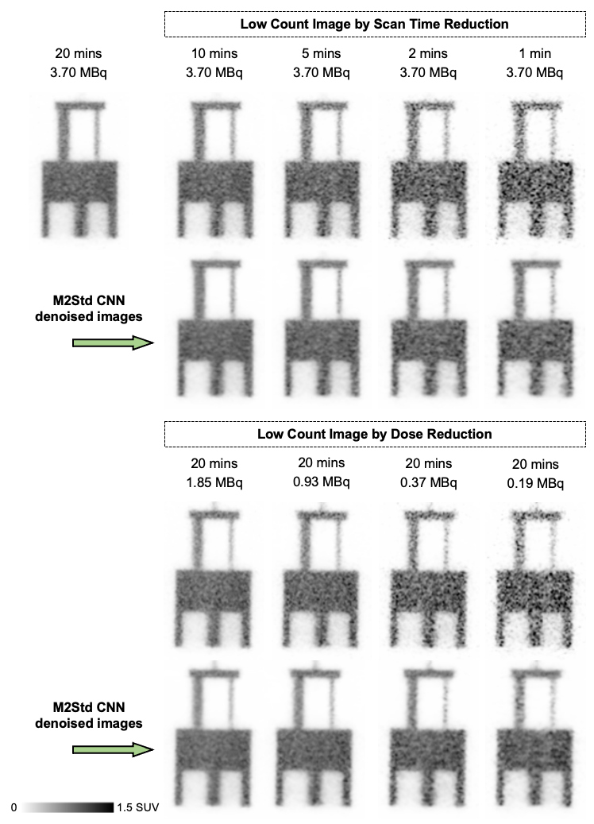
Suppl. Figure 6: A sagittal image slice from the NEMA-NU4 image quality phantom shows the different sections in the phantom: hollow cylinder section, uniform section and hot rod region. Visual comparison between the standard-count image (20 mins scan with 3.7 MBq), low-count images (obtained either by scan time or dose reduction) and corresponding M2Std CNN denoised images.

Suppl. Table 5: Summary of uniformity measurements with the NEMA-NU4 phantom; Coefficient of variation (COV, in percent) was calculated by taking the ratio between the standard deviation and the mean value (in SUV) measured in the uniform section. Maximum-to-mean and minimum-to-mean ratios are reported. The measures are compared between the standard-count image (20 mins scan with 3.7 MBq), low-count (obtained by scan time and dose reduction) and M2Std CNN denoised images.
Image Uniformity Measures | COV (%) |  | Max/Mean Ratio |  | Min/Mean Ratio
Image Uniformity Measures | Original | M2Std CNN | Original | M2Std CNN | Original | M2Std CNN
Standard  20 min | 9.16 | // | 1.41 | // | 0.67 | //
Scan Time Reduction
Half Time | 10.94 | 8.18 | 1.52 | 1.43 | 0.60 | 0.72
Quarter Time | 14.03 | 9.91 | 1.70 | 1.48 | 0.53 | 0.67
Tenth Time | 20.89 | 13.14 | 2.13 | 1.77 | 0.37 | 0.58
Twentieth Time | 28.89 | 14.83 | 2.80 | 1.96 | 0.23 | 0.56
Dose Reduction
Half Dose | 10.74 | 7.80 | 1.47 | 1.37 | 0.63 | 0.72
Quarter Dose | 13.56 | 9.38 | 1.64 | 1.50 | 0.54 | 0.67
Tenth Dose | 20.22 | 12.06 | 2.05 | 1.73 | 0.41 | 0.61
Twentieth Dose | 27.82 | 13.24 | 2.63 | 1.83 | 0.27 | 0.58
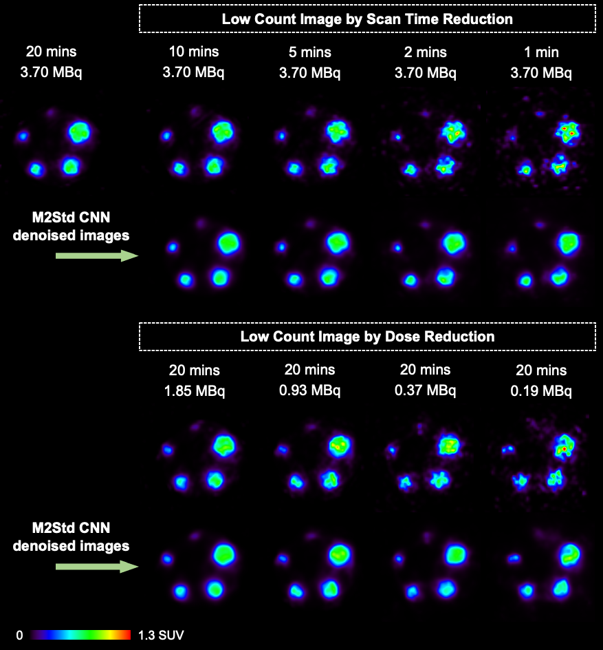
Suppl. Figure 7: A transverse image slice from the hot rod region of the NEMA-NU4 phantom: Visual comparison between the standard-count image (20 mins scan with 3.7 MBq), low-count images (obtained either by scan time or dose reduction) and corresponding M2Std CNN denoised images.

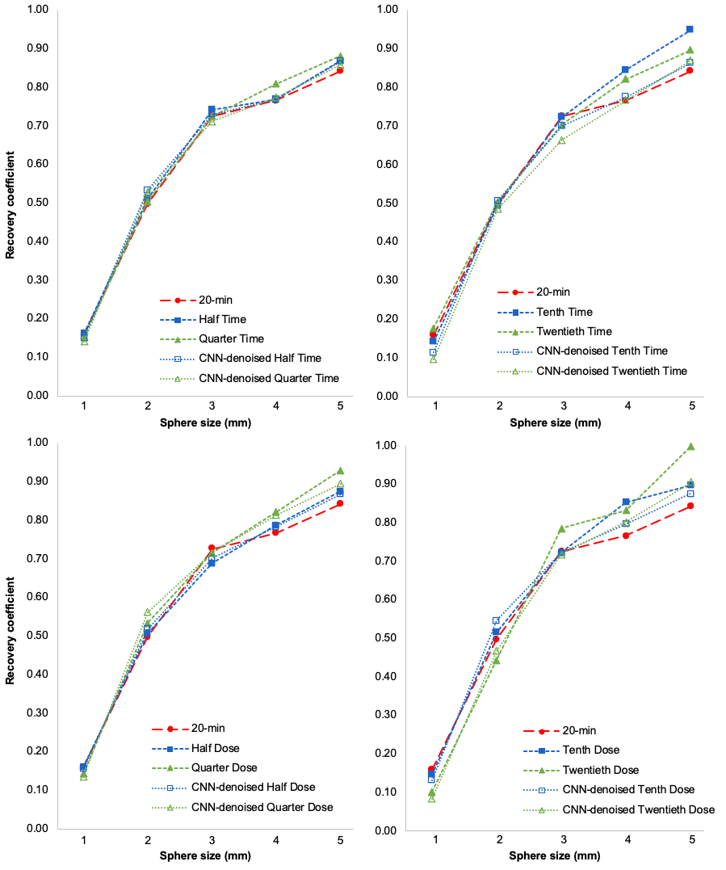
Suppl. Figure 8: Comparison of contrast recovery coefficients between the low-count images (in dashed lines) obtained either by scan time (top row) or dose reduction (bottom row) and the M2Std CNN denoised images (in dotted lines). The red dashed line (same in all four graphs) represents the standard-count image (20 mins scan with 3.7 MBq).

Supplemental Information 7: Visual comparison of M2Std CNN denoised mouse images from low-count (input) images reconstructed without and with attenuation correction

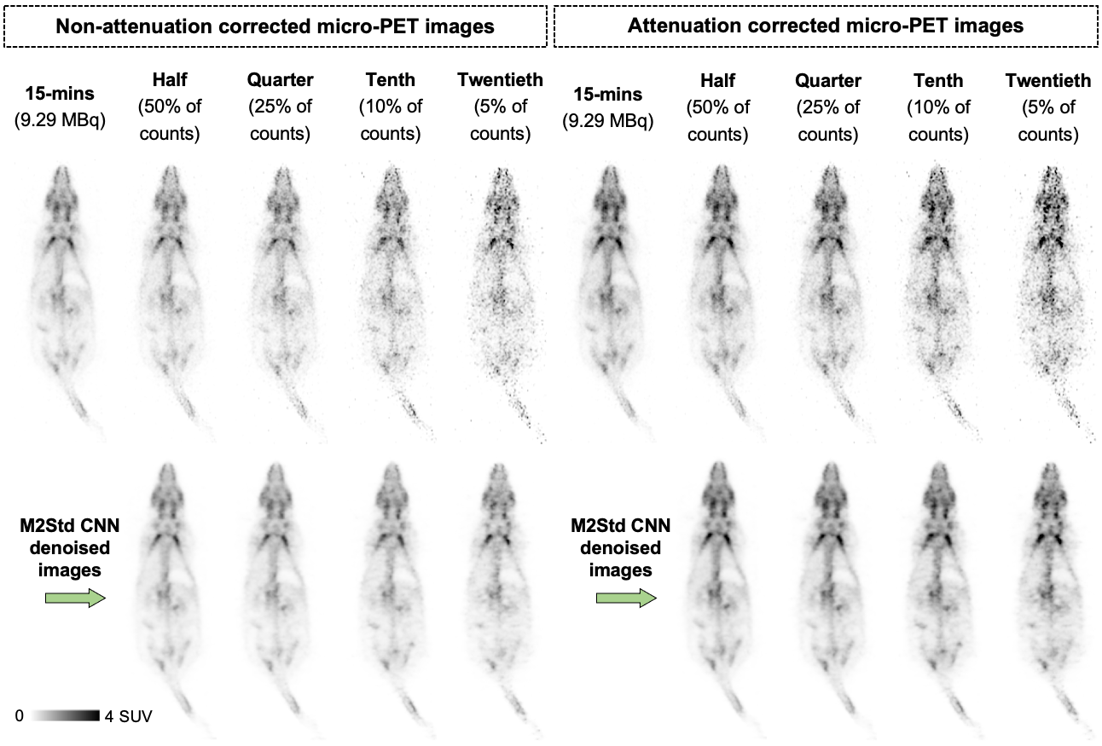
Suppl. Figure 9: Example image slice from a ¹⁸F-FDG PET scan of a mouse (24.6 g) which was injected with 9.29 MBq and then scanned (40 min p.i.) for 15 mins. Visual comparison between the high-count (top left), low-count (top row) and M2Std CNN-denoised images (bottom row) without attenuation correction (left) and with CT-based attenuation correction (right). Note that the non-attenuation corrected micro-PET images are representative of the image datasets included in the training.
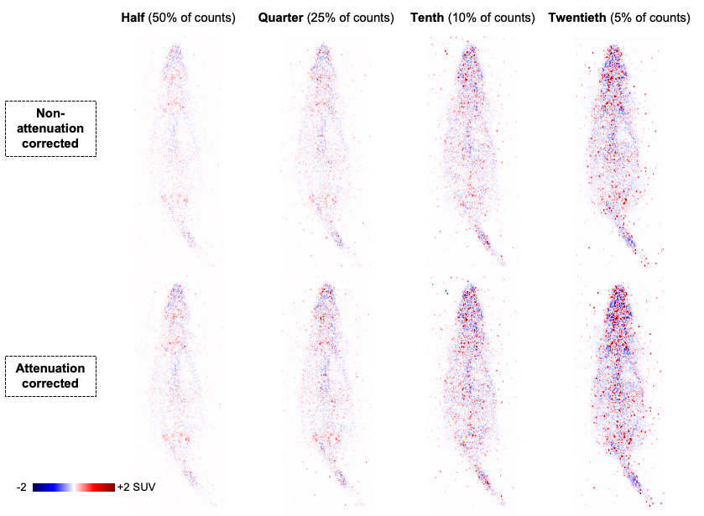
Suppl. Figure 10: Difference images (PET_{lowcount} – PET_{CNN-denoised}) derived from the coronal image slices in Suppl. Figure 9. These difference images represent the removed noise maps (with seismic color scale) which are very similar in pattern and intensity when comparing the non-attenuation and with attenuation-corrected micro-PET images.

National Electrical Manufacturers A (2008) Performance measurements of small animal positron emission tomographs. NEMA Standards Publication, NU4-2008:1-23
Piron S, Verhoeven J, Courtyn J, et al. (2022) Preclinical comparative study of [18F]AlF-PSMA-11 and [18F]PSMA-1007 in varying PSMA expressing tumors. Scientific Reports 12(1):15744
Lee IK, Noguera-Ortega E, Xiao Z, et al. (2022) Monitoring Therapeutic Response to Anti-FAP CAR T Cells Using [18F]AlF-FAPI-74. Clin Cancer Res 28(24):5330-5342

