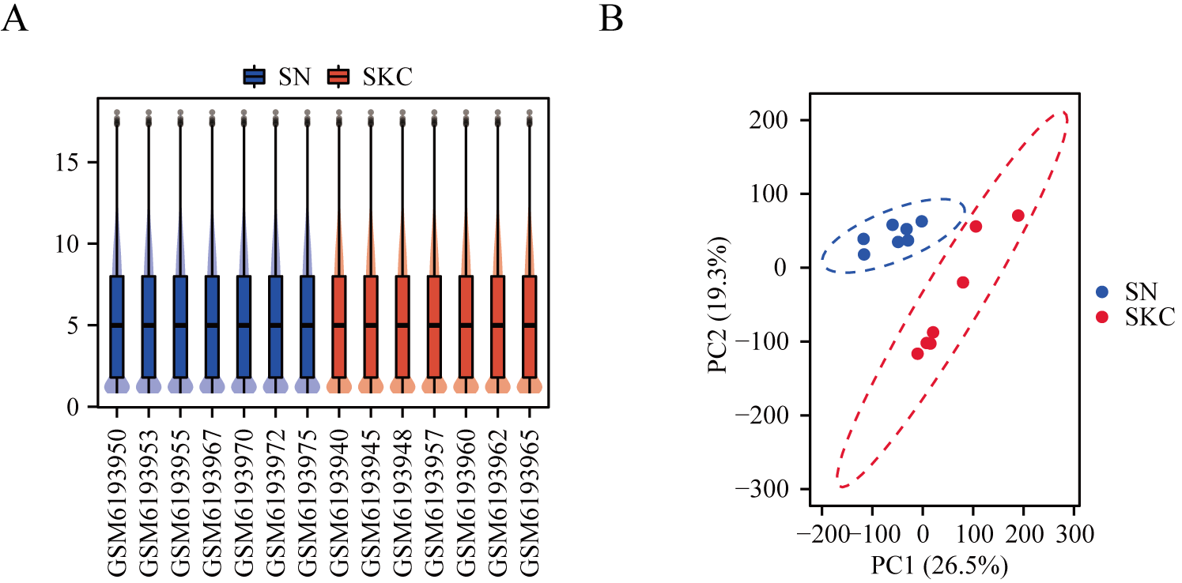
Supplementary Figure S1. Validation of SN and SKC samples from GEO204791. (A) The blue boxes of the box-plot represents SN samples, and the red boxes represents SKC samples. The black lines represent the sample median, and its distribution represents the degree of sample standardization. (B) Visualization of principal component analysis of SN and SKC.

Supplementary Figure S2. Representative results of GSEA analysis in the expression data of SN and SKC. (A) A significant gene set negatively correlated with EKC group was Cytokine Cytokine Receptor Interaction(NES=-2.240, P.adj＜0.001). (B) Signaling by Interleukins was negatively correlated with EKC(NES=-2.209, P.adj＜0.001). (C) Ferroptosis-related genes were negatively correlated with keratoconus (NES=-1.757, P.adj=0.022). NES, normalized enrichment score.

Supplementary Figure S3. The differential gene expression and Receiver operating characteristic analysis (ROC). (A) The mRNA expression of AKR1C3. (B) The mRNA expression of SLC7A11. (C) The AUC analysis of AKR1C3. Receiver operating characteristic, ROC; AUC, area under the ROC curve.

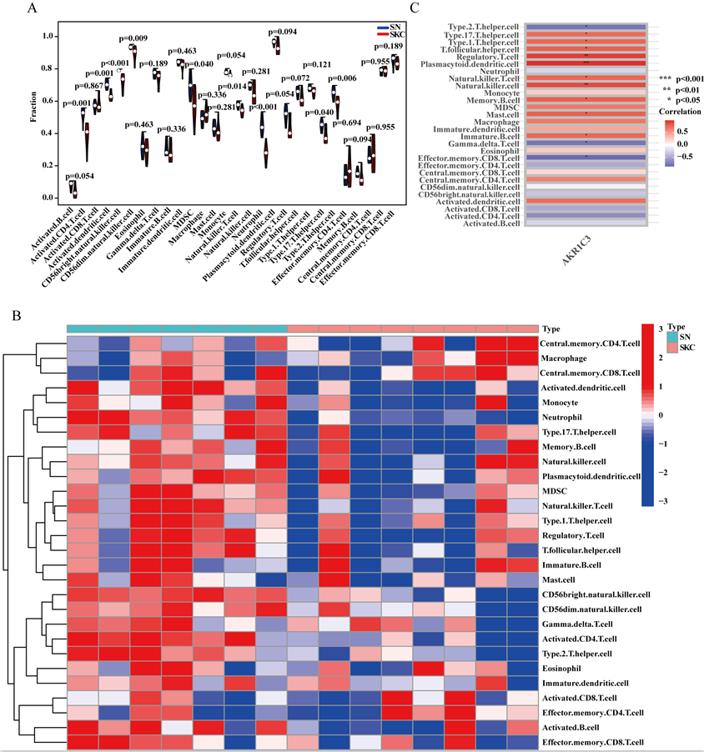

Supplementary Figure S4. ssGSEA analysis. (A and B) Differential identification of immunophenotypic cells. (C) Immune subtype cells affected by AKR1C3. *p＜0.05.

