Comprehensive study on the occurrence of heavy metals and their environmental risks in PM2.5 of indoor dusts in Xi’an, China

Naiwang Yang ª, Yiyu Wang ^{b}, Pingqiang Gao ^{b}, Jiayin Zhang ^{c}, Wenbin Song ª, Xuejuan Song ª, Shiyun Liu ^{d}, Huijun Su ^{b,}*

ª Xi’an Environmental Monitoring Station, Xi’an, Shaanxi, China
^{b} School of Chemistry and Chemical Engineering, Yulin University, Yulin, Shaanxi, China
^{c} Shaanxi Environmental Monitoring Center, Shaanxi Key Lab for Environmental Monitoring and Forewarning of Trace Pollutants, Xi’an, Shaanxi, China
^{d} Clear Science & Technology Co., Ltd., Beijing, China

* Corresponding author:
Huijun Su
Tel.: 86-1-518-073-5884
Email: hjsu@yulinu.edu.cn.

Table S1. Measurement conditions and limits of quantification for target analytes in PM2.5 of indoor dusts by EDXRF
Element | Secondary  target | Analyzed  line | Accelerating  voltage (kV) | Current  (mA) | Analysis time (s) | Limits of quantification (LOD, mg/kg)
Cr | Fe | Kα | 100 | 6 | 200 | 0.003
Mn | Ge | Kα | 100 | 6 | 200 | 0.040
Ni | Ge | Kα | 100 | 6 | 200 | 0.007
Cu | Ge | Kα | 100 | 6 | 200 | 0.006
Zn | Ge | Kα | 100 | 6 | 200 | 0.009
Pb | Al₂O₃ | Lα | 100 | 6 | 200 | 0.174
As | KBr | Kα | 100 | 6 | 200 | 0.007
Cd | Al₂O₃ | Kα | 100 | 6 | 200 | 0.007

Table S2. Geo-accumulation index (I_{geo}) to determine the heavy metal pollution levels
I_{geo} | Classification | Degree of pollution
I_{geo} ≤ 0 | Ⅰ | Unpolluted
0 < I_{geo} ≤ 1 | Ⅱ | Unpolluted to moderately polluted
1 < I_{geo} ≤ 2 | Ⅲ | Moderately polluted
2 < I_{geo} ≤ 3 | Ⅳ | Moderately to strongly polluted
3 < I_{geo} ≤ 4 | Ⅴ | Strongly polluted
4 < I_{geo} ≤ 5 | Ⅵ | Strongly to very strongly polluted
I_{geo} > 5 | Ⅶ | Very strongly polluted

Table S3. Risk grades indexes and grades of potential ecological risk of heavy metal contamination
Class | E_{r}^{i} value | RI value | Risk grade
1 | <40 | <150 | Low potential ecological risk
2 | 40–80 | 150–300 | Moderate potential ecological risk
3 | 80–160 | 300–600 | Considerable potential ecological risk
4 | 160–320 | ≥600 | High potential ecological risk
5 | ≥320 | / | Significantly high potential ecological risk

Table S4. The definitions and reference values of evaluation parameters of average daily exposure to heavy metals
Parameters | Definitions | Unit | Adult | Children
$$C$$ | Concentration of metal | mg/kg | -
$$D_{ }$$ | Dose | mg/(kg·d) | -
$${RfD}_{ }$$ | Reference dose | mg/(kg·d) | The reference values see Table S4
SF | Slope factor | - | The reference values see Table S4
$${HQ}_{ }$$ | Hazard quotient | - | -
HI | Hazard index | - | -
$$IngR$$ | Ingestion rate | mg/d | 100 | 200
$$InhR$$ | Inhalation rate | mg/d | 14.5 | 7.5
$$EF$$ | Ingestion rate | d/a | 350 | 350
$$ED$$ | Exposure duration | a | 24 | 6
$$SA$$ | Exposed skin area | cm² | 5373.99 | 2848.01
$$SL$$ | Skin adherence factor | mg/ (cm²·d) | 0.07 | 0.2
$$ABS$$ | Dimensionless dermal absorption factor | - | 0.001 | 0.001
$$PEF$$ | Particle emission factor | m³/kg | 1.36×10⁹ | 1.36×10⁹
$$BW$$ | Average body weight | kg | 61.8 | 19.2
$$AT$$ | Averaging time | d | ED × 365 days for non-carcinogens, and 70 × 365 = 25550 days for carcinogens

Table S5. The reference doses and carcinogenic slope factors of target heavy metals (mg/(kg·d)) in this study
Parameters | Cr | Ni | Cu | Zn | Cd | Pb | Mn | As
RfD_{inh} | 2.86$×$10⁻⁵ | 2.06$×$10⁻² | 4.02$×$10⁻² | 3.00$×$10⁻¹ | 1.00$×$10⁻³ | 3.52$×$10⁻³ | 1.43$×$10⁻⁵ | 3.01$×$10⁻⁴
RfD_{ing} | 3.00$×$10⁻³ | 2.00$×$10⁻² | 4.00$×$10⁻² | 3.00$×$10⁻¹ | 1.00$×$10⁻³ | 3.50$×$10⁻³ | 4.6$0×$10⁻² | 3.00$×$10⁻⁴
RfD_{dermal} | 6.00$×$10⁻⁵ | 5.40$×$10⁻³ | 1.20$×$10⁻² | 6.00$×$10⁻² | 1.00$×$10⁻⁵ | 5.25$×$10⁻⁴ | 1.84$×$10⁻³ | 1.23$×$10⁻⁴
SF | $$42$$ | 0.84 | - | - | 6.3 | - | - | 15.1

Table S6. Hazard quotient (HQ) and risk for each metal in PM2.5 of indoor dusts in Xi’an
Metals | Adult |  |  |  | Children
Metals | HQ_{ing} | HQ_{inh} | HQ_{dermal} | HI | HQ_{ing} | HQ_{inh} | HQ_{dermal} | HI
Cr | 0.1 | 1.12$×$10⁻⁹ | 0.0189 | 0.119 | 0.889 | 2.57$×$10⁻⁹ | 0.0919 | 0.981
Mn | 0.0234 | 8.02$×$10⁻⁹ | 0.00225 | 0.0256 | 0.0234 | 2.07$×$10⁻⁹ | 0.011 | 0.0343
Ni | 0.00558 | 5.78$×$10⁻¹³ | 7.78$×$10⁻⁵ | 0.00566 | 0.0495 | 1.33$×$10⁻¹² | 0.000379 | 0.0499
Cu | 0.0111 | 1.18$×$10⁻¹² | 0.00014 | 0.0113 | 0.0987 | 2.71$×$10⁻¹² | 0.000681 | 0.0994
Zn | 0.00691 | 7.37$×$10⁻¹³ | 0.00013 | 0.00704 | 0.0613 | 1.69$×$10⁻¹² | 0.000633 | 0.0619
Pb | 0.162 | 1.73$×$10⁻¹¹ | 0.00409 | 0.166 | 1.44 | 3.97$×$10⁻¹² | 0.02 | 1.46
As | 0.242 | 2.57$×$10⁻¹¹ | 0.00222 | 0.244 | 2.14 | 5.89$×$10⁻¹¹ | 0.0108 | 2.15
Cd | 0.0108 | 1.15$×$10⁻¹² | 0.00407 | 0.0149 | 0.096 | 2.65$×$10⁻¹² | 0.0199 | 0.116

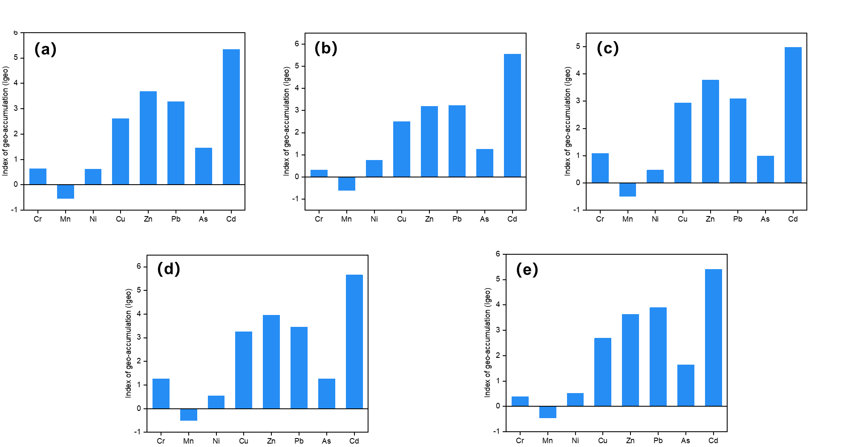

Figure S1. Mean I_{geo} values of target analytes in the PM2.5 of indoor dusts collected from five sampling areas (a-d: the sampling areas located at east, west, south, north and central of Xi’an, and named CJZ, KGC, CHA, JIK and BAQ, respectively).
Figure S2. Potential ecological risks of heavy metals in PM2.5 of indoor dust from Xi’an.

