A spatial transcriptome map of developing maize ear

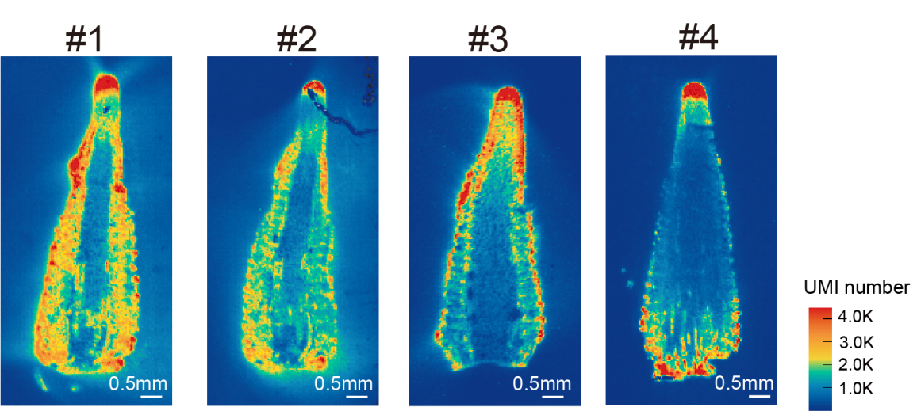
Supplemental Figure 1 | UMI distribution on four sections of maize 6mm ear.

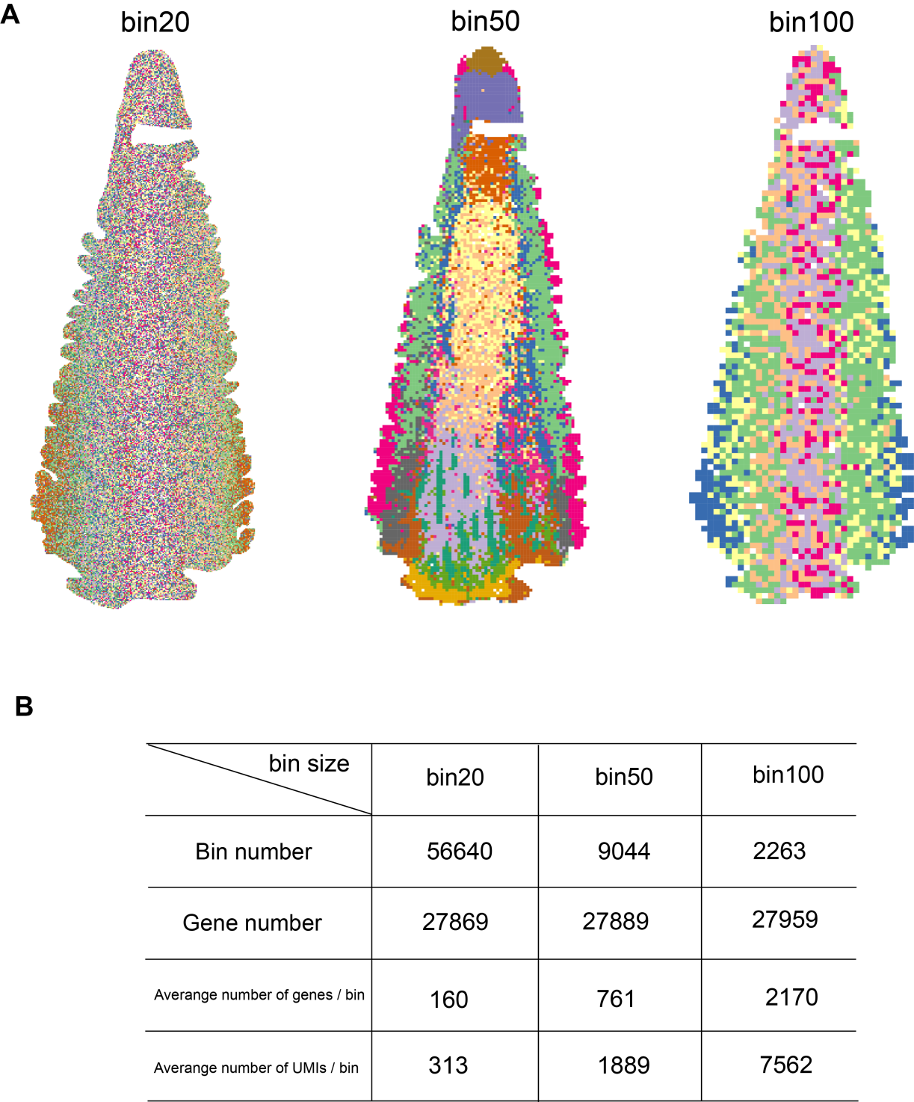

Supplemental Figure 2 | Unsupervised clustering based on Stereo-seq data at different bin sizes. (A) Spatial distribution of cell types identified in #4 section at different bin sizes. (B) Table summarizing total number of bins, total number of genes, average captured number of genes, average captured number of UMIs at different bin sizes in Stereo-seq.

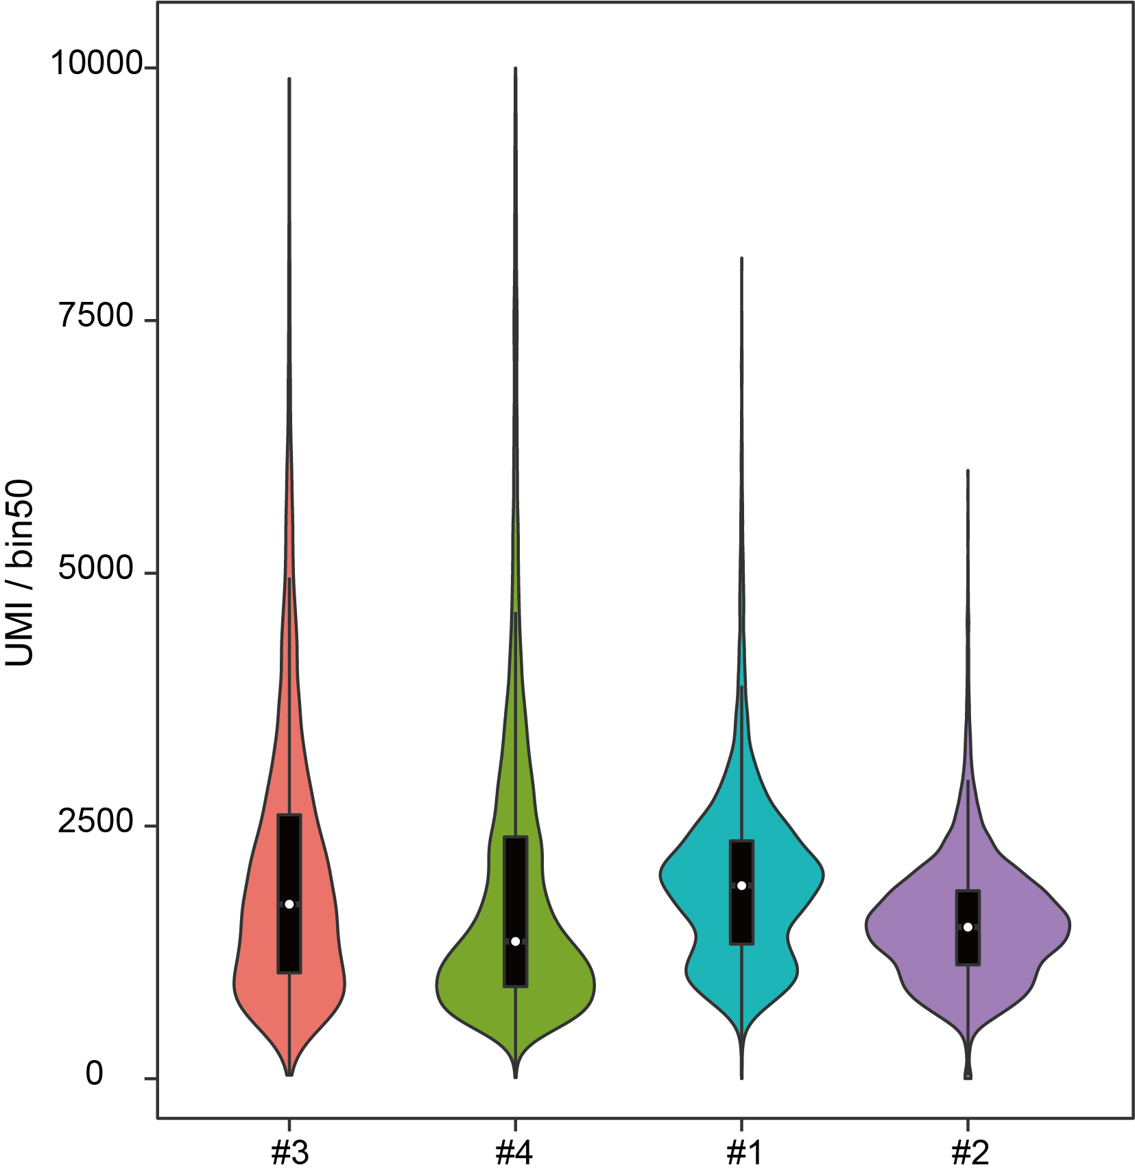

Supplemental Figure 3 | Violin plot of the number of UMI of four maize ear section.

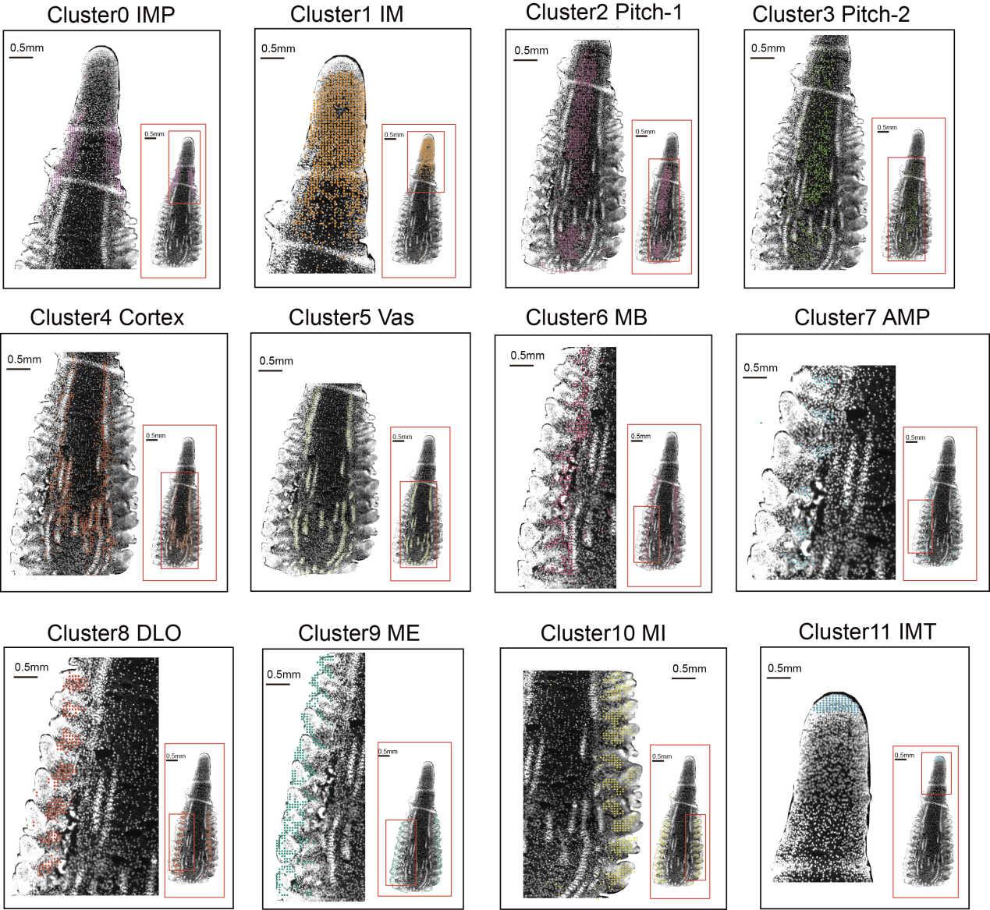
Supplemental Figure 4 | Restoring the physical distribution of each cluster on nucleic acid stained images based on unsupervised clustering results. Each dot representing a bin50 of #1 section.
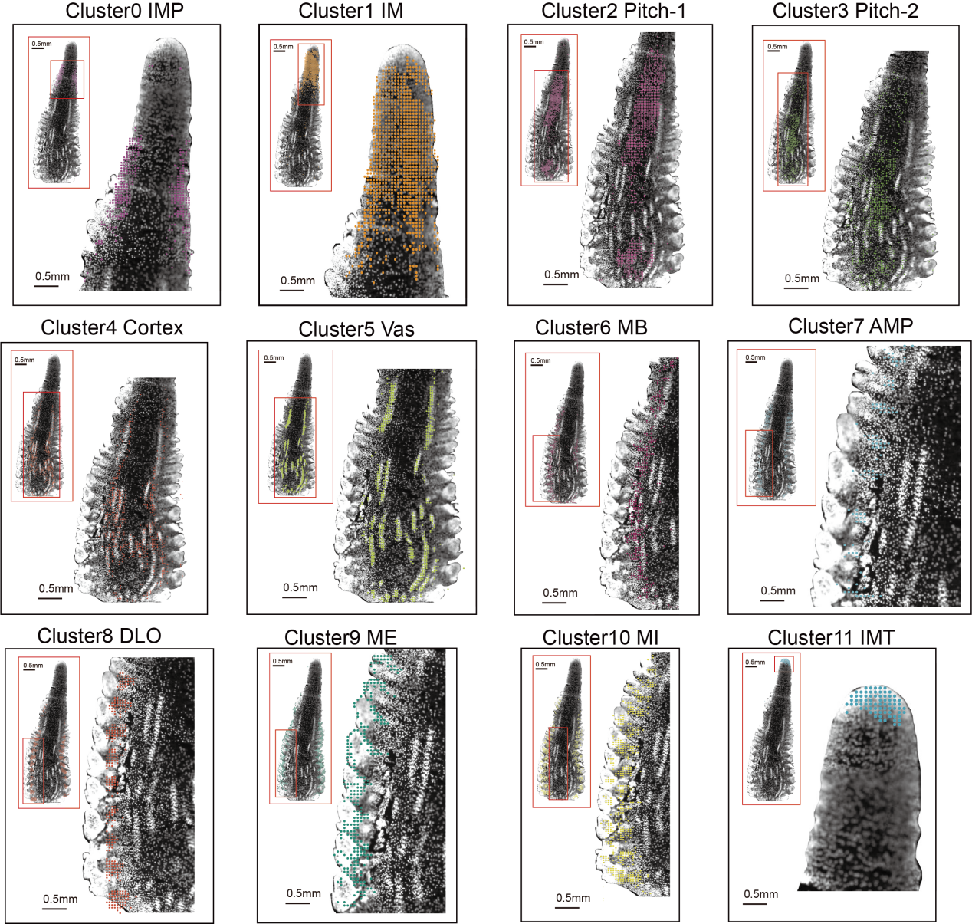
Supplemental Figure 5 | Restoring the physical distribution of each cluster on nucleic acid stained images based on unsupervised clustering results. Each dot representing a bin50 of #2 section.

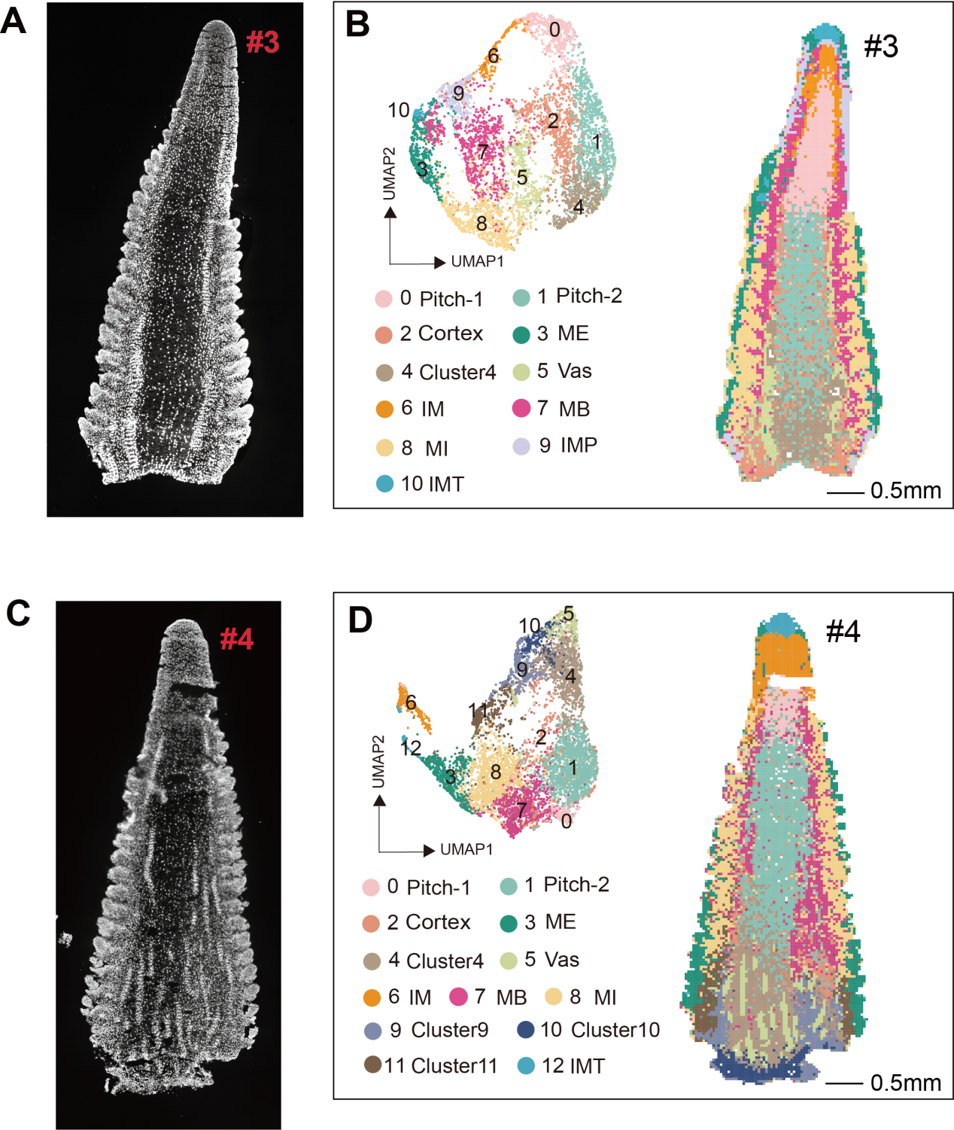
Supplemental Figure 6 | Clustering analysis of #3 and #4 section.
- Nucleic-acid dye staining of the maize 6mm ear (#3 section). (B) Left, 11 clusters displayed by an integrated uniform manifold approximation and projection (UMAP) plot in #3 section. Different colors correspond to the different cell types. Right, Spatial distribution of cell types identified in #3 sections. Scale bar=0.5mm. (C) Nucleic-acid dye staining of the maize 6mm ear (#4 section). (D) Left, 13 clusters displayed by an integrated uniform manifold approximation and projection (UMAP) plot in #4 section. Different colors correspond to the different cell types. Right, Spatial distribution of cell types identified in #4 sections. In (C-D), Vas,Vasculatur (xylem, phelom, bundle sheath); IM, inflorescence meristem; MB, meristem base; ME, meristem epidermis; MI, meristem internal; IMP, inflorescence meristem periphery; IMT, inflorescence meristem tip. Scale bar=0.5mm.
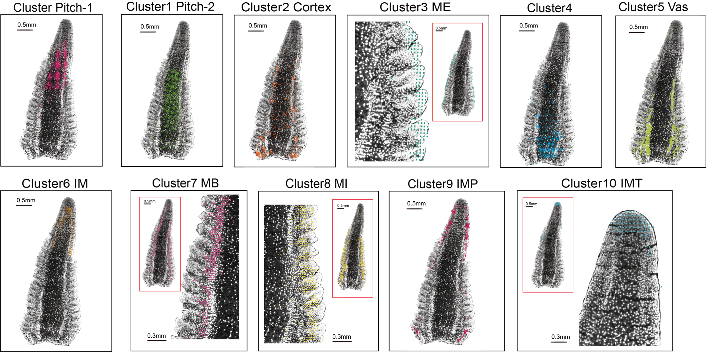
Supplemental Figure 7 | Restoring the physical distribution of each cluster on nucleic acid stained images based on unsupervised clustering results. Each dot representing a bin50 of #3 section.

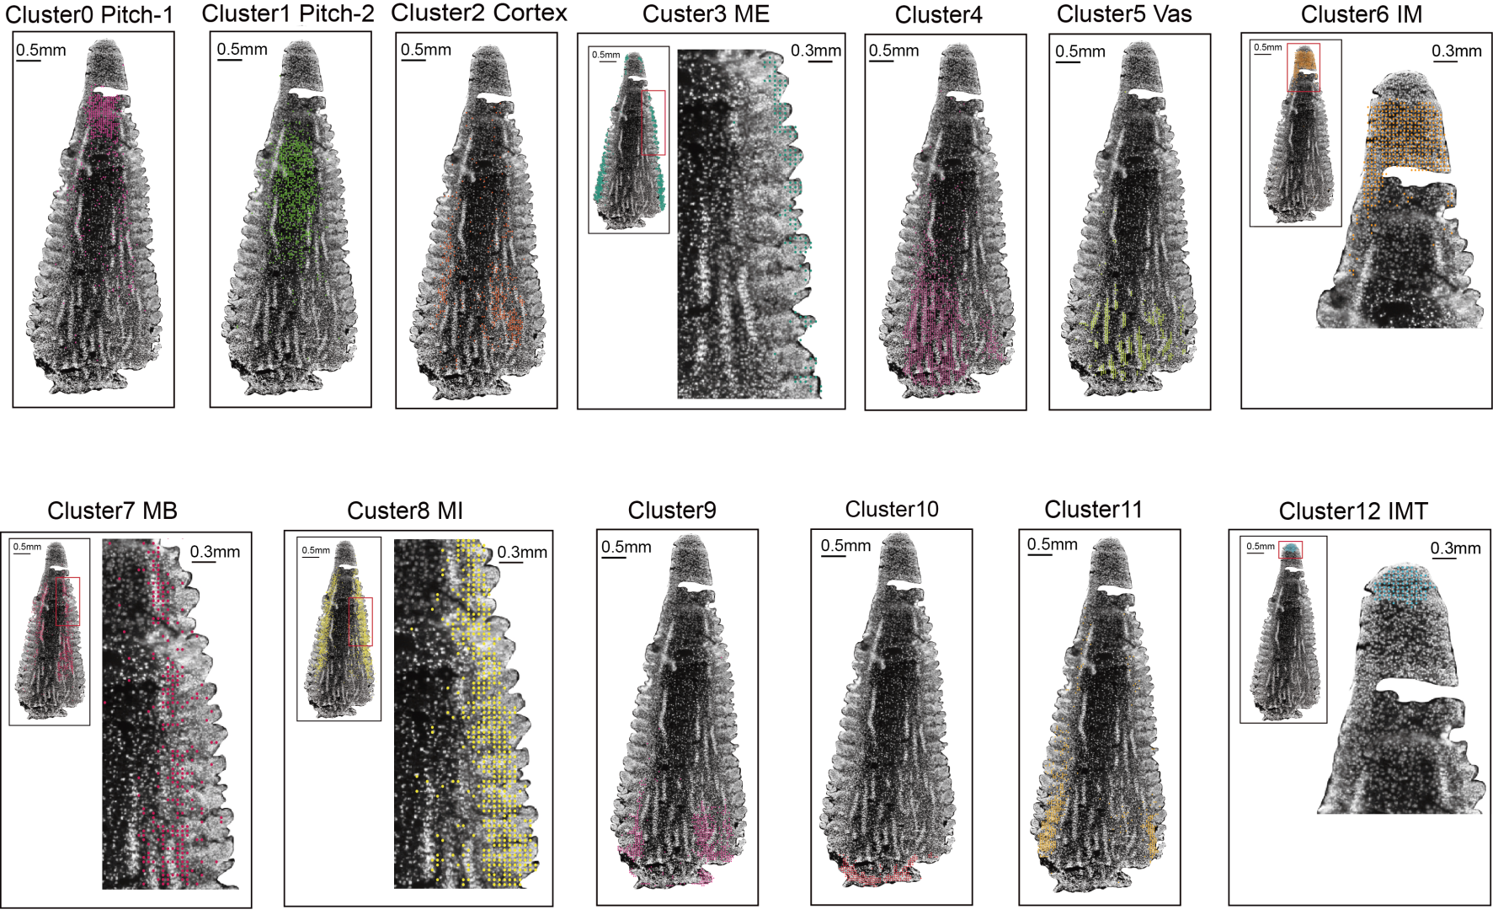
Supplemental Figure 8 | Restoring the physical distribution of each cluster on nucleic acid stained images based on unsupervised clustering results. Each dot representing a bin50 of #4 section.
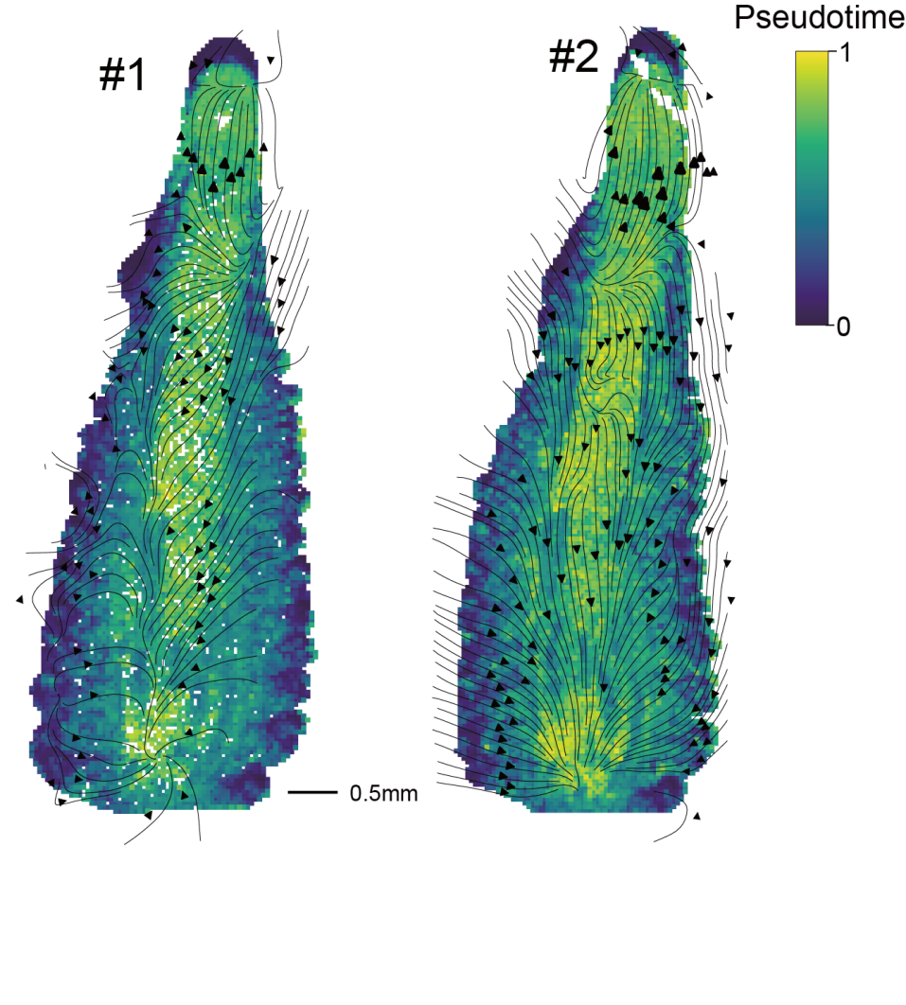
Supplemental Figure 9 | RNA velocity streamline plot visualizes the migratory trajectory of the maize 6mm ear. Cells (represented by bin50s from #1 and #2 sections) are colored by the vector field-based pseudotime score.

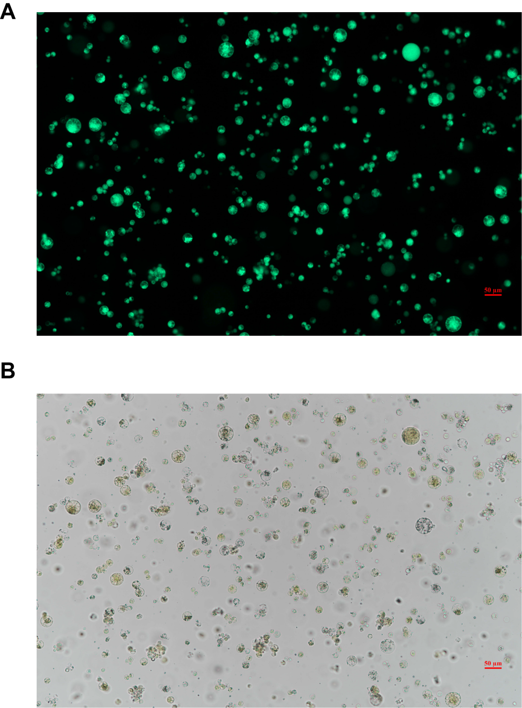
Supplemental Figure 10 | Image of ear protoplasts. (A) Fluorescence and (B) Bright-field images of the same maize protoplasts stained with FDA. Living protoplasts were stained green. Scale bars, 50 μm.

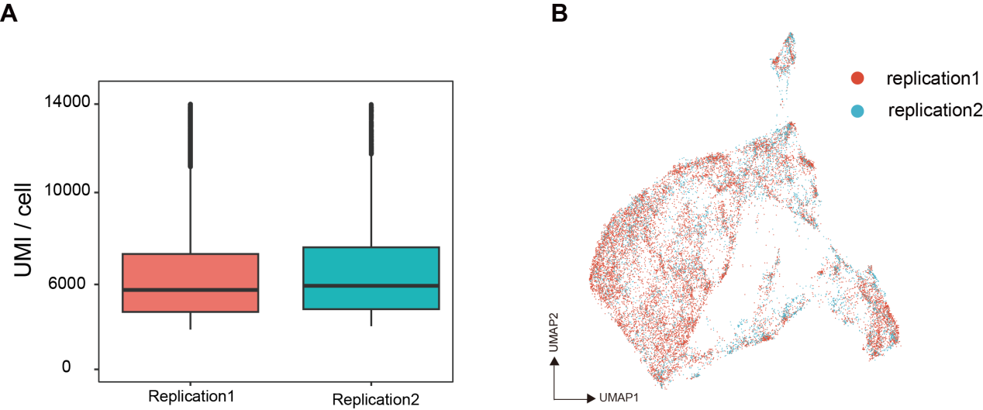
Supplemental Figure 11 | Summary the maize ear scRNA-seq. (A) UMI numbers in each cell of two biological replicates. (B) The batch-effect from two biological replicates was removed by the Harmony algorithm.

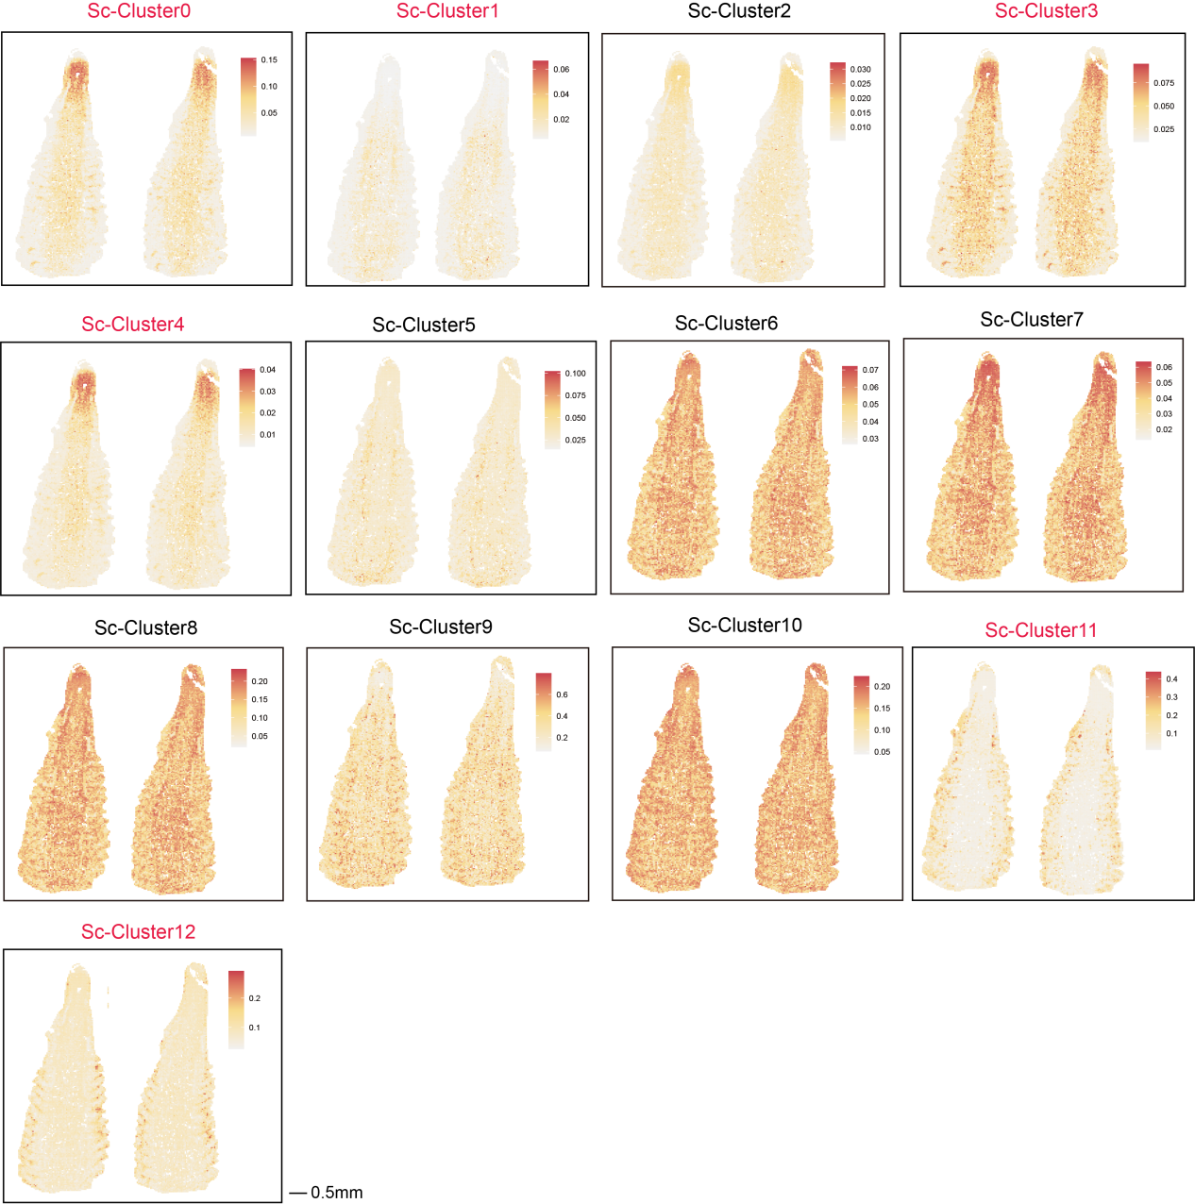
Supplemental Figure 12 | STRIDE was applied to project Sc-Cluster to the #1 and #2 section. STRIDE was applied to infer Sc-Cluster identity, with color scale indicating the proportion of cells from different Sc-clusters in the spots. The text marked in red represents Sc-Cluster that show a clear spatial distribution characteristics in the STRIDE predicted results and are supported by marker genes.
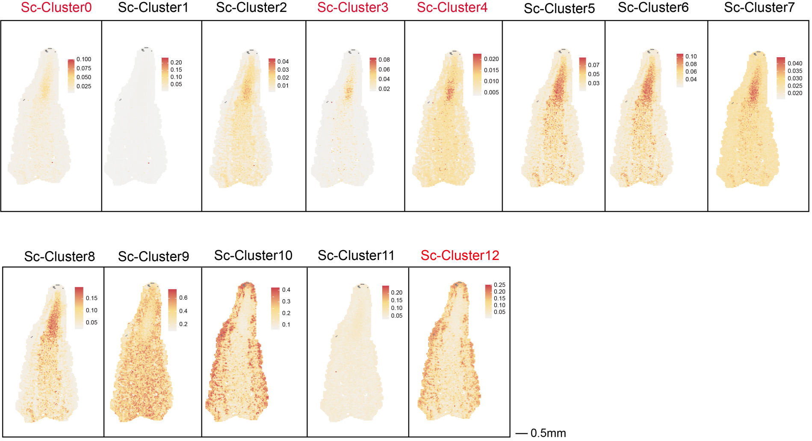
Supplemental Figure 13 | STRIDE was applied to project Sc-Cluster to the #3 section. STRIDE was applied to infer Sc-Cluster identity, with color scale indicating the proportion of cells from different Sc-clusters in the spots. The text marked in red represents Sc-Cluster that show a clear spatial distribution characteristics in the STRIDE results and are supported by marker genes.

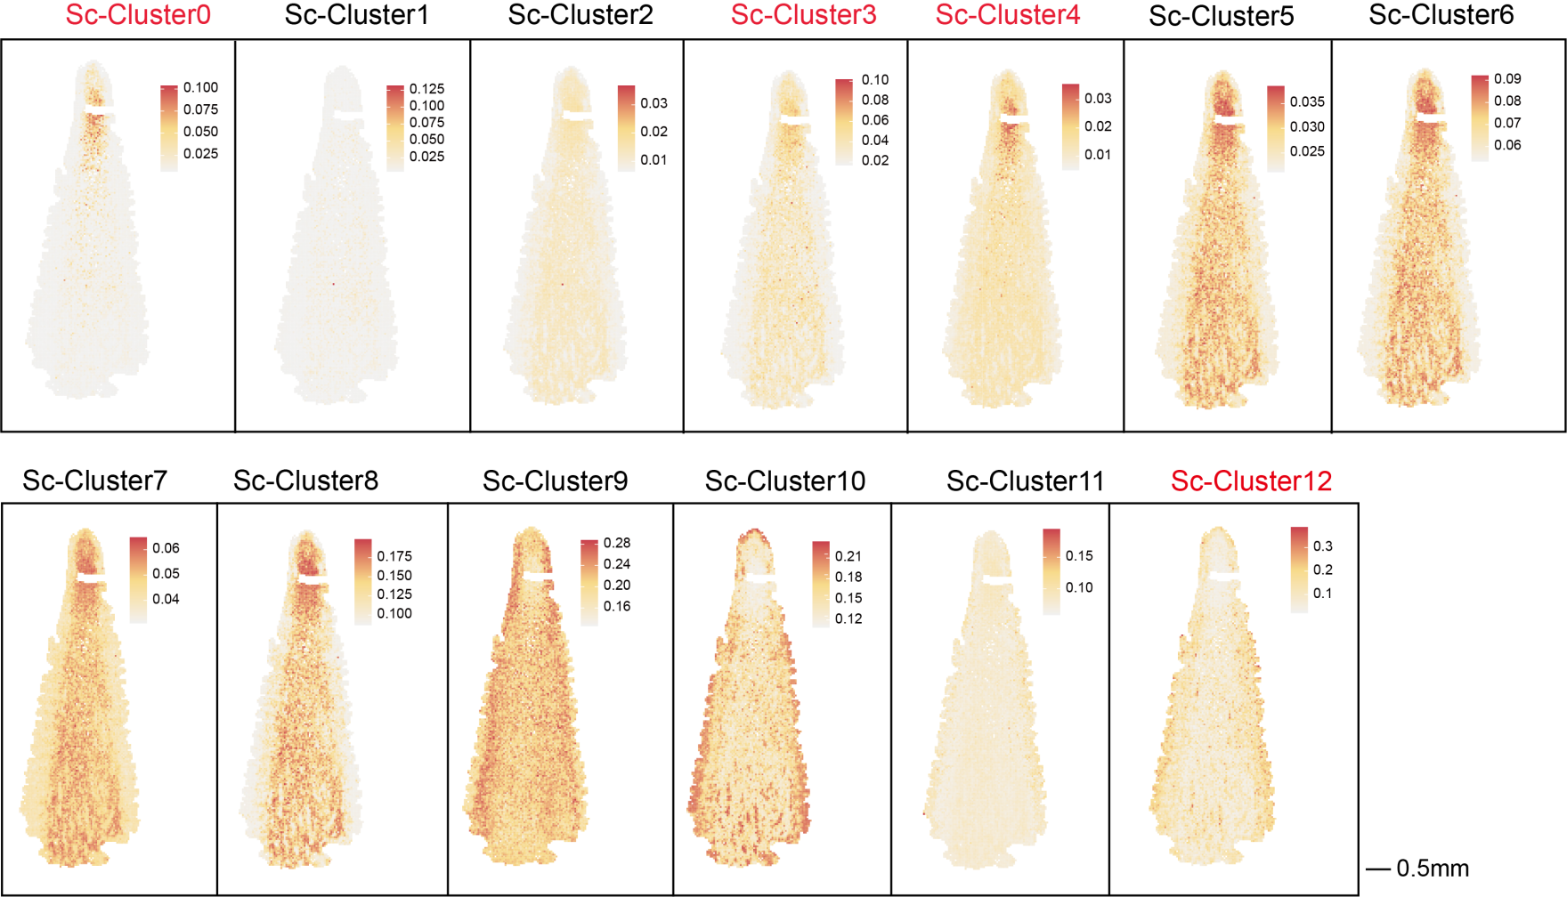
Supplemental Figure 14 | STRIDE was applied to project Sc-Cluster to the #4 section. STRIDE was applied to infer Sc-Cluster identity, with color scale indicating the proportion of cells from different Sc-clusters in the spots. The text marked in red represents Sc-Cluster that show a clear spatial distribution characteristics in the STRIDE results and are supported by marker genes.
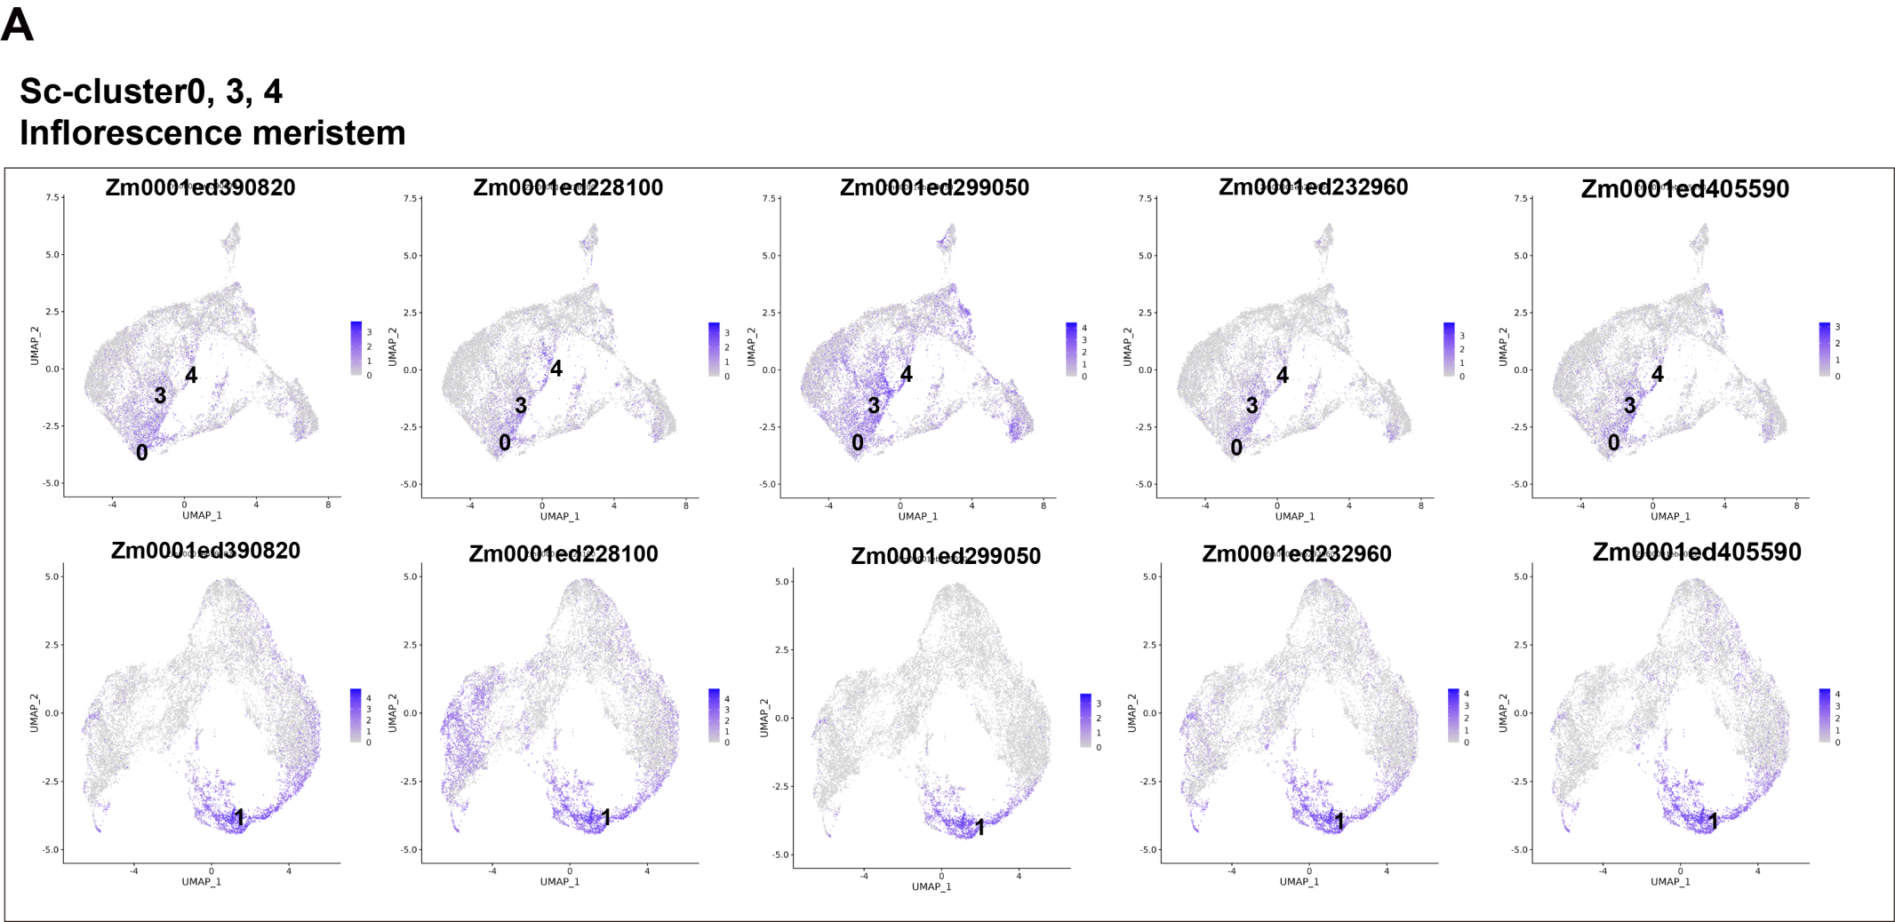

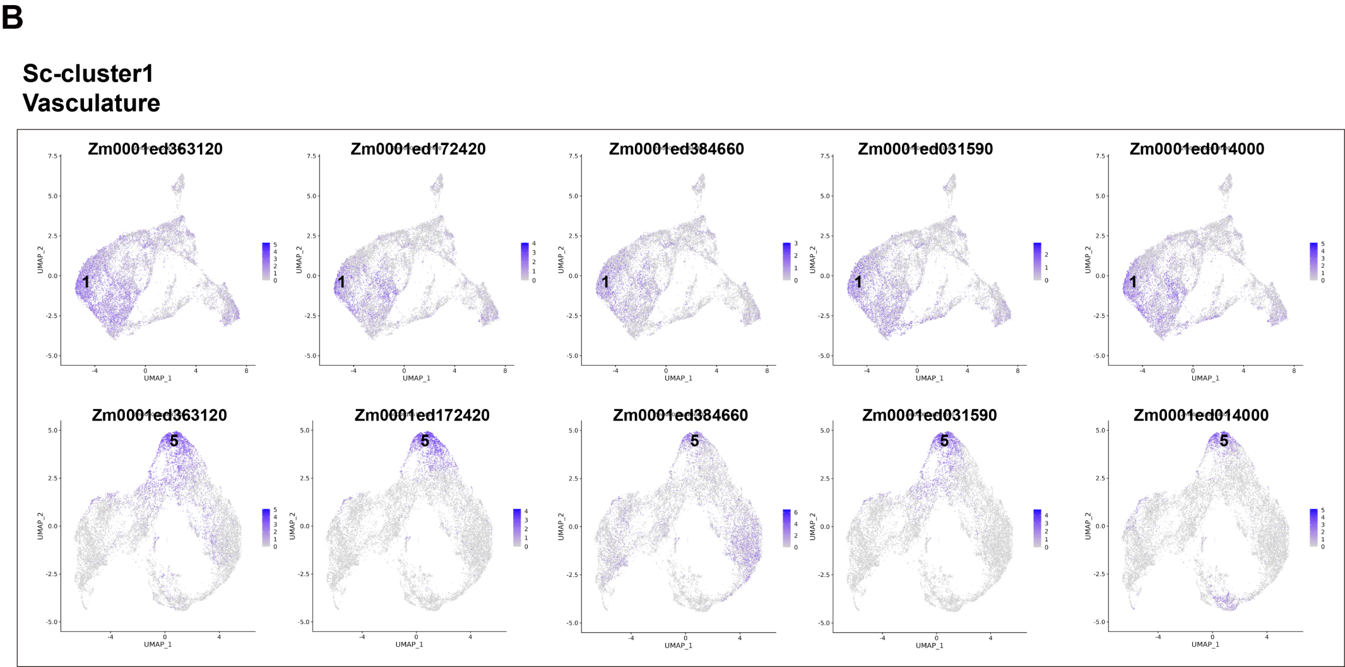
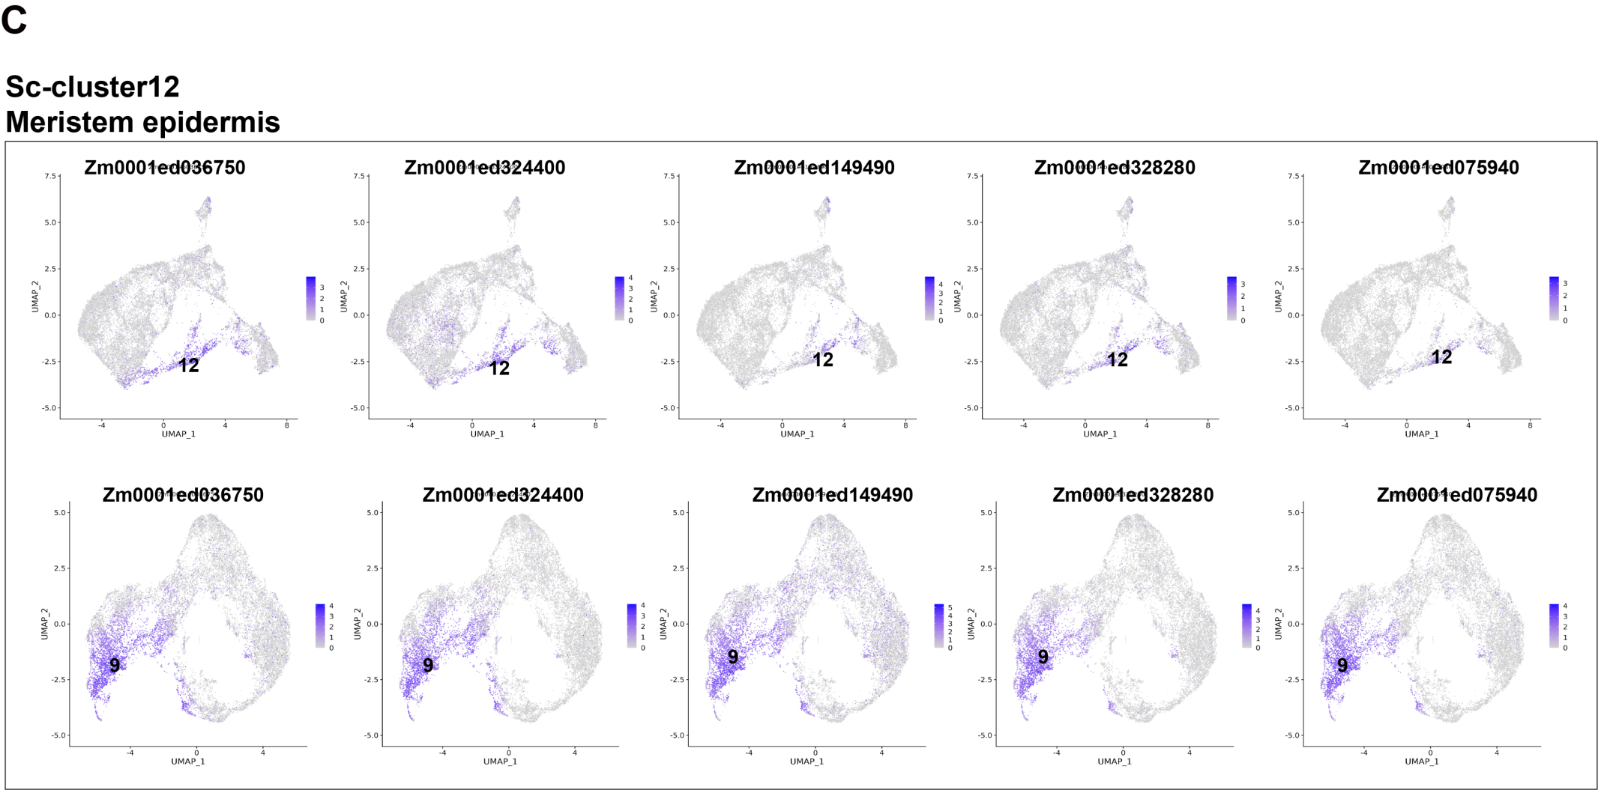

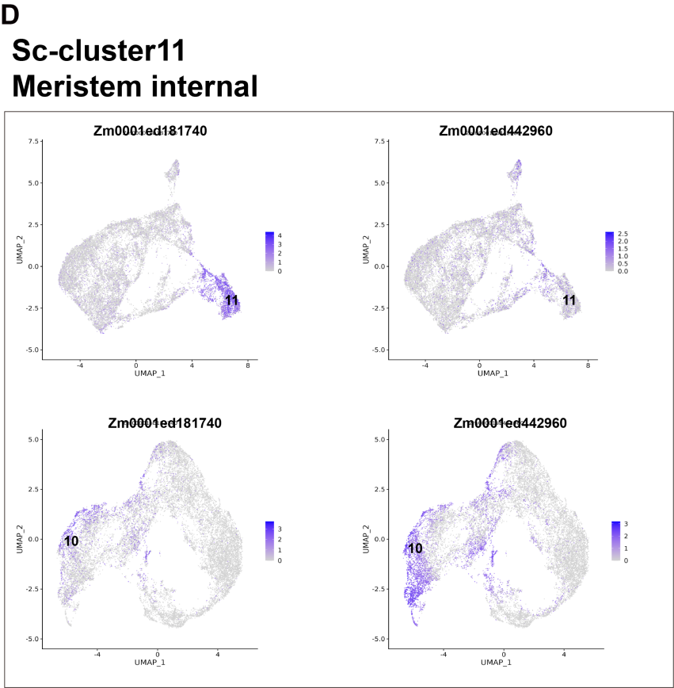
Supplemental Figure 15 | UMAP plots of marker genes predicting the identities of Sc-Cluster. (A-D) Top, UMAP plots of marker genes, the numbers in the figures indicate that the gene is the marker gene of the corresponding Sc-Cluster, with color scale indicating normalized expression level in scRNA-seq. Bottom, UMAP plots of the same genes, the numbers in the figures indicate that the gene is the marker gene of the corresponding cluster, with color scale indicating normalized expression level in Stereo-seq of #1 and #2 sections.
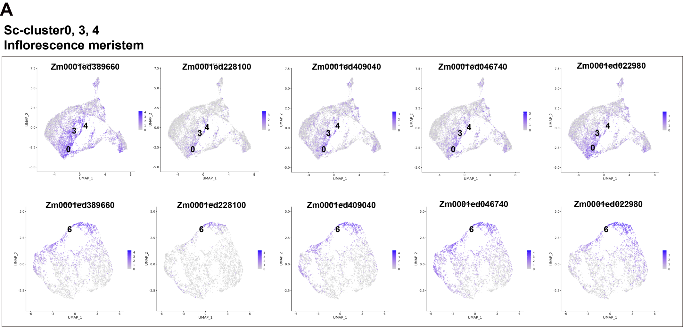
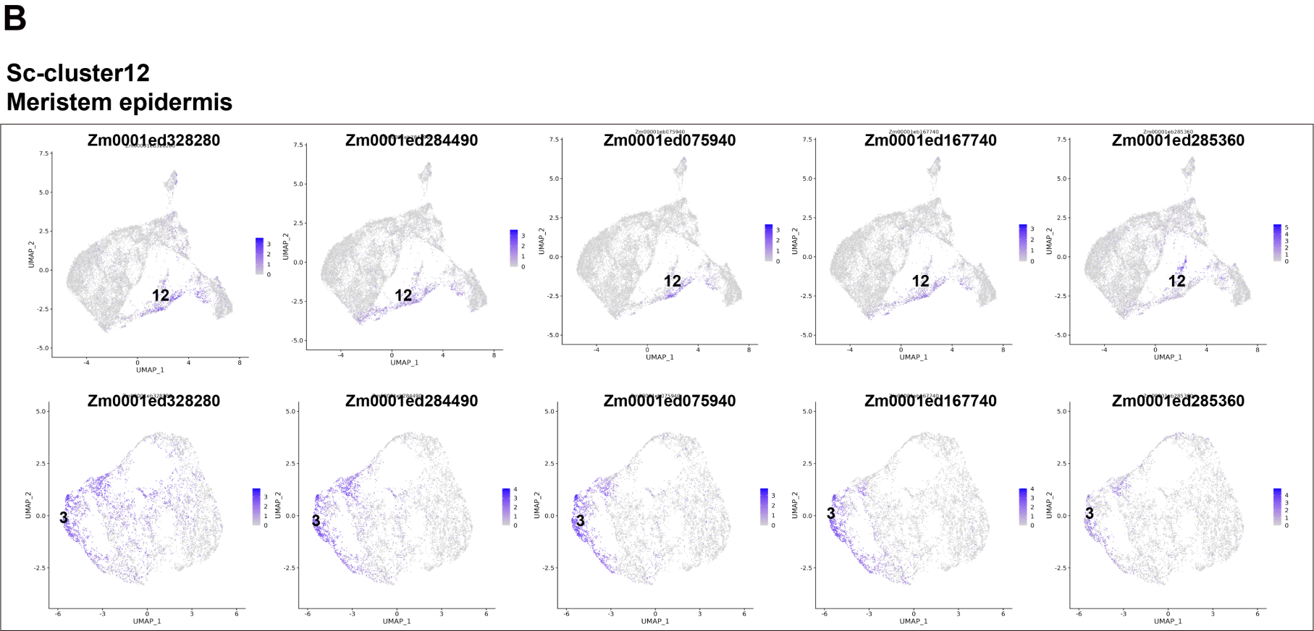
Supplemental Figure 16 | UMAP plots of marker genes predicting the identities of Sc-Cluster (A-B) Top, UMAP plots of marker genes, the numbers in the figures indicate that the gene is the marker gene of the corresponding Sc-Cluster, with color scale indicating normalized expression level in scRNA-seq. Bottom, UMAP plots of the same genes, the numbers in the figures indicate that the gene is the marker gene of the corresponding cluster, with color scale indicating normalized expression level in Stereo-seq of #3 section.

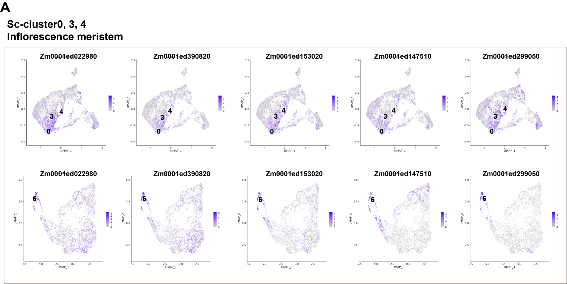
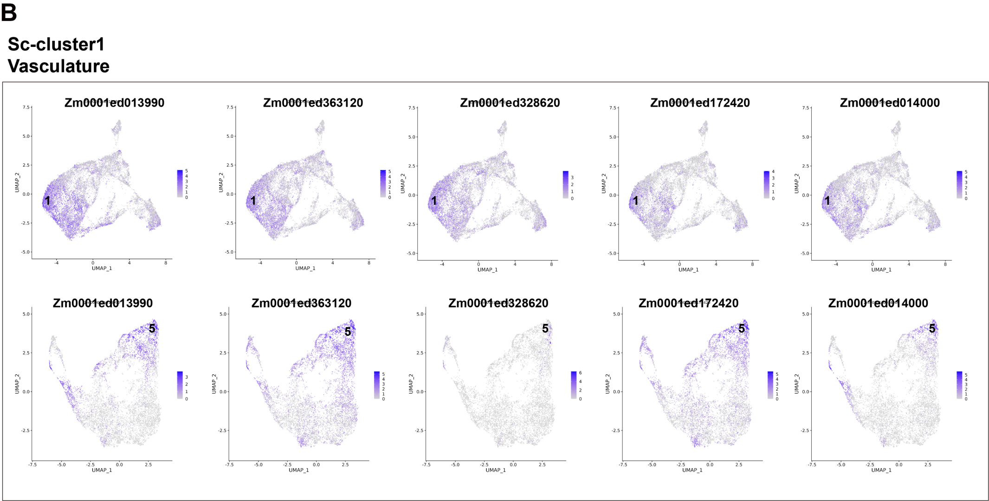
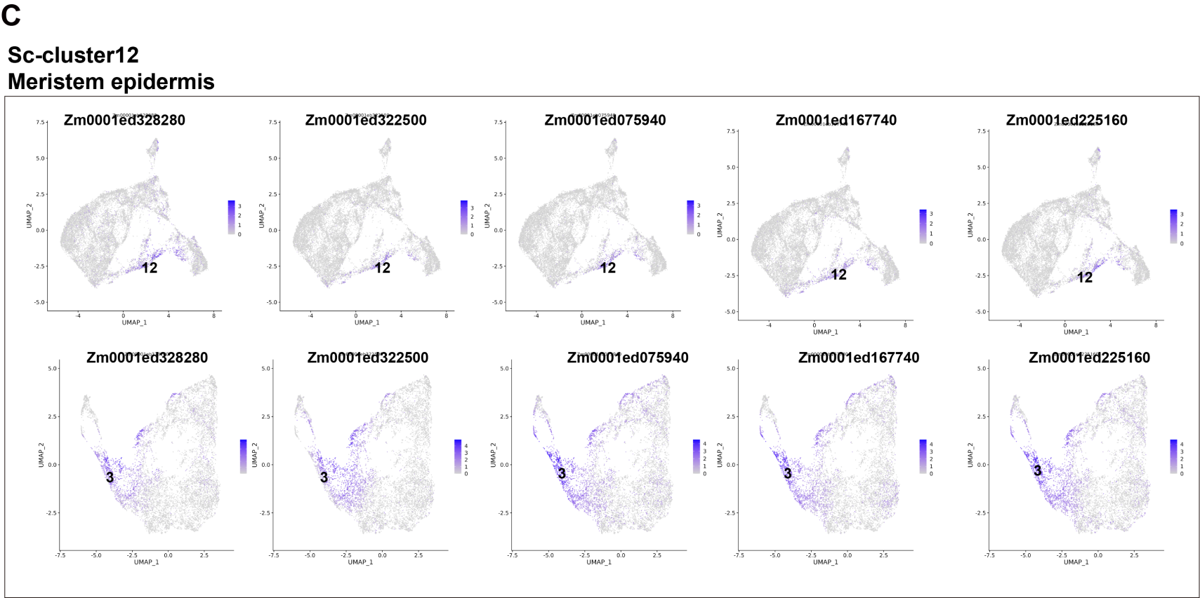
Supplemental Figure 17 | UMAP plots of marker genes predicting the identities of Sc-Cluster (A-B) Top, UMAP plots of marker genes, the numbers in the figures indicate that the gene is the marker gene of the corresponding Sc-Cluster, with color scale indicating normalized expression level in scRNA-seq. Bottom, UMAP plots of the same genes, the numbers in the figures indicate that the gene is the marker gene of the corresponding cluster, with color scale indicating normalized expression level in Stereo-seq of #4 section.

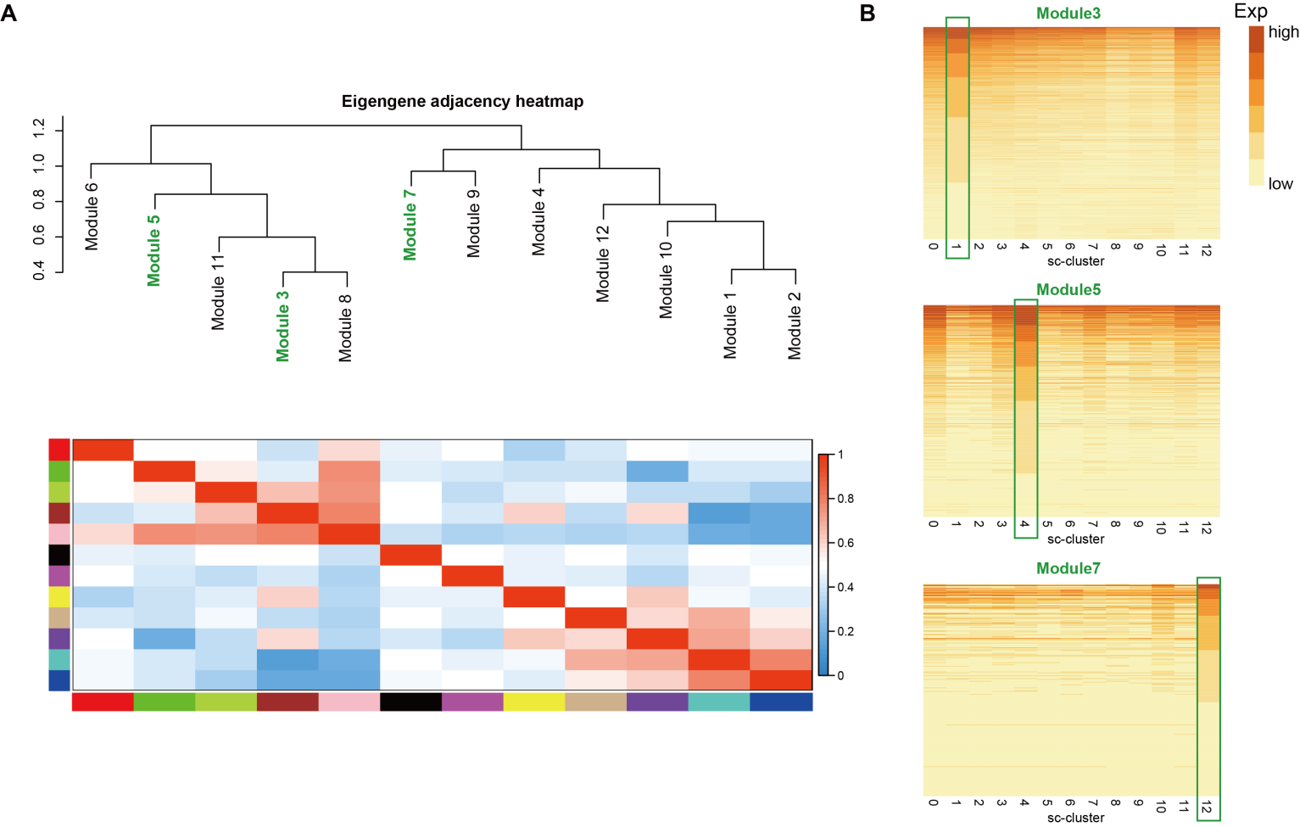
Supplemental Figure 18 | Constructing co-expression network. (A) Correlation heatmap and dendrogram of eigengene profiles for twelve gene modules that identified in scRNA-seq. (B) Genes from three modules showed the highest expression level in the specific Sc-Cluster, which is highlighted with green boxes.
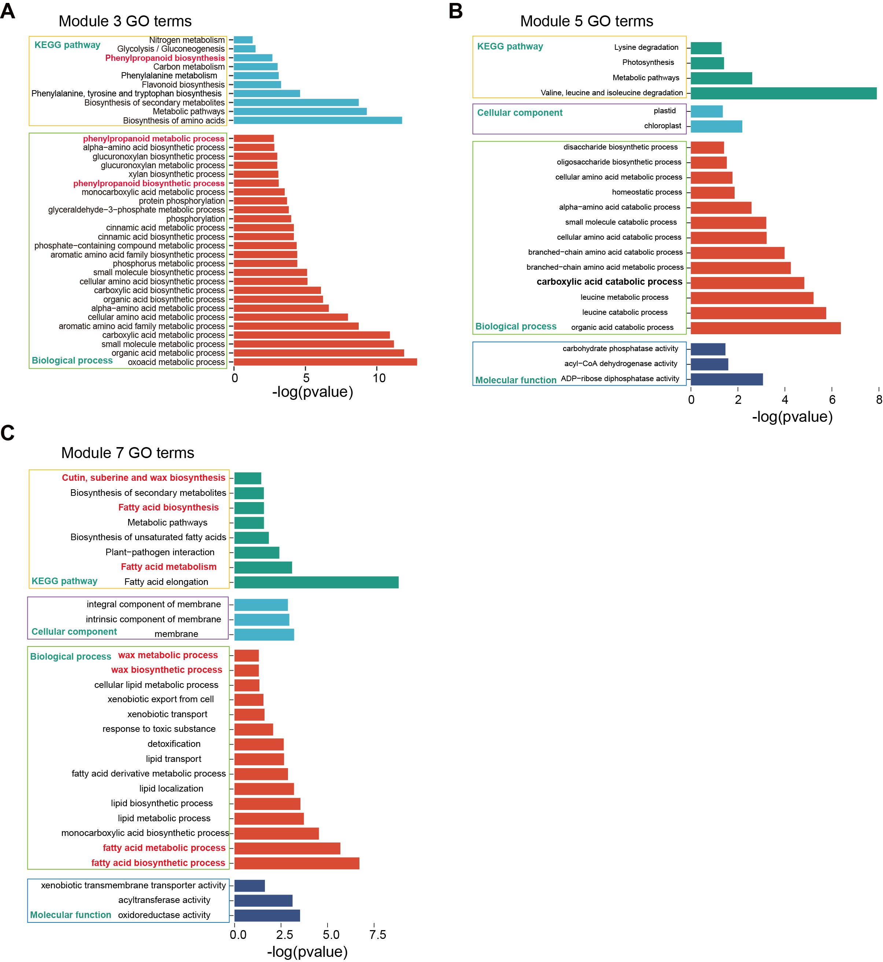

Supplemental Figure 19 | Enriched GO terms for three gene modules of scRNA-seq. (A-C) Bar graph shows significantly enriched selected gene ontology terms in module 3, module 5 and module 7.

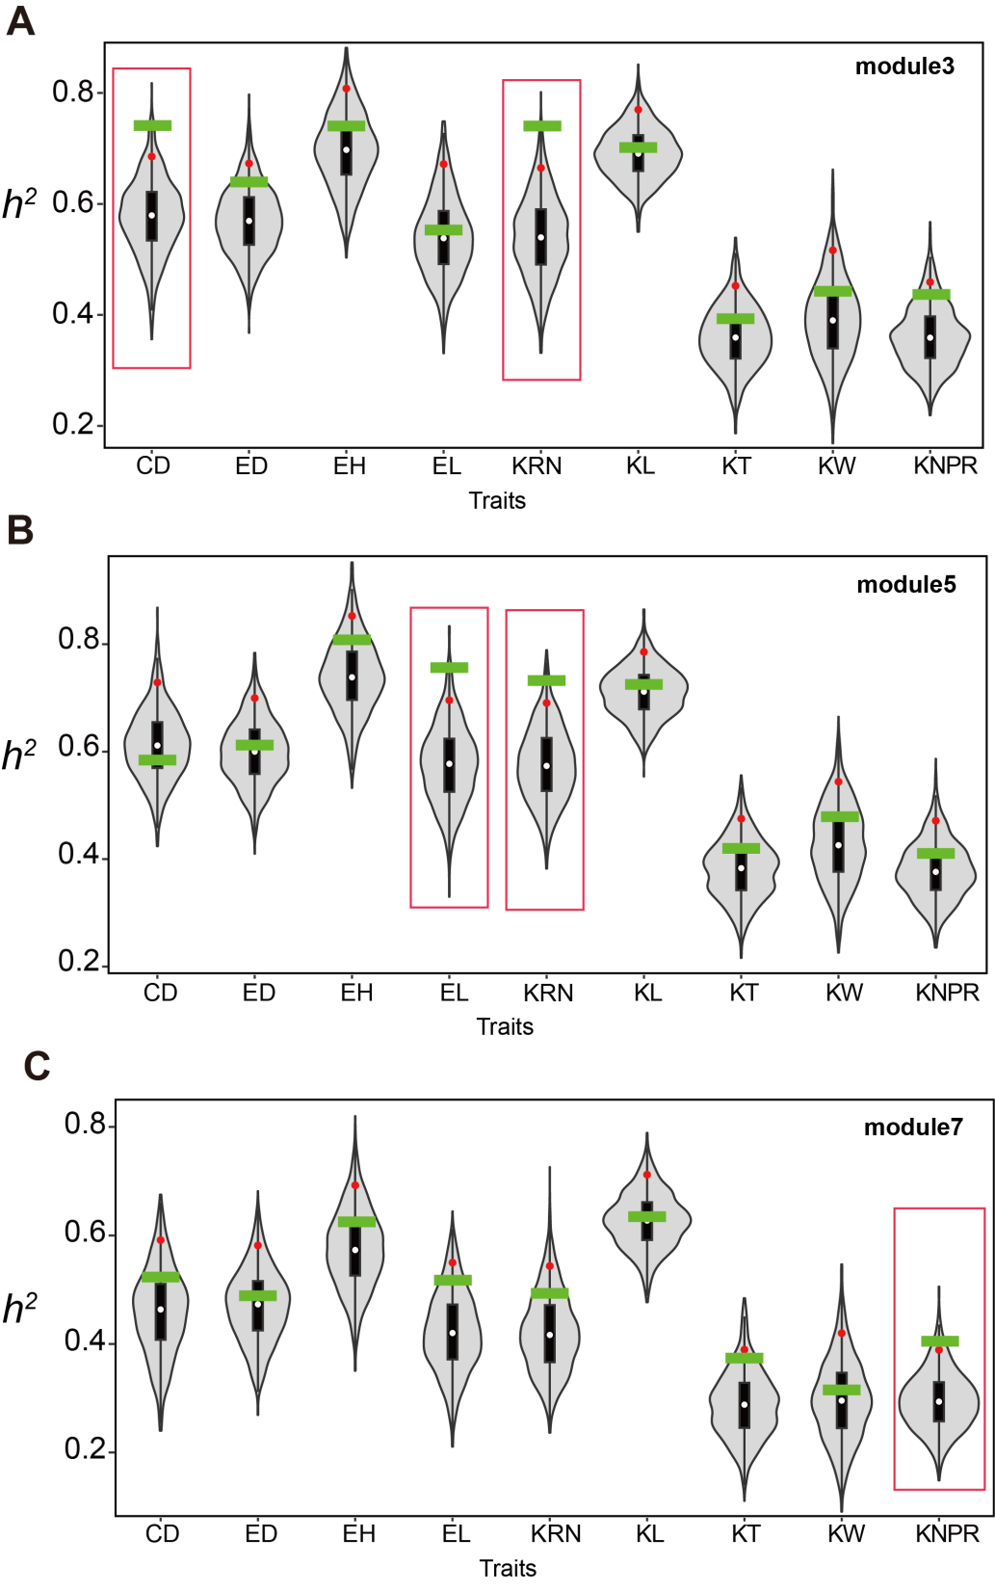

Supplemental Figure 20 | Distributions of SNP heritability (h²) (A-C) using SNPs within 2kb of genes. h² values for hub genes (green bars) are greater than the top5% permuted h² values (red dots) using 1000 random subsets of maize genes (gray violin plots), are highlight by red boxes. CD, cob diameter; ED, ear diameter; EH, ear hight, EL, ear length; KRN, kernel row number; KL, kernel length; KT, kernel thickness; KW, kernel width; KNPR, kernel row number per row. h² values are reported in Supplemental Table 5

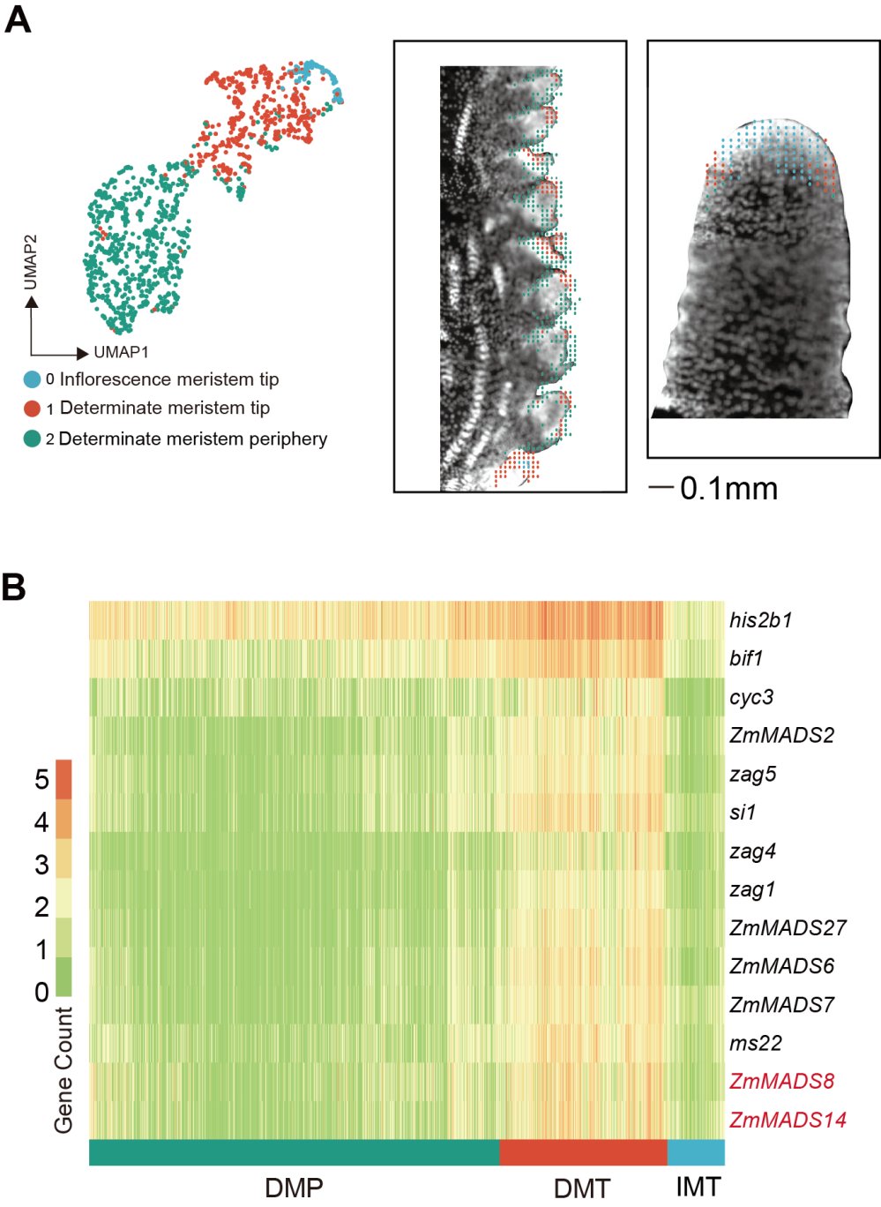
Supplemental Figure 21 | Two MADS-box genes ZmMADS8 and ZmMADS14 were identified highly expressed in determinate meristem tip. (A) Left, Stereo-seq allows separation between meristem epidermis and inflorescence meristem tip cells. UMAP plot displayed there 3 sub-clusters. Right, Spatial distribution of bin50s of 3 sub-cluster on #2 sections. Scale bar=0.1mm. (B) Heatmap shows the mean expression level of the 14 genes that involved in maize ear development and highly expressed in determinate meristem tip. ZmMADS8 and ZmMADS14 are highlighted by red color. DMP, determinate meristem periphery; DMT, determinate meristem tip; IMT, inflorescence meristem tip.

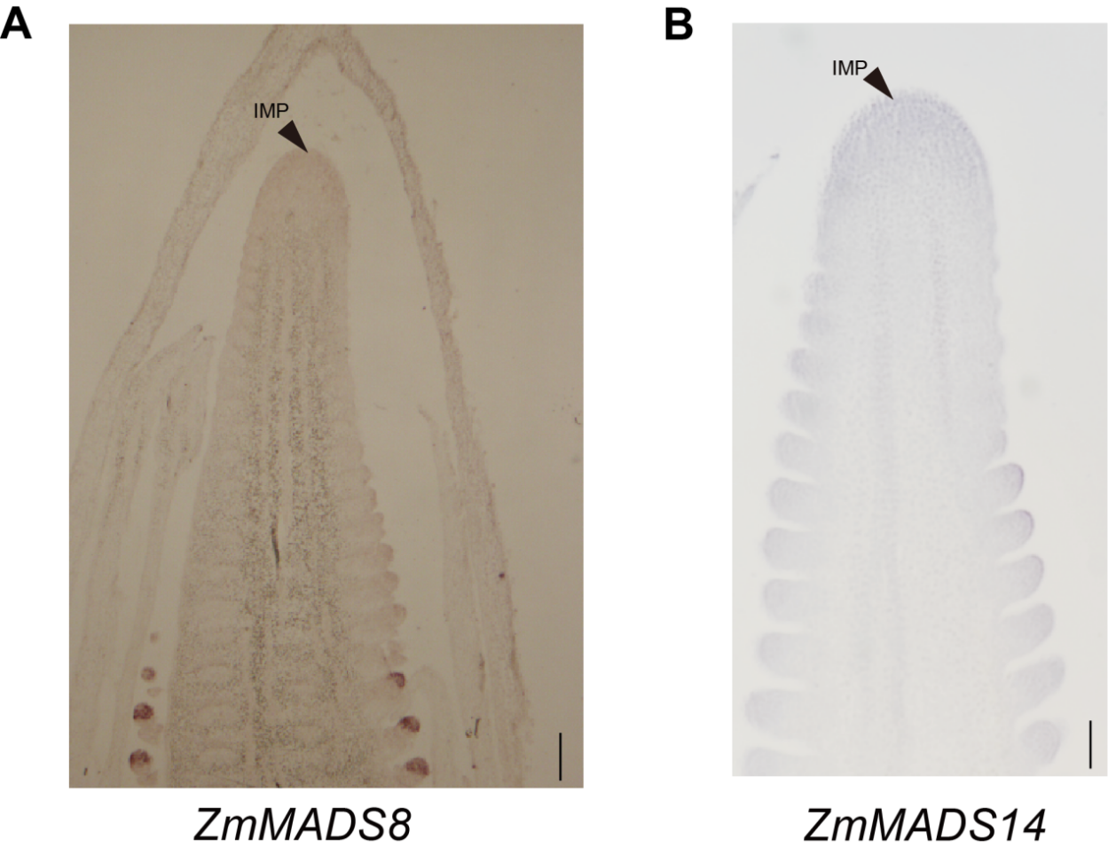

Supplemental Figure 22 | mRNA in situ hybridization with antisense probes of ZmMADS8 (A) and ZmMADS14 (B). Arrows point out the inflorescence meristem tip (IMP). Scale bar = 0.1mm.
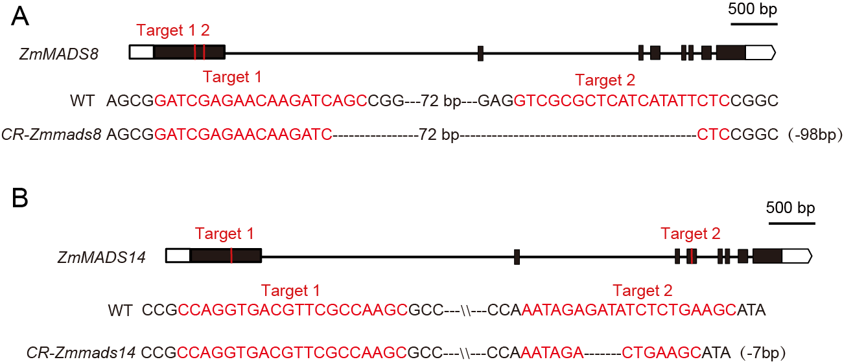
Supplemental Figure 23 | Genotype of ZmMADS8 and ZmMADS14 CRISPR-Cas9 edited plants. (A) Sequence of ZmMADS8 in wild type and CRISPR-Cas9 edited plants. Red lines denote sgRNA, The black boxes indicated the coding sequence, and UTR regions are highlighted with white boxes. (B) Sequence of ZmMADS14 in wild type and CRISPR-Cas9 edited plants. Red lines denote sgRNA, The black boxes indicated the coding sequence, and UTR regions are highlighted with white boxes.
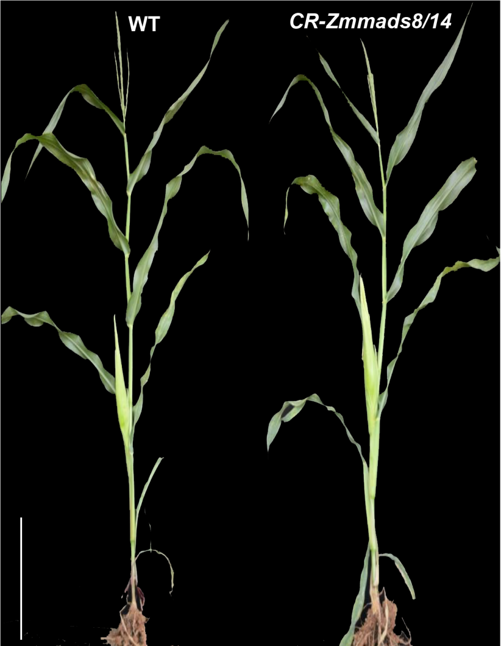

Supplemental Figure 24 | Plant morphology of WT and CR-Zmmads8/14 double mutant. Scale bars=0.5m

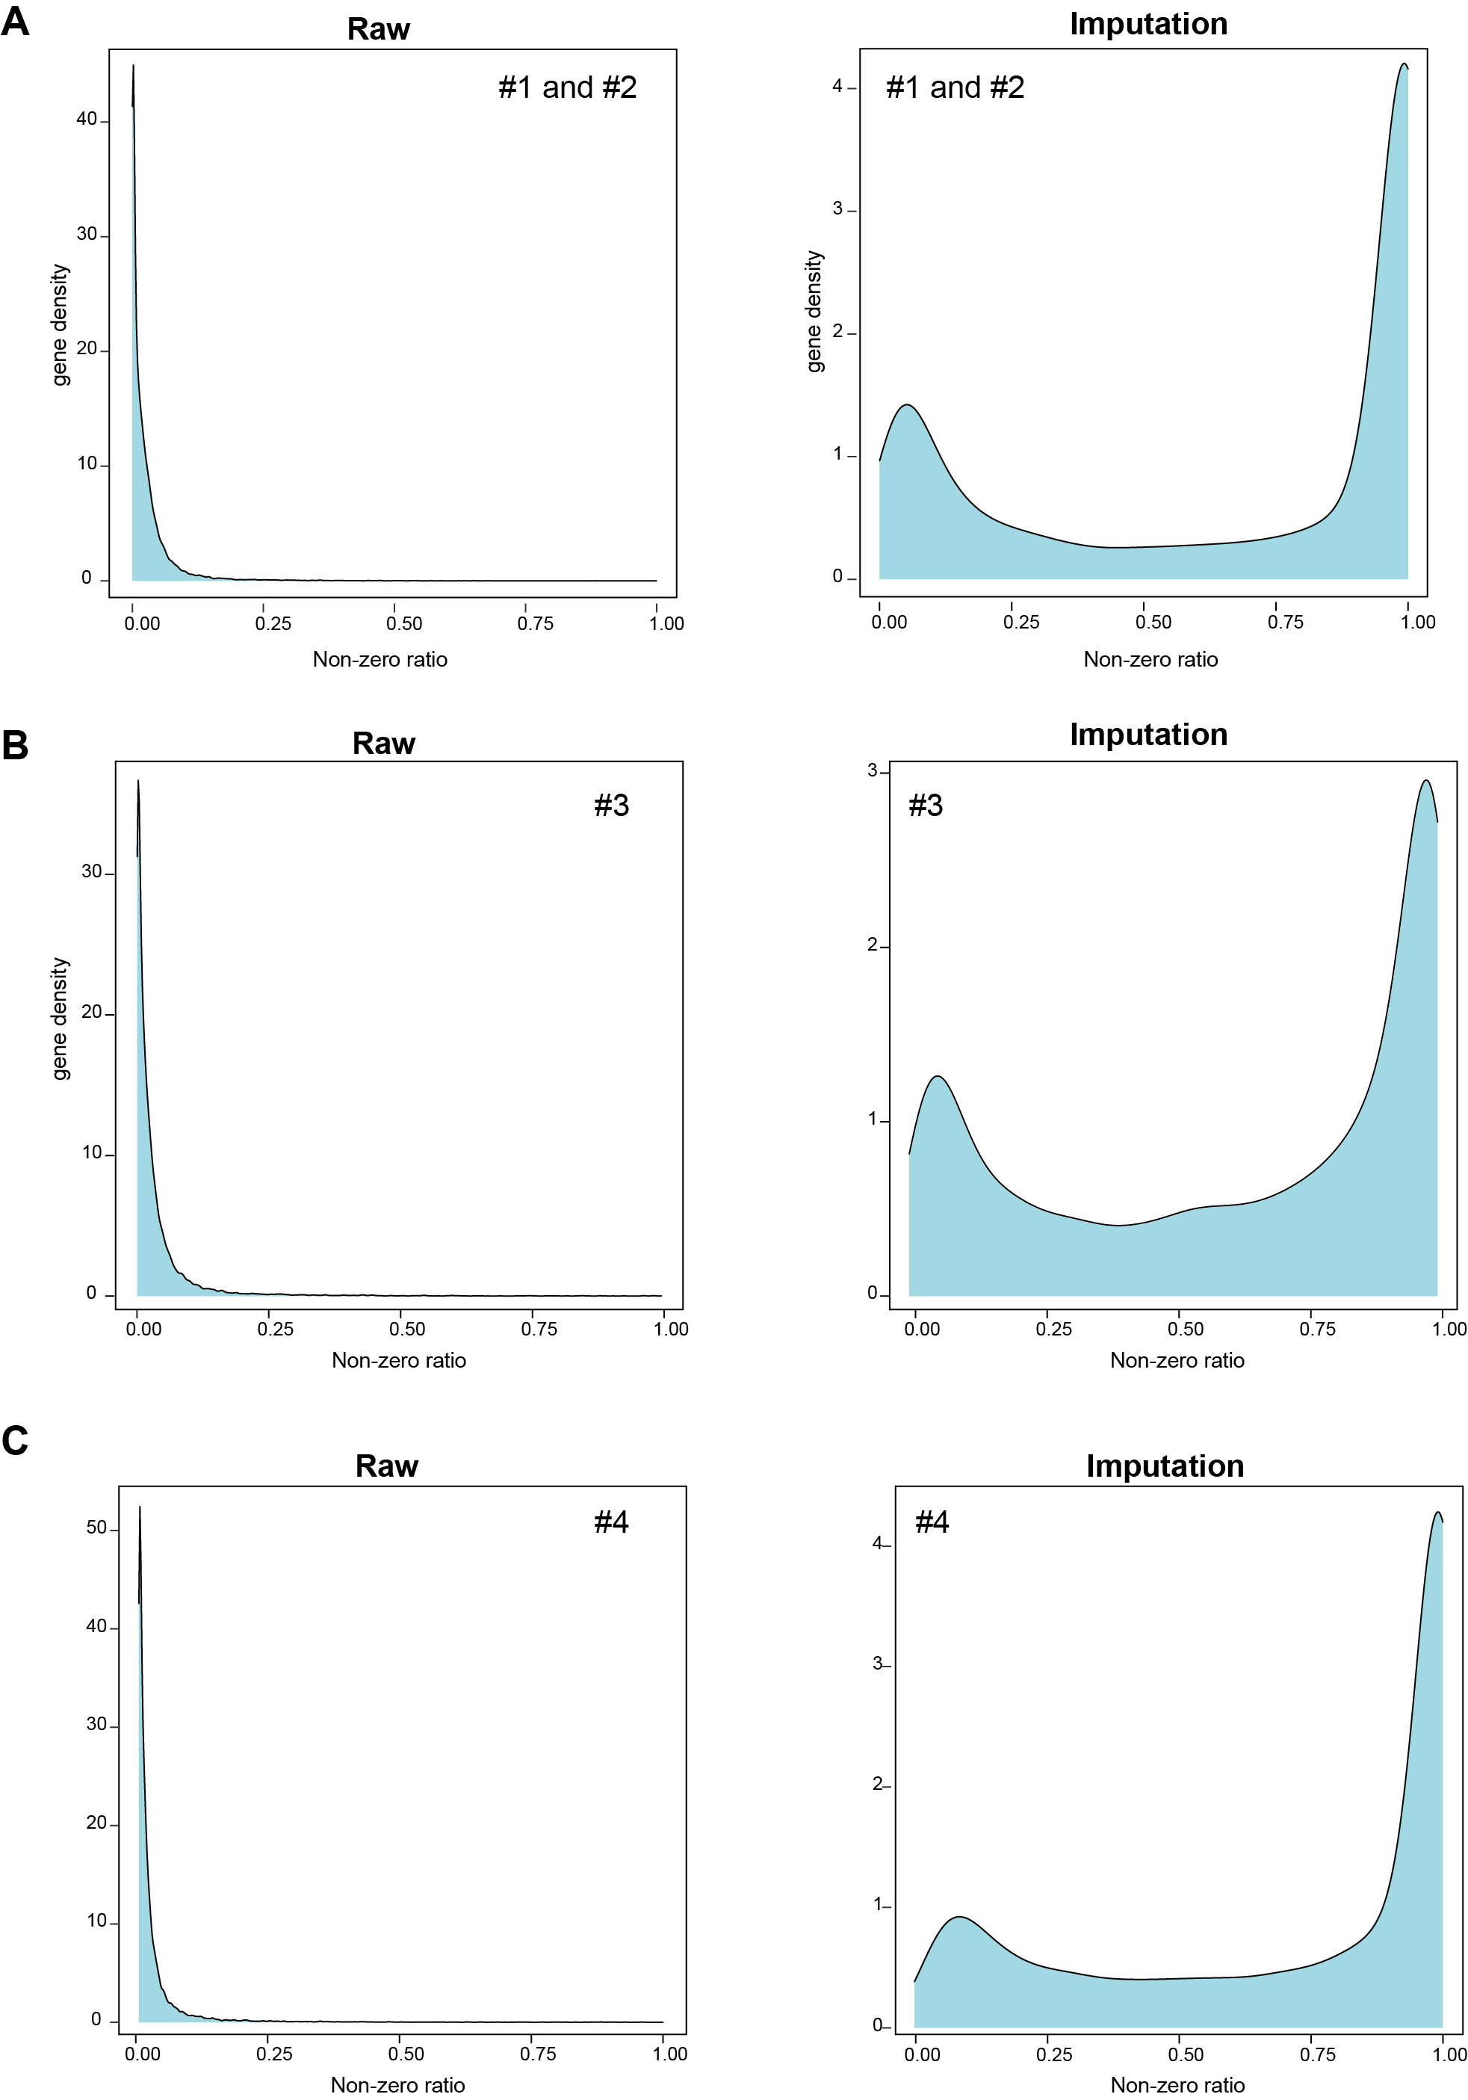
Supplemental Figure 25 | Gene density of non-zero ratio across four ear sections before and after imputation. (A) Gene density of non-zero ratio across #1 and #2 section before and after imputation. (B) Gene density of non-zero ratio across #3 section before and after imputation. (C) Gene density of non-zero ratio across #4 section before and after imputation.

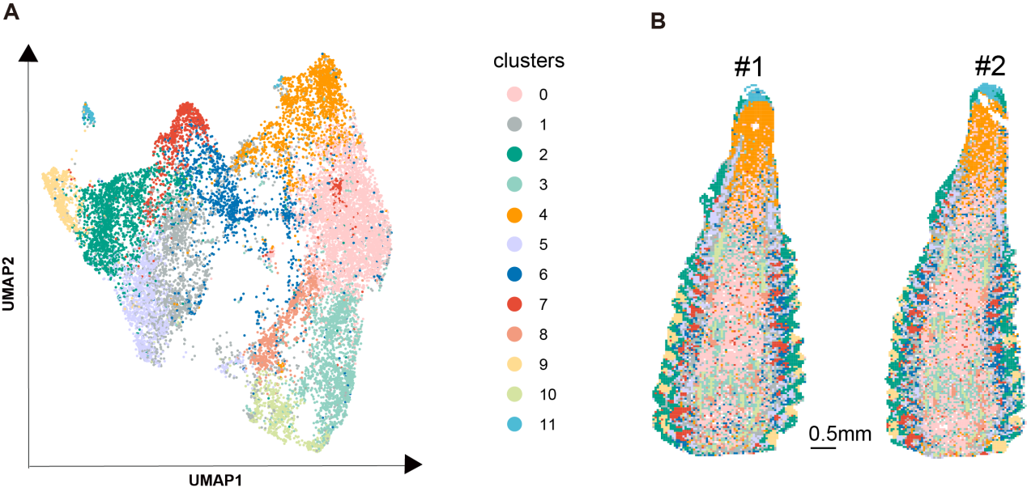
Supplemental Figure 26 | Unsupervised clustering of #1 and #2 section based on raw Stereo-seq data. (A) 12 meta-clusters displayed by an integrated uniform manifold approximation and projection (UMAP) plot in two dimensions, with each dot representing a bin50. (B) Physical distribution of bin50s corresponding to different clusters.

