Supporting Information

Ultrahigh-Conductive Covalent Organic Framework Films
Rui Wang¹, Hang Lyu², Gerald Siu Hang Poon Ho¹, Huanhuan Chen¹, Yufei Yuan¹, Ki-Taek Bang¹, and Yoonseob Kim^{1,}*
¹Department of Chemical and Biological Engineering, The Hong Kong University of Science and Technology, Hong Kong SAR, China
²Department of Chemistry, The Hong Kong University of Science and Technology, Hong Kong SAR, China
*To whom correspondence should be addressed: yoonseobkim@ust.hk

Table of Contents
Section A. Characterization and Methods----------------------------------------------------------S2
Section B. Materials and Synthesis-----------------------------------------------------------------S5
Section C. Supporting Figures-----------------------------------------------------------------------S9
Section D. Supporting Tables---------------------------------------------------------------------- S47
Section E. Supporting References------------------------------------------------------------------S54
Section A. Characterization and Methods
Characterization. ¹H NMR spectra were recorded on a Bruker AVII 400 MHz NMR Spectrometer, Chemical shifts are reported in delta (δ) units, expressed in parts per million (ppm) relative to the residual solvent as an internal standard (CDCl₃, ¹H: 7.26 ppm; DMSO-d₆, ¹H: 2.50 ppm). Abbreviation associated with the peak assignment: s, singlet. Field emission scanning electron microscopy (FE-SEM) was performed on a JEOL model JSM-6700F equipped with EDX spectroscopy. The samples were dispersed with acetone, drop-casted on a silica wafer, and then stuck on a copper substrate with carbon tape. The sample was coated with gold before measurement. Aberration Corrected TEM (AC-TEM) images were recorded by JEM-ARM200F (JEOL) operated with the acceleration voltage of 200 kV at room temperature. Power X-ray diffraction (PXRD) data were collected on an analytical X-ray diffractometer (Cu Kα radiation λ = 1.54056 Å). Sample was measured on a glass substrate from 2θ = 3° up to 30° with a 0.02° increment. The Uv-Vis was employed with Lambda 1050+ (PerkinElmer) model to obtain Kubelka-Munk-transformed reflectance spectra. The TGA was measured from 25°C to 700°C with a heating rate of 5°C min⁻¹. The FTIR spectra were recorded by a Thermo Fisher Nicolet IS50 . The XPS was measured by a Kratos Axis Ultra DLD multi-technique surface analysis system.

Conductivity measurement: The COF powder samples were first pressed into pellets with a thickness of around 0.45 mm and a diameter of 11mm using a tablet machine under 1 GPa. Four-point (van der Pawn) method was employed to analyze sheet resistance and Hall coefficients with Nanometrics HL5500 Hall System. Conductive silver ink was employed to connect COF pellets and probes. Moreover, I-V curves were measured to ensure all the contacts were Ohmic contacts.¹

Field-effect transistor (FET) application measurement: FET devices were fabricated in a bottom-gate, top-contact configuration by depositing source and drain electrodes (50 nm Au), with a channel length of 50 μm and a width of 1 mm. The performance of transistors was evaluated under ambient conditions with an Agilent 4155C parameter analyzer.

Theoretical Calculation: For the periodic models, the first principle calculations were conducted using the Vienna ab initio simulation package (VASP 5.4.4)^{2–5}, with the projector augmented wave (PAW) potentials⁶ used as the plane wave basis sets and a unified plane wave cutoff energy of 560 eV. To accurately simulate the electronic interaction in our COF systems containing both main group elements and transition metals, the PBE + U method⁷ was applied, with the generalized gradient approximation (GGA) in the Perdew-Burke-Ernzerhof (PBE) formulation^{8,9} and a Hubbard correction^{7,10} (U = 4 eV, J = 1 eV) added to the 3d electrons of Co, Ni and Cu. This combination of U and J has been widely tested in previous theoretical works^{11–16}. Spin-polarization (ISPIN = 2) was turned on to account for the possibly unpaired electrons (for example, in Co- and Cu-). Zero damping DFT-D3 method of Grimme^{17,18} was used to take the van der Waals (vdW) interaction into consideration. In self-consistent field (scf) calculation and geometric optimization, the energy and force convergence criteria were 1 × 10⁻⁶ eV and 0.015 eV/Å respectively, and the Γ-centered k-point mesh were set to be 1 × 1 × 1 and 1 × 1 × 7 for monolayer and bulk models respectively (k-point mesh density = 0.04 × 2π/Å). For the monolayer model, a vacuum space of 15 Å along the z-axis was reserved to minimize the interaction between the layer and its replicas in the next period. The AA and AB stacking modes were built as initial guesses of the bulk structure. And since the optimized AA stacking model has the simulated XRD pattern resembling the experimental data more, it was finally chosen for further calculation. In band structure calculation, the Brillouin zone was sampled by the k-paths shown in Figure S1. The VASP calculated data were post-processed using the VASPKIT 1.4.0 code.
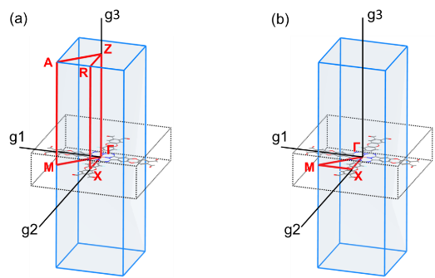
Figure S1 (a) The k-path for calculating both in-plane and out-plane direction band structure of AA-stacking bulk COF. (b) The k-path for calculating the in-plane direction band structure of monolayer COF and AA-stacking bulk COF.

The DFT calculations of the separated Cu-Phthalocyanine (CuPc) center and the linkage moieties were performed in the Gaussian09 package.¹⁹ Structural optimizations and energy calculations were conducted at the m06-2x²⁰ level of density functional theory. The def-2svp basis set^{21,22} was used for all elements. To have a common ground to compare the interaction between the CuPc center and the linkage moieties in our as-synthesized 2D COF with that in 2D COFs reported in other publication,^{23,24} we took the way shown in Figure S2 to cut the CuPc center and the linkage moieties. Hydrogen atoms saturated the as-cleave bonds. Similar studies using separated CuPc center and linkage moieties to study the effect of the difference in linkage moieties on the final electronic structure of the as-synthesized 2D COFs can be referred to the research conducted by Xu et.al²⁵ and Wu et.al.²⁶
Figure S2 Separated Cu-Phthalocyanine center and linkage moieties of THAQ, THDMA, TOPyr (COF-DC-8²⁴ ) and TFPN (PAE-PcCu²³).

Section B. Materials and Synthesis

Materials: 1,2-dimethoxybenzene (Energy Chemical, ACS reagent, 99%), 3,4,5,6-tetrafluorophthalonitrile (Energy Chemical, ACS reagent, 98%), acetaldehyde (Aladdin, anhydrous grade, 99%), 1,3,5-trimethylbenzene (Aladdin, anhydrous, Water ≤50 ppm, 98%), dichloromethane (Scharlau, anhydrous, 99.8%), sodium dichromate Dihydrate (Sigma, ACS reagent, ≥99.5%), acetic acid (Sigma, ACS reagent, ≥99.7%), concentrated sulfuric acid (Sigma, ACS reagent, 95.0-98.0%),triethylamine (Et₃N) (Acros, ACS reagent, 99%), N,N-Dimethylacetamide (Sigma, anhydrous, 99.8%), copper(II) chloride (3A, ACS reagent, 98 %), cobalt(II) acetate tetrahydrate (ACS reagent, 99.5%), Nickel(II) acetate tetrahydrate (Sigma, 99.995% trace metals basis), Zinc nitrate hexahydrate (Sigma, ACS reagent, 98%),1,2,3,4,8,9,10,11,15,16,17,18,22,23,24,25-Hexadecafluorophthalocyanine Copper(II) (Aladdin, ACS reagent, 98%), boron tribromide, 1.0mol/L in dichloromethane (Energy Chemical), hydrogen bromide, 48% in H₂O (Energy Chemical, ACS reagent), acetone (RCI, ACS reagent, 99.8%),N,N-Dimethylformamide (Sigma, ACS reagent, 99.8%), tetrahydrofuran (anhydrous, contains 250 ppm BHT as inhibitor, ≥99.9%), magnesium sulphate (Sigma-Aldrich, anhydrous, reagent grade, ≥97%), acetonitrile (Scharlau, anhydrous, 99.8%), Deionized water (18.2 MΩ•cm) was used.

9,10-Dimethyl-2,3,6,7-tetramethoxyanthracene (1)²⁷:
A cooled mixture of 1,2-dimethoxybenzene (6.9 g, 0.05 mol), acetaldehyde (2.8 mL, 0.05 mol), and acetonitrile (2.6 mL, 0.05 mol) was added dropwise to 50 mL of concentrated sulfuric acid over 15 minutes. The purple reaction mixture was stirred at 0 °C for 2 h and then poured over ice. The formed precipitate was filtered, washed with water, and recrystallized from acetone to give a grey solid (2.149 g, 13 %). ¹H NMR (400 MHz, CDCl₃): δ = 7.40 (s, 4H), 4.08 (s, 12H), 2.95 (s, 6H).

2,3,6,7-tetrahydroxy-9,10-dimethyl-anthracene (THDMA) (2) ²⁷:
An oven-dried Schlenk flask was equipped with a magnetic stir bar and charged with 9,10-dimethyl-2,3,6,7-tetramethoxyanthracene (800 mg, 2.45 mmol). The flask was sealed with a rubber septum and then evacuated and backfilled with N₂ for 3 times. Anhydrous dichloromethane (20 mL) was then added, and 10.8 mL of a 1.0 M boron tribromide solution in anhydrous dichloromethane (2.71 g, 10.8 mmol) was injected quickly into the suspension, which immediately turned pink. After 2 h of stirring at room temperature, the reaction mixture turned brown/yellow. The solution was filtered and washed with water to give a yellow powder that was dried at 60 °C overnight (496 mg, 75 %). ¹ H NMR (400 MHz, DMSO-d₆): δ = 9.43 (s,4H), 7.33 (s, 4H), 2.68 (s, 6H).

2,3,6,7-tetramethoxy-9,10-anthraquinone(3)²⁸:
A mixture of powder 2 (1.0 g, mmol), sodium dichromate (5.0 g, mmol), and 50 ml acetic acid was refluxed for 60 mins. After the solvent was cooled to room temperature, the precipitate filter was washed with water and dried. 0.58g yellow product was obtained (57.3 % yield). ¹H NMR(CDCl₃): δ=7.69 (s, 4H), 4.07 (s, 12H).

2,3,6,7-tetrahydroxy-9,10-anthraquinone (THAQ) (4)²⁹:
2,3,6,7-tetramethoxy-9,10-anthraquinone (0.75 g, 2.3 mmol) and 1.5 ml 48% HBr water solution were heated under reflux for 3 days. The foaming phenomenon occurred, which may lead the reactant to sticky on the top bottle. Another 1.5ml 48% HBr solution was added after 24h to wash down the unreacted reactant. After 72 h, the substance color changed from yellow to ochre, and the no foaming in the bottle. Stop heating. After cooling to room temperature, the product was collected by vacuum filtration, washed with distilled water to neutral pH, and air-dried: 0.61g of crude without further purification was obtained. ¹H NMR (DMSO-d₆): 10.41 (s, 4OH), 7.43 (s, aromatic 4H).

1,2,3,4,8,9,10,11,15,16,17,18,22,23,24,25-Hexadecafluorophthalocyanine Cobalt(II) (CoPcF₁₆) (5)³⁰:
A 15ml Pyrex tube was charged with 2,3,4,5-tetrafluorophthalonitrile (0.5 g, 2.5 mmol) and Co(OAc)₂·4H₂O (0.623 g, 2.5 mmol) and then evacuated and backfilled with N₂ for 3 times. Heat for 3 h at 250 °C and form a dark blue solid. After cooling down to room temperature, it was crushed, vacuum filtrated, and washed with water (5 × 10 ml), EtOH (5 × 10 ml), and acetone (10 × 10 ml) until the filtrate was clear. The residue was vacuum evaporated and gave product 247 mg (44.9 mol% based on tetrafluorophthalonitrile). MALDI-TOF for C₃₂CoF₁₆N₈, m/z=858.9487, calculated: 858.9322, FTIR (cm⁻¹): 1471, 1261, 1097, 1027, 802; Raman shift/cm⁻¹: 587, 729, 1400, 1530, 1614.
The synthesis of NiPcF₁₆ was performed similarly, starting from Ni(OAc)₂·4H₂O (622 mg, 2.5 mmol, 41.6 mol% yields). MALDI-TOF for C₃₂NiF₁₆N₈, m/z=857.9632, calculated: 857.9344.

Synthesis of COF Films: COF films were fabricated using the vapor-assisted conversion procedure according to the literature. ³¹ A Schott Duran glass bottle (100 ml) with a PBT cap and a Teflon seal was adopted as the container. A glass Raschig ring (10 mm×10 mm) was installed as an elevated flat platform on the bottom of the bottle. A mixture of solvent (20mL) DMAc/mesitylene/Et₃N =1:1:0.4 (v/v/v) was added to the bottle. Various substrates (glass, quartz, ITO, or SiO₂/Si) with a dimension of 1.0 cm×1.0 cm were placed horizontally on the top of the Raschig ring. Then CuPcF₁₆ (17.286 mg, 20 mmol) and THAQ (10.884 mg, 40 mmol) were well dispersed in 1 mL DMAc/mesitylene=1:1 (v/v) as a homogeneous suspension, which was dropped on the top surface of substrates. The Schott Duran bottle was sealed and transferred into a preheated oven at 120 °C for 24 hours. The bottle was carefully removed from the oven and slowly cooled to room temperature. The substrates covered with COF films were removed and carefully washed with THF (10 mL × 3). The COF films on various substrates were obtained upon drying under a vacuum for 6 hours. Similarly, the synthesis of CuPc-DMA-COFs (film) was conducted under the same conditions using THDMA (2) (10.804 mg, 40 mmol) and CuPcF₁₆ (17.286 mg, 20 mmol) as the monomer.

Synthesis of CuPc-AQ-COFs powder: CuPcF₁₆ (17.286 mg, 20 mmol) and THAQ (10.884 mg, 40 mmol) were added into 0.5 mL mesitylene and 0.5 ml DMAc in a 15 mL Pyrex tube. The mixture was sonicated for 15 mins to form a homogeneous suspension. Then 0.1 ml Et₃N was added to the mixture. The mixture was sonicated for another 5 mins. After three freeze-pump-thaw cycles, the Pyrex tube was sealed and heated in an oven at 120 °C for 7 days. The black precipitate was collected by vacuum filtration and washed with acetone, methanol, dichloromethane, and THF. Then rinse with THF in a Soxhlet extractor for 3 days and DMF for 1 day separately. The resulting COF was obtained as black powder with a yield of 84%.
Similarly, the synthesis of CuPc-DMA-COF was conducted under the same conditions using THDMA (2) (10.804 mg, 40 mmol) and CuPcF₁₆ (17.286 mg, 20 mmol) as a monomer with a yield of 81%.

Section C. Supporting Figures
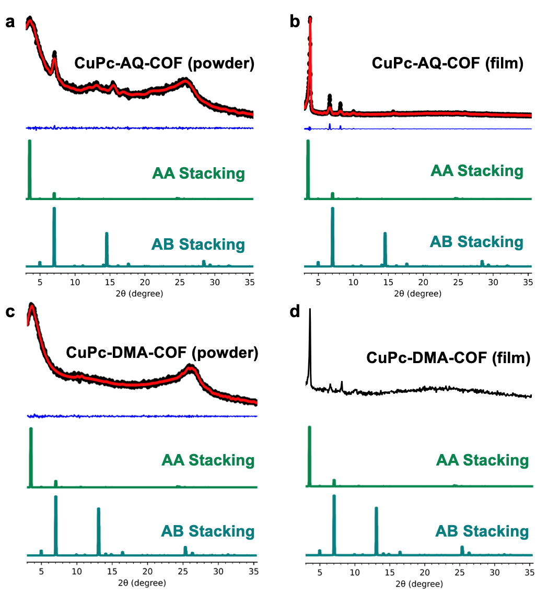
Figure S3. PXRD patterns of a) CuPc-AQ-COF (powder), b) CuPc-AQ-COF (film), c) CuPc-DMA-COF (powder) and d) CuPc-DMA-COF (film). Black, red, blue, green, and cyan curves are for experimental, Pawley refinement, difference, AA stacking mode, and AB stacking mode, respectively.

Figure S4. The a) AA and b) AB stacking mode of CuPc-AQ-COF (C, grey; O, red; F, green; N, cyan; Cu, blue; H, white.

Figure S5. The nitrogen sorption isotherm of a) CuPc-AQ-COFs powder, b) CuPc-DMA-COFs (film), c)CuPc-DMA-COFs powder at 77 K resulting surface area of 330.3, 287.3, and 263.8 m² g⁻¹ respectively. Inset is a pore size distribution profile calculated by NLDFT method.

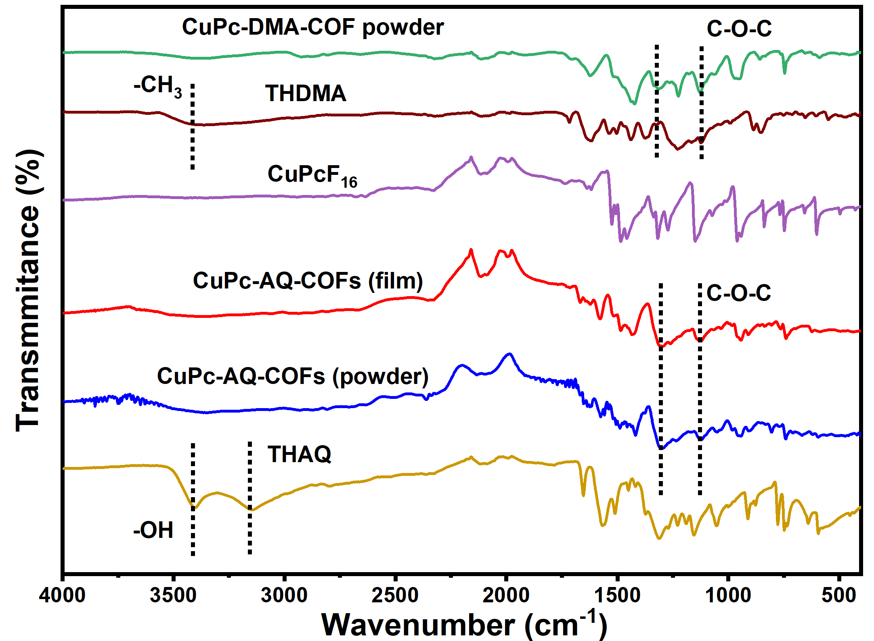
Figure S6. FTIR spectra of CuPc-AQ-COFs (film), CuPc-AQ-COFs (powder), CuPcF₁₆, THAQ, CuPc-DMA-COFs, and THDMA. Dioxin C−O−C asymmetric and symmetric stretching vibration bands of CuPc-AQ-COFs are 1286 cm⁻¹ and 1118 cm⁻¹, and of CuPc-DMA-COFs are 1124 cm⁻¹ and 1311 cm⁻¹. Bands at 3404 cm⁻¹3400 cm⁻¹ are O−H of THAQ. The band at 3128 cm⁻¹ is −CH₃ of THDMA.

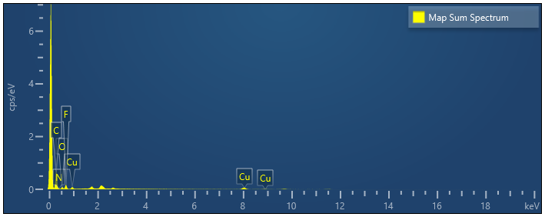 Figure S7. EDX of CuPc-AQ-COFs (film).

Figure S8. XPS a) full spectrum, b) signal of Cu(II), and c) Cu LMM of CuPc-AQ-COFs (film).

Figure S9. FE-SEM image of CuPc-AQ-COFs (film).
Figure S10. FE-SEM image of CuPc-AQ-COFs (powder).

Figure S11. a) Relations between precursor’s volume and COF films’ thickness and b) Thickness profiles for films.

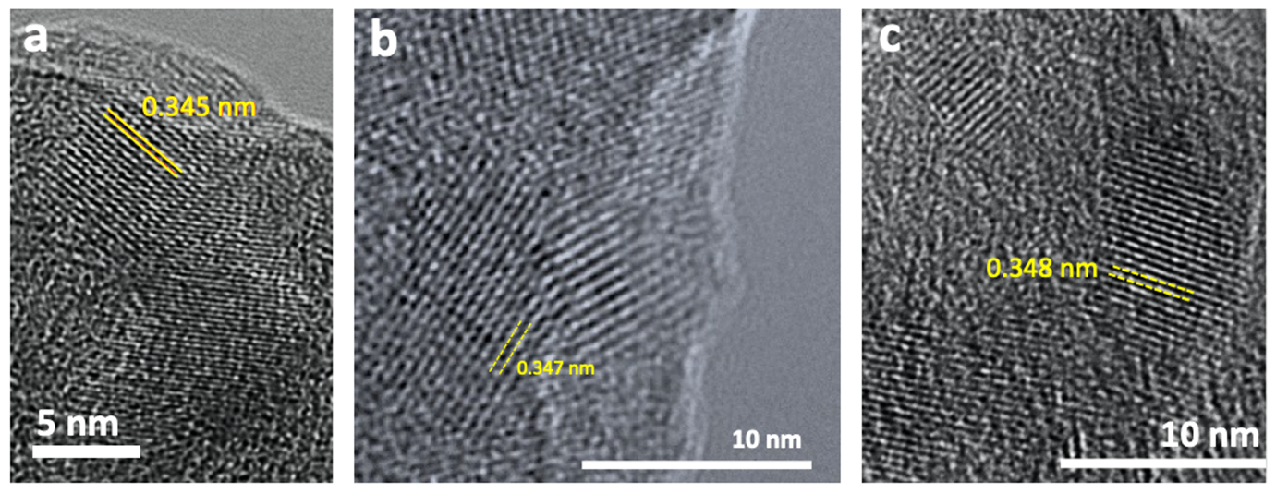
Figure S12. AC-TEM of a) CuPc-AQ-COFs (powder), b)CuPc-DMA-COFs (film), and c) CuPc-DMA-COFs (powder).

Figure S13. a) The thickness of pressed pellets was around 0.35 ± 0.05 mm. Four points are silver paint. b) Schematic illustration of COF devices for Hall effect measurement. c) Schematic illustration of FET devices and d) Drain and source electrodes under microscopy.

Figure S14. TGA of a) CuPc-AQ-COFs (film), CuPc-DMA-COFs (film), and b) CuPc-AQ-COFs (powder), and CuPc-DMA-COFs (powder).

Figure S15. Chemical stability of CuPc-AQ-COFs (film) after treatment in different solutions.

Figure S16. The residual weight percentage of a) CuPc-AQ-COFs (film), b) CuPc-AQ-COFs (powder), c) CuPc-DMA-COFs (film) and d) CuPc-DMA-COFs (powder) after treatment in different solutions.

Figure S17. The optical band gap of CuPc-AQ-COFs (film) was evaluated from Kubelka–Munk-transformed reflectance spectra.

Figure S18. CV spectrum of CuPc-AQ-COFs (film).

Figure S19. UPS spectrum of CuPc-AQ-COFs (film).

Figure S20. The a) AA and b) AB stacking stacking mode of CuPc-DMA-COF (C, grey; O, red; F, green; N, cyan; Cu, blue; H, white).

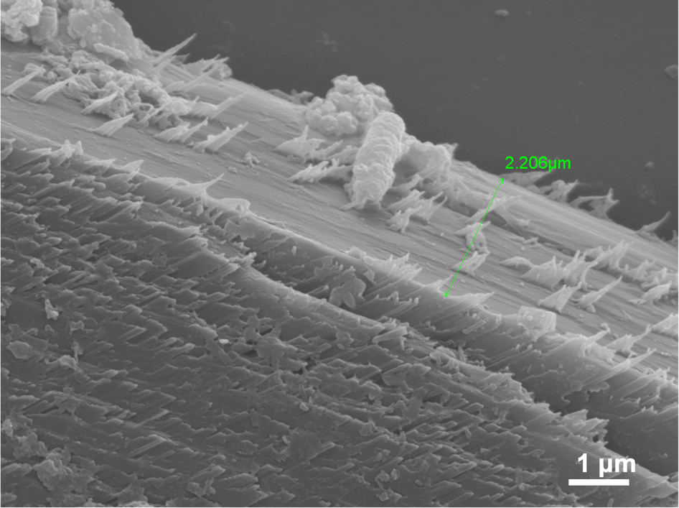
Figure S21. FE-SEM image of CuPc-DMA-COFs (film).

Figure S22. EDX of CuPc-DMA-COFs (film).

Figure S23. XPS a) full spectrum and b) signal of Cu(II) of CuPc-DMA-COFs (film).

Figure S24. FE-SEM image of CuPc-DMA-COFs (powder).

Figure S25. I–V curves of CuPc-DMA-COFs (film) (red curve) and CuPc-DMA-COFs (powder) (blue curve).

Figure S26. Band structure of a) monolayer CuPc-DMA-COF and b) AA stacking CuPc-DMA-COF.

Figure S27. PXRD patterns of a) CoPc-AQ-COFs (film) and b) NiPc-AQ-COFs (film).
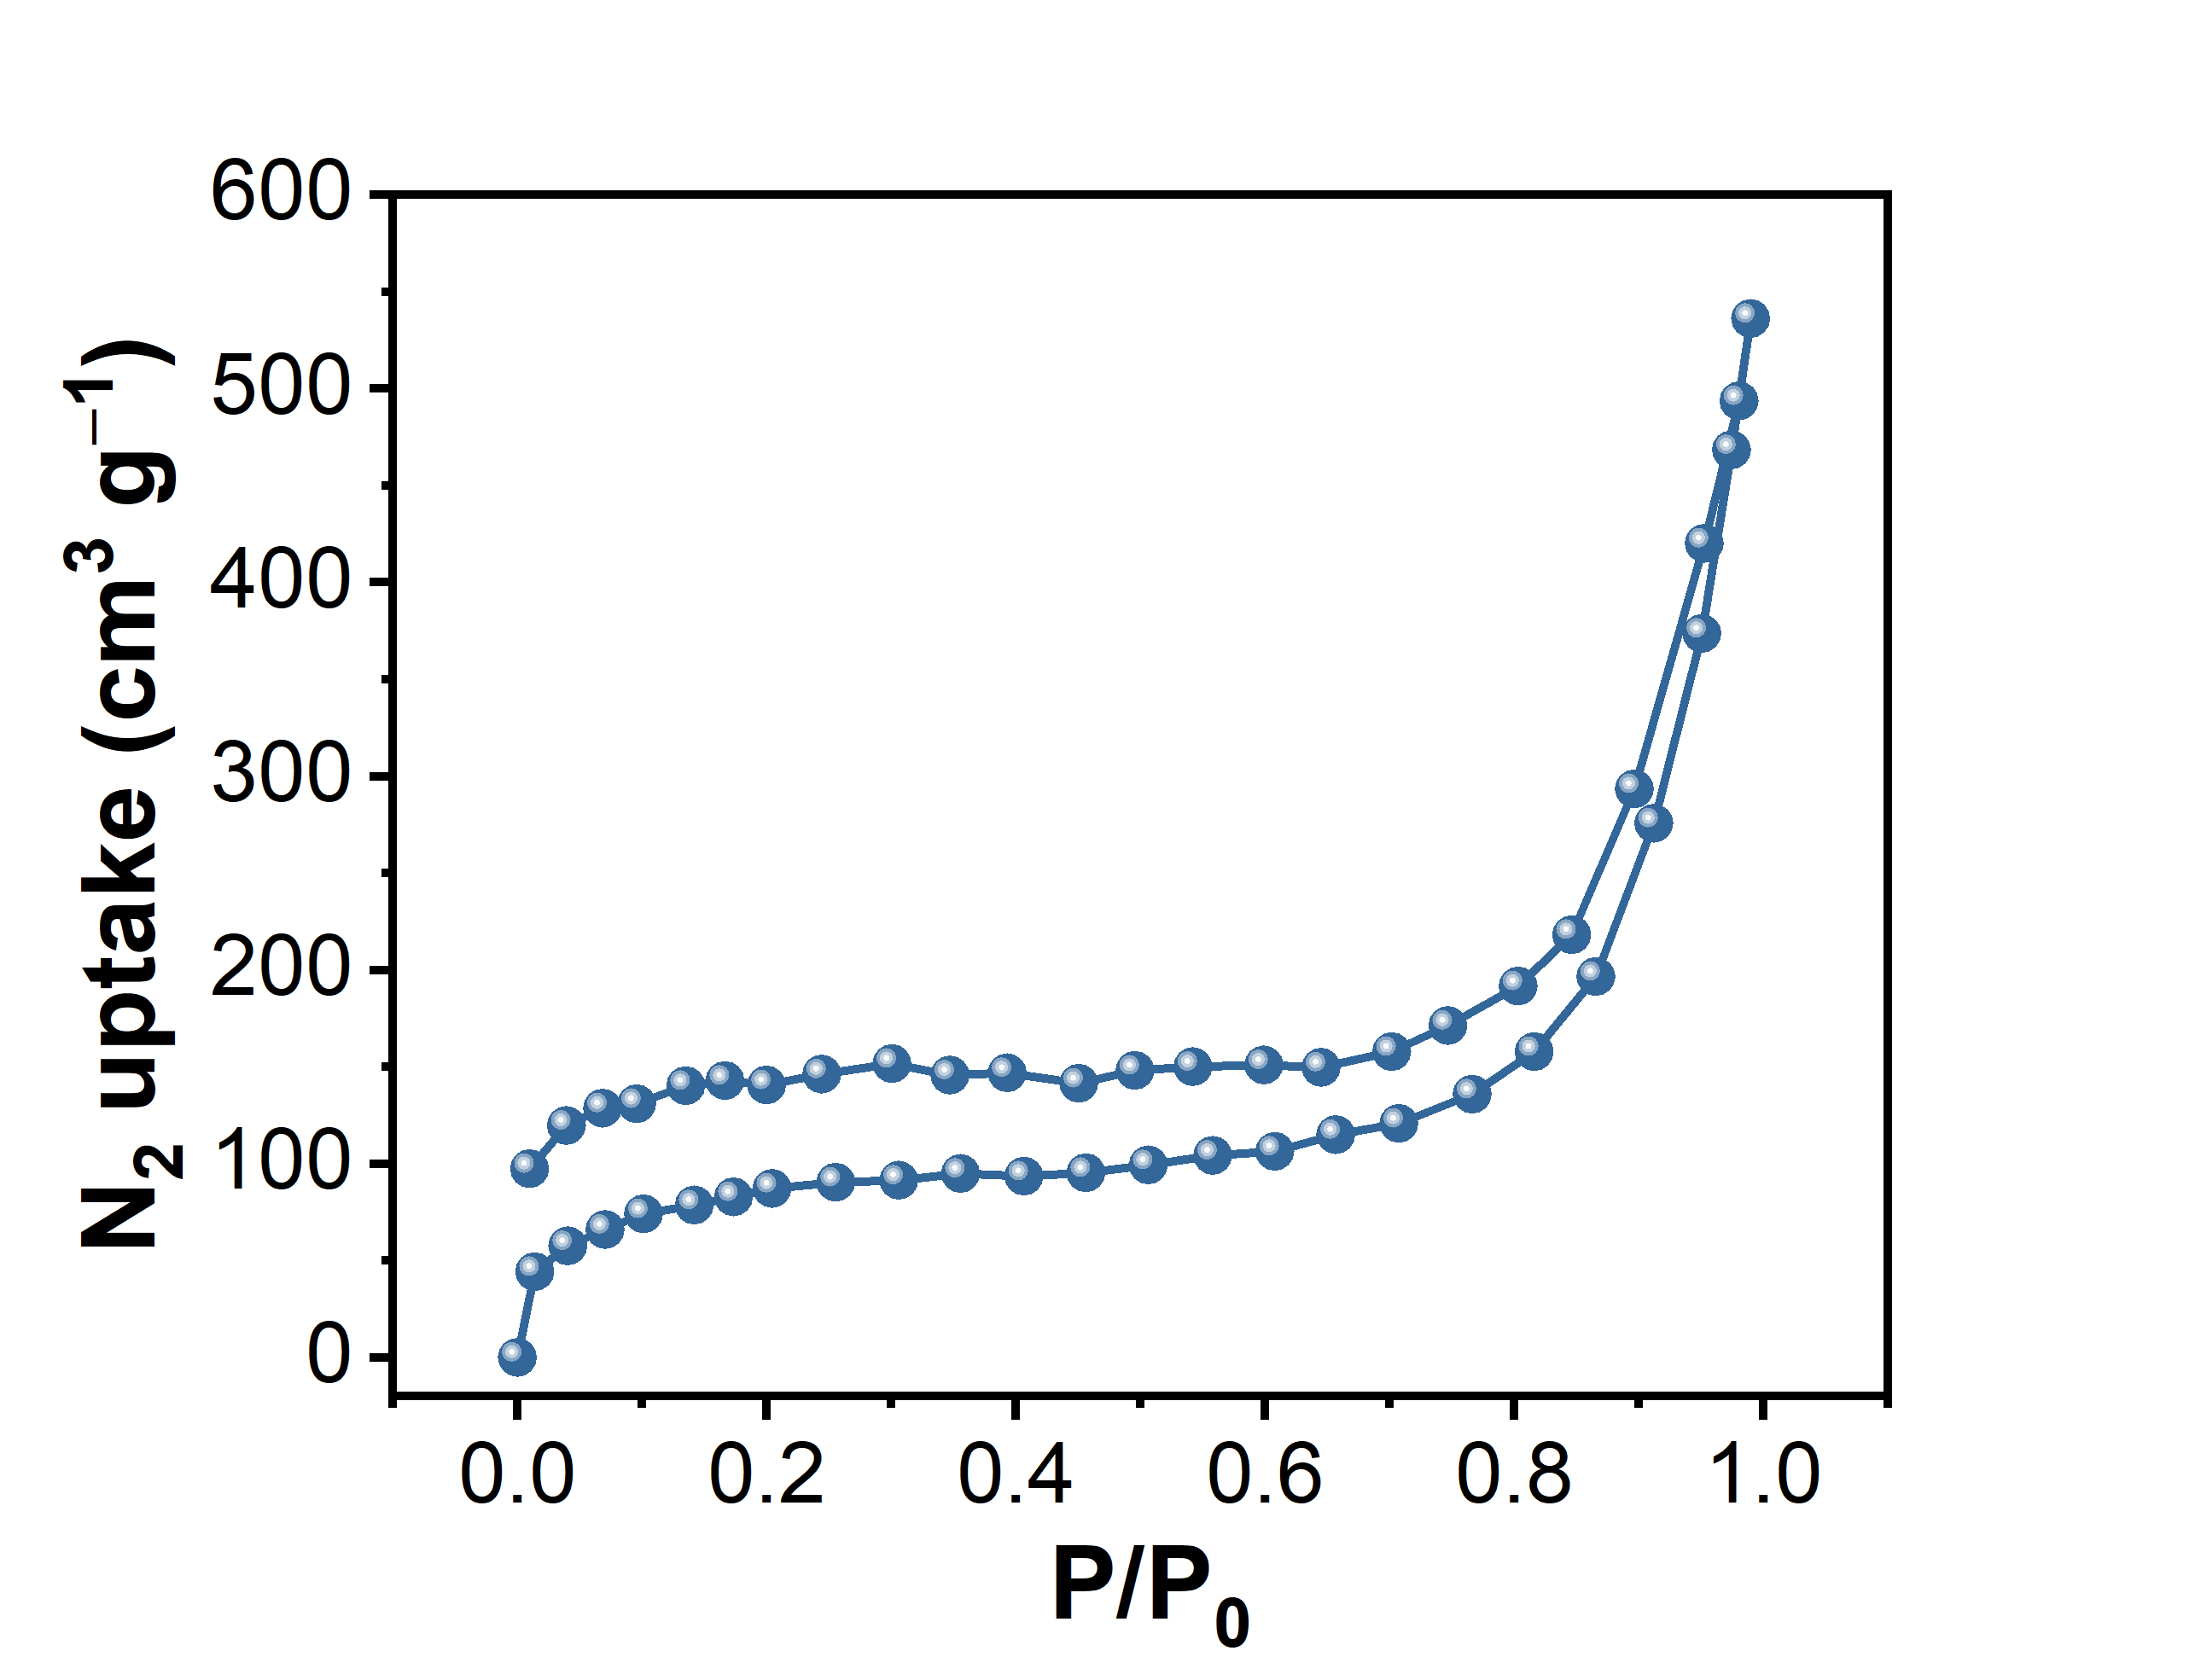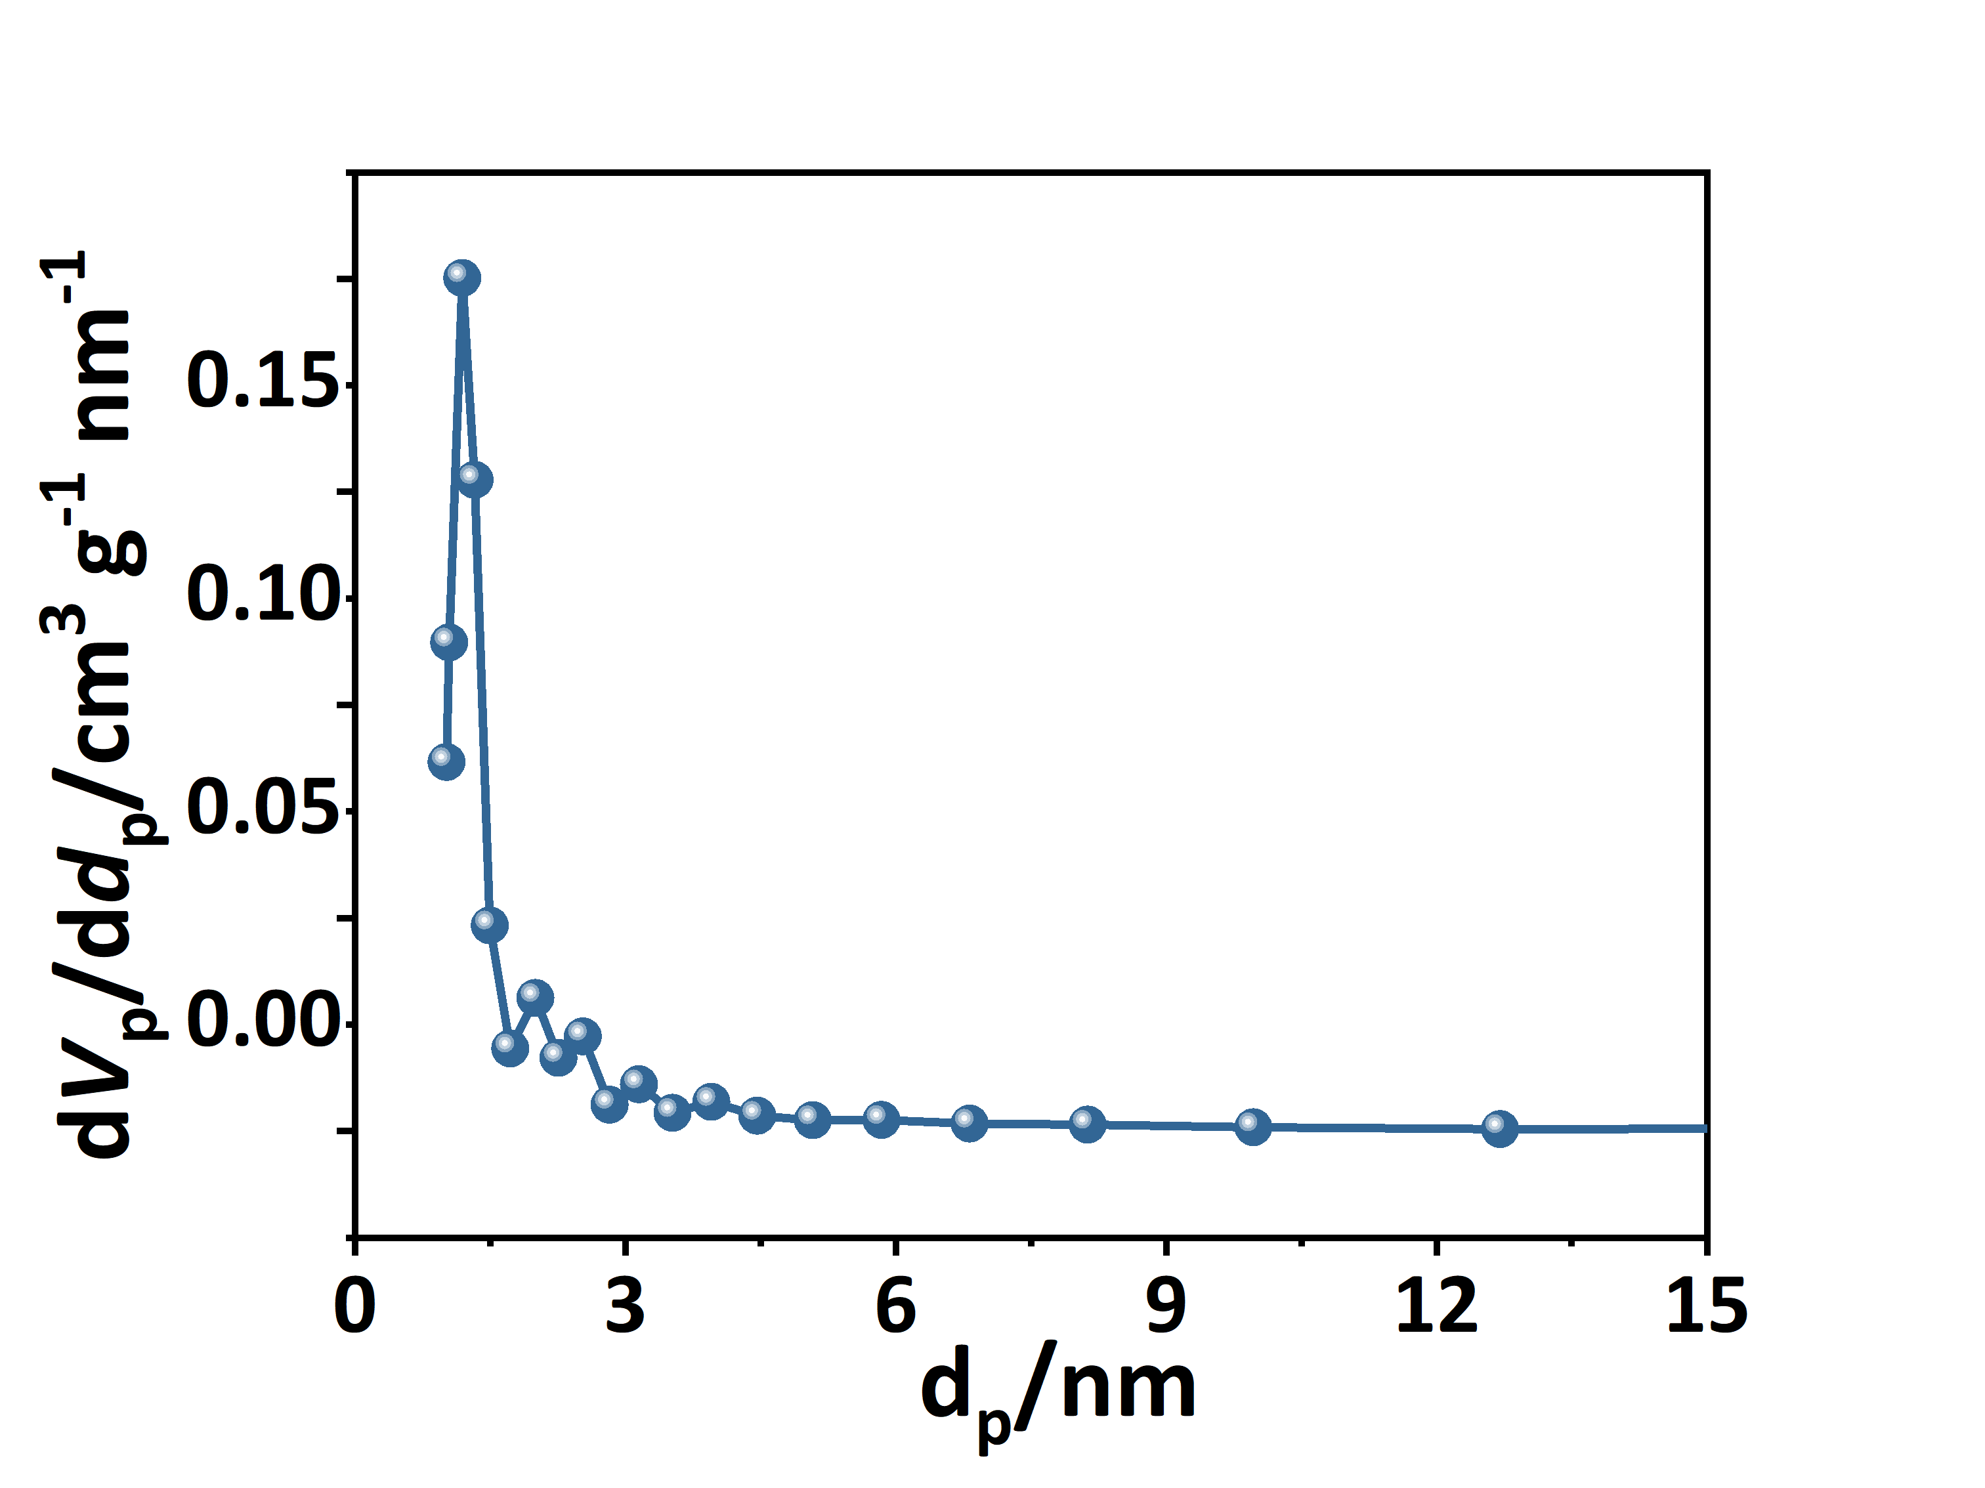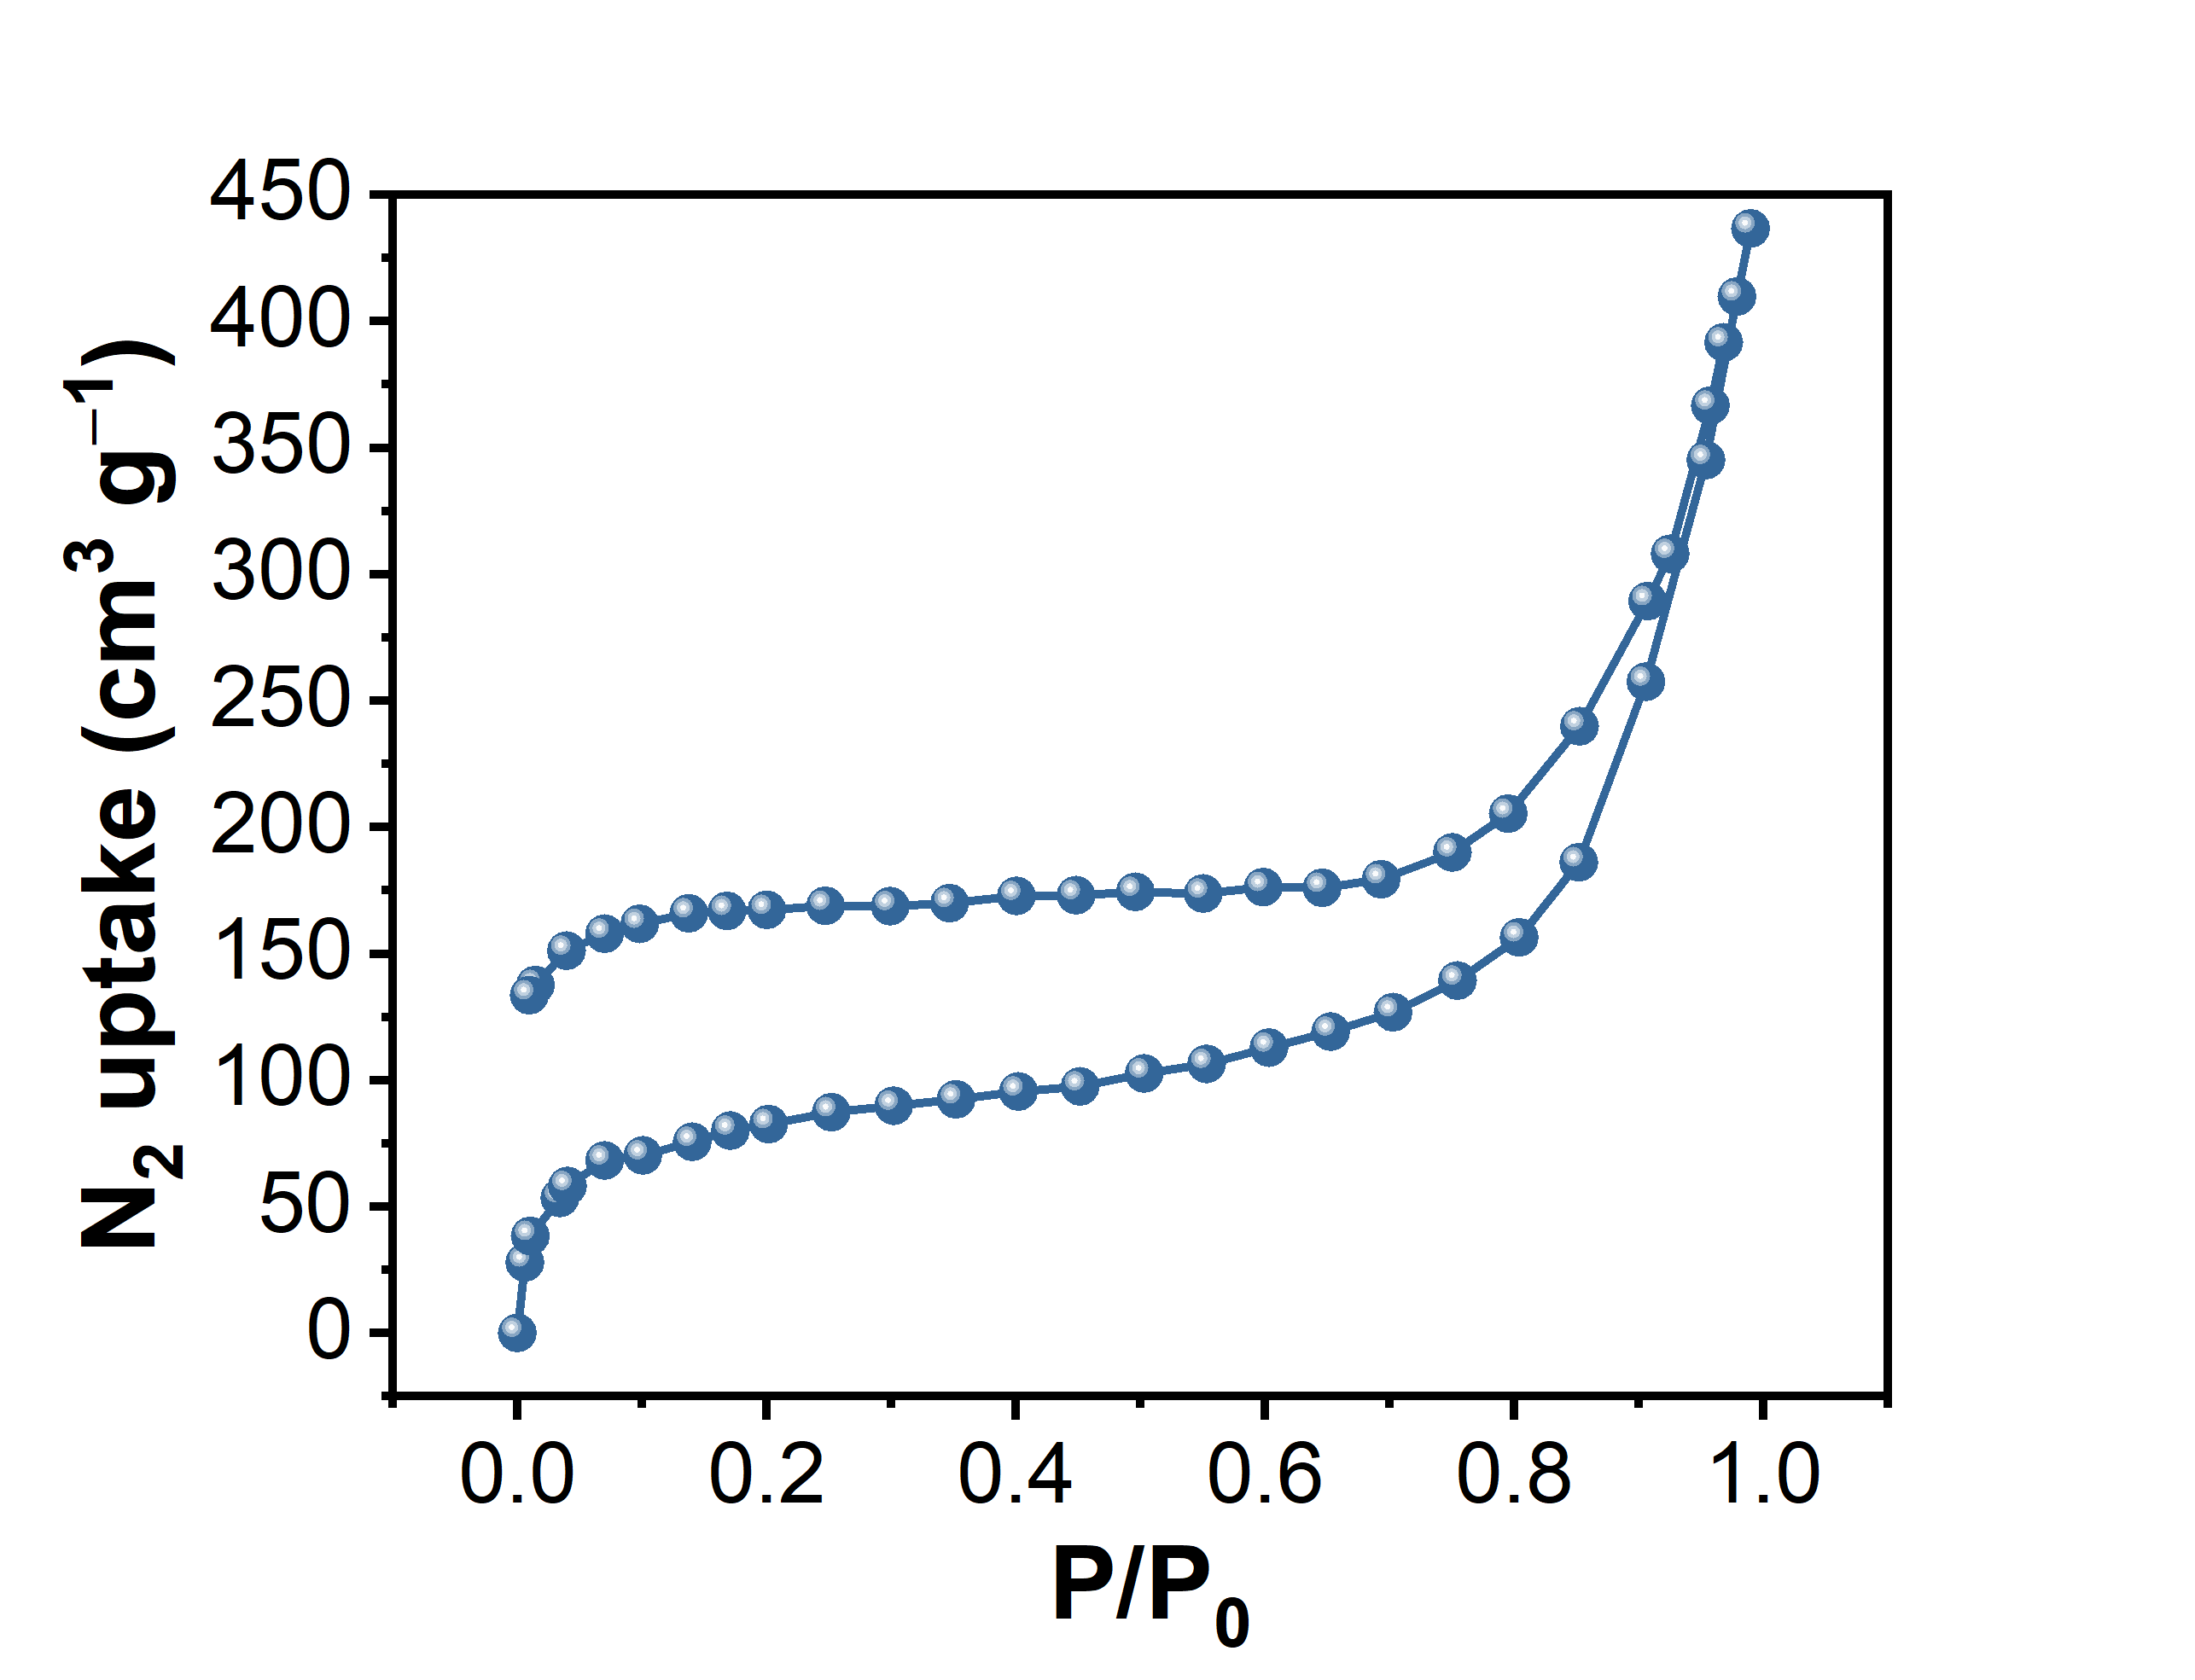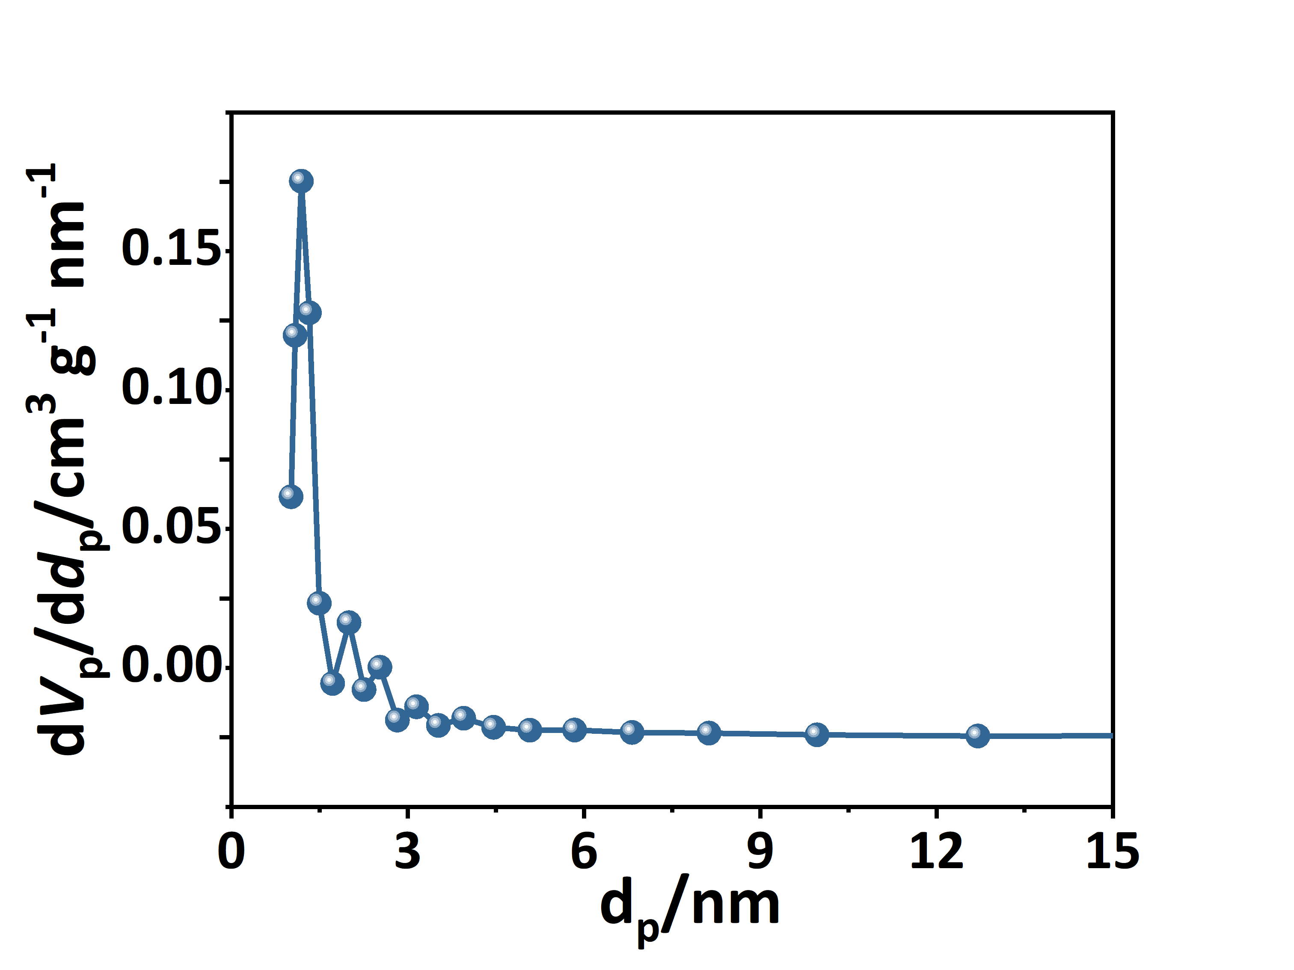
b
a
Figure S28. The nitrogen sorption isotherm of a) CoPc-AQ-COFs (film) and b) NiPc-AQ-COFs (film) at 77 K resulting a surface area of 328.6 and 337.1 m² g⁻¹, respectively. Inset is a pore size distribution profile calculated by the NLDFT method.
Figure S29. Band structure of a) monolayer CoPc-AQ-COF, b) AA stacking CoPc-AQ-COF, c) monolayer NiPc-AQ-COF, and d) AA stacking NiPc-AQ-COF.

Section D. Supporting Tables
Table S1. Comparison of conductivity (carrier mobility) among reported conductive COFs.
Materials | Measurement | Types | Method | σ/S m⁻¹ | Ref
CuPc-AQ-COF | 4-probe | Pellet | Vapor-assisted | 4.14 × 10¹ | This work
sp²c-COF | 2-probe | Pellet | Solvothermal, doped | 7.1 × 10⁻² | 32
COF-DC-8 | 4-probe | Pellet | Solvothermal, doped | 2.51 × 10⁻³ | 24
ZnPc-pz-I₂ | hall | Pellet | Solvothermal, doped | 3.1 × 10^{–2} | 1
TANG-COF | 4-probe | Pellet | Solvothermal, doped | 1.0 × 10⁰ | 33
CoPc-PDQ-CO | 4-probe | Pellet | Solvothermal | 3.68 × 10⁻³ | 34
NiPc-NH-CoPcF₈ | 4-probe | Pellet | Solvothermal | 2.72 × 10⁰ | 35
TFPPy-ICTO-COF | 4-probe | Pellet | Solvothermal | 5.6 × 10⁻¹ | 36
CuPc-AQ-COF | 4-probe | Film | Vapor-assisted | 1.54 × 10³ | This work
AntTTH COF | 2-probe | Film | Solvothermal in-situ | 1.2 × 10^{–5} | 37
TpAzo COF | 4-probe | Film | Interfacial | 3.7 × 10^{–3} | 38
TTF-COF | 2-probe | Film | Solvothermal in-situ, doped | 2.8 × 10⁻¹ | 39
BTT TTA COF | 2-probe | Film | Solvothermal in-situ | 1 × 10^{–4} | 40
PyTTA-TPA COF | 4-probe | Film | CVD | 8.4 × 10⁻⁴ | 41
NiPc-NH-CoPcF₈ | 4-probe | Film | Vapor-assisted | 1.27 × 10¹ | 35
PhDBP-TFP COF | I-t | Film | Solvothermal& exfoliation, doped | 4 × 10^{–6} | 42

Table S2. Atomistic coordinates for the AA-stacking mode of CuPc-AQ-COFs powder via Pawley refinement.
Space Group: P4/MMM; a = 25.1595 Å and c = 3.6172 Å; α = β = γ = 90°; R_{wp} = 2.27%, R_{p} = 1.77%
Atom | x/a | y/b | z/c
N1 | 0.42208 | 0.5 | 0.5
N2 | 0.40499 | 0.59501 | 0.5
C1 | 0.39015 | 0.45544 | 0.5
C2 | 0.33474 | 0.47188 | 0.5
C9 | 0.55621 | 0.71295 | 0.5
C10 | 0.528 | 0.7608 | 0.5
C33 | 0.14596 | 0.47204 | 0.5
C35 | 0.09852 | 0.44416 | 0.5
C36 | 0.05037 | 0.47199 | 0.5
O1 | 0.19271 | 0.44319 | 0.5
F1 | 0.28526 | 0.39039 | 0.5
H1 | 0.09839 | 0.40083 | 0.5
C45 | 0.55887 | 1 | 0.5
O9 | 1 | 0.39207 | 0.5
Cu1 | 0.5 | 0.5 | 0.5

Table S3. Atomistic coordinates for the AB-stacking mode of CuPc-AQ-COFs (film) via Pawley refinement.
Space Group: P4/MMM; a = 25.1744 Å and c = 3.6196 Å; α = β = γ = 90°; Rwp = 10.39%, Rp = 5.95%
Atom | x/a | y/b | z/c
N1 | 0.42208 | 0.5 | 0.5
N2 | 0.40499 | 0.59501 | 0.5
C1 | 0.39015 | 0.45544 | 0.5
C2 | 0.33474 | 0.47188 | 0.5
C9 | 0.55621 | 0.71295 | 0.5
C10 | 0.528 | 0.7608 | 0.5
C33 | 0.14596 | 0.47204 | 0.5
C35 | 0.09852 | 0.44416 | 0.5
C36 | 0.05037 | 0.47199 | 0.5
O1 | 0.19271 | 0.44319 | 0.5
F1 | 0.28526 | 0.39039 | 0.5
H1 | 0.09839 | 0.40083 | 0.5
C45 | 0.55887 | 1 | 0.5
O9 | 1 | 0.39207 | 0.5
Cu1 | 0.5 | 0.5 | 0.5

Table S4. Atomistic coordinates for the AA-stacking mode of CuPc-DMA-COFs powder via Pawley refinement.
Space Group: P4/MMM; a = 25.1303 Å and c = 3.6882 Å; α = β = γ = 90°; R_{wp} = 2.02%, R_{p} = 1.60%
Atom | x/a | y/b | z/c
H1 | 0.97651 | 0.63241 | 0.26184
H9 | 0.10011 | 0.40098 | 0.5
H13 | 0.1015 | 0.59867 | 0.5
H17 | 0.03721 | 0.63584 | 0.5
N1 | 0.42197 | 0.49978 | 0.5
N5 | 0.40461 | 0.59492 | 0.5
C1 | 0.39008 | 0.45509 | 0.5
C5 | 0.33458 | 0.47141 | 0.5
C9 | 0.33452 | 0.52778 | 0.5
C13 | 0.38993 | 0.54434 | 0.5
C17 | 0.55574 | 0.71322 | 0.5
C21 | 0.52753 | 0.76117 | 0.5
C25 | 0.47142 | 0.7612 | 0.5
C29 | 0.44331 | 0.71315 | 0.5
C33 | 0.14535 | 0.47138 | 0.5
C37 | 0.14545 | 0.52784 | 0.5
C41 | 0.09819 | 0.44423 | 0.5
C45 | 0.04837 | 0.4714 | 0.5
C49 | 0.04845 | 0.52909 | 0.5
C53 | 0.09863 | 0.55551 | 0.5
C57 | 0.55735 | 0.00011 | 0.5
C61 | 0.99791 | 0.61723 | 0.5
O1 | 0.19232 | 0.44263 | 0.5
O5 | 0.19249 | 0.55642 | 0.5
F1 | 0.28508 | 0.38976 | 0.5
F5 | 0.2848 | 0.60929 | 0.5
Cu1 | 0.5 | 0.5 | 0.5

Table S5. Conductivity and mobility of MPc-AQ-COFs (M=Cu, Ni, Co) and CuPc-DMA-COFs.
 | Type | σ (S m^{–1}) | µ (cm² V^{–1} s^{–1})
CuPc-AQ-COFs | Film | 1534.9 | 601.53
CuPc-AQ-COFs | Pellet | 41.4 | 37.18
NiPc-AQ-COFs | Film | 1432.4 | 563.82
NiPc-AQ-COFs | Pellet | 37.9 | 36.24
CoPc-AQ-COFs | Film | 1369.2 | 547.18
CoPc-AQ-COFs | Pellet | 35.3 | 32.67
CuPc-DMA-COFs | Film | 1067.4 | 367.25
CuPc-DMA-COFs | Pellet | 25.1 | 21.41

Table S6. 2D monolayer band gap, 3D multilayer stacking mode band gap and interlayer distance of MPc-AQ-COF (M=Cu, Ni, Co).
 | E_{g} of 2D (eV) | E_{g} of 3D (eV) | Interlayer distance (Å)
CuPc-AQ-COFs | 1.1442 | 0.4135 | 3.61718
NiPc-AQ-COFs | 1.1605 | 0.4513 | 3.62186
CoPc-AQ-COFs | 1.1588 | 0.4515 | 3.61765

Table S7. Comparison of HOMO and LOMO among reported linker moieties of phthalocyanine-based COFs. The metal center has been fixed to copper (Cu) to maintain consistency.
 | Fragments | HOMO (eV) | LUMO (eV) | Ref
Donor | CuPc | -6.7798 | -2.8715 | This work
Acceptors (linkage moieties) | THAQ | -7.601 | -2.4907 | This work
Acceptors (linkage moieties) | THDMA | -6.6363 | -1.4555 | This work
Acceptors (linkage moieties) | TOPyr | -7.3343 | -1.7521 | ²⁴
Acceptors (linkage moieties) | TFPN | -7.2472 | -1.8218 | ²³
Acceptors (linkage moieties) | CuPc-NH-CuPcF₈ | -5.8559 | 0.0161 | ³⁵
Acceptors (linkage moieties) | ^{t}Bu-PT | -7.2216 | -1.7091 | ⁴³

Section E. Supporting Reference
(1) Wang, M.; Wang, M.; Lin, H. H.; Ballabio, M.; Zhong, H.; Bonn, M.; Zhou, S.; Heine, T.; Cánovas, E.; Dong, R.; Feng, X. High-Mobility Semiconducting Two-Dimensional Conjugated Covalent Organic Frameworks with p-Type Doping. J. Am. Chem. Soc. 2020, 142 (52), 21622–21627.
(2) Kresse, G.; Furthmüller, J. Efficiency of Ab-Initio Total Energy Calculations for Metals and Semiconductors Using a Plane-Wave Basis Set. Comput. Mate.r Sci. 1996, 6 (1), 15–50.
(3) Kresse, G.; Hafner, J. Ab Initio Molecular Dynamics for Liquid Metals. Phys. Rev. B 1993, 47 (1), 558–561.
(4) Kresse, G.; Hafner, J. Ab Initio Molecular-Dynamics Simulation of the Liquid-Metal--Amorphous-Semiconductor Transition in Germanium. Phys. Rev. B 1994, 49 (20), 14251–14269.
(5) Kresse, G.; Furthmüller, J. Efficient Iterative Schemes for Ab Initio Total-Energy Calculations Using a Plane-Wave Basis Set. Phys. Rev. B 1996, 54 (16), 11169–11186.
(6) Kresse, G.; Joubert, D. From Ultrasoft Pseudopotentials to the Projector Augmented-Wave Method. Phys. Rev. B 1999, 59 (3), 1758–1775.
(7) Dudarev, S. L.; Botton, G. A.; Savrasov, S. Y.; Humphreys, C. J.; Sutton, A. P. Electron-Energy-Loss Spectra and the Structural Stability of Nickel Oxide: An LSDA+U Study. Phys. Rev. B 1998, 57 (3), 1505–1509.
(8) Perdew, J. P.; Burke, K.; Ernzerhof, M. Generalized Gradient Approximation Made Simple. Phys. Rev. Lett. 1996, 77 (18), 3865–3868.
(9) Perdew, J. P.; Burke, K.; Ernzerhof, M. Generalized Gradient Approximation Made Simple [Phys. Rev. Lett. 77, 3865 (1996)]. Phys. Rev. Lett. 1997, 78 (7), 1396.
(10) Anisimov, V. I.; Zaanen, J.; Andersen, O. K. Band Theory and Mott Insulators: Hubbard U Instead of Stoner I. Phys. Rev. B 1991, 44 (3), 943–954.
(11) Bernien, M.; Miguel, J.; Weis, C.; Ali, Md. E.; Kurde, J.; Krumme, B.; Panchmatia, P. M.; Sanyal, B.; Piantek, M.; Srivastava, P.; Baberschke, K.; Oppeneer, P. M.; Eriksson, O.; Kuch, W.; Wende, H. Tailoring the Nature of Magnetic Coupling of Fe-Porphyrin Molecules to Ferromagnetic Substrates. Phys. Rev. Lett. 2009, 102 (4), 47202.
(12) Panchmatia, P. M.; Sanyal, B.; Oppeneer, P. M. GGA + U Modeling of Structural, Electronic, and Magnetic Properties of Iron Porphyrin-Type Molecules. Chem. Phys. 2008, 343 (1), 47–60.
(13) Shick, A. B.; Kudrnovský, J.; Drchal, V. Coulomb Correlation Effects on the Electronic Structure of III-V Diluted Magnetic Semiconductors. Phys. Rev. B 2004, 69 (12), 125207.
(14) Zhou, J.; Sun, Q. Magnetism of Phthalocyanine-Based Organometallic Single Porous Sheet. J. Am. Chem. Soc. 2011, 133 (38), 15113–15119.
(15) Sato, K.; Dederichs, P. H.; Katayama-Yoshida, H.; Kudrnovský, J. Exchange Interactions in Diluted Magnetic Semiconductors. J. Phys. Condens. Matter
2004, 16 (48).
(16) Sato, K.; Bergqvist, L.; Kudrnovský, J.; Dederichs, P. H.; Eriksson, O.; Turek, I.; Sanyal, B.; Bouzerar, G.; Katayama-Yoshida, H.; Dinh, V. A.; Fukushima, T.; Kizaki, H.; Zeller, R. First-Principles Theory of Dilute Magnetic Semiconductors. Rev Mod Phys. 2010, 82 (2), 1633–1690.
(17) Grimme, S. Semiempirical GGA-Type Density Functional Constructed with a Long-Range Dispersion Correction. J. Comput. Chem. 2006, 27 (15), 1787–1799.
(18) Grimme, S.; Antony, J.; Ehrlich, S.; Krieg, H. A Consistent and Accurate Ab Initio Parametrization of Density Functional Dispersion Correction (DFT-D) for the 94 Elements H-Pu. J. Chem. Phys. 2010, 132 (15), 154104.
(19) Frisch, M. J.; Trucks, G. W.; Schlegel, H. B.; Scuseria, G. E.; Robb, M. A.; Cheeseman, J. R.; Scalmani, G.; Barone, V.; Petersson, G. A.; Nakatsuji, H.; Li, X.; Caricato, M.; Marenich, A. V; Bloino, J.; Janesko, B. G.; Gomperts, R.; Mennucci, B.; Hratchian, H. P.; Ortiz, J. V; Izmaylov, A. F.; Sonnenberg, J. L.; Williams-Young, D.; Ding, F.; Lipparini, F.; Egidi, F.; Goings, J.; Peng, B.; Petrone, A.; Henderson, T.; Ranasinghe, D.; Zakrzewski, V. G.; Gao, J.; Rega, N.; Zheng, G.; Liang, W.; Hada, M.; Ehara, M.; Toyota, K.; Fukuda, R.; Hasegawa, J.; Ishida, M.; Nakajima, T.; Honda, Y.; Kitao, O.; Nakai, H.; Vreven, T.; Throssell, K.; Montgomery Jr., J. A.; Peralta, J. E.; Ogliaro, F.; Bearpark, M. J.; Heyd, J. J.; Brothers, E. N.; Kudin, K. N.; Staroverov, V. N.; Keith, T. A.; Kobayashi, R.; Normand, J.; Raghavachari, K.; Rendell, A. P.; Burant, J. C.; Iyengar, S. S.; Tomasi, J.; Cossi, M.; Millam, J. M.; Klene, M.; Adamo, C.; Cammi, R.; Ochterski, J. W.; Martin, R. L.; Morokuma, K.; Farkas, O.; Foresman, J. B.; Fox, D. J. Gaussian˜09 {R}evision {D}.01. 2009.
(20) Zhao, Y.; Truhlar, D. G. The M06 Suite of Density Functionals for Main Group Thermochemistry, Thermochemical Kinetics, Noncovalent Interactions, Excited States, and Transition Elements: Two New Functionals and Systematic Testing of Four M06-Class Functionals and 12 Other Function. Theor Chem. Acc 2008, 120 (1–3), 215–241.
(21) Weigend, F.; Ahlrichs, R. Balanced Basis Sets of Split Valence, Triple Zeta Valence and Quadruple Zeta Valence Quality for H to Rn: Design and Assessment of Accuracy. Physical Chemistry Chemical Physics 2005, 7 (18), 3297–3305.
(22) Schäfer, A.; Horn, H.; Ahlrichs, R. Fully Optimized Contracted Gaussian Basis Sets for Atoms Li to Kr. J. Chem. Phys. 1992, 97 (4), 2571–2577.
(23) Yang, C.; Jiang, K.; Zheng, Q.; Li, X.; Mao, H.; Zhong, W.; Chen, C.; Sun, B.; Zheng, H.; Zhuang, X.; A. Reimer, J.; Liu, Y.; Zhang, J. Chemically Stable Polyarylether-Based Metallophthalocyanine Frameworks with High Carrier Mobilities for Capacitive Energy Storage. J. Am. Chem. Soc. 2021, 143 (42), 17701–17707.
(24) Meng, Z.; M. Stolz, R.; A. Mirica, K. Two-Dimensional Chemiresistive Covalent Organic Framework with High Intrinsic Conductivity. J. Am. Chem. Soc. 2019, 141 (30), 11929–11937.
(25) Xu, N.; Diao, Y.; Qin, X.; Xu, Z.; Ke, H.; Zhu, X. Donor-Acceptor Covalent Organic Frameworks of Nickel(Ii) Porphyrin for Selective and Efficient CO2reduction into CO. Dalton Trans. 2020, 49 (44), 15587–15591.
(26) Wu, Q.; Mao, M. J.; Wu, Q. J.; Liang, J.; Huang, Y. B.; Cao, R. Construction of Donor–Acceptor Heterojunctions in Covalent Organic Framework for Enhanced CO2 Electroreduction. Small 2021, 17 (22), 1–8.
(27) Roeser, J.; Prill, D.; Bojdys, M. J.; Fayon, P.; Trewin, A.; Fitch, A. N.; Schmidt, M. U.; Thomas, A. Anionic Silicate Organic Frameworks Constructed from Hexacoordinate Silicon Centres. Nat. Chem. 2017, 9 (10), 977–982.
(28) Yu, T.; Wang, Y.; Jiang, K.; Zhai, G.; Ke, C.; Zhang, J.; Li, J.; Tranca, D.; Kymakis, E.; Zhuang, X. Catechol-Coordinated Framework Film-Based Micro-Supercapacitors with AC Line Filtering Performance. Chem. Eur. J. 2021, 27 (20), 6340–6347.
(29) Balaban, T. S.; Eichhöfer, A.; Krische, M. J.; Lehn, J. M. Hierarchic Supramolecular Interactions within Assemblies in Solution and in the Crystal of 2,3,6,7-Tetrasubstituted 5,5′-(Anthracene-9,10-Diyl) Bis[Pyrimidin-2-Amines]. Helv. Chim. Acta. 2006, 89 (2), 333–351.
(30) Denekamp, I. M.; Veenstra, F. L. P.; Jungbacker, P.; Rothenberg, G. A Simple Synthesis of Symmetric Phthalocyanines and Their Respective Perfluoro and Transition-Metal Complexes. Appl. Organomet. Chem. 2019, 33 (5), e4872.
(31) Virmani, E.; Rotter, J. M.; Mähringer, A.; Von Zons, T.; Godt, A.; Bein, T.; Wuttke, S.; Medina, D. D. On-Surface Synthesis of Highly Oriented Thin Metal-Organic Framework Films through Vapor-Assisted Conversion. J. Am. Chem. Soc. 2018, 140 (14), 4812–4819.
(32) Jin, E.; Asada, M.; Xu, Q.; Dalapati, S.; Addicoat, M. A.; Brady, M. A.; Xu, H.; Nakamura, T.; Heine, T.; Chen, Q.; Jiang, D. Two-Dimensional Sp2 Carbon–Conjugated Covalent Organic Frameworks. Science 2017, 357 (6352), 673–676.
(33) Lakshmi, V.; Liu, C.-H.; Rajeswara Rao, M.; Chen, Y.; Fang, Y.; Dadvand, A.; Hamzehpoor, E.; Sakai-Otsuka, Y.; S. Stein, R.; F. Perepichka, D. A Two-Dimensional Poly(Azatriangulene) Covalent Organic Framework with Semiconducting and Paramagnetic States. J. Am. Chem. Soc. 2020, 142 (5), 2155–2160.
(34) Huang, N.; Lee, K. H.; Yue, Y.; Xu, X.; Irle, S.; Jiang, Q.; Jiang, D. A Stable and Conductive Metallophthalocyanine Framework for Electrocatalytic Carbon Dioxide Reduction in Water. Angew. Chem., Int. Ed. 2020, 59 (38), 16587–16593.
(35) Yue, Y.; Li, H.; Chen, H.; Huang, N. Piperazine-Linked Covalent Organic Frameworks with High Electrical Conductivity. J. Am. Chem. Soc. 2022, 144 (7), 2873–2878.
(36) Xu, X.; Zhang, S.; Xu, K.; Chen, H.; Fan, X.; Huang, N. Janus Dione-Based Conjugated Covalent Organic Frameworks with High Conductivity as Superior Cathode Materials. J. Am. Chem. Soc. 2023, 145 (2), 1022–1030.
(37) Ghosh, S.; Tsutsui, Y.; Kawaguchi, T.; Matsuda, W.; Nagano, S.; Suzuki, K.; Kaji, H.; Seki, S. Band-like Transport of Charge Carriers in Oriented Two-Dimensional Conjugated Covalent Organic Frameworks. Chem. Mater. 2022, 34 (2), 736–745.
(38) Kumar Mahato, A.; Bag, S.; Sekhar Sasmal, H.; Dey, K.; Giri, I.; Linares-Moreau, M.; Carbonell, C.; Falcaro, P.; Bhoje Gowd, E.; K Vijayaraghavan, R.; Banerjee, R. Crystallizing Sub 10 Nm Covalent Organic Framework Thin Films via Interfacial–Residual Concomitance. J. Am. Chem. Soc. 2021, 143 (49), 20916–20926.
(39) Cai, S. L.; Zhang, Y. B.; Pun, A. B.; He, B.; Yang, J.; Toma, F. M.; Sharp, I. D.; Yaghi, O. M.; Fan, J.; Zheng, S. R.; Zhang, W. G.; Liu, Y. Tunable Electrical Conductivity in Oriented Thin Films of Tetrathiafulvalene-Based Covalent Organic Framework. Chem. Sci. 2014, 5 (12), 4693–4700.
(40) Frey, L.; Pöhls, J. F.; Hennemann, M.; Mähringer, A.; Reuter, S.; Clark, T.; Weitz, R. T.; Medina, D. D. Oriented Thiophene-Extended Benzotrithiophene Covalent Organic Framework Thin Films: Directional Electrical Conductivity. Adv. Funct. Mater. 2022, 32 (47), 2205949.
(41) Liu, M.; Liu, Y.; Dong, J.; Bai, Y.; Gao, W.; Shang, S.; Wang, X.; Kuang, J.; Du, C.; Zou, Y.; Chen, J.; Liu, Y. Two-Dimensional Covalent Organic Framework Films Prepared on Various Substrates through Vapor Induced Conversion. Nat. Commun. 2022, 13 (1), 1411.
(42) Sprachmann, J.; Wachsmuth, T.; Bhosale, M.; Burmeister, D.; Smales, G. J.; Schmidt, M.; Kochovski, Z.; Grabicki, N.; Wessling, R.; List-Kratochvil, E. J. W.; Esser, B.; Dumele, O. Antiaromatic Covalent Organic Frameworks Based on Dibenzopentalenes. J. Am. Chem. Soc. 2023, 145 (5), 2840–2851.
(43) Wang, M.; Ballabio, M.; Wang, M.; Lin, H. H.; Biswal, B. P.; Han, X.; Paasch, S.; Brunner, E.; Liu, P.; Chen, M.; Bonn, M.; Heine, T.; Zhou, S.; Cánovas, E.; Dong, R.; Feng, X. Unveiling Electronic Properties in Metal-Phthalocyanine-Based Pyrazine-Linked Conjugated Two-Dimensional Covalent Organic Frameworks. J. Am. Chem. Soc. 2019, 141 (42), 16810–16816.

