Ayurveda botanicals in COVID-19 management: An in silico- multitarget approach
Swapnil Borse^{1#}, Manali Joshi^{2#$} , Akash Saggam^{1#}, Vedika Bhat^{1#}, Safal Walia², Sneha Sagar³, Preeti Chavan-Gautam^{1*}, Girish Tillu¹
¹AYUSH-Center of Excellence, Center for Complementary and Integrative Health, Interdisciplinary School of Health Sciences, Savitribai Phule Pune University, Pune - 411 007
²Bioinformatics Center, Savitribai Phule Pune University, Pune - 411 007
³Department of Pharmaceutical Chemistry, L.J. Institute of Pharmacy, Sarkhej, Ahmedabad - 382210

#Authors have equal contribution
*Corresponding author: Preeti Chavan-Gautam; E-mail:chavanpriti@gmail.com
$Corresponding author for molecular docking studies: Manali Joshi; E-mail: manali.joshi@gmail.com

Short Title: Ayurvedic Rasayana Botanicals for COVID-19 Management

S1 Appendix: Bioavailability RADAR graphs for phytochemicals of AR, TC and WS.
Bioavailability RADAR graph represents five important properties lipophilicity, size, polarity, solubility, saturation and flexibility for predicting whether test molecule is orally bioavailable or not. Pink area of graph represents optimal ranges for all properties and molecule having all 6 axes lying within pink area may be considered to be orally bioavailable. Optimum ranges for each axes represented are as follows.
- Lipophilicity (LIPO): XLOGP3 between − 0.7 and + 5.0
- Size: molecular weight between 150-500 g/mol
- Polarity (POLAR): Topological Polar Surface Area (TPSA) between 20-130 A°
- Solubility (INSOLU): log S not higher than 6
- Saturation (INSATU): fraction of carbons in the sp3 hybridization not less than 0.25
- Flexibility (FLEX): No more than 9 rotatable bond

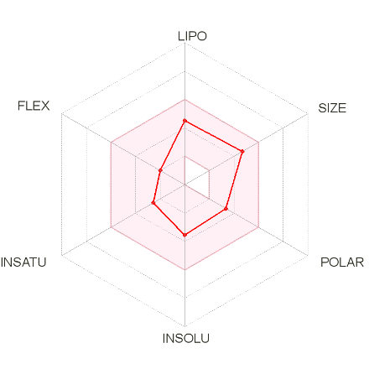
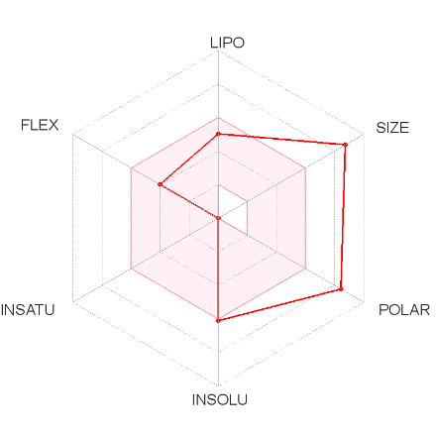
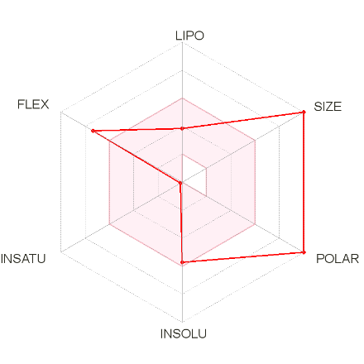
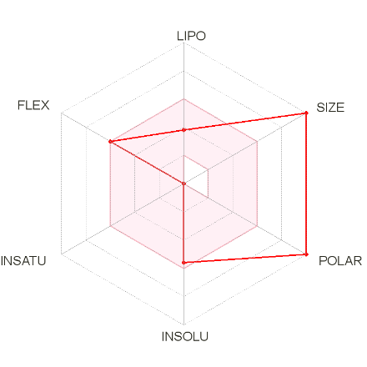
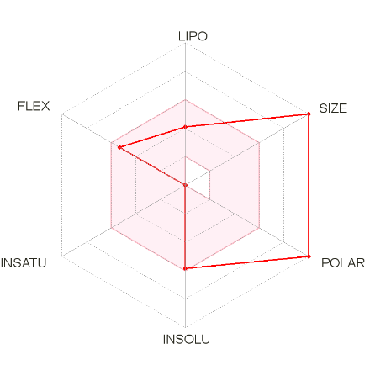
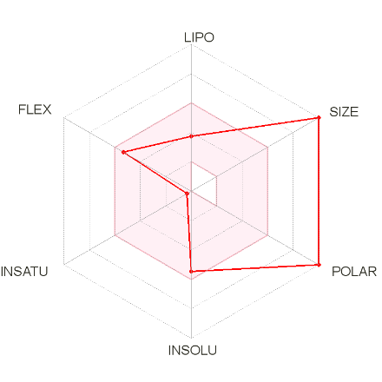
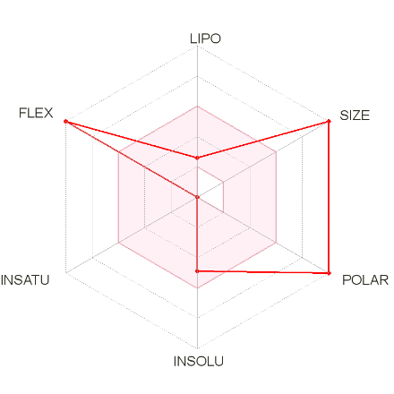
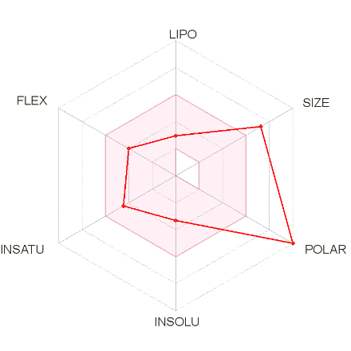
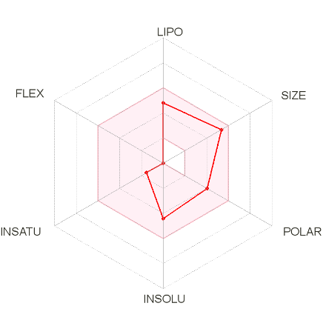
Asparagamin A

Asparanin A

Shatavarin X

Shatavarin IX

Shatavarin IV

ShatavarinVII

Asparagus racemosus

Shatavarin I

Rutin

Muzanzagenin

Shatavarin VI

Isoagatharesinol

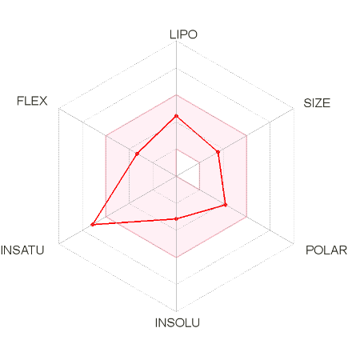

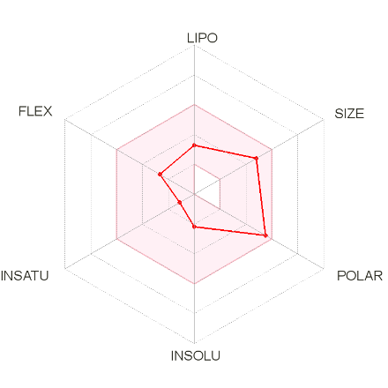
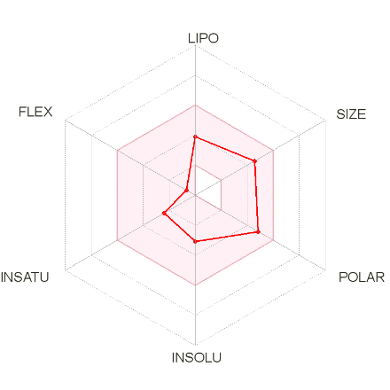
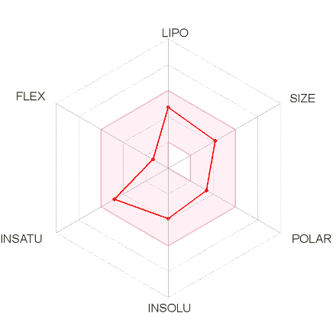
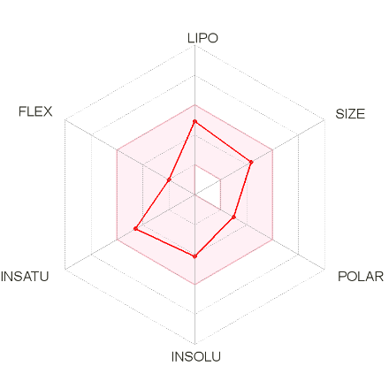
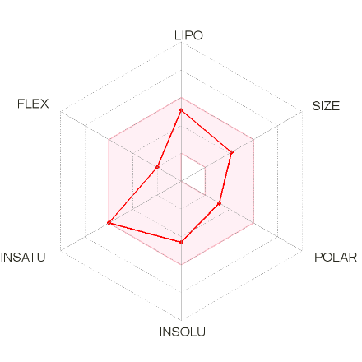
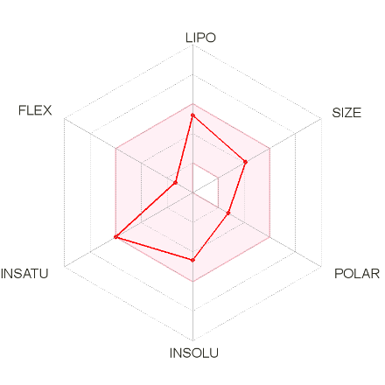
Tinocordiside

Magnoflorine

Tinospora cordifolia

Menisperine

Columbamine

Berberine

Tinosporide

20-β-Hydroxy Ecdysone

Columbin

Syringin

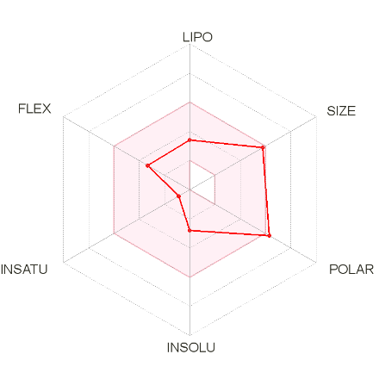
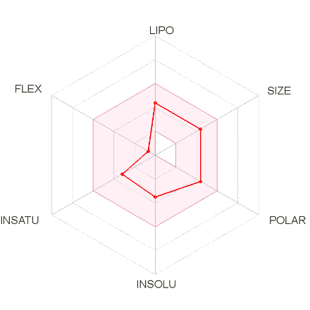
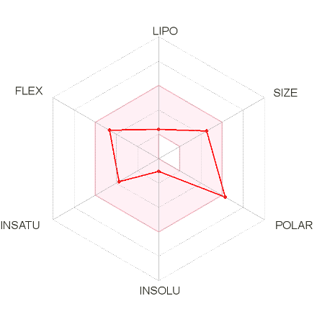
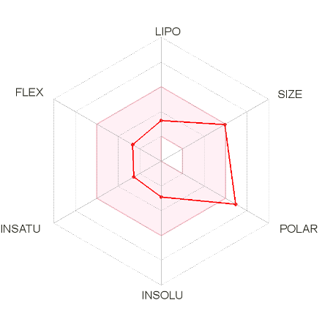
Tinosporaside

Withania somnifera

Withacoagin

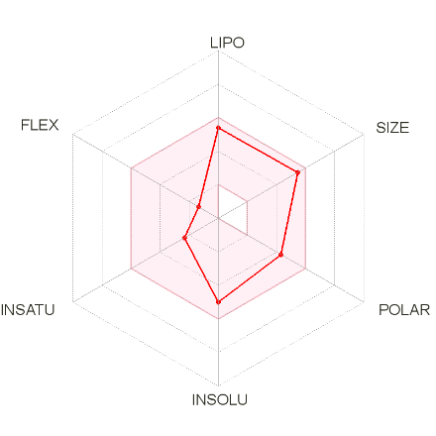
Withastramonolide-12-Deoxy

Withanolide B

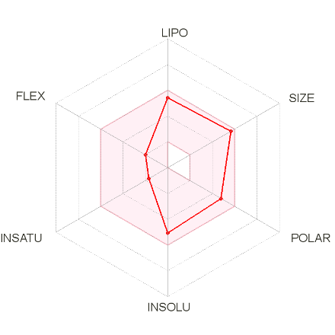
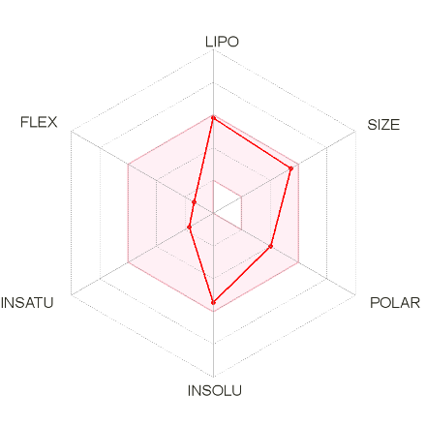

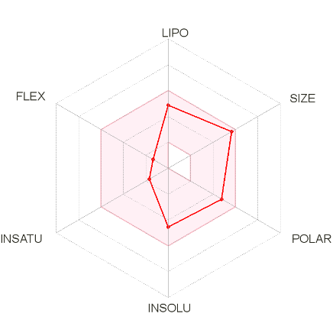
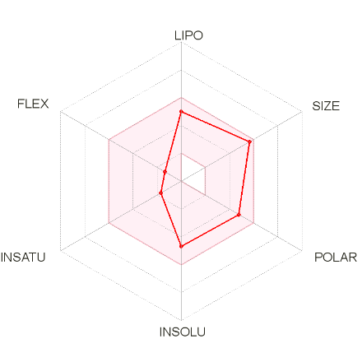
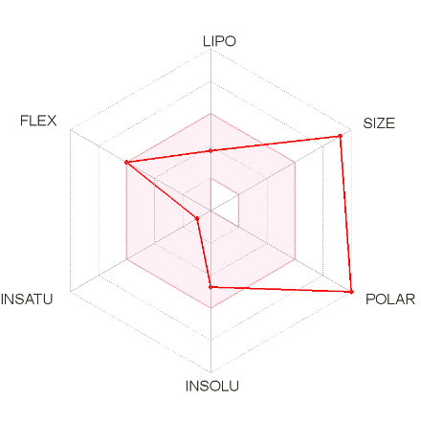
Withanone

Withanolide A

Withanoside IV

Withanoside V

27-hydroxy Withanone

Withaferin A

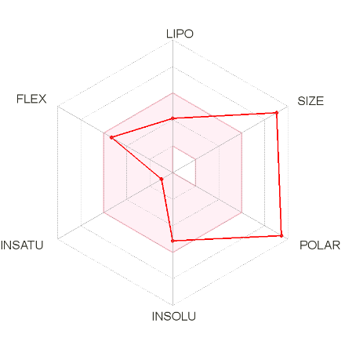
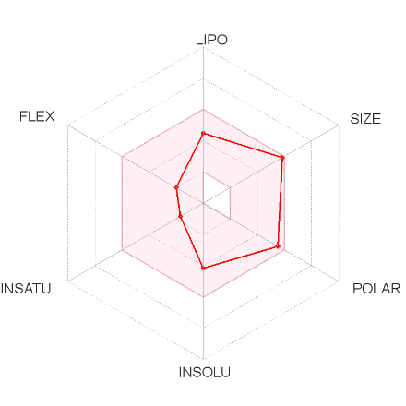
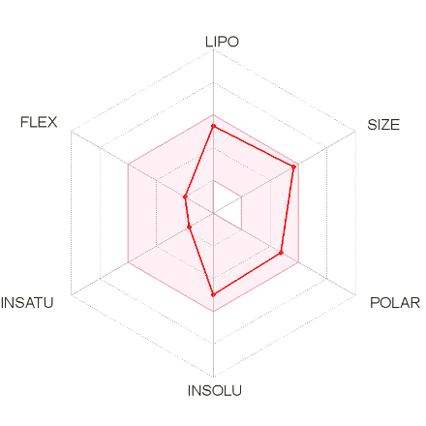
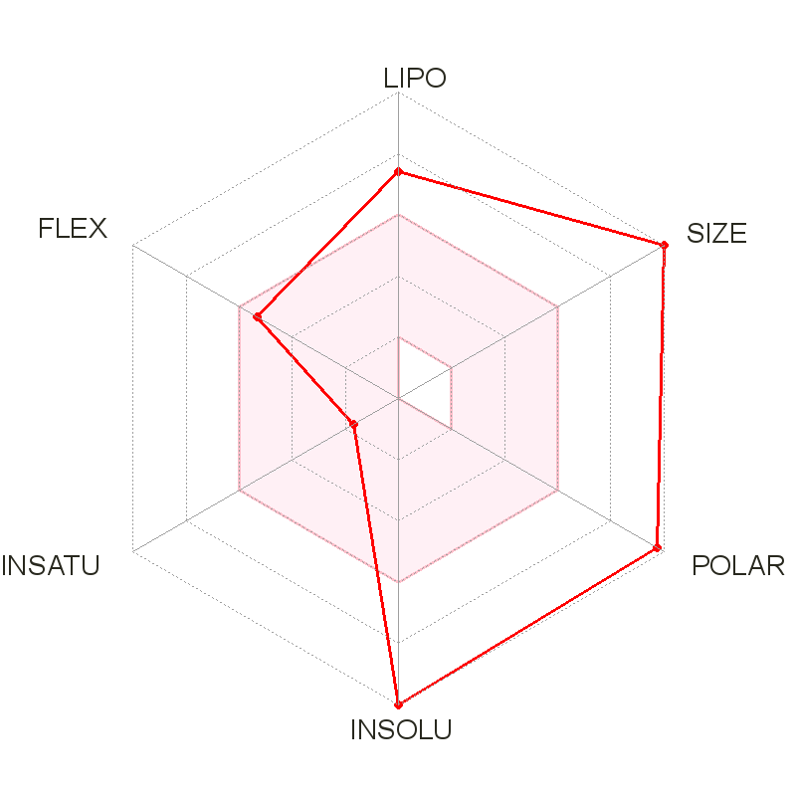
Ashwagandhanolide

