Ayurveda botanicals in COVID-19 management: An in silico- multitarget approach
Swapnil Borse^{1#}, Manali Joshi^{2#$} , Akash Saggam^{1#}, Vedika Bhat^{1#}, Safal Walia², Sneha Sagar³, Preeti Chavan-Gautam^{1*}, Girish Tillu¹
¹AYUSH-Center of Excellence, Center for Complementary and Integrative Health, Interdisciplinary School of Health Sciences, Savitribai Phule Pune University, Pune - 411 007
²Bioinformatics Center, Savitribai Phule Pune University, Pune - 411 007
³Department of Pharmaceutical Chemistry, L.J. Institute of Pharmacy, Sarkhej, Ahmedabad - 382210

#Authors have equal contribution
*Corresponding author: Preeti Chavan-Gautam; E-mail:chavanpriti@gmail.com
$Corresponding author for molecular docking studies: Manali Joshi; E-mail: manali.joshi@gmail.com

Short Title: Ayurvedic Rasayana Botanicals for COVID-19 Management

S1 Table: Structure and Docking details of the phytoconstituents from AS, TC and WS were to the binding site
Ligand | Heavy atoms | Main Protease |  | Spike Glycoprotein (RBD) |  | RNA dependent RNA polymerase
Ligand | Heavy atoms | Docking Score | Ligand efficiency | Docking Score | Ligand efficiency | Docking Score | Ligand efficiency
Asparagamine A | 28 | -7.1 | -0.25 | -5.4 | -0.19 | -6.3 | -0.22
Asparanin A | 52 | -6.3 | -0.12 | -5.8 | -0.11 | -7.5 | -0.14
Isoagatharesinol | 21 | -5.8 | -0.28 | -4.6 | -0.22 | -5.0 | -0.24
Muzanzagenin | 32 | -7.6 | -0.24 | -7.1 | -0.22 | -9.3 | -0.29
Rutin | 43 | -5.3 | -0.12 | -3.3 | -0.08 | -3.6 | -0.08
Shatavarin-I | 74 | -1.1 | -0.01 | -1.7 | -0.02 | -3.3 | -0.04
Shatavarin-IV | 62 | -2.7 | -0.04 | -6 | -0.1 | -6.3 | -0.10
ShatavarinI-X | 63 | -0.6 | -0.01 | -5.4 | -0.09 | -6.7 | -0.11
Shatavarin-VI | 62 | -4.9 | -0.08 | -4.6 | -0.07 | -7.5 | -0.12
ShatavarinVII | 62 | -6.6 | -0.11 | -5.7 | -0.09 | -6.3 | -0.10
ShatavarinX | 66 | -0.4 | -0.01 | -4 | -0.06 | -5.2 | -0.08
20-Hydroxy Ecdysone | 34 | -6.4 | -0.19 | -4.8 | -0.14 | -5.7 | -0.17
Berberine | 25 | -6.3 | -0.25 | -5 | -0.2 | -5.7 | -0.23
Columbamine | 25 | -5.9 | -0.23 | -4.6 | -0.18 | -5.4 | -0.22
Columbin | 26 | -7.9 | -0.30 | -5.8 | -0.22 | -6.8 | -0.26
Magnoflorine | 25 | -7.0 | -0.28 | -5.2 | -0.21 | -6.6 | -0.27
Menisperine | 26 | -6.9 | -0.27 | -5.2 | -0.2 | -6.2 | -0.24
Syringin | 26 | -5.3 | -0.20 | -3 | -0.11 | -4.2 | -0.16
Tinocordiside | 28 | -8.1 | -0.29 | -5.1 | -0.18 | -6.6 | -0.24
Tinosporaside | 35 | -7.9 | -0.23 | -5.7 | -0.16 | -6.6 | -0.19
Tinosporide | 27 | -4.3 | -0.16 | -4.6 | -0.17 | -4.4 | -0.16
12-Deoxywithastramonolide | 34 | -8.1 | -0.24 | -6.9 | -0.2 | -7.9 | -0.23
27-Hydroxywithanone | 35 | -8.6 | -0.25 | -7.6 | -0.22 | -7.6 | -0.22
Ashwagandhanolide | 69 | -9.9 | -0.14 | -10 | -0.14 | -10.2 | -0.15
Withacoagin | 33 | -8.8 | -0.27 | -7.6 | -0.23 | -8.8 | -0.27
Withaferin | 34 | -8.8 | -0.26 | -6.9 | -0.2 | -8.5 | -0.25
WithanolideA | 34 | -8.5 | -0.25 | -6.7 | -0.2 | -8.2 | -0.24
WithanolideB | 33 | -8.3 | -0.25 | -7.4 | -0.22 | -8.9 | -0.27
Withanone | 34 | -8.8 | -0.26 | -7.1 | -0.21 | -8.9 | -0.26
WithanosideIV | 55 | -5.6 | -0.10 | -4.6 | -0.08 | -5.8 | -0.11
WithanosideV | 54 | -6.1 | -0.11 | -5.1 | -0.1 | -6.0 | -0.11

Sr. No | Compound | Structure
1 | Asparagamine A | 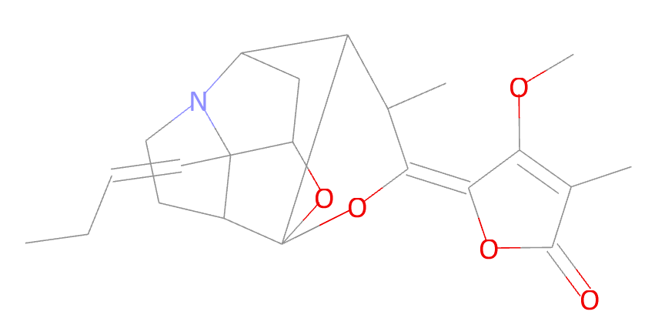
2 | Asparanin A | 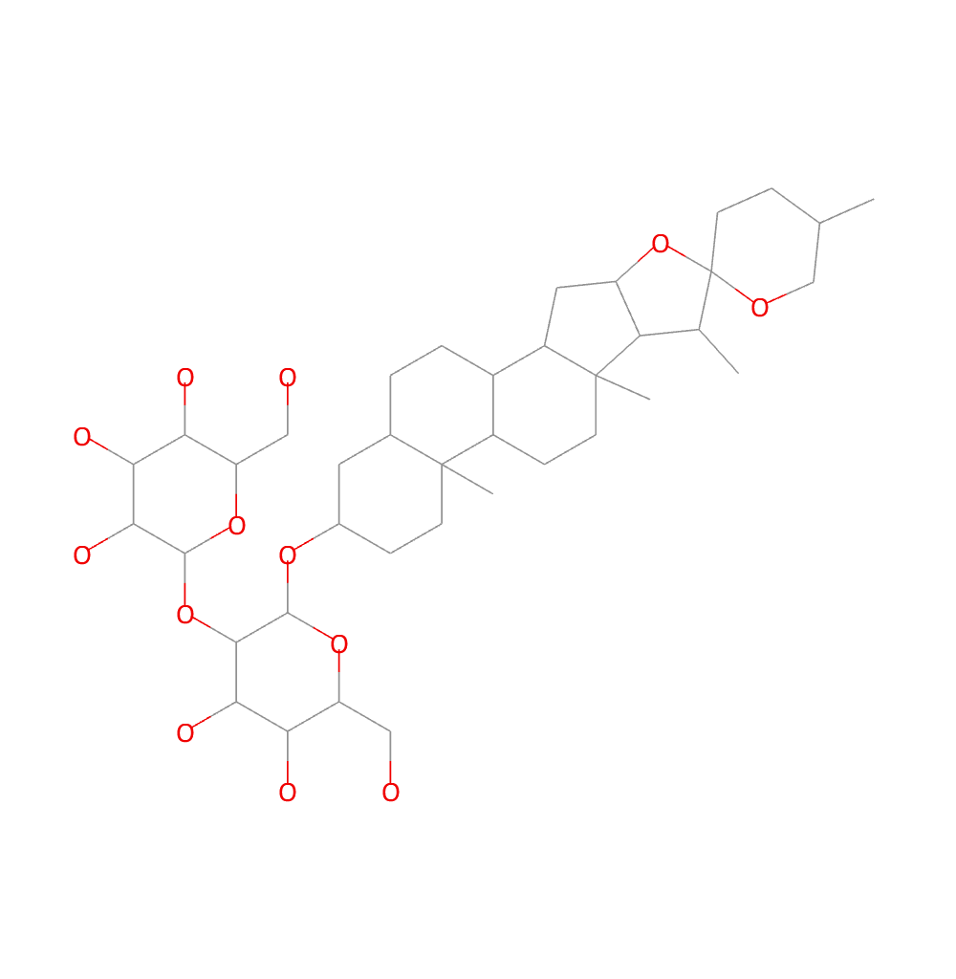
3 | Isoagatharesinol | 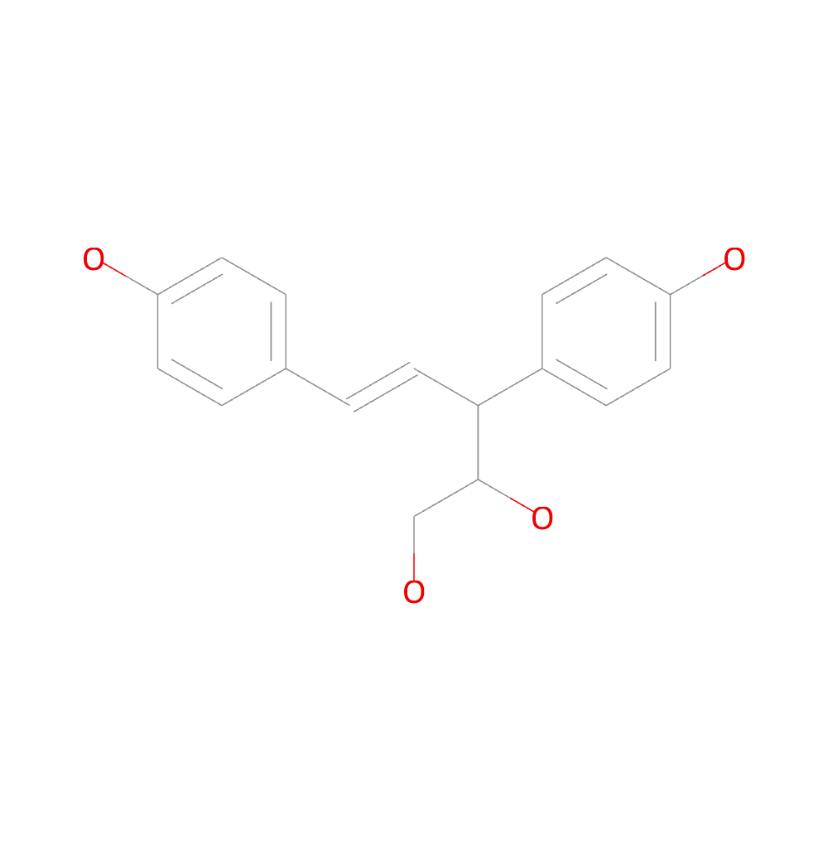
4 | Muzanzagenin | 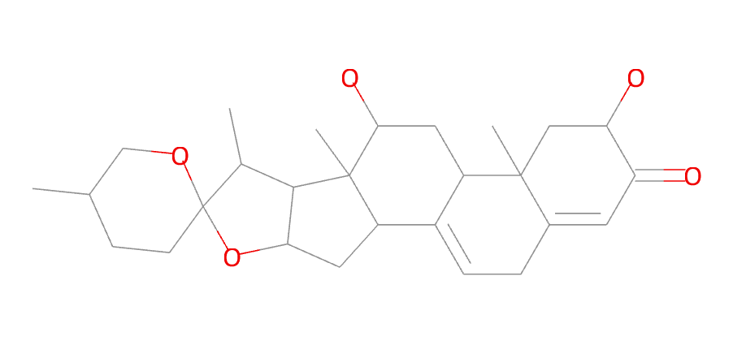
5 | Rutin | 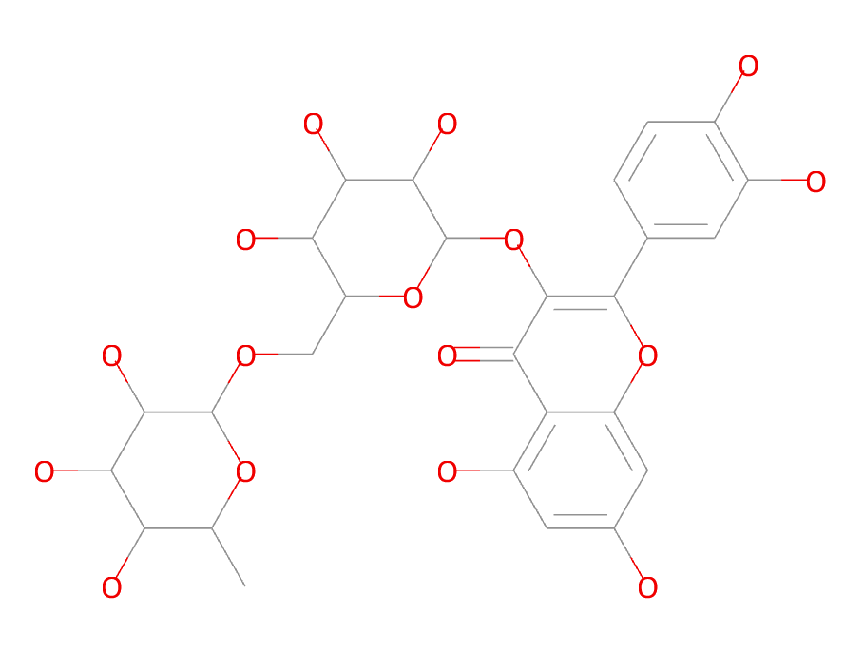
6 | ShatavarinI | 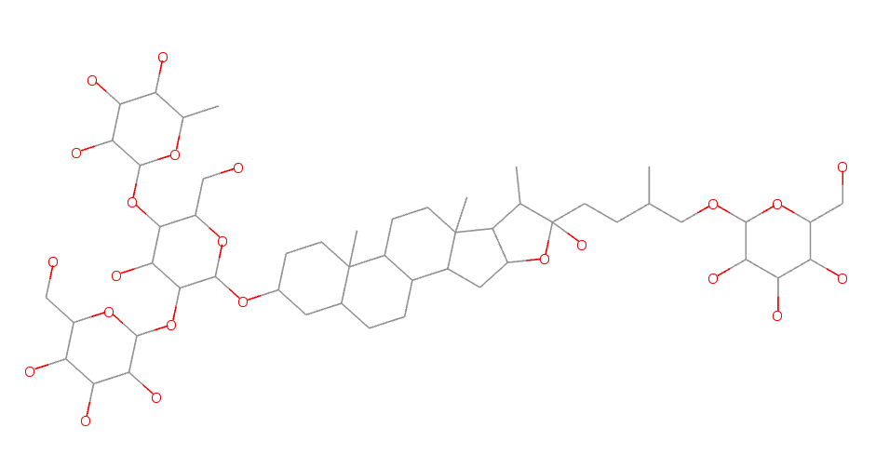
7 | ShatavarinIV | 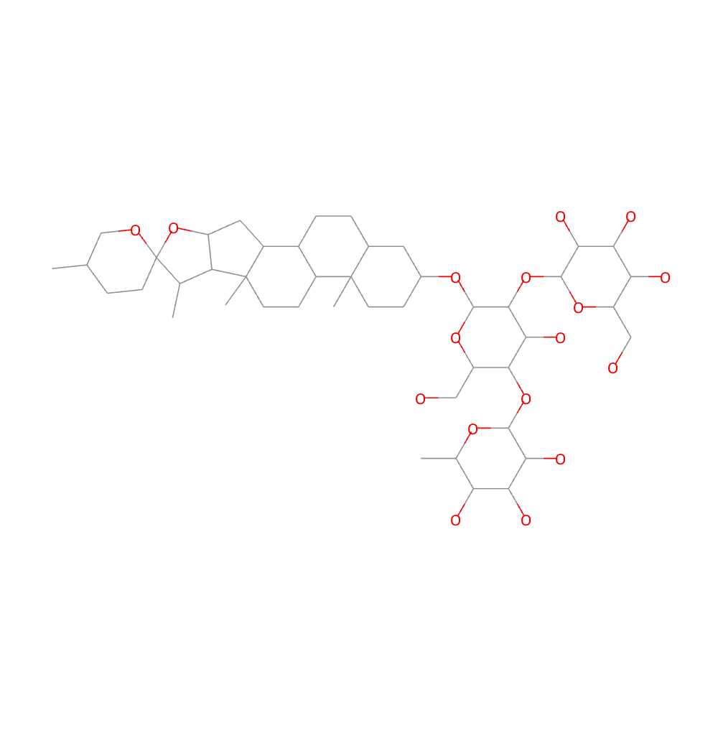
8 | ShatavarinIX | 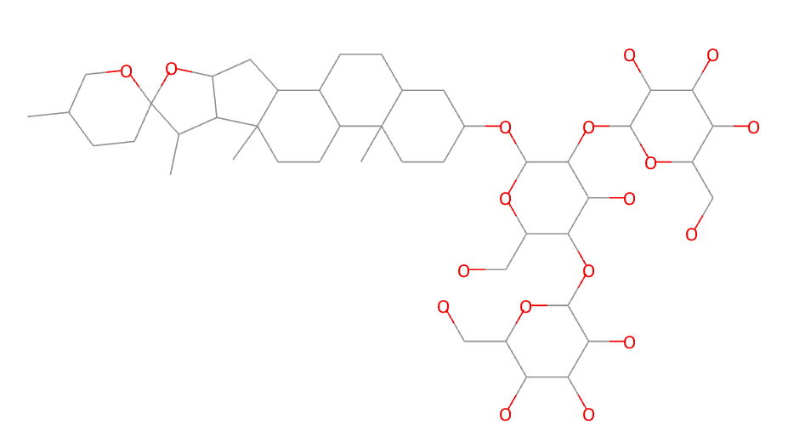
9 | ShatavarinVI
10 | ShatavarinVII | 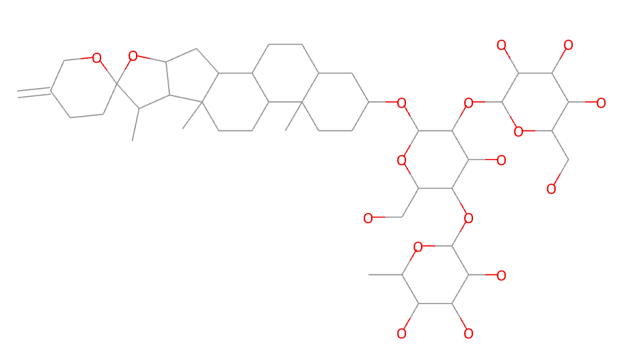
11 | ShatavarinX | 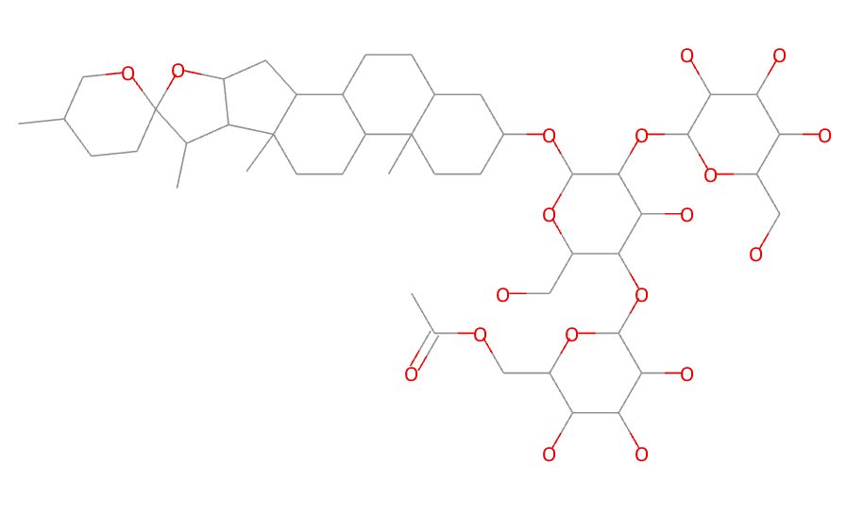
12 | 20-Hydroxy Ecdysone | 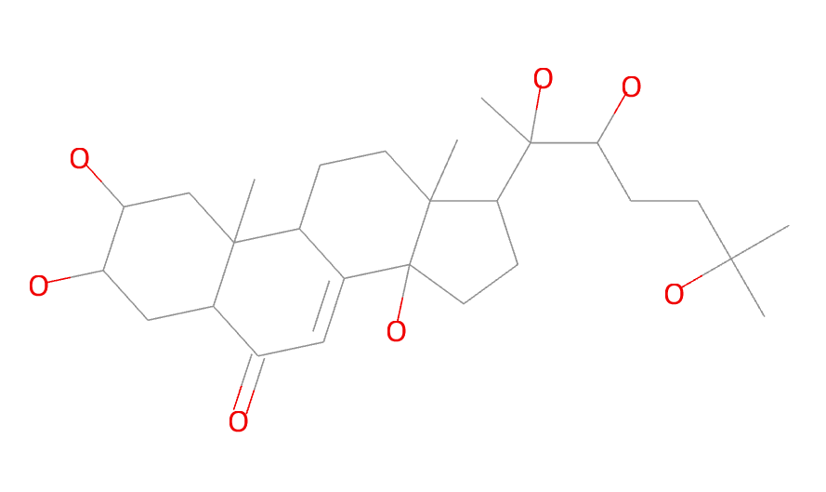
13 | Berberine | 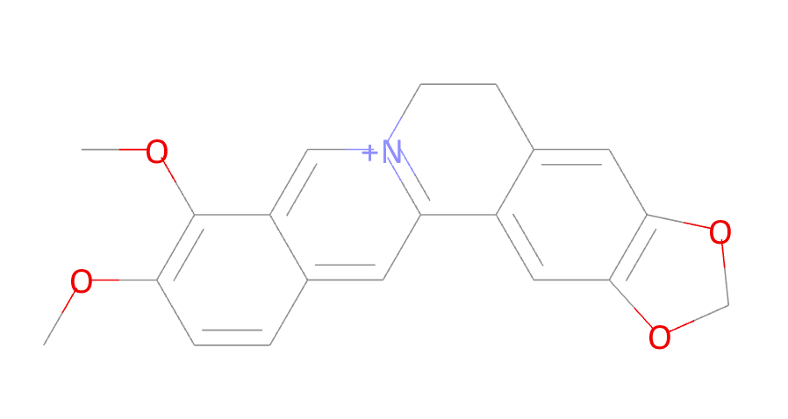
14 | Columbamine | 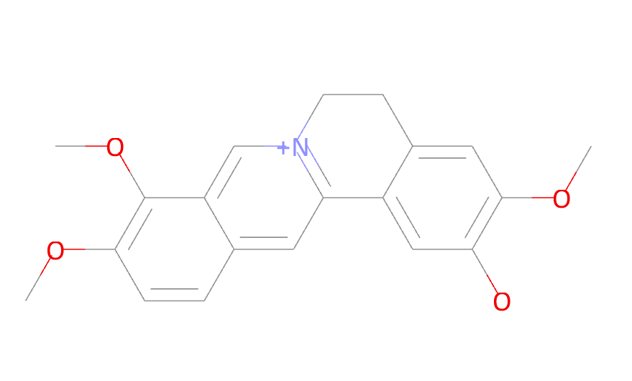
15 | Columbin | 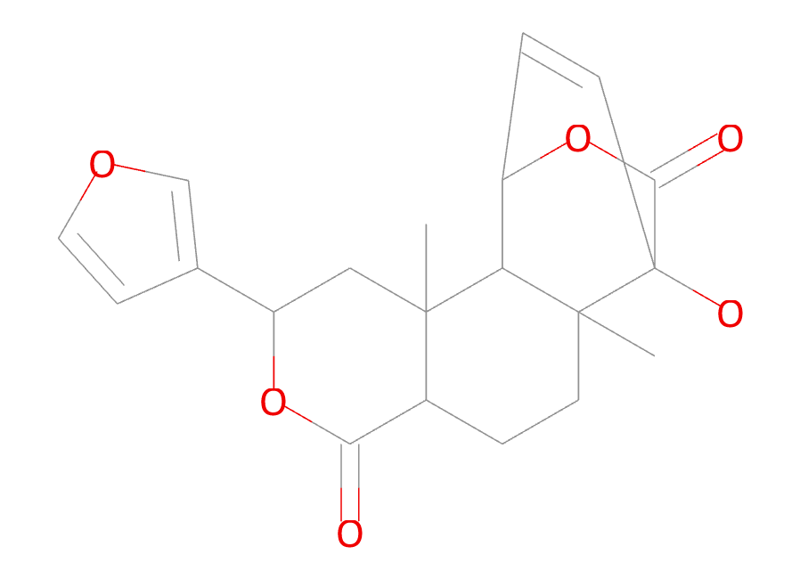
16 | Magnoflorine | 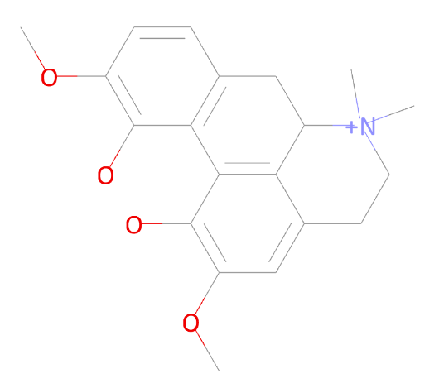
17 | Menisperine | 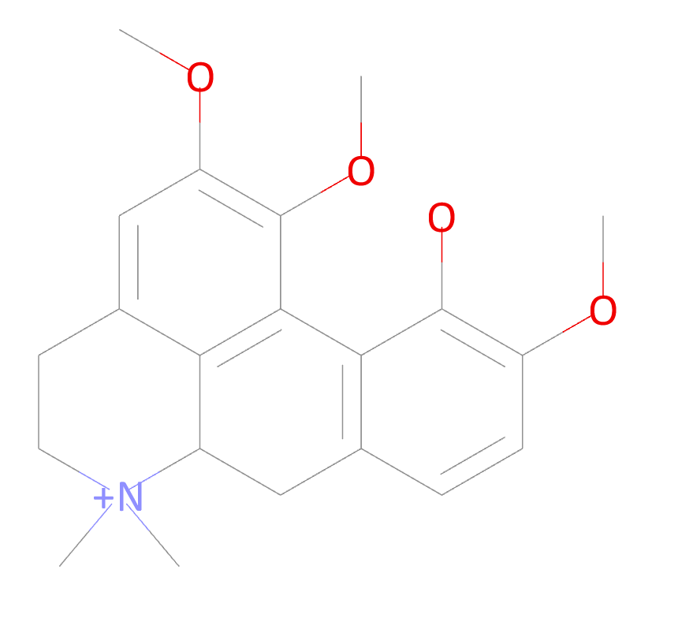
18 | Syringin | 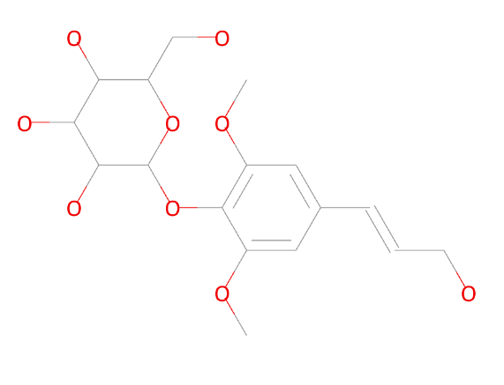
19 | Tinocordiside | 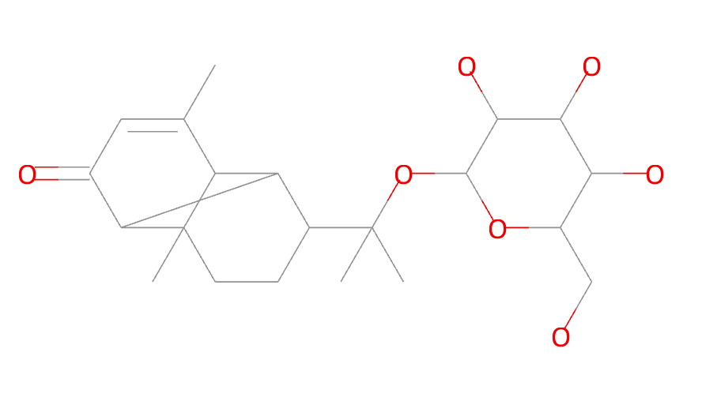
20 | Tinosporaside | 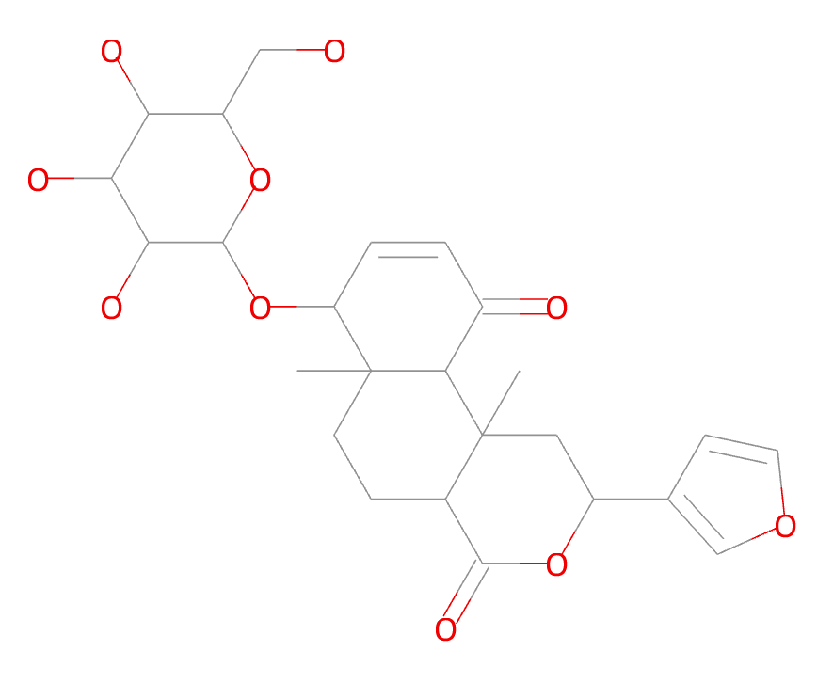
21 | Tinosporide | 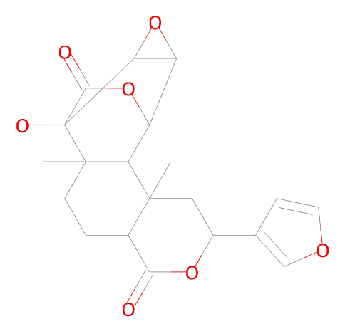
22 | 12-Deoxywithastramonolide | 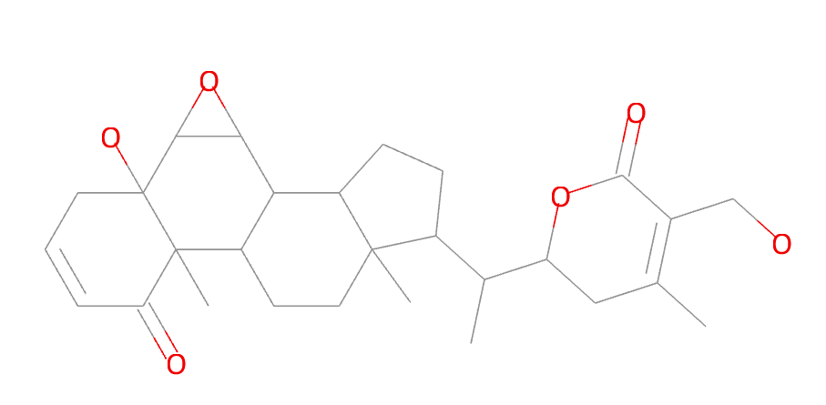
23 | 27-Hydroxywithanone | 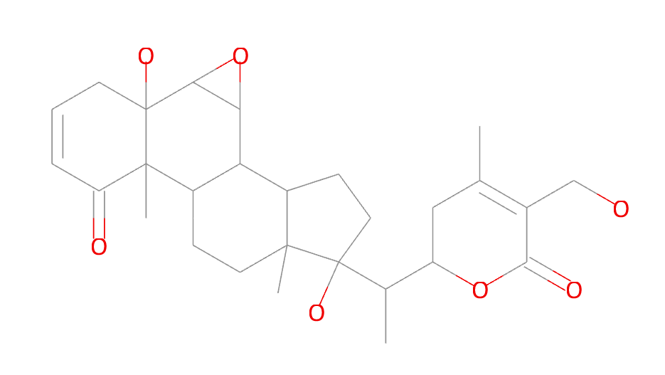
24 | Ashwagandhanolide | 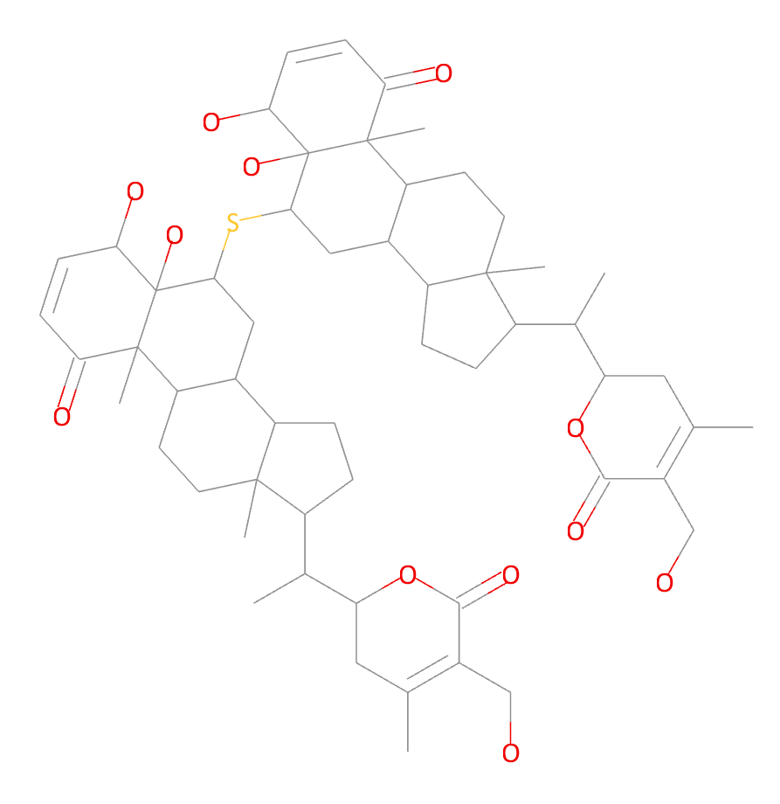
25 | Withacoagin | 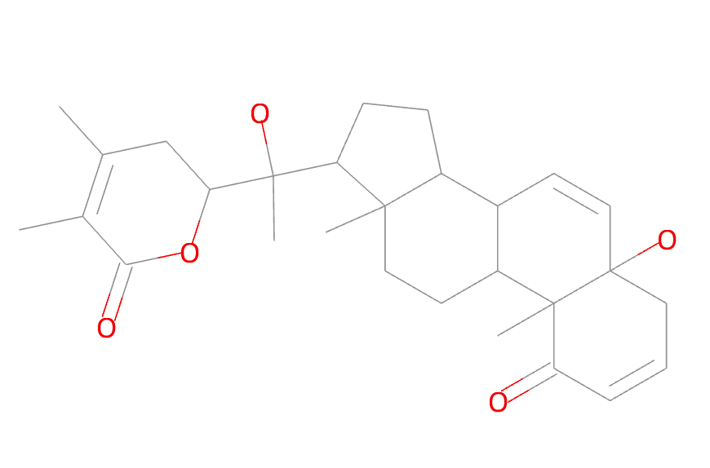
26 | Withaferin | 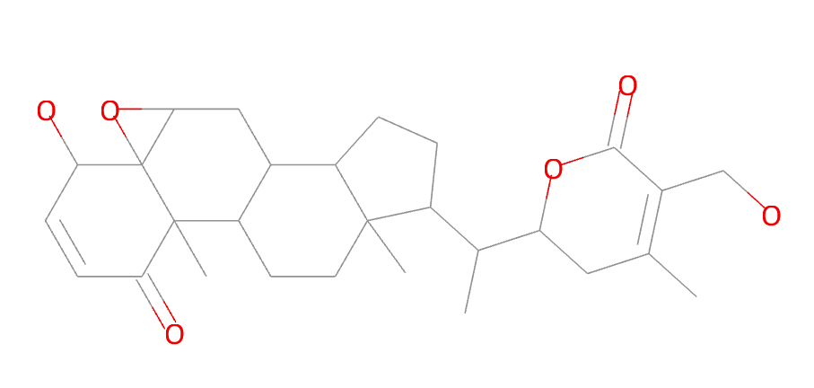
27 | WithanolideA | 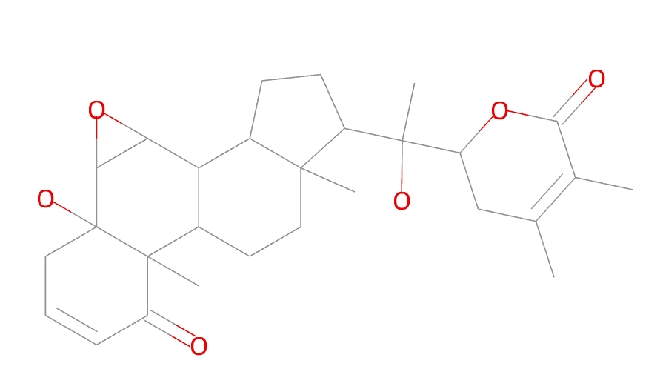
28 | WithanolideB | 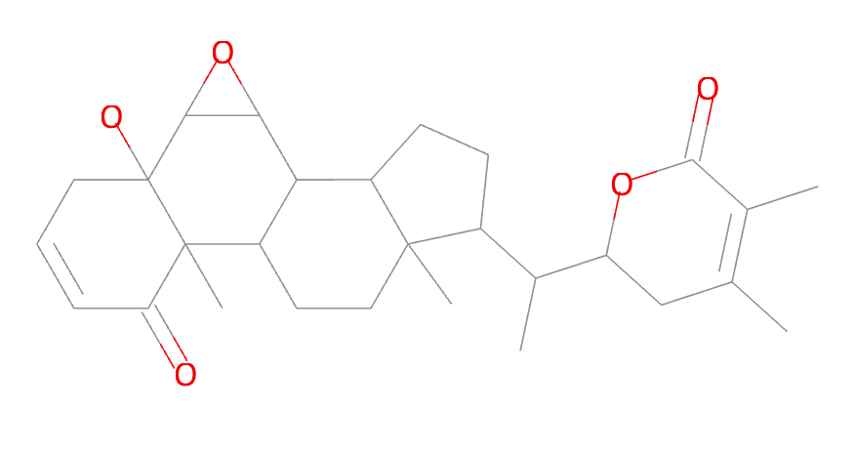
29 | Withanone | 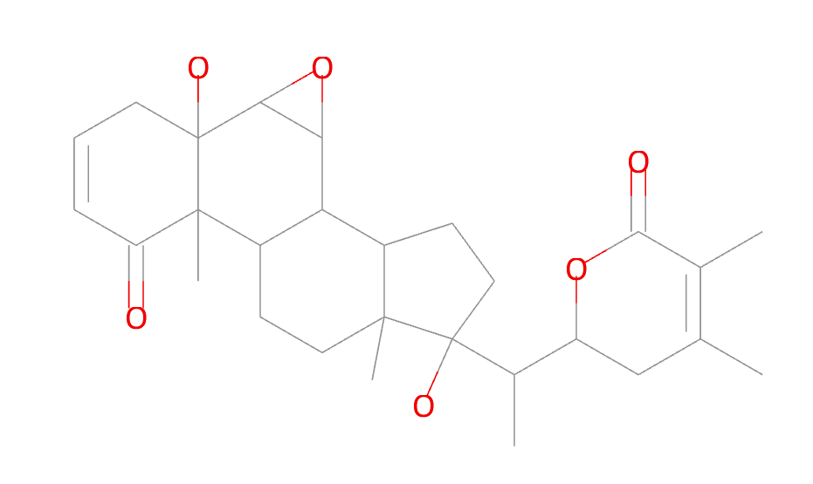
30 | WithanosideIV | 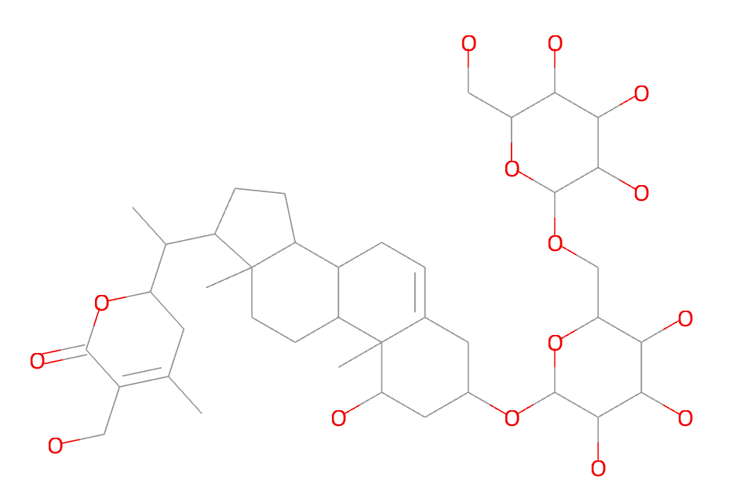
31 | WithanosideV | 