Supplementary Information

Catching the red eye: field evidence that artificial prey with red eye-like markings are preferentially avoided by avian predators

Karl Loeffler-Henry & Thomas N. Sherratt

Figure S1

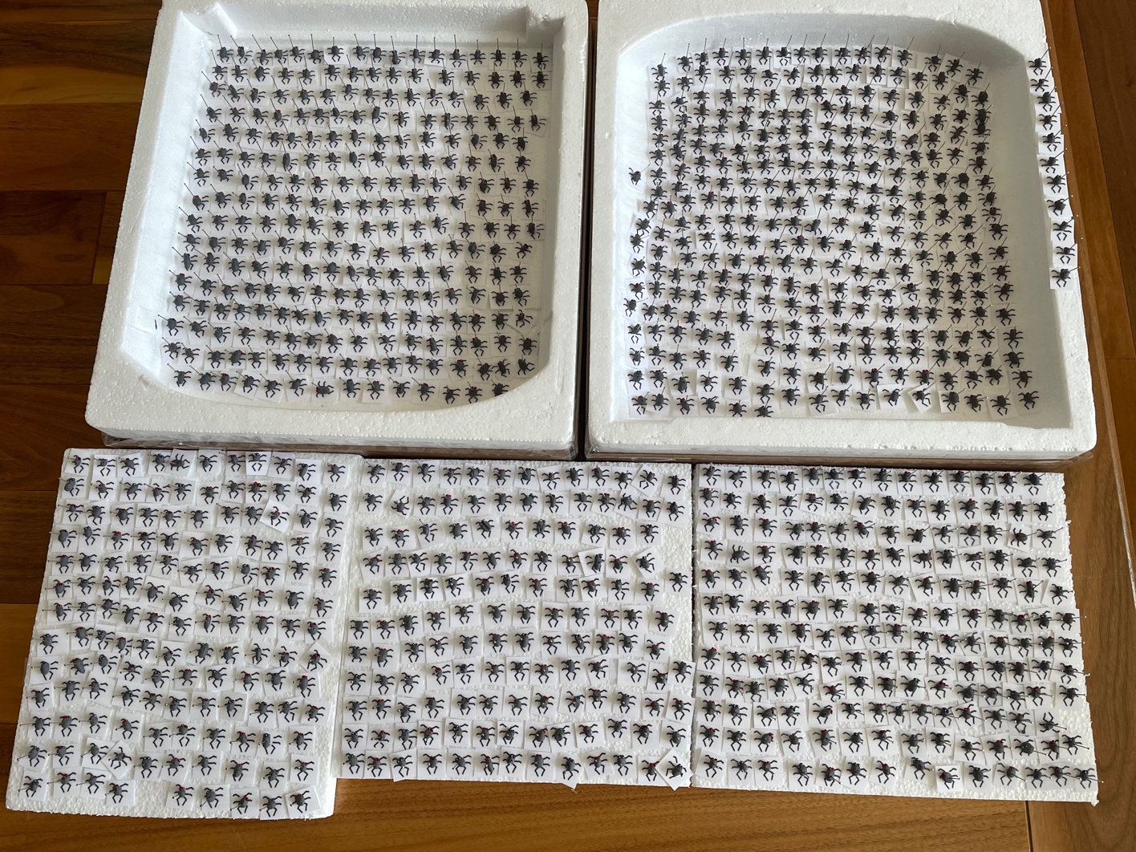

Figure S1. A collection of red-eyed and grey-eyed targets prior to deployment in the field.

Figure S2
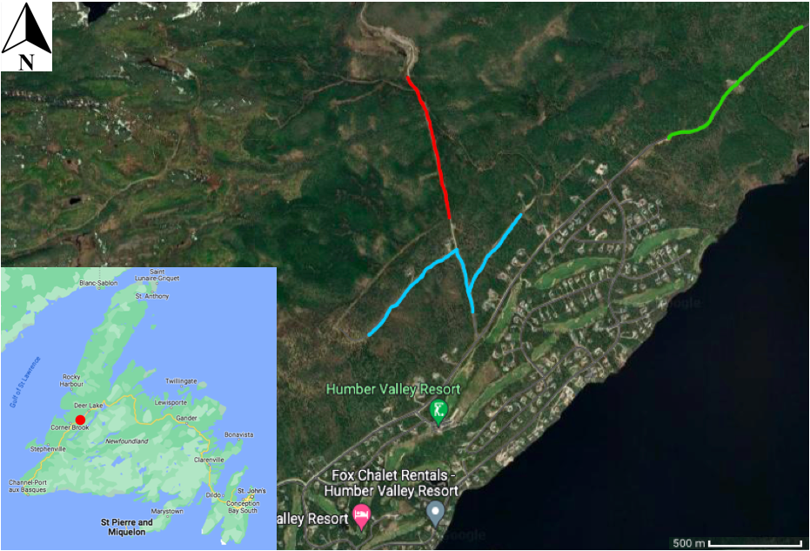
Figure S2. A map of the study site in Newfoundland, Canada showing the locations of the three transects used when deploying plasticine targets. Transect 1 is depicted in blue, transect 2 is depicted in green and transect 3 is depicted in red. Images derived from Google Maps (https://www.google.com/maps/). Accessed: 24th May 2023.

Figure S3a-c

Figure S3a-c. The fate of the 166(7) grey-eyed and 166(7) red-eyed targets over each of the three transects. The graphs show the observed frequency of outcomes along with the estimates of the 95% multinomial confidence intervals derived using the MultinomialCI package (Villacorta 2021).

