Table S1 Details of the study species used in the experiment
Species | Genus | Family | Status | Life history
Hydrocotyle sibthorpioides Lam. | Hydrocotyle | Araliaceae | Native | Perennial
Alternanthera sessilis (L.) R.Br. ex-DC. | Alternanthera | Amaranthaceae | Native | Perennial
Sphagneticola calendulacea (L.) Pruski | Sphagneticola | Compositae | Native | Perennial
Glechoma longituba (Nakai) Kuprian. | Glechoma | Lamiaceae | Native | Perennial
Oxalis corniculata L. | Oxalis | Oxalidaceae | Native | Perennial
Duchesnea indica (Jacks.) Focke | Duchesnea | Rosaceae | Native | Perennial
Hydrocotyle verticillata Thunb. | Hydrocotyle | Araliaceae | Alien | Perennial
Alternanthera philoxeroides (Mart.) Griseb. | Alternanthera | Amaranthaceae | Alien | Perennial
Sphagneticola trilobata (L.) Pruski | Sphagneticola | Compositae | Alien | Perennial
Erigeron annuus (L.) Pers. | Erigeron | Compositae | Alien | Annual
Trifolium repens L. | Trifolium | Fabaceae | Alien | Perennial
Eleusine indica Gaertn. | Eleusine | Poaceae | Alien* | Annual
Paspalum dilatatum Poir. | Paspalum | Poaceae | Alien | Perennial
Ambrosia artemisiifolia L. | Ambrosia | Compositae | Alien | Annual
Amaranthus retroflexus L. | Amaranthus | Amaranthus | Alien | Annual

Status and habitat information is based on the Flora of China (www.efloras.org), on the Scientific Database of China Plant Species (DCP) (http://www.plants.csdb.cn/eflora) and on additional references as cited.
* The original center of the species is East Africa (www.cabidigitallibrary.org).

Table S2 The result of the general linear model testing the effects of different enemy suppression treatments on above-ground biomass and total biomass of the alien target species and the native communities. Significant effects (P < 0.05) are in bold, while marginal significant effects (0.05<P < 0.1) are underlined
Fixed effect |  | Aboveground biomass of alien target species |  | Total biomass of alien target species |  | Aboveground biomass of native communities |  | Total biomass of native communities
Fixed effect | DF | F | P | F | P | F | P | F | P
Nutrient | 1 | 7.058 | 0.009 | 11.290 | 0.001 | 2.095 | 0.150 | 3.605 | 0.060
Without nutrient | 1 | 0.225 | 0.636 | 0.078 | 0.780 | 30.800 | 0.000 | 24.24 | 0.000

Table S3 Linear mixed-effect models testing the effects of the nutrient-availability (without vs with nutrient) and enemy suppression (without vs with enemy suppression) treatments and their interactions on below-ground biomass of the alien target species and the native communities. Significant effects (P < 0.05) are in bold, while marginal significant effects (0.05<P < 0.1) are underlined.
Explanatory variables  (Fixed and random effects) |  | Below-ground biomass of alien target species  (natural-log-transformed) |  | Below-ground biomass of native communities (natural-log-transformed)
Explanatory variables  (Fixed and random effects) | Df | χ2 | P | χ2 | P
Nutrient availability (N) | 1 | 33.060 | 0.000 | 209.594 | 0.000
Enemy suppression (ES) | 1 | 4.704 | 0.030 | 0.860 | 0.354
N × ES | 1 | 3.171 | 0.075 | 5.548 | 0.019
Random effects |  | SD | SD | SD
Family |  | 0.100 | ＜0.000 | ＜0.000
Species |  | 0.164 | 0.278 | 0.278
Residual |  | 0.161 | 0.664 | 0.664
R² of the model |  | Marginal | Conditional | Marginal | Conditional
R² of the model |  | 0.112 | 0.633 | 0.518 | 0.590
* Standard deviations for individual alien species random effects for the saturated model are found in Table S4.

Table S4 Standard deviation of individual species random effects for the metrics analyzed with Gaussian error distribution models. The standard deviations given refer to the first species respectively. For each species, these should be multiplied by the multiplication factors. The names of the species in the table are abbreviated using the first letter of the genus and species epithet
Metric | Multiplication factor standard deviation
Metric | AP | AR | ST | AA | EA | TR | EI | PD | HV
Below-ground biomass of alien target species | 1.000 | 1.786 | 0.925 | 1.589 | 2.317 | 1.045 | 1.193 | 1.476 | 0.655
Above-ground biomass of alien target species | - | - | - | - | - | - | - | - | -
Total biomass of alien target species | - | - | - | - | - | - | - | - | -
Below-ground biomass of native communities | - | - | - | - | - | - | - | - | -
Above-ground biomass of native communities | 1.000 | 1.803 | 1.275 | 1.146 | 1.916 | 1.125 | 1.071 | 1.278 | 1.389
Total biomass of native communities | 1.000 | 1.849 | 1.340 | 1.277 | 1.789 | 1.194 | 1.133 | 1.307 | 1.493
Biomass proportion of the alien target species | 1.000 | 1.861 | 0.963 | 0.772 | 1.533 | 1.345 | 1.420 | 1.114 | 1.296
Biomass proportion of native communities | 1.000 | 1.864 | 0.964 | 0.773 | 1.531 | 1.346 | 1.419 | 1.114 | 1.296
Root-shoot ratio of the alien target species | 1.000 | 1.815 | 0.919 | 2.105 | 2.525 | 1.867 | 1.818 | 1.391 | 0.890
Root-shoot ratio of native communities | - | - | - | - | - | - | - | - | -
The evenness of native communities | - | - | - | - | - | - | - | - | -

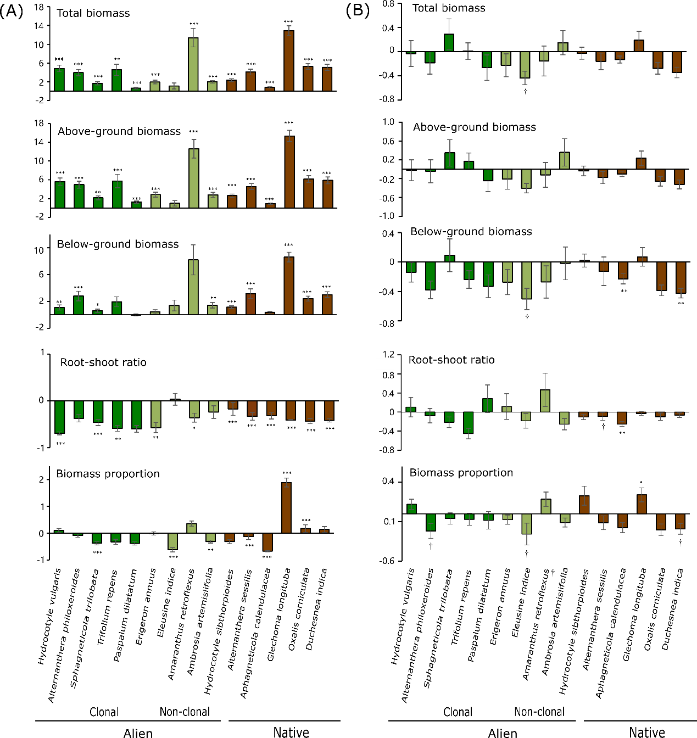
Fig. S1 Relative nutrient addition (A) and enemy suppression (B) responses for total biomass, above-ground biomass, below-ground biomass, root: shoot (R: S) ratios, and biomass proportion for each native and alien target species. Bars represent means ±SE. Asterisks above bars for each species indicate a significant enemy suppression and nutrient addition response from t-tests comparing trait values: *, 0.05＞P ＞0.1; **, P < 0.05; ***, P < 0.01.

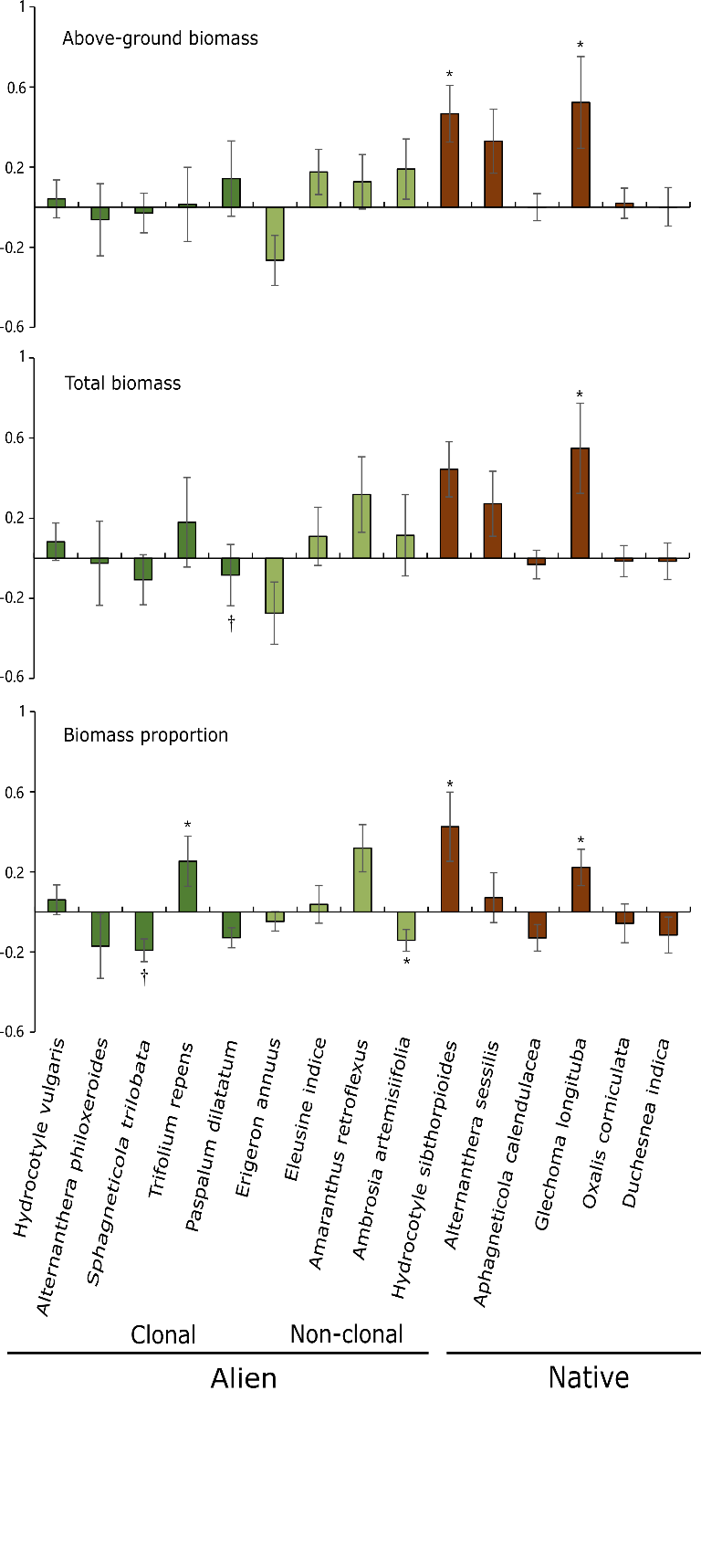
Fig. S2 Relative enemy suppression responses for total biomass, above-ground biomass, and biomass proportion for each native and alien target species under without nutrient addition. Bars represent means ±SE. Asterisks above bars for each species indicate a significant enemy suppression and nutrient addition response from t-tests comparing trait values: *, 0.05＞P ＞0.1; **, P < 0.05; ***, P < 0.01.
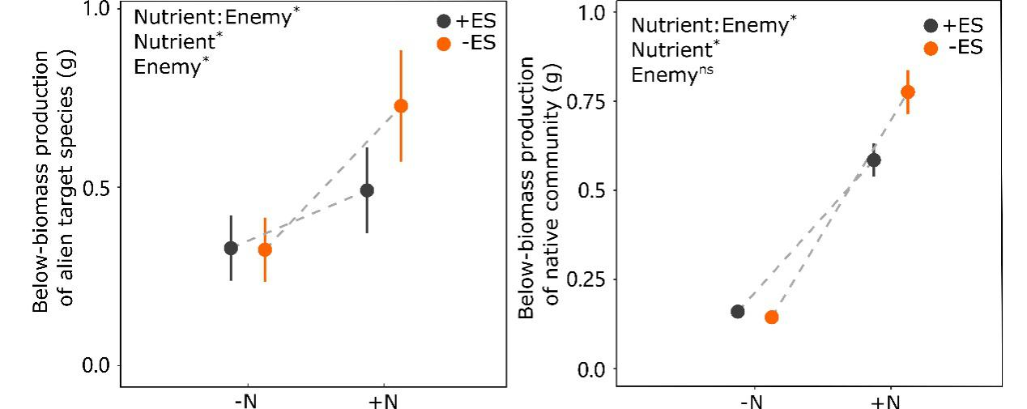
Fig. S3 Effects of nutrient addition (without vs. with), enemy suppression (with vs. without) and their interaction on below-ground biomass for alien target species and native community

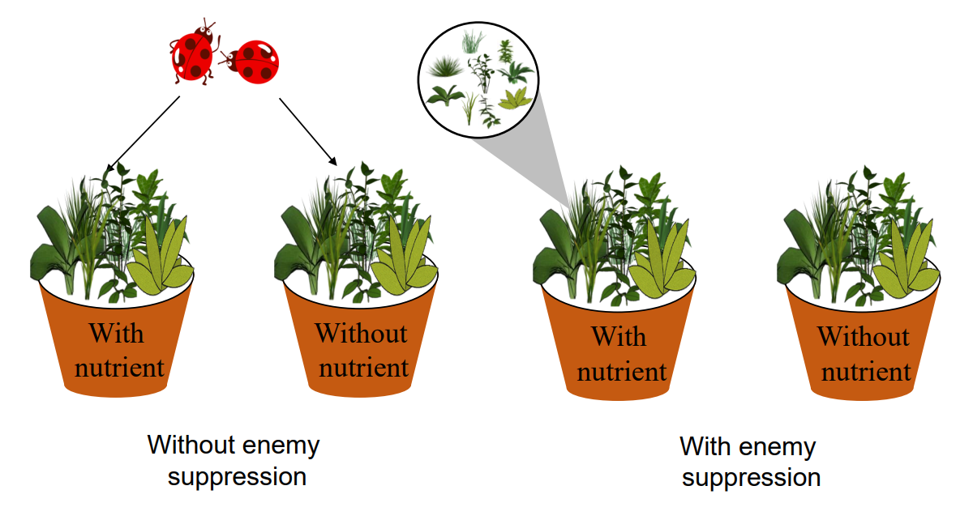
Fig. S4 Graphical illustration of the experimental design. The panel shows an overview of the nutrient addition treatment, enemy suppression treatment and the locations of the alien target species and native community plants in the pots.

