Supplementary Figure 1. Correlation between the latitude of the last received location and the date of last transmission for each bird (n=9).

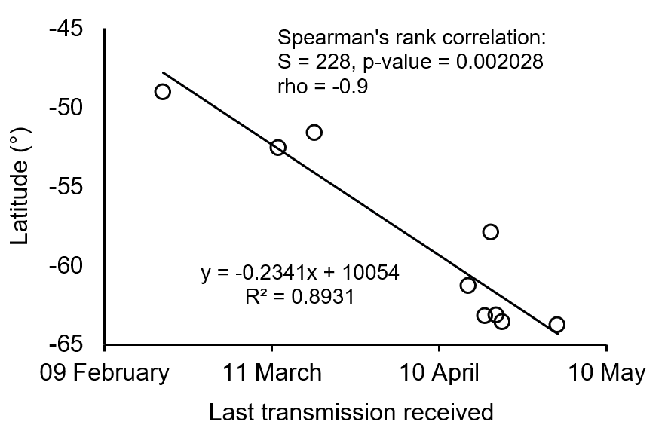

Supplementary Figure 2. Examples of a significant changepoint detected in the fledglings’ at-sea dispersal. Upper panel: log-likelihood for the existence of a change point; lower panel: relative distance of each location from the colony (grey thick line), with beta regression fitted (dashed black curve) and the change point inferred (vertical red dashed line).
(a) bird tagged # 167967, showing a first changepoint at time step 165 (95% confidence interval = 30), i.e. 20 February 2018 01:38:25.
(b) bird tagged # 167969, showing a second changepoint at time step 1284 (95% confidence interval = 58), i.e. 05 April 2018 17:21:50.
