Supplementary Figures:

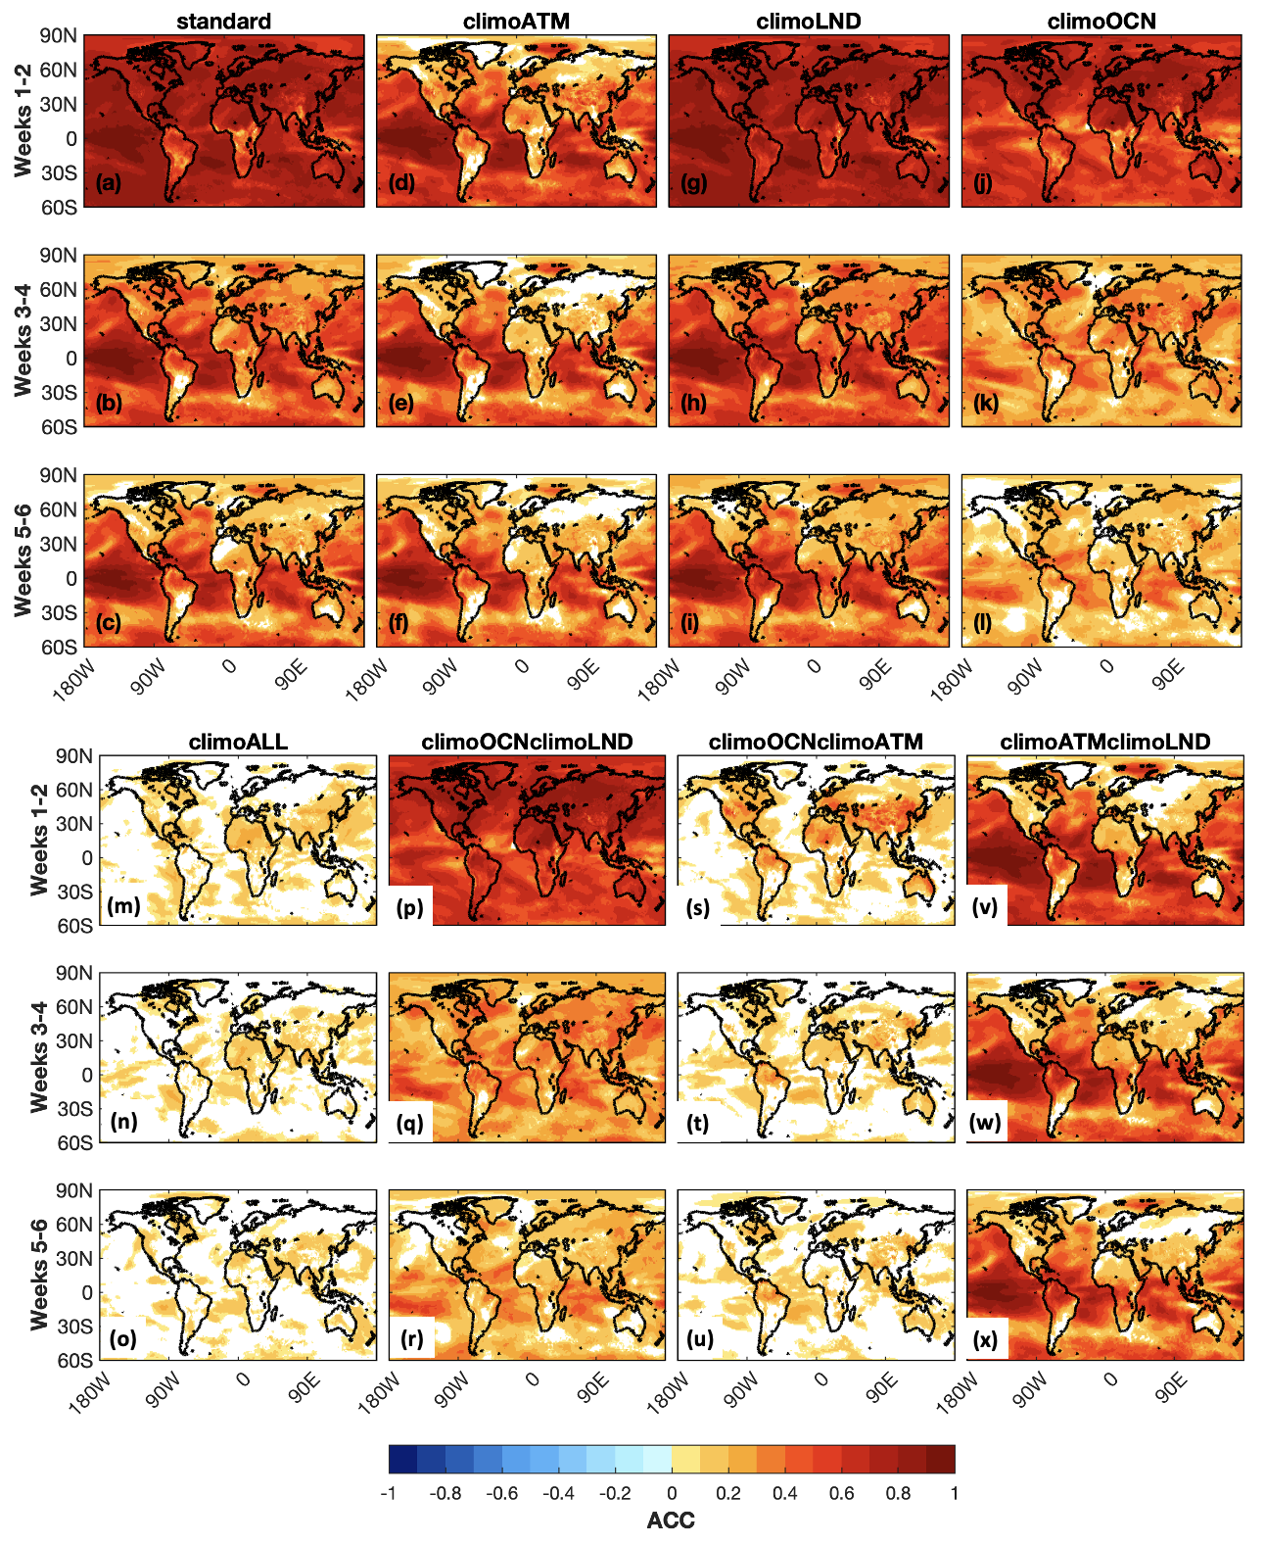
Figure S1: Same as Figure 2 but for DJF.

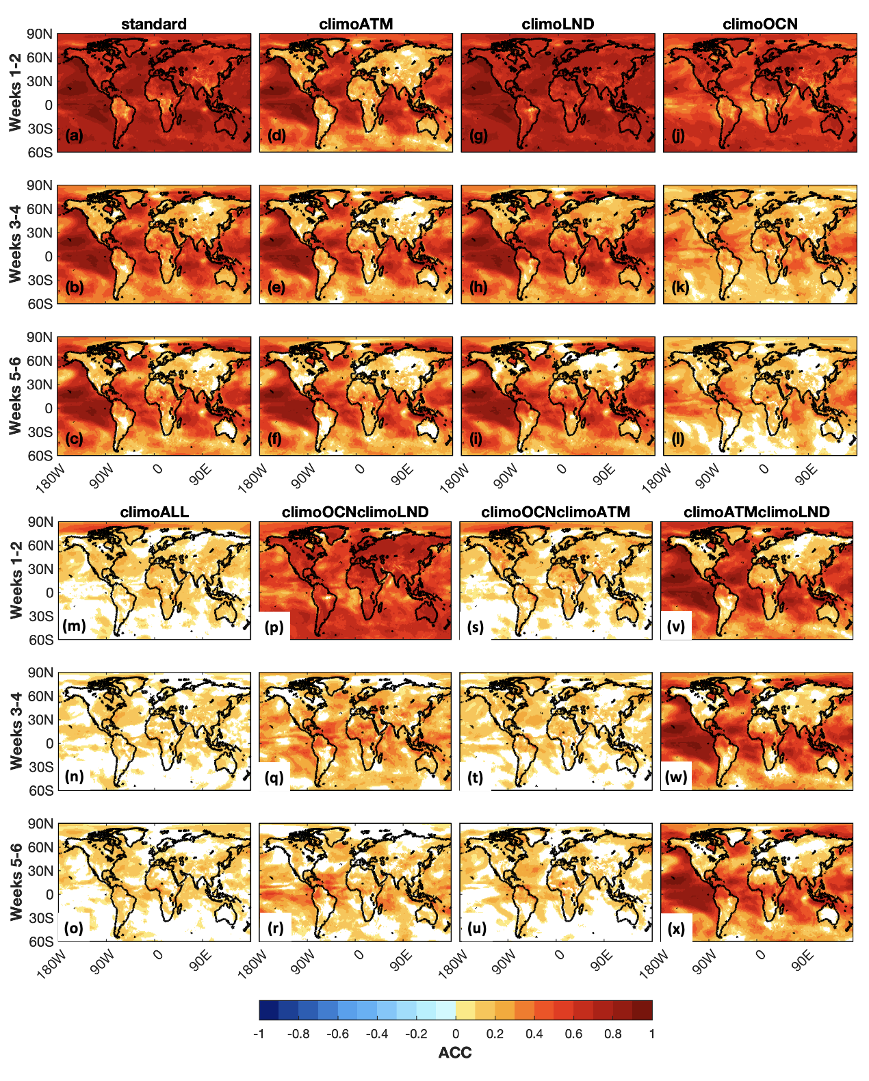
Figure S2: Same as Figure 2 but for JJA.

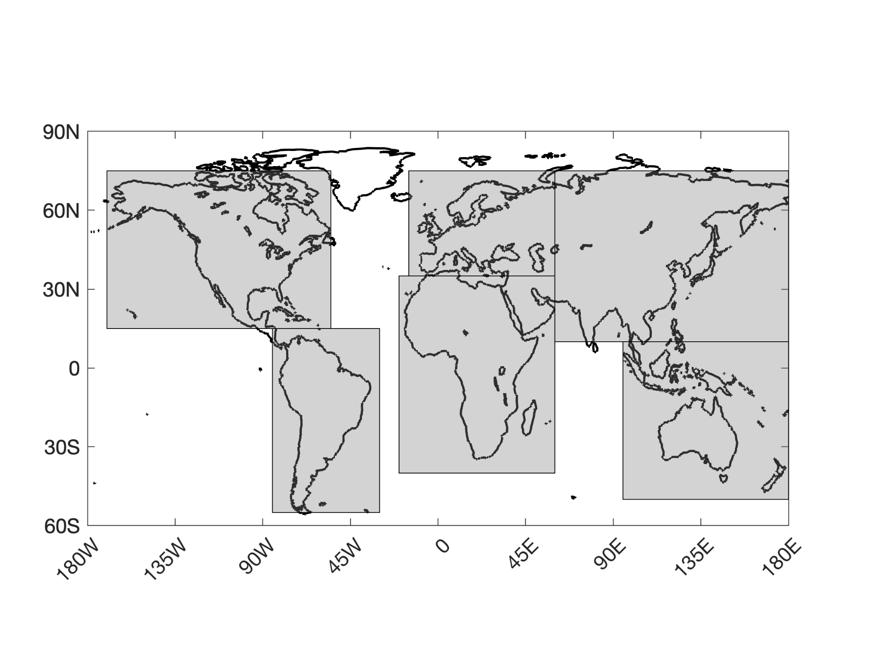
Figure S3: Regions over which ACC is calculated in Figure 4: North America (170ºW-55ºW, 15ºN-75ºN), South America (85ºW-30ºW, 55ºS-15ºN), Europe(15ºW-60ºE, 35ºN-75ºN), Africa (20ºW-60ºE, 40ºS-35ºN), Asia (60ºE-180ºE, 10ºN-75ºN), and SE Asia/Australia (95ºE-180ºE, 50ºS-10ºN). Note that ACC is only calculated over land regions in the depicted rectangles. The North American boundary follows that used by previous studies (Pegion et al. 2019).

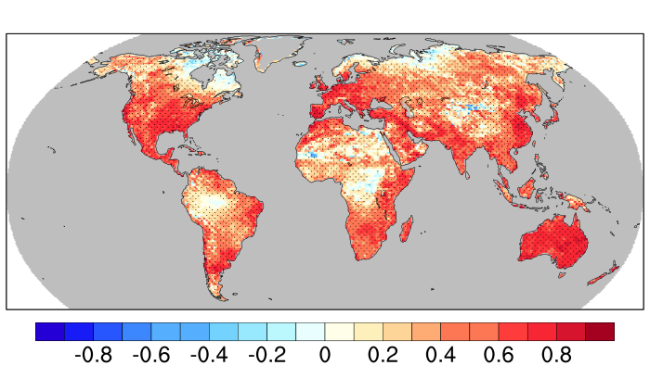

Figure S4: Land soil moisture (root zone) anomaly correlations for ERA5 and CLM5 from 1999 to 2021. Anomalies were calculated by removing a daily smoothed climatology. Stippling shows where the correlation is significant at the 99% confidence level.

