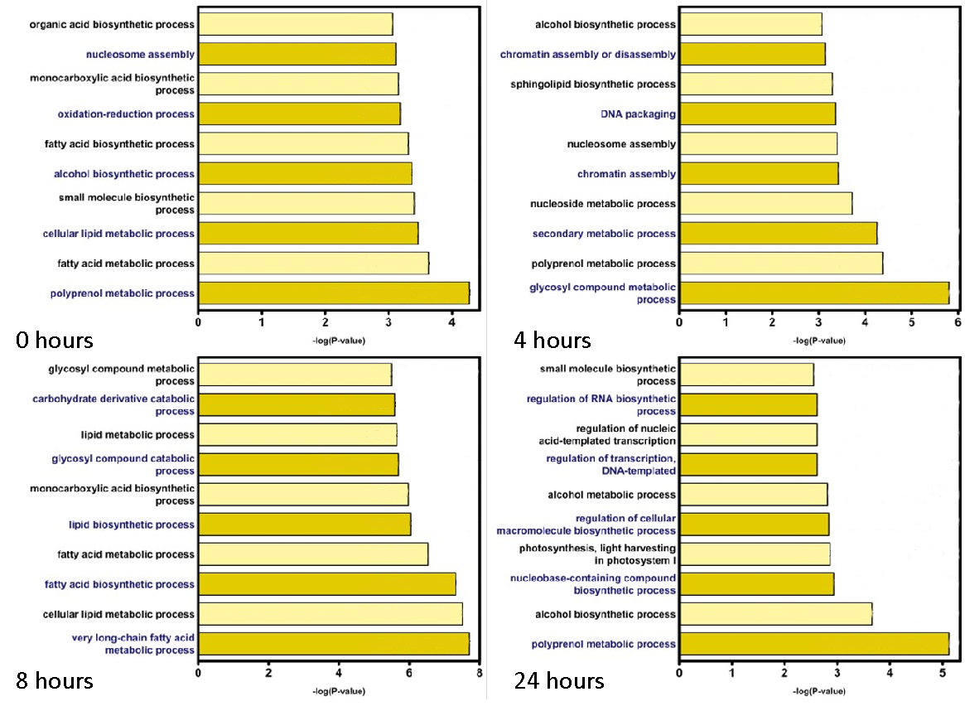
Supplementary Figure 2. Pathway and metabolic process enrichment analysis inferred from the transcriptome profiles of dark sampled timepoints during the perturbation study. Process ontology was inferred based on the nearest BLAST match to Arabidopsis orthologs (Identity ≥ 30%, Evalue ≤ 1E-03).

