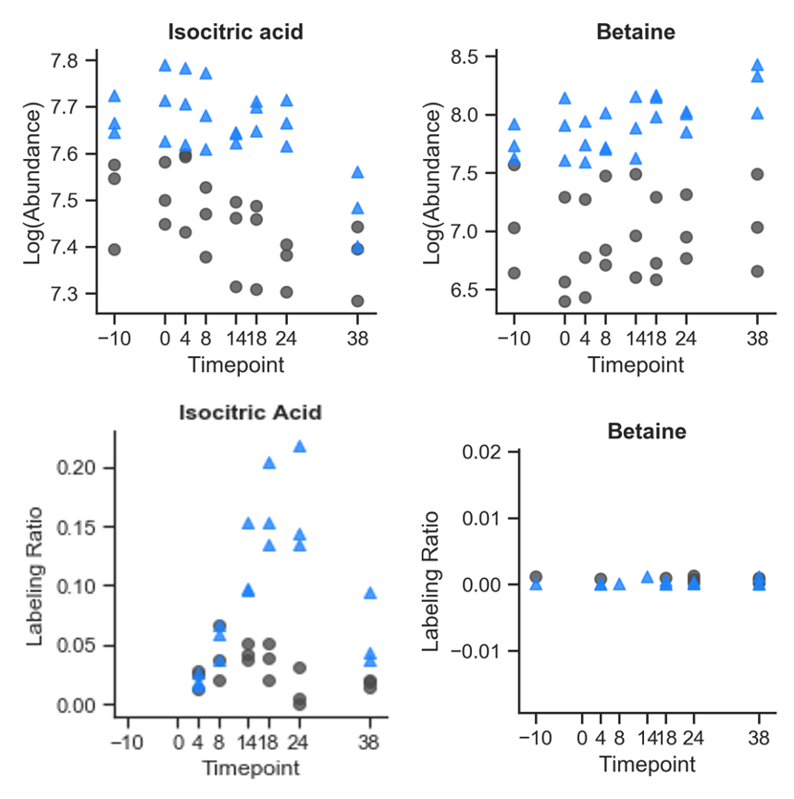
Supplementary Figure 3. D2O labeling ratios and abundance for isocitrate and betaine. D2O was added at the 0h timepoint immediately after sampling.

