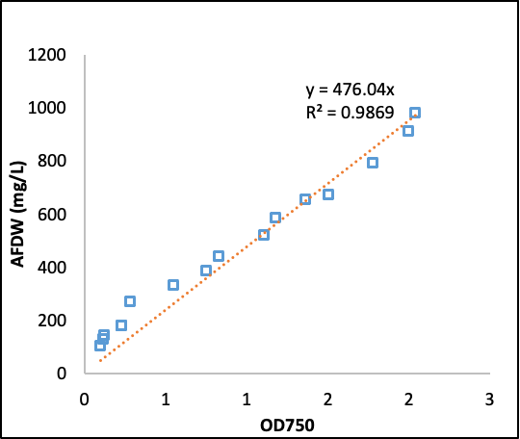
Supplementary Figure 1. Correlation of ash-free dry weight and optical density Scenedesmus obliquus UTEX393.

