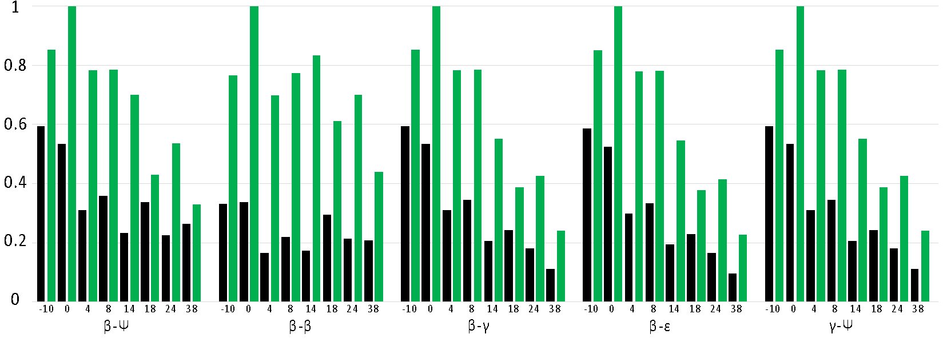
Supplementary Figure 4. Relative abundance of all metabolites identified within the 5 major classes of carotenes (Black = 15ppt, green = 5ppt, peaks scaled to the highest abundance in each lipid subtype). All values are scaled to the highest summed peak height value.

