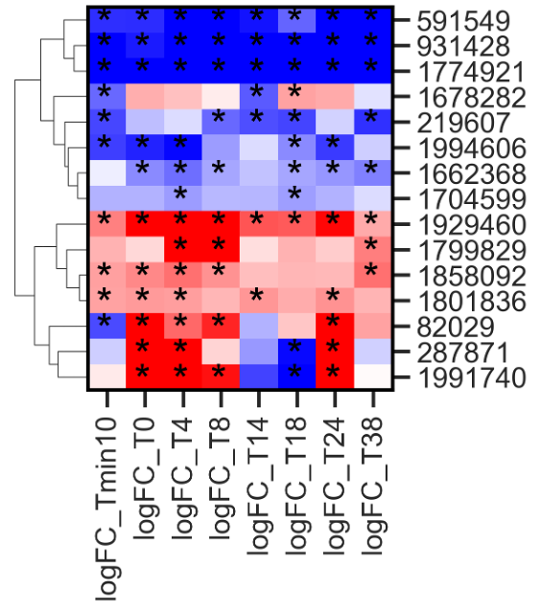
Supplementary Figure 5. Heatmap of differentially expressed transcription factors selected for DAP-seq analysis.

