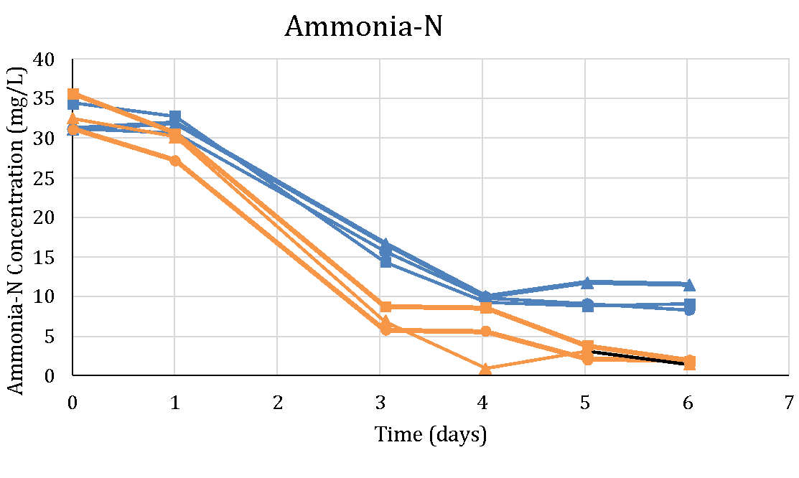
Supplementary Figure 6. Total media nitrogen (Ammonia-N) during the experimental time course. (Blue line = 15 ppt salt, Orange lines = 5 ppt salt)

