Supplementary data
Table 4: Comparison of viscoelastic moduli for individual samples
Sample | G' [Pa] | G'' [Pa] | Linear viscoelastic region |  | Cross over |  | Average G' /G''
Sample | G' [Pa] | G'' [Pa] | G' [Pa] | G'' [Pa] | G' = G" [Pa] | Deformation amplitude [%] | Average G' /G''
PVA | 2123,39 | 157,14 | 1564,01 | 297,01 | 530,73 | 799 | 13,51
PVA/SA | 4813,82 | 524,80 | 2094,71 | 663,72 | 642,33 | 252,26 | 9,17
1-LEC | 5454,18 | 526,45 | 2302,38 | 748,89 | 512,76 | 350,27 | 10,36
2-LEC | 6579,73 | 808,48 | 1543,25 | 855,93 | 122,53 | 1015,12 | 8,14
3-LEC | 6659,22 | 744,64 | 1543,25 | 803,77 | 206,46 | 918,99 | 8,94

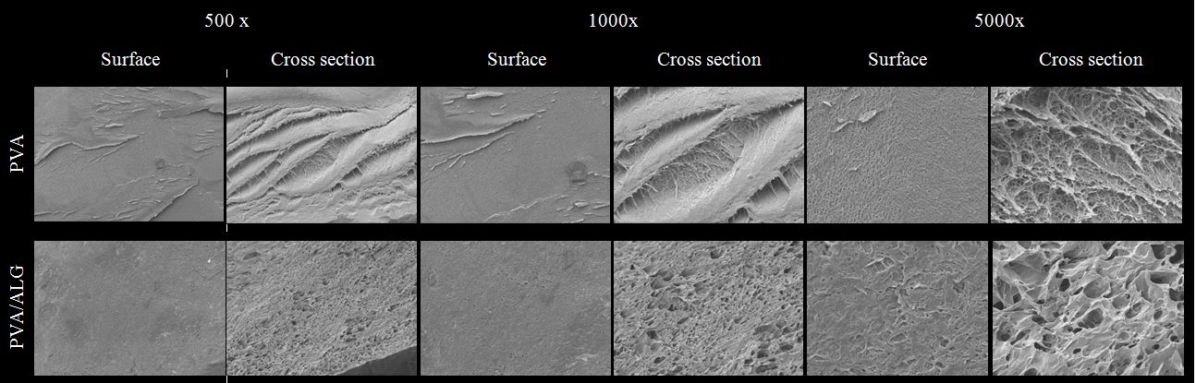
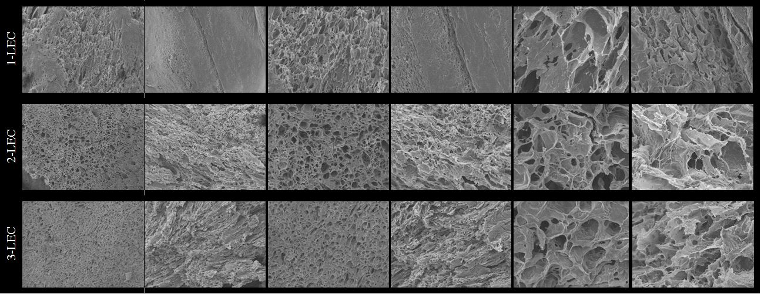
Figure 9: Scanning electron microscope images

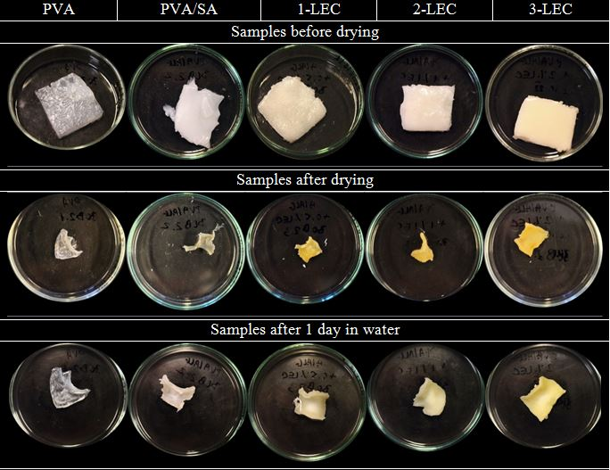
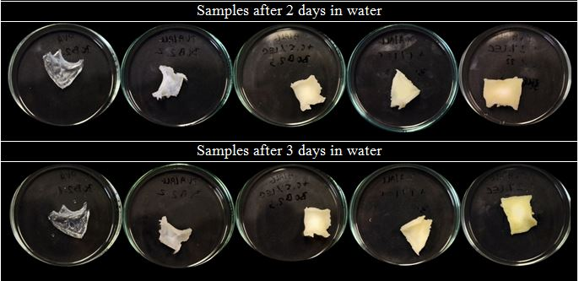
Figure 10: Illustration of the gradual swelling of gel systems
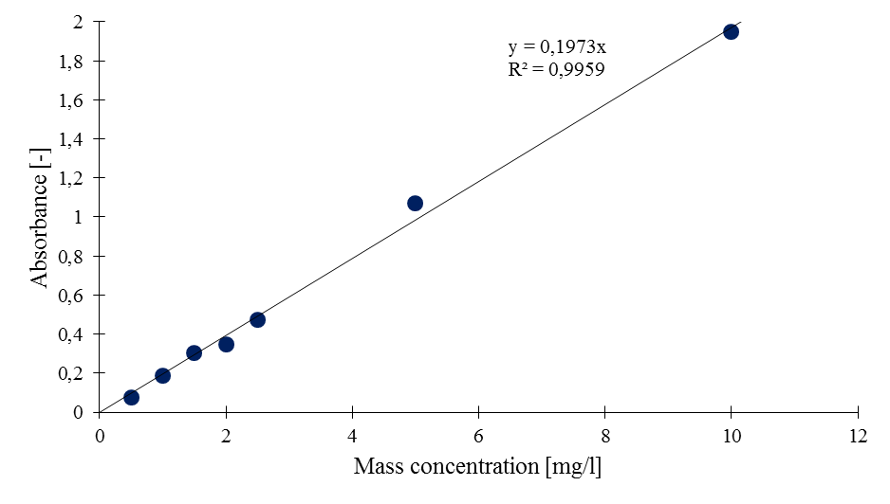
Figure 11: Calibration curve for methylene blue
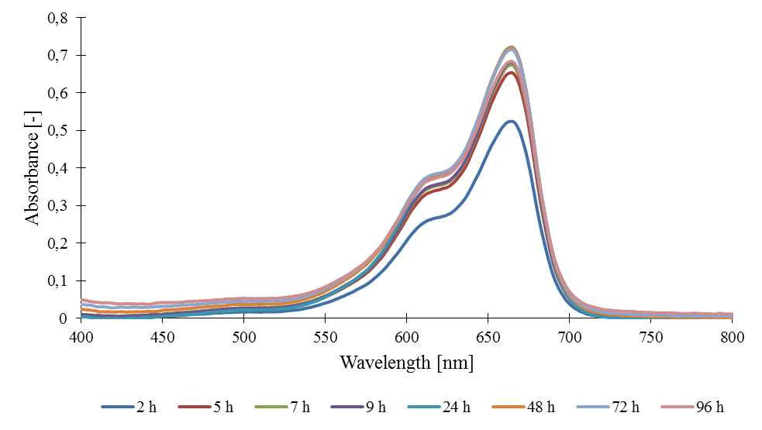
Figure 12: Absorption spectrum for methylene blue release from PVA hydrogel matrix

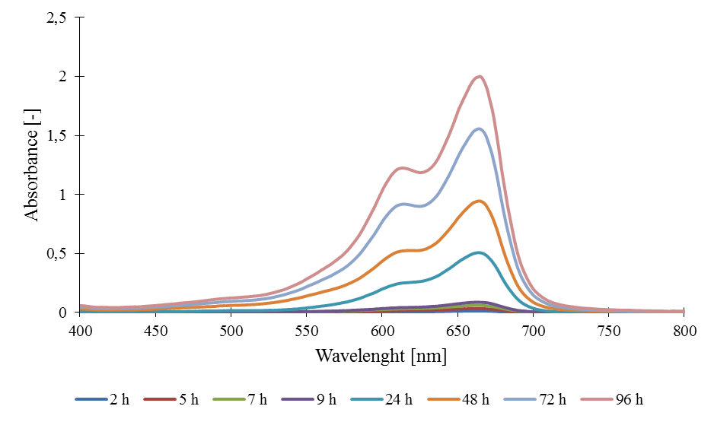
Figure 13: Absorption spectrum for methylene blue release from PVA/SA hybrid hydrogel matrix

