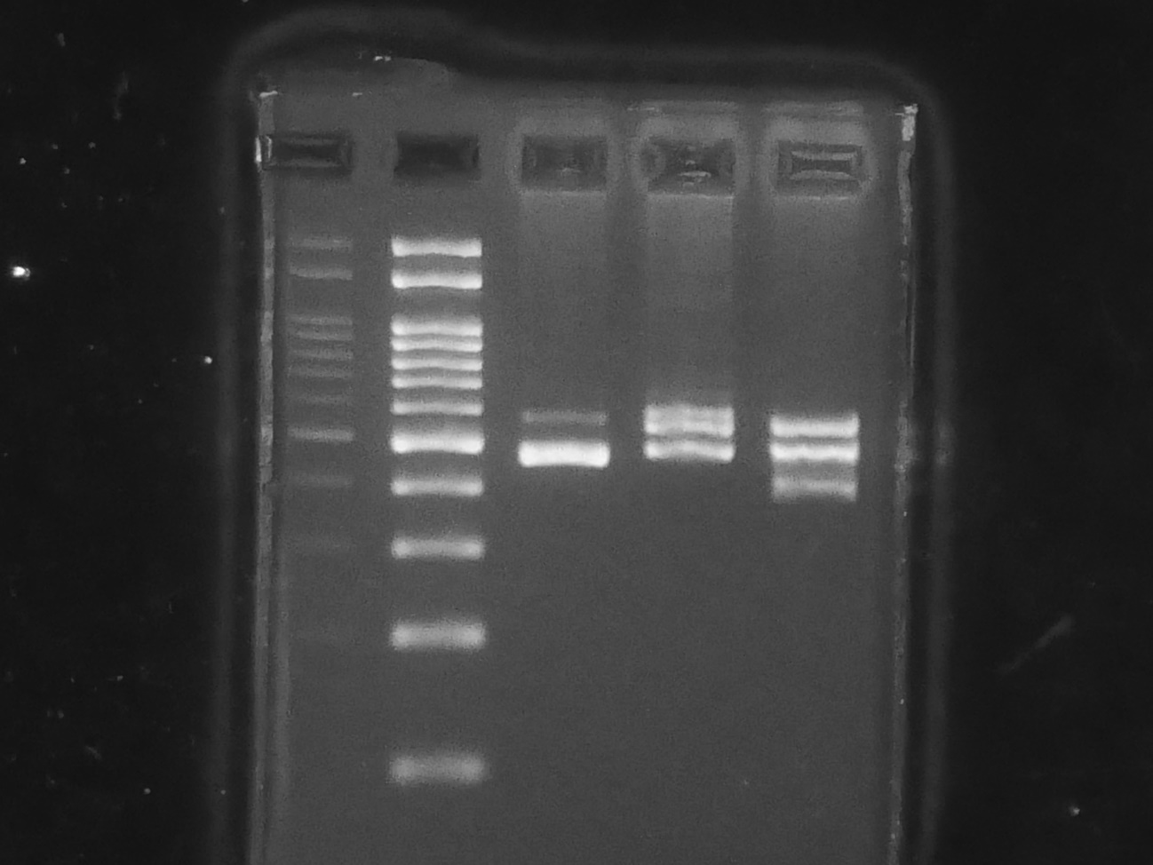
eAppendix 2
The full-length blots/gels.

