Supplementary materials

Questionnaire S1. Sample of a questionnaire conducted among people suffering from type 2 diabetes.

PART 1. PRELIMINARY INFORMATION
Sex  (W/M) | Country | Voivodeship  (birth) | City  of residence | Age | Height | Weight

Do you suffer from diabetes? If so, what type?

Do you suffer from chronic diseases other than diabetes? If so, which ones?

PART 2. LIFESTYLE
Do you play sports? How many hours per week?
Do you smoke cigarettes? How many years? How many packs a day?
Do you take medications? Which medications?
Do you consume alcohol? In what amount (in grams of alcohol)? How often?

PART 3. DISEASES IN THE FAMILY
Do your parents have diabetes?
If so, what type/at what age was it diagnosed?
Do your siblings have diabetes?
Jeśli tak – jakiego typu/w jakim wieku ją zdiagnozowano?
Does the father/brother below 55 years of age had a myocardial infarction?
Does the father/brother below 55 years of age sudden death occurred?
Does the father/brother below 55 years of age suffered a stroke?
Does the mother/sister below 65 years of age had a myocardial infarction?
Does the mother/sister below 65 years of age sudden death occurred?
Does the mother/sister below 65 years of age suffered a stroke?
Have your parents been diagnosed with cancer?
If so, what/at what age?
Have your siblings been diagnosed with cancer?
If so, what/at what age?

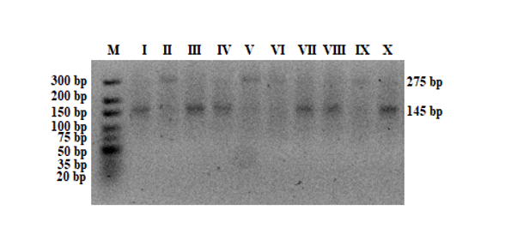
Figure S1. Example of electropherogram for rs3842729 (INS). M – marker ladder; II, V, VI, IX – A/G genotype; I, III, IV, VII, VIII, X – G/G genotype.
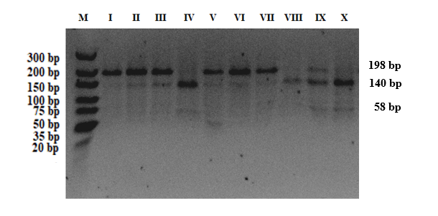
Figure S2. Example of electropherogram for rs1800795 (IL6). M – marker ladder; I – G/G genotype; II, III, V, VI, VII, IX – G/C genotype; IV, VIII, X – C/C genotype.

